Stroke Prediction Using Logistic Regression
Brendan Tice | BRETIC0307 | November 1, 2026

Project overview
The dataset contains 15,000 records and 34 columns. The outcome is Diagnosis (Stroke versus No Stroke). Patient names and IDs were excluded. Categorical predictors were converted to binary dummy variables; missing numeric values were filled with training-workflow median values. An 80/20 stratified split was used, followed by standardized logistic regression with balanced class weights.

Model evaluation
ACCURACY: 0.5080
PRECISION: 0.5060
RECALL: 0.5114
MAE: 0.4920
MSE: 0.4920
R2: -0.9680
Confusion matrix (rows: actual No Stroke, Stroke; columns: predicted No Stroke, Stroke): [[760, 746], [730, 764]]

Feature ranking
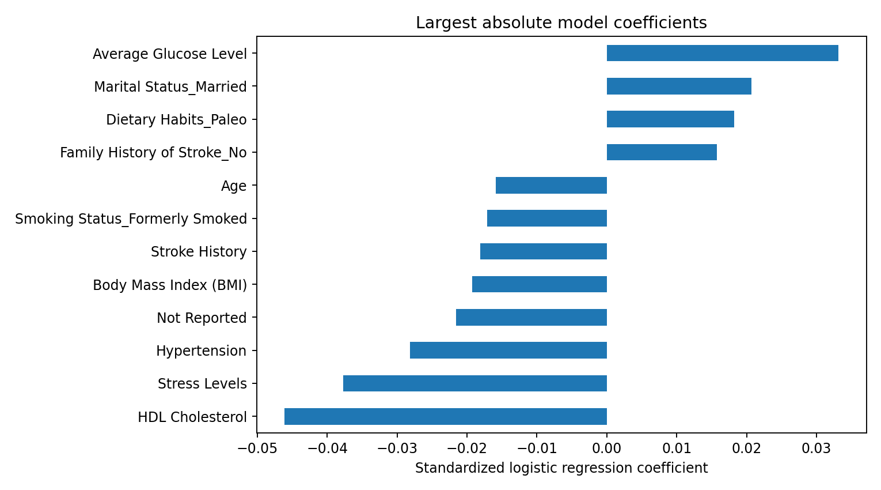
Ranking uses absolute standardized logistic regression coefficients; positive coefficients increase model log-odds and negative coefficients decrease them, conditional on other features.

BMI what-if analysis
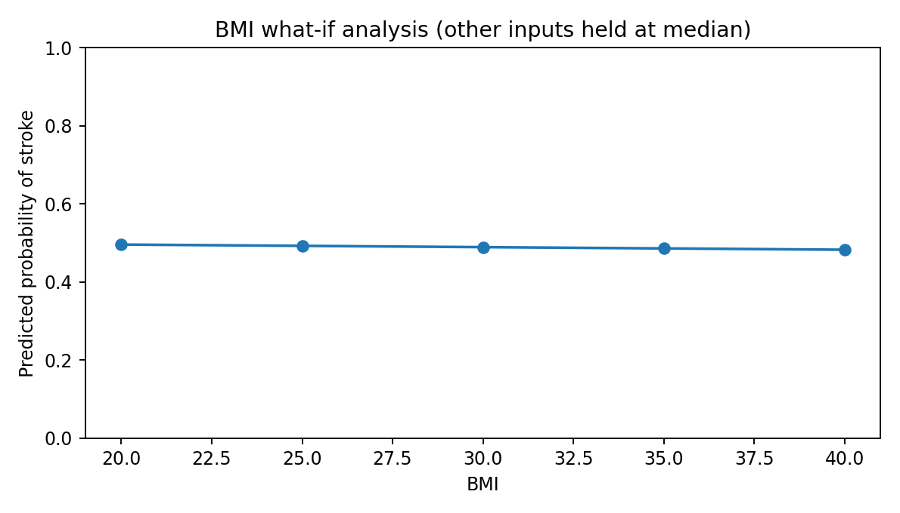

Assignment questions
1. Accuracy, precision, and recall: Accuracy was 50.80%, precision 50.60%, and recall 51.14% on the held-out test set. Because stroke outcomes may be imbalanced, accuracy alone does not adequately describe model performance.
2. Most significant predictor: HDL Cholesterol had the largest absolute standardized coefficient (-0.046) in this fitted model. This measures predictive association, not causation.
3. BMI: Holding other encoded variables at their median values, the model-predicted stroke probability decreases as BMI rises from 20 (49.6%) to 40 (48.3%). These are model predictions, not an individual clinical risk assessment.
4. Another notable predictor besides Work Type_Never Worked: HDL Cholesterol (standardized coefficient -0.046) ranked highly by absolute coefficient. Its association should not be interpreted as causal.

Screenshots and GitHub submission
Open and run the attached notebook in VS Code or JupyterLab. Capture screenshots of the dataset, preprocessing, train/test split, evaluation metrics, coefficient ranking, and BMI analysis with the computer date and time visible. Add these screenshots to this report before submission. Create a GitHub repository, commit the notebook, dataset if permitted, and report, then submit the repository URL and screenshot report.
Limitations: The coefficients may be affected by correlated predictors; using balanced class weights changes the classification threshold behavior. R² is a regression metric and is not a useful primary measure for this binary classification problem.

