Voice Production and Synthesis

Lab Submission

The following pages should be filled in from your completed lab script, and submitted alongside the rest of your assignment for the Voice Synthesis module. You **do not** need to submit the rest of the lab script.

**Exam number: Y3161870**

**Partner’s exam number (if applicable): n/a**

**Recorded voice type: n/a**

1. **Insert your IPA transcription from 1.3 here:**

ðʌ dʌpɑ:tmɛnt ɒv ɛlɛktɹɒnɪks æt ðʌ u:nivɜ:sɪti: ɒv jʊək

1. **Comment on the transcription of your recording compared to your expected IPA of the phrase:**

Doesn’t line up precisely. There is more of an ‘r’ sound in department that I neglected to transcribe. In real life I didn’t pronounce the ‘t’ at the end of ‘department’ fully so it sounds more like ‘departmen’. Clearly prosody/accent have a huge impact on pronunciation which isn’t captured by this simplified IPA transcription.

1. **Insert one of your three plots from 7.2 here:**

Contour Plot 1 Vowel (IPA): /i/

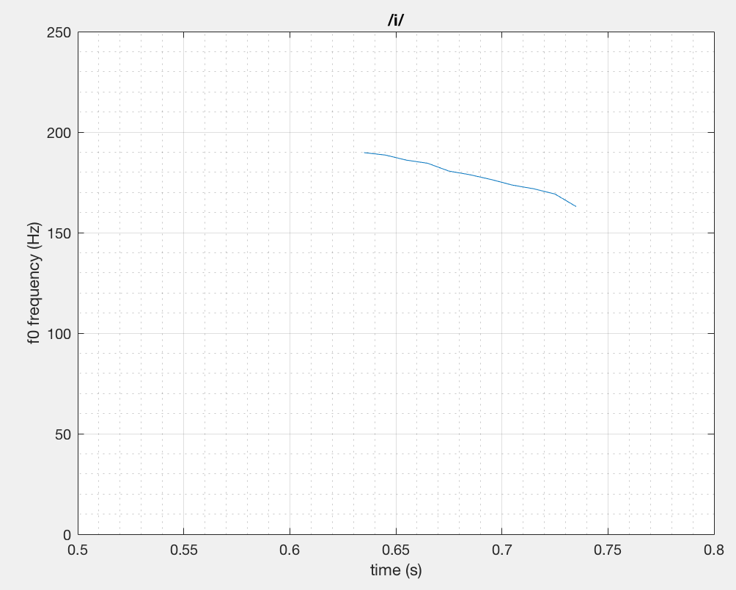

1. Insert your table from 9 here:

|  |  |  |  |  |
| --- | --- | --- | --- | --- |
| ***vowel*** | ***F1*** | ***F2*** |  |  |
| /i/ | 545.3388150616257 | 2501.1862569075456 |
| /ɛ/ | 1004.8520549850004 | 2304.691972628361 |
| /æ/ | 1267.7899724397907 | 2312.9188245434952 |
| /ɑ:/ | 865.3055760389218 | 1303.5309955802165 |
| /ɒ/ | 756.7045553628125 | 1575.4090008686253 |
| /u:/ | 329.6131188302091 | 1988.088766425628 |

1. Insert your plot from 9.1 here:

**Plot showing the first and second formant values of six vowels:**

1. **Insert your two plots from 10.3 here stating the diphthongs using IPA:**

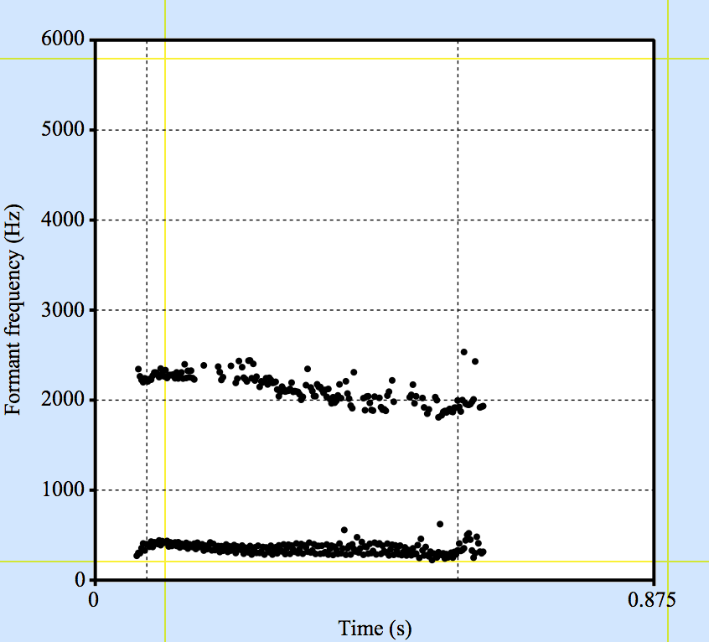**/ɪə/**

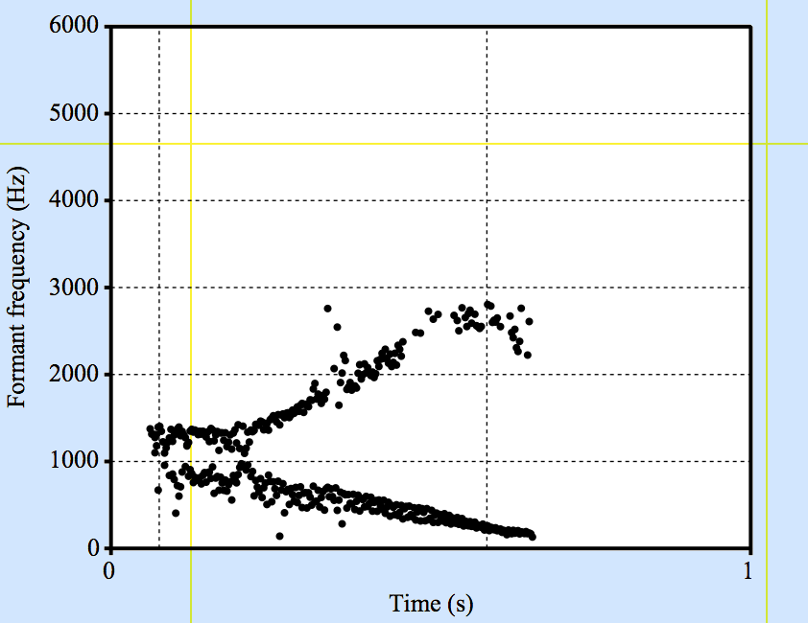/aɪ/