Airi Chow (#40003396)
COMP 479
Fall ‘20

Project #3

Using Python3
Yellow Highlight: Issue with running.
Green Highlight: Given names for outputs/inputs.

Subproject #1:

Sorting & Building an Index

Tested Commands
- python3 spimi-indexer.py -i tokens.json
- Running –> build_index_block(args.input_file,args.output_file)
============================================================
- Input: Lists of Tokens [ID, Token] (In this case of the entire REUTERS collection)
- Output: Sorted individual Blocks
============================================================

os.chdir(os.getcwd() + "/BLOCKS"): The Block will be stored in this folder to not clutter up the root folder.

- The tokens are read line by line and parse to retrieve the docID then the term.
- If the term exists already in the dictionary, we have now to check if the current docID is already in the list of docIDs.
> If that docID is a duplicate, it is ignored.
> Else, we will append it to the list.
- If the term doesn’t exist in the dictionary, we just add it to the dictionary as a key. The value is a list version of the docID.

- len(current_dictionary) == 500: After the # of keys in the dictionary reaches 500, we need to sort the dictionary by iterating through it and creating a sorted dictionary done as so: sorted_dictionary = collections.OrderedDict(sorted(current_dictionary.items()))
- This sorted_dictionary is then dumped into a file with the name “BLOCK” + block_counter.
- After this block has been created, the current_dictionary is clear and the block_counter goes up by one.

Merging the Blocks and creating the final index

Tested Commands
- python3 spimi-indexer.py -i tokens.json
- Running –> create_final_index()
============================================================
- Input: Block files
- Output:
============================================================

files = os.listdir(os.getcwd()): Used to account the # of blocks in the directory.
current_dictionary = dict(current_dictionary, **data): Data is a keyword parameter which is a JSON dictionary object that is passed to the current_dictonary and appended. For each block that is open, this is what will happen. In the end, current_dictionary will consists of all the terms from blocks.

sorted_dictionary = collections.OrderedDict(sorted(current_dictionary.items())): This has to be sorted once again before the final merging can be done.
os.chdir(".."): We change the directory back to root so that the intermediate “sorted_dictionary.json” can be written in the root folder. If not, it would interfere and mess up the “files” listed above and the count of blocks.

Timing:
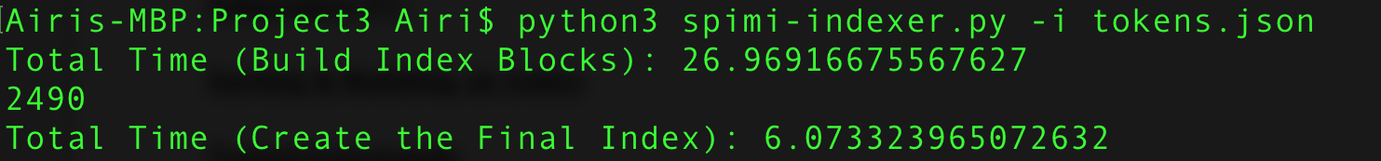
SPIMI total run time: 26.97 + 6.07 = 33.04 sec
- Creating the blocks (500 terms each block): 26.97 sec
- Creating an index: 6.07 sec
- Creating an index using the naive way: 31 sec

It takes close to 5x as much time to create an index using the naive indexer. But SPIMI takes more time with creating the blocks. But creating the final index is much shorter.

