HOW DOES IT WORK?

As soon as you have add-on installed, you will get two additional menu items for each project:  
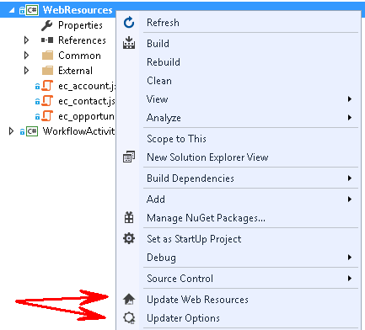

You have to set-up connection to Microsoft Dynamics CRM solution you are working on before start using add-on (see Configuration Section).

To update web resources just press "Update Web Resources". Add-on will ask CRM for all web resources that belong to Microsoft Dynamics CRM solution. As second step it will try to find appropriate web resource for each file from you project and if content is differ it will update it. If you configured add-on to atomically publish updated web resources, it will do it for you.

You can also publish selected web resource, to do that just right click on web resource and select “Update Web Resource”:

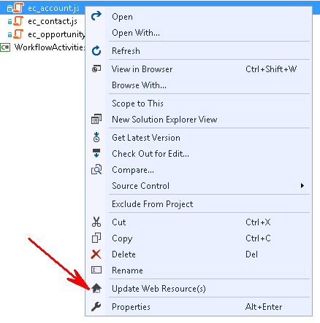

IMPORTANT

*Add-on defines web resource to be updated by comparing file name (with extension) and web resource name. Let's say we have ec_contact.js in the project. Add-on will look for a web resource with name ec_contact.js to update its content.*

*You can set-up tool to search web resource by file name with and without extension:*

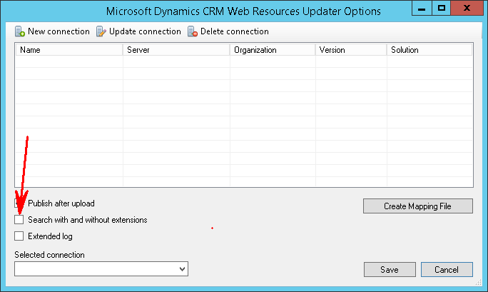

*You can use mapping file to map files in your project and web resources.*

*Using add-on assumes that web resources for each Microsoft Dynamics CRM solution you are working on are stored in separated projects. Such projects do not take part in building Visual Studio solution. Add-on enables you to configure separated connection for each project and publish web resources for each project (Microsoft Dynamics CRM solution) separately.*

HOW TO START?

INSTALLATION

* You can install add-on by using *.VSIX file. It is available for downloading on [CodePlex](https://crmupdater.codeplex.com/)
* You can install add-on from Visual Studio Gallery

CONFIGURATION

To configure add-on for a project right-click on project and select "Updater Options". Following window will be opened:  
  
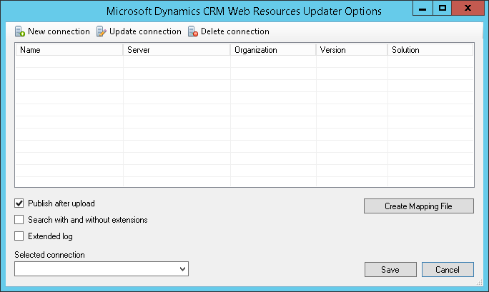   
  
Press "New connection" as shown:  
  
[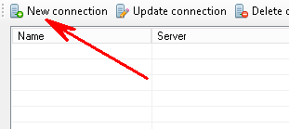](http://4.bp.blogspot.com/-ifumRgmWrOo/VrCelZ-v8QI/AAAAAAAAI6g/wRnYAjMrAy8/s1600/NewConnectionButton.png)   
  
Connection set-up window will be opened. Fill-in appropriate fields and press Button "OK":  
  
[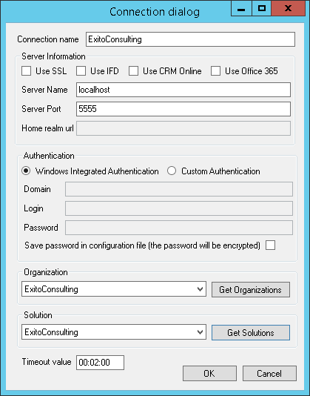](http://2.bp.blogspot.com/-CkKdX8rutNk/VrCelHA9QvI/AAAAAAAAI6o/v_GaGbcKOW0/s1600/ConnectionDialog.png)   
  
As soon as you create new connection, it will be listed in the grid as shown:  
  
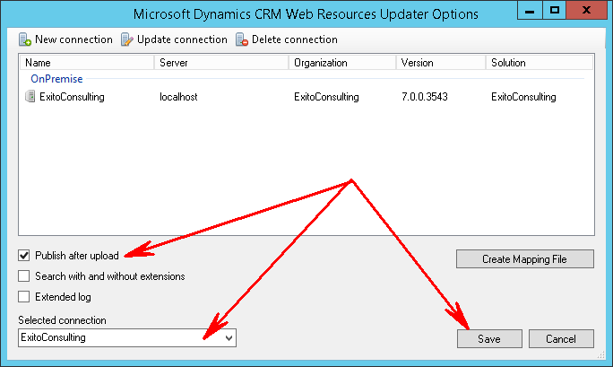   
  
Select just created connection using dropdown list. Set check box if you want updated web resources to be published. Press button "Save".   
  
That's all. Now you are ready to use add-on.

USING MAPPING FILE

Mapping files allows having custom mapping between files in your project and web resources names. To create mapping file just press on “Create mapping File”:

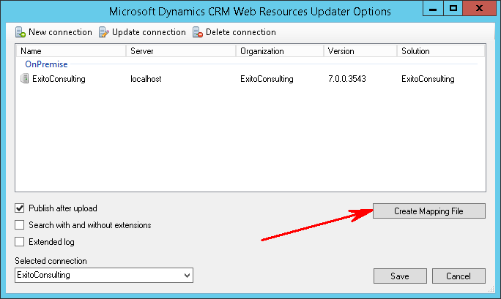

New file will be added to your project. Use following syntax to define mapping:

**<Mapping scriptPath="scripts\contact.js" webResourceName="new_contact"/>**

**<Mapping scriptPath="account.js" webResourceName="new_account"/>**