AutoTrust
Comprehensive Business Proposal, SRS, Agile Plan and Hackathon Blueprint
Version 1.0

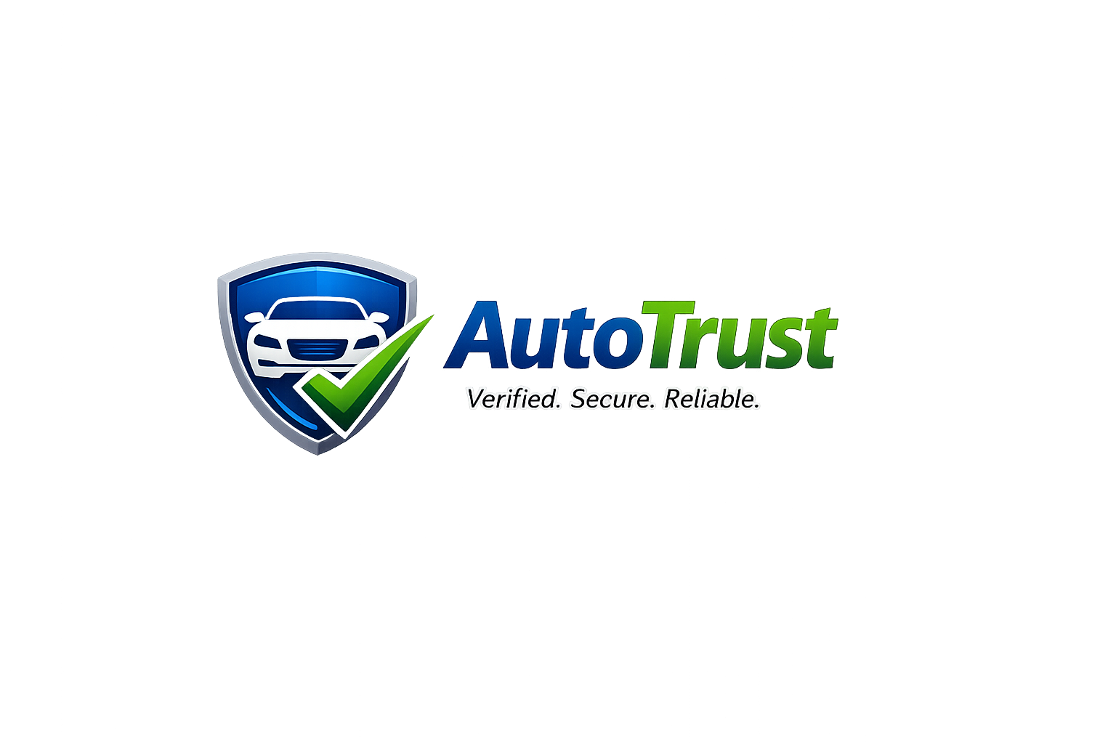

Executive Summary
AutoTrust is an AI-powered vehicle certification and marketplace platform designed to solve trust issues in used vehicle transactions.
The platform combines physical inspections, AI-generated reports, vehicle valuation, listing generation, and buyer assistance.
The business model focuses on inspection fees, dealer subscriptions, premium reports, and featured listings.

Problem Statement
The used-car market suffers from fraud, hidden defects, inaccurate descriptions, and low buyer confidence.
Many buyers lack technical expertise to assess vehicle condition before purchase.

Vision and Mission
Vision: Become Africa's most trusted vehicle marketplace.
Mission: Use AI and certified inspections to make every used vehicle transaction transparent and trustworthy.

Business Model
Revenue Streams:
1. Vehicle inspection fees.
2. Dealer subscriptions.
3. Featured listings.
4. Premium buyer reports.
5. Transaction commissions.

Market Analysis
Target customers include individual sellers, buyers, dealerships, fleet operators, ride-hailing drivers, and SMEs.
Initial focus market: Nigeria, followed by West Africa.

System Overview
Frontend: React + Tailwind.
Backend: FastAPI.
Database: Firestore.
AI: Gemini.
Hosting: Firebase Hosting and Google Cloud Run.
Payments: Paystack and Flutterwave.

Functional Requirements
User Registration and Authentication
Vehicle Listing Management
Inspection Request Workflow
Inspector Dashboard
AI Report Generation
Marketplace Search
Payment Processing
Notifications and Messaging
Administration

Non-Functional Requirements
Security, Scalability, Availability, Performance, Reliability, Maintainability and Usability.

User Roles
Seller
Buyer
Inspector
Administrator
AI Agent

Database Design
Collections:
Users
Vehicles
Inspections
Reports
Payments
Subscriptions
Notifications
Audit Logs

API Specification
POST /auth/register
POST /auth/login
GET /vehicles
POST /vehicles
POST /inspection/request
POST /report/generate
GET /reports/{id}

AI Architecture
Agent 1: Inspection Analysis Agent
Agent 2: Listing Generation Agent
Agent 3: Vehicle Pricing Agent
Agent 4: Buyer Support Agent
Agent 5: Operations Scheduling Agent

Security Design
Role-based access control.
HTTPS everywhere.
Input validation.
Secure file uploads.
Audit logging.

Deployment Architecture
Frontend deployed to Firebase Hosting.
Backend deployed to Cloud Run.
Gemini integration through secure backend APIs.
Firestore for persistence.
Firebase Storage for media.

Agile Development Plan
Sprint 1: Discovery and Architecture.
Sprint 2: Authentication and User Management.
Sprint 3: Vehicle Listing Module.
Sprint 4: Inspection Workflow.
Sprint 5: AI Reporting.
Sprint 6: Marketplace and Search.
Sprint 7: Payments.
Sprint 8: Testing and Launch.

90-Day Roadmap
Days 1-15: MVP Architecture and Setup.
Days 16-30: Vehicle and Inspection Modules.
Days 31-45: AI Features.
Days 46-60: Payments and Launch.
Days 61-75: Customer Acquisition.
Days 76-90: Scale and Hackathon Submission.

Financial Projections
Year 1 Assumptions:
100 inspections/month at ₦15,000.
10 dealer subscriptions.
Featured listings revenue.
Projected annual revenue exceeds ₦20 million with moderate adoption.

Risk Register
Low user adoption.
Inspector quality issues.
AI inaccuracies.
Operational costs.
Regulatory concerns.
Mitigation plans included for each risk.

Hackathon Submission Strategy
Demonstrate production AI.
Show agent execution logs.
Present real users and testimonials.
Provide revenue evidence.
Document Google Cloud usage.

Conclusion
CertiCar AI has the potential to become a trusted infrastructure layer for vehicle transactions while satisfying the requirements of the Build with Gemini XPRIZE competition.

