**CRAMPS**

**I. Function description:**

- The CRAMPS design is intended to provide a simple low-cost board to interface the BeagleBone to typical desktop 3D printers, mini-mills, and other CNC machines. The design is inspired by the simplicity and success of the [RAMPS](http://reprap.org/wiki/Ramps) board for the Arduino Mega, and borrows from the [RAMPS-FD](http://reprap.org/wiki/RAMPS-FD) design for the Arduino Due.

**II. Features:**

* Six Pololu stepper driver sockets
* 15A 12V-24V Output for heated bed
* (3) high-current 12V-24V outputs for extruders
* Independent fused power inputs for the motors, heated bed, and extruders
* Four thermistor inputs for temperature sensing
* Two low-current 5V-12V FET outputs for fans/LEDs
* Six limit switch inputs (may also be used for GPIO), 5V tolerant
* External ESTOP loop
* Expansion headers with I2C and SPI signals
* Optional add-on board for three additional stepper drivers (9 total)
* Four additional 5V tolerant GPIO signals available when not used by the add-on board

**III. Usage:**

1. Wiring and hardware description:



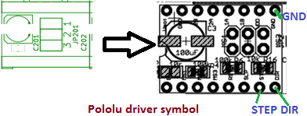

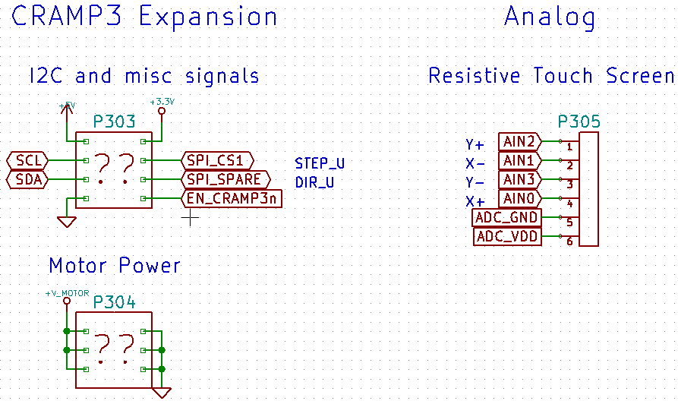

2. Software operation:

**- Start LinuxCNC:**

Step 1: open terminal and type command: linuxcnc&

A screen will display as below:

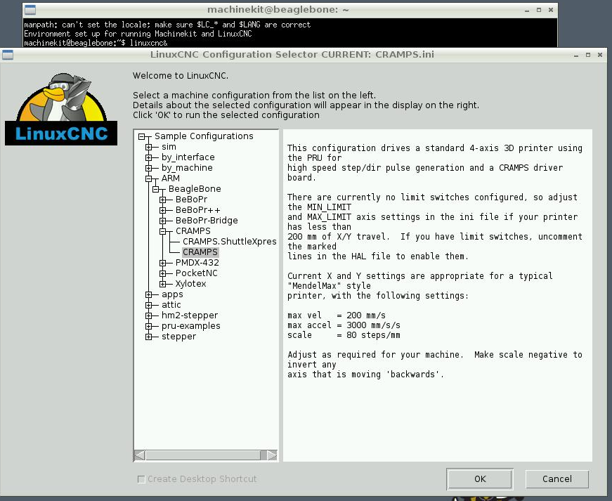

**Step 2: Choose target board:**

Select the target board that we want to control. Here I choose CRAMPS board and press OK button.

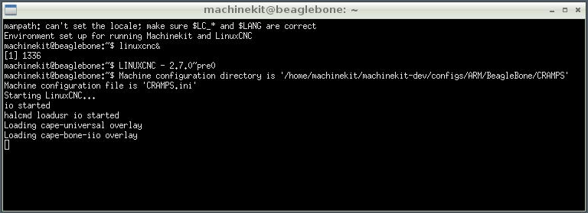

As you can see in above picture, the software read a configuration file (.ini) from a specific directory. We need to adjust that file to meet our requirements. The file with name CRAMPS.ini

**Step 3: operate user interface.**

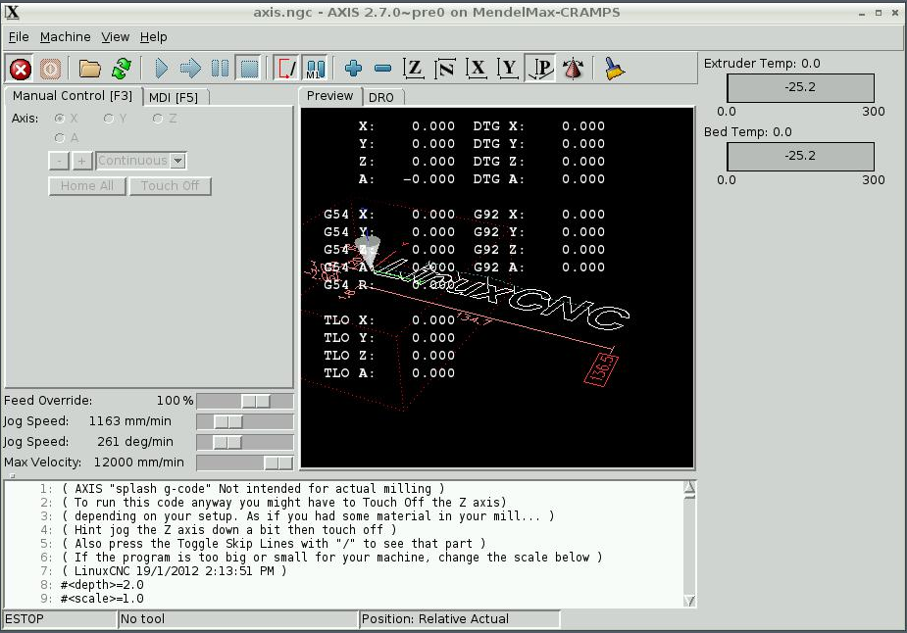

We could face with some problems about .ini file before the program run. To solve that, we adjust some parameters to adapt with the file, machine we want to run.

The .ini file locate on a directory as below:



After load a file, we can see the interface as below:

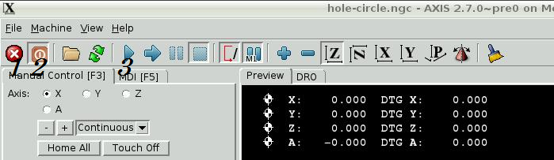

To control machine,

+ We need to release emergency button (1).

+ Press the power button (2) to turn on power for machine.

+ Press ‘Home All’ to move all axes to original coordinate.

+ Press start button (3) to start program.

We can observe the process via 3D Visual:

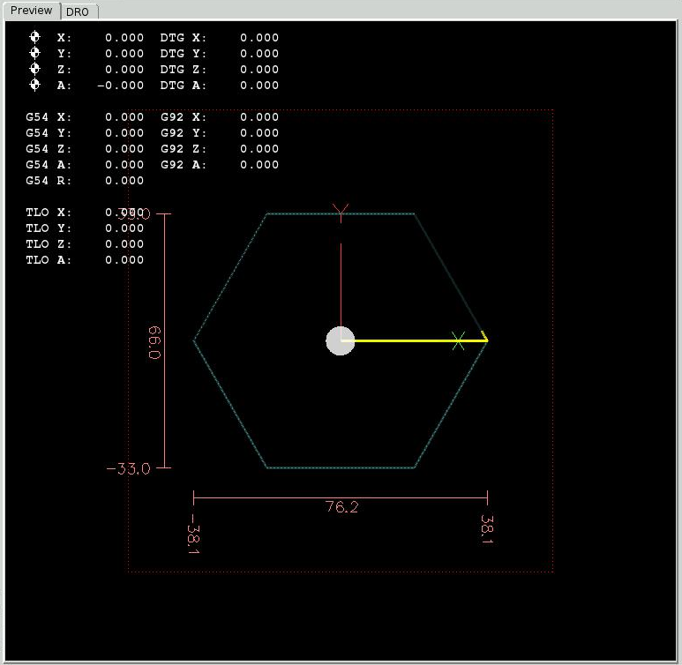

**Step4: Monitoring output:**

To monitor output, we can use oscilloscope or relevant tool, here I use Hantek tool.

Hantek tool as same as with another tool, it has two probes, each of probe has two polar, one is GND, another is used for signal measure. We use to measure pulses on axes.

We want to monitor output on Stepper axes so we need to connect 2 GND pins of probes to GND, STEP to channel 1, DIR to channel 2.

**III. Place to make this PCB:**

Send an email to below company.

**Address**: 17/1B Nguyen Thi Minh Khai Str., Ben Nghe Ward, Distric 1, HCMC  
**Phone**: 08.38296605, Email: [kimsonpcb@yahoo.com](mailto:kimsonpcb@yahoo.com)  
**Website**: [**http://kimsonpcb.vn**](http://kimsonpcb.vn),[**http://facebook.com/kimsonpcb**](http://facebook.com/kimsonpcb) **Skype :** kimsonpcb.kt  
**Yêu Cầu Báo Giá**: <http://kimsonpcb.vn/dat-mach.html>