Electric Vehicle Driving Range Prediction
A Machine Learning Framework for Real-World EV Range Estimation
A machine learning framework for predicting real-world remaining driving range in Battery Electric Vehicles (BEVs), specifically calibrated for the 2013 Nissan Leaf (24 kWh battery pack) based on the University of Michigan Vehicle Energy Dataset (VED) telemetry schema.

1. Overview
Accurate driving range estimation is critical to mitigating driver range anxiety. This repository implements an end-to-end regression pipeline that accounts for non-linear physical dynamics:
- Aerodynamic drag losses: scaling with the cube of speed (P_drag proportional to v^3).
- Electro-chemical degradation: in sub-zero winter temperatures (< 15 deg C).
- Cabin HVAC energy consumption: (PTC heaters and A/C compressor drawing up to 4.5 kW).
- Gravitational resistance: on road inclines and hilly terrain.
Three regression models were evaluated: Random Forest Regressor, Gradient Boosting Regressor, and Support Vector Regressor (SVR). SVR with a Radial Basis Function (RBF) kernel achieved the highest accuracy (R2 = 0.9953, MAE = 1.30 km) and was deployed as the primary model.

2. Model Performance Scoreboard
Evaluated on an unseen 20% test holdout split (1,000 driving trips):
Model Architecture | MAE | RMSE | R2 Score | Status
Support Vector Regressor (SVR) | 1.30 km | 1.92 km | 0.9953 | Deployed Champion
Gradient Boosting Regressor | 1.88 km | 2.69 km | 0.9909 | Baseline Comparison
Random Forest Regressor | 2.52 km | 3.61 km | 0.9835 | Baseline Comparison
Actual vs. Predicted Range Comparison:
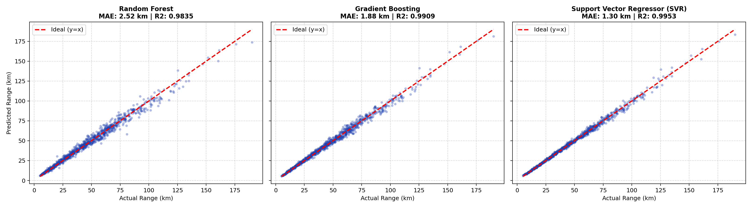
Figure 1: Benchmark evaluation scatter plot showing ideal y=x reference.

3. Repository Structure
.
|-- .gitignore # Standard git ignore rules
|-- README.md # Project documentation and guide
|-- requirements.txt # Python package dependencies
|-- app.py # Interactive Streamlit Web Application
|-- data/
| `-- ev_driving_dataset.csv # 5,000 trip records (VED Nissan Leaf specification)
|-- models/
| `-- svr_pipeline.joblib # Pre-trained SVR pipeline (StandardScaler + SVR)
|-- notebooks/
| `-- ev_range_prediction.ipynb # Executable Jupyter Notebook with analysis & plots
|-- src/
| |-- __init__.py
| |-- data_generator.py # Physics-grounded EV data simulation module
| |-- train.py # Training, benchmarking, and serialization script
| `-- predict.py # Standalone CLI inference utility
|-- assets/
| `-- ev_model_comparison.png # Benchmark evaluation scatter plot
|-- docs/
| `-- PROJECT_REPORT.md # Detailed academic/technical report
`-- EV_Range_Prediction_Presentation.pptx # Widescreen presentation slide deck

4. Installation and Setup
Prerequisites:
Python 3.10 or higher. Recommended: Virtual environment (venv).
Step 1 - Clone Repository:
git clone https://github.com/airlord-0/EV-range-range-prediction.git
cd EV-range-range-prediction
Step 2 - Virtual Environment:
python3 -m venv venv
source venv/bin/activate # On Windows: venv\Scripts\activate
Step 3 - Install Dependencies:
pip install -r requirements.txt

5. Usage
Launch Interactive Web Application:
streamlit run app.py
Starts local web server with interactive sliders for speed, temperature, SoC, slope, and HVAC power.
Retrain Models & Benchmark:
python src/train.py
Regenerates the dataset, evaluates all candidate models, and exports the champion model.
Run Standalone CLI Predictor:
python src/predict.py
Predicts remaining range for sample operational scenarios.
View Jupyter Notebook:
jupyter lab notebooks/ev_range_prediction.ipynb
Interactive exploration, mathematical formulas, and inline visualization.

6. Real-World Scenario Examples
- Scenario 1: Harsh Winter Highway
- Inputs: -5 deg C, 100 km/h, 80% SoC, 4.0 kW Heater
- Predicted Range: 39.8 km (~62% penalty due to cold chemistry and drag).
- Scenario 2: Mild Spring Urban Commute
- Inputs: +20 deg C, 40 km/h, 80% SoC, HVAC Off
- Predicted Range: 106.3 km (Optimal operating zone).
- Scenario 3: Hot Summer Mountain Climb
- Inputs: +34 deg C, 60 km/h, 50% SoC, +4% Grade, 2.5 kW A/C
- Predicted Range: 37.1 km.

7. License
This project is licensed under the Apache License 2.0.

