Creating Web App using Maven

Step 1: Open Eclipse/STS, Create a maven project

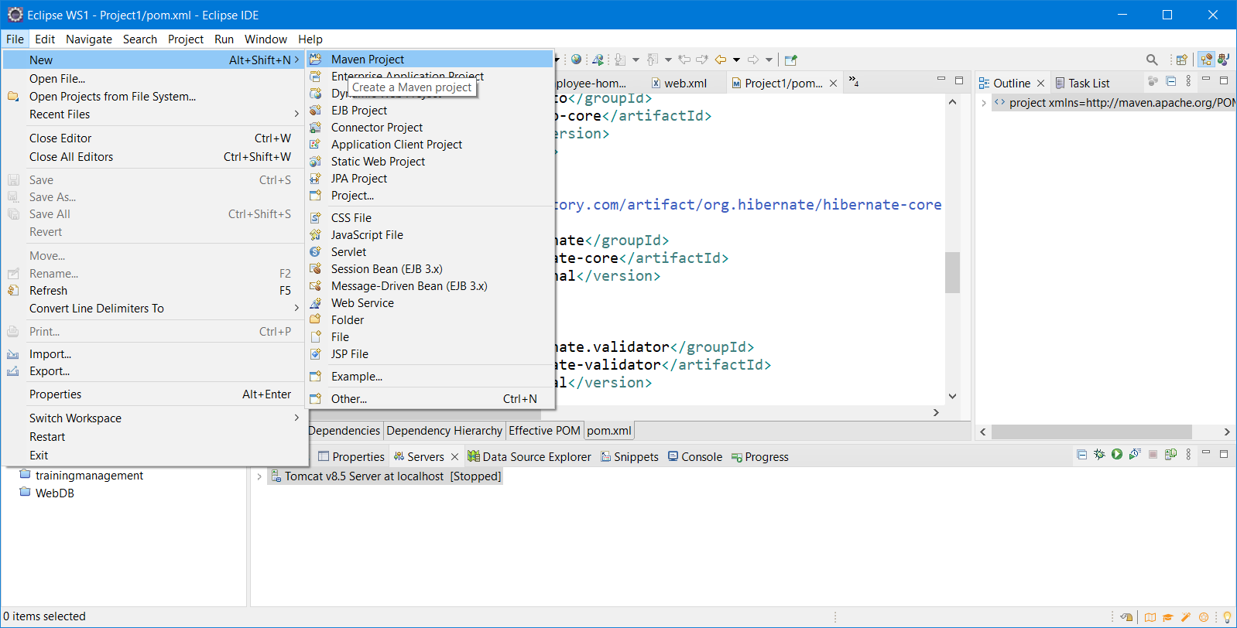

Step 2: Make sure to leave the “Create a simple project” check box unselected and click “next”

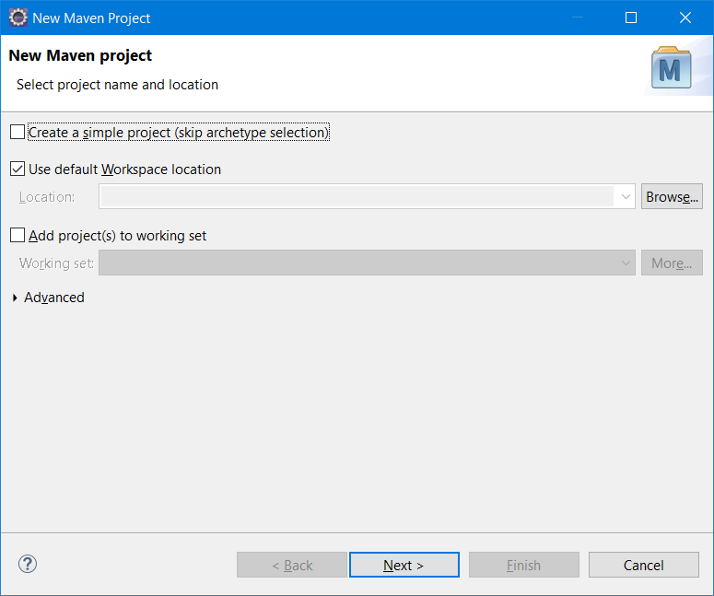

Step 3:

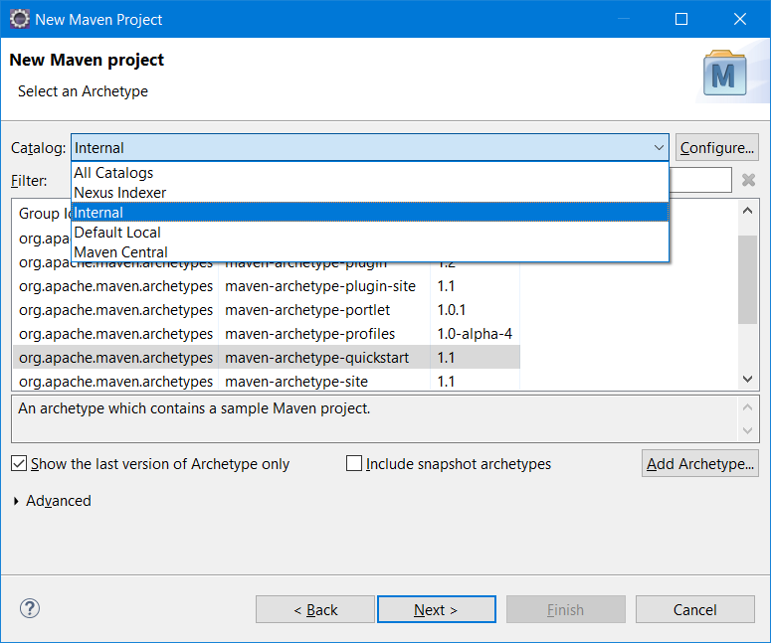

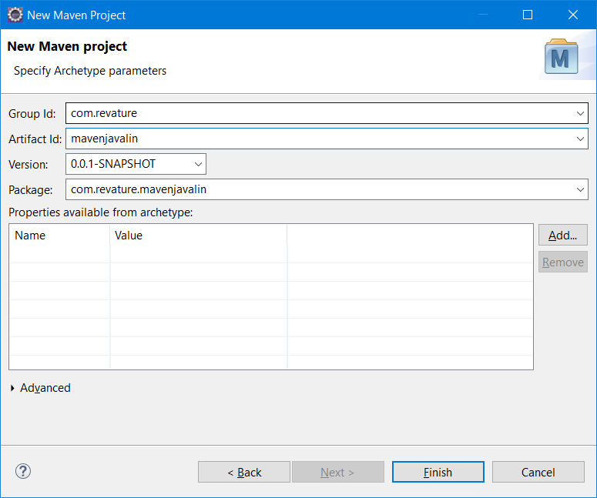

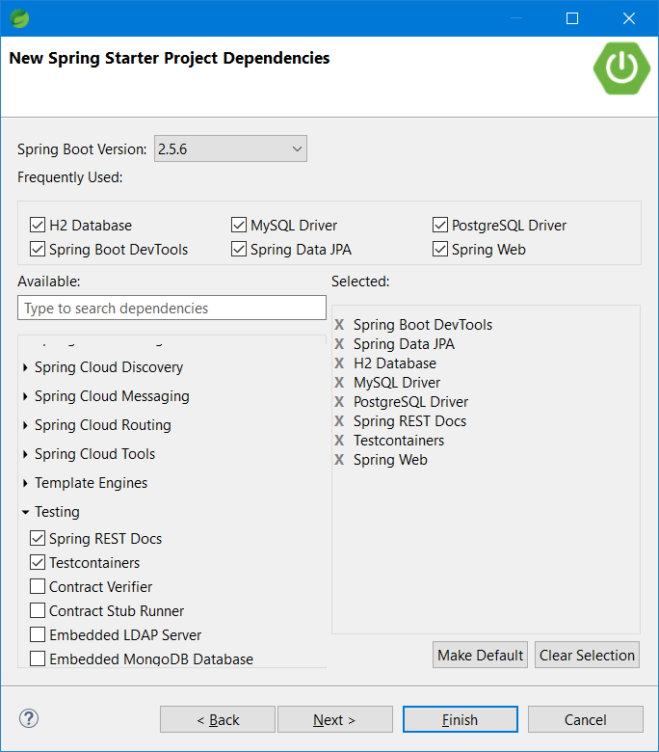

<dependency>

<groupId>io.springfox</groupId>

<artifactId>springfox-swagger2</artifactId>

<version>2.9.2</version>

</dependency>

<dependency>

<groupId>io.springfox</groupId>

<artifactId>springfox-swagger-ui</artifactId>

<version>2.9.2</version>

</dependency>

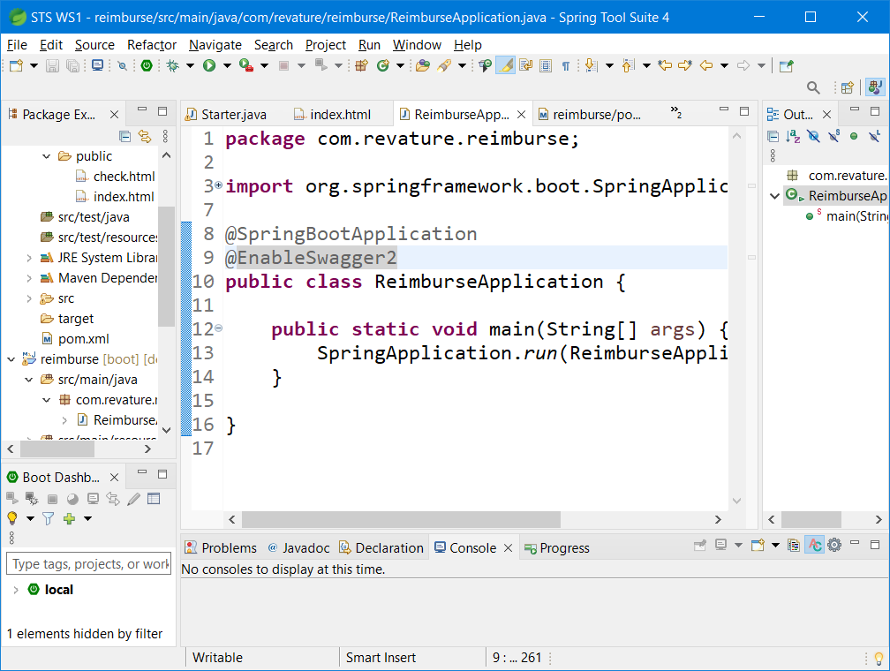

Testing the API End points using JMeter

<http://www.testautomationguru.com/how-to-test-rest-api-using-jmeter/>

<https://www.guru99.com/guide-to-install-jmeter.html>

<http://jmeter.apache.org/download_jmeter.cgi>

