Testing

Testing Pyramid

1. Unit Test (Base, Happy Path (positive test), Error Path (Negative Test), Testing Individual components) Very Faster
2. Integration Test (Slower than Unit Test)
3. E2E Test (End to End Test) (Slower than Integration Test)

<https://www.browserstack.com/guide/testing-pyramid-for-test-automation>

<https://www.browserstack.com/guide/selenium-webdriver-tutorial>

Selenium

1. Selenium Web Driver (Selenium 2.0)
2. Selenium IDE (Integrated Development Environment) Record Function
3. Selenium Grid

<https://www.selenium.dev/downloads/>

**Selenium WebDriver Framework Architecture**

**WebDriver Architecture is made up of four major components:**

1. Selenium Client library
2. JSON wire protocol over HTTP
3. Browser Drivers
4. Browsers

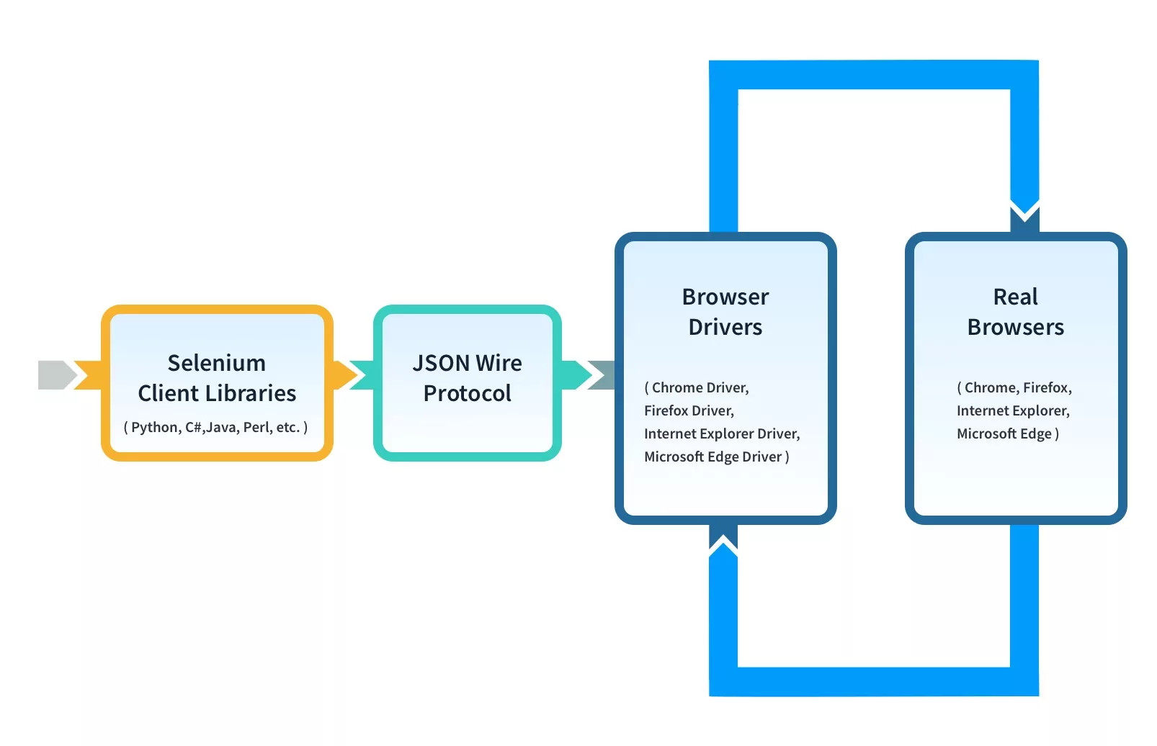

### ****Basic Steps in a Selenium WebDriver Script****

* Create a WebDriver instance.
* Navigate to a webpage.
* Locate a web element on the webpage via [locators in selenium](https://www.browserstack.com/guide/locators-in-selenium).
* Perform one or more user actions on the element.
* Preload the expected output/browser response to the action.
* Run test.
* Record results and compare results from them to the expected output.

In order to run tests, one must be familiar with the [Basic Commands in Selenium WebDriver](https://www.browserstack.com/guide/selenium-commands).

<https://www.browserstack.com/guide/locators-in-selenium>

<https://www.browserstack.com/guide/selenium-webdriver-tutorial>

Types of Testing

* [Accessibility testing](https://www.perfecto.io/accessibility-testing)
* Acceptance testing
* Black box testing
* End to end testing
* [Functional testing](https://www.perfecto.io/functional-testing-web-mobile-apps)
* [Interactive testing](https://www.perfecto.io/interactive-testing)
* Integration testing
* Load testing
* [Non functional testing](https://www.perfecto.io/blog/what-is-non-functional-testing)
* Performance testing
* [Regression testing](https://www.perfecto.io/regression-testing)
* Sanity testing
* Security testing
* [Single user performance testing](https://www.perfecto.io/blog/single-user-performance-testing)
* Smoke testing
* Stress testing
* Unit testing
* White-box testing

<https://www.javatpoint.com/types-of-software-testing>

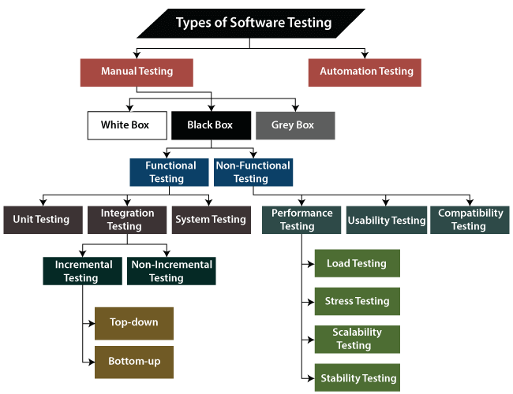

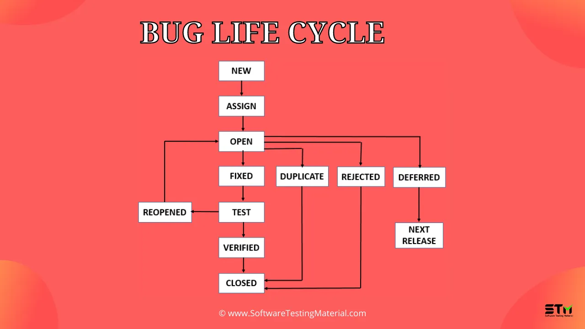

## STLC Phases

There are following six major phases in every Software Testing Life Cycle Model (STLC Model):

1. Requirement Analysis
2. Test Planning
3. Test case development
4. Test Environment setup
5. Test Execution
6. Test Cycle closure

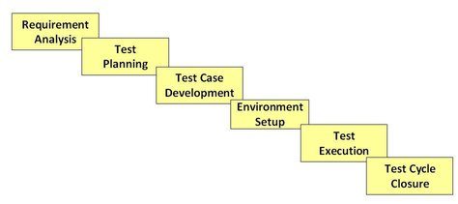

**phases of STLC:**

1. Requirements phase
2. Planning Phase
3. Analysis phase
4. Design Phase
5. Implementation Phase
6. Execution Phase
7. Conclusion Phase
8. Closure Phase

<https://www.softwaretestinghelp.com/what-is-software-testing-life-cycle-stlc/>

<https://www.guru99.com/software-testing-life-cycle.html>

INSERT INTO `p2`.`account` (`id`, `acc_number`, `acc_type`, `interest_rate`, `min_balance`) VALUES ('100', 'SA890340934', 'saving', '5.6', '500');

INSERT INTO `p2`.`account` (`id`, `acc_number`, `acc_type`, `interest_rate`, `min_balance`) VALUES ('101', 'CA788909679', 'current', '3.6', '0');

INSERT INTO `p2`.`account` (`id`, `acc_number`, `acc_type`, `interest_rate`, `min_balance`) VALUES ('102', 'LA677889674', 'loan', '8.9', '0');

<https://www.bacancytechnology.com/blog/unit-testing-in-angular-application-using-jasmine-and-karma-part-1>

customers/100/accounts