GAMS by guild behavior subset

2022-12-02

### Notes from meeting with Katrine 29.11.2022

## 

## 2. For the guild / behavior specific data sets

1. Find appropriate k values for each model type
2. Re run with y = bat pass count (bat pass sum, bat pass mean) rather than the binary response.
   * managed some version of this for all model sets
3. Diagnose under dispersion where it exists
4. Experiment with leaving out or including the interaction between wind and temperature
   * I did this for night and habitat more often
5. Make figures that show the overall activity at the different sites across time (perhaps include the mean or median as an added line with CI’s)

## Did not make it here

## 

## Generally helpful links

<https://fromthebottomoftheheap.net/2021/02/02/random-effects-in-gams/> <https://www.ncbi.nlm.nih.gov/pmc/articles/PMC6542350/> <https://typeset.io/papers/ordinal-regression-models-for-zero-inflated-and-or-over-16rgcdiks5>

# set project working directory according to the user system info   
# Otherwise, all the data (inputs and outputs, including figures) can be stored on a shared OneDrive folder  
  
user <- Sys.info()['effective_user']   
user  
# this should print your nmbu user name - "apmc" in my case.   
  
wd <- getwd()  
wd  
  
# "C:/Users/apmc/OneDrive - Norwegian University of Life Sciences/Documents/1. PhD_Main/GitHub_link/MarkerBatAcousticAnalyses/MarkerBatAcousticAnalyses2022"  
  
  
  
### Here is some example code from Pierre that I would like to implement soon which allows us to adjust all the directories based on the user  
  
# if(Sys.info()['user'] == 'pidu') { ## Pierre  
# gitDir <- 'C:/myDocuments/AlpineWolf'  
# dataDir <- 'C:/Users/pidu/Dropbox (AQEG)/AQEG Team Folder/AlpineWolf/01_Data'   
# analysisDir <- 'C:/Users/pidu/Dropbox (AQEG)/AQEG Team Folder/AlpineWolf/02_Analysis'  
# simulationDir <- 'C:/Users/pidu/Dropbox (AQEG)/AQEG Team Folder/AlpineWolf/03_Simulations'  
# meetingDir <- 'C:/Users/pidu/Dropbox (AQEG)/AQEG Team Folder/AlpineWolf/04_Meetings'  
# reportDir <- 'C:/Users/pidu/Dropbox (AQEG)/AQEG Team Folder/AlpineWolf/06_Report'  
# } else if(Sys.info()['user'] == 'virginia') { ## Virginia  
# gitDir <- '/Users/virginia/Dropbox/Mac/Documents/GitHub/AlpineWolf'  
# dataDir <- '/Users/virginia/Dropbox/AlpineWolf/01_Data'  
# analysisDir <- '/Users/virginia/Dropbox/AlpineWolf/02_Analysis'  
# simulationDir <- '/Users/virginia/Dropbox/AlpineWolf/03_Simulations'  
# meetingDir <- '/Users/virginia/Dropbox/AlpineWolf/04_Meetings'  
# reportDir <- '/Users/virginia/Dropbox/AlpineWolf/06_Report'  
#   
  
##########################################################  
#### Work environment set up ####  
##########################################################  
library(knitr)  
library(data.table)  
library(tidyverse)

## ── Attaching packages ─────────────────────────────────────── tidyverse 1.3.2 ──  
## ✔ ggplot2 3.4.0 ✔ purrr 0.3.5   
## ✔ tibble 3.1.8 ✔ dplyr 1.0.10  
## ✔ tidyr 1.2.1 ✔ stringr 1.4.1   
## ✔ readr 2.1.3 ✔ forcats 0.5.2   
## ── Conflicts ────────────────────────────────────────── tidyverse_conflicts() ──  
## ✖ dplyr::between() masks data.table::between()  
## ✖ dplyr::filter() masks stats::filter()  
## ✖ dplyr::first() masks data.table::first()  
## ✖ dplyr::lag() masks stats::lag()  
## ✖ dplyr::last() masks data.table::last()  
## ✖ purrr::transpose() masks data.table::transpose()

library(beepr)  
library(lubridate)

## Loading required package: timechange  
##   
## Attaching package: 'lubridate'  
##   
## The following objects are masked from 'package:data.table':  
##   
## hour, isoweek, mday, minute, month, quarter, second, wday, week,  
## yday, year  
##   
## The following objects are masked from 'package:base':  
##   
## date, intersect, setdiff, union

library(purrr)  
#renv::install("rstudio/renv")  
library(renv)

##   
## Attaching package: 'renv'  
##   
## The following object is masked from 'package:purrr':  
##   
## modify  
##   
## The following objects are masked from 'package:stats':  
##   
## embed, update  
##   
## The following objects are masked from 'package:utils':  
##   
## history, upgrade  
##   
## The following objects are masked from 'package:base':  
##   
## autoload, load, remove

library(stringr)  
library(janitor)

##   
## Attaching package: 'janitor'  
##   
## The following objects are masked from 'package:stats':  
##   
## chisq.test, fisher.test

library(anytime)  
library(kableExtra)

## Warning in !is.null(rmarkdown::metadata$output) && rmarkdown::metadata$output  
## %in% : 'length(x) = 2 > 1' in coercion to 'logical(1)'

##   
## Attaching package: 'kableExtra'  
##   
## The following object is masked from 'package:dplyr':  
##   
## group_rows

library(papeR)

## Loading required package: car  
## Loading required package: carData  
##   
## Attaching package: 'car'  
##   
## The following object is masked from 'package:dplyr':  
##   
## recode  
##   
## The following object is masked from 'package:purrr':  
##   
## some  
##   
## Loading required package: xtable  
## Registered S3 method overwritten by 'papeR':  
## method from  
## Anova.lme car   
##   
## Attaching package: 'papeR'  
##   
## The following objects are masked from 'package:dplyr':  
##   
## summarise, summarize  
##   
## The following object is masked from 'package:utils':  
##   
## toLatex

library(skimr)  
library(vtable)  
library(gratia)  
library(DHARMa)

## This is DHARMa 0.4.6. For overview type '?DHARMa'. For recent changes, type news(package = 'DHARMa')

library(mgcv)

## Loading required package: nlme  
##   
## Attaching package: 'nlme'  
##   
## The following object is masked from 'package:dplyr':  
##   
## collapse  
##   
## This is mgcv 1.8-41. For overview type 'help("mgcv-package")'.

library(tidymv)

## tidymv will be deprecated. Users are recommended  
## to check out the in-progress replacement tidygam  
## (https://github.com/stefanocoretta/tidygam).

##########################################################  
#### Import data, set up directories ####  
##########################################################  
  
# All input data can be found on a shared OneDrive folder - we can both share the same input folder but we should have different Output folders.   
  
# for Katrine   
#input <- ""  
  
# for Reed   
input <- "C:/Users/apmc/OneDrive - Norwegian University of Life Sciences/2. Marker 2019-2020/Marker 2022/SecondDraftAnalyses/Input/forModels"  
  
dataset1 <- "guild_behavior_summarytable_site.csv"   
# df2C for the dataset aggregated by guild and bahavior from Marker aggregated to night_all bats  
dataset2 <- "totalbatpass_summarytable_withbinary_batpass_night_aggregated_site data.csv"  
# df2C for the dataset aggregated to all batsa from Marker aggregated to night_all bats  
dataset3 <- "nightlyaggregated_zeros_binary_behavior and guild.csv"  
# dataset aggregated to guild and behavior before being table transformed   
dataset4 <- "nightlyaggregatedMarker2020_totalbats_zeroinserted_weather_binary.csv"  
# dataset aggregated to night by total bats before table transformed   
dataset5 <- "guild_behavior_batpass_summarytable_trimmed MRE social and met tower.csv"  
  
  
path1 <- str_c(input, "/", dataset1)  
path2 <- str_c(input, "/", dataset2)  
path3 <- str_c(input, "/", dataset3)  
path4 <- str_c(input, "/", dataset4)  
path5 <- str_c(input, "/", dataset5)  
  
bats_gb <- read_csv(path1) # 11412 obs of 20 variables

## New names:  
## Rows: 11412 Columns: 20  
## ── Column specification  
## ──────────────────────────────────────────────────────── Delimiter: "," chr  
## (6): Site, guild, behavior, Habitat, Facility, Locality dbl (13): ...1,  
## Batpass_sum, Batpass_mean, Batpass_max, batpass01_sum, batp... date (1): night  
## ℹ Use `spec()` to retrieve the full column specification for this data. ℹ  
## Specify the column types or set `show_col_types = FALSE` to quiet this message.  
## • `` -> `...1`

bats_tot <- read.csv(path2) # # 951 obs of 18 variables variables  
bats_gb_simple <- read.csv(path3) # 11412 obs of 17 vars   
bats_tot_simple <- read.csv(path4) # 951 obs of 15 variables  
bats_gb_trim <- read.csv(path5) # 4866 obs of 20 variables   
  
# for Reed  
output <- "C:/Users/apmc/OneDrive - Norwegian University of Life Sciences/2. Marker 2019-2020/Marker 2022/SecondDraftAnalyses/Reed/Outputs"  
  
# for Katrine   
#output <- ""  
  
##   
 file.name <- "Step4.GAMS by guild behavior subset"  
#   
 todays_date <- Sys.Date()  
#   
dir.name <- str_c(output,"/", file.name, "_", todays_date)  
 dir.name  
#   
# dir.create(dir.name) # be careful not to recreate existing directories   
  
output_today <- dir.name  
output_today

### Recommended Youtube videos on GAM to understand the R code below

<https://www.youtube.com/watch?v=q4_t8jXcQgc> <https://www.youtube.com/watch?v=sgw4cu8hrZM&t=4038s>

# Prepate the datasets for modeling

Similar approach, now with 4 different data sets -

LRE feeding LRE commuting SRE feeding SRE commuting

Prepare new subsetted data Take from bats_gb_trim (already removed met tower, MRE and social passes)’

summary(bats_gb_trim)

## X night Site guild   
## Min. : 1 Length:4866 Length:4866 Length:4866   
## 1st Qu.:1217 Class :character Class :character Class :character   
## Median :2434 Mode :character Mode :character Mode :character   
## Mean :2434   
## 3rd Qu.:3650   
## Max. :4866   
## behavior Batpass_sum Batpass_mean Batpass_max   
## Length:4866 Min. : 0.000 Min. : 0.000 Min. : 0.000   
## Class :character 1st Qu.: 0.000 1st Qu.: 0.000 1st Qu.: 0.000   
## Mode :character Median : 0.000 Median : 0.000 Median : 0.000   
## Mean : 3.815 Mean : 3.815 Mean : 3.815   
## 3rd Qu.: 2.000 3rd Qu.: 2.000 3rd Qu.: 2.000   
## Max. :426.000 Max. :426.000 Max. :426.000   
## batpass01_sum batpass01_length wind_mean wind_min   
## Min. :0.000 Min. :1 Min. : 2.571 Min. : 2.571   
## 1st Qu.:0.000 1st Qu.:1 1st Qu.: 4.486 1st Qu.: 4.486   
## Median :0.000 Median :1 Median : 6.012 Median : 6.012   
## Mean :0.357 Mean :1 Mean : 6.230 Mean : 6.230   
## 3rd Qu.:1.000 3rd Qu.:1 3rd Qu.: 7.822 3rd Qu.: 7.822   
## Max. :1.000 Max. :1 Max. :13.413 Max. :13.413   
## wind_max temp_mean temp_min temp_max   
## Min. : 2.571 Min. : 8.789 Min. : 8.789 Min. : 8.789   
## 1st Qu.: 4.486 1st Qu.:13.419 1st Qu.:13.419 1st Qu.:13.419   
## Median : 6.012 Median :14.930 Median :14.930 Median :14.930   
## Mean : 6.230 Mean :15.610 Mean :15.610 Mean :15.610   
## 3rd Qu.: 7.822 3rd Qu.:17.494 3rd Qu.:17.494 3rd Qu.:17.494   
## Max. :13.413 Max. :24.579 Max. :24.579 Max. :24.579   
## batpass_prop Habitat Facility Locality   
## Min. :0.000 Length:4866 Length:4866 Length:4866   
## 1st Qu.:0.000 Class :character Class :character Class :character   
## Median :0.000 Mode :character Mode :character Mode :character   
## Mean :0.357   
## 3rd Qu.:1.000   
## Max. :1.000

bats_gb_trim$Habitat <- factor(bats_gb_trim$Habitat)  
bats_gb_trim$Locality <- factor(bats_gb_trim$Locality)  
bats_gb_trim$Site <- factor(bats_gb_trim$Site)  
bats_gb_trim$Facility <- factor(bats_gb_trim$Facility)  
bats_gb_trim$guild <- factor(bats_gb_trim$guild)  
bats_gb_trim$behavior <- factor(bats_gb_trim$behavior)  
bats_gb_trim$jnight <- yday(bats_gb_trim$night)  
  
# binary effects   
bats_gb_trim$yes_batpass <- bats_gb_trim$batpass01_sum #batpass01_sum is sum of '1' values in batpass01, i.e. number of observ. hours per night when batpass recorded  
bats_gb_trim$no_batpass <- bats_gb_trim$batpass01_length - bats_gb_trim$batpass01_sum #batpass01_length is number of observ. hours per night  
  
## addressing outliers for the count nightly bat pass  
dotchart(bats_gb_trim$Batpass_sum)

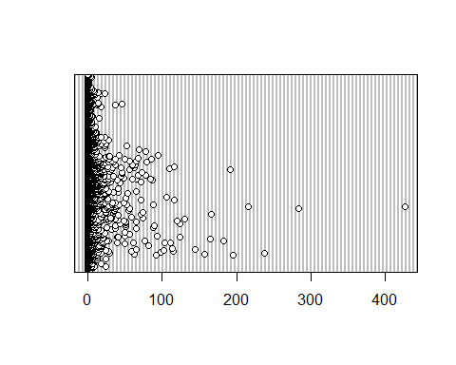

hist(bats_gb_trim$Batpass_sum)

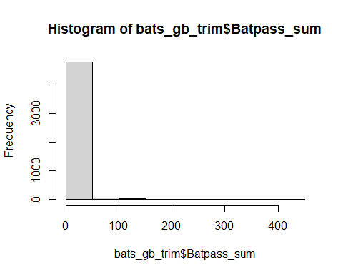

ggplot(bats_gb_trim) + geom_histogram(aes(x = Batpass_sum)) + xlim(c(1,100))

## `stat_bin()` using `bins = 30`. Pick better value with `binwidth`.

## Warning: Removed 3153 rows containing non-finite values (`stat_bin()`).

## Warning: Removed 2 rows containing missing values (`geom_bar()`).

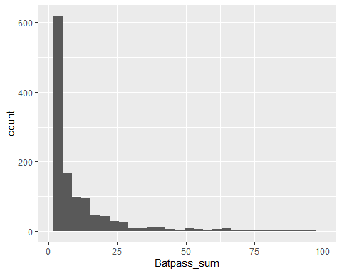

ggplot(bats_gb_trim) + geom_histogram(aes(x = Batpass_sum)) + xlim(c(1,50))

## `stat_bin()` using `bins = 30`. Pick better value with `binwidth`.

## Warning: Removed 3205 rows containing non-finite values (`stat_bin()`).  
## Removed 2 rows containing missing values (`geom_bar()`).

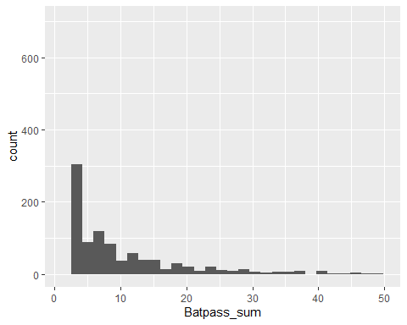

ggplot(bats_gb_trim) + geom_histogram(aes(x = Batpass_sum)) + xlim(c(0,50))

## `stat_bin()` using `bins = 30`. Pick better value with `binwidth`.

## Warning: Removed 76 rows containing non-finite values (`stat_bin()`).  
## Removed 2 rows containing missing values (`geom_bar()`).

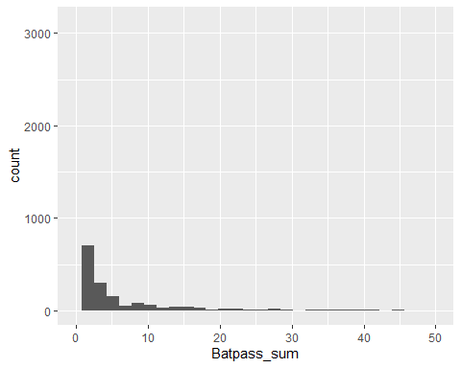

# Warning messages:  
# 1: Removed 76 rows containing non-finite values (`stat_bin()`).   
# 2: Removed 2 rows containing missing values (`geom_bar()`).   
(4866-78)/4866*100

## [1] 98.39704

# lost less than 2 % of the observations by trimming data to 50 batpasses per night.  
# Will convert batpasses over 50 to 50 and create a new column for it.  
  
#Make a new column in the dataset  
bats_gb_trim$batpass50 <- bats_gb_trim$Batpass_sum  
  
# reassign batpass values over 50 to 50  
bats_gb_trim$batpass50[bats_gb_trim$Batpass_sum>50] <- 50

# Survey effort

survey.effort <- bats_gb_trim %>%   
 select(Site, night) %>% unique()   
  
survey.nights <- count(survey.effort, Site)  
  
bats_gb_trim1 <- left_join(bats_gb_trim, survey.nights) %>% rename(survey.nights = n)

## Joining, by = "Site"

summary(bats_gb_trim1)

## X night Site guild behavior   
## Min. : 1 Length:4866 N08 : 360 LRE :1622 Commuting:2433   
## 1st Qu.:1217 Class :character N10 : 360 NoID:1622 Feeding :2433   
## Median :2434 Mode :character N11 : 360 SRE :1622   
## Mean :2434 N14 : 360   
## 3rd Qu.:3650 P02 : 360   
## Max. :4866 P04 : 360   
## (Other):2706   
## Batpass_sum Batpass_mean Batpass_max batpass01_sum   
## Min. : 0.000 Min. : 0.000 Min. : 0.000 Min. :0.000   
## 1st Qu.: 0.000 1st Qu.: 0.000 1st Qu.: 0.000 1st Qu.:0.000   
## Median : 0.000 Median : 0.000 Median : 0.000 Median :0.000   
## Mean : 3.815 Mean : 3.815 Mean : 3.815 Mean :0.357   
## 3rd Qu.: 2.000 3rd Qu.: 2.000 3rd Qu.: 2.000 3rd Qu.:1.000   
## Max. :426.000 Max. :426.000 Max. :426.000 Max. :1.000   
##   
## batpass01_length wind_mean wind_min wind_max   
## Min. :1 Min. : 2.571 Min. : 2.571 Min. : 2.571   
## 1st Qu.:1 1st Qu.: 4.486 1st Qu.: 4.486 1st Qu.: 4.486   
## Median :1 Median : 6.012 Median : 6.012 Median : 6.012   
## Mean :1 Mean : 6.230 Mean : 6.230 Mean : 6.230   
## 3rd Qu.:1 3rd Qu.: 7.822 3rd Qu.: 7.822 3rd Qu.: 7.822   
## Max. :1 Max. :13.413 Max. :13.413 Max. :13.413   
##   
## temp_mean temp_min temp_max batpass_prop   
## Min. : 8.789 Min. : 8.789 Min. : 8.789 Min. :0.000   
## 1st Qu.:13.419 1st Qu.:13.419 1st Qu.:13.419 1st Qu.:0.000   
## Median :14.930 Median :14.930 Median :14.930 Median :0.000   
## Mean :15.610 Mean :15.610 Mean :15.610 Mean :0.357   
## 3rd Qu.:17.494 3rd Qu.:17.494 3rd Qu.:17.494 3rd Qu.:1.000   
## Max. :24.579 Max. :24.579 Max. :24.579 Max. :1.000   
##   
## Habitat Facility Locality jnight yes_batpass   
## Natural :2346 North:2778 Turbine10:720 Min. :183.0 Min. :0.000   
## TurbinePad:2520 South:2088 Turbine11:720 1st Qu.:204.0 1st Qu.:0.000   
## Turbine14:720 Median :227.0 Median :0.000   
## Turbine2 :714 Mean :227.4 Mean :0.357   
## Turbine4 :624 3rd Qu.:251.0 3rd Qu.:1.000   
## Turbine8 :720 Max. :273.0 Max. :1.000   
## Turbine9 :648   
## no_batpass batpass50 survey.nights   
## Min. :0.000 Min. : 0.000 Min. :44.00   
## 1st Qu.:0.000 1st Qu.: 0.000 1st Qu.:60.00   
## Median :1.000 Median : 0.000 Median :60.00   
## Mean :0.643 Mean : 3.066 Mean :58.35   
## 3rd Qu.:1.000 3rd Qu.: 2.000 3rd Qu.:60.00   
## Max. :1.000 Max. :50.000 Max. :60.00   
##

# Make guild - behavior subsets

summary(bats_gb_trim1)

## X night Site guild behavior   
## Min. : 1 Length:4866 N08 : 360 LRE :1622 Commuting:2433   
## 1st Qu.:1217 Class :character N10 : 360 NoID:1622 Feeding :2433   
## Median :2434 Mode :character N11 : 360 SRE :1622   
## Mean :2434 N14 : 360   
## 3rd Qu.:3650 P02 : 360   
## Max. :4866 P04 : 360   
## (Other):2706   
## Batpass_sum Batpass_mean Batpass_max batpass01_sum   
## Min. : 0.000 Min. : 0.000 Min. : 0.000 Min. :0.000   
## 1st Qu.: 0.000 1st Qu.: 0.000 1st Qu.: 0.000 1st Qu.:0.000   
## Median : 0.000 Median : 0.000 Median : 0.000 Median :0.000   
## Mean : 3.815 Mean : 3.815 Mean : 3.815 Mean :0.357   
## 3rd Qu.: 2.000 3rd Qu.: 2.000 3rd Qu.: 2.000 3rd Qu.:1.000   
## Max. :426.000 Max. :426.000 Max. :426.000 Max. :1.000   
##   
## batpass01_length wind_mean wind_min wind_max   
## Min. :1 Min. : 2.571 Min. : 2.571 Min. : 2.571   
## 1st Qu.:1 1st Qu.: 4.486 1st Qu.: 4.486 1st Qu.: 4.486   
## Median :1 Median : 6.012 Median : 6.012 Median : 6.012   
## Mean :1 Mean : 6.230 Mean : 6.230 Mean : 6.230   
## 3rd Qu.:1 3rd Qu.: 7.822 3rd Qu.: 7.822 3rd Qu.: 7.822   
## Max. :1 Max. :13.413 Max. :13.413 Max. :13.413   
##   
## temp_mean temp_min temp_max batpass_prop   
## Min. : 8.789 Min. : 8.789 Min. : 8.789 Min. :0.000   
## 1st Qu.:13.419 1st Qu.:13.419 1st Qu.:13.419 1st Qu.:0.000   
## Median :14.930 Median :14.930 Median :14.930 Median :0.000   
## Mean :15.610 Mean :15.610 Mean :15.610 Mean :0.357   
## 3rd Qu.:17.494 3rd Qu.:17.494 3rd Qu.:17.494 3rd Qu.:1.000   
## Max. :24.579 Max. :24.579 Max. :24.579 Max. :1.000   
##   
## Habitat Facility Locality jnight yes_batpass   
## Natural :2346 North:2778 Turbine10:720 Min. :183.0 Min. :0.000   
## TurbinePad:2520 South:2088 Turbine11:720 1st Qu.:204.0 1st Qu.:0.000   
## Turbine14:720 Median :227.0 Median :0.000   
## Turbine2 :714 Mean :227.4 Mean :0.357   
## Turbine4 :624 3rd Qu.:251.0 3rd Qu.:1.000   
## Turbine8 :720 Max. :273.0 Max. :1.000   
## Turbine9 :648   
## no_batpass batpass50 survey.nights   
## Min. :0.000 Min. : 0.000 Min. :44.00   
## 1st Qu.:0.000 1st Qu.: 0.000 1st Qu.:60.00   
## Median :1.000 Median : 0.000 Median :60.00   
## Mean :0.643 Mean : 3.066 Mean :58.35   
## 3rd Qu.:1.000 3rd Qu.: 2.000 3rd Qu.:60.00   
## Max. :1.000 Max. :50.000 Max. :60.00   
##

LREf <- bats_gb_trim1 %>% filter(guild == "LRE", behavior == "Feeding") %>% droplevels()  
LREc <- bats_gb_trim1 %>% filter(guild %in% "LRE", behavior %in% "Commuting") %>% droplevels()  
  
SREf <- bats_gb_trim1 %>% filter(guild == "SRE", behavior == "Feeding") %>% droplevels()  
SREc <- bats_gb_trim1 %>% filter(guild == "SRE", behavior == "Commuting") %>% droplevels()  
  
summary(LREf) # 811 obs of 23 vars

## X night Site guild behavior   
## Min. : 4 Length:811 N08 : 60 LRE:811 Feeding:811   
## 1st Qu.:1219 Class :character N10 : 60   
## Median :2434 Mode :character N11 : 60   
## Mean :2434 N14 : 60   
## 3rd Qu.:3649 P02 : 60   
## Max. :4864 P04 : 60   
## (Other):451   
## Batpass_sum Batpass_mean Batpass_max batpass01_sum   
## Min. : 0.000 Min. : 0.000 Min. : 0.000 Min. :0.0000   
## 1st Qu.: 0.000 1st Qu.: 0.000 1st Qu.: 0.000 1st Qu.:0.0000   
## Median : 0.000 Median : 0.000 Median : 0.000 Median :0.0000   
## Mean : 4.566 Mean : 4.566 Mean : 4.566 Mean :0.3822   
## 3rd Qu.: 2.000 3rd Qu.: 2.000 3rd Qu.: 2.000 3rd Qu.:1.0000   
## Max. :216.000 Max. :216.000 Max. :216.000 Max. :1.0000   
##   
## batpass01_length wind_mean wind_min wind_max   
## Min. :1 Min. : 2.571 Min. : 2.571 Min. : 2.571   
## 1st Qu.:1 1st Qu.: 4.486 1st Qu.: 4.486 1st Qu.: 4.486   
## Median :1 Median : 6.012 Median : 6.012 Median : 6.012   
## Mean :1 Mean : 6.230 Mean : 6.230 Mean : 6.230   
## 3rd Qu.:1 3rd Qu.: 7.822 3rd Qu.: 7.822 3rd Qu.: 7.822   
## Max. :1 Max. :13.413 Max. :13.413 Max. :13.413   
##   
## temp_mean temp_min temp_max batpass_prop   
## Min. : 8.789 Min. : 8.789 Min. : 8.789 Min. :0.0000   
## 1st Qu.:13.419 1st Qu.:13.419 1st Qu.:13.419 1st Qu.:0.0000   
## Median :14.930 Median :14.930 Median :14.930 Median :0.0000   
## Mean :15.610 Mean :15.610 Mean :15.610 Mean :0.3822   
## 3rd Qu.:17.494 3rd Qu.:17.494 3rd Qu.:17.494 3rd Qu.:1.0000   
## Max. :24.579 Max. :24.579 Max. :24.579 Max. :1.0000   
##   
## Habitat Facility Locality jnight yes_batpass   
## Natural :391 North:463 Turbine10:120 Min. :183.0 Min. :0.0000   
## TurbinePad:420 South:348 Turbine11:120 1st Qu.:204.5 1st Qu.:0.0000   
## Turbine14:120 Median :227.0 Median :0.0000   
## Turbine2 :119 Mean :227.4 Mean :0.3822   
## Turbine4 :104 3rd Qu.:251.0 3rd Qu.:1.0000   
## Turbine8 :120 Max. :273.0 Max. :1.0000   
## Turbine9 :108   
## no_batpass batpass50 survey.nights   
## Min. :0.0000 Min. : 0.000 Min. :44.00   
## 1st Qu.:0.0000 1st Qu.: 0.000 1st Qu.:60.00   
## Median :1.0000 Median : 0.000 Median :60.00   
## Mean :0.6178 Mean : 3.699 Mean :58.35   
## 3rd Qu.:1.0000 3rd Qu.: 2.000 3rd Qu.:60.00   
## Max. :1.0000 Max. :50.000 Max. :60.00   
##

summary(LREc) # 811 obs of 23 vars

## X night Site guild behavior   
## Min. : 3 Length:811 N08 : 60 LRE:811 Commuting:811   
## 1st Qu.:1218 Class :character N10 : 60   
## Median :2433 Mode :character N11 : 60   
## Mean :2433 N14 : 60   
## 3rd Qu.:3648 P02 : 60   
## Max. :4863 P04 : 60   
## (Other):451   
## Batpass_sum Batpass_mean Batpass_max batpass01_sum   
## Min. : 0.00 Min. : 0.00 Min. : 0.00 Min. :0.0000   
## 1st Qu.: 1.00 1st Qu.: 1.00 1st Qu.: 1.00 1st Qu.:1.0000   
## Median : 4.00 Median : 4.00 Median : 4.00 Median :1.0000   
## Mean : 13.05 Mean : 13.05 Mean : 13.05 Mean :0.7645   
## 3rd Qu.: 13.00 3rd Qu.: 13.00 3rd Qu.: 13.00 3rd Qu.:1.0000   
## Max. :426.00 Max. :426.00 Max. :426.00 Max. :1.0000   
##   
## batpass01_length wind_mean wind_min wind_max   
## Min. :1 Min. : 2.571 Min. : 2.571 Min. : 2.571   
## 1st Qu.:1 1st Qu.: 4.486 1st Qu.: 4.486 1st Qu.: 4.486   
## Median :1 Median : 6.012 Median : 6.012 Median : 6.012   
## Mean :1 Mean : 6.230 Mean : 6.230 Mean : 6.230   
## 3rd Qu.:1 3rd Qu.: 7.822 3rd Qu.: 7.822 3rd Qu.: 7.822   
## Max. :1 Max. :13.413 Max. :13.413 Max. :13.413   
##   
## temp_mean temp_min temp_max batpass_prop   
## Min. : 8.789 Min. : 8.789 Min. : 8.789 Min. :0.0000   
## 1st Qu.:13.419 1st Qu.:13.419 1st Qu.:13.419 1st Qu.:1.0000   
## Median :14.930 Median :14.930 Median :14.930 Median :1.0000   
## Mean :15.610 Mean :15.610 Mean :15.610 Mean :0.7645   
## 3rd Qu.:17.494 3rd Qu.:17.494 3rd Qu.:17.494 3rd Qu.:1.0000   
## Max. :24.579 Max. :24.579 Max. :24.579 Max. :1.0000   
##   
## Habitat Facility Locality jnight yes_batpass   
## Natural :391 North:463 Turbine10:120 Min. :183.0 Min. :0.0000   
## TurbinePad:420 South:348 Turbine11:120 1st Qu.:204.5 1st Qu.:1.0000   
## Turbine14:120 Median :227.0 Median :1.0000   
## Turbine2 :119 Mean :227.4 Mean :0.7645   
## Turbine4 :104 3rd Qu.:251.0 3rd Qu.:1.0000   
## Turbine8 :120 Max. :273.0 Max. :1.0000   
## Turbine9 :108   
## no_batpass batpass50 survey.nights   
## Min. :0.0000 Min. : 0.000 Min. :44.00   
## 1st Qu.:0.0000 1st Qu.: 1.000 1st Qu.:60.00   
## Median :0.0000 Median : 4.000 Median :60.00   
## Mean :0.2355 Mean : 9.835 Mean :58.35   
## 3rd Qu.:0.0000 3rd Qu.:13.000 3rd Qu.:60.00   
## Max. :1.0000 Max. :50.000 Max. :60.00   
##

summary(SREf) # 811 obs of 23 vars

## X night Site guild behavior   
## Min. : 2 Length:811 N08 : 60 SRE:811 Feeding:811   
## 1st Qu.:1217 Class :character N10 : 60   
## Median :2432 Mode :character N11 : 60   
## Mean :2432 N14 : 60   
## 3rd Qu.:3647 P02 : 60   
## Max. :4862 P04 : 60   
## (Other):451   
## Batpass_sum Batpass_mean Batpass_max batpass01_sum   
## Min. : 0.000 Min. : 0.000 Min. : 0.000 Min. :0.0000   
## 1st Qu.: 0.000 1st Qu.: 0.000 1st Qu.: 0.000 1st Qu.:0.0000   
## Median : 0.000 Median : 0.000 Median : 0.000 Median :0.0000   
## Mean : 0.418 Mean : 0.418 Mean : 0.418 Mean :0.1603   
## 3rd Qu.: 0.000 3rd Qu.: 0.000 3rd Qu.: 0.000 3rd Qu.:0.0000   
## Max. :72.000 Max. :72.000 Max. :72.000 Max. :1.0000   
##   
## batpass01_length wind_mean wind_min wind_max   
## Min. :1 Min. : 2.571 Min. : 2.571 Min. : 2.571   
## 1st Qu.:1 1st Qu.: 4.486 1st Qu.: 4.486 1st Qu.: 4.486   
## Median :1 Median : 6.012 Median : 6.012 Median : 6.012   
## Mean :1 Mean : 6.230 Mean : 6.230 Mean : 6.230   
## 3rd Qu.:1 3rd Qu.: 7.822 3rd Qu.: 7.822 3rd Qu.: 7.822   
## Max. :1 Max. :13.413 Max. :13.413 Max. :13.413   
##   
## temp_mean temp_min temp_max batpass_prop   
## Min. : 8.789 Min. : 8.789 Min. : 8.789 Min. :0.0000   
## 1st Qu.:13.419 1st Qu.:13.419 1st Qu.:13.419 1st Qu.:0.0000   
## Median :14.930 Median :14.930 Median :14.930 Median :0.0000   
## Mean :15.610 Mean :15.610 Mean :15.610 Mean :0.1603   
## 3rd Qu.:17.494 3rd Qu.:17.494 3rd Qu.:17.494 3rd Qu.:0.0000   
## Max. :24.579 Max. :24.579 Max. :24.579 Max. :1.0000   
##   
## Habitat Facility Locality jnight yes_batpass   
## Natural :391 North:463 Turbine10:120 Min. :183.0 Min. :0.0000   
## TurbinePad:420 South:348 Turbine11:120 1st Qu.:204.5 1st Qu.:0.0000   
## Turbine14:120 Median :227.0 Median :0.0000   
## Turbine2 :119 Mean :227.4 Mean :0.1603   
## Turbine4 :104 3rd Qu.:251.0 3rd Qu.:0.0000   
## Turbine8 :120 Max. :273.0 Max. :1.0000   
## Turbine9 :108   
## no_batpass batpass50 survey.nights   
## Min. :0.0000 Min. : 0.0000 Min. :44.00   
## 1st Qu.:1.0000 1st Qu.: 0.0000 1st Qu.:60.00   
## Median :1.0000 Median : 0.0000 Median :60.00   
## Mean :0.8397 Mean : 0.3909 Mean :58.35   
## 3rd Qu.:1.0000 3rd Qu.: 0.0000 3rd Qu.:60.00   
## Max. :1.0000 Max. :50.0000 Max. :60.00   
##

summary(SREc) # 811 obs of 23 vars

## X night Site guild behavior   
## Min. : 1 Length:811 N08 : 60 SRE:811 Commuting:811   
## 1st Qu.:1216 Class :character N10 : 60   
## Median :2431 Mode :character N11 : 60   
## Mean :2431 N14 : 60   
## 3rd Qu.:3646 P02 : 60   
## Max. :4861 P04 : 60   
## (Other):451   
## Batpass_sum Batpass_mean Batpass_max batpass01_sum   
## Min. : 0.000 Min. : 0.000 Min. : 0.000 Min. :0.0000   
## 1st Qu.: 0.000 1st Qu.: 0.000 1st Qu.: 0.000 1st Qu.:0.0000   
## Median : 2.000 Median : 2.000 Median : 2.000 Median :1.0000   
## Mean : 4.656 Mean : 4.656 Mean : 4.656 Mean :0.6905   
## 3rd Qu.: 5.000 3rd Qu.: 5.000 3rd Qu.: 5.000 3rd Qu.:1.0000   
## Max. :165.000 Max. :165.000 Max. :165.000 Max. :1.0000   
##   
## batpass01_length wind_mean wind_min wind_max   
## Min. :1 Min. : 2.571 Min. : 2.571 Min. : 2.571   
## 1st Qu.:1 1st Qu.: 4.486 1st Qu.: 4.486 1st Qu.: 4.486   
## Median :1 Median : 6.012 Median : 6.012 Median : 6.012   
## Mean :1 Mean : 6.230 Mean : 6.230 Mean : 6.230   
## 3rd Qu.:1 3rd Qu.: 7.822 3rd Qu.: 7.822 3rd Qu.: 7.822   
## Max. :1 Max. :13.413 Max. :13.413 Max. :13.413   
##   
## temp_mean temp_min temp_max batpass_prop   
## Min. : 8.789 Min. : 8.789 Min. : 8.789 Min. :0.0000   
## 1st Qu.:13.419 1st Qu.:13.419 1st Qu.:13.419 1st Qu.:0.0000   
## Median :14.930 Median :14.930 Median :14.930 Median :1.0000   
## Mean :15.610 Mean :15.610 Mean :15.610 Mean :0.6905   
## 3rd Qu.:17.494 3rd Qu.:17.494 3rd Qu.:17.494 3rd Qu.:1.0000   
## Max. :24.579 Max. :24.579 Max. :24.579 Max. :1.0000   
##   
## Habitat Facility Locality jnight yes_batpass   
## Natural :391 North:463 Turbine10:120 Min. :183.0 Min. :0.0000   
## TurbinePad:420 South:348 Turbine11:120 1st Qu.:204.5 1st Qu.:0.0000   
## Turbine14:120 Median :227.0 Median :1.0000   
## Turbine2 :119 Mean :227.4 Mean :0.6905   
## Turbine4 :104 3rd Qu.:251.0 3rd Qu.:1.0000   
## Turbine8 :120 Max. :273.0 Max. :1.0000   
## Turbine9 :108   
## no_batpass batpass50 survey.nights   
## Min. :0.0000 Min. : 0.000 Min. :44.00   
## 1st Qu.:0.0000 1st Qu.: 0.000 1st Qu.:60.00   
## Median :0.0000 Median : 2.000 Median :60.00   
## Mean :0.3095 Mean : 4.271 Mean :58.35   
## 3rd Qu.:1.0000 3rd Qu.: 5.000 3rd Qu.:60.00   
## Max. :1.0000 Max. :50.000 Max. :60.00   
##

|  |
| --- |
| # LRE feeding |

# m1_LREf

m1_LREf <- gam(cbind(yes_batpass,no_batpass) ~  
 s(Locality, bs = "re") + #bs = "re" is equivalent to adding Locality as random intercept in a mixed model (GAMM)  
 s(jnight, by = Habitat, bs = "gp", k =90) +   
 Habitat +   
 s(temp_mean) +   
 s(wind_mean) + #same as for temp  
 ti(temp_mean,wind_mean) , #interaction between temp and wind  
 data = LREf, method = "REML", #REML is not default, but is highly recommended by experts  
 family = binomial, select=TRUE) #may have to shift to quasibinomial if overdispersion, select = TRUE gives you automatic model selection  
  
summary(m1_LREf) #

##   
## Family: binomial   
## Link function: logit   
##   
## Formula:  
## cbind(yes_batpass, no_batpass) ~ s(Locality, bs = "re") + s(jnight,   
## by = Habitat, bs = "gp", k = 90) + Habitat + s(temp_mean) +   
## s(wind_mean) + ti(temp_mean, wind_mean)  
##   
## Parametric coefficients:  
## Estimate Std. Error z value Pr(>|z|)   
## (Intercept) -1.2595 0.3560 -3.538 0.000403 ***  
## HabitatTurbinePad 0.6617 0.1992 3.321 0.000896 ***  
## ---  
## Signif. codes: 0 '***' 0.001 '**' 0.01 '*' 0.05 '.' 0.1 ' ' 1  
##   
## Approximate significance of smooth terms:  
## edf Ref.df Chi.sq p-value   
## s(Locality) 5.5265823 6 55.65 < 2e-16 ***  
## s(jnight):HabitatNatural 1.8601064 87 18.16 6.89e-05 ***  
## s(jnight):HabitatTurbinePad 3.7275409 88 23.97 7.41e-05 ***  
## s(temp_mean) 3.2288598 9 72.42 < 2e-16 ***  
## s(wind_mean) 3.4219551 9 31.51 < 2e-16 ***  
## ti(temp_mean,wind_mean) 0.0004462 16 0.00 0.475   
## ---  
## Signif. codes: 0 '***' 0.001 '**' 0.01 '*' 0.05 '.' 0.1 ' ' 1  
##   
## R-sq.(adj) = 0.372 Deviance explained = 33.6%  
## -REML = 393.62 Scale est. = 1 n = 811

# Basic diagnostics

#windows()  
par(mfrow = c(2,2))  
gam.check(m1_LREf, rep = 500)

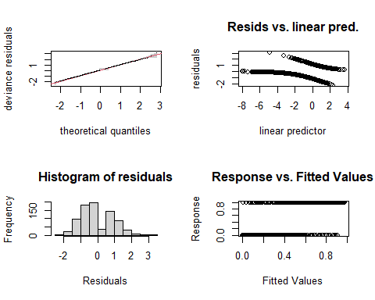

##   
## Method: REML Optimizer: outer newton  
## full convergence after 19 iterations.  
## Gradient range [-3.393868e-05,2.48727e-05]  
## (score 393.6178 & scale 1).  
## Hessian positive definite, eigenvalue range [1.524733e-06,2.440823].  
## Model rank = 221 / 221   
##   
## Basis dimension (k) checking results. Low p-value (k-index<1) may  
## indicate that k is too low, especially if edf is close to k'.  
##   
## k' edf k-index p-value   
## s(Locality) 7.00e+00 5.53e+00 NA NA   
## s(jnight):HabitatNatural 8.90e+01 1.86e+00 0.94 0.040 *   
## s(jnight):HabitatTurbinePad 8.90e+01 3.73e+00 0.94 0.015 *   
## s(temp_mean) 9.00e+00 3.23e+00 0.93 0.025 *   
## s(wind_mean) 9.00e+00 3.42e+00 0.94 0.055 .   
## ti(temp_mean,wind_mean) 1.60e+01 4.46e-04 0.90 <2e-16 ***  
## ---  
## Signif. codes: 0 '***' 0.001 '**' 0.01 '*' 0.05 '.' 0.1 ' ' 1

#look at the plots, but also the output to check if k needs to be adjusted  
gam.check(m1_LREf)

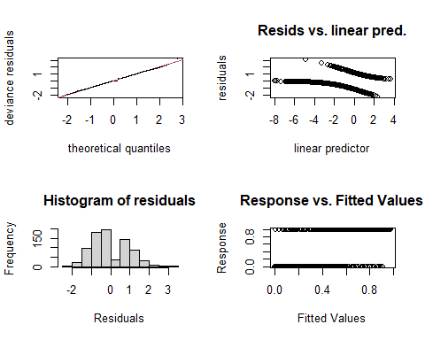

##   
## Method: REML Optimizer: outer newton  
## full convergence after 19 iterations.  
## Gradient range [-3.393868e-05,2.48727e-05]  
## (score 393.6178 & scale 1).  
## Hessian positive definite, eigenvalue range [1.524733e-06,2.440823].  
## Model rank = 221 / 221   
##   
## Basis dimension (k) checking results. Low p-value (k-index<1) may  
## indicate that k is too low, especially if edf is close to k'.  
##   
## k' edf k-index p-value   
## s(Locality) 7.00e+00 5.53e+00 NA NA   
## s(jnight):HabitatNatural 8.90e+01 1.86e+00 0.94 0.055 .   
## s(jnight):HabitatTurbinePad 8.90e+01 3.73e+00 0.94 0.040 *   
## s(temp_mean) 9.00e+00 3.23e+00 0.93 0.005 **   
## s(wind_mean) 9.00e+00 3.42e+00 0.94 0.055 .   
## ti(temp_mean,wind_mean) 1.60e+01 4.46e-04 0.90 <2e-16 ***  
## ---  
## Signif. codes: 0 '***' 0.001 '**' 0.01 '*' 0.05 '.' 0.1 ' ' 1

#rep=500 gives you a polygon on the QQ plot, which the observed values should lie within  
  
  
overdispersion.m1_LREf <- sum( residuals(m1_LREf, "pearson")^2 ) / m1_LREf$df.residual  
overdispersion.m1_LREf

## [1] 0.984761

# 0.984761 ... it is alright!   
  
# From Katrine's Step3B GAM modelling script:   
#[1] 1.022701 #this value should ideally be 0.8-1.2, but it's not very bad!

# Basis dimension (k) checking results:

bmp(file.path(output_today, "checking k dimensions m1_LREf bats_tot.jpeg"), width = 9, height = 6, units = "in", res = 350)  
  
##windows()  
plot(m1_LREf, pages=1,scheme=2,shade=TRUE,seWithMean = TRUE)  
  
draw(m1_LREf, scales ="free") #function 'draw' is from package 'gratia'  
draw(m1_LREf, scales ="fixed")  
  
dev.off()

## png   
## 2

## Visualize the 3D GAM  
bmp(file.path(output_today, "3D gam m1_LREf bats_tot.jpg"), width = 9, height = 6, units = "in", res = 350)  
par(mfrow = c(1,2))  
  
vis.gam(m1_LREf, view = c("temp_mean", "wind_mean")) #Not a very elegant plot, you can find prettier solutions, but helps understand the interaction between tempp and wind  
vis.gam(m1_LREf, view = c("wind_mean", "temp_mean"))   
  
dev.off()

## png   
## 2

Try again after adjusting the k terms on the smooths

# m2_LREf - LRE feeding

## Adjusting smooth terms

m2_LREf <- gam(cbind(yes_batpass,no_batpass) ~  
 s(Locality, bs = "re") +   
 s(jnight, by = Habitat, bs = "gp", k = 12) +   
 Habitat +   
 s(temp_mean, k = 12) +   
 s(wind_mean, k = 15) +   
 ti(temp_mean,wind_mean, k = c(20,20)) ,   
 data = LREf, method = "REML",   
 family = binomial, select=TRUE)   
summary(m2_LREf) #

##   
## Family: binomial   
## Link function: logit   
##   
## Formula:  
## cbind(yes_batpass, no_batpass) ~ s(Locality, bs = "re") + s(jnight,   
## by = Habitat, bs = "gp", k = 12) + Habitat + s(temp_mean,   
## k = 12) + s(wind_mean, k = 15) + ti(temp_mean, wind_mean,   
## k = c(20, 20))  
##   
## Parametric coefficients:  
## Estimate Std. Error z value Pr(>|z|)   
## (Intercept) -1.3019 0.3731 -3.490 0.000484 ***  
## HabitatTurbinePad 0.6717 0.2003 3.353 0.000800 ***  
## ---  
## Signif. codes: 0 '***' 0.001 '**' 0.01 '*' 0.05 '.' 0.1 ' ' 1  
##   
## Approximate significance of smooth terms:  
## edf Ref.df Chi.sq p-value   
## s(Locality) 5.542 6 55.08 < 2e-16 ***  
## s(jnight):HabitatNatural 1.602 11 14.37 8.53e-05 ***  
## s(jnight):HabitatTurbinePad 3.277 11 18.23 7.65e-05 ***  
## s(temp_mean) 3.600 11 48.70 < 2e-16 ***  
## s(wind_mean) 3.138 14 22.26 3.79e-06 ***  
## ti(temp_mean,wind_mean) 19.920 65 36.20 0.00104 **   
## ---  
## Signif. codes: 0 '***' 0.001 '**' 0.01 '*' 0.05 '.' 0.1 ' ' 1  
##   
## R-sq.(adj) = 0.41 Deviance explained = 38.5%  
## -REML = 389.76 Scale est. = 1 n = 811

# Basic diagnostics

par(mfrow = c(2,2))  
gam.check(m2_LREf, rep = 500)

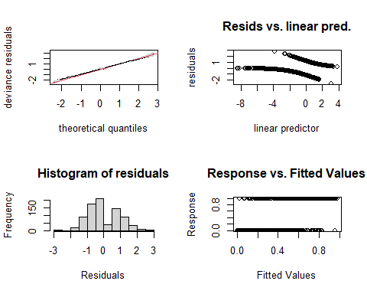

##   
## Method: REML Optimizer: outer newton  
## full convergence after 7 iterations.  
## Gradient range [-0.001344403,0.0001781463]  
## (score 389.763 & scale 1).  
## Hessian positive definite, eigenvalue range [1.475197e-05,2.456389].  
## Model rank = 121 / 121   
##   
## Basis dimension (k) checking results. Low p-value (k-index<1) may  
## indicate that k is too low, especially if edf is close to k'.  
##   
## k' edf k-index p-value   
## s(Locality) 7.00 5.54 NA NA   
## s(jnight):HabitatNatural 11.00 1.60 0.99 0.47   
## s(jnight):HabitatTurbinePad 11.00 3.28 0.99 0.43   
## s(temp_mean) 11.00 3.60 0.98 0.30   
## s(wind_mean) 14.00 3.14 0.99 0.46   
## ti(temp_mean,wind_mean) 65.00 19.92 0.96 0.06 .  
## ---  
## Signif. codes: 0 '***' 0.001 '**' 0.01 '*' 0.05 '.' 0.1 ' ' 1

#look at the plots, but also the output to check if k needs to be adjusted  
gam.check(m2_LREf)

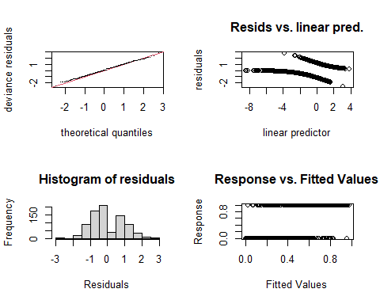

##   
## Method: REML Optimizer: outer newton  
## full convergence after 7 iterations.  
## Gradient range [-0.001344403,0.0001781463]  
## (score 389.763 & scale 1).  
## Hessian positive definite, eigenvalue range [1.475197e-05,2.456389].  
## Model rank = 121 / 121   
##   
## Basis dimension (k) checking results. Low p-value (k-index<1) may  
## indicate that k is too low, especially if edf is close to k'.  
##   
## k' edf k-index p-value   
## s(Locality) 7.00 5.54 NA NA   
## s(jnight):HabitatNatural 11.00 1.60 0.99 0.435   
## s(jnight):HabitatTurbinePad 11.00 3.28 0.99 0.420   
## s(temp_mean) 11.00 3.60 0.98 0.320   
## s(wind_mean) 14.00 3.14 0.99 0.395   
## ti(temp_mean,wind_mean) 65.00 19.92 0.96 0.055 .  
## ---  
## Signif. codes: 0 '***' 0.001 '**' 0.01 '*' 0.05 '.' 0.1 ' ' 1

#rep=500 gives you a polygon on the QQ plot, which the observed values should lie within  
  
overdispersion.m2_LREf <- sum( residuals(m2_LREf, "pearson")^2 ) / m2_LREf$df.residual  
overdispersion.m2_LREf

## [1] 0.8102803

# 0.8102803 ... it is alright!   
  
# From Katrine's Step3B GAM modelling script:   
#[1] 1.022701 #this value should ideally be 0.8-1.2, but it's not very bad!  
  
# Just barely passes

# Basis dimension (k) checking results:

bmp(file.path(output_today, "checking k dimensions m2_LREf bats_tot.jpeg"), width = 9, height = 6, units = "in", res = 350)  
  
##windows()  
plot(m2_LREf, pages=1,scheme=2,shade=TRUE,seWithMean = TRUE)  
  
draw(m2_LREf, scales ="free") #function 'draw' is from package 'gratia'  
draw(m2_LREf, scales ="fixed")  
  
dev.off()

## png   
## 2

## Visualize the 3D GAM  
bmp(file.path(output_today, "3D gam m2_LREf bats_tot.jpg"), width = 9, height = 6, units = "in", res = 350)  
par(mfrow = c(1,2))  
  
vis.gam(m2_LREf, view = c("temp_mean", "wind_mean")) #Not a very elegant plot, you can find prettier solutions, but helps understand the interaction between tempp and wind  
vis.gam(m2_LREf, view = c("wind_mean", "temp_mean"))   
  
dev.off()

## png   
## 2

#Sketching the results - difference between Habitats

summary(LREf$temp_mean)

## Min. 1st Qu. Median Mean 3rd Qu. Max.   
## 8.789 13.419 14.930 15.610 17.494 24.579

# Min. 1st Qu. Median Mean 3rd Qu. Max.   
 # 8.789 13.419 14.930 15.610 17.494 24.579   
summary(LREf$wind_mean)

## Min. 1st Qu. Median Mean 3rd Qu. Max.   
## 2.571 4.486 6.012 6.230 7.822 13.413

# Min. 1st Qu. Median Mean 3rd Qu. Max.   
 # 2.571 4.486 6.012 6.230 7.822 13.413   
  
levels(LREf$Habitat)

## [1] "Natural" "TurbinePad"

# "Natural" "TurbinePad"  
  
levels(LREf$Locality)

## [1] "Turbine10" "Turbine11" "Turbine14" "Turbine2" "Turbine4" "Turbine8"   
## [7] "Turbine9"

# [1] "Turbine10" "Turbine11" "Turbine14"   
# [5] "Turbine2" "Turbine4" "Turbine8" "Turbine9"  
  
pdata <- with(LREf,  
 expand.grid(temp_mean=c(8, 10, 12, 14, 16, 18, 20),  
 wind_mean = c(2, 4, 6, 8, 10, 12),  
 Habitat = c("Natural", "TurbinePad"),  
 Locality = c("Turbine9"),  
 jnight = seq(min(jnight), max(jnight), 1))) #1 to keep the integer format  
  
head(pdata)

## temp_mean wind_mean Habitat Locality jnight  
## 1 8 2 Natural Turbine9 183  
## 2 10 2 Natural Turbine9 183  
## 3 12 2 Natural Turbine9 183  
## 4 14 2 Natural Turbine9 183  
## 5 16 2 Natural Turbine9 183  
## 6 18 2 Natural Turbine9 183

tail(pdata)

## temp_mean wind_mean Habitat Locality jnight  
## 7639 10 12 TurbinePad Turbine9 273  
## 7640 12 12 TurbinePad Turbine9 273  
## 7641 14 12 TurbinePad Turbine9 273  
## 7642 16 12 TurbinePad Turbine9 273  
## 7643 18 12 TurbinePad Turbine9 273  
## 7644 20 12 TurbinePad Turbine9 273

fit <- data.frame(predict(m2_LREf, newdata=pdata, se.fit=TRUE, type = 'response'))  
fit <- transform(fit, upper = fit + (2*se.fit), lower = fit-(2*se.fit))  
pred <- cbind(pdata,fit)  
  
head(pred)

## temp_mean wind_mean Habitat Locality jnight fit se.fit upper  
## 1 8 2 Natural Turbine9 183 0.82802557 0.35710991 1.5422454  
## 2 10 2 Natural Turbine9 183 0.04229445 0.08437969 0.2110538  
## 3 12 2 Natural Turbine9 183 0.48655573 0.28411750 1.0547907  
## 4 14 2 Natural Turbine9 183 0.62162666 0.22841474 1.0784562  
## 5 16 2 Natural Turbine9 183 0.28391819 0.42449707 1.1329123  
## 6 18 2 Natural Turbine9 183 0.95569371 0.09596582 1.1476253  
## lower  
## 1 0.11380576  
## 2 -0.12646493  
## 3 -0.08167928  
## 4 0.16479718  
## 5 -0.56507596  
## 6 0.76376208

bmp(file.path(output_today, "predictions m2_LREf bats_tot.jpeg"), width = 9, height = 6, units = "in", res = 350)  
  
##windows()  
plt2 <- ggplot(pred, aes(x=jnight, y = fit, group = factor(Habitat))) +  
   
 geom_ribbon(aes(ymin = lower, ymax = upper), fill = 'blue', alpha = 0.2) +  
 geom_point() + facet_wrap(Locality ~ Habitat, scales ='free_y') +  
 labs(x = "Julian night", y ="prop of hours per night with batpass>0")  
plt2  
  
dev.off()

## png   
## 2

# m3_LREf - LRE feeding

## negbinom / count response

m3_LREf <- gam(Batpass_sum ~  
 s(Locality, bs = "re") +   
 s(jnight, by = Habitat, bs = "gp", k = 15) +   
 Habitat +   
 s(temp_mean, k = 10) +   
 s(wind_mean, k = 10) +   
 ti(temp_mean,wind_mean, k = c(10,10)) ,   
 data = LREf, method = "REML",   
 family = nb())   
  
summary(m3_LREf) #

##   
## Family: Negative Binomial(0.409)   
## Link function: log   
##   
## Formula:  
## Batpass_sum ~ s(Locality, bs = "re") + s(jnight, by = Habitat,   
## bs = "gp", k = 15) + Habitat + s(temp_mean, k = 10) + s(wind_mean,   
## k = 10) + ti(temp_mean, wind_mean, k = c(10, 10))  
##   
## Parametric coefficients:  
## Estimate Std. Error z value Pr(>|z|)   
## (Intercept) -0.7888 0.5424 -1.454 0.146   
## HabitatTurbinePad 0.8116 0.1651 4.917 8.8e-07 ***  
## ---  
## Signif. codes: 0 '***' 0.001 '**' 0.01 '*' 0.05 '.' 0.1 ' ' 1  
##   
## Approximate significance of smooth terms:  
## edf Ref.df Chi.sq p-value   
## s(Locality) 5.880 6.000 292.367 < 2e-16 ***  
## s(jnight):HabitatNatural 1.001 1.002 35.787 < 2e-16 ***  
## s(jnight):HabitatTurbinePad 2.824 3.593 22.930 0.000116 ***  
## s(temp_mean) 2.666 3.303 60.633 < 2e-16 ***  
## s(wind_mean) 3.270 4.043 25.600 4.41e-05 ***  
## ti(temp_mean,wind_mean) 3.328 72.000 8.346 0.010913 *   
## ---  
## Signif. codes: 0 '***' 0.001 '**' 0.01 '*' 0.05 '.' 0.1 ' ' 1  
##   
## R-sq.(adj) = -0.0739 Deviance explained = 60.9%  
## -REML = 1249.5 Scale est. = 1 n = 811

# Basic diagnostics

par(mfrow = c(2,2))  
gam.check(m3_LREf, rep = 500)

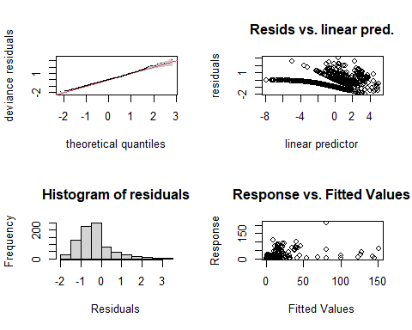

##   
## Method: REML Optimizer: outer newton  
## full convergence after 6 iterations.  
## Gradient range [-3.381798e-05,0.0004416051]  
## (score 1249.541 & scale 1).  
## Hessian positive definite, eigenvalue range [3.400352e-05,133.7593].  
## Model rank = 127 / 127   
##   
## Basis dimension (k) checking results. Low p-value (k-index<1) may  
## indicate that k is too low, especially if edf is close to k'.  
##   
## k' edf k-index p-value   
## s(Locality) 7.00 5.88 NA NA   
## s(jnight):HabitatNatural 14.00 1.00 0.74 <2e-16 ***  
## s(jnight):HabitatTurbinePad 14.00 2.82 0.74 0.005 **   
## s(temp_mean) 9.00 2.67 0.74 0.005 **   
## s(wind_mean) 9.00 3.27 0.75 0.025 *   
## ti(temp_mean,wind_mean) 72.00 3.33 0.75 0.005 **   
## ---  
## Signif. codes: 0 '***' 0.001 '**' 0.01 '*' 0.05 '.' 0.1 ' ' 1

#look at the plots, but also the output to check if k needs to be adjusted  
gam.check(m3_LREf)

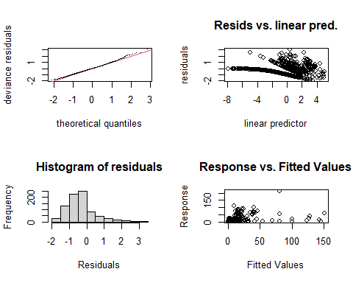

##   
## Method: REML Optimizer: outer newton  
## full convergence after 6 iterations.  
## Gradient range [-3.381798e-05,0.0004416051]  
## (score 1249.541 & scale 1).  
## Hessian positive definite, eigenvalue range [3.400352e-05,133.7593].  
## Model rank = 127 / 127   
##   
## Basis dimension (k) checking results. Low p-value (k-index<1) may  
## indicate that k is too low, especially if edf is close to k'.  
##   
## k' edf k-index p-value   
## s(Locality) 7.00 5.88 NA NA   
## s(jnight):HabitatNatural 14.00 1.00 0.74 0.005 **  
## s(jnight):HabitatTurbinePad 14.00 2.82 0.74 0.005 **  
## s(temp_mean) 9.00 2.67 0.74 0.015 *   
## s(wind_mean) 9.00 3.27 0.75 0.035 *   
## ti(temp_mean,wind_mean) 72.00 3.33 0.75 0.010 **  
## ---  
## Signif. codes: 0 '***' 0.001 '**' 0.01 '*' 0.05 '.' 0.1 ' ' 1

#rep=500 gives you a polygon on the QQ plot, which the observed values should lie within  
  
  
overdispersion.m3_LREf <- sum( residuals(m3_LREf, "pearson")^2 ) / m3_LREf$df.residual  
overdispersion.m3_LREf

## [1] 1.156822

##   
  
  
# From Katrine's Step3B GAM modelling script:   
#[1] 1.022701 #this value should ideally be 0.8-1.2, but it's not very bad!  
  
# Just barely passes

# Basis dimension (k) checking results:

bmp(file.path(output_today, "checking k dimensions m3_LREf bats_tot.jpeg"), width = 9, height = 6, units = "in", res = 350)  
  
##windows()  
plot(m3_LREf, pages=1,scheme=2,shade=TRUE,seWithMean = TRUE)  
  
draw(m3_LREf, scales ="free") #function 'draw' is from package 'gratia'  
draw(m3_LREf, scales ="fixed")  
  
dev.off()

## png   
## 2

## Visualize the 3D GAM  
bmp(file.path(output_today, "3D gam m3_LREf bats_tot.jpg"), width = 9, height = 6, units = "in", res = 350)  
par(mfrow = c(1,2))  
  
vis.gam(m3_LREf, view = c("temp_mean", "wind_mean")) #Not a very elegant plot, you can find prettier solutions, but helps understand the interaction between tempp and wind  
vis.gam(m3_LREf, view = c("wind_mean", "temp_mean"))   
  
dev.off()

## png   
## 2

## Recap

When the response variable is count data, I cannot manage to get a model that with an appropriate distribution **and** K values that fit. I will try using the bat pass 50 (nightly bat passes > 50 are 50) as a response variable to address outliers that may be driving the dispersion issues.

# m4_LREf - LRE feeding

## negbinom / count response

# Site and habitat random effects

# Removed the interaction between Site and jnight

m4_LREf <- gam(batpass50 ~  
 s(Site, bs = "re") +  
 s(Habitat, bs = "re") +  
 s(jnight, bs = "gp", k = 35) +  
 s(temp_mean, k = 15) +  
 s(wind_mean, k = 11) +  
 ti(temp_mean,wind_mean, k = c(15, 15)) ,  
 data = LREf, method = "REML",  
 family = nb())   
  
 summary(m4_LREf) #

##   
## Family: Negative Binomial(0.521)   
## Link function: log   
##   
## Formula:  
## batpass50 ~ s(Site, bs = "re") + s(Habitat, bs = "re") + s(jnight,   
## bs = "gp", k = 35) + s(temp_mean, k = 15) + s(wind_mean,   
## k = 11) + ti(temp_mean, wind_mean, k = c(15, 15))  
##   
## Parametric coefficients:  
## Estimate Std. Error z value Pr(>|z|)  
## (Intercept) -0.4644 0.4048 -1.147 0.251  
##   
## Approximate significance of smooth terms:  
## edf Ref.df Chi.sq p-value   
## s(Site) 12.4468 13.000 433.108 1.01e-06 ***  
## s(Habitat) 0.1101 1.000 10.328 0.2973   
## s(jnight) 2.4881 3.162 50.373 < 2e-16 ***  
## s(temp_mean) 3.3338 4.137 72.368 < 2e-16 ***  
## s(wind_mean) 3.4054 4.195 30.468 8.04e-06 ***  
## ti(temp_mean,wind_mean) 4.1408 66.000 8.665 0.0214 *   
## ---  
## Signif. codes: 0 '***' 0.001 '**' 0.01 '*' 0.05 '.' 0.1 ' ' 1  
##   
## R-sq.(adj) = 0.482 Deviance explained = 63.2%  
## -REML = 1213.6 Scale est. = 1 n = 811

# Basic diagnostics

par(mfrow = c(2,2))  
 gam.check(m4_LREf, rep = 500)

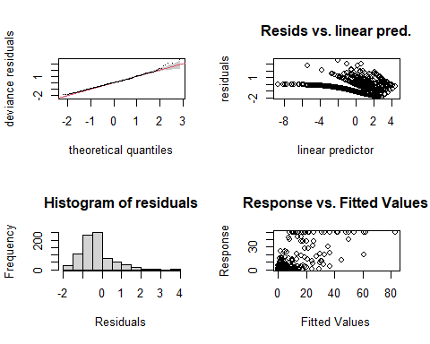

##   
## Method: REML Optimizer: outer newton  
## full convergence after 8 iterations.  
## Gradient range [-6.971616e-05,0.00118783]  
## (score 1213.648 & scale 1).  
## Hessian positive definite, eigenvalue range [0.0004474653,111.7865].  
## Model rank = 141 / 141   
##   
## Basis dimension (k) checking results. Low p-value (k-index<1) may  
## indicate that k is too low, especially if edf is close to k'.  
##   
## k' edf k-index p-value   
## s(Site) 14.00 12.45 NA NA   
## s(Habitat) 2.00 0.11 NA NA   
## s(jnight) 34.00 2.49 0.79 0.07 .  
## s(temp_mean) 14.00 3.33 0.78 0.04 *  
## s(wind_mean) 10.00 3.40 0.79 0.09 .  
## ti(temp_mean,wind_mean) 66.00 4.14 0.81 0.16   
## ---  
## Signif. codes: 0 '***' 0.001 '**' 0.01 '*' 0.05 '.' 0.1 ' ' 1

#look at the plots, but also the output to check if k needs to be adjusted  
 gam.check(m4_LREf)

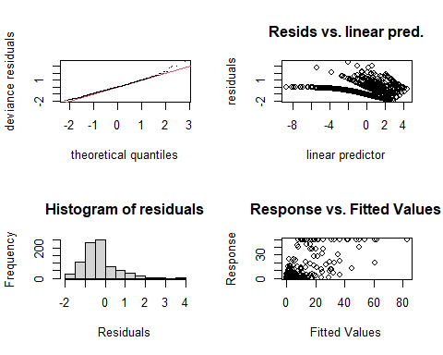

##   
## Method: REML Optimizer: outer newton  
## full convergence after 8 iterations.  
## Gradient range [-6.971616e-05,0.00118783]  
## (score 1213.648 & scale 1).  
## Hessian positive definite, eigenvalue range [0.0004474653,111.7865].  
## Model rank = 141 / 141   
##   
## Basis dimension (k) checking results. Low p-value (k-index<1) may  
## indicate that k is too low, especially if edf is close to k'.  
##   
## k' edf k-index p-value   
## s(Site) 14.00 12.45 NA NA   
## s(Habitat) 2.00 0.11 NA NA   
## s(jnight) 34.00 2.49 0.79 0.045 *  
## s(temp_mean) 14.00 3.33 0.78 0.040 *  
## s(wind_mean) 10.00 3.40 0.79 0.055 .  
## ti(temp_mean,wind_mean) 66.00 4.14 0.81 0.170   
## ---  
## Signif. codes: 0 '***' 0.001 '**' 0.01 '*' 0.05 '.' 0.1 ' ' 1

# #rep=500 gives you a polygon on the QQ plot, which the observed values should lie within  
#  
#  
 overdispersion.m4_LREf <- sum( residuals(m4_LREf, "pearson")^2 ) / m4_LREf$df.residual  
 overdispersion.m4_LREf

## [1] 1.388482

# From Katrine's Step3B GAM modelling script:  
#[1] 1.022701 #this value should ideally be 0.8-1.2, but it's not very bad!  
  
# Just barely passes

# Basis dimension (k) checking results:

# bmp(file.path(output_today, "checking k dimensions m4_LREf bats_tot.jpeg"), width = 9, height = 6, units = "in", res = 350)  
#   
# ##windows()  
# plot(m4_LREf, pages=1,scheme=2,shade=TRUE,seWithMean = TRUE)  
#   
# draw(m4_LREf, scales ="free") #function 'draw' is from package 'gratia'  
# draw(m4_LREf, scales ="fixed")  
#   
# dev.off()   
#   
# ## Visualize the 3D GAM  
# bmp(file.path(output_today, "3D gam m4_LREf bats_tot.jpg"), width = 9, height = 6, units = "in", res = 350)  
# par(mfrow = c(1,2))  
#   
# vis.gam(m4_LREf, view = c("temp_mean", "wind_mean")) #Not a very elegant plot, you can find prettier solutions, but helps understand the interaction between tempp and wind  
# vis.gam(m4_LREf, view = c("wind_mean", "temp_mean"))   
#   
# dev.off()

## Still a bit over dispersed, try with an offset for Site

# m5_LREf - LRE feeding

## negbinom / count response

# Y = batpas50

m5_LREf <- gam(batpass50 ~  
 s(Site, bs = "re") +  
 s(Habitat, bs = "re") +  
 s(jnight, bs = "gp", k = 45) +  
 s(temp_mean, k = 20) +  
 s(wind_mean, k = 20) +  
 ti(temp_mean,wind_mean, k = c(15,15)) +  
 offset(survey.nights),  
 data = LREf, method = "REML",  
 family = nb())   
  
 summary(m5_LREf) #

##   
## Family: Negative Binomial(0.543)   
## Link function: log   
##   
## Formula:  
## batpass50 ~ s(Site, bs = "re") + s(Habitat, bs = "re") + s(jnight,   
## bs = "gp", k = 45) + s(temp_mean, k = 20) + s(wind_mean,   
## k = 20) + ti(temp_mean, wind_mean, k = c(15, 15)) + offset(survey.nights)  
##   
## Parametric coefficients:  
## Estimate Std. Error z value Pr(>|z|)   
## (Intercept) -58.460 1.692 -34.54 <2e-16 ***  
## ---  
## Signif. codes: 0 '***' 0.001 '**' 0.01 '*' 0.05 '.' 0.1 ' ' 1  
##   
## Approximate significance of smooth terms:  
## edf Ref.df Chi.sq p-value   
## s(Site) 12.7627 13.000 36413.90 0.001091 **   
## s(Habitat) 0.2096 1.000 6567.69 0.259017   
## s(jnight) 2.2495 2.833 48.17 < 2e-16 ***  
## s(temp_mean) 3.0492 3.749 76.47 < 2e-16 ***  
## s(wind_mean) 3.5952 4.424 30.89 1.17e-05 ***  
## ti(temp_mean,wind_mean) 11.1676 52.000 30.06 0.000189 ***  
## ---  
## Signif. codes: 0 '***' 0.001 '**' 0.01 '*' 0.05 '.' 0.1 ' ' 1  
##   
## R-sq.(adj) = 0.454 Deviance explained = 96.2%  
## -REML = 1229.6 Scale est. = 1 n = 811

# Basic diagnostics

par(mfrow = c(2,2))  
gam.check(m5_LREf, rep = 500)

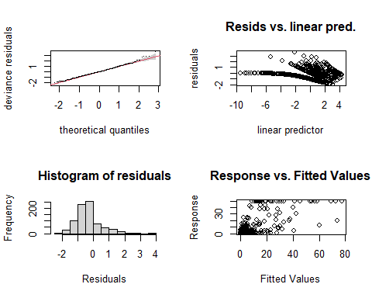

##   
## Method: REML Optimizer: outer newton  
## full convergence after 12 iterations.  
## Gradient range [-0.0002849362,2.862848e-06]  
## (score 1229.567 & scale 1).  
## Hessian positive definite, eigenvalue range [0.02104275,107.7913].  
## Model rank = 151 / 151   
##   
## Basis dimension (k) checking results. Low p-value (k-index<1) may  
## indicate that k is too low, especially if edf is close to k'.  
##   
## k' edf k-index p-value  
## s(Site) 14.00 12.76 NA NA  
## s(Habitat) 2.00 0.21 NA NA  
## s(jnight) 44.00 2.25 0.81 0.17  
## s(temp_mean) 19.00 3.05 0.80 0.10  
## s(wind_mean) 19.00 3.60 0.81 0.24  
## ti(temp_mean,wind_mean) 52.00 11.17 0.83 0.46

#look at the plots, but also the output to check if k needs to be adjusted  
gam.check(m5_LREf)

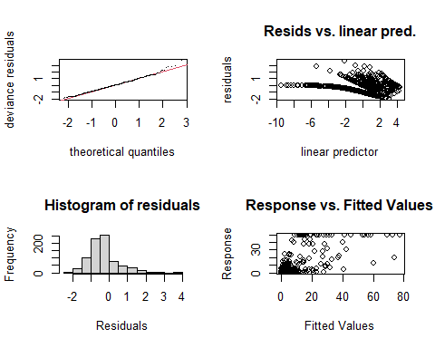

##   
## Method: REML Optimizer: outer newton  
## full convergence after 12 iterations.  
## Gradient range [-0.0002849362,2.862848e-06]  
## (score 1229.567 & scale 1).  
## Hessian positive definite, eigenvalue range [0.02104275,107.7913].  
## Model rank = 151 / 151   
##   
## Basis dimension (k) checking results. Low p-value (k-index<1) may  
## indicate that k is too low, especially if edf is close to k'.  
##   
## k' edf k-index p-value   
## s(Site) 14.00 12.76 NA NA   
## s(Habitat) 2.00 0.21 NA NA   
## s(jnight) 44.00 2.25 0.81 0.095 .  
## s(temp_mean) 19.00 3.05 0.80 0.110   
## s(wind_mean) 19.00 3.60 0.81 0.215   
## ti(temp_mean,wind_mean) 52.00 11.17 0.83 0.515   
## ---  
## Signif. codes: 0 '***' 0.001 '**' 0.01 '*' 0.05 '.' 0.1 ' ' 1

#rep=500 gives you a polygon on the QQ plot, which the observed values should lie within  
  
  
overdispersion.m5_LREf <- sum( residuals(m5_LREf, "pearson")^2 ) / m5_LREf$df.residual  
overdispersion.m5_LREf

## [1] 1.387848

# The overdispersion is better but not gone... k values are okay  
  
  
# From Katrine's Step3B GAM modelling script:   
#[1] 1.022701 #this value should ideally be 0.8-1.2, but it's not very bad!  
  
# Just barely passes

# Basis dimension (k) checking results:

bmp(file.path(output_today, "checking k dimensions m5_LREf bats_tot.jpeg"), width = 9, height = 6, units = "in", res = 350)  
  
##windows()  
plot(m5_LREf, pages=1,scheme=2,shade=TRUE,seWithMean = TRUE)  
  
draw(m5_LREf, scales ="free") #function 'draw' is from package 'gratia'  
draw(m5_LREf, scales ="fixed")  
  
dev.off()

## png   
## 2

## Visualize the 3D GAM  
bmp(file.path(output_today, "3D gam m5_LREf bats_tot.jpg"), width = 9, height = 6, units = "in", res = 350)  
par(mfrow = c(1,2))  
  
vis.gam(m5_LREf, view = c("temp_mean", "wind_mean")) #Not a very elegant plot, you can find prettier solutions, but helps understand the interaction between tempp and wind  
vis.gam(m5_LREf, view = c("wind_mean", "temp_mean"))   
  
dev.off()

## png   
## 2

## Recap

The over dispersion is better but not gone… k values are okay but also not great. Not sure what would be the next best step to take here…

| # LRE commuting |
| --- |
| # m1_LREc - LRE commuting |
| ```r m1_LREc <- gam(cbind(yes_batpass,no_batpass) ~ s(Locality, bs = “re”) + s(jnight, by = Habitat, bs = “gp”) + Habitat + s(temp_mean) + s(wind_mean) + ti(temp_mean,wind_mean) , data = LREc, method = “REML”, family = binomial, select=TRUE) |
| summary(m1_LREc) # ``` |
| ## ## Family: binomial ## Link function: logit ## ## Formula: ## cbind(yes_batpass, no_batpass) ~ s(Locality, bs = "re") + s(jnight, ## by = Habitat, bs = "gp") + Habitat + s(temp_mean) + s(wind_mean) + ## ti(temp_mean, wind_mean) ## ## Parametric coefficients: ## Estimate Std. Error z value Pr(>|z|) ## (Intercept) 1.7307 0.2770 6.248 4.16e-10 *** ## HabitatTurbinePad 0.9087 0.2973 3.056 0.00224 ** ## --- ## Signif. codes: 0 '***' 0.001 '**' 0.01 '*' 0.05 '.' 0.1 ' ' 1 ## ## Approximate significance of smooth terms: ## edf Ref.df Chi.sq p-value ## s(Locality) 4.4719 6 15.521 0.00186 ** ## s(jnight):HabitatNatural 1.5081 11 9.263 0.00292 ** ## s(jnight):HabitatTurbinePad 3.9159 11 26.609 2.52e-05 *** ## s(temp_mean) 0.9739 9 32.208 < 2e-16 *** ## s(wind_mean) 3.7945 9 27.947 < 2e-16 *** ## ti(temp_mean,wind_mean) 5.5909 16 39.221 < 2e-16 *** ## --- ## Signif. codes: 0 '***' 0.001 '**' 0.01 '*' 0.05 '.' 0.1 ' ' 1 ## ## R-sq.(adj) = 0.434 Deviance explained = 42.5% ## -REML = 292.78 Scale est. = 1 n = 811 |
| r par(mfrow = c(2,2)) gam.check(m1_LREc) #look at the plots, but also the output to check if k needs to be adjusted |
|  |
| ## ## Method: REML Optimizer: outer newton ## full convergence after 11 iterations. ## Gradient range [-7.837836e-05,1.996036e-05] ## (score 292.7757 & scale 1). ## Hessian positive definite, eigenvalue range [1.613242e-06,1.542137]. ## Model rank = 65 / 65 ## ## Basis dimension (k) checking results. Low p-value (k-index<1) may ## indicate that k is too low, especially if edf is close to k'. ## ## k' edf k-index p-value ## s(Locality) 7.000 4.472 NA NA ## s(jnight):HabitatNatural 11.000 1.508 0.91 0.01 ** ## s(jnight):HabitatTurbinePad 11.000 3.916 0.91 0.01 ** ## s(temp_mean) 9.000 0.974 0.90 0.01 ** ## s(wind_mean) 9.000 3.794 0.89 <2e-16 *** ## ti(temp_mean,wind_mean) 16.000 5.591 0.82 <2e-16 *** ## --- ## Signif. codes: 0 '***' 0.001 '**' 0.01 '*' 0.05 '.' 0.1 ' ' 1 |
| r gam.check(m1_LREc, rep=500) #rep=500 gives you a polygon on the QQ plot, which the observed values should lie within* |
|  |
| ## ## Method: REML Optimizer: outer newton ## full convergence after 11 iterations. ## Gradient range [-7.837836e-05,1.996036e-05] ## (score 292.7757 & scale 1). ## Hessian positive definite, eigenvalue range [1.613242e-06,1.542137]. ## Model rank = 65 / 65 ## ## Basis dimension (k) checking results. Low p-value (k-index<1) may ## indicate that k is too low, especially if edf is close to k'. ## ## k' edf k-index p-value ## s(Locality) 7.000 4.472 NA NA ## s(jnight):HabitatNatural 11.000 1.508 0.91 0.005 ** ## s(jnight):HabitatTurbinePad 11.000 3.916 0.91 0.010 ** ## s(temp_mean) 9.000 0.974 0.90 0.005 ** ## s(wind_mean) 9.000 3.794 0.89 0.005 ** ## ti(temp_mean,wind_mean) 16.000 5.591 0.82 <2e-16 *** ## --- ## Signif. codes: 0 '***' 0.001 '**' 0.01 '*' 0.05 '.' 0.1 ' ' 1 |
| ```r ## |
| overdispersion.m1_LREc <- sum( residuals(m1_LREc, “pearson”)^2 ) / m1_LREc$df.residual overdispersion.m1_LREc ``` |
| ## [1] 0.710618 |
| ```r # 0.710618 … under dispersed |
| # From Katrine’s Step3B GAM modelling script: #[1] 1.022701 #this value should ideally be 0.8-1.2, but it’s not very bad! ``` |
| # Basis dimension (k) checking results: The k-index should be approx. 1 or larger Play play around with k…. |
| ```r bmp(file.path(output_today, “checking k dimensions m1_LREc bats_tot.jpeg”), width = 9, height = 6, units = “in”, res = 350) |
| plot(m1_LREc, pages=1,scheme=2,shade=TRUE,seWithMean = TRUE) |
| draw(m1_LREc, scales =“free”) #function ‘draw’ is from package ‘gratia’ draw(m1_LREc, scales =“fixed”) |
| dev.off() ``` |
| ## png ## 2 |
| ```r ## Visualize the 3D GAM bmp(file.path(output_today, “3D gam m1_LREc bats_tot.jpg”), width = 9, height = 6, units = “in”, res = 350) par(mfrow = c(1,2)) |
| vis.gam(m1_LREc, view = c(“temp_mean”, “wind_mean”)) #Not a very elegant plot, you can find prettier solutions, but helps understand the interaction between tempp and wind vis.gam(m1_LREc, view = c(“wind_mean”, “temp_mean”)) |
| dev.off() ``` |
| ## png ## 2 |

# m2_LREc - LRE commuting

m2_LREc <- gam(cbind(yes_batpass,no_batpass) ~  
 s(Locality, bs = "re", k = 11) +   
 s(jnight, by = Habitat, bs = "gp", k = 10) +   
 Habitat +   
 s(temp_mean, k = 10) +   
 s(wind_mean, k = 13) +   
 ti(temp_mean,wind_mean, k = c(15,15)) ,   
 data = LREc, method = "REML",   
 family = binomial, select=TRUE)   
  
summary(m2_LREc) #

##   
## Family: binomial   
## Link function: logit   
##   
## Formula:  
## cbind(yes_batpass, no_batpass) ~ s(Locality, bs = "re", k = 11) +   
## s(jnight, by = Habitat, bs = "gp", k = 10) + Habitat + s(temp_mean,   
## k = 10) + s(wind_mean, k = 13) + ti(temp_mean, wind_mean,   
## k = c(15, 15))  
##   
## Parametric coefficients:  
## Estimate Std. Error z value Pr(>|z|)   
## (Intercept) 2.3485 0.4888 4.804 1.55e-06 ***  
## HabitatTurbinePad 0.9024 0.2957 3.052 0.00227 **   
## ---  
## Signif. codes: 0 '***' 0.001 '**' 0.01 '*' 0.05 '.' 0.1 ' ' 1  
##   
## Approximate significance of smooth terms:  
## edf Ref.df Chi.sq p-value   
## s(Locality) 4.774 6 18.142 0.000748 ***  
## s(jnight):HabitatNatural 0.767 9 1.771 0.054568 .   
## s(jnight):HabitatTurbinePad 3.324 9 17.022 6.76e-05 ***  
## s(temp_mean) 3.545 9 50.425 < 2e-16 ***  
## s(wind_mean) 2.945 12 12.526 0.000326 ***  
## ti(temp_mean,wind_mean) 29.696 69 83.533 < 2e-16 ***  
## ---  
## Signif. codes: 0 '***' 0.001 '**' 0.01 '*' 0.05 '.' 0.1 ' ' 1  
##   
## R-sq.(adj) = 0.536 Deviance explained = 54.2%  
## -REML = 275.76 Scale est. = 1 n = 811

par(mfrow = c(2,2))  
gam.check(m2_LREc) #look at the plots, but also the output to check if k needs to be adjusted

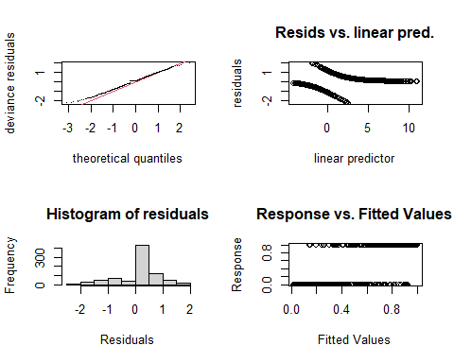

##   
## Method: REML Optimizer: outer newton  
## full convergence after 8 iterations.  
## Gradient range [-0.0003888622,0.0001318491]  
## (score 275.7598 & scale 1).  
## Hessian positive definite, eigenvalue range [3.857827e-06,2.375157].  
## Model rank = 117 / 117   
##   
## Basis dimension (k) checking results. Low p-value (k-index<1) may  
## indicate that k is too low, especially if edf is close to k'.  
##   
## k' edf k-index p-value  
## s(Locality) 7.000 4.774 NA NA  
## s(jnight):HabitatNatural 9.000 0.767 1.07 0.99  
## s(jnight):HabitatTurbinePad 9.000 3.324 1.07 0.98  
## s(temp_mean) 9.000 3.545 1.07 0.98  
## s(wind_mean) 12.000 2.945 1.05 0.97  
## ti(temp_mean,wind_mean) 69.000 29.696 0.98 0.40

gam.check(m2_LREc, rep=500) #rep=500 gives you a polygon on the QQ plot, which the observed values should lie within*

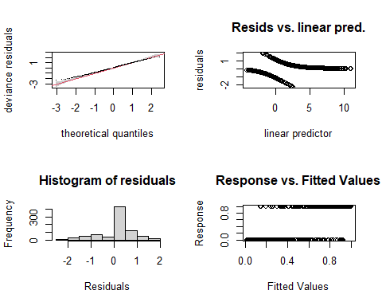

##   
## Method: REML Optimizer: outer newton  
## full convergence after 8 iterations.  
## Gradient range [-0.0003888622,0.0001318491]  
## (score 275.7598 & scale 1).  
## Hessian positive definite, eigenvalue range [3.857827e-06,2.375157].  
## Model rank = 117 / 117   
##   
## Basis dimension (k) checking results. Low p-value (k-index<1) may  
## indicate that k is too low, especially if edf is close to k'.  
##   
## k' edf k-index p-value  
## s(Locality) 7.000 4.774 NA NA  
## s(jnight):HabitatNatural 9.000 0.767 1.07 0.99  
## s(jnight):HabitatTurbinePad 9.000 3.324 1.07 0.98  
## s(temp_mean) 9.000 3.545 1.07 0.98  
## s(wind_mean) 12.000 2.945 1.05 0.97  
## ti(temp_mean,wind_mean) 69.000 29.696 0.98 0.30

##   
  
overdispersion.m2_LREc <- sum( residuals(m2_LREc, "pearson")^2 ) / m2_LREc$df.residual  
overdispersion.m2_LREc

## [1] 0.4812066

# From Katrine's Step3B GAM modelling script:   
#[1] 1.022701 #this value should ideally be 0.8-1.2, but it's not very bad!

# Basis dimension (k) checking results:

The k-index should be approx. 1 or larger Play play around with k….

bmp(file.path(output_today, "checking k dimensions m2_LREc bats_tot.jpeg"), width = 9, height = 6, units = "in", res = 350)  
  
plot(m2_LREc, pages=1,scheme=2,shade=TRUE,seWithMean = TRUE)  
  
draw(m2_LREc, scales ="free") #function 'draw' is from package 'gratia'  
draw(m2_LREc, scales ="fixed")  
  
dev.off()

## png   
## 2

## Visualize the 3D GAM  
bmp(file.path(output_today, "3D gam m2_LREc bats_tot.jpg"), width = 9, height = 6, units = "in", res = 350)  
par(mfrow = c(1,2))  
  
vis.gam(m2_LREc, view = c("temp_mean", "wind_mean")) # Both are super duper wiggly   
vis.gam(m2_LREc, view = c("wind_mean", "temp_mean"))   
  
dev.off()

## png   
## 2

Not so sure that a binary model is the best fit in this case. But can I be switching back and forth between count/negative binomial models and binomial models? I imagine that will make the results section a bit difficult to follow and especially challenging to compare results across guild/behavior interactions….

### Recap

### Should try all these models with count/negbinom since this may be the least bad, one size fits most solution…

| # m3_LREc - LRE commuting ## Negbinom, y = Batpass_sum |
| --- |
| # m4_LREc - LRE commuting ## Negbinom, y = Batpass_sum ## Adjusted k values |
| ```r m4_LREc <- gam(Batpass_sum ~ s(Locality, bs = “re”) + s(jnight, by = Habitat, bs = “gp”, k = 13) + Habitat + s(temp_mean, k = 13) + s(wind_mean, k = 11) + ti(temp_mean,wind_mean, k = c(20, 20)), data = LREc, method = “REML”, family = nb()) |
| summary(m4_LREc) # ``` |
| ## ## Family: Negative Binomial(1.297) ## Link function: log ## ## Formula: ## Batpass_sum ~ s(Locality, bs = "re") + s(jnight, by = Habitat, ## bs = "gp", k = 13) + Habitat + s(temp_mean, k = 13) + s(wind_mean, ## k = 11) + ti(temp_mean, wind_mean, k = c(20, 20)) ## ## Parametric coefficients: ## Estimate Std. Error z value Pr(>|z|) ## (Intercept) 1.29150 0.29569 4.368 1.25e-05 *** ## HabitatTurbinePad 0.40963 0.07938 5.161 2.46e-07 *** ## --- ## Signif. codes: 0 '***' 0.001 '**' 0.01 '*' 0.05 '.' 0.1 ' ' 1 ## ## Approximate significance of smooth terms: ## edf Ref.df Chi.sq p-value ## s(Locality) 5.893 6.000 317.50 < 2e-16 *** ## s(jnight):HabitatNatural 4.458 5.303 73.98 < 2e-16 *** ## s(jnight):HabitatTurbinePad 7.883 8.864 76.92 < 2e-16 *** ## s(temp_mean) 5.797 6.622 64.84 < 2e-16 *** ## s(wind_mean) 4.724 5.508 30.55 2.33e-05 *** ## ti(temp_mean,wind_mean) 39.437 68.000 132.32 < 2e-16 *** ## --- ## Signif. codes: 0 '***' 0.001 '**' 0.01 '*' 0.05 '.' 0.1 ' ' 1 ## ## R-sq.(adj) = 0.399 Deviance explained = 68.9% ## -REML = 2340.1 Scale est. = 1 n = 811 |
| r par(mfrow = c(2,2)) gam.check(m4_LREc) #look at the plots, but also the output to check if k needs to be adjusted |
|  |
| ## ## Method: REML Optimizer: outer newton ## full convergence after 6 iterations. ## Gradient range [-4.972245e-08,4.735091e-06] ## (score 2340.065 & scale 1). ## Hessian positive definite, eigenvalue range [0.6706107,207.6445]. ## Model rank = 123 / 123 ## ## Basis dimension (k) checking results. Low p-value (k-index<1) may ## indicate that k is too low, especially if edf is close to k'. ## ## k' edf k-index p-value ## s(Locality) 7.00 5.89 NA NA ## s(jnight):HabitatNatural 12.00 4.46 0.96 0.96 ## s(jnight):HabitatTurbinePad 12.00 7.88 0.96 0.92 ## s(temp_mean) 12.00 5.80 0.95 0.93 ## s(wind_mean) 10.00 4.72 0.97 0.95 ## ti(temp_mean,wind_mean) 68.00 39.44 0.88 0.15 |
| r gam.check(m4_LREc, rep=500) #rep=500 gives you a polygon on the QQ plot, which the observed values should lie within* |
|  |
| ## ## Method: REML Optimizer: outer newton ## full convergence after 6 iterations. ## Gradient range [-4.972245e-08,4.735091e-06] ## (score 2340.065 & scale 1). ## Hessian positive definite, eigenvalue range [0.6706107,207.6445]. ## Model rank = 123 / 123 ## ## Basis dimension (k) checking results. Low p-value (k-index<1) may ## indicate that k is too low, especially if edf is close to k'. ## ## k' edf k-index p-value ## s(Locality) 7.00 5.89 NA NA ## s(jnight):HabitatNatural 12.00 4.46 0.96 0.94 ## s(jnight):HabitatTurbinePad 12.00 7.88 0.96 0.94 ## s(temp_mean) 12.00 5.80 0.95 0.92 ## s(wind_mean) 10.00 4.72 0.97 0.97 ## ti(temp_mean,wind_mean) 68.00 39.44 0.88 0.12 |
| ```r ## |
| overdispersion.m4_LREc <- sum( residuals(m4_LREc, “pearson”)^2 ) / m4_LREc$df.residual overdispersion.m4_LREc ``` |
| ## [1] 1.18526 |
| r # From Katrine's Step3B GAM modelling script: #[1] 1.022701 #this value should ideally be 0.8-1.2, but it's not very bad! |
| # Basis dimension (k) checking results: The k-index should be approx. 1 or larger Play play around with k…. |
| ```r bmp(file.path(output_today, “checking k dimensions m4_LREc bats_tot.jpeg”), width = 9, height = 6, units = “in”, res = 350) |
| plot(m4_LREc, pages=1,scheme=2,shade=TRUE,seWithMean = TRUE) |
| draw(m4_LREc, scales =“free”) #function ‘draw’ is from package ‘gratia’ draw(m4_LREc, scales =“fixed”) |
| dev.off() ``` |
| ## png ## 2 |
| ```r ## Visualize the 3D GAM bmp(file.path(output_today, “3D gam m4_LREc bats_tot.jpg”), width = 9, height = 6, units = “in”, res = 350) par(mfrow = c(1,2)) |
| vis.gam(m4_LREc, view = c(“temp_mean”, “wind_mean”)) # Both are super duper wiggly vis.gam(m4_LREc, view = c(“wind_mean”, “temp_mean”)) |
| dev.off() ``` |
| ## png ## 2 |

## # SRE feeding

# mr1_SREF

m1_SREf <- gam(cbind(yes_batpass,no_batpass) ~  
 s(Locality, bs = "re") +   
 s(jnight, by = Habitat, bs = "gp", k =90) +  
 Habitat +  
 s(temp_mean) +  
 s(wind_mean) +   
 ti(temp_mean,wind_mean) ,   
 data = SREf, method = "REML",   
 family = binomial, select=TRUE)   
  
summary(m1_SREf) #

##   
## Family: binomial   
## Link function: logit   
##   
## Formula:  
## cbind(yes_batpass, no_batpass) ~ s(Locality, bs = "re") + s(jnight,   
## by = Habitat, bs = "gp", k = 90) + Habitat + s(temp_mean) +   
## s(wind_mean) + ti(temp_mean, wind_mean)  
##   
## Parametric coefficients:  
## Estimate Std. Error z value Pr(>|z|)   
## (Intercept) -2.1860 0.3842 -5.690 1.27e-08 ***  
## HabitatTurbinePad -1.0164 0.2370 -4.289 1.80e-05 ***  
## ---  
## Signif. codes: 0 '***' 0.001 '**' 0.01 '*' 0.05 '.' 0.1 ' ' 1  
##   
## Approximate significance of smooth terms:  
## edf Ref.df Chi.sq p-value   
## s(Locality) 5.224e+00 6 47.884 < 2e-16 ***  
## s(jnight):HabitatNatural 1.170e-04 87 0.000 0.99307   
## s(jnight):HabitatTurbinePad 8.904e-05 87 0.000 0.83201   
## s(temp_mean) 9.683e-01 9 34.763 < 2e-16 ***  
## s(wind_mean) 2.947e+00 9 12.172 0.00187 **   
## ti(temp_mean,wind_mean) 1.865e+00 16 4.475 0.05490 .   
## ---  
## Signif. codes: 0 '***' 0.001 '**' 0.01 '*' 0.05 '.' 0.1 ' ' 1  
##   
## R-sq.(adj) = 0.309 Deviance explained = 33.7%  
## -REML = 257.62 Scale est. = 1 n = 811

par(mfrow = c(2,2))  
gam.check(m1_SREf) #look at the plots, but also the output to check if k needs to be adjusted

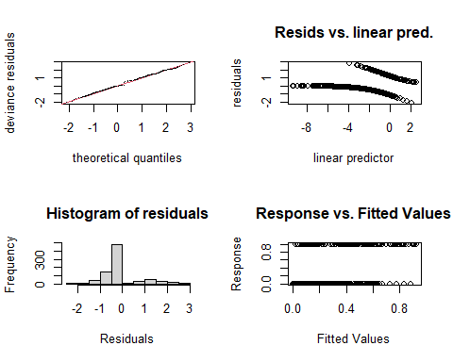

##   
## Method: REML Optimizer: outer newton  
## full convergence after 20 iterations.  
## Gradient range [-5.396082e-05,2.616888e-06]  
## (score 257.6168 & scale 1).  
## Hessian positive definite, eigenvalue range [5.835366e-07,2.357136].  
## Model rank = 221 / 221   
##   
## Basis dimension (k) checking results. Low p-value (k-index<1) may  
## indicate that k is too low, especially if edf is close to k'.  
##   
## k' edf k-index p-value  
## s(Locality) 7.00e+00 5.22e+00 NA NA  
## s(jnight):HabitatNatural 8.90e+01 1.17e-04 0.99 0.63  
## s(jnight):HabitatTurbinePad 8.90e+01 8.90e-05 0.99 0.64  
## s(temp_mean) 9.00e+00 9.68e-01 1.01 0.84  
## s(wind_mean) 9.00e+00 2.95e+00 1.02 0.92  
## ti(temp_mean,wind_mean) 1.60e+01 1.86e+00 0.98 0.64

gam.check(m1_SREf, rep=500) #rep=500 gives you a polygon on the QQ plot, which the observed values should lie within*

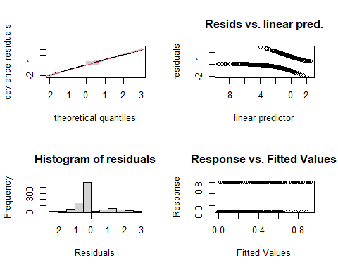

##   
## Method: REML Optimizer: outer newton  
## full convergence after 20 iterations.  
## Gradient range [-5.396082e-05,2.616888e-06]  
## (score 257.6168 & scale 1).  
## Hessian positive definite, eigenvalue range [5.835366e-07,2.357136].  
## Model rank = 221 / 221   
##   
## Basis dimension (k) checking results. Low p-value (k-index<1) may  
## indicate that k is too low, especially if edf is close to k'.  
##   
## k' edf k-index p-value  
## s(Locality) 7.00e+00 5.22e+00 NA NA  
## s(jnight):HabitatNatural 8.90e+01 1.17e-04 0.99 0.62  
## s(jnight):HabitatTurbinePad 8.90e+01 8.90e-05 0.99 0.69  
## s(temp_mean) 9.00e+00 9.68e-01 1.01 0.88  
## s(wind_mean) 9.00e+00 2.95e+00 1.02 0.90  
## ti(temp_mean,wind_mean) 1.60e+01 1.86e+00 0.98 0.61

##   
  
overdispersion.m1_SREf <- sum( residuals(m1_SREf, "pearson")^2 ) / m1_SREf$df.residual  
overdispersion.m1_SREf

## [1] 0.7270936

# From Katrine's Step3B GAM modelling script:   
#[1] 1.022701 #this value should ideally be 0.8-1.2, but it's not very bad!

# Basis dimension (k) checking results:

The k-index should be approx. 1 or larger Play play around with k….

bmp(file.path(output_today, "checking k dimensions m1_SREf bats_tot.jpeg"), width = 9, height = 6, units = "in", res = 350)  
  
plot(m1_SREf, pages=1,scheme=2,shade=TRUE,seWithMean = TRUE)  
  
draw(m1_SREf, scales ="free") #function 'draw' is from package 'gratia'  
draw(m1_SREf, scales ="fixed")  
  
dev.off()

## png   
## 2

## Visualize the 3D GAM  
bmp(file.path(output_today, "3D gam m1_SREf bats_tot.jpg"), width = 9, height = 6, units = "in", res = 350)  
par(mfrow = c(1,2))  
  
vis.gam(m1_SREf, view = c("temp_mean", "wind_mean")) # Both are super duper wiggly   
vis.gam(m1_SREf, view = c("wind_mean", "temp_mean"))   
  
dev.off()

## png   
## 2

## Recap

K values look good but now we have underdispersion issues, now I am going to try and make Site the main location variable and also make Habitat and random effect.

#### Could work on making predictions with this perhaps…

# mr2_SREf

m2_SREf <- gam(batpass50 ~  
 s(Site, bs = "re") +   
 Habitat +   
 s(jnight, by = Habitat, bs = "gp") +  
 s(temp_mean) +  
 s(wind_mean) +   
 ti(temp_mean,wind_mean) ,   
 data = SREf, method = "REML",   
 family = nb(), select=TRUE)   
  
summary(m2_SREf) #

##   
## Family: Negative Binomial(0.53)   
## Link function: log   
##   
## Formula:  
## batpass50 ~ s(Site, bs = "re") + Habitat + s(jnight, by = Habitat,   
## bs = "gp") + s(temp_mean) + s(wind_mean) + ti(temp_mean,   
## wind_mean)  
##   
## Parametric coefficients:  
## Estimate Std. Error z value Pr(>|z|)   
## (Intercept) -2.0617 0.5260 -3.919 8.88e-05 ***  
## HabitatTurbinePad -1.0588 0.7431 -1.425 0.154   
## ---  
## Signif. codes: 0 '***' 0.001 '**' 0.01 '*' 0.05 '.' 0.1 ' ' 1  
##   
## Approximate significance of smooth terms:  
## edf Ref.df Chi.sq p-value   
## s(Site) 1.054e+01 12 146.291 < 2e-16 ***  
## s(jnight):HabitatNatural 1.681e+00 11 5.730 0.03489 *   
## s(jnight):HabitatTurbinePad 3.592e-04 11 0.000 0.99945   
## s(temp_mean) 1.910e+00 9 31.752 < 2e-16 ***  
## s(wind_mean) 2.139e+00 9 8.870 0.00393 **   
## ti(temp_mean,wind_mean) 1.826e+00 16 4.086 0.04400 *   
## ---  
## Signif. codes: 0 '***' 0.001 '**' 0.01 '*' 0.05 '.' 0.1 ' ' 1  
##   
## R-sq.(adj) = -0.346 Deviance explained = 58.6%  
## -REML = 442.07 Scale est. = 1 n = 811

par(mfrow = c(2,2))  
gam.check(m2_SREf) #look at the plots, but also the output to check if k needs to be adjusted

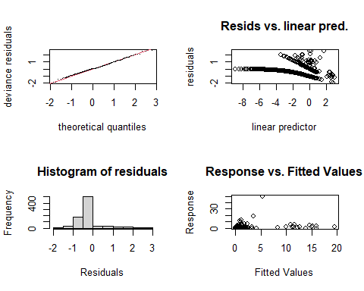

##   
## Method: REML Optimizer: outer newton  
## full convergence after 10 iterations.  
## Gradient range [-0.0001377655,5.524529e-05]  
## (score 442.0652 & scale 1).  
## Hessian positive definite, eigenvalue range [4.763773e-06,34.32309].  
## Model rank = 72 / 72   
##   
## Basis dimension (k) checking results. Low p-value (k-index<1) may  
## indicate that k is too low, especially if edf is close to k'.  
##   
## k' edf k-index p-value  
## s(Site) 1.40e+01 1.05e+01 NA NA  
## s(jnight):HabitatNatural 1.10e+01 1.68e+00 0.84 0.67  
## s(jnight):HabitatTurbinePad 1.10e+01 3.59e-04 0.84 0.71  
## s(temp_mean) 9.00e+00 1.91e+00 0.85 0.80  
## s(wind_mean) 9.00e+00 2.14e+00 0.86 0.83  
## ti(temp_mean,wind_mean) 1.60e+01 1.83e+00 0.84 0.56

gam.check(m2_SREf, rep=500) #rep=500 gives you a polygon on the QQ plot, which the observed values should lie within*

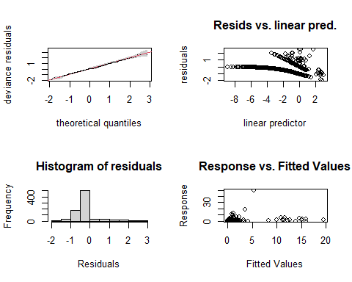

##   
## Method: REML Optimizer: outer newton  
## full convergence after 10 iterations.  
## Gradient range [-0.0001377655,5.524529e-05]  
## (score 442.0652 & scale 1).  
## Hessian positive definite, eigenvalue range [4.763773e-06,34.32309].  
## Model rank = 72 / 72   
##   
## Basis dimension (k) checking results. Low p-value (k-index<1) may  
## indicate that k is too low, especially if edf is close to k'.  
##   
## k' edf k-index p-value  
## s(Site) 1.40e+01 1.05e+01 NA NA  
## s(jnight):HabitatNatural 1.10e+01 1.68e+00 0.84 0.66  
## s(jnight):HabitatTurbinePad 1.10e+01 3.59e-04 0.84 0.68  
## s(temp_mean) 9.00e+00 1.91e+00 0.85 0.80  
## s(wind_mean) 9.00e+00 2.14e+00 0.86 0.82  
## ti(temp_mean,wind_mean) 1.60e+01 1.83e+00 0.84 0.49

##   
  
overdispersion.m2_SREf <- sum( residuals(m2_SREf, "pearson")^2 ) / m2_SREf$df.residual  
overdispersion.m2_SREf

## [1] 0.6592785

# From Katrine's Step3B GAM modelling script:   
#[1] 1.022701 #this value should ideally be 0.8-1.2, but it's not very bad!

# Basis dimension (k) checking results:

The k-index should be approx. 1 or larger Play play around with k….

bmp(file.path(output_today, "checking k dimensions m2_SREf bats_tot.jpeg"), width = 9, height = 6, units = "in", res = 350)  
#windows()  
plot(m2_SREf, pages=1,scheme=2,shade=TRUE,seWithMean = TRUE)  
  
draw(m2_SREf, scales ="free") #function 'draw' is from package 'gratia'  
draw(m2_SREf, scales ="fixed")  
  
dev.off()

## png   
## 2

## Visualize the 3D GAM  
bmp(file.path(output_today, "3D gam m2_SREf bats_tot.jpg"), width = 9, height = 6, units = "in", res = 350)  
par(mfrow = c(1,2))  
  
vis.gam(m2_SREf, view = c("temp_mean", "wind_mean")) # Both are super duper wiggly   
vis.gam(m2_SREf, view = c("wind_mean", "temp_mean"))   
  
dev.off()

## png   
## 2

## Recap

K values fit but it is underdispersed and the partial effect plot for jnight and habitat shows no relationship…

| # mr2_SREf Try modeling jnight alone instead of as an interaction with habitat |
| --- |
| # SRE commuting |

# mr1_SREc

m1_SREc <- gam(cbind(yes_batpass,no_batpass) ~  
 s(Locality, bs = "re") +   
 s(jnight, by = Habitat, bs = "gp", k =90) +  
 Habitat +  
 s(temp_mean) +  
 s(wind_mean) +   
 ti(temp_mean,wind_mean) ,   
 data = SREc, method = "REML",   
 family = binomial, select=TRUE)   
  
summary(m1_SREc) #

##   
## Family: binomial   
## Link function: logit   
##   
## Formula:  
## cbind(yes_batpass, no_batpass) ~ s(Locality, bs = "re") + s(jnight,   
## by = Habitat, bs = "gp", k = 90) + Habitat + s(temp_mean) +   
## s(wind_mean) + ti(temp_mean, wind_mean)  
##   
## Parametric coefficients:  
## Estimate Std. Error z value Pr(>|z|)   
## (Intercept) 1.37150 0.27630 4.964 6.91e-07 ***  
## HabitatTurbinePad 0.06346 0.19587 0.324 0.746   
## ---  
## Signif. codes: 0 '***' 0.001 '**' 0.01 '*' 0.05 '.' 0.1 ' ' 1  
##   
## Approximate significance of smooth terms:  
## edf Ref.df Chi.sq p-value   
## s(Locality) 4.540 6 17.203 0.000811 ***  
## s(jnight):HabitatNatural 2.381 87 24.589 3.43e-06 ***  
## s(jnight):HabitatTurbinePad 3.608 88 43.538 < 2e-16 ***  
## s(temp_mean) 4.845 9 24.045 1.07e-05 ***  
## s(wind_mean) 3.045 9 44.741 < 2e-16 ***  
## ti(temp_mean,wind_mean) 1.239 16 2.866 0.052734 .   
## ---  
## Signif. codes: 0 '***' 0.001 '**' 0.01 '*' 0.05 '.' 0.1 ' ' 1  
##   
## R-sq.(adj) = 0.296 Deviance explained = 28.7%  
## -REML = 395.62 Scale est. = 1 n = 811

par(mfrow = c(2,2))  
gam.check(m1_SREc) #look at the plots, but also the output to check if k needs to be adjusted

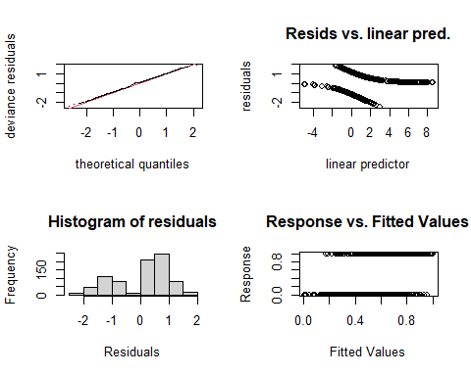

##   
## Method: REML Optimizer: outer newton  
## full convergence after 17 iterations.  
## Gradient range [-3.073231e-05,3.358286e-05]  
## (score 395.6206 & scale 1).  
## Hessian positive definite, eigenvalue range [1.685351e-05,1.641151].  
## Model rank = 221 / 221   
##   
## Basis dimension (k) checking results. Low p-value (k-index<1) may  
## indicate that k is too low, especially if edf is close to k'.  
##   
## k' edf k-index p-value   
## s(Locality) 7.00 4.54 NA NA   
## s(jnight):HabitatNatural 89.00 2.38 0.90 <2e-16 ***  
## s(jnight):HabitatTurbinePad 89.00 3.61 0.90 0.005 **   
## s(temp_mean) 9.00 4.84 0.90 <2e-16 ***  
## s(wind_mean) 9.00 3.04 0.91 0.005 **   
## ti(temp_mean,wind_mean) 16.00 1.24 0.85 <2e-16 ***  
## ---  
## Signif. codes: 0 '***' 0.001 '**' 0.01 '*' 0.05 '.' 0.1 ' ' 1

gam.check(m1_SREc, rep=500) #rep=500 gives you a polygon on the QQ plot, which the observed values should lie within*

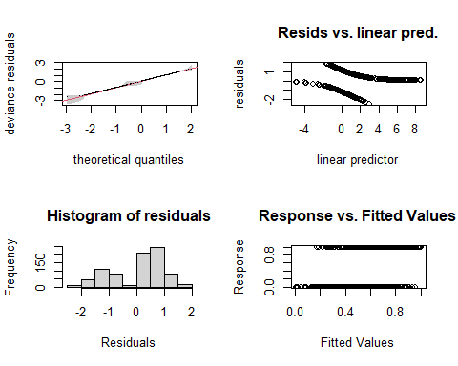

##   
## Method: REML Optimizer: outer newton  
## full convergence after 17 iterations.  
## Gradient range [-3.073231e-05,3.358286e-05]  
## (score 395.6206 & scale 1).  
## Hessian positive definite, eigenvalue range [1.685351e-05,1.641151].  
## Model rank = 221 / 221   
##   
## Basis dimension (k) checking results. Low p-value (k-index<1) may  
## indicate that k is too low, especially if edf is close to k'.  
##   
## k' edf k-index p-value   
## s(Locality) 7.00 4.54 NA NA   
## s(jnight):HabitatNatural 89.00 2.38 0.90 0.010 **   
## s(jnight):HabitatTurbinePad 89.00 3.61 0.90 0.005 **   
## s(temp_mean) 9.00 4.84 0.90 <2e-16 ***  
## s(wind_mean) 9.00 3.04 0.91 0.010 **   
## ti(temp_mean,wind_mean) 16.00 1.24 0.85 <2e-16 ***  
## ---  
## Signif. codes: 0 '***' 0.001 '**' 0.01 '*' 0.05 '.' 0.1 ' ' 1

overdispersion.m1_SREc <- sum( residuals(m1_SREc, "pearson")^2 ) / m1_SREc$df.residual  
overdispersion.m1_SREc

## [1] 0.811134

# From Katrine's Step3B GAM modelling script:   
#[1] 1.022701 #this value should ideally be 0.8-1.2, but it's not very bad!

# Basis dimension (k) checking results:

The k-index should be approx. 1 or larger Play play around with k….

bmp(file.path(output_today, "checking k dimensions m1_SREc bats_tot.jpeg"), width = 9, height = 6, units = "in", res = 350)  
  
plot(m1_SREc, pages=1,scheme=2,shade=TRUE,seWithMean = TRUE)  
  
draw(m1_SREc, scales ="free") #function 'draw' is from package 'gratia'  
draw(m1_SREc, scales ="fixed")  
  
dev.off()

## png   
## 2

## Visualize the 3D GAM  
bmp(file.path(output_today, "3D gam m1_SREc bats_tot.jpg"), width = 9, height = 6, units = "in", res = 350)  
par(mfrow = c(1,2))  
  
vis.gam(m1_SREc, view = c("temp_mean", "wind_mean")) # Both are super duper wiggly   
vis.gam(m1_SREc, view = c("wind_mean", "temp_mean"))   
  
dev.off()

## png   
## 2

## Recap

All the k values need adjusting

|  |
| --- |
| # mr1_SREc |
| ```r m1_SREc <- gam(cbind(yes_batpass,no_batpass) ~ s(Locality, bs = “re”) + s(jnight, by = Habitat, bs = “gp”, k = 40) + Habitat + s(temp_mean, k = 15) + s(wind_mean,k = 15) + ti(temp_mean,wind_mean, k = c(15,15)) , data = SREc, method = “REML”, family = binomial, select=TRUE) |
| summary(m1_SREc) # ``` |
| ## ## Family: binomial ## Link function: logit ## ## Formula: ## cbind(yes_batpass, no_batpass) ~ s(Locality, bs = "re") + s(jnight, ## by = Habitat, bs = "gp", k = 40) + Habitat + s(temp_mean, ## k = 15) + s(wind_mean, k = 15) + ti(temp_mean, wind_mean, ## k = c(15, 15)) ## ## Parametric coefficients: ## Estimate Std. Error z value Pr(>|z|) ## (Intercept) 1.37251 0.26933 5.096 3.47e-07 *** ## HabitatTurbinePad 0.08946 0.21026 0.425 0.67 ## --- ## Signif. codes: 0 '***' 0.001 '**' 0.01 '*' 0.05 '.' 0.1 ' ' 1 ## ## Approximate significance of smooth terms: ## edf Ref.df Chi.sq p-value ## s(Locality) 4.7542 6 20.00 0.000267 *** ## s(jnight):HabitatNatural 2.6658 38 20.92 1.05e-06 *** ## s(jnight):HabitatTurbinePad 3.2714 39 34.20 < 2e-16 *** ## s(temp_mean) 0.9698 14 26.30 < 2e-16 *** ## s(wind_mean) 2.4101 14 15.11 3.59e-05 *** ## ti(temp_mean,wind_mean) 32.1997 62 97.73 < 2e-16 *** ## --- ## Signif. codes: 0 '***' 0.001 '**' 0.01 '*' 0.05 '.' 0.1 ' ' 1 ## ## R-sq.(adj) = 0.403 Deviance explained = 39.9% ## -REML = 378.28 Scale est. = 1 n = 811 |
| r par(mfrow = c(2,2)) gam.check(m1_SREc) #look at the plots, but also the output to check if k needs to be adjusted |
|  |
| ## ## Method: REML Optimizer: outer newton ## full convergence after 12 iterations. ## Gradient range [-0.0001390073,3.187295e-05] ## (score 378.2781 & scale 1). ## Hessian positive definite, eigenvalue range [2.272367e-06,2.689363]. ## Model rank = 177 / 177 ## ## Basis dimension (k) checking results. Low p-value (k-index<1) may ## indicate that k is too low, especially if edf is close to k'. ## ## k' edf k-index p-value ## s(Locality) 7.00 4.75 NA NA ## s(jnight):HabitatNatural 39.00 2.67 1.03 0.84 ## s(jnight):HabitatTurbinePad 39.00 3.27 1.03 0.78 ## s(temp_mean) 14.00 0.97 1.03 0.86 ## s(wind_mean) 14.00 2.41 1.04 0.93 ## ti(temp_mean,wind_mean) 62.00 32.20 1.00 0.56 |
| r gam.check(m1_SREc, rep=500) #rep=500 gives you a polygon on the QQ plot, which the observed values should lie within* |
|  |
| ## ## Method: REML Optimizer: outer newton ## full convergence after 12 iterations. ## Gradient range [-0.0001390073,3.187295e-05] ## (score 378.2781 & scale 1). ## Hessian positive definite, eigenvalue range [2.272367e-06,2.689363]. ## Model rank = 177 / 177 ## ## Basis dimension (k) checking results. Low p-value (k-index<1) may ## indicate that k is too low, especially if edf is close to k'. ## ## k' edf k-index p-value ## s(Locality) 7.00 4.75 NA NA ## s(jnight):HabitatNatural 39.00 2.67 1.03 0.88 ## s(jnight):HabitatTurbinePad 39.00 3.27 1.03 0.90 ## s(temp_mean) 14.00 0.97 1.03 0.86 ## s(wind_mean) 14.00 2.41 1.04 0.91 ## ti(temp_mean,wind_mean) 62.00 32.20 1.00 0.64 |
| r overdispersion.m1_SREc <- sum( residuals(m1_SREc, "pearson")^2 ) / m1_SREc$df.residual overdispersion.m1_SREc |
| ## [1] 0.6930812 |
| r # From Katrine's Step3B GAM modelling script: #[1] 1.022701 #this value should ideally be 0.8-1.2, but it's not very bad! |
| # Basis dimension (k) checking results: The k-index should be approx. 1 or larger Play play around with k…. |
| ```r bmp(file.path(output_today, “checking k dimensions m1_SREc bats_tot.jpeg”), width = 9, height = 6, units = “in”, res = 350) |
| plot(m1_SREc, pages=1,scheme=2,shade=TRUE,seWithMean = TRUE) |
| draw(m1_SREc, scales =“free”) #function ‘draw’ is from package ‘gratia’ draw(m1_SREc, scales =“fixed”) |
| dev.off() ``` |
| ## png ## 2 |
| ```r ## Visualize the 3D GAM bmp(file.path(output_today, “3D gam m1_SREc bats_tot.jpg”), width = 9, height = 6, units = “in”, res = 350) par(mfrow = c(1,2)) |
| vis.gam(m1_SREc, view = c(“temp_mean”, “wind_mean”)) # Both are super duper wiggly vis.gam(m1_SREc, view = c(“wind_mean”, “temp_mean”)) |
| dev.off() ``` |
| ## png ## 2 |
| ## Recap |
| K values are fixed but now it is super underdispersed… |
| # SRE commuting |

# mr1_SREc

m1_SREc <- gam(cbind(yes_batpass,no_batpass) ~  
 s(Locality, bs = "re") +   
 s(jnight, by = Habitat, bs = "gp", k =90) +  
 Habitat +  
 s(temp_mean) +  
 s(wind_mean) +   
 ti(temp_mean,wind_mean) ,   
 data = SREc, method = "REML",   
 family = binomial, select=TRUE)   
  
summary(m1_SREc) #

##   
## Family: binomial   
## Link function: logit   
##   
## Formula:  
## cbind(yes_batpass, no_batpass) ~ s(Locality, bs = "re") + s(jnight,   
## by = Habitat, bs = "gp", k = 90) + Habitat + s(temp_mean) +   
## s(wind_mean) + ti(temp_mean, wind_mean)  
##   
## Parametric coefficients:  
## Estimate Std. Error z value Pr(>|z|)   
## (Intercept) 1.37150 0.27630 4.964 6.91e-07 ***  
## HabitatTurbinePad 0.06346 0.19587 0.324 0.746   
## ---  
## Signif. codes: 0 '***' 0.001 '**' 0.01 '*' 0.05 '.' 0.1 ' ' 1  
##   
## Approximate significance of smooth terms:  
## edf Ref.df Chi.sq p-value   
## s(Locality) 4.540 6 17.203 0.000811 ***  
## s(jnight):HabitatNatural 2.381 87 24.589 3.43e-06 ***  
## s(jnight):HabitatTurbinePad 3.608 88 43.538 < 2e-16 ***  
## s(temp_mean) 4.845 9 24.045 1.07e-05 ***  
## s(wind_mean) 3.045 9 44.741 < 2e-16 ***  
## ti(temp_mean,wind_mean) 1.239 16 2.866 0.052734 .   
## ---  
## Signif. codes: 0 '***' 0.001 '**' 0.01 '*' 0.05 '.' 0.1 ' ' 1  
##   
## R-sq.(adj) = 0.296 Deviance explained = 28.7%  
## -REML = 395.62 Scale est. = 1 n = 811

par(mfrow = c(2,2))  
gam.check(m1_SREc) #look at the plots, but also the output to check if k needs to be adjusted

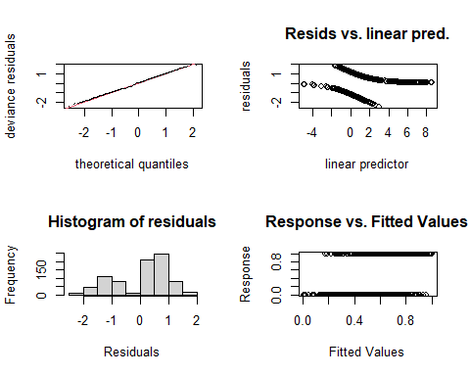

##   
## Method: REML Optimizer: outer newton  
## full convergence after 17 iterations.  
## Gradient range [-3.073231e-05,3.358286e-05]  
## (score 395.6206 & scale 1).  
## Hessian positive definite, eigenvalue range [1.685351e-05,1.641151].  
## Model rank = 221 / 221   
##   
## Basis dimension (k) checking results. Low p-value (k-index<1) may  
## indicate that k is too low, especially if edf is close to k'.  
##   
## k' edf k-index p-value   
## s(Locality) 7.00 4.54 NA NA   
## s(jnight):HabitatNatural 89.00 2.38 0.90 <2e-16 ***  
## s(jnight):HabitatTurbinePad 89.00 3.61 0.90 0.005 **   
## s(temp_mean) 9.00 4.84 0.90 0.015 *   
## s(wind_mean) 9.00 3.04 0.91 0.010 **   
## ti(temp_mean,wind_mean) 16.00 1.24 0.85 <2e-16 ***  
## ---  
## Signif. codes: 0 '***' 0.001 '**' 0.01 '*' 0.05 '.' 0.1 ' ' 1

gam.check(m1_SREc, rep=500) #rep=500 gives you a polygon on the QQ plot, which the observed values should lie within*

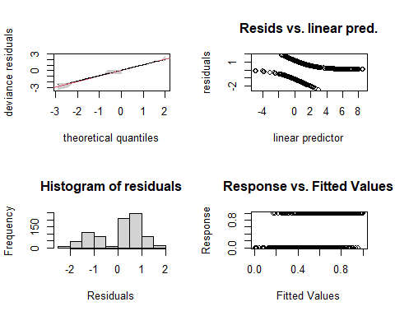

##   
## Method: REML Optimizer: outer newton  
## full convergence after 17 iterations.  
## Gradient range [-3.073231e-05,3.358286e-05]  
## (score 395.6206 & scale 1).  
## Hessian positive definite, eigenvalue range [1.685351e-05,1.641151].  
## Model rank = 221 / 221   
##   
## Basis dimension (k) checking results. Low p-value (k-index<1) may  
## indicate that k is too low, especially if edf is close to k'.  
##   
## k' edf k-index p-value   
## s(Locality) 7.00 4.54 NA NA   
## s(jnight):HabitatNatural 89.00 2.38 0.90 0.005 **   
## s(jnight):HabitatTurbinePad 89.00 3.61 0.90 <2e-16 ***  
## s(temp_mean) 9.00 4.84 0.90 0.005 **   
## s(wind_mean) 9.00 3.04 0.91 0.010 **   
## ti(temp_mean,wind_mean) 16.00 1.24 0.85 <2e-16 ***  
## ---  
## Signif. codes: 0 '***' 0.001 '**' 0.01 '*' 0.05 '.' 0.1 ' ' 1

overdispersion.m1_SREc <- sum( residuals(m1_SREc, "pearson")^2 ) / m1_SREc$df.residual  
overdispersion.m1_SREc

## [1] 0.811134

# From Katrine's Step3B GAM modelling script:   
#[1] 1.022701 #this value should ideally be 0.8-1.2, but it's not very bad!

# Basis dimension (k) checking results:

The k-index should be approx. 1 or larger Play play around with k….

bmp(file.path(output_today, "checking k dimensions m1_SREc bats_tot.jpeg"), width = 9, height = 6, units = "in", res = 350)  
  
plot(m1_SREc, pages=1,scheme=2,shade=TRUE,seWithMean = TRUE)  
  
draw(m1_SREc, scales ="free") #function 'draw' is from package 'gratia'  
draw(m1_SREc, scales ="fixed")  
  
dev.off()

## png   
## 2

## Visualize the 3D GAM  
bmp(file.path(output_today, "3D gam m1_SREc bats_tot.jpg"), width = 9, height = 6, units = "in", res = 350)  
par(mfrow = c(1,2))  
  
vis.gam(m1_SREc, view = c("temp_mean", "wind_mean")) # Both are super duper wiggly   
vis.gam(m1_SREc, view = c("wind_mean", "temp_mean"))   
  
dev.off()

## png   
## 2

## Recap

All the k values need adjusting

|  |
| --- |
| # mr2_SREc Try Habitat as a random effect |
| ```r m2_SREc <- gam(cbind(yes_batpass,no_batpass) ~ s(Locality, bs = “re”) + s(Habitat, bs = “re”) + s(jnight, by = Habitat, bs = “gp”, k = 45) + s(temp_mean, k = 15) + s(wind_mean, k = 15) + ti(temp_mean,wind_mean) , data = SREc, method = “REML”, family = binomial, select=TRUE) |
| summary(m2_SREc) # ``` |
| ## ## Family: binomial ## Link function: logit ## ## Formula: ## cbind(yes_batpass, no_batpass) ~ s(Locality, bs = "re") + s(Habitat, ## bs = "re") + s(jnight, by = Habitat, bs = "gp", k = 45) + ## s(temp_mean, k = 15) + s(wind_mean, k = 15) + ti(temp_mean, ## wind_mean) ## ## Parametric coefficients: ## Estimate Std. Error z value Pr(>|z|) ## (Intercept) 1.6230 0.4027 4.031 5.57e-05 *** ## --- ## Signif. codes: 0 '***' 0.001 '**' 0.01 '*' 0.05 '.' 0.1 ' ' 1 ## ## Approximate significance of smooth terms: ## edf Ref.df Chi.sq p-value ## s(Locality) 4.650e+00 6 18.620 0.000468 *** ## s(Habitat) 9.213e-05 1 0.000 0.708523 ## s(jnight):HabitatNatural 3.320e+00 44 31.327 < 2e-16 *** ## s(jnight):HabitatTurbinePad 3.829e+00 44 45.698 < 2e-16 *** ## s(temp_mean) 7.448e+00 14 33.992 3.34e-06 *** ## s(wind_mean) 1.105e+01 14 71.471 < 2e-16 *** ## ti(temp_mean,wind_mean) 6.470e-01 16 0.916 0.180838 ## --- ## Signif. codes: 0 '***' 0.001 '**' 0.01 '*' 0.05 '.' 0.1 ' ' 1 ## ## R-sq.(adj) = 0.356 Deviance explained = 35% ## -REML = 395.86 Scale est. = 1 n = 811 |
| r par(mfrow = c(2,2)) gam.check(m2_SREc) #look at the plots, but also the output to check if k needs to be adjusted |
|  |
| ## ## Method: REML Optimizer: outer newton ## full convergence after 10 iterations. ## Gradient range [-4.524714e-05,4.020939e-05] ## (score 395.8611 & scale 1). ## Hessian positive definite, eigenvalue range [2.074661e-06,1.946737]. ## Model rank = 142 / 142 ## ## Basis dimension (k) checking results. Low p-value (k-index<1) may ## indicate that k is too low, especially if edf is close to k'. ## ## k' edf k-index p-value ## s(Locality) 7.00e+00 4.65e+00 NA NA ## s(Habitat) 2.00e+00 9.21e-05 NA NA ## s(jnight):HabitatNatural 4.40e+01 3.32e+00 0.97 0.20 ## s(jnight):HabitatTurbinePad 4.40e+01 3.83e+00 0.97 0.22 ## s(temp_mean) 1.40e+01 7.45e+00 0.98 0.24 ## s(wind_mean) 1.40e+01 1.10e+01 0.98 0.34 ## ti(temp_mean,wind_mean) 1.60e+01 6.47e-01 0.93 0.01 ** ## --- ## Signif. codes: 0 '***' 0.001 '**' 0.01 '*' 0.05 '.' 0.1 ' ' 1 |
| r gam.check(m2_SREc, rep=500) #rep=500 gives you a polygon on the QQ plot, which the observed values should lie within* |
|  |
| ## ## Method: REML Optimizer: outer newton ## full convergence after 10 iterations. ## Gradient range [-4.524714e-05,4.020939e-05] ## (score 395.8611 & scale 1). ## Hessian positive definite, eigenvalue range [2.074661e-06,1.946737]. ## Model rank = 142 / 142 ## ## Basis dimension (k) checking results. Low p-value (k-index<1) may ## indicate that k is too low, especially if edf is close to k'. ## ## k' edf k-index p-value ## s(Locality) 7.00e+00 4.65e+00 NA NA ## s(Habitat) 2.00e+00 9.21e-05 NA NA ## s(jnight):HabitatNatural 4.40e+01 3.32e+00 0.97 0.185 ## s(jnight):HabitatTurbinePad 4.40e+01 3.83e+00 0.97 0.180 ## s(temp_mean) 1.40e+01 7.45e+00 0.98 0.275 ## s(wind_mean) 1.40e+01 1.10e+01 0.98 0.365 ## ti(temp_mean,wind_mean) 1.60e+01 6.47e-01 0.93 0.005 ** ## --- ## Signif. codes: 0 '***' 0.001 '**' 0.01 '*' 0.05 '.' 0.1 ' ' 1 |
| r overdispersion.m2_SREc <- sum( residuals(m2_SREc, "pearson")^2 ) / m2_SREc$df.residual overdispersion.m2_SREc |
| ## [1] 0.7313103 |
| r # From Katrine's Step3B GAM modelling script: #[1] 1.022701 #this value should ideally be 0.8-1.2, but it's not very bad! |
| # Basis dimension (k) checking results: The k-index should be approx. 1 or larger Play play around with k…. |
| ```r bmp(file.path(output_today, “checking k dimensions m2_SREc bats_tot.jpeg”), width = 9, height = 6, units = “in”, res = 350) |
| plot(m2_SREc, pages=1,scheme=2,shade=TRUE,seWithMean = TRUE) |
| draw(m2_SREc, scales =“free”) #function ‘draw’ is from package ‘gratia’ draw(m2_SREc, scales =“fixed”) |
| dev.off() ``` |
| ## png ## 2 |
| ```r ## Visualize the 3D GAM bmp(file.path(output_today, “3D gam m2_SREc bats_tot.jpg”), width = 9, height = 6, units = “in”, res = 350) par(mfrow = c(1,2)) |
| vis.gam(m2_SREc, view = c(“temp_mean”, “wind_mean”)) # Both are super duper wiggly vis.gam(m2_SREc, view = c(“wind_mean”, “temp_mean”)) |
| dev.off() ``` |
| ## png ## 2 |
| ## Recap |
| k values look good but now it is underdispered… |

# mr2_SREc

Try Habitat as a random effect

m3_SREc <- gam(batpass50 ~  
 s(Locality, bs = "re") +   
 s(Habitat, bs = "re") +  
 s(jnight, bs = "gp", k = 90) +  
 s(temp_mean, k = 15) +  
 s(wind_mean, k = 15) +   
 ti(temp_mean,wind_mean, k = c(15, 15)),   
 data = SREc, method = "REML",   
 family = nb(), select=TRUE)   
  
summary(m3_SREc) #

##   
## Family: Negative Binomial(2.11)   
## Link function: log   
##   
## Formula:  
## batpass50 ~ s(Locality, bs = "re") + s(Habitat, bs = "re") +   
## s(jnight, bs = "gp", k = 90) + s(temp_mean, k = 15) + s(wind_mean,   
## k = 15) + ti(temp_mean, wind_mean, k = c(15, 15))  
##   
## Parametric coefficients:  
## Estimate Std. Error z value Pr(>|z|)   
## (Intercept) 0.8489 0.2777 3.057 0.00224 **  
## ---  
## Signif. codes: 0 '***' 0.001 '**' 0.01 '*' 0.05 '.' 0.1 ' ' 1  
##   
## Approximate significance of smooth terms:  
## edf Ref.df Chi.sq p-value   
## s(Locality) 5.861 6 295.35 < 2e-16 ***  
## s(Habitat) 0.950 1 19.64 1.05e-05 ***  
## s(jnight) 3.703 87 45.45 < 2e-16 ***  
## s(temp_mean) 2.205 14 47.21 < 2e-16 ***  
## s(wind_mean) 3.189 14 43.38 < 2e-16 ***  
## ti(temp_mean,wind_mean) 38.069 62 154.02 < 2e-16 ***  
## ---  
## Signif. codes: 0 '***' 0.001 '**' 0.01 '*' 0.05 '.' 0.1 ' ' 1  
##   
## R-sq.(adj) = 0.435 Deviance explained = 60.5%  
## -REML = 1750.8 Scale est. = 1 n = 811

par(mfrow = c(2,2))  
gam.check(m3_SREc) #look at the plots, but also the output to check if k needs to be adjusted

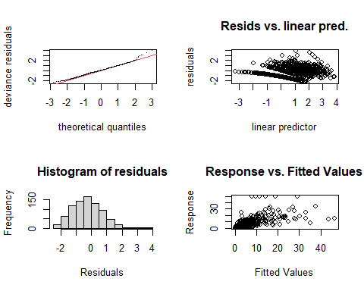

##   
## Method: REML Optimizer: outer newton  
## full convergence after 7 iterations.  
## Gradient range [-0.0003802013,0.000357111]  
## (score 1750.847 & scale 1).  
## Hessian positive definite, eigenvalue range [9.77467e-06,98.92528].  
## Model rank = 189 / 189   
##   
## Basis dimension (k) checking results. Low p-value (k-index<1) may  
## indicate that k is too low, especially if edf is close to k'.  
##   
## k' edf k-index p-value  
## s(Locality) 7.00 5.86 NA NA  
## s(Habitat) 2.00 0.95 NA NA  
## s(jnight) 89.00 3.70 0.95 0.86  
## s(temp_mean) 14.00 2.21 0.95 0.80  
## s(wind_mean) 14.00 3.19 0.95 0.85  
## ti(temp_mean,wind_mean) 62.00 38.07 0.89 0.17

gam.check(m3_SREc, rep=500) #rep=500 gives you a polygon on the QQ plot, which the observed values should lie within*

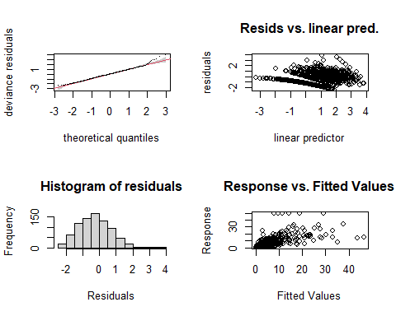

##   
## Method: REML Optimizer: outer newton  
## full convergence after 7 iterations.  
## Gradient range [-0.0003802013,0.000357111]  
## (score 1750.847 & scale 1).  
## Hessian positive definite, eigenvalue range [9.77467e-06,98.92528].  
## Model rank = 189 / 189   
##   
## Basis dimension (k) checking results. Low p-value (k-index<1) may  
## indicate that k is too low, especially if edf is close to k'.  
##   
## k' edf k-index p-value  
## s(Locality) 7.00 5.86 NA NA  
## s(Habitat) 2.00 0.95 NA NA  
## s(jnight) 89.00 3.70 0.95 0.86  
## s(temp_mean) 14.00 2.21 0.95 0.81  
## s(wind_mean) 14.00 3.19 0.95 0.81  
## ti(temp_mean,wind_mean) 62.00 38.07 0.89 0.17

overdispersion.m3_SREc <- sum( residuals(m3_SREc, "pearson")^2 ) / m3_SREc$df.residual  
overdispersion.m3_SREc

## [1] 1.106072

# From Katrine's Step3B GAM modelling script:

# Basis dimension (k) checking results:

The k-index should be approx. 1 or larger Play play around with k….

bmp(file.path(output_today, "checking k dimensions m3_SREc bats_tot.jpeg"), width = 9, height = 6, units = "in", res = 350)  
  
plot(m3_SREc, pages=1,scheme=2,shade=TRUE,seWithMean = TRUE)  
  
draw(m3_SREc, scales ="free") #function 'draw' is from package 'gratia'  
draw(m3_SREc, scales ="fixed")  
  
dev.off()

## png   
## 2

## Visualize the 3D GAM  
bmp(file.path(output_today, "3D gam m3_SREc bats_tot.jpg"), width = 9, height = 6, units = "in", res = 350)  
par(mfrow = c(1,2))  
  
vis.gam(m3_SREc, view = c("temp_mean", "wind_mean")) # Both are super duper wiggly   
vis.gam(m3_SREc, view = c("wind_mean", "temp_mean"))   
  
dev.off()

## png   
## 2

## Recap

Got to a good place with the k values and dispersion! This may be worth plotting some predictions with.