***BY ORDER OF THE COMMANDER***

***AIR MOBILITY COMMAND***

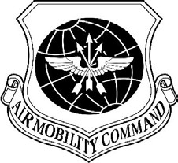

***CONCEPT OF EMPLOYMENT***

***XX February 2021***

***Command Policy***

***MOBILE COLLABORATION SOFTWARE***

***FOR AIRCREW AND C2***

**ACCESSIBILITY**: This publication is available digitally on the HQ AMC Director of Staff SharePoint site: <https://eim2.amc.af.mil/org/amcds/SitePages/Director%20Of%20Staff%20Landing%20Page.aspx> and on the Aircrew Pubs Share Point site. If you lack access, contact the Office of Primary Responsibility (OPR) below.

**RELEASABILITY:** There are no releasability restrictions on this publication.

OPR: AMC/A3-10

Lt Col Richard Aguirre

Certified by: HQ AMC/A3-10

Maj Gen Jackson

Pages: 17

This Concept of Employment (CONEMP) implements the use of Mobile Collaboration Software for use by Aircrew and C2 agencies across the global mobility enterprise in support of the Digital Aircrew Initiative and applies to all Air Mobility Command (AMC), Air National Guard (ANG), Air Force Reserve Command (AFRC), Pacific Air Forces (PACAF), United States Air Forces in Europe (USAFE) Mobility Air Forces (MAF) units. It establishes a baseline concept of employment for text-messaging and file-sharing collaboration software on mobile devices across the MAF flying squadron and C2 enterprise to enhance interconnectivity and accelerate information.

The Privacy Act of 1974 affects this publication. Privacy Act System Number FO11 AF XO A, Aviation Resource Management Systems (ARMS) covers required information. The Paperwork Reduction Act of 1974 as amended in 1996 affects this publication. Ensure that all records created as a result of processes prescribed in this publication are maintained IAW Air Force Policy Directive (AFPD) 33-3, *Information Management* and Air Force Manual (AFMAN) 33-363, *Management of Records* and disposed of IAW the Air Force Records Disposition Schedule (RDS) located at [https://www.my.af.mil/afrims/afrims/afrims/rims.cfm.](https://www.my.af.mil/afrims/afrims/afrims/rims.cfm)

Add URL for guides and videos

# CHAPTER 1 – GENERAL INFORMATION

* 1. Purpose. This CONEMP provides baseline guidance on the employment of mobile collaboration software to enhance aircrew and command and control communication. It includes concept of use, on-boarding guidance, setup instructions and operating guidelines. The basic concept of employment leverages wing-level unit initiative supported by AFWERX along with HQ AMC staff oversight. It provides general guidance and structure to aid unit adoption and to encourage standardization for interoperability across the MAF enterprise. It also provides best practices based upon lessons-learned by test wings. This guidance is not intended to preclude adaptation by specific wings, units, or activities as necessary but should be followed to promote ease and reliability of use.
  2. **Roles and Responsibilities.** The following organizations support this effort, within the scope of their existing functional responsibilities, to accomplish the following:
     1. **AMC/A3.** Serves as overall program OPR and provides MAJCOM guidance for the operational aspects and requirements of the Digital Aircrew Initiative. Designates a MAJCOM action officer.
     2. **AMC/A3VR.** Coordinates employment with 618 AOC, AMC wings, MAJCOMs, and outside agencies such as AFWERX.
        1. Monitors and synchronizes unit-level implementation and use.
        2. Ensures collection and dissemination of best practices and lessons-learned.
        3. Coordinates and reports on staff support.
        4. Maintains a repository of information on the Aircrew Publications website.
        5. Provides requirements and functional expertise on behalf of the MAF flying units. Issues Flight Crew Information Files (FCIF) when necessary to clarify existing mission policy affected by this initiative. Plans and initiates permanent aircrew policy as required.
     3. **AMC/A38C.** Serve as the OPR for 1C3 functional manager and C2 operational issues related to use of this software and will coordinate as required with the MAJCOM OPR, Wing and AMCCs.
     4. **AMC/A3TF.** Coordinates policies and procedures, IAW applicable MAJCOM, Air Force, and DoD policy to support related 1C0 processes at the wing and AMCC level.
     5. **AMC/A5/8.** Serves as the primary Major Command (MAJCOM) liaison to system program offices (SPO). AMC/A5R provides guidance for programmatic actions under appropriate authorities.
     6. **AMC/A6:** Advises the OPR on all communications and information technology aspects of the use of the software on the Air Force network including, but not limited to, policy, security, and information assurance. Serves as the primary MAJCOM liaison to agencies outside of HQ AMC on issues affecting use of the software tools, such as ACC/CCC, AFSPC/A6 and DISA.
     7. **618 AOC**: Provides AOC policy, training, and leadership direction to:
        1. Support use of Mattermost software as the alternative crew paper delivery method when aircrew are unable to utilize primary methods.
        2. Prepare to expand use of mobile collaboration capabilities as software development allows. Implement 618 AOC policy and procedures for efficient C2 communication using Mattermost as determined by 618 AOC. Coordinate policy with the MAJCOM OPR.
        3. Provide the MAJCOM OPR with feedback on operational assessments and development of innovative solutions using the software.
     8. **Wing Commanders.**  Provide wing-level advocacy and support as follows:
        1. Designate Wing personnel as primary Points of Contact to the MAJCOM OPR.
        2. Direct subordinate units to support the initiative as specified in this CONEMP.
        3. Plan for software employment sustainment costs in annual wing budgetary processes, as necessary.
     9. Flying Squadron Commanders. Designate primary and alternate Squadron Mattermost POCs to the Wing OPR. The squadron POCs should be assigned Team Administrative rights.
        1. Ensure assigned aircrew download the software, create a user account, and reference training information on Mattermost. At a minimum, Aircraft Commanders should have access.
        2. Direct assigned aircrew to use Mattermost as the sole mobile collaboration software for official mission-related information instead of non-protected sources (e.g., commercial email, text messaging, and other file-sharing services unapproved for mission related Controlled Unclassified Information).
     10. Communications Squadron Commanders. Within the scope of existing responsibilities, provide communications, information assurance, and information technology support as follows:
     11. The AFWERX and PlatformONE development teams provide primary support for Mattermost. Requests for assistance with user account creation, onboarding, and technical support should be directed to the PlatformOne help desk.
     12. As required, coordinate wing-level policies and procedures, IAW applicable MAJCOM, Air Force, and DoD policy to facilitate use of the software on wing-level Air Force networks. The web-based software is accessible on the AF network IAW its continuous Authorization To Operate (ATO) granted 9 March 2020, and requires no additional direct support at base level.
     13. Continue to support procurement and maintenance of commercial internet access in coordination with 38CYRS and the Wing EFB program manager, IAW AFI 33-115, *Air Force Information Technology (IT) Service Management,* Para 7.8. Commercial internet access is a unit-funded mission-critical requirement.
     14. Wing OPRs. Maintain responsibility for employing the software across units as follows:
         1. Identify, address, and elevate, as necessary, requirements and concerns to wing leadership and the MAJCOM OPR.
         2. Serve as the wing implementation manager, ensuring users are provided access and onboarding directions, rules of engagement, and guidance as needed to efficiently employ this collaboration tool across multiple units and C2 agencies as required based upon the wing mission. Direct questions, requirements and issues regarding mission impact or policy to the MAJCOM OPR. Direct users to the Platform One Help Desk for account creation, onboarding, and help desk support. Initial onboarding guides and process guides are included in Attachment 1, and posted in Mattermost. The wing OPR should be assigned Team Administrative rights.
         3. Inform the MAJCOM OPR of feedback, operational benefits, challenges, and local innovations solutions using the software. The Wing OPR should routinely coordinate with local flying unit and C2 OPRs to facilitate use and address issues or mission impacts.
         4. The Wing OPR should have experience working with digital collaboration tools, and with C2 and Aircrew processes and procedures.  Most issues will be resolved by simply referring users to community assistance within Mattermost, or via Platform One help desk support.

### CHAPTER 2 - IMPLEMENTATION

* 1. **General.**
     1. **Implementation Plan.** The Mattermost software employment is a phased process. Initial adoption during 2Q CY20 was accomplished by test wings at JBMDL and Travis AFB to include procurement of the software, onboarding of personnel, and development of initial concept of employment and operating practices across. The following phases will lead to full adoption across MAF units and within C2 channels.
     2. **Phase 1.** The first phase is adoption by 618 AOC as the alternative method of crew paper delivery at austere locations. MM replaces DoD email, or DoDSAFE, which require .mil networks; and commercial email which does not have approval for use with Controlled Unclassified Information (CUI) at DoD Impact-level 4 (FOUO/Non-critical Mission Related Information),
     3. **Phase 2.** The second phase uses MM as the primary method of aircrew paper delivery (at all locations) in lieu of downloading and printing from GDSS during the mission alert process. This provides earlier access to mission information to increase situational awareness, more time to address potentially mission-impacting issues, and more time for mission review, thereby enhancing safety. Phase 2 delivery is implemented initially by local and enroute wing C2 agencies to distribute workload that would otherwise be concentrated on AOC Flight Managers (FMs). Pending development of an automated software interface with GDSS2 to streamline the process, FMs will eventually use mobile collaboration software to push crew papers on all flight-managed sorties.
     4. **Phase 3.** The third-phase uses MM for all unit-level mission-related text and file-sharing communications when mobile devices are used. As demonstrated during recent quarantine and emergency evacuation scenarios, units should employ DoD Platform One’s Mattermost for all mobile device-based squadron coordination to reduce the number of apps in use, and to speed adoption for mission-related purposes. Pending software updates, this may include AOC C2 comms.
     5. **Phase 4.** The fourth phase includes other mission support agencies such as Air Mobility Squadrons for routine mission status and coordination. This phase depends on determination of programmatic support to expand the number of users, development of specific procedures, and adoption of Mattermost by those supporting agencies and their mission partners as required. Current users (such as AMOWs) are encouraged to continue exploring use of the software for their missions.
     6. **Lead Test Units.** AMC lead units have accomplished implementation through phase 4 and can provide an additional source of knowledge and best practices. Lead test units are:
        1. 305 AMW/87 ABW, Joint Base McGuire-Dix-Lakehurst, NJ (KWRI) (C-17/KC-10, command post.
        2. 60 AMW, Travis AFB, CA (KSUU) (C-17/C-5/KC-10, Command Post.
     7. **Follow-on CONUS MAF Bases.** To promote an orderly transition, ensure effective onboarding and responsive help desk support, the following units are identified for adoption of the software in the order listed below. The planned order is based upon units that have already partially adopted the software, and those operating related weapons systems. Phased implementation dates will be coordinated by the MAJCOM OPR and are subject to changes based on upon results. Wing OPRs should contact the MAJCOM OPR for coordination and timelines.
        1. KDOV, KCHS, KTCM
        2. KPOB, KADW, KBLV
        3. KIAB, KMCF, KSKA, KLTS, KGSB
        4. KDYS, KLRF
     8. **OCONUS Units.** Pending concurrent coordination with owning MAJCOMs:
        1. ETAR, ETAD, EGUN, LICZ, LTAG, OTBH, OKAS, OKBK, OMAM, OAIX.
        2. PAED, PAEI, PHNL, RJTY, RODN, PGUA
        3. USAF/EC School Houses at Scott AFB and Hurlburt, pending courseware adoption.
  2. **Funding.** Initial funding has been provided by DoD Platform One, by agreement with AMC/CC, resulting in a zero cost to MAF units through April 2021. Pending other arrangements which may extend that time, or until a formal program of record established and funded, sustainment cost responsibility will be determined by the MAJCOMs. Potential costs were quoted on a fee-for-service basis at $43.75 per user-year for up to 25,000 licenses and help desk support. Participating MAJCOMS will be provided timely notification if the program becomes fee-for-service and may opt-out at that time (if desired).
  3. **Onboarding**. Users visit the PlatformOne website at <https://chat.il4.dso.mil/login> from a computer with a CAC reader, and follow the account registration instructions provided in **Attachment 1.** If mobile device setup is desired, follow the instructions for setting up Multi-Factor Authentication using your mobile device. For desktop-only users those steps can be skipped. Note: Multi-Factor Authentication requires users download the Google Authenticator app to provide a remote access code through GitLab.
     1. Follow this username convention when setting up the PlatformOne account to avoid complications when changing base assignments (also provided in Attachment 1).
        1. **Username**: your exact email, but without the “us.af.mil”
        2. **Email:** your complete .mil email
        3. **First Name**: your “First Name”. This will form part of the Displayed Name.
        4. **Last name**: your “Last Name (Unit)” or “Last Name (Unit/Office Symbol)”. This will form the rest of the Displayed Name. This convention allows the user to change their displayed unit information without help desk intervention and possible account problems.
        5. **Affiliation and Rank**: Select as appropriate from drop-down menu. This will not display within Mattermost.
        6. **Unit, Organization or Company Name:** Type as appropriate or use “US Air Force”. This will not display within Mattermost.
     2. Once your account has been created, your Mattermost Display Name setup should be continued using the Account Settings menu IAW the following conventions.
        1. **Full Name and Username**: cannot be changed in this menu
        2. **Nickname:** leave blank
        3. **Position:** your “Rank, Job Title or Role”, this will display when clicked (34 characters).
     3. User should notify their unit POC Team Admin who will add them to their unit’s Team. This will provide access to the Team’s “Town Hall” starting page were additional guidance is posted.

### CHAPTER 3 - OPERATIONS AND EMPLOYMENT

* 1. **Impact Levels.** Impact levels (IL) are standards developed by the Defense Information Security Agency (DISA) for categorizing information and information systems. The DoD Cloud Computing Security Requirements Guide (SRG) defines the baseline security requirements for cloud service providers (CSPs) that host DoD information, systems, and applications for DoD use. It replaces the DoD Cloud Security Model, and maps to the DoD Risk Management Framework and NIST 800-37/53.
     1. **IL2** is public information.
     2. **IL4** is personally identifiable information (PII), personal health information (PHI), controlled unclassified information (CUI), Health Insurance Portability Assurance Act (HIPAA) information.
     3. **IL5** is national security information (Ex. source code for a weapons system or anything touching national security).
     4. **IL6** is information classified Secret.
  2. **Information Protection.** 
     1. This instance of Platform One’s Mattermost for DoD is approved for IL4. Mattermost allows For Official Use Only (FOUO) PII/CUI/HIPAA in Private Teams, or in Private Channels and Direct Messages (DMs) within Public Teams.
     2. **Nuclear Alert and Operations.** The available IL4 CUI version of Mattermost is not compatible with Prime Nuclear Alert Force (PNAF) operations or any KC-135 aircraft supporting OPLAN 8010 (IL-5 or IL-6 CUI). This restriction includes training, local exercises, command-directed exercises, assessments, inspection, and real-world execution.
     3. Information Security Incidents.In the event of an information or communications security incident involving Mattermost such as classified spillage or malicious logic:
        1. Using individuals contact their base Security Manager and Cybersecurity Office. Place the device in question in a secure container until the Security Manager and/or Cybersecurity Office can take possession. Follow standard practices for security incidents.
     4. All AMC-approved EFB devices are approved for use with Mattermost. EFBs and Exclusive Use Stand-Alone (EUSA) systems must be configured and secured IAW the existing AF EFB ATO.
     5. Personal devices and USG-provided mobile devices are also approved for use with Mattermost through use of the Single Sign-On provision for multi-factor authentication of users.
     6. Only government-issued devices, such as EFBs or government-issued cell phones may be used to *store* DoD information and for flight operations IAW AFMAN 33-282, *Computer Security (COMPUSEC)*. Non-critical mission-related information may be referenced through the Mattermost web-based interface but will not be transferred or stored onto personally-owned (IL-2) devices. This includes information conveyed via aircrew mission papers.
  3. **General Operating Guidance**. As with any communication involving official government resources, users are expected to conform to Air Force professional standards. Mattermost software may be utilized to support the following digital processes (this list is not all-inclusive):
     1. Routine squadron member coordination
     2. Unit recalls, emergency notifications and messaging.
     3. Flight scheduling coordination
     4. Training schedule coordination, cancellations, changes and notices
     5. Digital transfer of Planning, Pre-/post-mission Crew Paperwork
     6. Digital transfer of mission Crew Papers (CP)
     7. C2 communications (Note: text messaging is not the official method of Aircrew Alerting).
     8. Passing information during crew rest.
        1. AFI11-202V3, *General Flight Rules*, 10 June 2020, para 3.1 specifies crew rest does not begin until the completion of aircrew duties and will impact mission timelines if interrupted except, PICs may initiate mission-related communication with official agencies without interrupting crew rest
        2. In accordance with this provision, passively providing information to aircrew via text or file sharing does not constitute an interruption of crew rest. This may include crew paper delivery, confirmation of pending coordination actions, maintenance status updates, waiver status, expected delays, changes to follow-on mission requirements, severe weather hazards, or other time-critical information that improves aircrew situational awareness without requiring immediate interaction with, or response from the aircrew member.
        3. Unless initiated by the PIC, communications requiring a two-way exchange between C2 agencies and Aircrew are an interruption of crew rest. Aircrew are expected to turn-off audible text-messaging alerts during rest periods to preclude inadvertent disruption of sleep.
        4. This interpretation is intended to help preserve rest cycles by eliminating the need for crews to wait for simple confirmation of post-mission coordination actions to conclude official business before entering crew rest. It protects crew rest by providing earlier assurance that pending issues are resolved which might otherwise create a distraction from effective rest.
        5. Official Alert Notification is only accomplished via direct phone call to the PIC, unless self-alerting IAW approved guidance.
  4. **Basic Setup.** Mattermost ‘chat rooms’ are organized into “Teams” and “Channels”, which can be made Public or Private. All access is protected by requiring CAC authentication for initial sign-on and multi-factor authentication (MFA) for use on mobile devices. In addition, access to Private Teams or Channels requires an invitation from an administrator. Based on experience of established users, the following basic setup is recommended.
     1. **Base level.** Bases should create a Private Team for their location, and then add Public Channels within it for sub-organizations. This should include a single Command Post or AMCC Channel for use in communicating with crews or support units. Individual users are added to the base Team by the administrator (Wing or unit OPR) and can then select and access the appropriate public channels. This protects access while minimizing actions needed to onboard members. Example for JBMDL: the base team is “USAF-305AMW”, and the command post channel is “Command Post”. At base level, command post support consists of posting the daily local flying schedule information to the Command Post Team. For AOC flight-managed missions originating from or transiting the base, as part of the Crew Alert sequence, local command post or AMCC controllers post crew papers from GDSS to the specific mission channels in the AOC Team,
     2. **AOC level**. 618 AOC Tanker Airlift Control Center has a Private Team called “USAF-618AOC-MOD”. Within this Team, individual Public Channels are added for each flight-managed mission using the convention “RCHxxx – Tail # – ADNxxxxxx123”. Crew papers are posted to the appropriate channel for each mission. The mission channel is based upon the originating sortie’s Julian day sortie number (mission day 1).
     3. **Notifications and Tags.** User profiles can be set to recognize Tags such as “@username” that trigger pop-up notifications across any Team, Channel, or Direct Message the user has joined. Users can create any number of custom notifications which will act the same way as “@username” (i.e. @fm, @ddo, @scheduling, @execs, @ado). Note: C2 nodes should use the standard “@icaocp” or “@icaoamcc” tag format (where icao represents the base’s 4-letter identifier). Use these instead of individual controllers’ username tags to create alerts that will be seen across shift changes. Use of this standardized convention will enable enroute aircrew to easily reach controllers at any location. The tag format for aircraft commanders should be “@username” or as listed in GDSS2. For TFI locations with multiple command posts, consider differentiating with a format such as @icaocpang” or “@icaocpafrc”.
     4. **Workflow**. Currently, at test wings, originating mission Channels are primarily created by unit schedulers or wing command posts to distribute the additional AOC flight manager workload. Flying units using PlatformOne’s Puckboard scheduling software can use its automated channel creation feature. If those channels were not already created by the unit or enroute C2 node, AOC Flight Managers can create channels for posting crew papers to crews at austere locations. Automated Mattermost-GDSS interface features in development should eventually allow Flight Managers to post crew papers to 100% of AOC flight-managed sorties.
  5. **Command Post and Air Mobility Control Center Procedures.** A Controller Basic Checklist (CBC) should be used to integrate Mattermost into existing mission support processes. An example of the JBMDL Mattermost Crew Support CBC is located in **Appendix 2**. Local command posts may need to adapt for their specific mission requirements, manning levels, etc. Recommended procedures based on trial use by AMC test wings are detailed below (also in sample checklist in Appendix 2).
     1. **Local Sorties.** NLT Crew Alert time, controllers post the morning and evening flying period flight information in the command post Channel. Format as an Excel table with: Callsign, Tail Number, Parking Spot, Mx Status, Configuration, Fuel Onboard, and Final Fuel Request.
        1. If crew papers exist in GDSS, command post controllers download and post them to the Public Command Post Channel for aircrew review.
        2. Tag the aircraft commanders for each local sortie following the post using, “@username” to provide a notification. Aircrew should use the “@icaocp” or “@icaoamcc” tag to notify controllers when posting messages to coordinate maintenance, final fuel loads, receiver/tanker status updates, and airspace re-coordination.
        3. Monitor the channel. After aircrew alert, controller and aircrew must monitor the channel to stay aware of updates. This requires keeping Mattermost open in a browser window and staying alert to pop-up notifications. Unread messages change the channel name to white font. Development work is in progress to provide persistent desktop notifications that will remain on the screen until acknowledged. Mobile users must set device notification options.
     2. **Operational Missions Originating at Home Station**. Operational Mission Channels are created either by the flying unit scheduler, the command post controllers, or by request (for austere locations only) by AOC Flight Managers. Command Post controllers access the USAF-618AOC-MOD Team and search for the mission channel by callsign. If not already created, the controller or unit (IAW wing policy) creates the channel using the naming convention “CALLSIGN–TAIL#–MISSION#” (example: RCH123–12345–ABCD1234C269).
        1. At positive alert time, the controller adds the flight information to the mission channel formatted as an Excel table including: Callsign, Tail Number, Parking Spot, Mx Status, Configuration, Fuel Onboard, and Final Fuel Request.
        2. Tag the aircraft commanders for each local sortie following the post using their username in the format “@username” to provide a notification. Aircrew use the command post tag in the format “@icaocp” or “@icaoamcc” (Ex., “@kwricp”) to notify controllers when posting messages to coordinate maintenance, final fuel loads, receiver/tanker status updates, and airspace re-coordination, etc.
        3. Monitor the channel. After aircrew alert, controller and aircrew must monitor the channel to stay aware of updates. This requires keeping Mattermost open in a browser window and staying alert to pop-up notifications. Unread messages change the channel name to white font. Development work is in progress to provide persistent desktop notifications that will remain on the screen until acknowledged. Mobile users must set device notification options.
     3. **Transient Operational Missions.** Local controllers follow the same procedures as for missions originating from home station except, the channel should already exist. For new missions originating enroute, controllers may have to build a new channel.
        1. For crew assigned a connected mission number in GDSS, the originating unit should have created the connected channel. Use this channel or create it using the connected mission number in GDSS and notify the crew in the original channel of the change.
        2. For new missions originating enroute and assigned to a crew away from home station, controllers may have to build a new channel. Alternatively, aircrew can also create a channel.
     4. **Mission Closure.** The command post controller at the terminating location changes the mission name to the format “COMPLETE-CALLSIGN–TAIL#– MISSION#”. The mission may then be archived. Prior to archive, controllers can “leave” the channel to clear it from their screen. Units and/or AOC should establish a process for mission review and archive as required.
     5. **Flying Unit Procedures.** For units adopting MM, at a minimum, all aircraft commanders and unit schedulers should create PlatformOne accounts using the onboarding instructions in Attachment 1. Unit-developed guides, videos and assistance are posted within Mattermost for mission scheduling, channel creation, crew assignment, and use of Mattermost for digital pre- and post-mission paperwork.
     6. **Training Resources.** Unit-developed training on Mattermost Teams and Channels are posted as Rules of Engament (RoE) within the “Town Hall” and “RoE” channels for each Team. All users are encouraged to post training resources in Mattermost to facilitate dissemination, collaboration, and updating.
        1. Account creation via CAC registration and Single Sign-On setup for use with mobile devices are explained in **Attachment** 1.
        2. Briefing slides for Initial Mattermost Training, Notification Settings, and RoE for posting new messages and replies, using tags, attaching files, and linking to other posts is available in the EFB folder on the Aircrew Pubs Sharepoint at the following link: [https://cs2.eis.af.mil/sites/12679/Aircrew%20Pubs%20Library/Forms/Better.aspx?RootFolder=%2Fsites%2F12679%2FAircrew%20Pubs%20Library%2FMaster%5FLibrary%5FVerified%2FAll%5FGlobal%2FEFB&FolderCTID=0x01200021370D19BF5D9F459D8FD907C237955A&View={701BF038-D3D9-416D-BBEC-BF178FBE44E9}](https://cs2.eis.af.mil/sites/12679/Aircrew%20Pubs%20Library/Forms/Better.aspx?RootFolder=%2Fsites%2F12679%2FAircrew%20Pubs%20Library%2FMaster%5FLibrary%5FVerified%2FAll%5FGlobal%2FEFB&FolderCTID=0x01200021370D19BF5D9F459D8FD907C237955A&View=%7b701BF038-D3D9-416D-BBEC-BF178FBE44E9%7d)
        3. Sample checklists for Command Post and AMCC controllers are at **Attachment 2**.

JOEL D. JACKSON, Major General, USAF

Director, AMC/A3-10

### Attachment 1

**P1 MATTERMOST SETUP**

**A1.1. PlatformOne Account Registration with CAC.**

1. **Get started on a Desktop computer. You’ll need Internet Access, a CAC Card/Reader, and access to your .mil email account. Open Chrome, Edge, or Firefox (not Internet Explorer)**
2. 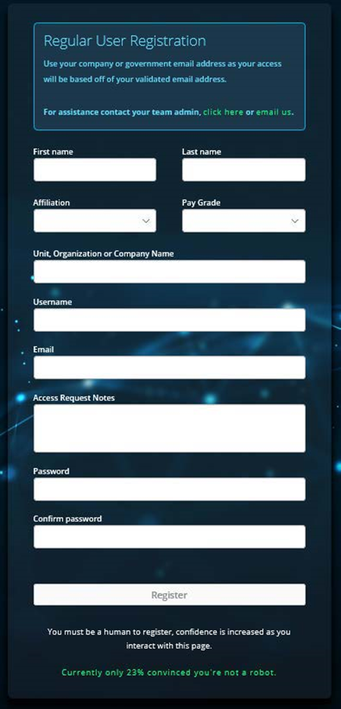**ENTER REGISTRATION LINK:** [**https://login.dso.mil/register**](https://login.dso.mil/register)
3. **Fill out your profile with your Info as follows to avoid problems with your Displayed Name when changing units.**

**First Name** - your actual first name

**Last Name –** your **“**Last Name (Unit)” or “Last Name (Unit/Office Symbol) i.e. Jones (45AS/DOP)

**Affiliation and Pay Grade**: Select as appropriate from drop-down menu. This will not be part of your displayed name within Mattermost.

**Unit, Organization or Company Name:** Type as appropriate or use US Air Force. This will not be part of displayed name within Mattermost.

**- Username**: use the **front part of the .mil Email** as your username **(Ex.** [**John.Doe.23@us.af.mil**](mailto:John.Doe.23@us.af.mil) **use John.Doe.23**

**- Access Request Notes: (Leave Blank)**

**- Password – IF SETTING UP DESKTOP ONLY, LEAVE BLANK AND SKIP TO STEP 4.**

**(12 characters minimum 2 special characters, 1 uppercase, 1 number)**

1. **Click Register.**

**NOTE: At the bottom, a security feature in green makes you move the mouse around before you can click register.**

1. 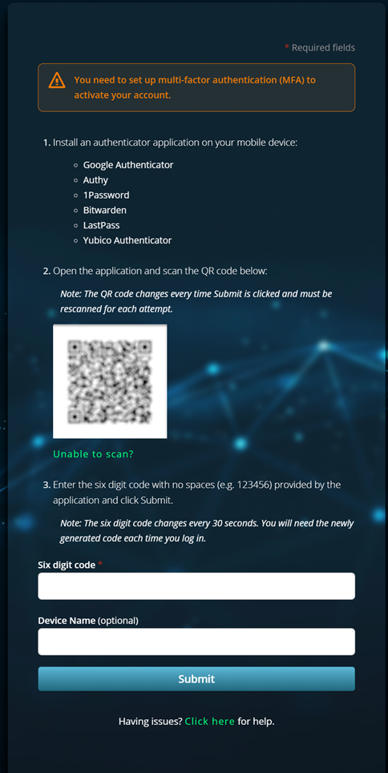**Setting up Multi-Factor Authentication (MFA) for mobile devices. IF SETTING UP DESKTOP ONLY, SKIP TO STEP 10.**

* The next screen will ask you to install an authenticator app on your mobile device
* Recommended app: Google Authenticator

🡪**SCAN QR CODE TO DOWNLOAD ON MOBILE PHONE (or visit app store)**

**IOS ANDROID**

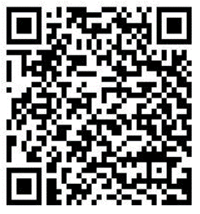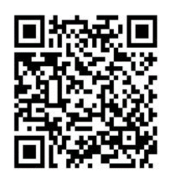

1. **Open the MFA app click “Get Started” at the bottom of screen followed by “Scan QR Code”**
2. **Using the camera view from the MFA App, Scan the QR Code on the MFA Setup Page with your mobile device.**
3. **Scanning the QR code will create a six digit code in the MFA app.**
4. **Type in the Six Digit Code with no spaces**

(e.g. 123456) from the app into the “Six Digit Code” field on the MFA Setup Page.

* This six digit code changes every 30 seconds.
* The Device Name field is optional and can be anything you desire.

**\*\*NOTE: DO NOT DELETE THE MFA APP on your mobile device as you will need a new Six Digit Code each time you log in without a CAC**

1. **Email Verification. Check your .mil inbox.** 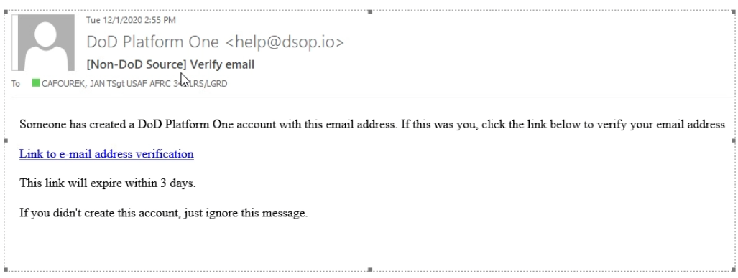

* 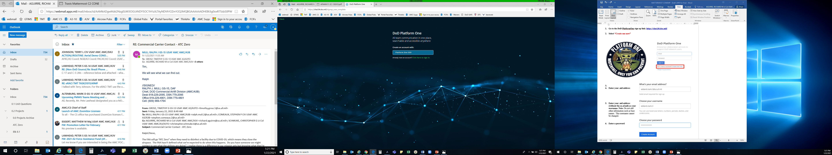The email will be from “DoD Platform One”
* It may take up to 10-15 minutes to receive the email
* The email link expires after 3 days

1. **After confirming email, verify your profile information**

* Go to: login.dso.mil, click Platform One SSO button
* Fill out missing information in Account Tab (see para 2.3.2)

1. **To join Your Team; use one of these options**

* **Option 1.** Contact your Team admin, who will provide you with a Team Invite Link. Copy and paste that link into a browser. This will automatically add you to your organization’s Team Chat.
* **Option 2. Copy and Paste Link below**

If your team admin has made your team visible, you may search for the team name here: (<https://chat.il4.dso.mil/welcome/pl/aqwxa7baztdnpq1smzbxwa9tec>)

Next, in the “write” box at the bottom type command: /requestaccess team (Insert Team Team)

* + Example: **/requestaccess team USAF-618AOC-MOD**
  + (Note: USAF-618AOC-MOD is the team used for alternate crew paper delivery and for C2 personnel to access an existing mission channel)
  + A Team Admin will get the request and approve your access to the team.
* **Once added, you should automatically be joined into the selected Team’s starting Channel, called the “Town Hall” (or “RoE” for the 618 AOC team) as a starting point.**

- Here you will have access to more guides and instructions. You can also post messages requesting access to other specific Channels within the Team. If you do not see your organization’s Team, contact your local MM Team Admin.

***NOTE: Do NOT omit any required telephone alert calls or radio calls, even if using MatterMost***

______ 1. Verify correct checklist. Calendar Date/Time: _______________________Z

______ 2. Obtain the flying schedule for the next day from MOC.

______ A. Locate **305/514 AMW local training** (ex: TEAM, BEEF callsign) mission. → **Go to Step 3**

______ B. Locate **305/514 AMW operational** (ex: RCH callsign/TACC) mission → **Go to Step 4**

______ C. Locate each flying mission from all other units → **Go to Step 5**

______ 3. (0900Z/1800Z) For all **305/514 AMW local training** missions:

______ A. Open GDSS Mission Dashboard, customize your columns, and copy & paste one flight at a time into Microsoft Excel



Also save Crew Papers as a PDF (right click and select Publish Package if needed)

______ B. Open Microsoft Excel, select blank workbook

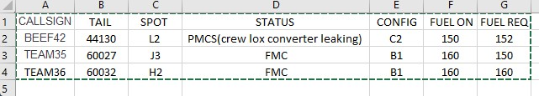

______ C. Open Mattermost

______ (1). Go to 305 AMW Team / Command Post Channel (Local Flights Only)

______ (2). Type [date] [morning/evening] [locals] (ex: 23 OCT EVENING LOCALS), press ENTER

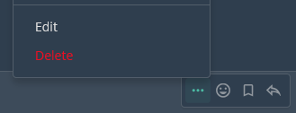______ (3). Copy & paste the table from Microsoft Excel for local missions, press ENTER

(click “…” and “edit” if the chart does not paste correctly, or the spot check changes)

______ (4). Click  and attach ew papers, press ENTER

______ (5). Tag the acft commander by typing “@[lastname][squadron]”, press ENTER

***NOTE: If you can not find an AC in MM, type “ACs not found in MM” @john.cockburn***

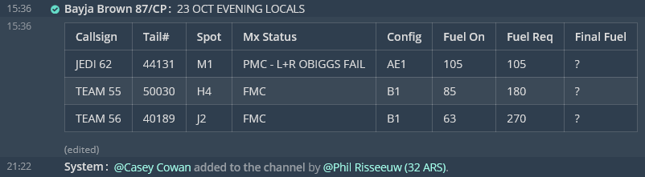

______ (6). Monitor channel for follow on remarks from aircrew (ex: final fuel)

______ 4. For all **305/514 AMW operational** missions

______ A. Note scheduled Legal For Alert time: Z & Acft Commander

______ (1). Download published crew papers and save as [CALLSIGN] [Depart ICAO]- [Arrive ICAO]” (ex: RCH123 KWRI-ETAR)

______ B. Open MatterMost

______ (1). Go to  618 AOC-MOD Team

______ (2). Check to see if a channel has already been created. 618 AOC manages some missions from start to finish. 87 CP will manage all missions starting out of KWRI

______ (3). Create public channel by clicking (+) on 

______­ (4). Name channel [CALLSIGN] - [TAIL#] - [MISSION#] – CP SPT ONLY

(ex: RCH147 - 70028 - PJZF5141C269)

Tag @first.last; @first.last (continue list of controllers & AC)

______ (5). Type “KWRI CP is only providing support on MatterMost for KWRI departure leg only. Enroute support via MM may be provided by local CP or AMCC (location dependent). 618 AOC will support MM for crew paper delivery at austere locations.” press ENTER

______ (6). Fill in Callsign:_ Tail#:_Spot:_Status:_Config:_Fuel on board:_Req Fuel:_

Click  and attach crew papers. Then tag the AC by typing “@[lastname]”

Press ENTER at **LFA time**

Example: CALLSIGN: RCH286 TAIL#: 44134 SPOT: L2 STATUS: PMCB (RIGHT OBIGGS FAIL) CONFIG: C3 FUEL ON BOARD: 28 REQ FUEL: 140 RCH286 KWRI-EGUN.pdf @Noah Clark @David Yi

***NOTE: If you can not find an acft cmdr in MatterMost. Type “ACs not found in MM” @john.cockburn***

______ (7). Monitor channel for follow on remarks from aircrew (ex: final fuel)

______ 5. For Transient or other mission in GDSS.

______ A. Note scheduled Legal For Alert time: _______Z & Acft Commander ________________

______ (1). If crew papers are requested by aircrew, you can offer two methods:

______ a. Print: Crews must come to the 87 ABW/CP vestibule, utilizing COVID19 precautionary measures (social distancing and face coverings)

______ b. Email: Can only be sent to their us.af.mil addresses and must be encrypted CUI