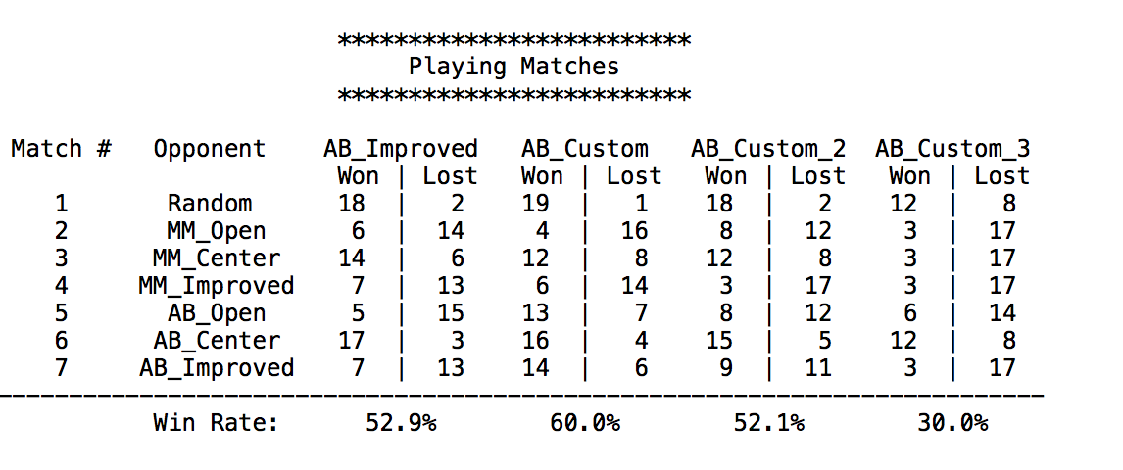

The rate of matches among different heuristic agents are shown above. As we can see, the custom_score is relatively higher. While custom_score_3 is giving very low performance.

**custom_score:**

I used (own_moves – 2 * opp_moves) to estimate the board score. This means I would put more weight on preventing my opponent from winning. If my opponent has less spaces to move to, I would have more chance to win.

**custom_score_2:**

I used (2 * own_moves – 3 * opp_moves) to estimate the board score. In which I just tried different weights for my own moves and opponent moves.

**custom_score_3:**

I used the (distance from current position to center - opp_moves). The more distance from current position to center, the more space to explore, while there should be less opportunities for the opponent to win. But this turns out to have a very low score among all the strategies. I think it’s because the distance from current position to center cannot really represents the chance of more spaces for myself.