- create the sub theme using drush
drush omega-subtheme cephas –starterkit=starterkit_omega_xhtml

- Quickly disable overlay before adjusting our theme settings and enable the admin_menu for easy navigation
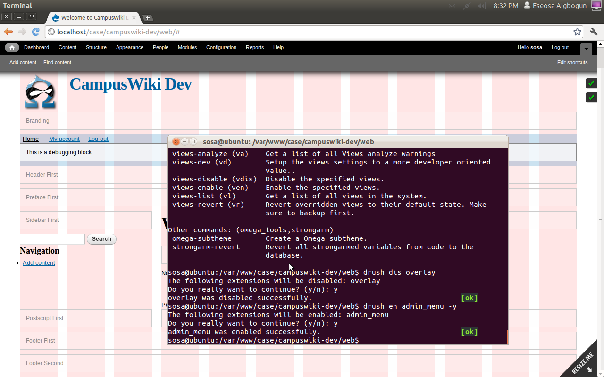
media query
narrow: all and (min-width: 740px) and (min-device-width: 740px), (max-device-width: 800px) and (min-width: 740px) and (orientation:landscape)

normal layout: all and (min-width: 980px) and (min-device-width: 980px), all and (max-device-width: 1024px) and (min-width: 1024px) and (orientation:landscape)

wide: all and (min-width: 1220px)

set up the theme and commit

Department:
create faculty taxonomy
create a department taxonomy
add faculty as a required field to the department taxonomy tearm
add image field to faculty and department terms
add department field as a required field the user registration form
configure pathauto for department and faculty. Url = faculty/[term:name]

Create Group Content type:
name → Group
Description → A group can be public or private
Title field → Group name
preview before submitting → disabled
publishing options → publish
display settings → !display authour information
comment settings → hidden
menu settings → none
group → group type, not group content type

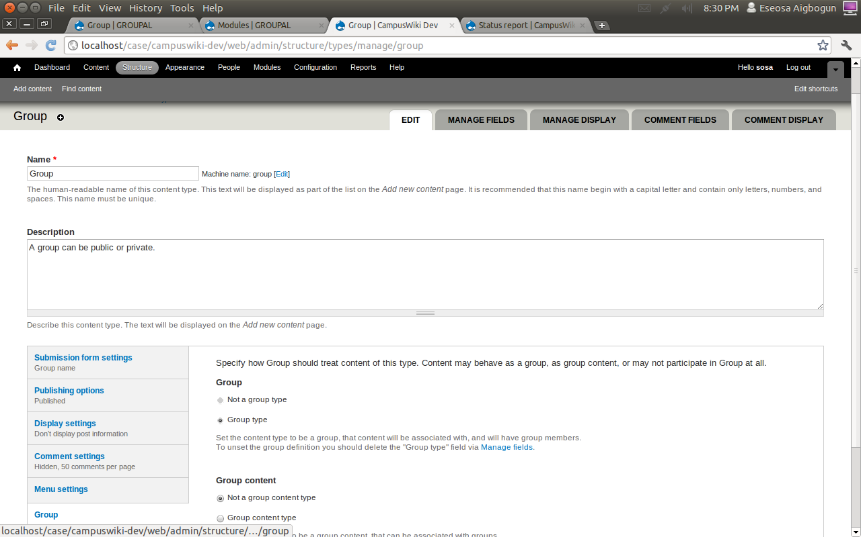

Manage Fields
first enable the og access module, not the og field access module, then go to configuration then og group first settings. Chose the group bundle. Then under fields chose the group visibility field. Then click add field

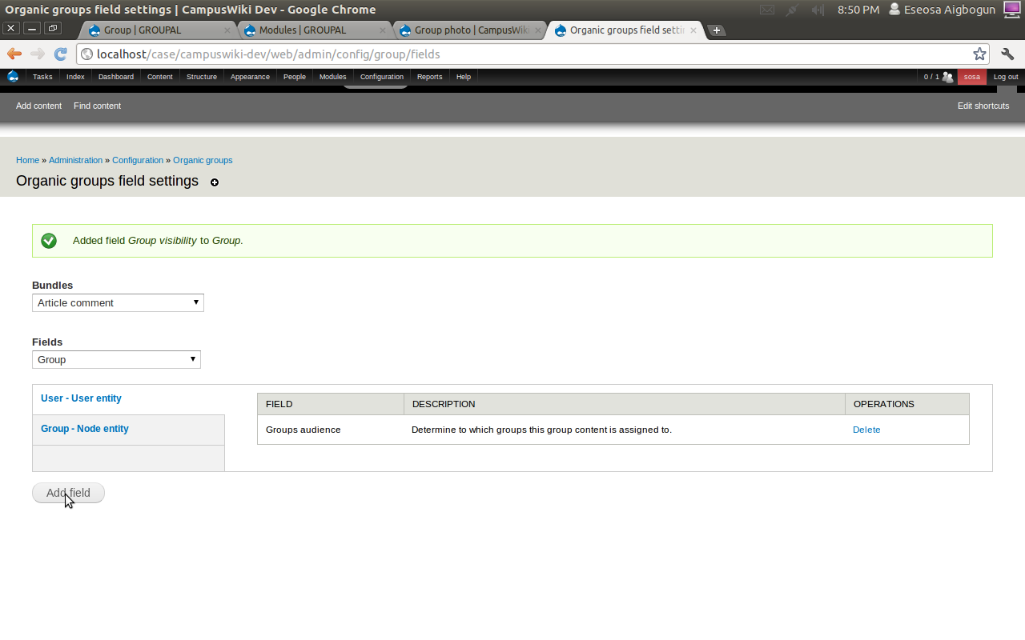

Manage fields

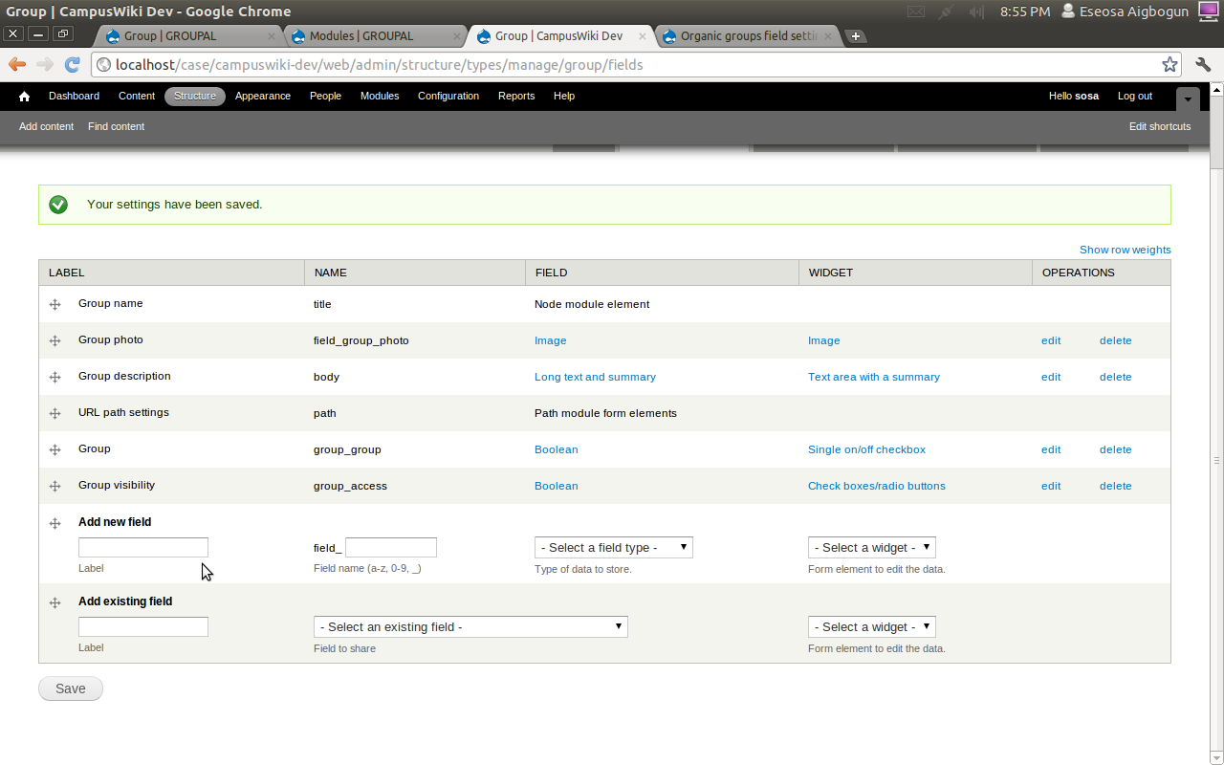

Create the wiki content type
enable the diff and talk modules
Edit the article content type to use for wiki
Name → Wiki page
Machine-readable name → wiki
Description → A page that any authenticated user may edit and view changes
submission form settings → left unedited
Publishing options → not published (we would use vbo workflow config for publishing), create new revision
display settings → don't display post information
menu settings → none
comment settings → talk pages: display comments on a separate page
diff → show view changes button on node edit form, enable the revisions page for this content type
group → not a group type, group content type

configure access permission anon authenticated admin manager
wiki page: create new content checked checked checked
Edit own content checked checked checked
edit any content checked checked checked
delete own content
delete any content checked checked

wiki input format
enable freelinking and markdown modules

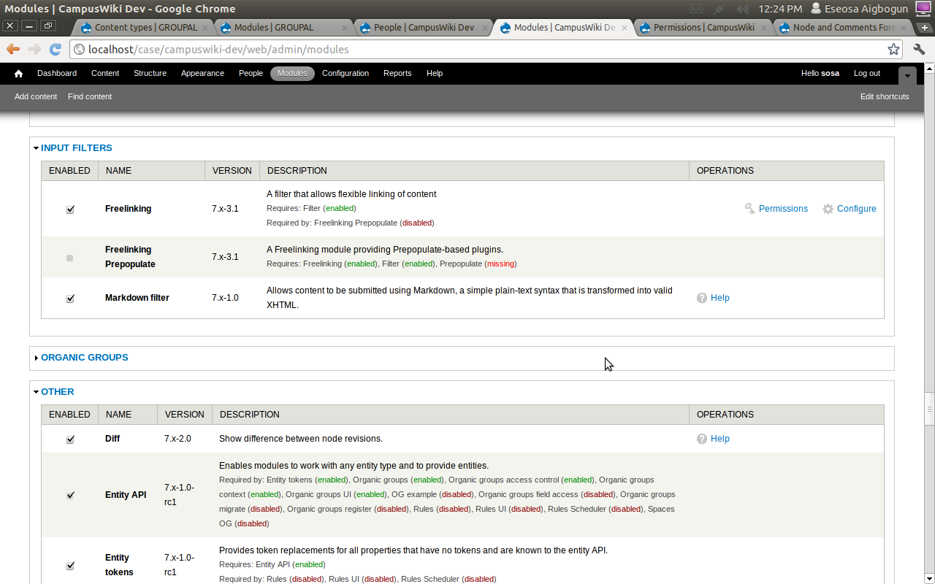

click of configure to configure the freelinking module

Creating wiki text format
goto cofiguration → content authoring → text format

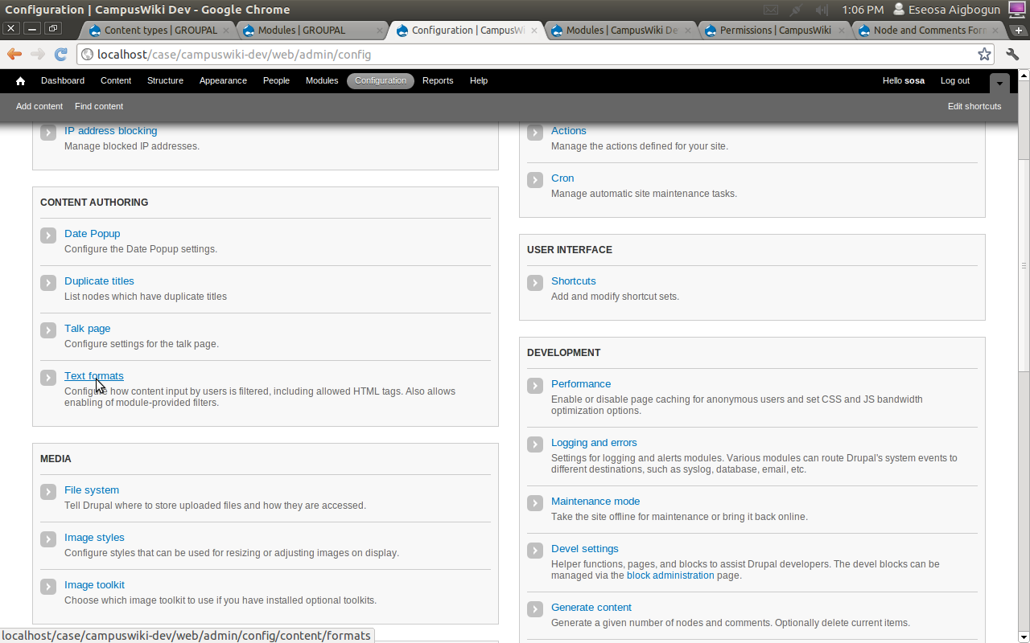

admin/config/content/formats

click “add text format”

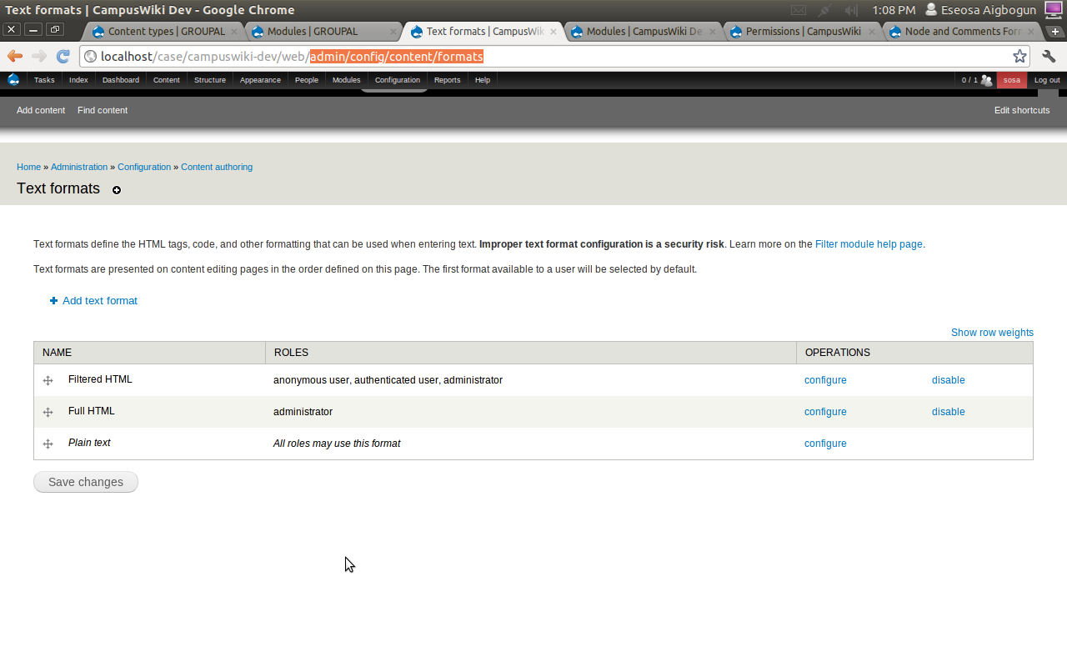
set the name to Wiki
Check the following filters: Limite allowed HTML tags, Markdown, Convert line breaks into HTML, Freelinking, Convert URLs into links, Correct faulty and chopped off HTML.

Filter processing order: take Freelinking and Markdown to the top

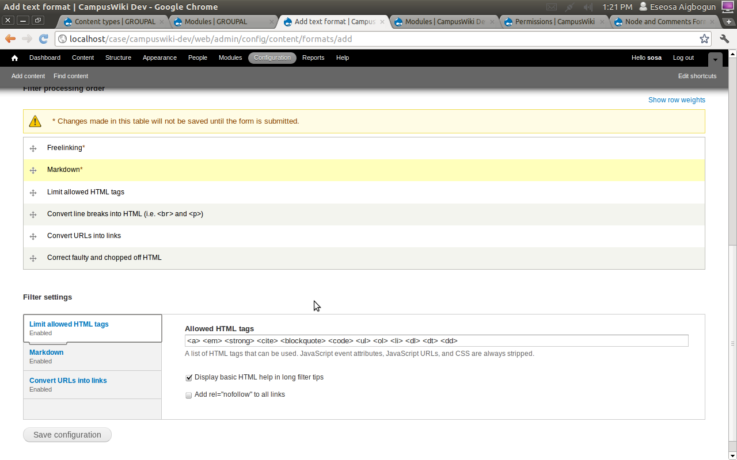

roles → manager, authenticated and administrator

click save configuration

Pathauto configuration
goto configuration → search and metadate → url aliases

User feature
Create some new users and add the a full name file to the user registration page
configure → people → account settings → manage field
add About me and My interest text area
configuration the display i.e. manage display to rearrange the fields

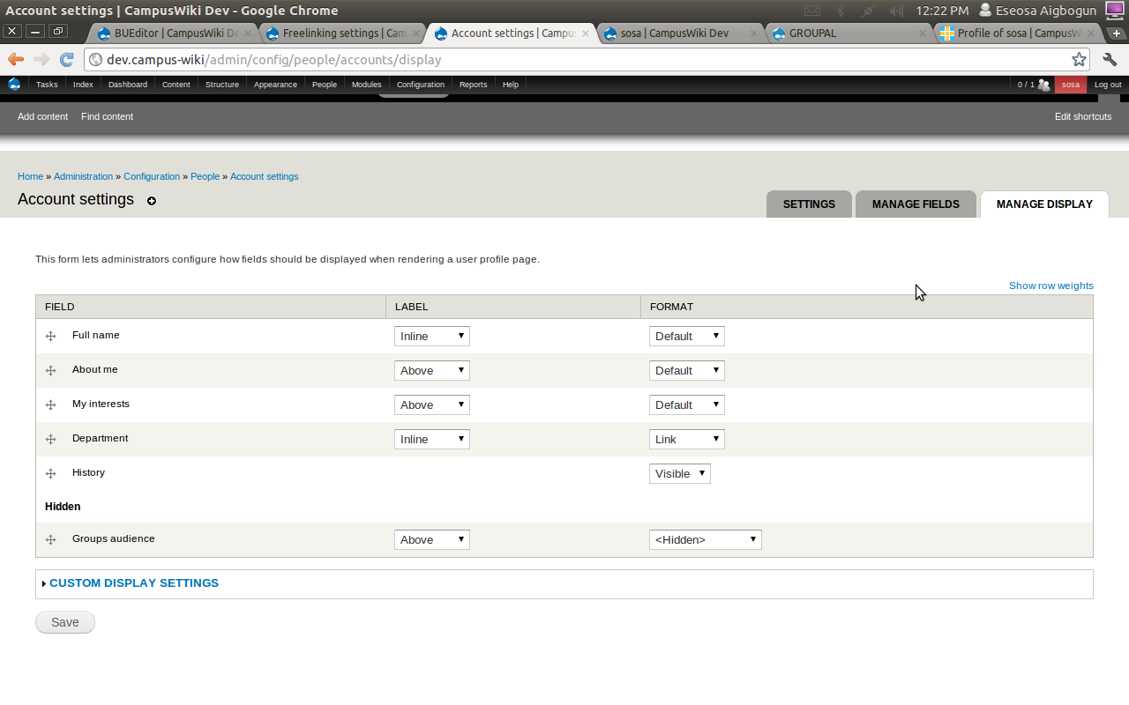

user relationship
download and enable the user_relationship module

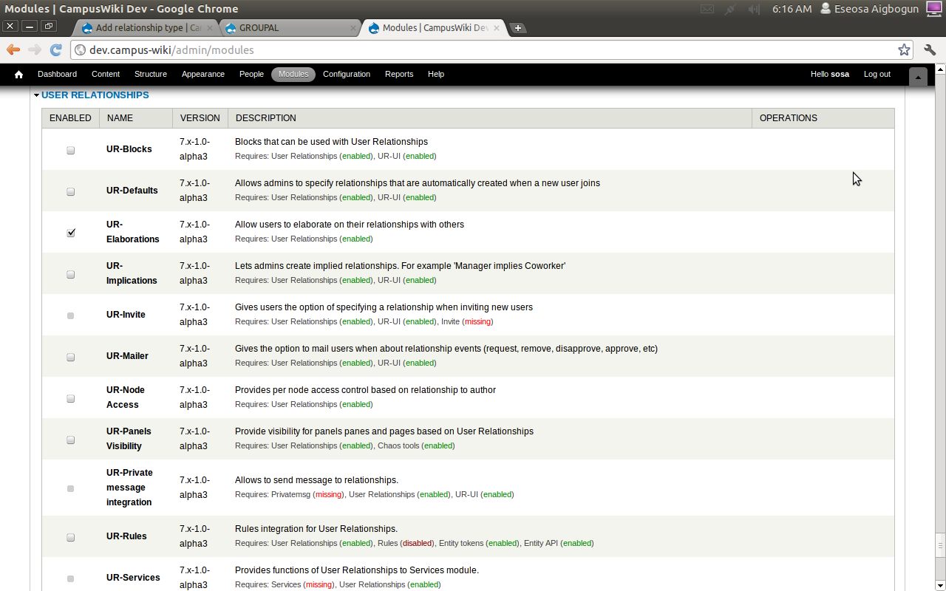

navigate to administration → configuration → people → relationships and click on add new relationship

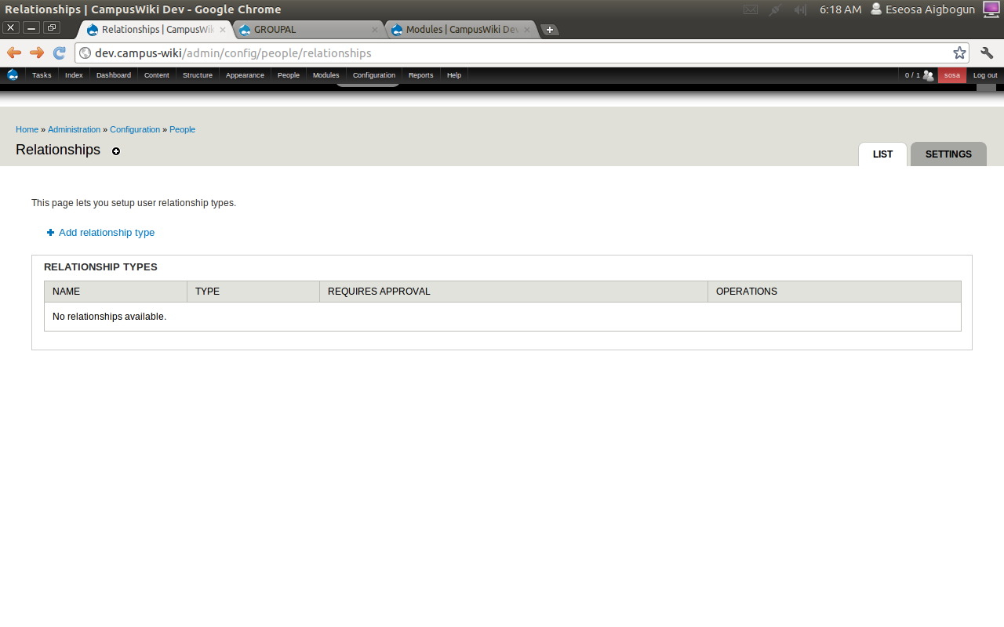

create a two way relationship called friend

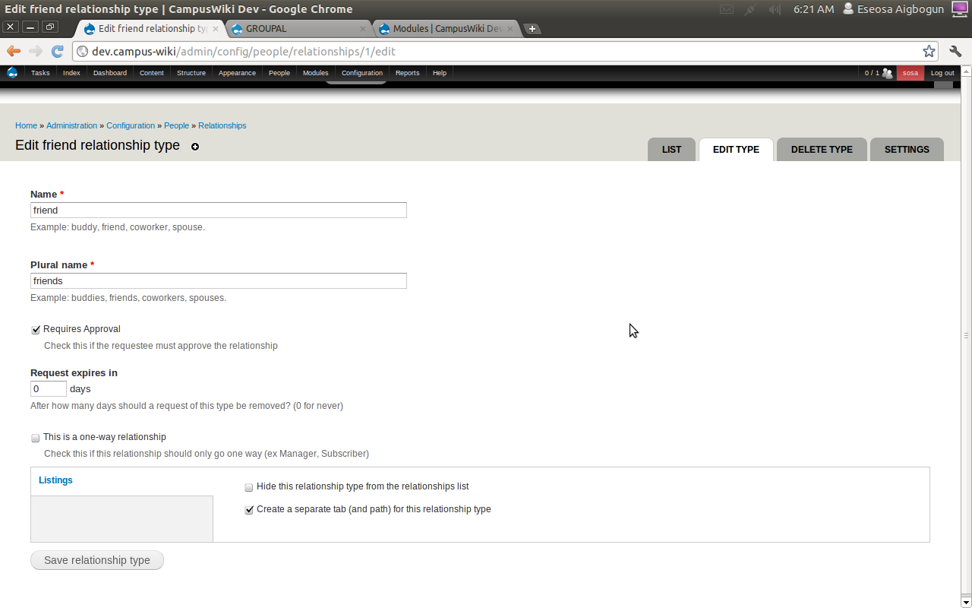

also add a two way relationship called project partner

click settings to configure the user relationship module
configure the required settings
set up required permission for user relationship
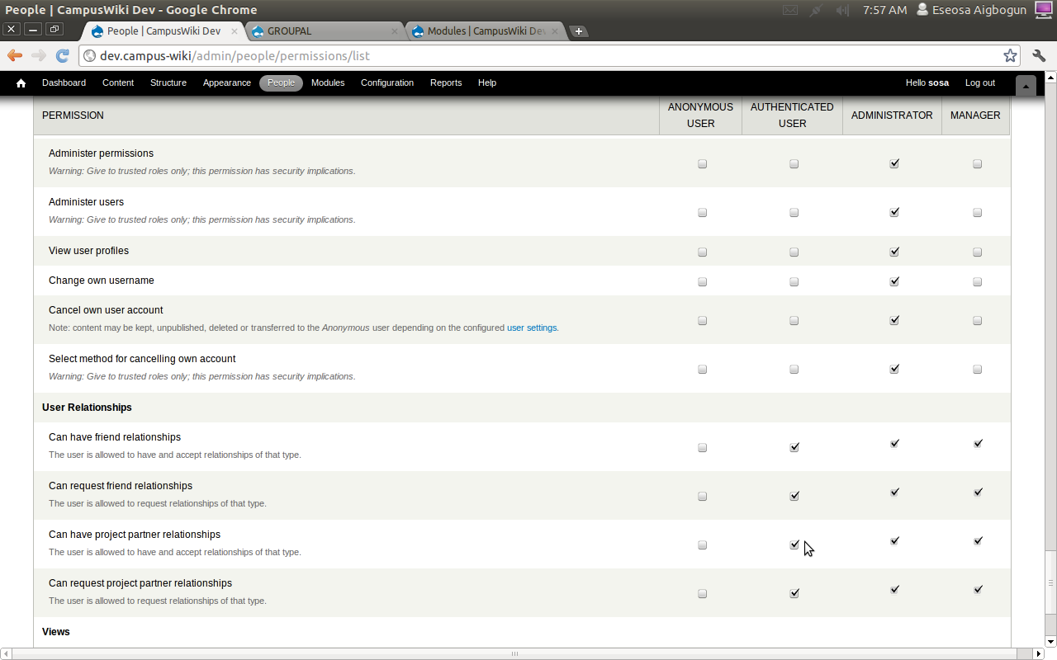

Configuring related user activity stream
- enable the heartbeat module and related modules
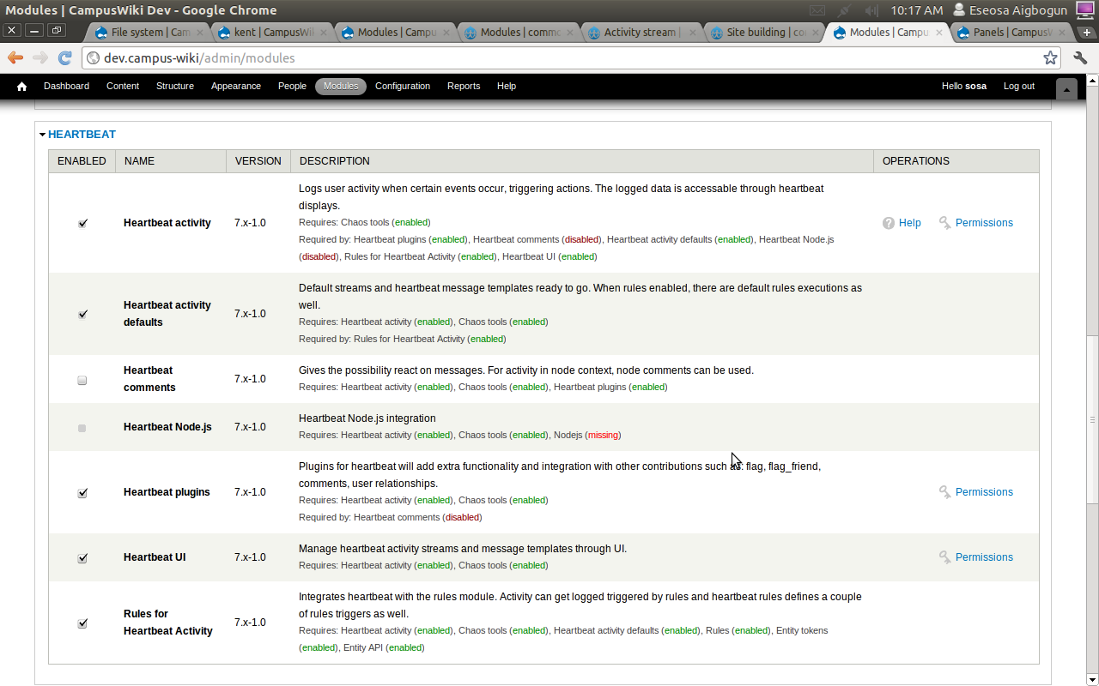

This will involve us:
• Creating a template for heartbeat to inform users of the relationship in
their stream
• Creating a new rule to detect when a relationship is approved (we don't want
to add the relationship to the stream until it has been approved) and to send
notification to heartbeat

create a template for each relationship type
goto administration → structure → heartbeat → heartbeat template
click on the add link to add a new template for the relationship approval

Definition:
Message id → Heartbeat Approve Relationship 1
Description of the message → User approves relationship

Access:
Message display access → user and relations are allowed to see this message

Content:
single message → !requestee and !requester are now friends
Type of message → single:

Attachments:
Enable comments for this activity template

enable flag module for flag to work with heartbeat

Set up rule s for relationship
goto administration → configuration → workflow → rules

click on add rules
Name → users are now friends
react on event → a user relationship has been approved

add condition for the relationship to be of type friend
add action select heartbeat log activity for user approves relationship

set up for users are now project partners also.

Creating the event content type:

enable the following modules
location, node locations, node reference, node reference url, automatic node tiltle and cck signup.

Create the event content type
add fields:
date: field_event_date
configure all settings on the date, including granularity,

capacity: integer type, maximum value 99, suffix people.

Can members RSVP for this event: list (integer)
allowed values:
1|Yes
0|No

add address field, first enable the addressfield module
Address: field_event_address
leave the default settings as is
reorder the address field to come after the venue field.

