**INFO 6205 Final Project: EPL Ranking System**

Team members: Kuo, DahWei/ Tsai YuTing/ Lin, LiangYen

**Introduction to our system:**

*Main page:*

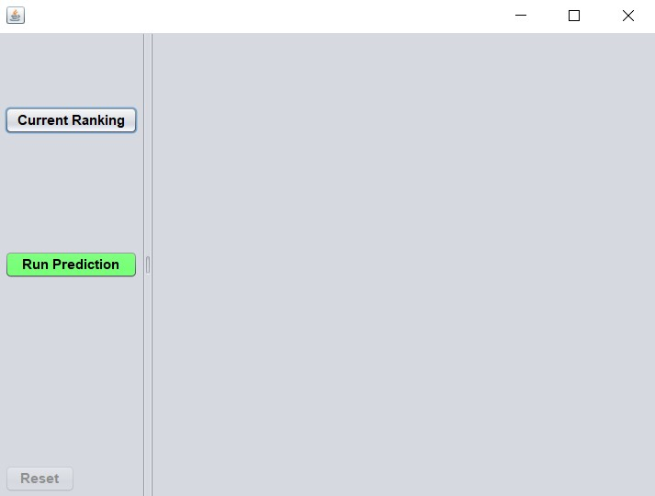

This is the main page of our system. User can click the button of the left side to see current ranking and can also run prediction.

*Current Ranking Page:*

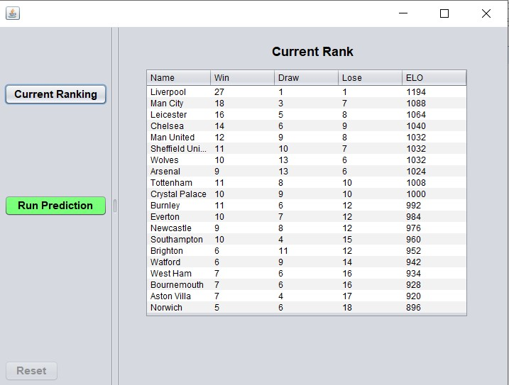

Current ranking page can see the results of the games that were already played.

*Run Prediction Page:*

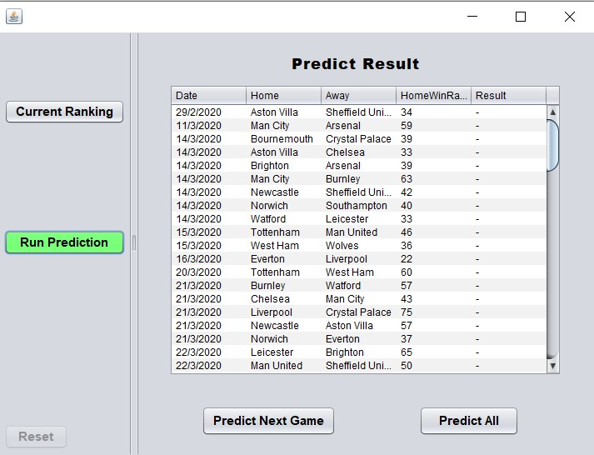

After clicking Run Prediction, a table will show all the remaining games of the seasons.

After clicking Predict Next Game in below, the system will predict ONE next game each time. By clicking Predict All, the system will show all the prediction of the matchups in the rest of the season.

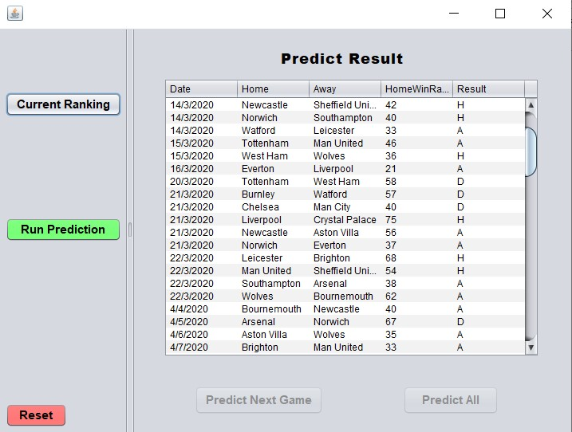

***Math behind our ranking system:***

**How do we calculate Elo rating score?**

In this system, we applied Elo rating system. It is a method for calculating the relative skill levels of players or teams. Team’s ratings depend on the ratings of their opponents and the results scored against them. The formula we used to calculate their ELO rating is based on logistic distribution.

The exact formula is: EA

Where EA is the ELO rating of team A, Ra is their performance rating.

The formula for Ra is : 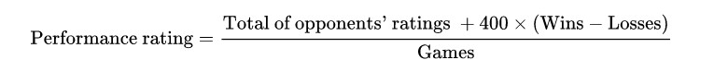

To see this in an easier way is, each team’s ELO rating is started with 1000. When they win more, their ELO rating will increase more. On the other hand, when they lose, their ELO rating will drop. And the ELO rating is a big factor of the prediction system.

**How did we predict each game?**

In the original ranking table, we’ve already used all the matchup results in the season to calculate each team’s ELO rating. And we set up two values (drawValue, winValue) to be the standards of our prediction. We randomly generate a integer, if the integer is larger than drawValue, away team wins; When integer is larger than winValue but smaller than drawValue, it’s a draw. Every other result means that home team wins.

After each game is predicted, the Elo rating will be updated(Elo rating is dynamic). So the results of the remaining games will also be affected by the predictions of our system.

***Data Structures:***

In the system, we mainly used ArrayList to store the win/lose data and their rating score. The reason we use ArrayList is because that we don’t know how much data are waiting to be predict, and ArrayList can be growth as needed, so that’s the data structure we need to stored the data.

Besides, in the Team class, we implemented comparable<>, and override compare.To() method with our own calculating way which is team1.ELO – team2.ELO, so it will be more convenient for us to create the system and predict the remaining games.

There’s not much data structures being used in this system. The most important part of the system is the math behind our prediction method. And we believe the way we implemented it, and keep updating Elo score in our system made this prediction system very precise.

References:

<https://en.wikipedia.org/wiki/Elo_rating_system>

<https://metinmediamath.wordpress.com/2013/11/27/how-to-calculate-the-elo-rating-including-example/>