Installing OpenClinica 3.1
on Windows

Screenshots used as examples and might not match exactly what is written in the instructions. Please follow the instructions as they are written.

This document is available on the web at https://docs.openclinica.com/3.1/installation

Note: Many windows systems are not configured to show the file extensions by default. In order to use this guide, you will need to be able to see the file extensions. To configure this behavior, open a Windows Explorer window. Click Tools > Folder Options. Go to the View tab, and in Advanced settings uncheck the ‘Hide extensions for known file types’.

This installation was performed successfully on Windows Server 2003 Standard Edition SP2.
This installation was performed successfully on Windows Server 2003 Standard Edition SP1.
This installation was performed successfully on Windows XP Professional Version 2002 SP2.
The system should work on Windows 2000 Professional and compatible systems, but has not been tested on other Windows platforms.

NOTE: All characters are case sensitive. Please be aware of any additional white space between or after characters this may cause installation errors.

Table of Contents*

*Please note; all links to a sub-chapter will bring you to a screen shot where appropriate. 4
1. About OpenClinica 5
2. Software Dependencies 6
3. Install Java 7
License Agreement 7
Custom Setup 8
Installation Completed 8
Create JAVA_HOME Environment Variable 8
4. Install PostgreSQL 9
Setup 9
Installation Directory 9
Data Directory 9
Password 9
Port 10
Advanced Options 10
Ready to Install 10
Setup 11
5. Install Tomcat 12
Tomcat Setup 12
License Agreement 12
Choose Components 12
Choose Install Location 12
Set Configuration Options 13
Locate the Java Virtual Machine 13
Install Complete 14
Create CATALINA_HOME Environment Variable 14
6. Install OpenClinica Package 15
Extract OpenClinica Package 15
7. Configure PostgreSQL 16
Create a Database 16
8. Configuring the Web Application 17
Start Tomcat 17
Create Data Folders 18
Modify Configuration Files for Server Specific Settings 19
9. Verify your Environment 21
10. Troubleshooting 22
11. Using Oracle as the Database 22

*Please note; all links to a sub-chapter will bring you to a screen shot where appropriate.

1. About OpenClinica

Professional Open Source Solutions for the Clinical Research Enterprise

OpenClinica: Open Source Software Platform for Managing Clinical Research Studies Professional Open Source Solutions for the Clinical Research Enterprise
OpenClinica is a free, open source clinical trial software platform for Electronic Data Capture (EDC) clinical data management in clinical research. The software is web-based and designed to support all types of clinical studies in diverse research settings. From the ground up, OpenClinica is built on leading independent standards to achieve high levels of interoperability. Its modular architecture and transparent, collaborative development model offer outstanding flexibility while supporting a robust, enterprise-quality solution.
More about OpenClinica: https://www.openclinica.com
Software License
OpenClinica is distributed under the GNU Lesser General Public License (GNU LGPL). For details see: http://www.openclinica.org/license or LICENSE.txt distributed with this distribution.
Developer and Contact Information
Akaza Research, based in Cambridge, MA, provides clinical trials informatics solutions based on OpenClinica, the world's most widely used open source clinical trials software.
Akaza Research
460 Totten Pond Rd
Suite 200
Waltham, MA 02451
email: contact@akazaresearch.com
For more about Akaza’s products and services see:
https://www.openclinica.com

2. Software Dependencies
OpenClinica runs on top of any Servlet/JSP container that implements the Servlet 2.4 and JavaServer Pages 2.0 specifications from the Java Community Process. It was developed to run on Apache Jakarta Tomcat 6.0.20.

Currently, OpenClinica runs on top of either the Postgres relational database or an Oracle relational database. Using a JDBC (Java Database Connectivity) driver, the database connects to the web application and provides the data to the end-user.

Required for new installs:
Jakarta Tomcat 6.0.32
Java 2 Standard Edition Development Kit 6.0 Update 24
Postgres 8.4.7.2 or Oracle 10g or higher

This installation guide will show you how to acquire and setup each of the required components and configure the OpenClinica web application.

Note: The software stack OpenClinica runs on is open source, and most open source projects release minor versions and revisions often. Sometimes only a matter of weeks may separate the release of two adjacent versions of the software.

For this release, the latest stable version of each component was used in integrated testing, and its revision number is referenced in this document. In some cases, the revision number mentioned may no longer be available. For the most part, you should be able to use later minor versions and revisions of the same software without incident. For instance, if the install guide uses PostgreSQL 8.4.7.2, PostgreSQL 8.4.8 should work as well.

We recommend that you record the revision number you use. If you have concerns about a particular combination, please post your question to the users@openclinica.com mailing list.
3. Install Java

OpenClinica 3.1 is designed to run on a Java 2 SDK 1.6x platform. To avoid conflicts with other versions of Java, you should clear out any other Java installations on the system.

- Go to Start>Control Panel>Add Remove Programs, and remove all Java JRE and SDKs.
- Create a directory called “c:\oc\install”
- Download J2SE Development Kit 6.0 Update 23 into “c:\oc\install”
- Setup the Java 2 SDK

Windows offline installation (EXE)
Filename: jdk-6u24-windows-i586.exe
Size: 77 MB
Website: https://cds.sun.com/is-bin/INTERSHOP.enfinity/WFS/CDS-CDS_Developer-Site/en_US/-/USD/ViewProductDetail-Start?ProductRef=jdk-6u24-oth-JPR@CDS-CDS_Developer

Our Download Site: http://svn.akazaresearch.com/oc/software/OpenClinica-3.1/windows/

- Run C:\oc\install\jdk-6u24-windows-i586.exe
- When the “Open File – Security Warning” opens click on “Run”
- Click “Next >” on the Welcome to the Installation Wizard for Java screen.
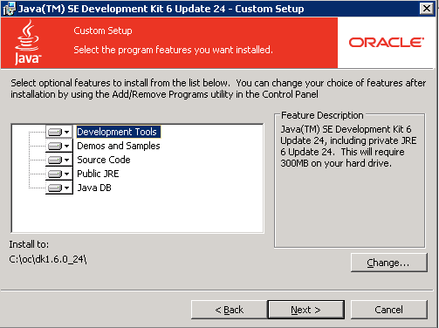

- On the “Custom Setup” screen Click “Change…”
- Change the path to “c:\oc\jdk1.6.0_24\” and click “OK”
- Your screen should look like the screenshot above, now click “Next >”
- Setup installs the JDK
- Once the first setup completes you will see another page for installing the JRE6. Click “Cancel” and then “Yes” on the confirmation pop-up.
- Now click “Finish” on the Install Success screen.
- Exiting the setup will open a web browser to register the JDK, feel free to register or close the web browser.

4. Install PostgreSQL

The default installation of OpenClinica uses a PostgreSQL database. PostgreSQL is an open source application and can be installed to the Window platform as follows.

- Download postgresql-8.4.7-2-windows.exe and save it to “c:\oc\install”

Windows binary distribution (ZIP)
Filename: postgresql-8.4.7-2-windows.exe
Size: 42 MB
Website: http://svn.akazaresearch.com/oc/software/OpenClinica-3.1/windows/

- Run c:\oc\install\postgresql-8.4.7-2-windows.exe
- When the “Open File – Security Warning” opens click on “Run”
- The PostgreSQL Installation Wizard Opens, and click “Next >” to continue.
- For the Installation directory screen accept the defaults by clicking “Next >”
- For the Data directory screen accept the defaults by clicking “Next >”
- For the Password screen, please enter a password for the postgres superuser. (Remember this password you will need it later)
- Once you have entered the password twice click “Next >”
- For the Port screen accept the defaults (5432) by clicking “Next >”
- Next you will see the Advanced Options screen

Advanced Options
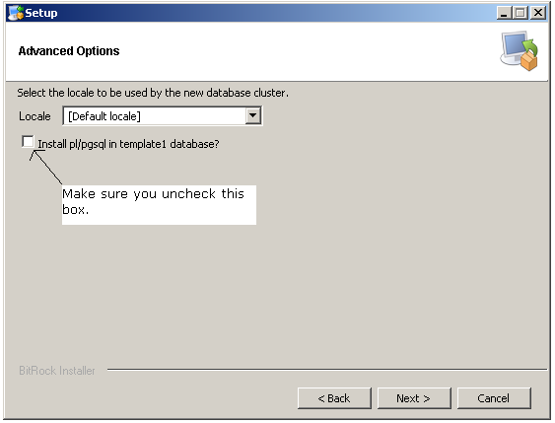

- Use Default locale
- Uncheck the checkbox next to Install pl/pgsql in template1 database
- Click “Next >”.
- For the Ready to install screen click “Next >” to start the installation.
- Once you see the Completing the PostgreSQL Setup Wizard screen, uncheck the “Launch Stackbuilder at exit” checkbox and click “Finish>”

5. Install Tomcat

- Download Apache Tomcat 6.0.320 and save it to “c:\oc\install”, use the Windows Service Installer version.

Windows binary distribution (EXE)
Filename: apache-tomcat-6.0.32.exe
Size: 7 MB
Website: http://tomcat.apache.org/download-60.cgi

Our Download Site: http://svn.akazaresearch.com/oc/software/OpenClinica-3.1/windows/

- Run c:\oc\install\apache-tomcat-6.0.20.exe, the Apache Tomcat Setup installation wizard appears.
- When the “Open File – Security Warning” opens click on “Run”
- On the Welcome to the Apache Tomcat Setup Wizard page click “Next >”
- On the License Agreement page click “I Agree” to accept the agreement.
- On the Choose Components screen click “Next >” to accept the defaults.
- On the Configuration page leave the defaults and click “Next >”
- On the Java Virtual Machine page click on the “…” and select the path we installed the jdk into “c:\oc\jdk1.6.0_24\”. Should look like screenshot below. Once the jdk path is shown click “Next >” to continue.

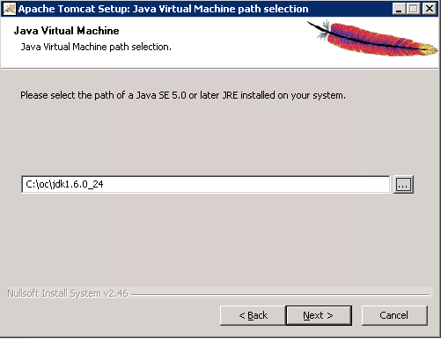

- On the choose Install Location page edit the destination folder to read “c:\oc\tomcat”. This should now look like the screenshot below.
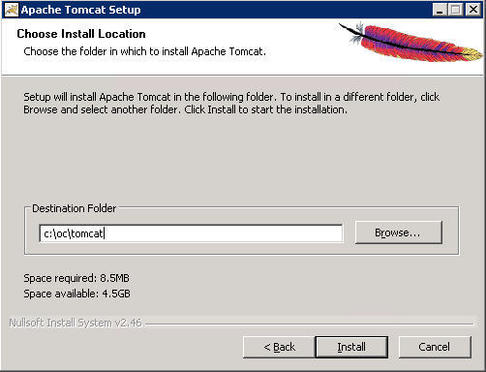
- Now click “Install” to start the installation.
- Once done you will be on the Completing the Apache Tomcat Setup Wizard page

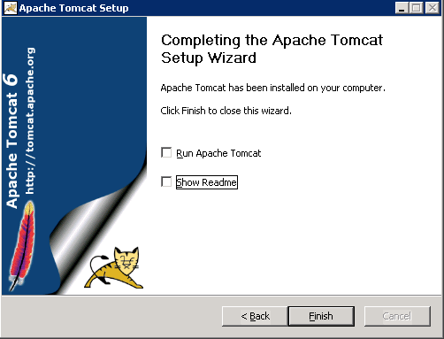

- Uncheck the Run Apache Tomcat checkbox.
- Uncheck the Show Readme checkboxes.
- Click Finish. Tomcat is now installed
- Create a new directory in “c:\oc\tomcat” called “oldwebapps”
- Move all default webapps from “c:\oc\tomcat\webapps” to “c:\oc\tomcat\oldwebapps”

6. Install OpenClinica Package

To install OpenClinica, you must first acquire the package and install it on the server.

Download OpenClinica 3.1
Filename: OpenClinica-3.1.zip (ZIP)
Website: https://www.openclinica.com (you must register)

- Download OpenClinica-3.1.zip and save it to “c:\oc\install”
- Right click on OpenClinica-3.1.zip and click “Extract All”
- On the extraction wizard window click “Next >”
- Now change the directory to “c:\oc\install” and click “Next >”
- Uncheck the “Show Extracted Files” checkbox and click “Finish”
- Now copy “c:\oc\install\OpenClinica-3.1\distribution\OpenClinica.war” to “c:\oc\tomcat\webapps”

7. Setup PostgreSQL OpenClinica DB and User.
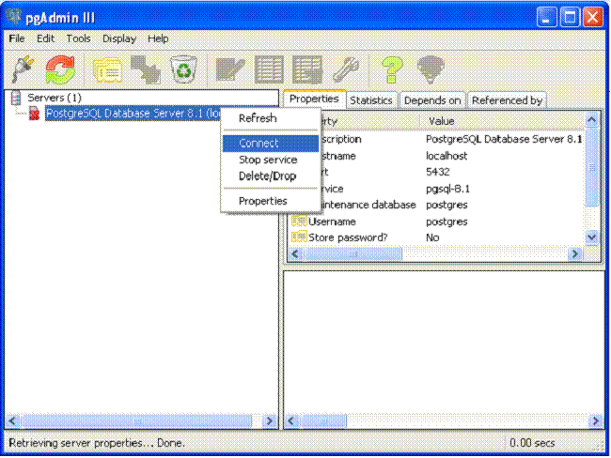

- Open pgAdminIII. Go to Start>Programs>PostgreSQL 8.4 > pgAdminIII. The pgAdminIII interface opens.
- Right click on the “PostgreSQL 8.4 (localhost:5432)” icon with a red “X” next to it and select “Connect”.
- Now login to the database server. Enter the password you setup in the PostgreSQL installation.
- Next we will create the DB user “clinica” which OpenClinica uses to connect to the database with.
- Expand databases and click the “postgres” database so that it is highlighted
- Now click “Tools” and select “Query tool”.
- The Query window is now open, please select and delete all text in the “SQL Editor” box so it is blank.
- Once the “SQL Editor” box is blank type the following into the “SQL Editor” box “CREATE ROLE clinica LOGIN ENCRYPTED PASSWORD 'clinica' SUPERUSER NOINHERIT NOCREATEDB NOCREATEROLE;” (NOTE: NO QUOTES)
- Once the above is in the “SQL Editor” box click on “Query” from the top menu and select “Execute” to run the sql query.
  - You will see a message in the “History” window indicating the query has completed.
- Once the query is ran please delete all text in the “SQL Editor” box so it is blank again.
- Once the “SQL Editor” box is blank again type the following into the “SQL Editor” box “CREATE DATABASE openclinica WITH ENCODING='UTF8' OWNER=clinica;” (NOTE: NO QUOTES)
- Once the above is in the “SQL Editor” box click on “Query” from the top menu and select “Execute” to run the sql query.
  - You will see a message in the “History” window indicating the query has completed.
- Once done close the “Query” window, when prompted to save changes click “No”
- We have created the “clinica” db user and the “openclinica” db that OpenClinica will use. As of right now the “clinica” db user has a default password of “clinica”. Since this is a potential security risk we recommend you change the password immediately.
- To change the “clinica” db users password expand and highlight “Login Roles” within PGAdmin and then click “View” from the top menu and select “Refresh”.
- Now you should see the “clinica” db user. Right click on the “clinica” account and select “Properties”
- In the Login Role clinica box that opens up you should see two relevant fields “Password” and “Password (again)”. Enter the newly wanted “clinica” db users password into both fields and the click “OK” to apply the changes. You have now changed the “clinica” db users password. (Remember this password as you will need it when you configure OpenClinica)

8. Configuring Tomcat and the Web Application

- Open the “Configure Tomcat” application by going to “Start -> Apache Tomcat 6.0 -> Configure Tomcat”
- Now click on the “Java” tab
- Put “1280” into the “Maximum memory pool” section
- Now add “-XX:MaxPermSize=180m” on a new line in the JAVA Options text entry on the “Java” tab.
- Once done it should look like the screenshot below.
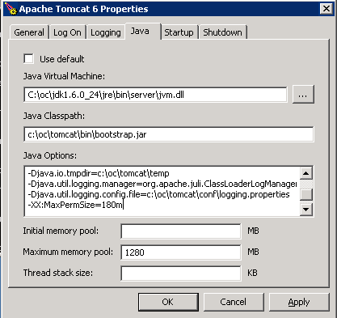
- When all settings have been entered and it looks like the screenshot above click “Apply”.
- Tomcat is now configured; next we will deploy and configure OpenClinica.
- We have already copied the OpenClinica.war into the tomcat webapps directory so to deploy it all we have to do is start tomcat.
- To start tomcat click on the “General” tab, once on the tab click on “Start”
  - We have to wait for tomcat to fully startup, you can do this by looking at catalina.out in “c:\oc\tomcat\logs” and look for a line that says “INFO: Server Startup in XXXXX ms” or just wait about 5 minutes.
- Once tomcat has fully started up click on “Stop” on the “General” tab.
  - Wait two minutes for tomcat to stop.
- Now that tomcat is stopped go to “c:\oc\tomcat\webapps” and delete “OpenClinica.war”
- Next we will modify the OpenClinica configuration file for server specific settings.
- Open the OpenClinica configuration file located at C:\oc\tomcat\webapps\OpenClinica\WEB-INF\classes\datainfo.properties file in WordPad and modify it to suit your setup.
  - Note the only thing you have to change for OpenClinica to startup in 3.1 is the dbPass entry to match what you changed the “clinica” db users password to.
  - There are other options you should configure for your environment such as sysURL, please read the full file and configure accordingly.
- There are many other configuration options in this file. Please read the instructions in the file for more information. This installation document was created to get the application up and running in as few steps as possible.
- Once the file is configured, save it.
- Now start tomcat. This can be done in general through one of the following methods.
  - The “General” tab in “Configure Tomcat” that we used earlier allows you to start and stop tomcat.
  - Click “start -> run” type “cmd” in the run box and click “OK”. In the new command prompt window the following will start tomcat “net start tomcat6” the following will stop tomcat “net stop tomcat6”
  - Via windows services mmc.
- Once tomcat is started verify your environment

9. Verify your Environment

- Open a web browser on the server to http://localhost:8080/OpenClinica and verify the web application loads. You should see the OpenClinica login screen.

- Login to the system. The default username is root and the password is 12345678.

- Add a user that has the same privileges as root. Login as the new user and remove the Root user account so no one will have access to it.

At this point the application has been installed correctly. You should now spend some time setting up a secure environment, and then creating your studies.

- You should set up SSL for Tomcat. More information is available here: http://tomcat.apache.org/tomcat-6.0-doc/ssl-howto.html

- You will need to change the localhost URLs in the datainfo.properties to match your desired server settings. If you are planning on using OpenClinica over the web, this will need to be your server’s or proxies URL and you may need to open the Tomcat port. These SysURLs will be used in emails the application sends (This should have been done when we edited the datainfo.properties file)

- Enterprise support services, mailing lists, and additional resources for OpenClinica are available at https://www.openclinica.com.

11. Using Oracle as the Database

OpenClnica 3.1 has been ported so it can work on the Oracle database as well as the PostgreSQL database. We will not instruct you on how to install Oracle, but there are instructions on how to create the database OpenClinica will use.

Please go to the following wiki page for separate instructions for installing OpenClinica with Oracle. http://www.openclinica.org/dokuwiki/doku.php?id=ocoracleinstall:start The document you find there should be followed instead of Chapters 4 and 7 above.

