Screen 1: Jenkins Unlock Screen

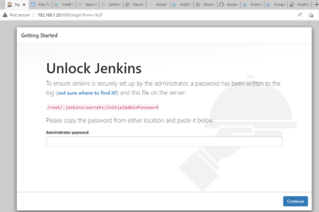

2. Jenkins Setup Screen

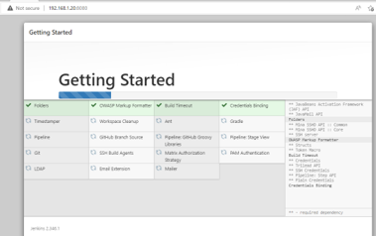

3. Jenkins First Admin User Creation Screen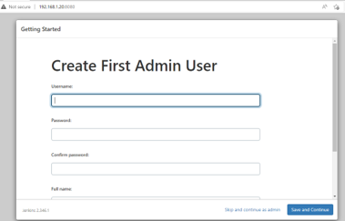

4. Jenkins Login Screen:

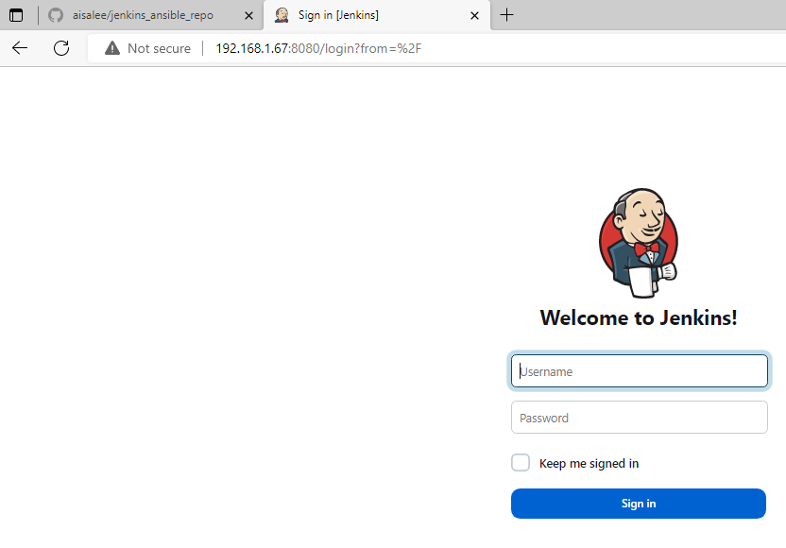

5. Install Ansible Plugins

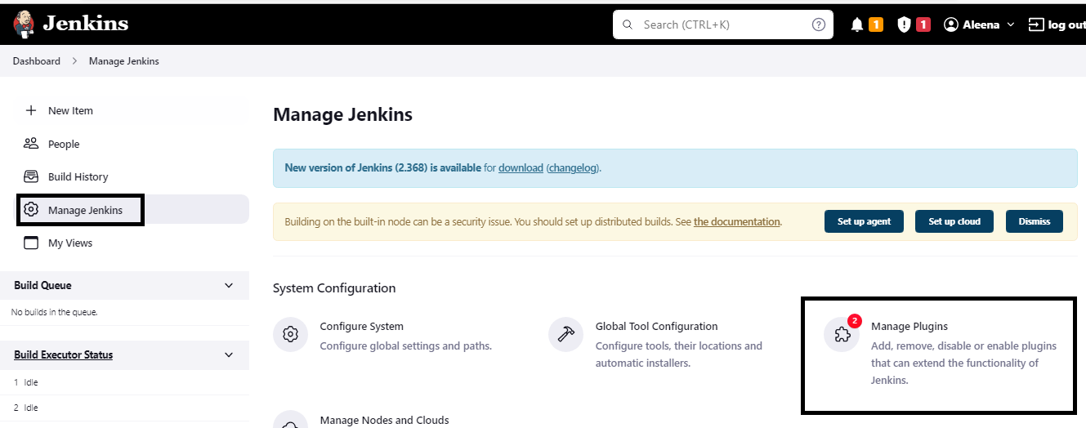

6. Go to available Plugins, search for Ansible. Install it without Jenkins restart.

7. The plugins will list in Installed Plugins section once installation is complete.

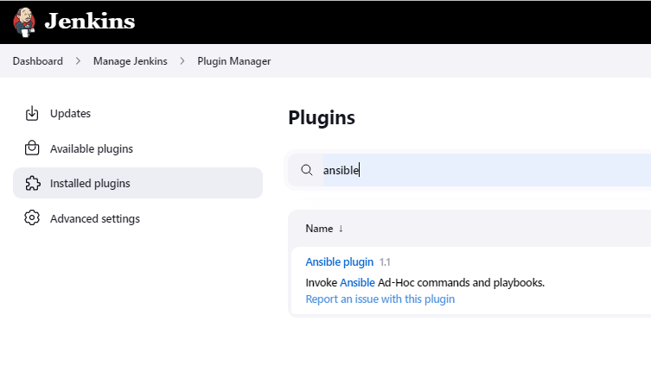

8. Click on New Item to start creating the first job

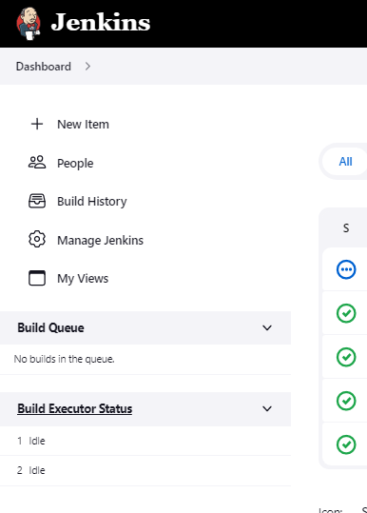

9. Setting the Job to use Ansible playbook:

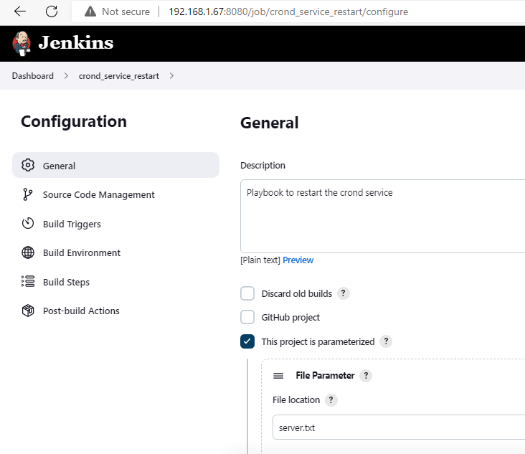

10. Add Invoke Ansible playbook in the build step and set the playbook path.

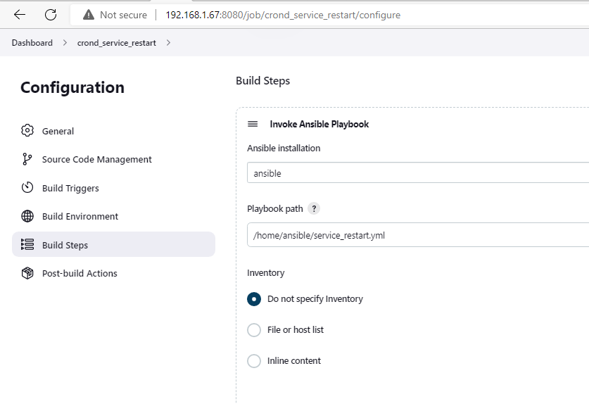

11. Set additional parameters to invoke the inventory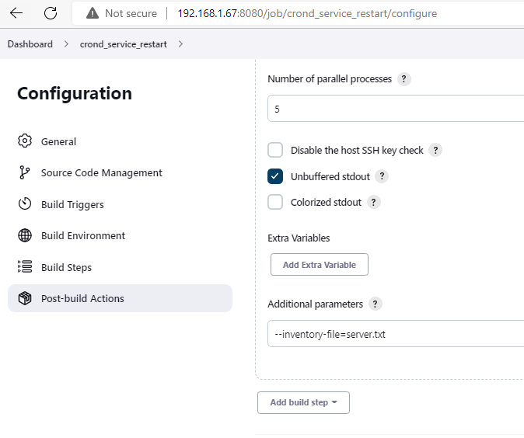

12. Sample Jobs

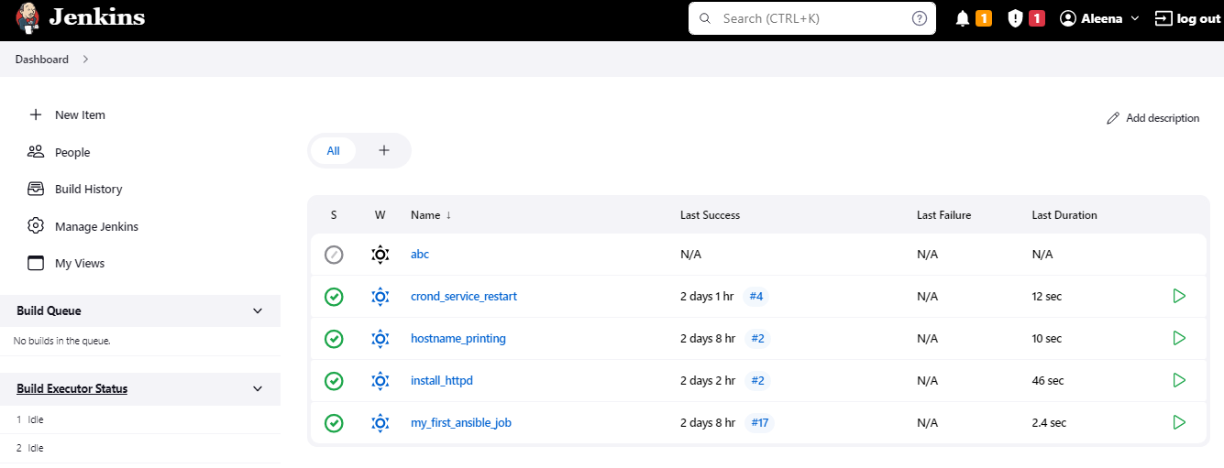

13 Job Output :

