GenerativeSimulation
Common-Pool Fishery Run Report
Branch: sim/run-20260820-230628 | Rounds analyzed: 1-11

1. Simulation Setup
Ten LLM-driven fisher agents share a common lake, modeled on Gupta et al.'s common-pool-resource formulation: each agent chooses an effort level in [0.0, 1.0] each round, and the resulting catch is effort x stock x harvest_productivity (0.05) — a linear Schaefer-style catch equation, not a direct kg request. After harvest, the lake regrows logistically on whatever stock is left: stock + growth_rate x stock x (1 - stock/carrying_capacity), with growth_rate = 0.2 and a carrying capacity of 300kg.
Each round, agents harvest, then propose a shared rule for how the lake should be fished, then vote on the proposals; whichever proposal wins is hard-coded into the simulation's own mechanism/phase code by a separate code-editing agent (the "norm-implementer") before the next round begins.

Agent roster
Fisher | Disposition | Personal norm (shapes their decisions)
Kai | Altruistic | Leave enough fish for others and future generations
Mara | Altruistic | Prioritize long-term sustainability over short-term gain
Toa | Altruistic | Prioritize long-term sustainability over short-term gain
Rina | Altruistic | Consider the needs of the entire community before fishing
Beti | Altruistic | Prioritize long-term sustainability over short-term gain
Solo | Selfish | The lake is there to be used, take your maximum share
Lani | Selfish | The lake is there to be used, take your maximum share
Miro | Selfish | Fish aggressively to ensure your own survival
Nadia | Selfish | Fish aggressively to ensure your own survival
Tevita | Selfish | Get the most value from your fishing effort
Disposition is assigned deterministically by index against altruism_ratio (0.5): the first 5 of 10 agents (by generation order) are altruistic, the rest selfish — not a per-agent coin flip. Only the specific personal-norm sentence within each group is randomized.

2. Harvest and Effort, Per Fisher, Per Round
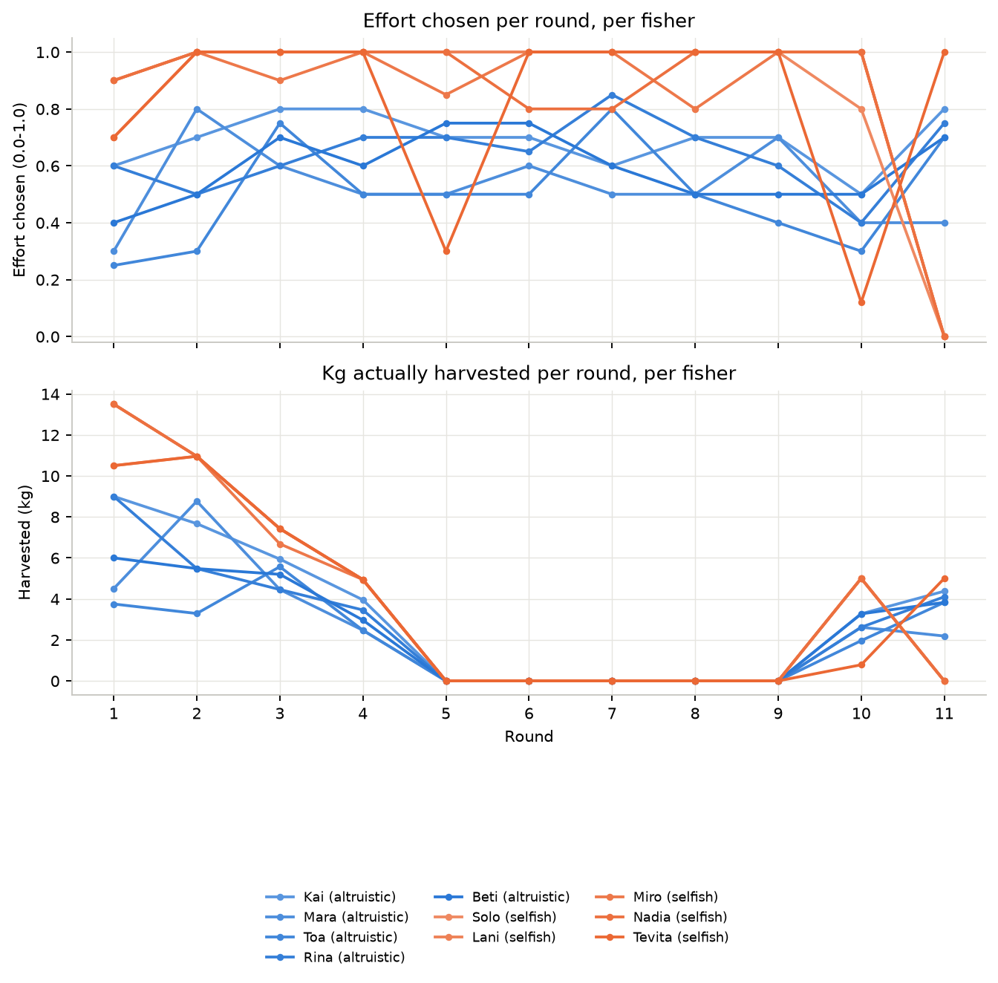
⚠ Rounds 5-9: zero harvest is a bug, not a conservation success
Every fisher's harvested_kg drops to exactly 0.000kg for five consecutive rounds despite unchanged, often high, effort. This was traced to the code committed for Round 4's norm (a "must complete 3 trips before you're eligible to fish" eligibility rule): the implementation initializes each agent's trip counter but never increments it anywhere, so every agent is permanently stuck below the 3-trip threshold and every harvest is forced to zero. This persisted until Round 9's proposal replaced that mechanism outright. See Section 5 for the exact code.
Selfish fishers (orange) consistently choose effort at or near 1.0 through the first several rounds, while altruistic fishers (blue) cluster lower (0.3-0.8) — a visible, if imperfect, split along the assigned disposition. That gap narrows by the later rounds as the shared, increasingly strict caps constrain everyone's realized harvest regardless of chosen effort.

3. Lake Stock and Regeneration
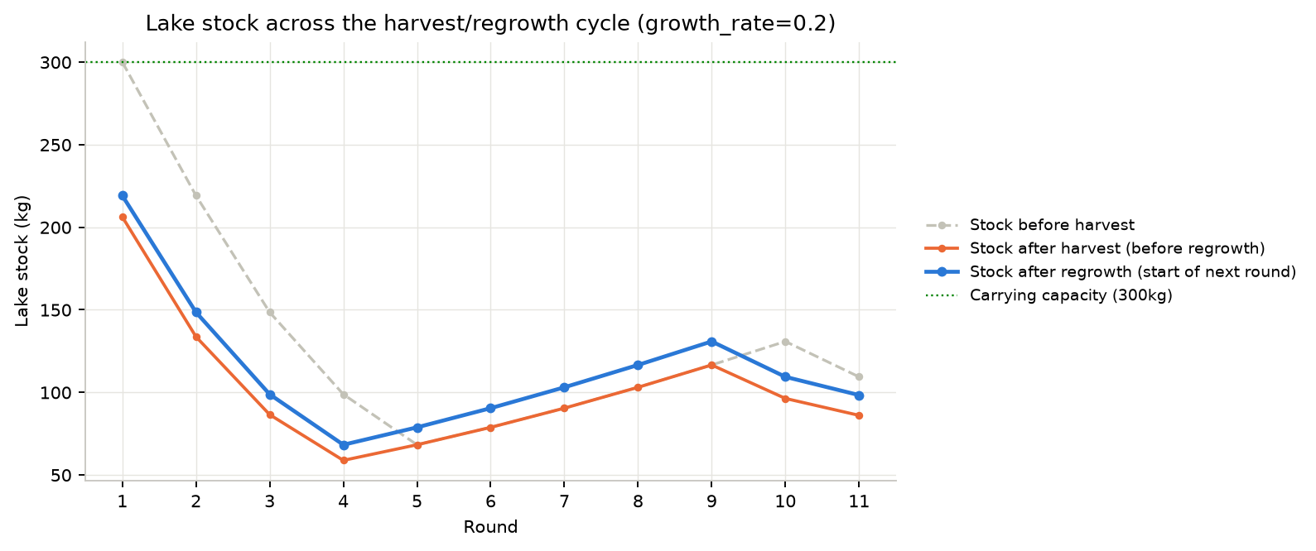
Regrowth rate: growth_rate = 0.2 (20% of current stock regrows each round, logistically damped as stock approaches the 300kg carrying capacity — not a flat per-round addition). The lake fell from its starting 300kg to a low of ~68kg by round 4, before the Round 4-9 harvest bug above gave it an unintended five-round recovery window, then resumed depleting once harvesting resumed in round 10, ending this run at 98.3kg.

4. Winning Norms by Round
Every round's vote produced a winner, but not every winning norm actually made it into the running code — the norm-implementer's own edit has to compile cleanly before it is committed; if it doesn't (or the agent fails to produce a working edit at all), the round's mechanics are left unchanged and the same or a similar norm gets another chance later. Rounds 5, 6, 7, 8, 10 fall into that category and are listed separately below.

Adopted and actually implemented
Round 1 — won by Lani (4/10 votes)
Policy: Each fisher may take up to 15kg per trip, leaving the rest of the lake for future harvests.
Operationalization: On each trip I will weigh my catch and, if it exceeds 15kg, I will set aside the excess back into the lake. We will keep a simple ledger of each person’s daily catch; if someone exceeds the 15kg limit, 5% of the excess is given to a community reserve. We meet monthly to review totals and if a fisher consistently over‑catches, that person must forgo one trip for a month as a penalty.

Round 2 — won by Nadia (3/10 votes)
Policy: Each fisher may take a maximum of 15 kg per day, and the lake must retain at least 120 kg of fish at all times.
Operationalization: Fisheries log their daily catch; the community meets weekly to weigh the lake. If the reserve falls below 120 kg, all fishing is suspended until the lake is replenished. Anyone who exceeds the 15 kg limit must return the excess to the lake or pay a fine equal to 2 kg of fish in the next round; repeated non‑compliance results in temporary suspension of the fisher’s permit.

Round 3 — won by Solo (4/10 votes)
Policy: Each fisher may take at most 30% of the lake's current weight per trip, must record catch in the communal ledger within 6 hours, and is required to deposit 5% of his catch into a communal maintenance fund.
Operationalization: Before departure, each fisher estimates his catch and records it in the ledger. After landing, he uploads the actual catch within 6 hours, calculates 5% and transfers it to the communal pool via the ledger. If a fisher fails to record or deposit, the community deducts 10% of the excess into the pool and logs the violation. This applies to all future trips, and the ledger is maintained by a rotating clerk chosen by vote.

Round 4 — won by Solo (4/10 votes)
Policy: Each fisher may catch up to 30% of the lake's current weight per trip; must report the catch within 4 hours of landing and deposit 5% of the catch into a communal maintenance fund. Failure to report or exceed the quota triggers a penalty of 10% of the excess catch, which is added to the communal pool.
Operationalization: At the community station, each fisher logs their catch into the communal ledger and pays 5% of that catch into the maintenance pot. The ledger is monitored by a rotating keeper; any fisher who fails to update the ledger within 4 hours of landing will be automatically charged a 10% penalty on any portion of the catch above the 30% quota, which will be added to the communal pool. The rule applies to all fishers who have participated in at least three consecutive trips; new entrants must wait for their first three trips before being eligible to fish under this rule.

Round 9 — won by Rina (2/10 votes)
Policy: Each fisher may take no more than 5 kg per trip, with a maximum of 60 kg harvested by the community in any rolling 30‑day period; any catch exceeding 5 kg must contribute 10 % of the excess to a communal restocking fund.
Operationalization: Fisheries will record each trip in a shared ledger. At the end of each month, the community will tally total catch; if the 30‑day rolling sum exceeds 60 kg, the excess will be withheld until the next month. Exceeding 5 kg per trip triggers a 10 % fund contribution that is deposited into a communal bank. If a fisher fails to record or attempts to exceed limits, the community will impose a temporary fishing ban for the next two trips. All members will review the ledger at monthly gatherings to adjust quotas if lake biomass changes.

Round 11 — won by Solo (4/10 votes)
Policy: Each fisher may take up to 45% of the lake’s current weight per trip; must record the catch in the communal ledger within 3 hours; deposit 1% of catch into the maintenance fund; if combined community catch in a round exceeds 70% of the lake’s weight, the lake replenishes to its pre‑fishing weight before the next round.
Operationalization: Everyone must log catch within 3 hours of returning; each fisher contributes 1% of catch to the maintenance fund; failure to log forfeits entire catch to the communal pool; the community ledger is checked daily by a rotating clerk; if total community catch >70% of lake weight, the council must replenish the lake to its pre‑fishing weight before the next round; any excess catch is returned to the lake immediately.

Won the vote, but never implemented (discarded or incomplete)
Round 5 — won by Solo (4/10 votes) — not implemented
Policy as proposed: Each fisher may take up to 35% of the lake’s current weight per trip, must record the catch in the communal ledger within 2 hours, and deposit 2% of his catch into the maintenance fund; failure to report within the time frame results in the catch being forfeited to the communal pool.
Round 6 — won by Toa (2/10 votes) — not implemented
Policy as proposed: No fisher may harvest more than 4 kg per day, and any fish under 2 kg must be returned to the lake. The community total daily harvest is capped at 35 kg, and all catches are recorded in a communal ledger.
Round 7 — won by Solo (4/10 votes) — not implemented
Policy as proposed: Each fisher may take up to 35% of the lake’s current weight per trip; must record catch within 2 hours; deposit 2% of catch into maintenance fund; failure to record forfeits entire catch.
Round 8 — won by Solo (5/10 votes) — not implemented
Policy as proposed: Each fisher may take up to 35% of the lake’s current weight per trip, must record catch in the communal ledger within 3 hours, and deposit 3% of his catch into a maintenance fund; failure to comply forfeits the entire catch to the communal pool and imposes a 10% penalty on any excess over the 35% quota.
Round 10 — won by Solo (4/10 votes) — not implemented
Policy as proposed: Each fisher may take up to 35% of the lake’s current weight per trip; must log the catch within 2 hours; deposit 1% of catch into maintenance; failure to log forfeits entire catch; if combined community catch in a round exceeds 70% of the lake’s weight, the lake must replenish to its pre‑fishing weight before the next round.

5. Code Changes Made Each Round
After every vote, a separate code-editing agent ("norm-implementer") rewrites the relevant mechanism/phase files so the winning norm's Operationalization becomes enforced behavior, then commits. Its edit only gets committed if the resulting code compiles; six of eleven rounds produced a working, committed change.
Round 1 (ae94869) — state/config.json (+2 lines)
Added default_effort_cap_kg=15 and community_reserve_kg=0 to config — the 15kg/trip cap is enforced purely as data via the existing effort_cap() clamp already in mechanisms/effort.py; no phase code needed changing.
Round 2 (bf5b009) — simulate.py (+14/-2)
Added RESERVE_THRESHOLD_KG=120 and logic in run_cycle() to skip the harvest phase entirely for a round if the lake's stock is below 120kg, and tightened the collapse check from a named constant to a literal stock_kg <= 0. This is the round where the norm-implementer first edited simulate.py itself, rather than a mechanisms/ or phases/ file — at the time this was still technically outside its permitted paths (see Section 6), and is the incident that led to that restriction later being lifted deliberately.
Round 3 (610cf18) — phases/harvest.py (+30/-1)
Introduced a 30%-of-current-stock per-trip cap and a 5% maintenance-fund deposit on every trip — the first version of what becomes a running pattern for the rest of the game: a percentage-of-stock cap, plus a small skim into a communal fund on every harvest.
Round 4 (10e231f) — phases/harvest.py (+29/-21)
Added a "must have completed 3 prior trips to be eligible to fish" gate on top of the Round 3 cap, per that round's Operationalization text. The gate reads agent_trip_counts.get(agent_id, 0) and forces harvested_kg=0 for anyone below 3 — but the branch that runs for already-eligible agents never increments that counter anywhere in the file. Every agent starts at 0 trips, so every agent stays stuck below the threshold forever: this is the root cause of the five-round zero-harvest stretch shown in Section 2 (rounds 5-9). It shipped because py_compile only checks that code parses, not that its logic is correct — a gap flagged separately below.
Round 9 (80ab12a) — phases/harvest.py (+74/-35)
A full rewrite: dropped the eligibility-gate mechanic completely in favor of a 5kg/trip cap, a 60kg rolling 30-round community cap, and a 10% excess penalty. Because this rewrite doesn't reference agent_trip_counts as a gating condition at all, it incidentally fixed the Round 4 bug — harvest resumes from this round onward. (Rounds 5-8 each produced a vote winner too, but every norm-implementer attempt in between failed outright — see the discard notes below — so the broken Round 4 code kept running unmodified until this commit.)
Round 11 (61b86d2) — phases/harvest.py (+17/-28 net), state/config.json (2 lines)
Current HEAD of this branch. Replaces the per-trip cap with 45% of current stock, adds a ledger/ban system (exceeding the cap contributes 10% of the excess to the communal reserve and bans that agent for their next two trips), a 1% maintenance-fund deposit on every trip, and a round-level rule: if the whole community's combined catch exceeds 70% of the lake's pre-harvest weight, the lake is replenished back to its pre-harvest level before regrowth is applied.

Rounds whose winning norm was never committed
- Round 5: norm-implementer returned an empty response — no edit attempted.
- Round 6: norm-implementer returned an empty response — no edit attempted.
- Round 7: norm-implementer's response was truncated mid-edit before any file was written.
- Round 8: norm-implementer explicitly reported the change as "completed" in its final message, but the session log shows zero Edit/Write tool calls actually made — a hallucinated success report, not a real edit.
- Round 10: norm-implementer produced a substantial edit, but it was discarded by the compile check: IndentationError: unexpected indent (harvest.py, line 58).
⚠ Two live issues found while assembling this report (not yet fixed)
(1) state/config.json as currently committed has a trailing comma before its closing brace, making it invalid JSON — the next round will crash in load_state() until this is corrected. (2) The current phases/harvest.py (Round 11's commit, shown above) references a variable stock_after_harvest in its regrowth call, but only ever assigns that variable inside the "community catch exceeded 70%" branch — on any round where that condition is false, the function will raise NameError. Both are the same class of gap: the pre-commit safety net only checks that norm-implementer edits compile (py_compile), not that they run correctly.

6. Norm Entrepreneurship and Simulation Design

What emerged
Across eleven rounds, every winning norm converged on the same three structural ingredients, proposed and re-proposed by different agents in different combinations: (a) a harvest ceiling expressed as a percentage of current stock rather than a flat kg number (round 3 onward — 30%, then 5kg flat again briefly in round 9, then 45% in round 11), (b) a mandatory skim of every catch into a shared fund (5% in round 3, 1% in round 11), and (c) an escalating consequence for exceeding the cap — first a same-round penalty (round 4), later a multi-trip ban (round 11). No proposal in this run ever attempted a flat total-harvest quota split evenly per agent; the norm space stayed anchored on percentage-of-stock caps plus a punitive add-on, suggesting agents (or the models generating their proposals) treat "cap relative to what's left" as the obvious CPR-management primitive, the way Ostrom's own case studies are framed.

Evolution vs. reinvention
The norms did evolve rather than cycle randomly: round 4 built directly on round 3's cap-plus-deposit shape by adding an eligibility precondition; round 11 is a visible descendant of round 3/9's cap-and-skim pattern with a ban mechanic layered in. But round 9's proposal was a step backward in sophistication relative to round 4 — it dropped the eligibility idea entirely rather than fixing its broken implementation, because the voting agents have no visibility into the norm-implementer's code; they can only see and react to the enforced kg numbers and constraints reported back in their prompts, not the underlying mechanism. A norm whose implementation silently breaks (round 4) looks to the fishers exactly like a norm that was never adopted at all — indistinguishable from the five straight rounds (5-8) where nothing was implemented because the norm-implementer itself failed. This is a structural blind spot in the simulation design: agents can propose against outcomes but cannot audit, debug, or hold accountable the mechanism that is supposed to be enforcing their own prior vote.

Why complexity stayed bounded
The proposals never escalated into deeply layered rule systems (multi-tier caps, role-based permissions, seasonal rules) despite ten rounds of opportunity. Two design factors plausibly explain this: first, each round's Operationalization is generated fresh from a short in-world prompt with no visibility into the actual code that will implement it, so agents have no way to compose on top of previous mechanisms deliberately — instead every new norm effectively proposes replacing the whole harvest rule again from scratch, which caps how intricate a single proposal can usefully get. Second, the norm-implementer's own compile-only safety net means only syntactically simple, self-contained edits reliably survive; the two most complex attempts in this run (round 4's eligibility gate, round 10's larger rewrite) were exactly the ones that shipped with a bug or failed to compile at all. In effect, implementation fragility acts as a soft complexity ceiling on the emergent norm space, independent of anything the fishers themselves proposed.

Altruism's visible effect
The clearest behavioral signal in this run is in Section 2: altruistic fishers chose measurably lower effort than selfish fishers in the early, unconstrained rounds, before any binding norm existed. Once caps and penalties took hold, that personality-driven gap narrowed — the shared mechanism increasingly did the disposition's job for it. That is itself a notable design outcome: the simulation's premise (personality shapes behavior until the community substitutes a shared rule) held up in this run's data, at least up to the point where the rule in force was actually the one that had been voted on.

7. Research Questions
The three questions below were posed after the fact, against this single 11-round run. None of them were designed into the run in advance — there is no matched control condition and no repeated trials — so what follows is a grounded read of what this run's data can and cannot support, not a statistically powered result.

RQ1 — Operationalizability as norm entrepreneurship
Operationalized here as: a norm is parametric if the norm-implementer could express its enforced version purely by supplying new values to a mechanism already present in the code (a cap number, a fee percentage, a threshold) with no new tracked state and no new branch of control flow. It is structural if it required inventing state or logic that did not exist before that round — a new cap formula, a new sanction type, a new aggregate-level trigger.
Round | Committed change | Classification | Why
1 | default_effort_cap_kg + community_reserve_kg added to config | Parametric | Reuses effort_cap(), a flat-kg-ceiling mechanism that already existed in mechanisms/effort.py before this run started; only two config values change.
2 | Reserve-threshold fishing suspension (simulate.py) | Structural | No prior mechanism paused a whole phase based on a stock threshold; new control flow at the orchestrator level.
3 | Percentage-of-stock cap + maintenance-fund deposit | Structural | First appearance of a cap expressed as a fraction of current stock (vs. flat kg) and of a fund separate from community_reserve_kg.
4 | 3-trip eligibility gate layered on Round 3's cap | Structural | New tracked state (agent_trip_counts) and a new eligibility branch; the underlying cap+deposit shape is reused from Round 3.
9 | Per-trip ban tracking, trip ledger, 30-round rolling community cap | Structural | Three concurrently new mechanisms — individual-cap enforcement shifts to a multi-trip ban, and a community-wide (not per-agent) rolling quota appears for the first time.
11 | 45% cap + 1% deposit (Round 3/9 shapes, reused) + 70% round-level replenishment trigger (new) | Mixed | The cap-and-deposit scaffolding is a parametric reuse of Round 3/9's code; the aggregate replenishment rule is new logic with no earlier precedent.
Result: of the six norms that were actually committed to code, only Round 1 is purely parametric (1/6 ≈ 17%). Every other committed round introduced at least one genuinely new mechanism, and Round 9 — the second-to-last committed round in an 11-round run — is the single most structurally novel change of the whole series. There is no visible convergence toward a stable, reusable institutional vocabulary at the code level within this run: structural novelty does not taper off with time.
That said, the picture is different one layer up, in the proposal text itself (Section 4): from Round 3 onward, literally every winning proposal — including all five that failed to be implemented — follows the same shape: a stock-relative or flat catch cap, a ledger-logging requirement, a fee deposited into a communal fund, and a penalty for non-compliance. That conceptual vocabulary stabilizes almost immediately and never changes again. The gap between those two findings is itself informative: the fishers' proposals converge on a shared institutional grammar quickly, but the code layer never catches up to that convergence, because (a) the mechanism layer has no reusable abstraction for "cap type" or "fund" that a later round could simply parametrize — every norm-implementer invocation edits phases/harvest.py's imperative logic close to from scratch rather than filling in a template — and (b) a recurring proposal element (ledger logging within N hours) has no corresponding concept anywhere in the simulation (there is no notion of elapsed hours between phases), so it is silently dropped by the implementer every single round regardless of how the code around it evolves. Norm entrepreneurship, on this run's evidence, is less a property of what the fishers keep proposing and more a property of what the implementation layer is structurally unable to reuse.

RQ2 — Enforcement vs. self-report
This run cannot answer RQ2 as a controlled comparison: it is a single experimental arm (mechanically enforced) with no matched run of the same seed, agents, and adopted norm text broadcast as self-judged compliance instead. Building that second arm is straightforward in this architecture — a phases/harvest.py variant that skips the norm-implementer entirely, appends the winning Operationalization text to the fisher's prompt, and asks the agent to self-report whether it complied, mirroring Gupta's and GovSim's own design — but it does not exist in this repo, and nothing below should be read as that comparison.
What this run's enforced arm does show, on its own terms:
Round | Rule active | Total harvested | Avg. effort chosen | Violations logged
1-2 | flat 15kg cap | 93.7kg / 85.5kg | 0.62 / 0.78 | 0 (not tracked yet)
3-4 | 30% cap + 5% fee (+ broken eligibility gate from R4) | 62.0kg / 40.0kg | 0.84 / 0.81 | 0 (not tracked yet)
5-9 | same broken eligibility gate silently zeroes every catch | 0.0kg (all 5 rounds) | 0.73-0.81 (unchanged) | n/a — enforcement code, not agent choice, forced this
10 | 5kg cap + ban + rolling community cap (Round 9's code) | 34.5kg | 0.60 | 4 trips over cap → banned
11 | 45% cap + fee + 70%-replenishment (Round 11's code) | 23.3kg | 0.44 | 1 trip over cap → banned
The single clearest effect visible is in rounds 5-9: chosen effort stayed essentially flat (0.73-0.81, no different from the surrounding rounds) while enforced harvest was zero every round. Agents kept behaving as if fishing normally — their prompt has no line reporting the eligibility gate at all, only effort_cap()'s separate kg-ceiling line, which was not the mechanism holding them at zero — so from the agents' own perspective nothing had changed. That is the sharpest version of the enforcement/self-report distinction this run can offer: under self-report, an agent that intends to comply (or intends to violate) at least knows what outcome it produced. Under this run's silent-enforcement-failure case, the agents' intent and the enforced outcome diverged completely and invisibly for five straight rounds. That is arguably a third condition RQ2's framing doesn't name — not "enforced" and not "self-report," but "enforcement present but broken and unreported" — and it produced the worst resource outcome of any stretch in the run (total harvest stall, though as a side effect it also gave the lake an uninterrupted recovery window).
⚠ A limitation worth flagging for anyone trying to reuse this run's fund/reserve figures
community_reserve_kg and maintenance_fund_kg are recomputed in memory every round but simulate.py never writes state/config.json back to disk (only runtime.json and fluents.json are persisted) — so every round's fee and penalty deposits are discarded the moment the process reloads config for the next round, and the committed config.json's fund fields (both currently 0) do not reflect the run's actual cumulative deposits. Any future RQ2-style comparison that wants to use fund accumulation as a compliance metric needs this fixed first.

RQ3 — Failure as data
Five of the eleven rounds' winning norms were never successfully operationalized (Section 5). Comparing their proposal text against the six that succeeded surfaces a distinction failure-rate alone would miss: the failures split into two structurally different causes, not one.
- Rounds 5, 6, 7, 8 — the norm-implementer returned an empty response, a truncated response, or (Round 8) a false "completed" claim with zero real edits made. Their proposal texts are not meaningfully more complex than Round 3 or Round 4's, which succeeded — Round 5's Operationalization (cap + ledger window + fee % + forfeiture penalty) is the same four-clause shape as Round 3's. These four failures look like agent-reliability noise in the norm-implementer itself, not a signal about which norms are hard to implement.
- Round 10 — a genuine implementation failure: the norm-implementer produced a substantial, on-topic edit that was discarded only for an IndentationError. Its proposal (35% cap + 1% fee + 70%-community replenishment) is essentially the same design Round 11 implemented successfully one round later. That this identical design failed once on a syntax slip and then succeeded immediately after argues the operationalization difficulty here was shallow — a one-line formatting mistake — not a case where the norm's content exceeded what the mechanism layer could express.
Taken together, none of this run's five failures is evidence of a norm that was conceptually too complex to operationalize — the two most structurally ambitious norms that were proposed (Round 9's rolling community-wide cap, Round 11's aggregate replenishment trigger) both succeeded on their first or second attempt. What actually blocked operationalization in this run was implementer reliability: whether the model produced a complete, syntactically valid edit at all, largely independent of the norm's own content. That is a distinction a text-only emergence study genuinely cannot surface, precisely because it has no implementation step to fail — every proposed norm there is definitionally "successful" the moment it's voted in, whether or not a real system could ever enforce it. The one caveat: with only five failures and no repeated trials at matched complexity, this run cannot rule out that a genuinely harder norm (say, one requiring cross-round state no mechanism here has ever tracked, like the multi-fund accounting Round 1's original proposal asked for and never got) would show a real complexity ceiling — it just didn't happen to get proposed and then fail in this particular run.

