Prediction of Breast Cancer using

Machine Learning

- Abstract- The number of cases of Breast cancer seems to be constantly increasing worldwide from the year 1990 to 2013. Diagnosis in the early stage can reduce the death rate, even during the stage 3 if the cancer is predicted it can be treated. Hence with the help of machine learning using artificial neural network, the cancer can be predicted. In this paper Artificial Neural Network Algorithm is used to predict the breast cancer if it is benign or malignant. ANN has been a powerful tool for analyzing the data when there are non-linear interactions between the input and the output to be predicted. The results show that the accuracy of artificial neural network (ANN) for the prediction was better than other approaches. The result varies based on the number of iterations performed. The results are very competitive and can be used for diagnosis, prognosis, and treatment.

  - Index Terms-Breast cancer, Wisconsin Dataset, Neural Network, Feed-Forward algorithm

II. INTRODUCTION

Breast cancer is known since ancient times. The visible symptoms at the later stages when the lumps turns to tumors are recorded in early period of time as the breast lumps tend to manifest themselves as visible tumors. The uncontrollable growth of cells in an organ is called a tumor which is termed as cancer. There are different forms of cancer, among which breast cancer is the most occurring disease. It is the leading cause for mortality between 40 and 55ages. Diagnosis in early stage can reduce the death rate. With the help of existing technologies such as data mining and machine learning, diagnosis can be made more accurate and medical errors can be minimized. The Wisconsin breast cancer database is used and analyzed.

III. MACHINE LEARNING ALGORITHMSAND ITS TYPES

Machine learning is a branch of artificial intelligence that deals with a variety of statistical, probabilistic and optimization techniques that allows computers to learn from past examples and to find patterns from large, noisy and complex data sets. It is concerned with designing and development of algorithms that allow computers to extend behaviors based on observation and documentation of patterns, like the sensor data or databases.

Supervised learning

Data is labelled with a class or value. The goal is to predict the value or class of the labelled data. It is based on the datasets available. It includes classification and regression, Classification is the identification the categories to which the observation belongs based on the training set of data support vector machine, naïve Bayes, nearest neighbor falls under this.

Unsupervised learning

The data here is unlabeled or the value is unknown. The goal is to find the pattern or clustering groups and interpret data based on the input given. we should explore the data and find the structures in them.

Reinforcement learning

It is a technique which sets the framework of an artificial neural network, where data is not fed but are created by the actions in the environment. In the absence of a training dataset it bounds to learn from its experience itself. It deals with the actions that has to be taken by the artificial neural networks.

Neural Networks and it’s learning rules

A neural network is a model which is similar to the brain that processes the information. It can be used to extract patterns from the complicated datasets. Many neural network models assume many simplifications over actual biological neural networks which are necessary to comprehend the properties and to attempt any mathematical analysis.. Neural networks can change the weights as a function of their performance. In ANNs, all the neurons operate together, which makes ANN to perform tasks at much faster rate. A neural network has to be trained prior to its usage.

1

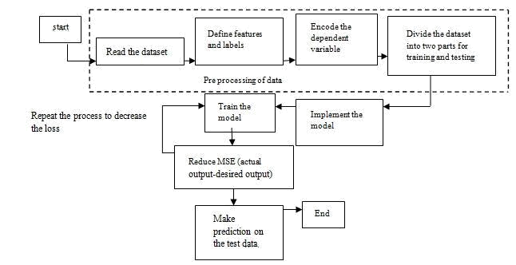

Figure 1. Working flow of Artificial Neural Network

Mathematical Model

The basic aspect of a neural network is neuron. It is a mathematical model that has three sets of rules such as multiplication, summation and activation. The input will get multiplied with its weight and all the weighted input will get summed in the middle section. At the output section the activation part also called as transfer function will be there to decide what should be fired asoutput.
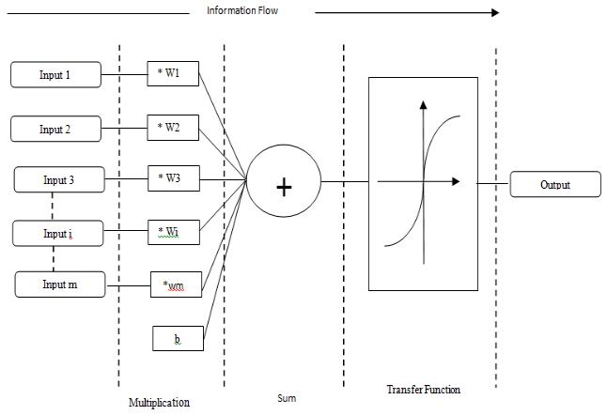

Figure 2. Working principle of an artificial neuron

Artificial Neural Network

Based on the flow of information artificial neural network is consist of two types. They are feed-forward topology and recurrent topology. In feed-forward topology the information is flow from input to output in only one direction as shown in Figure 3. Whereas in recurrent topology it takes more than one direction i.e., the

information can also flow in opposite direction as shown in figure 4
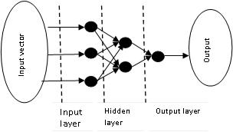

Figure 3. Feed forward topology

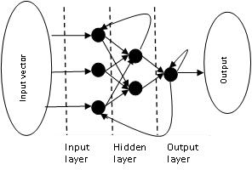

Figure 4. Recurrent topology Feed-forward Artificial Neural Networks
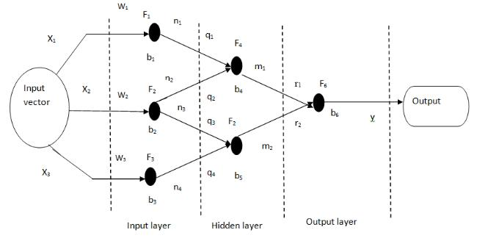

Figure 5. Feed forward Neural Network

The Figure 5 shows the basic feed forward network topology. The Network contains feed-forward topology is called as feed-forward network. It will work in a restraint that the information flow has to be only in one direction with no back-loops.
₁ | = ₁ | ₁₁+₁ |  |  | (1)
₂ | = ₂ | ₂₂+ ₂(2)
₃ | = ₂ | ₂ | ₂ | + ₂ | (3)
₄ | = ₃ | ₃ | ₃ | + ₃ | (4)
₁ = ₄ |  | ₁ | ₁ | +₂₂+₄ |  |  |  |  |  |  |  | (5)
₂ = ₅ |  | ₃₃+₄₄+₅ |  |  |  |  |  |  |  |  |  | (6)
=₆₁₁+₂₂+₆ |  |  |  |  |  |  |  |  | (7)
 | ₁ |  | ₄ | ₁₁ ₁₁+₁ |  |  |  |  |  |  |  |  | + | + ₄ | + ⋯
 |  |  | ₄ |  |  |  |  |  |  |  | + |  |  | + ₄ | + ⋯
= ₆ |  |  |  | 2 | 2 |  | 2 | 2 |  |  |  | 2 |  |  | (8)
 |  |  |  | ₃₂ ₂₂+₂ |  |  |  |  |  |  |  |  |  | + | (8)
 | … 2 5 |  |  |  |  |  |  |  | 3 |  |  | + |  | + | + ₆
 |  |  |  | 4 | 3 |  |  | 3 |  |  |  |  | 3 | 5

.

2

IV. RESULTS AND DISCUSSION

The Dataset is obtained from UCI WISCONSIN Breast Cancer dataset. The figure 6 shows the Wisconsin Breast Cancer dataset. The Dataset consist of 569 entries. MATLAB software is used for simulating the output. The dataset has 30 features from that only 10 significant features are inserted into the MATLAB. The network is trained and tested in the ratio of 70-30%. After partitioning the dataset, the functions are given step by step using the nntool in the MATLAB is shown in figure 7.Then the network is created and it is shown in figure 8. For each and every training session the regression graph will also get varied. The Figure 9 shows the last regression graph obtained during final training session. Then performance measures are calculated by using the below formula. The performance measures like confusion matrix (shown in Table 2), accuracy, error, sensitivity, specificity, positive predictive value and negative predictive value can be calculated by using the equations (9), (10), (11), (12), (13), (14) respectively. Finally, table 1 shows the overall performance.
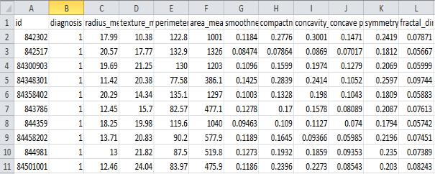

Figure 6. WISCONSIN Breast Cancer Dataset
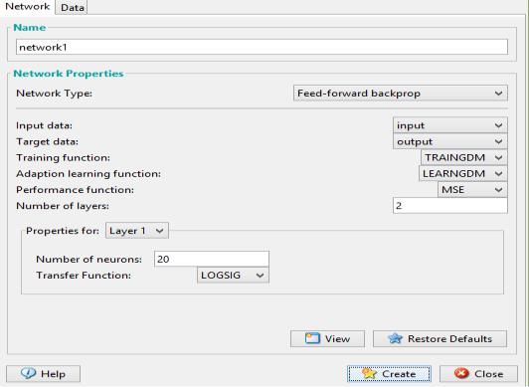

Figure 7. Creating Network or Data window
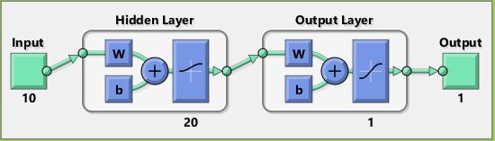

Figure 8. Custom Neural Network window

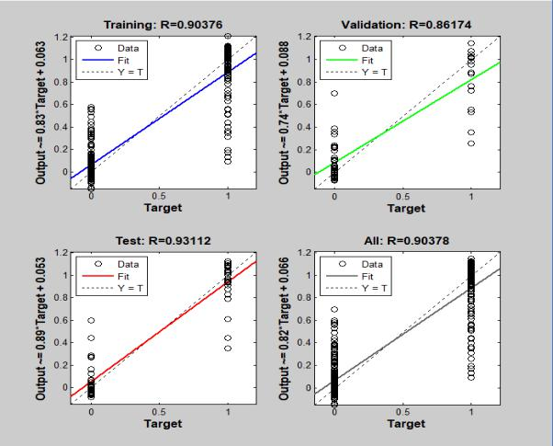

Figure 9. Training result
+
⁼ ⁽⁹⁾

+
⁼¹⁻ ⁼ ⁽¹⁰⁾

= ₊ (11)

= ₊ (13)

= ₊ (14)

Where tp, tn, fn, fp are found using the confusion matrix as shown in Table .2

Table.1.Performance Measures of Feed-Forward model

 | Feed-Forward
Accuracy | 0.8953
Error | 0.1047
Sensitivity | 0.7419
Specificity | 0.7419
Positive Predictive Value | 0.9583
Negative Predictive Value | 0.8709

Table.2. Confusion matrix
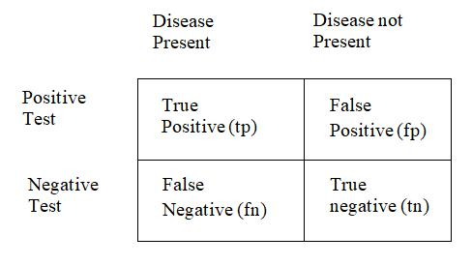

3
V. CONCLUSION

Neural network has the ability toderive different kinds of

samples. This characteristic seem to have an effect upon
various aspects which includes the neurons count,
connection type and the training extent of the network.
Neural Network also has the advantage that it is able to find

the lost values. Whereas logistic regression does not
consider the lost values foradditional analysis. The ANN
model performs better than logistic model. Given with
enough running time, Neural networks are able to predict
the output with high level accuracy. Being an easy and quick
tool, It helps the health care labours to gauge the risk of

breast cancer.

VI. REFERENCES

- Hiba Asria, Hajar Mousannif, Hassan Al Moatassime, Thomas Noel,

“Using Machine Learning Algorithms for Breast Cancer Risk
Prediction and Diagnosis”, Procedia Computer Science 83, (2016),

1064-1069.

- Abien Fred M. Agarap, “On Breast Cancer Detection : An
Application of Machine Learning Algorithms on the Wisconsin

Diagnostic Dataset”, arXiv:1711.07831v1 [cs.LG] 20 Nov 2017.

- Yasmeen Mourice George, et al.“Remote Computer-Aided Breast Cancer Detection and Diagnosis System Based on Cytological Image”, IEEE SYSTEMS JOURNAL, VOL. 8, NO. 3, SEPTEMBER 2014

- Kalpana Kaushik, Anil Arora, “Breast Cancer Diagnosis using Artificial Neural Network”, International Journal of Latest Trends in

Engineering and Technology (IJLTET), Vol 7 issue 2 July 2016

- AutsuoHiga, “Diagnosis of Breast Cancer using Decision Tree and Artificial Neural Network Algorithms”, International Journal of

Computer Applications Technology and Research Volume 7–Issue 01, 23-27, 2018, ISSN:-2319–8656

4

