**DETERMINING VISCOSITY USING LEAST SQUARE METHOD**

**FACULTY:** Prof. Karthik Chandrasekhar

**PROGRAMME:** BTech (Computer Science)

**COURSE:** Linear Algebra

**COURSE CODE:** UE18MA251

**PREPARED BY:**

1. Aishwarya Shanbhag (PES2201800006)
2. Apoorva Choudhary (PES2201800102)
3. Richa Angadi (PES2201800111)



**TABLE OF CONTENTS**

1. Problem Statement
2. Introduction
3. Review of Literature
4. Report on Present Investigation
5. Results and Discussions
6. Summary and Conclusions
7. Bibliography

**PROBLEM STATEMENT**

The value of viscosity differs with temperature. When the temperature increases, the dynamic viscosity either increases or decreases. In order to measure the value of liquid water viscosity, the method of least squares gives a way to find the best estimate, assuming that the errors (i.e. the differences from the true value) are random and unbiased.

Using a given set of data, we **determine the viscosity of liquid water at different temperature using least square method**.

**INTRODUCTION**

Informally, viscosity is the quantity that describes a fluid's resistance to flow. Fluids resist the relative motion of immersed objects through them as well as to the motion of layers with differing velocities within them.

Formally, viscosity (represented by the symbol “η” and pronounced as "eta") is the ratio of the shearing stress (F/A) to the velocity gradient (∆ $v_{x}$/∆z or dy/dz) in a fluid.

η = $\frac{F/A}{∆v_{x}/∆z}$

From everyday experiences we can observe that viscosity varies with temperature. Honey and syrups can be made to flow more readily when heated. Engine oil and hydraulic fluids thicken appreciably on cold days and significantly affect the performance of cars and other machinery during the winter months. In general, the viscosity of a simple liquid decreases with increasing temperature. As temperature increases, the average speed of the molecules in a liquid increase and the amount of time they spend "in contact" with their nearest neighbours decreases. Thus, as temperature increases, the average intermolecular forces decrease. The actual manner in which the two quantities vary is nonlinear and changes abruptly when the liquid changes phase.

Since viscosity is so dependent on temperature, it shouldn't be stated without it.

The set of data about several range of temperature and viscosity was observed in the previous article. It is used to study the effect of temperature on the viscosity of liquid water. A line of best fit can be roughly determined using a scatter plot so that the number of points above the line and below the line is about equal and the line passes through as many points as possible. A more accurate way of finding the line of best fit is the least square method.

**REVIEW OF LITERATURE**

Our prescribed syllabus book deals with least squares in matrices used best for approximation and projection of vectors. The previous papers and works on the same topic were less in number but the least squares methods have been presented using various concepts including differentiation, Gaussian elimination among many other methods. Least squares prove to be an important factor for analysis in Regression in Machine learning.

This paper analyses the work of Joseph Kestlin, Mordechai Sokolov and William Wakeham by representing their data as a set of function- linear, polynomial and exponential. Viscosity of the water was taken with the different temperature by the different method in linear least square. Based on the observation, the values of error are recorded. A line of best fit can be roughly determined using a scatter plot. This helps us to calculate an accurate value of the viscosity of liquid water at various temperature and essential conditions such as thermal expansion and buoyancy factors. The accuracy of the paper is limited to ± 0.2% which is in accordance with the paper.

Other papers take into account many other factors, like the pressure, density and other atmospheric conditions and implement least squares concept depending on the accuracy.

**REPORT ON PRESENT INVESTIGATION**

**Value of different temperature and viscosity.**

|  |  |
| --- | --- |
| **Temperature ( ̊C)** | **Viscosity, µ Pa⸱s** |
| 5 | 1519.3 |
| 10 | 1307 |
| 15 | 1138.3 |
| 20 | 1002 |
| 25 | 890.2 |
| 30 | 797.3 |
| 35 | 719.1 |
| 40 | 652.7 |
| 45 | 596.1 |
| 50 | 547.1 |
| 55 | 504.4 |
| 60 | 467 |
| 65 | 433.9 |
| 70 | 404.6 |
| 75 | 378.5 |
| 80 | 355.1 |
| 85 | 334.1 |
| 90 | 315 |
| 95 | 297.8 |
| 100 | 282.1 |

Independent variables, x = Temperature

Dependent variables, y = Viscosity of liquid water

When the same is plotted, we’ll arrive at the following graph.

**º**

Temperature

Viscosity

1. **Linear model**

**Linear equation: y=a0+a1x**

|  |  |  |  |  |
| --- | --- | --- | --- | --- |
| **No.** | **Temperature(ºC) (x)** | **Viscosity µPa.s (y)** | **X2** | **Xy** |
| 1 | 5 | 1519.3 | 25 | 7596.5 |
| 2 | 10 | 1307 | 100 | 13070 |
| 3 | 15 | 1138.3 | 225 | 17074.5 |
| 4 | 20 | 1002 | 400 | 20040 |
| 5 | 25 | 890.2 | 625 | 22255 |
| 6 | 30 | 797.3 | 900 | 23919 |
| 7 | 35 | 719.1 | 1225 | 25168.5 |
| 8 | 40 | 652.7 | 1600 | 26108 |
| 9 | 45 | 596.1 | 2025 | 26824.5 |
| 10 | 50 | 547.1 | 2500 | 27355 |
| 11 | 55 | 504.4 | 3025 | 27742 |
| 12 | 60 | 467 | 3600 | 28020 |
| 13 | 65 | 433.9 | 4225 | 28203.5 |
| 14 | 70 | 404.6 | 4900 | 28322 |
| 15 | 75 | 378.5 | 5625 | 28387.5 |
| 16 | 80 | 355.1 | 6400 | 28408 |
| 17 | 85 | 334.1 | 7225 | 28398.5 |
| 18 | 90 | 315 | 8100 | 28350 |
| 19 | 95 | 297.8 | 9025 | 28291 |
| 20 | 100 | 282.1 | 10000 | 28210 |
| ∑**=** | **1050** | **12941.6** | **71750** | **491743.5** |

We use the following equations:

na0 +a1Σx = Σy

a0Σx + a1Σx2 = Σxy

Substituting the values, we get:

20a0 +1050a1 = 12941.6

1050a0 + 71750a1 = 491743.5

$$\left(\begin{matrix}n & Σx \\ Σx & Σx^{2}\end{matrix}\right)\left({a^{0} \atop a^{1}}\right)=\left({Σx \atop Σxy}\right)$$

$$\left(\begin{matrix}20 & 1050 \\ 1050 & 71750\end{matrix}\right)\left({a^{0} \atop a^{1}}\right)=\left({12941.6 \atop 491743.5}\right)$$

On solving, we get

a₀ =1239.786842

a₁ = -11.28965414

y = - 11.28965414x + 1239.786842

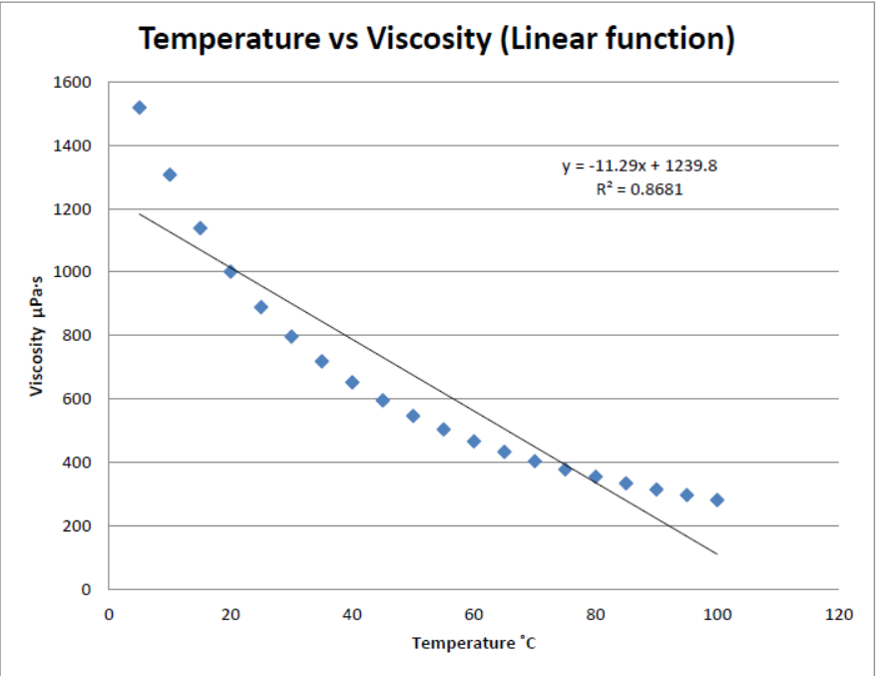

**II. Polynomial Model**.

Polynomial equation: y = a0 +a1x + a2x2

|  |  |  |  |  |  |  |  |
| --- | --- | --- | --- | --- | --- | --- | --- |
| **No** | **Temperature**  **( ̊C) (x)** | **Viscosity**  **µ, Pa⸱s (y)** | **X2** | **X3** | **X4** | **Xy** | **x2y** |
| 1 | 5 | 1519.3 | 25 | 125 | 625 | 7596.5 | 37982.5 |
| 2 | 10 | 1307 | 100 | 1000 | 10000 | 13070 | 130700 |
| 3 | 15 | 1138.3 | 225 | 3375 | 50625 | 17074.5 | 256117.5 |
| 4 | 20 | 1002 | 400 | 8000 | 160000 | 20040 | 400800 |
| 5 | 25 | 890.2 | 625 | 15625 | 390625 | 22255 | 556375 |
| 6 | 30 | 797.3 | 900 | 27000 | 810000 | 23919 | 717570 |
| 7 | 35 | 719.1 | 1225 | 42875 | 1500625 | 25168.5 | 880897.5 |
| 8 | 40 | 652.7 | 1600 | 64000 | 2560000 | 26108 | 1044320 |
| 9 | 45 | 596.1 | 2025 | 91125 | 4100625 | 26824.5 | 1207102.5 |
| 10 | 50 | 547.1 | 2500 | 125000 | 6250000 | 27355 | 1367750 |
| 11 | 55 | 504.4 | 3025 | 166375 | 9150625 | 27772 | 1525810 |
| 12 | 60 | 467 | 3600 | 216000 | 12960000 | 28020 | 1681200 |
| 13 | 65 | 433.9 | 4225 | 274625 | 17850625 | 28203.5 | 1833227.5 |
| 14 | 70 | 404.6 | 4900 | 343000 | 24010000 | 28322 | 1982540 |
| 15 | 75 | 378.5 | 5625 | 421875 | 31640625 | 28387.5 | 2129062.5 |
| 16 | 80 | 355.1 | 6400 | 512000 | 40960000 | 28408 | 2272640 |
| 17 | 85 | 334.1 | 7225 | 614125 | 52200625 | 28398.5 | 2413872.5 |
| 18 | 90 | 315 | 8100 | 729000 | 65610000 | 28350 | 2551500 |
| 19 | 95 | 297.8 | 9025 | 857375 | 81450625 | 28291 | 2687645 |
| 20 | 100 | 282.1 | 10000 | 1000000 | 100000000 | 28210 | 2821000 |
| 𝞢= | 1050 | 12941.6 | 71750 | 5512500 | 451666250 | 491743.5 | 28498112.5 |

We use the following equations:

na0 +a1Σx = Σy

a0Σx + a1Σx2 = Σxy

a0Σx2 + aΣx3 = Σx2y

Substituting the values, we get:

20a0 +1050a1 + 71750a2 = 12941.6.................. (1)

1050a0 + 71750a1 + 5512500a2= 491743.5........... (2)

71750a0 +5512500a1 + 451666250a2= 28498112.5........... (3)

$\left(\begin{matrix}n & Σx & {Σx}^{2} \\ Σx & {Σx}^{2} & {Σx}^{3} \\ {Σx}^{2} & {Σx}^{3} & {Σx}^{4}\end{matrix}\right)\left(\left.\begin{matrix}a_{0} \\ a_{1} \\ a_{2}\end{matrix}\right)\right.$ = $\left(\left.\begin{matrix}Σx \\ Σxy \\ {Σx}^{2}y\end{matrix}\right)\right.$

$\left(\begin{matrix}20 & 1050 & 71750 \\ 1050 & 71750 & 5512500 \\ 71750 & 5512500 & 451666250\end{matrix}\right)$ $\left(\left.\begin{matrix}a_{0} \\ a_{1} \\ a_{2}\end{matrix}\right)\right.$ = $\left(\left.\begin{matrix}12941.6 \\ 491743.5 \\ 28498112.5\end{matrix}\right)\right.$

a₀ =1551.650877

a₁ = -28.30041969

a₂ = 0.1620079291

y =0.1620079291x² -28.30041969X + 1551.650877

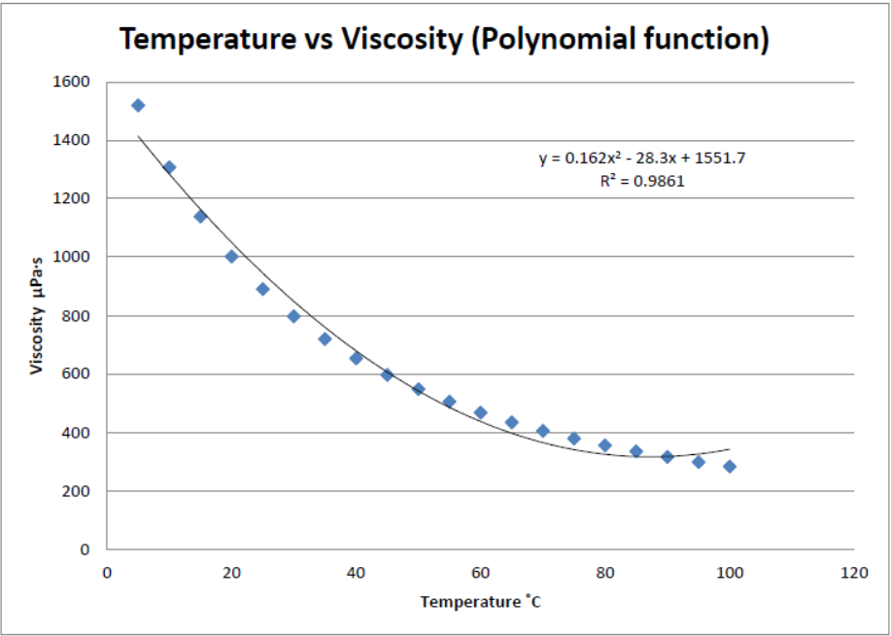

**III. Exponential model.**

Exponential equation: y = a $e^{bx}$

|  |  |  |  |  |  |
| --- | --- | --- | --- | --- | --- |
| **No** | **Temperature**  **( ̊C) (x)** | **Viscosity**  **µ, Pa⸱s (y)** | **X2** | **lny** | **Xlny** |
| 1 | 5 | 1519.3 | 25 | 7.326004981 | 36.63002491 |
| 2 | 10 | 1307 | 100 | 7.175489714 | 71.75489714 |
| 3 | 15 | 1138.3 | 225 | 7.0372912 | 105.559368 |
| 4 | 20 | 1002 | 400 | 6.909753282 | 138.1950656 |
| 5 | 25 | 890.2 | 625 | 6.791446157 | 169.7861539 |
| 6 | 30 | 797.3 | 900 | 6.68123102 | 200.4369306 |
| 7 | 35 | 719.1 | 1225 | 6.57800043 | 230.2300151 |
| 8 | 40 | 652.7 | 1600 | 6.481117606 | 259.2447042 |
| 9 | 45 | 596.1 | 2025 | 6.390408438 | 287.5683797 |
| 10 | 50 | 547.1 | 2500 | 6.304631601 | 315.2315801 |
| 11 | 55 | 504.4 | 3025 | 6.223369604 | 342.2853282 |
| 12 | 60 | 467 | 3600 | 6.146329258 | 368.7797555 |
| 13 | 65 | 433.9 | 4225 | 6.072814093 | 394.732916 |
| 14 | 70 | 404.6 | 4900 | 6.002898925 | 420.2029247 |
| 15 | 75 | 378.5 | 5625 | 5.936216073 | 445.2162055 |
| 16 | 80 | 355.1 | 6400 | 5.87239944 | 469.7919552 |
| 17 | 85 | 334.1 | 7225 | 5.811440349 | 493.9724297 |
| 18 | 90 | 315 | 8100 | 5.752572639 | 517.7315375 |
| 19 | 95 | 297.8 | 9025 | 5.69642212 | 541.1601014 |
| 20 | 100 | 282.1 | 10000 | 5.642261618 | 564.2261618 |
| 𝞢= | 1050 | 12941.6 | 71750 | 126.8320985 | 6372.736435 |

We use the following equations:

na0 +a1Σx = Σlny

a0Σx + a1Σx2 = Σxlny

Substituting the equations, we get:

20a0 +1050a1 = 126.8320985.................. (1)

1050a0 + 71750a1 = 6372.736435........... (2)

$$\left(\begin{matrix}n & Σx \\ Σx & Σx^{2}\end{matrix}\right)\left({lnα \atop β}\right)=\left({Σlnx \atop Σxlny}\right)$$

$$\left(\begin{matrix}20 & 1050 \\ 1050 & 71750\end{matrix}\right)\left({lnα \atop β}\right)=\left({126.8320985 \atop 6372.736435}\right)$$

Solving the equations, we arrive at the following values,

lnα=7.2446009834

α=e7.244600934

α=1400.522883

β= -0.01719992398

y=1400.522883e-0.01719992398x

**RESULTS AND DISCUSSIONS**

Using the derived equations, we try to find the difference between the expected value and the theoretical value and try to minimise that difference.

**SUM OF SQUARE ERRORS FOR:**

1. **LINEAR MODEL**

|  |  |  |  |  |
| --- | --- | --- | --- | --- |
| **Temperature ˚C (X)** | **Viscosity μPa·s (Y)** | **Y1 = - 11.29(X) + 1239.8** | **Error1 = Y - Y1** | **Error12** |
| 5 | 1519.3 | 1183.35 | 335.95 | 112862.4025 |
| 10 | 1307 | 1126.9 | 180.1 | 32436.01 |
| 15 | 1138.3 | 1070.45 | 67.85 | 4603.6225 |
| 20 | 1002 | 1014 | -12 | 144 |
| 25 | 890.2 | 957.55 | -67.35 | 4536.0225 |
| 30 | 797.3 | 901.1 | -103.8 | 10774.44 |
| 35 | 719.1 | 844.65 | -125.55 | 15762.8025 |
| 40 | 652.7 | 788.2 | -135.5 | 18360.25 |
| 45 | 596.1 | 731.75 | -135.65 | 18400.9225 |
| 50 | 547.1 | 675.3 | -128.2 | 16435.24 |
| 55 | 504.4 | 618.85 | -114.45 | 13098.8025 |
| 60 | 467 | 562.4 | -95.4 | 9101.16 |
| 65 | 433.9 | 505.95 | -72.05 | 5191.2025 |
| 70 | 404.6 | 449.5 | -44.9 | 2016.01 |
| 75 | 378.5 | 393.05 | -14.55 | 211.7025 |
| 80 | 355.1 | 336.6 | 18.5 | 342.25 |
| 85 | 334.1 | 280.15 | 53.95 | 2910.6025 |
| 90 | 315 | 223.7 | 91.3 | 8335.69 |
| 95 | 297.8 | 167.25 | 130.55 | 17043.3025 |
| 100 | 282.1 | 110.8 | 171.3 | 29343.69 |
| **∑=1050** | **12941.6** | **12941.5** | **130.55** | **321910.125** |

1. **POLYNOMIAL MODEL**

|  |  |  |  |  |
| --- | --- | --- | --- | --- |
| **Temperature (˚C) (X)** | **Viscosity μPa·s (Y)** | **Y2 = 0.162(X2) - 28.3(X) + 1551.7** | **E2 = Y – Y2** | **Error22** |
| 5 | 1519.3 | 1414.25 | 105.05 | 11035.5025 |
| 10 | 1307 | 1284.9 | 22.1 | 488.41 |
| 15 | 1138.3 | 1163.65 | -25.35 | 642.6225 |
| 20 | 1002 | 1050.5 | -48.5 | 2352.25 |
| 25 | 890.2 | 945.45 | -55.25 | 3052.5625 |
| 30 | 797.3 | 848.5 | -51.2 | 2621.44 |
| 35 | 719.1 | 759.65 | -40.55 | 1644.3025 |
| 40 | 652.7 | 678.9 | -26.2 | 686.44 |
| 45 | 596.1 | 606.25 | -10.15 | 103.0225 |
| 50 | 547.1 | 541.7 | 5.4 | 29.16 |
| 55 | 504.4 | 485.25 | 19.15 | 366.7225 |
| 60 | 467 | 436.9 | 30.1 | 906.01 |
| 65 | 433.9 | 396.65 | 37.25 | 1387.5625 |
| 70 | 404.6 | 364.5 | 40.1 | 1608.01 |
| 75 | 378.5 | 340.45 | 38.05 | 1447.8025 |
| 80 | 355.1 | 324.5 | 30.6 | 936.36 |
| 85 | 334.1 | 316.65 | 17.45 | 304.5025 |
| 90 | 315 | 316.9 | -1.9 | 3.61 |
| 95 | 297.8 | 325.25 | -27.45 | 753.5025 |
| 100 | 282.1 | 341.7 | -59.6 | 3552.16 |
| **∑=1050** | **12941.6** | **12942.5** | **-27.45** | **33921.955** |

1. **EXPONENTIAL FUNCTION**

|  |  |  |  |  |
| --- | --- | --- | --- | --- |
| **Temperature ˚C (X)** | **Viscosity μPa·s (Y)** | **Y3 =**  **1400.522883e-0.01719992398x** | **Error3 = Y - Y1** | **Error32** |
| 5 | 1519.3 | 207852.6293 | -206333.3293 | 42573442790 |
| 10 | 1307 | 30848065.35 | -30846758.35 | 9.51523E+14 |
| 15 | 1138.3 | 4578258830 | -4578257692 | 2.09604E+19 |
| 20 | 1002 | 6.79474 x1011 | -6.79474E+11 | 4.61685E+23 |
| 25 | 890.2 | 1.00843 x1014 | -1.00843E+14 | 1.01693E+28 |
| 30 | 797.3 | 1.49664 x1016 | -1.49664E+16 | 2.23993E+32 |
| 35 | 719.1 | 2.22121 x1018 | -2.22121E+18 | 4.93378E+36 |
| 40 | 652.7 | 3.29657 x1020 | -3.29657E+20 | 1.08674E+41 |
| 45 | 596.1 | 4.89254 x1022 | -4.89254E+22 | 2.3937E+45 |
| 50 | 547.1 | 7.26118 x1024 | -7.26118E+24 | 5.27247E+49 |
| 55 | 504.4 | 1.07765 x1027 | -1.07765E+27 | 1.16134E+54 |
| 60 | 467 | 1.59938 x1029 | -1.59938E+29 | 2.55802E+58 |
| 65 | 433.9 | 2.37369v x1031 | -2.37369E+31 | 5.63442E+62 |
| 70 | 404.6 | 3.52287 x1033 | -3.52287E+33 | 1.24106E+67 |
| 75 | 378.5 | 5.22841 x1035 | -5.22841E+35 | 2.73362E+71 |
| 80 | 355.1 | 7.75964 x1037 | -7.75964E+37 | 6.0212E+75 |
| 85 | 334.1 | 1.15163 x1040 | -1.15163E+40 | 1.32626E+80 |
| 90 | 315 | 1.70917 x1042 | -1.70917E+42 | 2.92128E+84 |
| 95 | 297.8 | 2.53664 x1044 | -2.53664E+44 | 6.43454E+88 |
| 100 | 282.1 | 3.76471 x1046 | -3.76471E+46 | 1.4173E+93 |
| **∑=1050** | **12941.6** | **3.79025 x1046** | **-2.53664E+44** | **1.41737E+93** |

**SUMMARY AND CONCLUSION**

We can summarise it as follows:

|  |  |  |  |
| --- | --- | --- | --- |
| **MODEL** | **LINEAR** | **POLYNOMIAL** | **EXPONENTIAL** |
| **SUM OF SQUARES OF ERRORS** | 321910.125 | 33921.955 | 1.41737E+93 |

This is gives evidence that the linear model gives the smallest error in finding the viscosity of the water compared to the exponential and polynomial least square methods.

We can then illustrate it,

|  |  |
| --- | --- |
| **Temperature ˚C (X)** | **Y1 = - 11.29(X) + 1239.8** |
| 5 | 1183.35 |
| 10 | 1126.9 |
| 15 | 1070.45 |
| 20 | 1014 |
| 25 | 957.55 |
| 30 | 901.1 |
| 35 | 844.65 |
| 40 | 788.2 |
| 45 | 731.75 |
| 50 | 675.3 |
| 55 | 618.85 |
| 60 | 562.4 |
| 65 | 505.95 |
| 70 | 449.5 |
| 75 | 393.05 |
| 80 | 336.6 |
| 85 | 280.15 |
| 90 | 223.7 |
| 95 | 167.25 |
| 100 | 110.8 |
| **∑=1050** | **12941.5** |

Where the slope is -11.29.

The studies were conducted on the influences of different temperature on viscosity of liquid water by using the method whose coefficients are redetermined through considering new numerical experiments. For a specified temperature, the relative viscosity nonlinearly decreases with enlarging temperature. For a given temperature, the relative viscosity of water inside the increases with decreasing temperature. Hence, viscosity of the liquid water can be found more accurately using linear function.

**BIBLIOGRAPHY**

1. Kestin, Joseph. Sokolov, Mordechai. & Wakeham, A. Wakeham. (1969). Viscosity of liquid water in the range -8 0C to 1500C. Brown University. http://engineersedge.com/imagefiles/water-viscosity.pdf
2. https://mathworld.wolfram.com/LeastSquaresFittingExponential.html
3. https://web.williams.edu/Mathematics/sjmiller/public_html/BrownClasses/54/handouts/MethodLeastSquares.pdf
4. https://www.slideshare.net/fieyzad1/application-of
5. https://en.wikipedia.org/wiki/Least_squares