11.Applying databases normalization techniques to eliminate redundancy and improve data integrity in workbench querry.

use science;
show databases;
1.Create unnormalized table:
CREATE TABLE students_courses(
student_id INT,
student_name VARCHAR(50),
course_id INT,
course_name VARCHAR(50),
PRIMARY KEY(student_id,course_id)
);
INSERT INTO students_courses VALUES
(1,'Arati',101,'Math'),
(1,'Arati',102,'Physics'),
(2,'Rohit',101,'Math'),
(3,'Sana',103,'Computer');
SELECT*FROM students_courses;
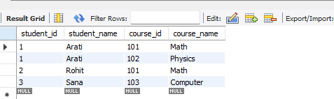

2.

