Pro 20: Implementing Distributed database System and Handling Data Partitioning.
Create database:
CREATE DATABASE science9;
Use science9;
CREATE TABLE Student(
student_id INT PRIMARY KEY,
name VARCHAR(50),
city VARCHAR(50),
department VARCHAR(50));
Create tables:
CREATE TABLE Course(
course_id INT PRIMARY KEY,
course_name VARCHAR(50),
credits INT);
Insert Sample data:
INSERT INTO Student VALUES
(1,'Rahul','Mumbai','Computer Science'),
(2,'Priya','Delhi','Mathematics'),
(3,'Amit','Mumbai','Physics'),
(4,'Neha','Delhi','Computer Science');
SELECT*FROM Student;
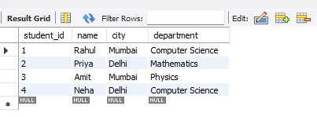

Horizonatal Partitioning:
CREATE TABLE Student_Mumbai AS
SELECT*FROM student
WHERE city = 'Mumbai';
CREATE TABLE Student_Dehli AS
SELECT*FROM Student
WHERE city = 'Dehli';

Verical Partitioning:
CREATE TABLE Student_Personal AS
SELECT student_id, name, city
FROM Student;
SELECT*FROM Student;
CREATE TABLE Student_Academic AS
SELECT student_id, department
FROM Student;
SELECT*FROM Student;

Check storage engines:
SHOW ENGINES;
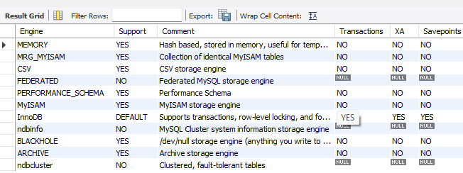

Combaine horizonatally partitioned tables:
SELECT*FROM Student_Mumbai
UNION
SELECT*FROM Student_Dehli;
