Pro17: Implementation full text search functionally in a database.
Create database job_portal5;
Use job_portal5;

Create Table jobs (
job_id INT AUTO_INCREMENT PRIMARY KEY,
title VARCHAR(255),
description TEXT,
location VARCHAR(100),
FULLTEXT (title,description) -- Full Text Index
);
INSERT INTO jobs (title, description, location) VALUES
('Software Devloper','Looking for a developer skilled in Java, Spring Boot and MySOL','Bengalore'),
('Data Analyst','Analyze data using Python,SQL,and Power BI','Mumbai'),
('Full Stack Engineer','React and Node js developer required for web development','Remote'),
('Database Administrator','Manage MySQL databases and optimize performance','Delhi'),
('Python Developer','Backend Python developer with experience in Django.','pune');
SELECT * FROM jobs
WHERE MATCH(title,description)AGAINST('Python developer'IN NATURAL LANGUAGE MODE);

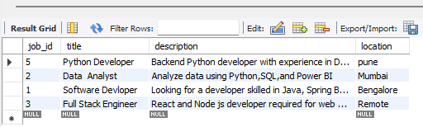

SELECT * FROM jobs
WHERE MATCH(title,description)AGAINST('+Python +Django-java' IN BOOLEAN MODE);
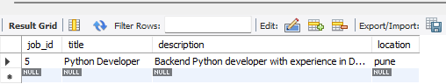

ALTER TABLE jobs ADD FULLTEXT(title,description);
SET @search='MySQL developer';
SELECT * FROM jobs
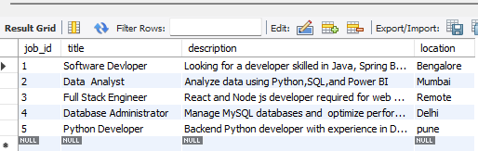

SELECT * FROM jobs
WHERE MATCH(title,description)AGAINST(@search IN NATURAL LANGUAGE MODE);
