WEEK 1

Name: Aisha Aslam

Position: Cybersecurity Intern

Organization: Skillset Go EduTech

Offer ID: SSG/REG/B1/0166

Task: 1.2 Linux & System Security Exercises

1. Introduction
For this task, I practiced Linux command-line basics on a WSL (Windows Subsystem for Linux) Ubuntu terminal. The exercises covered checking user identity, working with file permissions, creating and managing a new user, running basic system hardening (updates), checking open network services, and checking password policy. Screenshots of the terminal and short explanations are given below for each step.

2. User and System Identity
First I checked which user I was logged in as, and looked at the list of system users.
- whoami — shows the currently logged in user (dell).
- cat /etc/passwd — lists all user accounts on the system, along with their user ID, home directory, and default shell.
- id — shows the current user's UID, GID, and the groups the user belongs to (e.g. sudo, adm).
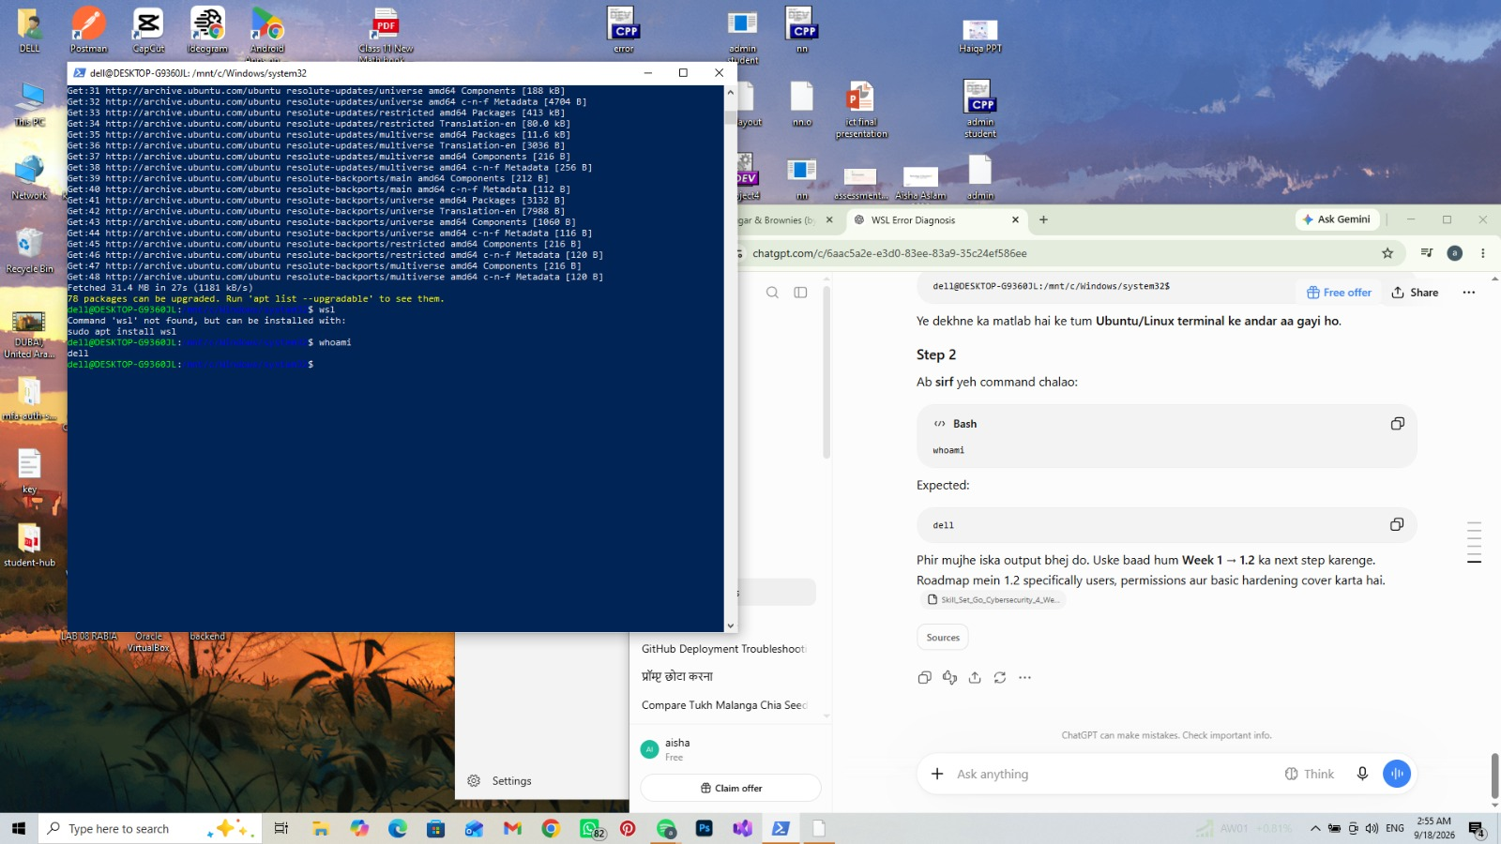
Figure 1: whoami output and start of apt update.
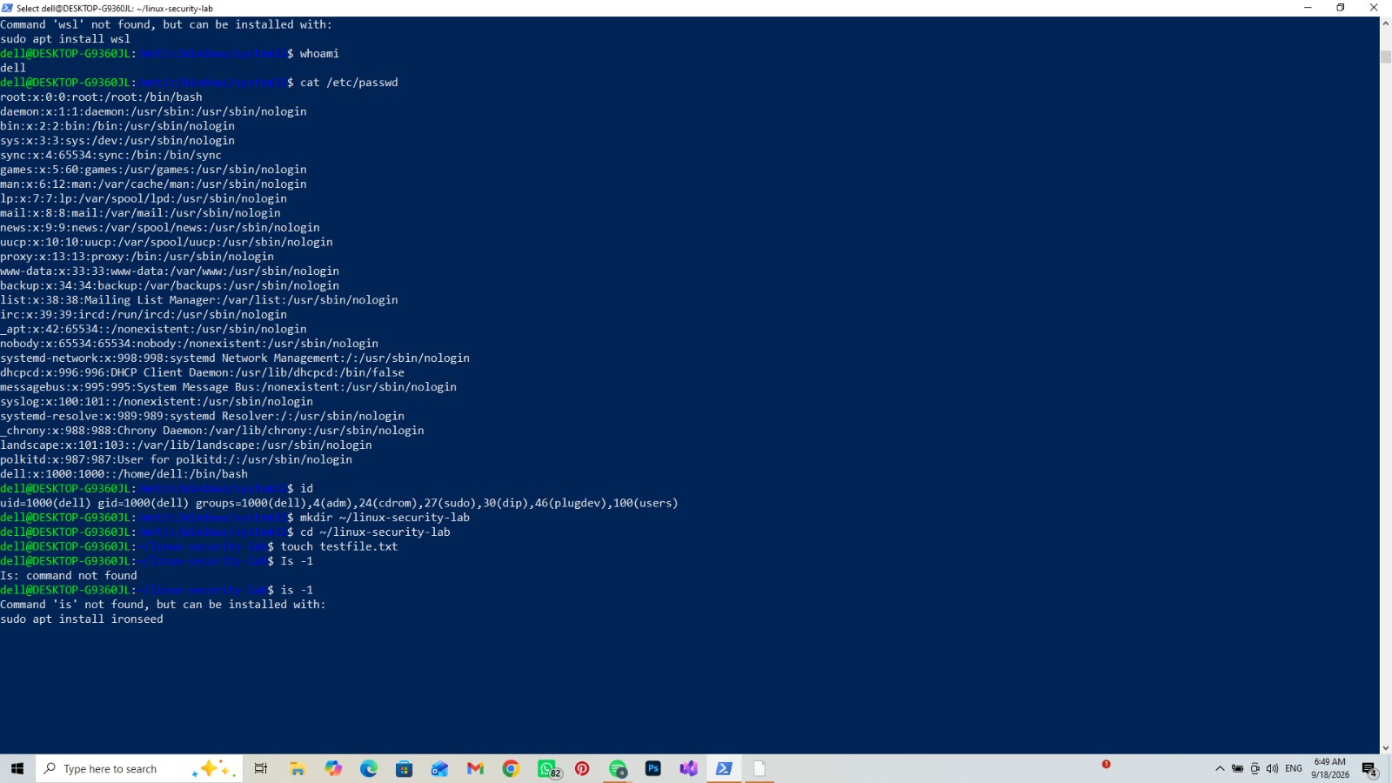
Figure 2: cat /etc/passwd (system users) and id command output.
Security relevance: knowing which user you are, and what privileges (groups) that user has, is the first step in access control. Checking /etc/passwd also helps spot unexpected or unauthorized accounts on a system.

3. Workspace Setup and File Permissions
Next I created a working folder and a test file, then checked and changed its permissions.
- mkdir ~/linux-security-lab — creates a new folder for this lab's files.
- cd ~/linux-security-lab — moves into that folder.
- touch testfile.txt — creates an empty test file.
- ls -l — lists files with permission details, owner, and size.
- chmod 600 testfile.txt — restricts the file so only the owner can read and write it (no access for group or others).
- chmod 644 testfile.txt — resets it so the owner can read/write, and everyone else can only read.
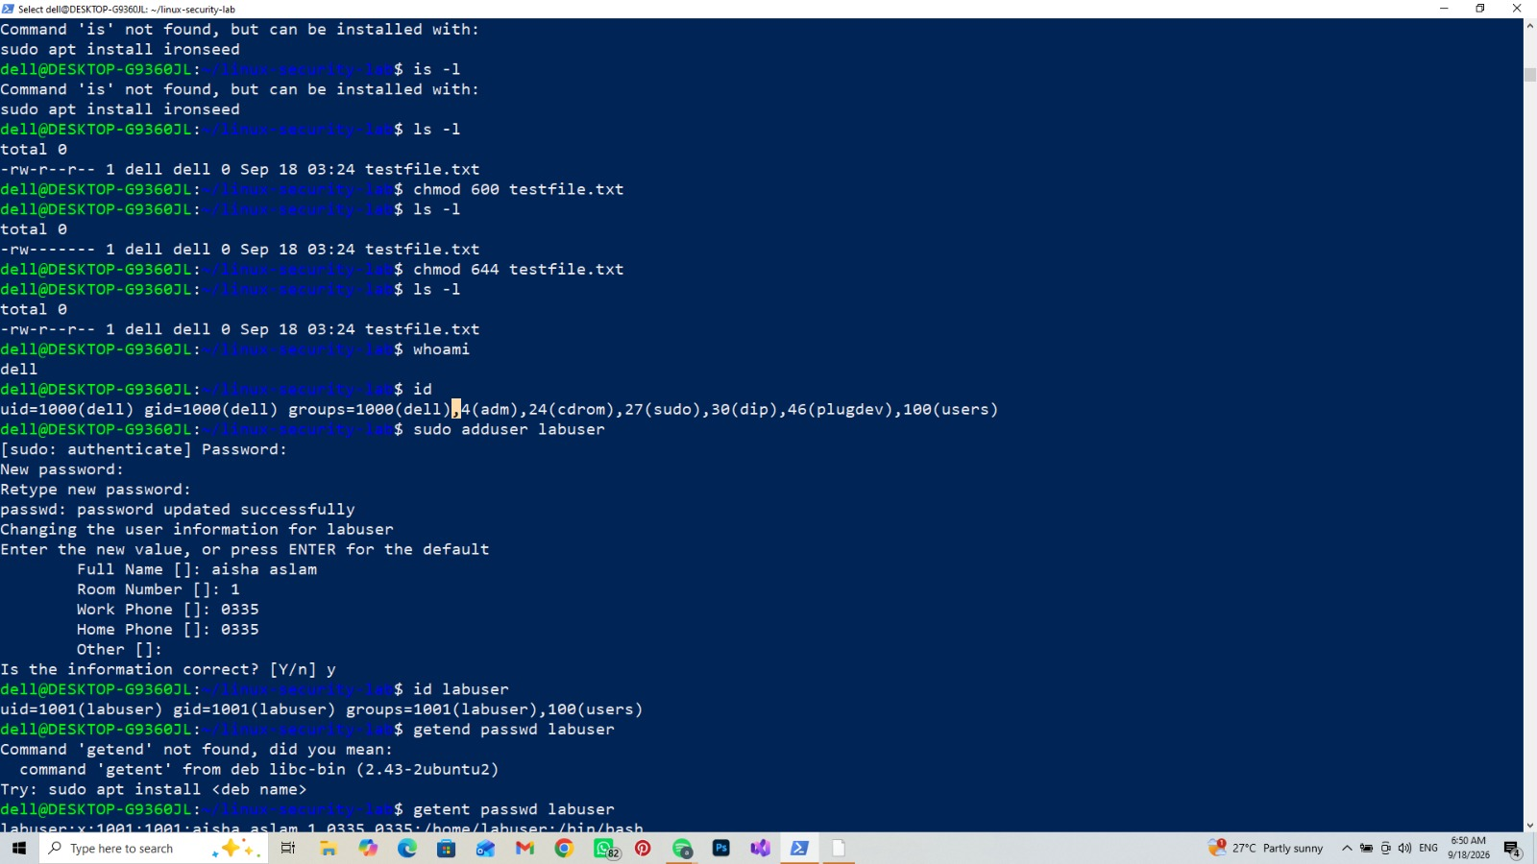
Figure 3: file permission changes with chmod 600 and chmod 644, verified using ls -l.
Security relevance: file permissions control who can read, write, or run a file. Setting overly open permissions (like 777) on sensitive files is a common security misconfiguration, since it lets any user on the system access or modify the file.

4. User Management
I created a new user account to practice basic user administration.
- sudo adduser labuser — creates a new user named labuser, sets a password, and asks for basic account details.
- id labuser — confirms the new user's UID/GID and group membership.
- getent passwd labuser — looks up the new user's account entry directly from the system database.
- ls -ld /home/labuser — checks the permissions of the new user's home directory.
(These commands are visible together with the permission changes above, in Figure 3, and continue into the update steps in Figure 4 below.)
Security relevance: creating and reviewing user accounts is a core SOC/sysadmin task. Checking a new account's group membership and home directory permissions confirms it was created with the correct, least-privilege access.

5. Basic System Hardening (Updates)
A basic hardening step is keeping the system up to date, since outdated packages can contain known vulnerabilities.
- sudo apt update — refreshes the list of available package updates from Ubuntu's repositories.
- apt list --upgradable — shows which installed packages have newer, more secure versions available.
- sudo dpkg --configure -a — finishes configuring any packages that were left in a partially installed state.
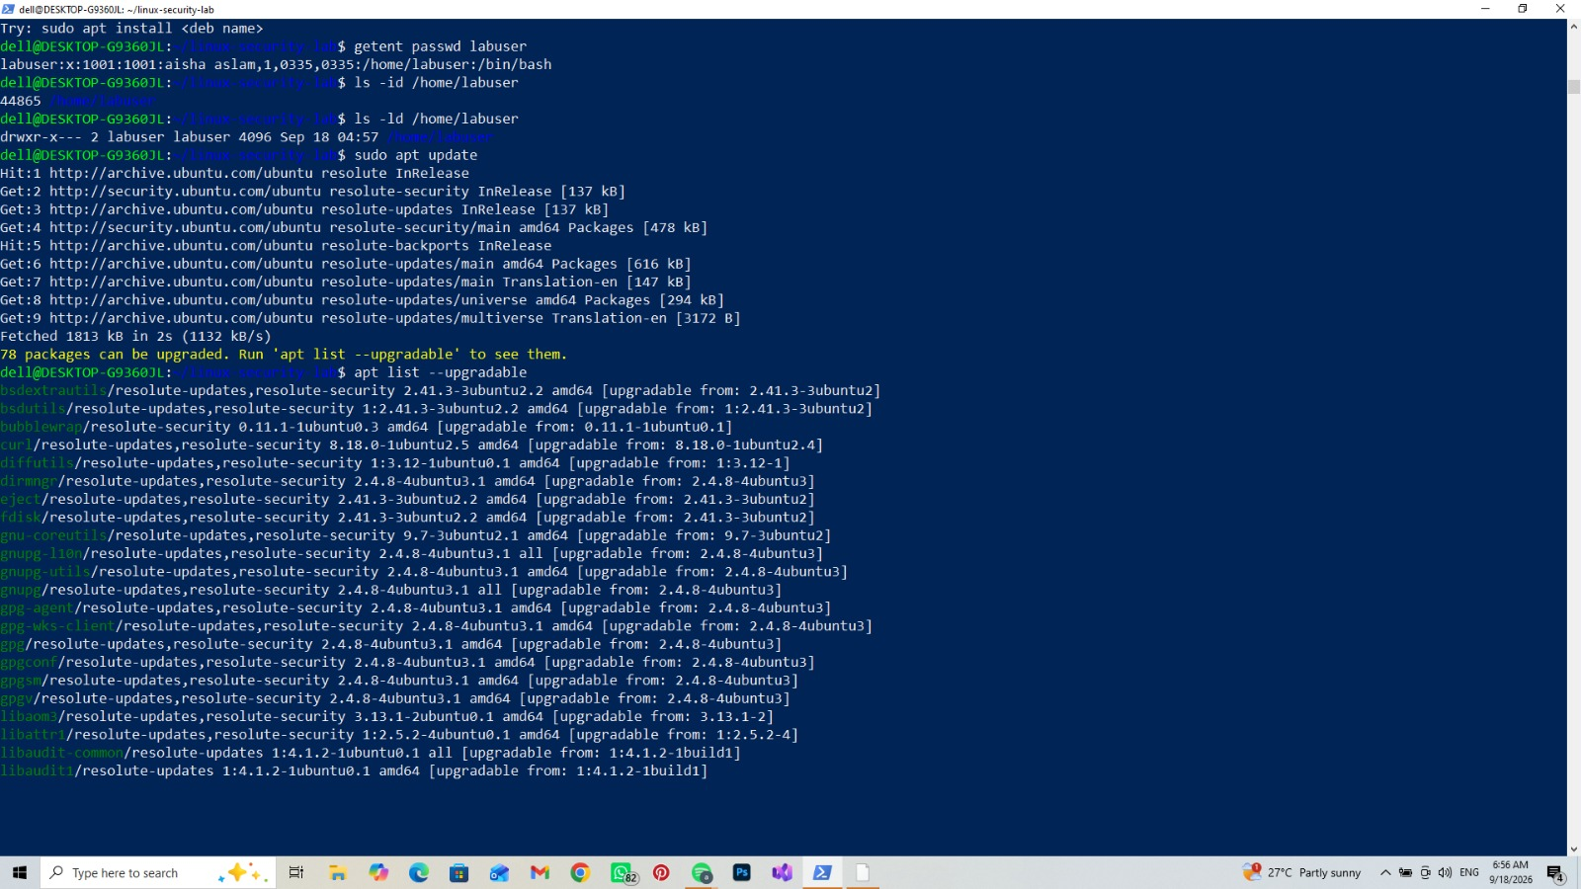
Figure 4: sudo apt update completing, followed by the list of upgradable packages.
Security relevance: unpatched software is one of the most common ways systems get compromised. Regularly checking for and applying updates closes known vulnerabilities before they can be exploited.

6. Network Service Check
I checked which network ports were open and listening on the system.
- ss -tuln — lists active listening ports (TCP and UDP) along with the local address and port number.
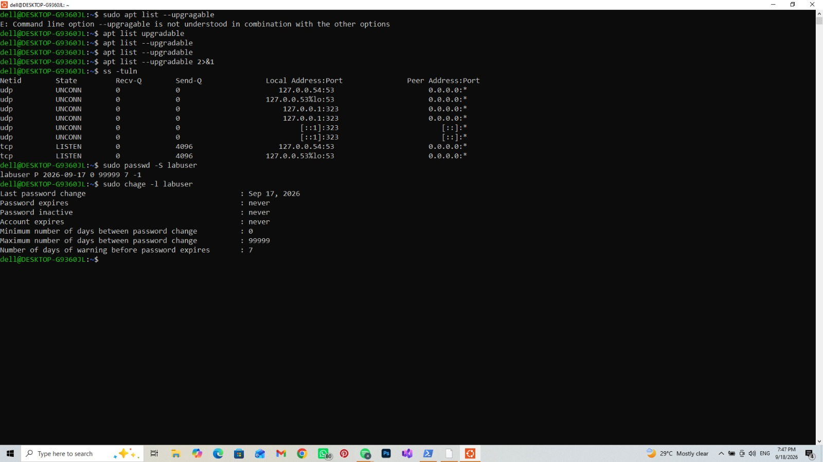
Figure 5: ss -tuln output, sudo passwd -S labuser, and sudo chage -l labuser.
Security relevance: reviewing open ports helps identify services that are running unnecessarily and could be a target for attackers. In this case, the only listening services were local DNS-related ports (127.0.0.x:53), which is expected on this system.

7. Password Policy Check
- sudo passwd -S labuser — shows the password status of the labuser account (e.g. whether a password is set and active).
- sudo chage -l labuser — shows the account's password aging policy: last change date, expiry, and warning period.
(Output for both commands is shown together with the network check, in Figure 5 above.)
Security relevance: checking password status and expiry policy is part of basic account hygiene. Accounts with no expiry or weak password policies are a common weakness attackers look for.

8. Conclusion
In this task, I practiced core Linux command-line skills relevant to system security: checking user identity, managing file permissions, creating and reviewing a new user account, applying basic system hardening through updates, checking listening network services, and reviewing password policy. These are foundational skills used daily by SOC analysts and system administrators to keep a system secure and to spot misconfigurations.

