WEEK 1

Basic Security Assessment

Name: Aisha Aslam

Position: Cybersecurity Intern

Organization: Skillset Go EduTech

Offer ID: SSG/REG/B1/0166

Task: 1.4 : Basic Security Assessment

1. Scope and Objective
This assessment was performed on a local, controlled lab environment: an Ubuntu 26.04.1 LTS system running under WSL2 on my own machine (hostname DESKTOP-G9360JL). The goal was to review the system's basic security posture, covering system identification, network exposure, user accounts and privilege separation, file permissions, password policy, and patch status, using only built-in Linux commands. No external or third-party systems were scanned or accessed.

2. System and Network Identification
Basic system information and network configuration were collected first, to establish what the target system is and how it is connected.
- whoami / hostname / pwd — confirm the current user (dell), machine name (DESKTOP-G9360JL), and working directory.
- cat /etc/os-release — confirms the OS is Ubuntu 26.04.1 LTS.
- uname -a — confirms kernel version and that this is a WSL2 environment.
- ip addr / ip route — show the system's IP address (172.18.77.169/20 on eth0) and default gateway (172.18.64.1).
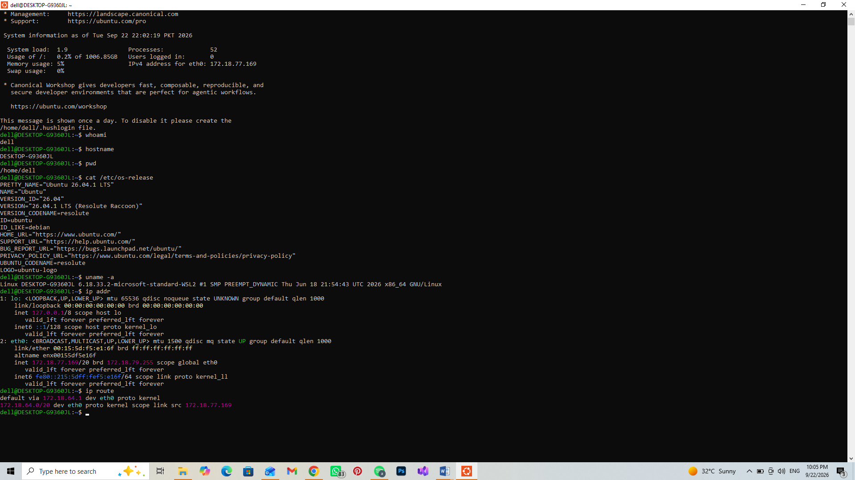
Figure 1: System identification (whoami, hostname, os-release, uname -a) and network configuration (ip addr, ip route).

3. Open Ports and User Accounts
Next, listening network services and the list of user accounts on the system were reviewed.
- ss -tuln — lists listening TCP/UDP ports. Only local DNS resolver ports (127.0.0.53/54:53) were found listening; no service is exposed to the wider network.
- cat /etc/passwd — lists all accounts on the system. Only dell and labuser have real login shells; the rest are system accounts set to nologin, which is expected.
- id / id labuser — confirm each account's UID/GID and group membership.
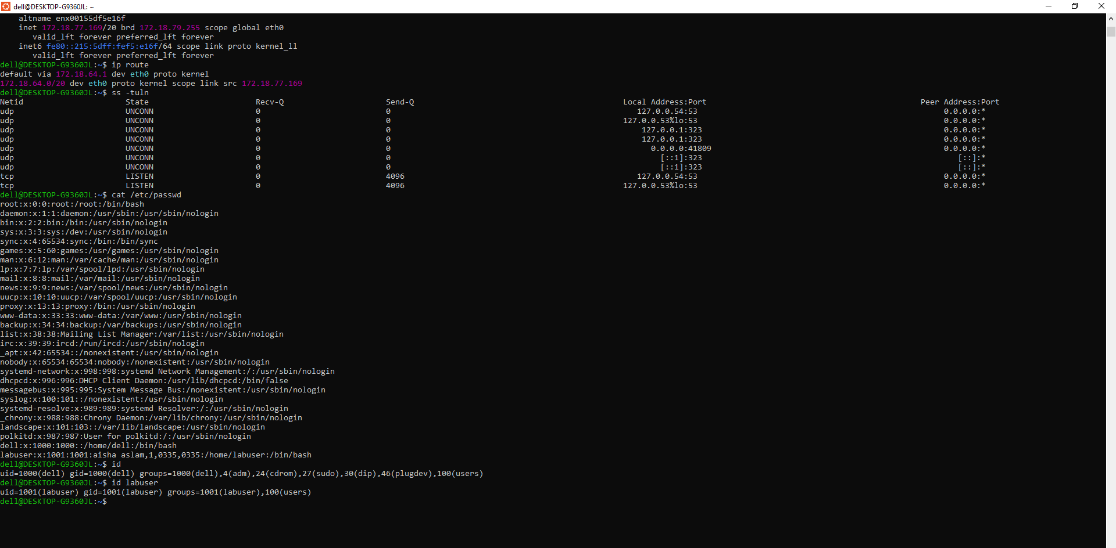
Figure 2: Open ports (ss -tuln), user accounts (/etc/passwd), and group membership (id, id labuser).

4. Privilege, Permissions, Password Policy and Patch Status
Finally, sudo privileges, key file/directory permissions, the password aging policy for the labuser account, and the system's patch status were checked.
- sudo -l — shows dell has full sudo rights (ALL : ALL) ALL, i.e. can run any command as any user.
- ls -l ~/linux-security-lab/testfile.txt — confirms testfile.txt permissions (644, owner read/write, others read-only).
- ls -ld /home/labuser — confirms labuser's home directory permissions (750, not world-readable).
- sudo passwd -S labuser — confirms labuser has a password set and active (P).
- sudo chage -l labuser — shows the password aging policy: no expiry is currently set (max days = 99999, expires = never).
- apt list --upgradable — returned no output, meaning there are currently no pending security/package updates.
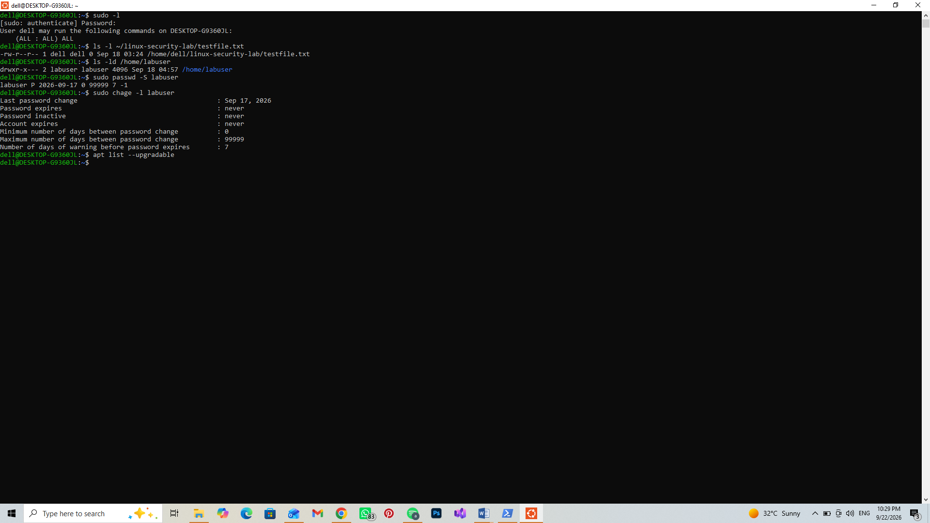
Figure 3: sudo privileges, file/directory permissions, password aging policy, and patch status.

5. Findings Summary
Area | Observation | Risk | Recommendation
Network exposure | ss -tuln shows only local DNS resolver ports listening (127.0.0.53/54:53); no other services exposed on eth0 | Low | No action needed; re-check after installing any new service
User accounts | /etc/passwd shows only two real login accounts (dell, labuser); all other accounts are system accounts with nologin shell | Low | Normal, expected configuration
Privilege separation | dell has full sudo rights (ALL:ALL); labuser is not in the sudo/adm groups | Low | Good practice, least privilege followed for labuser
Password expiry policy | chage -l labuser shows max days between change = 99999 and password/account expiry = never | Medium | Set a reasonable password expiry (e.g. 90 days) using chage -M 90 labuser
Home directory permissions | /home/labuser is drwxr-x--- (750); readable by group but not world-readable | Low | Acceptable; could be tightened to 700 if group access isn't needed
Test file permissions | testfile.txt is -rw-r--r-- (644); world-readable | Low | Fine for a non-sensitive test file; use 600 for anything sensitive
Patch status | apt list --upgradable returned no output, meaning no pending package updates | Low | Re-run apt update/upgrade periodically to keep this true

6. Conclusion
This basic assessment of the local lab environment found no exposed network services, sensible user account separation, and an up-to-date patch status. The one notable weakness identified was the lack of a password expiry policy on the labuser account, which is a common finding in real environments and a good first recommendation to make. This exercise reflects the kind of first-pass review a SOC analyst or junior penetration tester performs before going deeper into a target system.

