**POWERBI PROJECT: AUTOMOBILE SALES ANALYSIS**

**PROJECT OBJECTIVE:**

Owner of Automobile Shop want us to help them create a **dashboard** to track and analyze their sales across India

**DASHBOARD:**

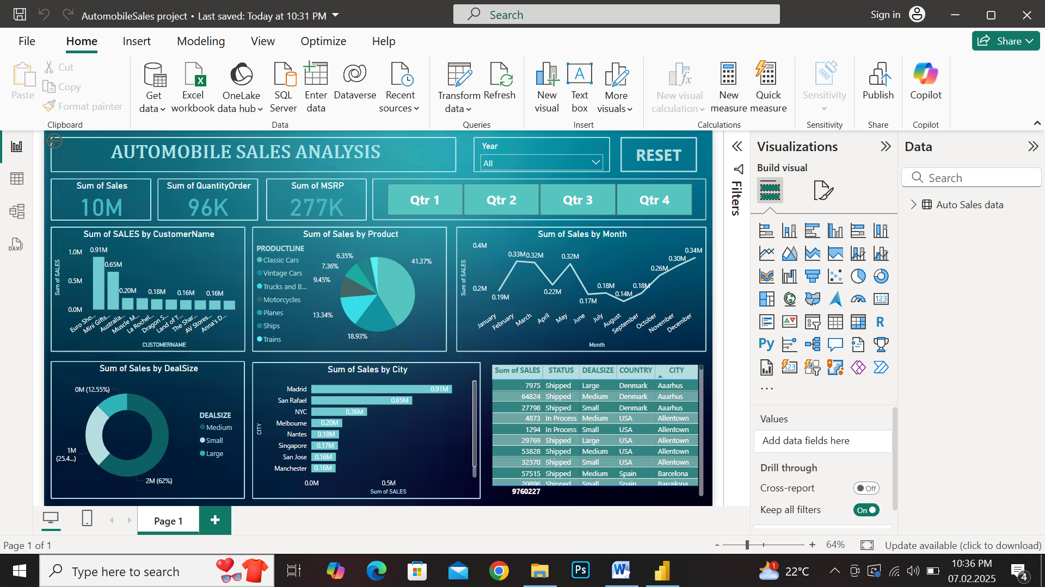

**PROJECT LEARNINGS:**

* Created interactive dashboard to track and analyze sales data
* Use Complex parameters to drill down in worksheet and customization using **Filters** and **Slicers**
* Created connections , join new tables, calculation to manipulate data and enable user driven parameters for visualization
* Use different type of customized Visualization(Bar chart, pie chart, donut chart, slicers, cards)