WeRateDogs Analysis
Now that we have our data cleaned it is time to start analyzing and answering some questions about it.
So, let’s take a look at our data frame, it has 1950 tweets; the first question that popped in my mind is how many of these were written recently?
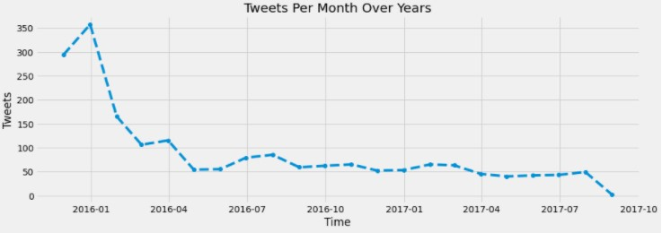
Well, it looks like he was more active at the beginning with a max of 350 tweets only in January 2016!
But maybe he is getting disappointed with peoples’ fewer interactions with his tweets?
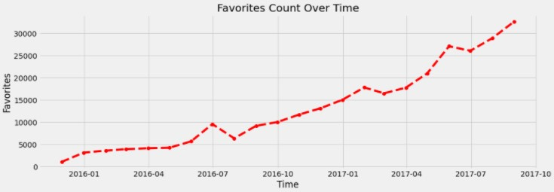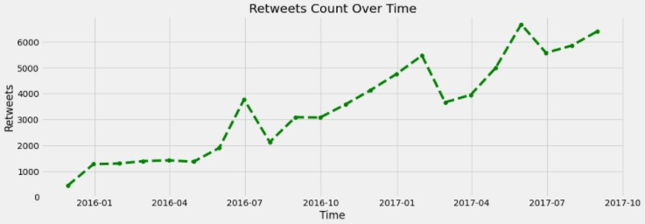
Humm, that does seem the answer :/ more fans fall for the cute dogs he posts over time, they even love to share the fun with their friends looking at the retweet’s growth graph! 😊
But what do people love most in his account? Small little puppers or the old wisdom doggos?
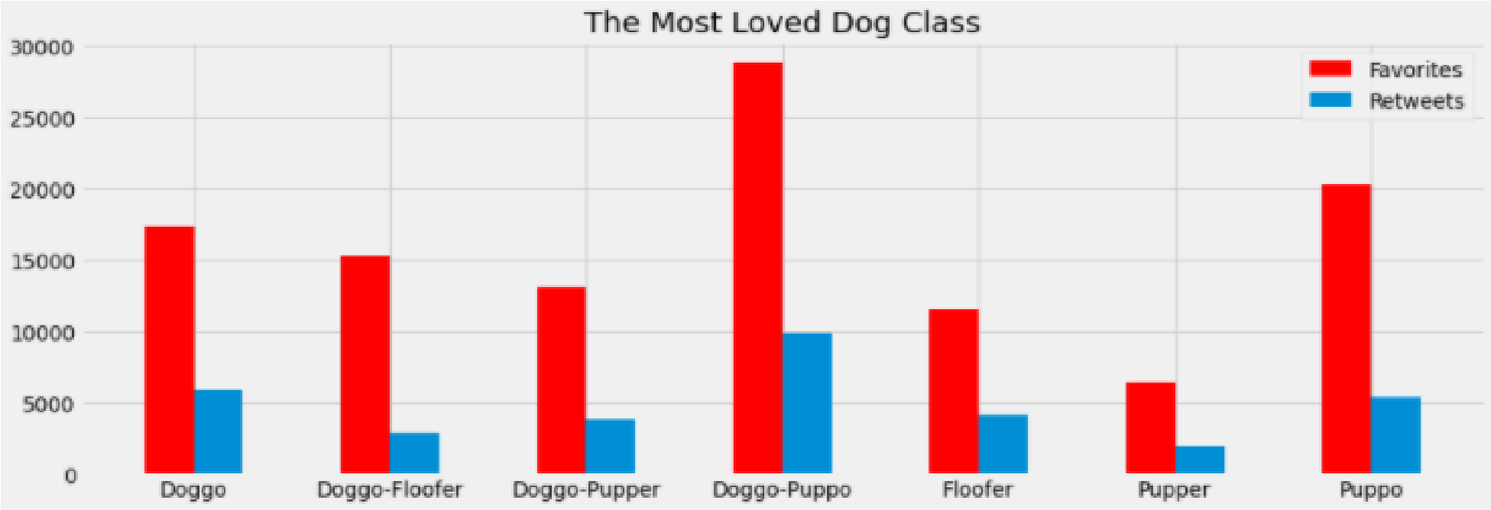
Oh, they seem to LOVE the oldies who have mastered that life thing! 😊
He has a unique rating system out of 10 where he gives most dogs (not the naughty ones) a numerator > 10. Why? Because "they're good dogs, Brent."
But is he fair at giving these rates? Does he also give much love to those old doggos or maybe he has another opinion?
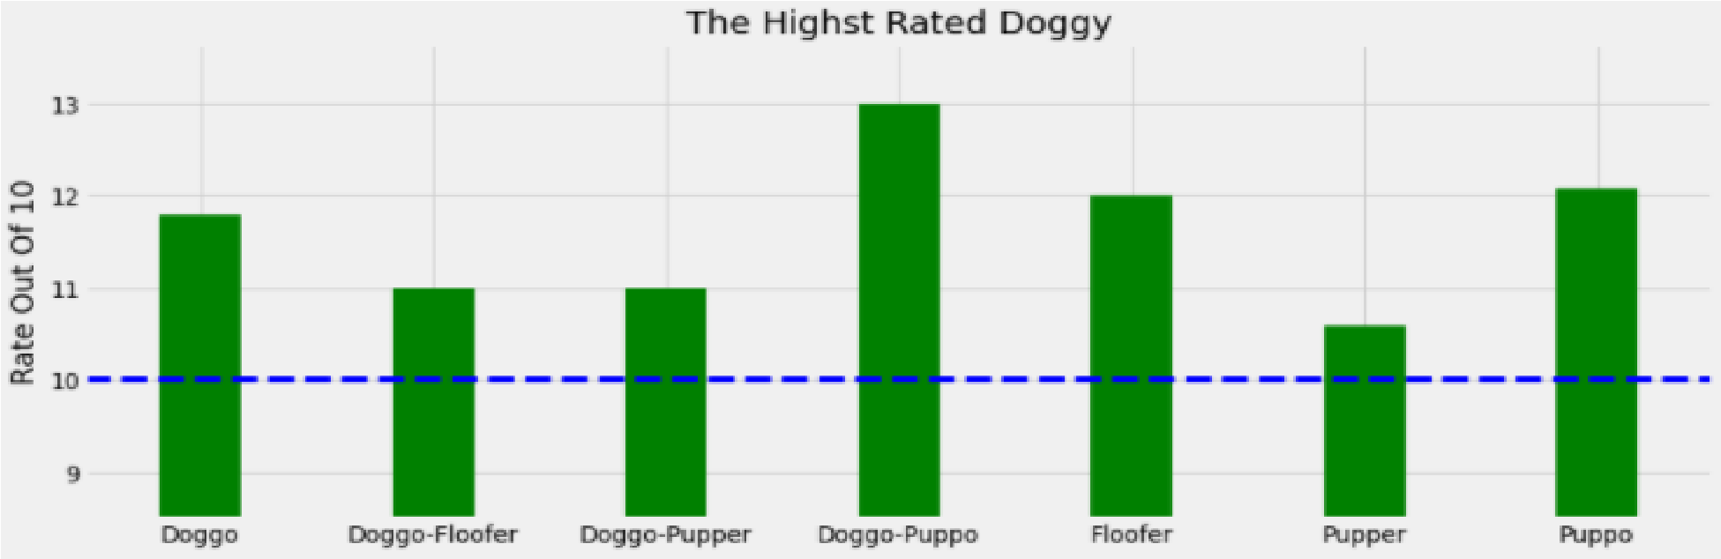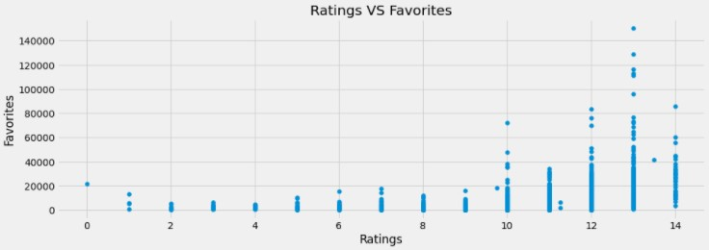
Looks like those puppers are a little naughty here :) the wisdom doggo-puppo kicks again! And there is also a good relationship between high rates and favorites’ count, good dogs deserve G-R-E-A-T LOVE.

Now let us move to their images to see our last analysis and see what the most predicted dog breed by our 3 neural network algorithms is:
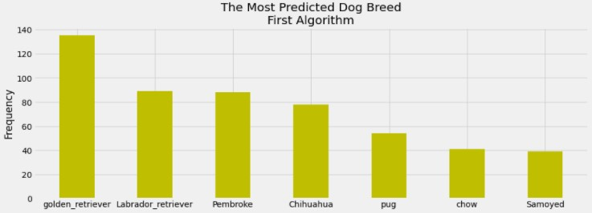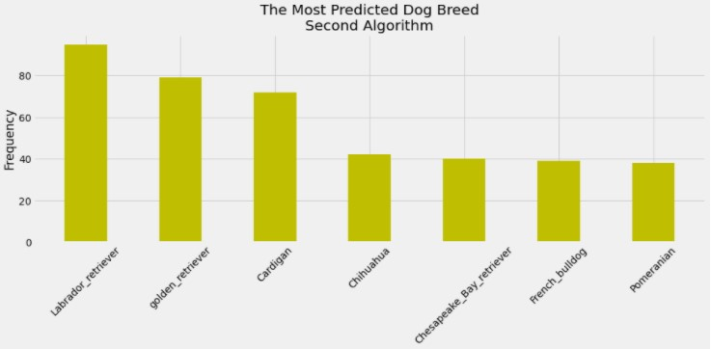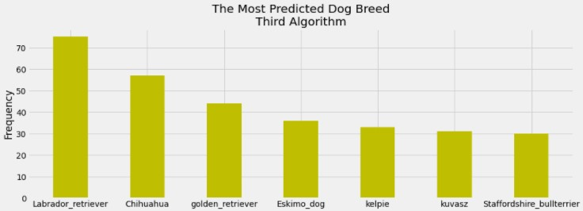 The Golden Retrievers, Labrador Retrievers, and the cute Chihuahuas were the most successful predictions. 😊

