|  |
| --- |
| **Aisha**    **MERN STACK WEB DEVELOPER**  **CONTACT ME**  **Address**    Sukkur, Sindh, Pakistan    **Phone**    +92 3072332214    **Linkedin**    https://www.linkedin.com/in/aisha-aisha-a8a91018b    **Email**    Aishaafzal157@gmail.com    **FRONTEND**  **HTML5, CSS3**  **JAVASCRIPT**  **BOOTSTRAP**  **REACT JS**  **BACKEND**  **NODEJS,API**  **MONGO DB**  **MYSQL, ORACLE**  **EXPRESS, EJS**  **OTHER TOOLS**  **POSTMAN**  **GITHUB**  **MICROSOFT OFFICE**  **NPM** |

An Experienced web developer with a wide range of skills, including programming, web development using the newest technology stack, and consulting. Expertise in a variety of programming languages as well as knowledge of web development. I am committed to delivering solutions that maximize productivity and go above and beyond customer expectations. Create cost-effective solutions by consistently utilizing an in-depth understanding of budgetary concerns that have a good impact on development and implementation. Ease talking about technical problems and solutions with clients, analysts, and superiors. Additionally, I have excellent communication and presentation skills.

**Skills**

I have complete familiarity with computer hardware and software, including internship expertise across the entire web development lifecycle.

Being proficient in several programming languages, such as HTML5, CSS3, JavaScript, React JS, Express.

Fluent in several other technologies Node JS, Twilio REST API, and expert in databases Mongo DB, MySQL, Oracle.

I have extremely good experience with Web Design, UI/UX Design, Bootstrap, and Material UI and android apps.

Good interpersonal and communication skills, including the capacity to explain technical concepts to clients and end users.

Strong analytical, mathematical, and problem-solving skills.

**Experience**

**Software Intern at Continental Biscuits LTD-------------------------------------------------Aug 2021 – Oct 2021**

They assigned me to develop software that will store information on all company products, perform calculations on each product, and save data into the database. They gave me excel files. I converted these files into dynamic forms to build a well-designed, testable working software for them.

**Freelancer-------------------------------------------------------------------------------------------------------2020 – Present**

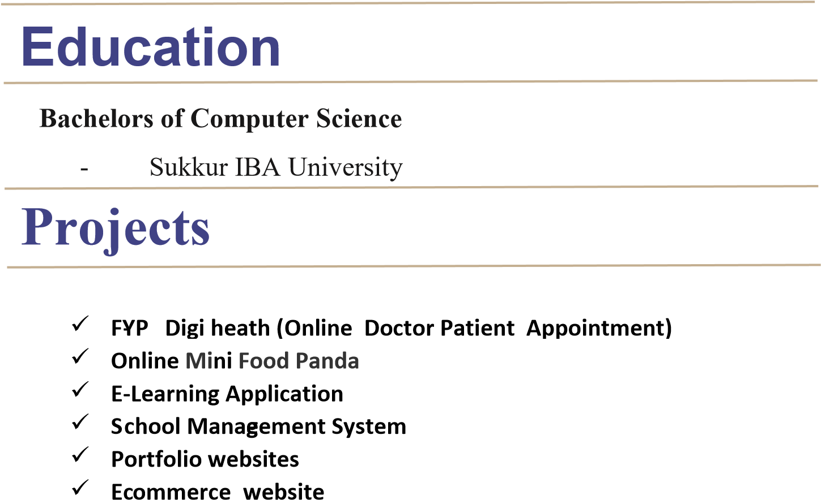I implemented websites using Reactjs, Nodejs, WordPress, and Wix and did tasks on DB (MySQL, Oracle).