

**PROGRAMMING TECHNIQUE II (SCSJ10123)**

**SEMESTER II 2015/2016** (**SEC 04)**

**GROUP PROJECT**

*Fast Food Restaurant Ordering System*

**GROUP MEMBERS**

1. AISHAH AINI BINTI NOR’AZAM (A16CS0010)
2. MOHD IZZAT BIN MOHD AZHAR (A16CS0086)

**LECTURER**

P.M. NORANIAH MOHD. YASSIN

1. **INTRODUCTION**

Fast food is becoming more and more relevant as the time goes by since people are getting busier day by day with works and their life. Thus, people doesn’t really have the time to cook for themselves and fast food seems like an excellent option. Our project is to design a system for ordering fast food online in hope this system might ease the work of the worker with ordering food.

So, the flow idea is;

1. Ask Customer either dine in or delivery
2. Start getting order
3. Ask for confirmation order
4. Payment
5. Show receipt

For step 1, the customer may have wanted to choose either to dine in or take away so we provided those option for them to choose their preference. Moving to step2, here is where all the information of orders is going to take into account. In this step, we provided various type of menu from set to ala carte and we also provide the customer to upgrade their meal in case they are super hungry. After all the orders has been entered, the system will ask for confirmation order or ask the customer either they wanted to add more menu in their cart. Then the customer makes the payment and the receipt will be shown after the payment have succeeded.

1. **PROJECT ANALYSIS & DESIGN**

***2.1. MODULE 1 – STAFF***

This module is designed for staff's usage. Staff login interface is different from customer login interface. When staff login to this system, they have to key in a password which only the staff knew. The staff will then be directed to a menu which shows options for staff which is to Monitor Sale and to Update Promo Code.

From Monitor Sale page, staff can monitor and stay updated on the stock and sale of each menu daily. From this, they can calculate the profit they gained and the loss they suffered. As for the Update Promo Code page, staff can edit, modify, add and update promo code anytime they want. They need to type in the promo code and how many percent of discount customer will get for that particular promo code.

***2.2. MODULE 2 – CUSTOMER***

The second module in this system is designed for customers' purpose. Customers login interface is different from staff login interface. Users or customers need to choose either to Dine In or Delivery.

In the Dine In, users need to type in their details such as name and phone number. It's different for Delivery page, as they need to fill in name, phone number and also address. After that users can choose which menu they want to buy with the quantity of each menu. Then they will be directed to the receipt of total price for their orders.

1. **CASE STUDY IMPLEMENTATION**

***3.1. UML CLASS DIAGRAM***

|  |
| --- |
| CustInfo() |
| name |
|  |

|  |
| --- |
|  |
|  |
|  |

***3.2. FLOWCHART***

***3.3. C++ CODING***

***3.4. SCREEN / INTERFACE DESIGN***

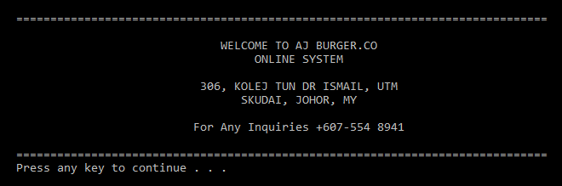

This is the main menu of our system. Users need to press any key to proceed to the next page.

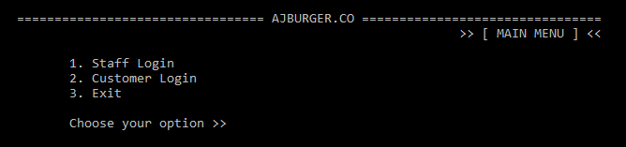

The next page display 3 options for users which is 1 for Staff Login, 2 for Customer Login and 3 to exit the program.

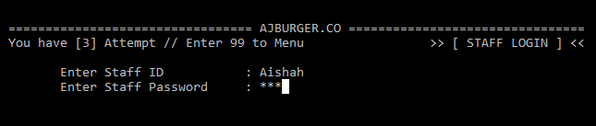

When users enter 1, they will be directed to Staff Login page. Users need to fill in the Staff ID and Staff Password that have been set in the system. Users can enter 99 to go back to main menu.

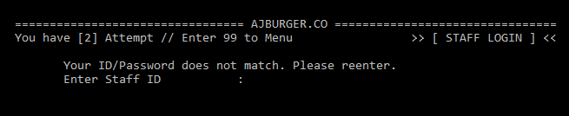

Users only have 3 attempts in entering the ID and Password. If they entered either wrong ID or Password, they need to try again and re enter the correct one.

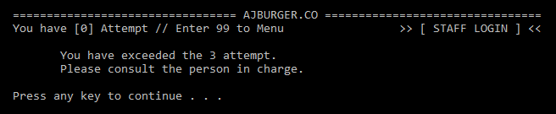

When all the 3 attempts have been used up, users will be directed to the main menu again. To reset the attempt back, user need to enter 0 at the main menu page and try to login again.

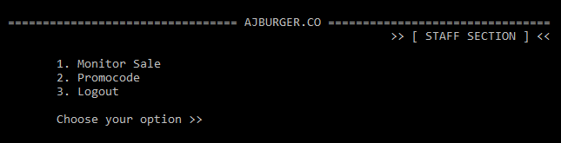

After users have successfully login in the login page, a page of Staff Section will be displayed. There are 3 options for staff which is 1 for Monitor Sale, 2 for Promotion and 3 to Logout.

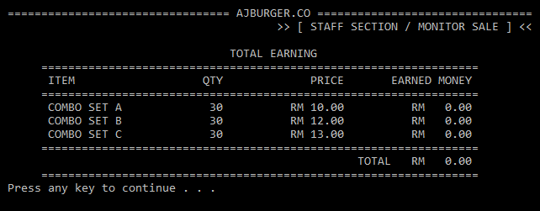

When users enter no 1, they will be directed to Monitor Sale page. In this page, they can monitor the quantity of each menu that have been sold. In this page, they can also know the profit they earned from the sale.

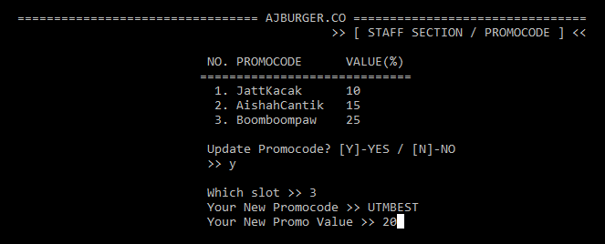

If users choose no 2 from the Staff Section page, they will be directed to Promo code page. In this page they can keep track of the current promo codes that are available. They can also edit current promo code and add the new one.

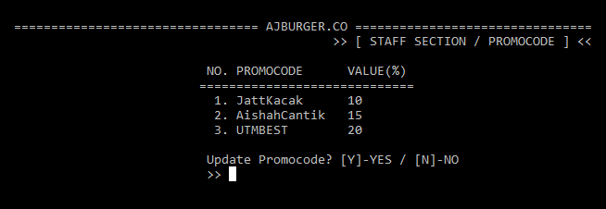

This shows that the old promo code has been replaced by the new one. All these promo code can be used to get discounts in purchasing food.

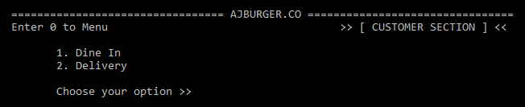

From the Main Menu, when users chose 2, they will be directed to Customer Section page. They can enter 0 to go back to Menu, or enter 1 for Dine In and 2 for Delivery.

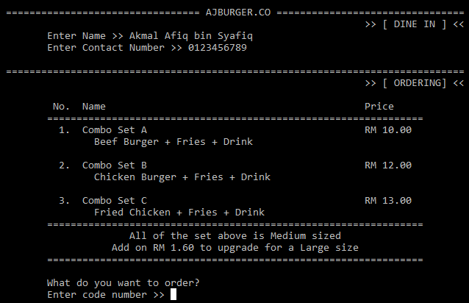

If users choose to Dine In, they will be directed to fill in their details such as name and phone number. Then, a set of menu appeared for customers to make their order.

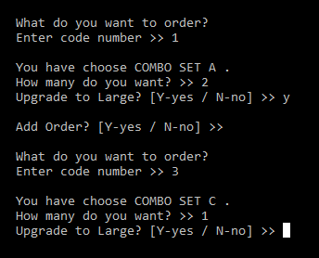

From the menu of food, users need to enter the code of the set and the quantity. Users can also upgrade the sets from medium to large by entering Y for yes and N for no. Users can also proceed to Add Order by entering Y for yes or N for no.

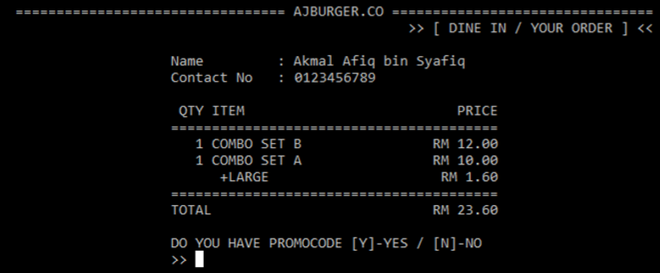

Receipt will be displayed after customers finished their order. Total price will be displayed also.

***14 –adding promo code for dine in picture***

Customers can enter promo code if there is any. So, discount will be given based on the promo code.

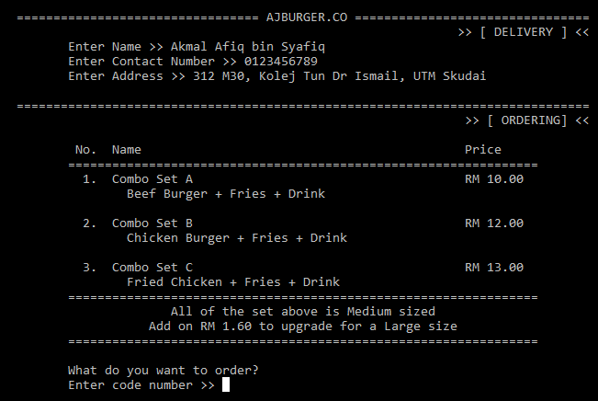

When users choose for Delivery, they will be directed to fill in their details such as name, phone number, address. Then, a set of menu appeared for customers to make their order.



From the menu of food, users need to enter the code of the set and the quantity. Users can also upgrade the sets from medium to large by entering Y for yes and N for no. Users can also proceed to Add Order by entering Y for yes or N for no.

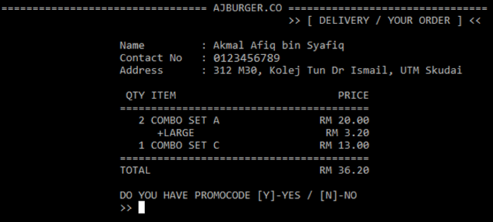

Receipt will be displayed after customers finished their order. Total price will be displayed also.

***18 –adding promo code for delivery picture***

Customers can enter promo code if there is any. So, discount will be given based on the promo code.

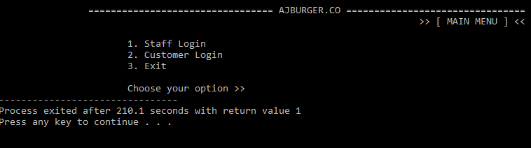

From the Main Menu, users can exit the program by entering 3.

1. **CONCLUSION**

From this system, we learned to apply the UML Class Diagram to our C++ coding. By using this, our coding has became more simplified and organized. It also a lot more easier when applying this in our coding.

One of the improvements that can be done to our system is by adding Cancel Order feature. This feature is made for user to cancel the orders they have made previously. We only have feature on Add Order only.

Another improvements that can be added to our system is Book Table feature. This feature give access to customers to book how many table they want and for them to keep track of how many table left for dine in purpose.

We can also add the feature of Paying Method whether it by cash, credit card or debit card. This feature can reduce the numbers of staff for cashier position. Thus, making this program user-friendly.

1. **REFERENCES**