

Class 9 Mathematics — Sindh Board
Exercise 4.1-Q8&9 Class 9
Class 9 Maths • Exercise 4.1 • @aishakashif996 1



Exercise 4.1
Q7:Find the factors of
(i), (ii), (iii), (iv), (v), (vi)
Class 9 Maths • Exercise 4.1 • @aishakashif996 2



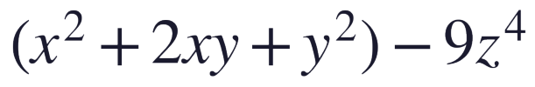
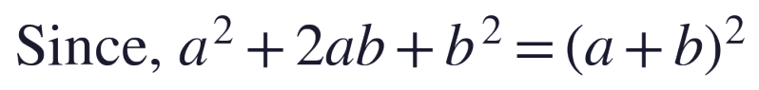
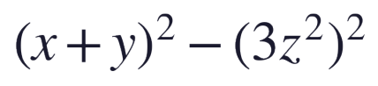
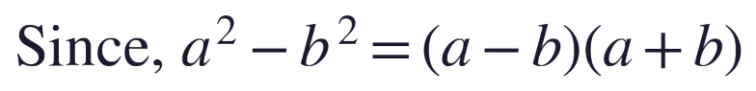

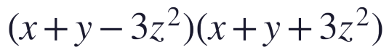
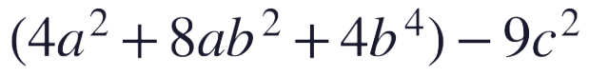
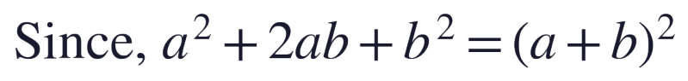
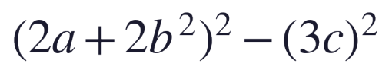


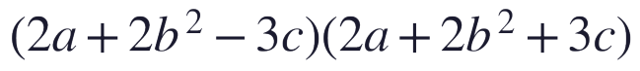
(i) (ii)
Solution: Solution:
Answer: Answer:
Class 9 Maths • Exercise 4.1 • @aishakashif996 3



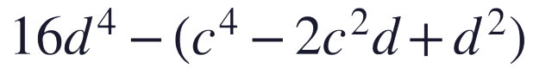
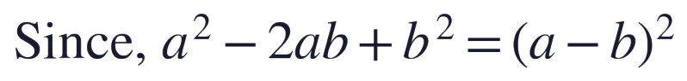
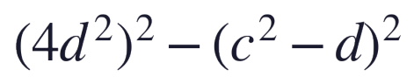


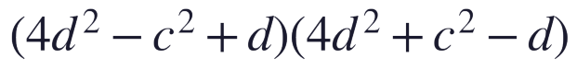
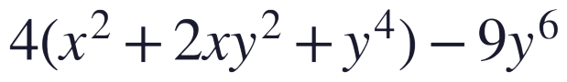

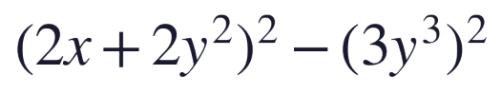


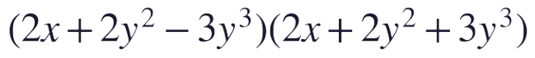
(iii) (iv)
Solution: Solution:
Answer: Answer:
Class 9 Maths • Exercise 4.1 • @aishakashif996 4





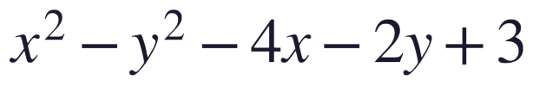
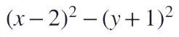
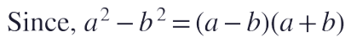
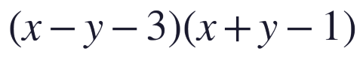
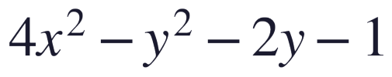

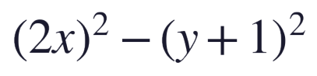

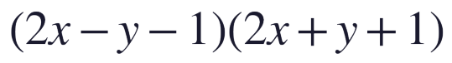
(v) (vi)
Solution: Solution:
(Detailed solution in the end)
Answer: Answer:
Class 9 Maths • Exercise 4.1 • @aishakashif996 5



Exercise 4.1
Q8:Factorize
(i), (ii), (iii), (iv)
Class 9 Maths • Exercise 4.1 • @aishakashif996 6



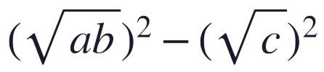
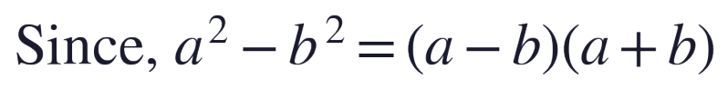


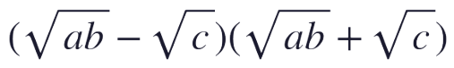
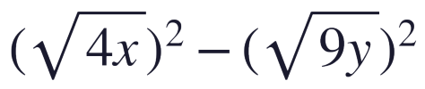
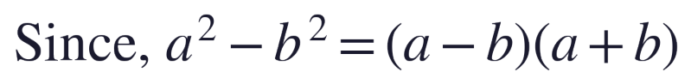


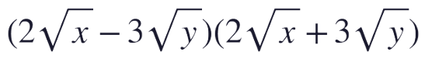
(i) (ii)
Solution: Solution:
Answer: Answer:
Class 9 Maths • Exercise 4.1 • @aishakashif996 7



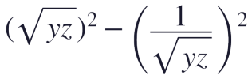

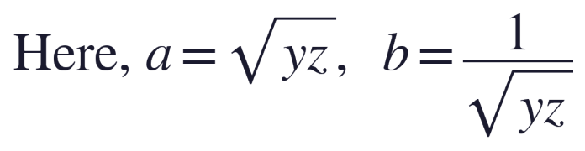

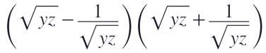
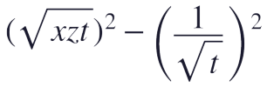

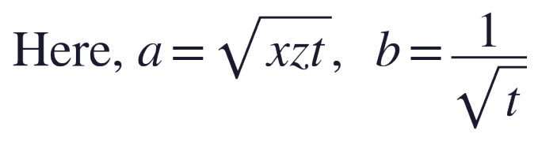

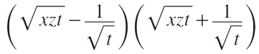
(iii) (iv)
Solution: Solution:
Answer: Answer:
Class 9 Maths • Exercise 4.1 • @aishakashif996 8

