PROJECT REPORT
Clarify – AI Powered Requirement Automation System
Prepared by: Aisha Noor
Institution: Bahria University Karachi Campus
Date: 09/12/2025

1. Introduction

1.1 Overview
Clarify is a smart, web-based platform created to simplify the process of Requirement Elicitation between clients and requirement engineers.
The system helps users:
- Create multiple software projects
- Add requirements easily
- Automatically categorize requirements (Functional / Non-Functional)
This project reduces misunderstandings, improves documentation, and enhances the clarity of requirements before software development begins.

1.2 Objectives
The main goals of Clarify are:
- To make requirement documentation simple and user-friendly
- To automate requirement classification
- To provide an organized platform for managing multiple projects’ requirements

2. Problem Statement
During requirement gathering, clients often express needs in unclear or incomplete language.
Requirement engineers struggle to interpret, categorize, or record them properly.
Misunderstandings at this early-stage lead to:
- Incorrect development
- Redesign efforts
- Time and cost overruns
There is no centralized, user-friendly system that allows clients to submit requirements and communicate directly with the engineer in an organized manner.
Clarify solves this problem by providing an automated and structured platform.

3. Proposed Solution – Clarify
Clarify offers:
✔ Automated Requirement Classification
The system uses keyword-based NLP logic to categorize each requirement into:
- Functional
- Non-Functional
- Uncertain
✔ Project-Based Requirement Organization
Users can create multiple projects and add requirements under each.
✔ Dashboard
Both client and admin dashboards provide a clear overview of:
- Projects
- Requirements
✔ Secure Authentication
Separate portals for:
- Clients
- Requirement Engineers (Admin)
Passwords are hashed using bcrypt for security.

4. System Scope
Clarify supports the entire requirement gathering cycle:
- User Registration & Login
- Project Creation
- Requirement Submission
- Requirement Analysis (Automated)
- Admin Oversight & Verification
This makes requirement management structured, transparent, and error-free.

5. System Architecture
Clarify follows a client–server architecture:
Frontend:
- HTML
- CSS
- JavaScript
- Bootstrap
Backend:
- Flask (Python)
- REST API communication
Database:
- MySQL
Data Storage (Optional):
- JSON file for requirement logs

6. Database Design

Main Tables:
- users
(id, email, password, role)
- projects
(id, user_id, project_name)
- requirements
(id, project_id, requirement_text, category, created_at)
The model supports multi-user, multi-project, and threaded messaging.

7. System Features

7.1 User Authentication
- Register/Login
- Session-based authentication
- Admin/User role differentiation

7.2 Project Management
Client can:
- Create new projects
- View their project list
Requirement Engineer can:
- View all user projects
- Access their requirements

7.3 Requirement Submission & Classification
- Tokenizes requirement text
- Removes stop words
- Matches keywords
- Categorizes requirement as:
  - Functional
  - Non-Functional
  - Uncertain

8. Frontend Features
- Clear and simple design for non-technical users
- Requirement list display

9. Non-Functional Requirements
Performance
- Page load under 3 seconds
- Messaging updates almost instantly
Security
- Password hashing
- Session security
- Role-based access control
Usability
- Simple language
- Client-friendly interface
- Clear instructions on each page
Maintainability
- Modular code
- Separate backend and frontend

10. Tools and Technologies Used
Category | Tools
Programming Language | Python, JavaScript
Framework | Flask
Database | MySQL
Styling | Bootstrap
Environment | Windows
Testing Tools | Postman

11. Results & Output
After implementing the system, Clarify successfully:
- Registers users and admin with secure authentication
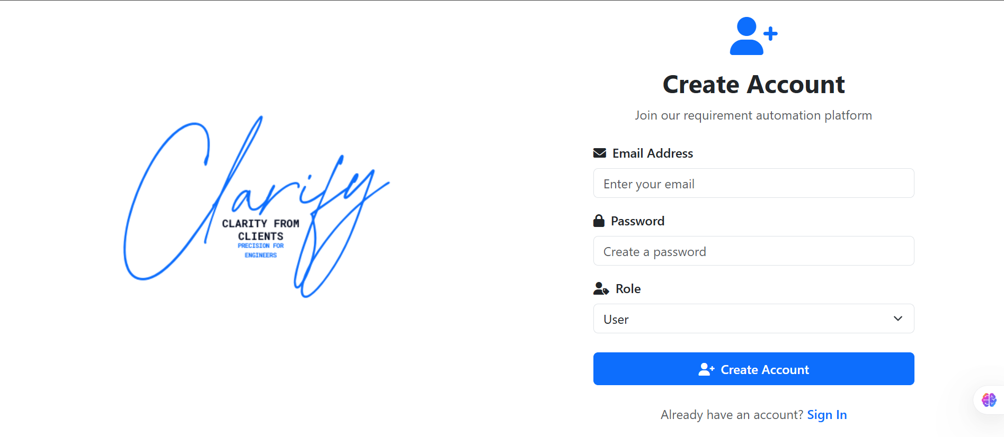
- Allows clients to create and manage requirements for unlimited projects
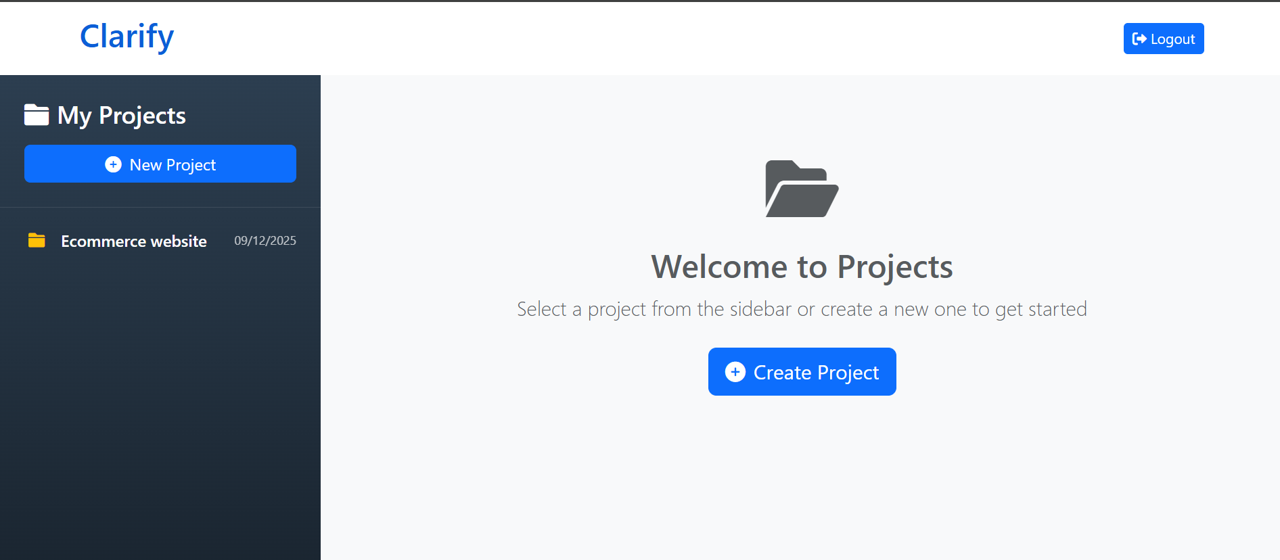
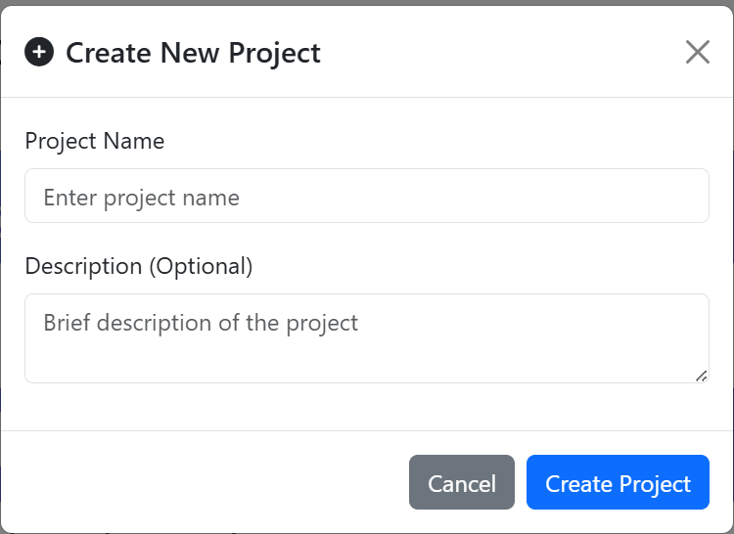
- Classifies requirements automatically
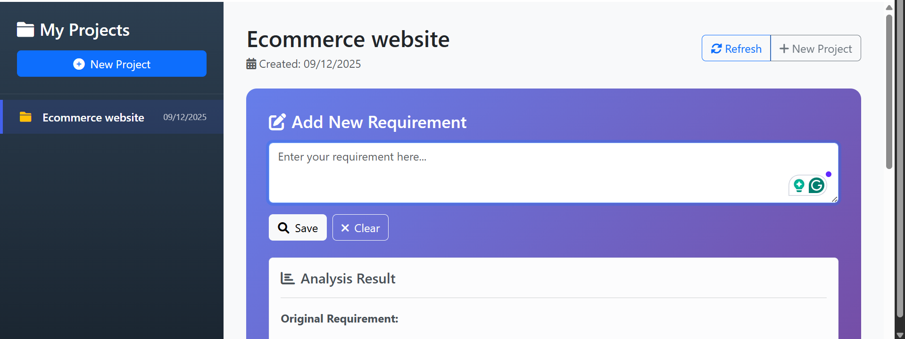
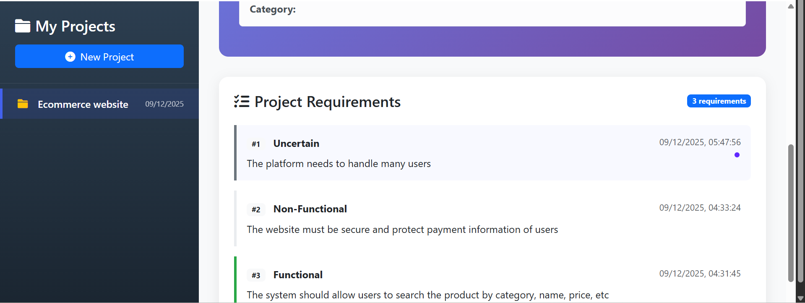
- Displays real-time project and requirement data
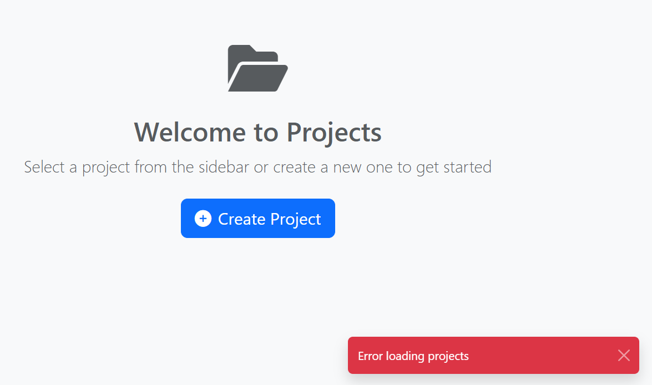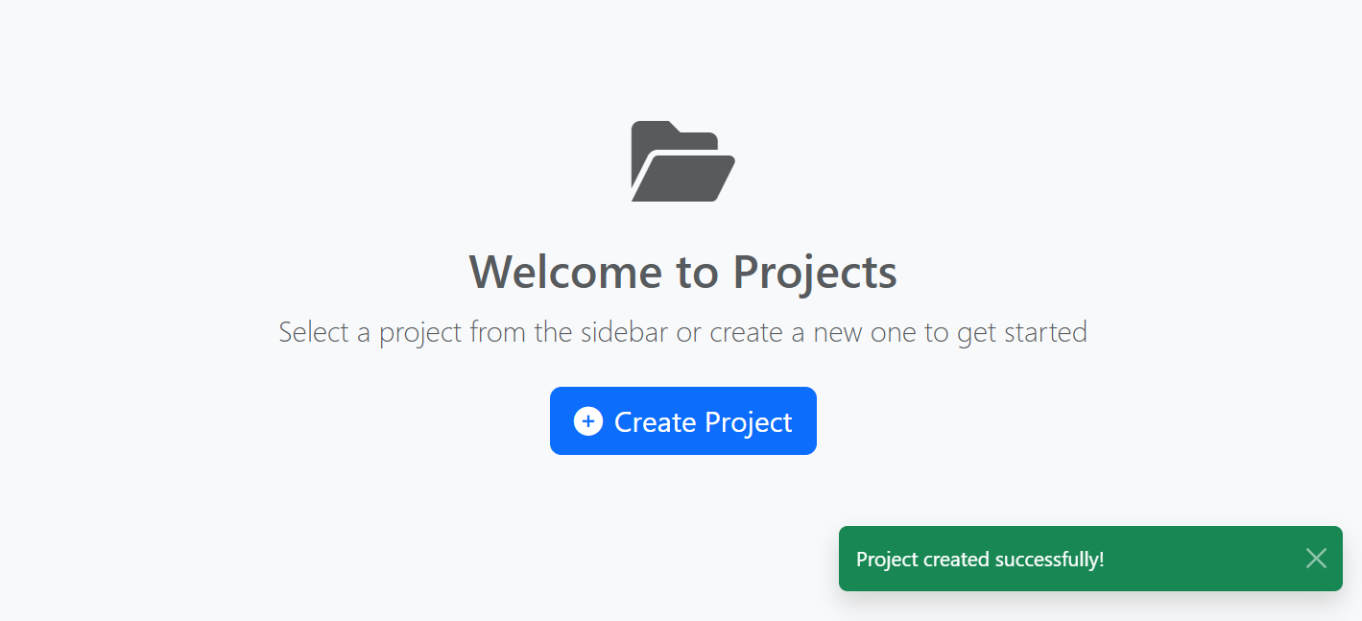
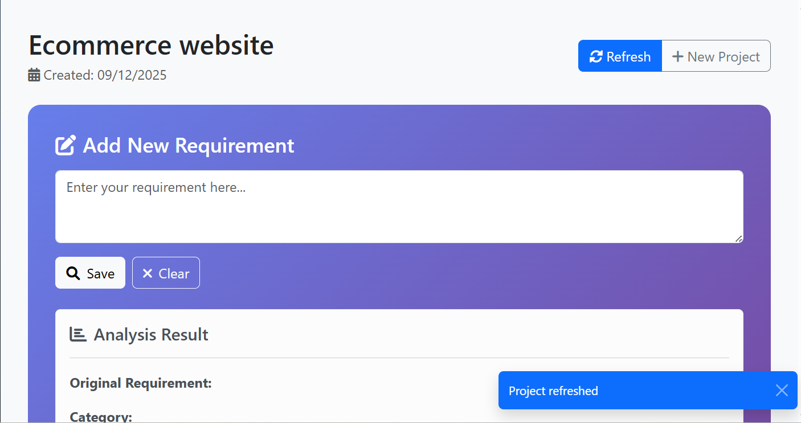
- Separates Dashboard for requirement engineers
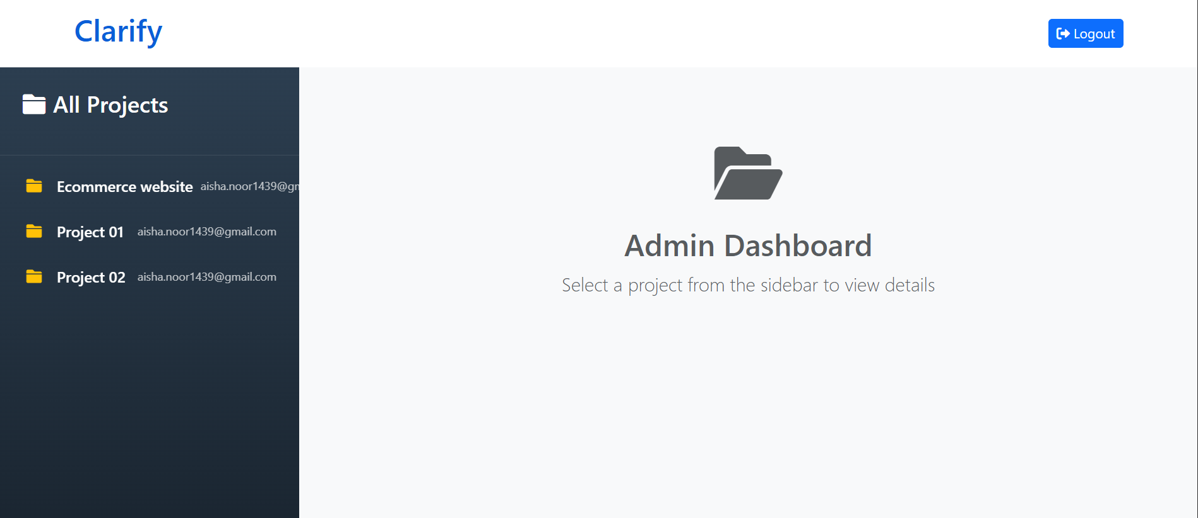
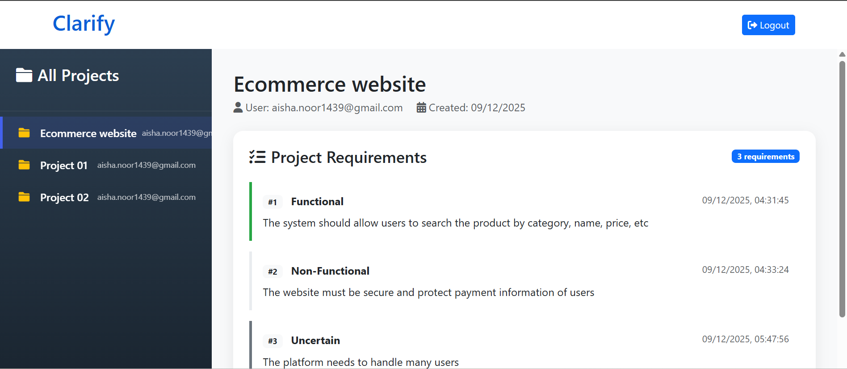
Code: https://github.com/aishanoor1439/Clarify

12. Conclusion
Clarify is a comprehensive requirement management system designed to reduce confusion, speed up documentation, and improve communication between clients and requirement engineers.
The system is efficient, user-friendly, and flexible enough for future enhancements such as:
- Email notifications
- Machine learning-based classification
- Mobile application version

13. Future Enhancements
- Smart chatbot for requirement refinement
- Integration with project management tools (Jira, Trello)

14. References
• Zhao, L., et al. “Natural Language Processing for Requirements Engineering: A Systematic Mapping Study.” ACM Digital Library, 2020.
Available via Research Explorer.
This study provides a broad overview of how NLP techniques support requirement analysis, classification, and automation, forming a foundation for intelligent requirement-processing systems.
• Cheligeer, C. “Machine Learning in Requirements Elicitation: A Literature Review.” AI EDAM (Artificial Intelligence for Engineering Design, Analysis and Manufacturing), Cambridge University Press, 2021.
This review summarizes modern machine learning approaches used in gathering, refining, and interpreting software requirements—supporting the technical direction adopted in this project.
• Ebrahim, M., et al. “Enhancing Software Requirements Engineering with Large Language Models.” ACL Anthology, ACL Workshop on LLMs for SE, 2025.
This work highlights how Large Language Models improve requirement extraction, refinement, and documentation, providing the conceptual backbone for the automated elements of this system.

