Bahria University,
Karachi Campus


COURSE: CSL-210 OBJECT ORIENTED PROGRAMMING
TERM: SPRING 2025, CLASS: BSE- 2(B)
BUSPs(Bahria University Society Polls)

Group Members
S. No. | Name | Enrollment #
01 | Aisha Noor | 02-131242-063
02 | Iffat Batool | 02-131242-126
03 | Kanwal Bibi | 02-131242-065

Submitted to:
Course Instructor: Engr. Muhammad Faisal
Lab Instructor: Engr. Saniya Sarim Zakai

Signed Remarks: Score:

Table of Content

Table of Content 2
1. INTRODUCTION 3
2. OOP CONCEPTS USED IN PROJECT 3
3. FEATURES OF YOUR PROJECT 3
4. CODE 4
LoginClass.java 4
MenuClass.java 5
ElectionLogic.java 5
CandidateLogic.java 8
VoterLogic.java 12
VotingLogic.java 15
DashboardLogic.java 20
5. INTERFACES 23
6. CONCLUSION 24

INTRODUCTION
Student societies are the backbone of campus life, nurturing leadership and teamwork skills. However, the existing manual election system in universities often faces problems like delayed results, inaccurate vote counting, and lack of transparency, which affects trust among participants. To resolve these challenges, our project BUSPs (Bahria University Society Polls) proposes a fully automated, user-friendly election management system. The solution leverages Java Swing for the graphical user interface and MariaDB for backend data management, aiming to deliver a reliable, secure, and efficient voting platform for Bahria University students and administrators.

OOP CONCEPTS USED IN PROJECT

OOP Concept | Application in BUSPs Project
Encapsulation | - All classes encapsulate logic related to specific features like login, candidate management, voter management, etc.  - Database connection and query execution are kept within the logic classes.
Abstraction | - AbstractBUSPs (though its full code is not visible) likely abstracts database setup or helper methods, reused across child classes.  - UI-related actions abstract away logic details from main UI.
Inheritance | - Classes like LoginClass, ElectionLogic, CandidateLogic, VotingLogic, VoterLogic, and DashboardLogic all extend AbstractBUSPs.  - This implies shared functionality (e.g., database connection variables like Con, St, Rs) are defined in the superclass.

FEATURES OF YOUR PROJECT
- User Login: Secure login for admin and students.
- Election Management: Admin can create, edit, and delete elections.
- Society Management: Admin manages elections, candidates and voters per society.
- Voting System: One student = one vote per election.
- Result Calculation: Auto-calculates and displays winning candidate.
- User-Friendly GUI: Built with Java Swing.

CODE

LoginClass.java
package com.mycompany.mavenproject26;
import java.sql.DriverManager;
import java.sql.PreparedStatement;
import java.sql.ResultSet;
public class LoginClass extends AbstractBUSPs {
public boolean validateAdmin(String username, String password) {
return username.equalsIgnoreCase("Admin") && password.equalsIgnoreCase("Password");
}
public int validateVoter(String username, String password) {
int voterId = -1;
try {
Con = DriverManager.getConnection("jdbc:mysql://localhost:3306/society_polls", "root", "");
String query = "SELECT * FROM voter_tbl WHERE LOWER(v_name) = LOWER(?) AND LOWER(v_pass) = LOWER(?)";
PreparedStatement pst = Con.prepareStatement(query);
pst.setString(1, username);
pst.setString(2, password);
ResultSet rs = pst.executeQuery();
if (rs.next()) {
voterId = rs.getInt(1);
}
rs.close();
pst.close();
Con.close();
} catch (Exception e) {
e.printStackTrace();
}
return voterId;
}
}

MenuClass.java
package com.mycompany.mavenproject26;
public class MenuClass {
public void openElections(Menu menu) {
new Elections().setVisible(true);
menu.dispose();
}
public void openCandidates(Menu menu) {
new Candidates().setVisible(true);
menu.dispose();
}
public void openVoters(Menu menu) {
new Voters().setVisible(true);
menu.dispose();
}
public void openDashboard(Menu menu) {
new Dashboard().setVisible(true);
menu.dispose();
}
}

ElectionLogic.java
public class ElectionLogic extends AbstractBUSPs {
int id = 0;
public ElectionLogic() {
try {
Con = DriverManager.getConnection("jdbc:mysql://localhost:3306/society_polls", "root", "");
} catch (SQLException e) {
e.printStackTrace();
}
}
public int getNextElectionId() {
try (Statement stmt = Con.createStatement(); ResultSet rs = stmt.executeQuery("SELECT MAX(e_id) FROM election_tbl")) {
if (rs.next()) {
id = rs.getInt(1) + 1;
}
} catch (SQLException e) {
e.printStackTrace();
}
return id;
}
public ResultSet getElections() {
try {
St = Con.createStatement();
Rs = St.executeQuery("SELECT * FROM election_tbl");
} catch (SQLException e) {
e.printStackTrace();
}
return Rs;
}
public ResultSet getSocieties() {
try {
Statement stmt = Con.createStatement();
return stmt.executeQuery("SELECT society_name FROM society_tbl");
} catch (SQLException e) {
e.printStackTrace();
return null;
}
}
public void addElection(int id, String name, String society, String date) throws SQLException {
String query = "INSERT INTO election_tbl VALUES (?, ?, ?, ?)";
try (PreparedStatement pst = Con.prepareStatement(query)) {
pst.setInt(1, id);
pst.setString(2, name);
pst.setString(3, society);
pst.setString(4, date);
pst.executeUpdate();
}
}
public void updateElection(int id, String name, String society, String date) throws SQLException {
String query = "UPDATE election_tbl SET e_name=?, e_society=?, e_date=? WHERE e_id=?";
try (PreparedStatement pst = Con.prepareStatement(query)) {
pst.setString(1, name);
pst.setString(2, society);
pst.setString(3, date);
pst.setInt(4, id);
pst.executeUpdate();
}
}
public void deleteElection(int id) throws SQLException {
String query = "DELETE FROM election_tbl WHERE e_id=?";
try (PreparedStatement pst = Con.prepareStatement(query)) {
pst.setInt(1, id);
pst.executeUpdate();
}
}
}

CandidateLogic.java
public class CandidateLogic extends AbstractBUSPs {
int CId = 0;
public CandidateLogic() {
try {
Con = DriverManager.getConnection("jdbc:mysql://localhost:3306/society_polls", "root", "");
} catch (SQLException e) {
e.printStackTrace();
}
}
public int getNextCandidateId() {
try {
St = Con.createStatement();
Rs = St.executeQuery("SELECT MAX(c_id) FROM candidate_tbl");
if (Rs.next()) {
CId = Rs.getInt(1) + 1;
}
} catch (SQLException ex) {
ex.printStackTrace();
}
return CId;
}
public boolean addCandidate(String name, String gender, String society, String election, String imgPath) throws FileNotFoundException {
try {
CId = getNextCandidateId();
InputStream img = new FileInputStream(imgPath);
pst = Con.prepareStatement("INSERT INTO candidate_tbl (c_id, c_name, c_gen, c_society, c_election, c_photo) VALUES (?, ?, ?, ?, ?, ?)");
pst.setInt(1, CId);
pst.setString(2, name);
pst.setString(3, gender);
pst.setString(4, society);
pst.setString(5, election);
pst.setBlob(6, img);
int row = pst.executeUpdate();
return row > 0;
} catch (SQLException | FileNotFoundException ex) {
ex.printStackTrace();
return false;
}
}
public ResultSet getCandidates() {
try {
St = Con.createStatement();
Rs = St.executeQuery("SELECT * FROM candidate_tbl");
} catch (SQLException e) {
e.printStackTrace();
}
return Rs;
}
public byte[] getCandidatePhoto(int cId) {
byte[] photo = null;
try {
pst = Con.prepareStatement("SELECT c_photo FROM candidate_tbl WHERE c_id = ?");
pst.setInt(1, cId);
Rs = pst.executeQuery();
if (Rs.next()) {
photo = Rs.getBytes("c_photo");
}
} catch (SQLException e) {
e.printStackTrace();
}
return photo;
}
public boolean deleteCandidate(int cId) {
try {
pst = Con.prepareStatement("DELETE FROM candidate_tbl WHERE c_id = ?");
pst.setInt(1, cId);
int rows = pst.executeUpdate();
return rows > 0;
} catch (SQLException e) {
e.printStackTrace();
return false;
}
}
public boolean updateCandidate(int cId, String name, String gender, String society, String election, Object imgPath) {
try {
if (imgPath == null) {
System.out.println("Error: Image path is empty.");
return false;
}
InputStream img = new FileInputStream((String) imgPath);
PreparedStatement pst = Con.prepareStatement("UPDATE candidate_tbl SET c_name = ?, c_gen = ?, c_society = ?, c_election = ?, c_photo = ? WHERE c_id = ?");
pst.setString(1, name);
pst.setString(2, gender);
pst.setString(3, society);
pst.setString(4, election);
pst.setBlob(5, img);
pst.setInt(6, cId);
int rows = pst.executeUpdate();
return rows > 0;
} catch (SQLException | FileNotFoundException e) {
e.printStackTrace();
return false;
}
}
public byte[] fetchCandidatePhoto(int id) {
String query = "SELECT c_photo FROM candidate_tbl WHERE c_id = " + id;
try (Statement st = Con.createStatement(); ResultSet rs = st.executeQuery(query)) {
if (rs.next()) {
return rs.getBytes("c_photo");
}
} catch (Exception e) {
e.printStackTrace();
}
return null;
}
}

VoterLogic.java
public class VoterLogic extends AbstractBUSPs {
int VId = 0;
public VoterLogic() {
try {
Con = DriverManager.getConnection("jdbc:mysql://localhost:3306/society_polls", "root", "");
} catch (SQLException ex) {
ex.printStackTrace();
}
}

public void GetElectionsAndSocieties(JComboBox<String> VElectionCb, JComboBox<String> VSocietyCb) {
try {
St = Con.createStatement();
ResultSet rsElections = St.executeQuery("SELECT e_name FROM election_tbl");
while (rsElections.next()) {
VElectionCb.addItem(rsElections.getString("e_name"));
}
ResultSet rsSocieties = St.executeQuery("SELECT society_name FROM society_tbl");
while (rsSocieties.next()) {
VSocietyCb.addItem(rsSocieties.getString("society_name"));
}
rsElections.close();
rsSocieties.close();
St.close();
} catch (Exception e) {
e.printStackTrace();
}
}
public ResultSet getVoters() {
try {
St = Con.createStatement();
Rs = St.executeQuery("SELECT * FROM voter_tbl");
} catch (SQLException e) {
e.printStackTrace();
}
return Rs;
}
public int GetNextVoterId() {
try {
St1 = Con.createStatement();
Rs1 = St1.executeQuery("SELECT MAX(v_id) FROM voter_tbl");
if (Rs1.next()) {
VId = Rs1.getInt(1) + 1;
}
} catch (SQLException e) {
e.printStackTrace();
}
return VId;
}
public boolean addVoter(String name, String gender, String society, String election, String password) {
try {
PreparedStatement Add = Con.prepareStatement("INSERT INTO voter_tbl (v_name, v_gen, v_society, v_election, v_pass) VALUES (?, ?, ?, ?, ?)");
Add.setString(1, name);
Add.setString(2, gender);
Add.setString(3, society);
Add.setString(4, election);
Add.setString(5, password);
Add.executeUpdate();
} catch (SQLException e) {
JOptionPane.showMessageDialog(null, e);
}
return true;
}
public boolean deleteVoter(int VoterId) {

try {
String Query = "DELETE FROM voter_tbl WHERE v_id=" + VoterId;
Statement Del = Con.createStatement();
Del.executeUpdate(Query);
} catch (SQLException e) {
JOptionPane.showMessageDialog(null, e);
}
return true;
}
public boolean updateVoter(int VoterId, String name, String gender, String society, String election, String password) {
try {
String Query = "UPDATE voter_tbl SET v_name=?, v_gen=?, v_society=?, v_election=?, v_pass=? WHERE v_id=?";
PreparedStatement UpdateQuery = Con.prepareStatement(Query);
UpdateQuery.setString(1, name);
UpdateQuery.setString(2, gender);
UpdateQuery.setString(3, society);
UpdateQuery.setString(4, election);
UpdateQuery.setString(5, password);
UpdateQuery.setInt(6, VoterId);
UpdateQuery.executeUpdate();
} catch (SQLException e) {
JOptionPane.showMessageDialog(null, e);
}
return true;
}
}

VotingLogic.java
public class VotingLogic extends AbstractBUSPs {
int id = -1;
public VotingLogic() {
try {
Con = DriverManager.getConnection("jdbc:mysql://localhost:3306/society_polls", "root", "");
} catch (SQLException e) {
JOptionPane.showMessageDialog(null, "Database connection failed: " + e.getMessage());
}
}
public ResultSet getCandidatesBySocietyAndElection(String societyName, String electionName) {
try {
PreparedStatement pst = Con.prepareStatement(
"SELECT * FROM candidate_tbl WHERE c_society = ? AND c_election = ?"
);
pst.setString(1, societyName.trim());
pst.setString(2, electionName.trim());
return pst.executeQuery();
} catch (SQLException e) {
e.printStackTrace();
}
return null;
}
public ResultSet getCandidates() {
try {
St = Con.createStatement();
Rs = St.executeQuery("SELECT * FROM candidate_tbl");
} catch (SQLException e) {
e.printStackTrace();
}
return Rs;
}
public ImageIcon fetchPhoto(int candidateId, JLabel label) {
try {
Statement st = Con.createStatement();
ResultSet rs = st.executeQuery("SELECT c_photo FROM candidate_tbl WHERE c_id = " + candidateId);

if (rs.next()) {
// CandidateNameLb.setText(rs.getString("c_name")); // ✅ Ye line add ki gayi hai,JLabel CandidateNameLb
return resizePhoto(null, rs.getBytes("c_photo"), label);
}
} catch (Exception e) {
e.printStackTrace();
}
return null;
}
public String fetchname(int candidateId) {
String name = null;
try {
Statement st = Con.createStatement();
ResultSet rs = st.executeQuery("SELECT c_name FROM candidate_tbl WHERE c_id = " + candidateId);
if (rs.next()) {
name = rs.getString("c_name");
}
} catch (Exception e) {
e.printStackTrace();
}
return name;
}
public int getSocietyIdByName(String name) {
try {
PreparedStatement pst = Con.prepareStatement("SELECT society_id FROM society_tbl WHERE society_name = ?");
pst.setString(1, name);
ResultSet rs = pst.executeQuery();
if (rs.next()) {
id = rs.getInt("society_id");
}
rs.close();
pst.close();
} catch (Exception e) {
e.printStackTrace();
}
return id;
}
public int getElectionIdByName(String name) {
try {
PreparedStatement pst = Con.prepareStatement("SELECT e_id FROM election_tbl WHERE e_name = ?");
pst.setString(1, name);
ResultSet rs = pst.executeQuery();
if (rs.next()) {
id = rs.getInt("e_id");
}
rs.close();
pst.close();
} catch (Exception e) {
e.printStackTrace();
}
return id;
}
public boolean hasAlreadyVoted(int voterId, int electionId) {
try {
PreparedStatement pst = Con.prepareStatement("SELECT * FROM vote_tbl WHERE v_id = ? AND e_id = ?");
pst.setInt(1, voterId);
pst.setInt(2, electionId);
ResultSet rs = pst.executeQuery();
return rs.next();
} catch (SQLException e) {
e.printStackTrace();
return true;
}
}
public int getNextVoteId() {
try {
Statement st = Con.createStatement();
ResultSet rs = st.executeQuery("SELECT MAX(vote_id) FROM vote_tbl");
if (rs.next()) {
id = rs.getInt(1) + 1;
}
} catch (Exception e) {
e.printStackTrace();
}
return id;
}
public boolean vote(int voteId, int electionId, int candidateId, int voterId, int societyId) {
try {
PreparedStatement pst = Con.prepareStatement("INSERT INTO vote_tbl (vote_id, e_id, c_id, v_id, society_id) VALUES (?, ?, ?, ?, ?)");
pst.setInt(1, voteId);
pst.setInt(2, electionId);
pst.setInt(3, candidateId);
pst.setInt(4, voterId);
pst.setInt(5, societyId);
pst.executeUpdate();
return true;
} catch (SQLException e) {
e.printStackTrace();
return false;
}
}
public ImageIcon resizePhoto(String ImgPath, byte[] pic, JLabel label) {
ImageIcon MyImage = (ImgPath != null) ? new ImageIcon(ImgPath) : new ImageIcon(pic);
Image img = MyImage.getImage();
Image newImg = img.getScaledInstance(label.getWidth(), label.getHeight(), Image.SCALE_SMOOTH);
return new ImageIcon(newImg);
}
}

DashboardLogic.java
public class DashboardLogic extends AbstractBUSPs{
public DashboardLogic() {
try {
Con = DriverManager.getConnection("jdbc:mysql://localhost:3306/society_polls", "root", "");
} catch (SQLException e) {
e.printStackTrace();
}
}
public ResultSet getAllElections() {
try {
St = Con.createStatement();
return St.executeQuery("SELECT * FROM election_tbl");
} catch (SQLException e) {
e.printStackTrace();
return null;
}
}
public int getWinnerCandidateId(int electionId) {
try {
St = Con.createStatement();
String query = "SELECT c_id, COUNT(c_id) AS total_votes FROM vote_tbl WHERE e_id = " + electionId +
" GROUP BY c_id ORDER BY total_votes DESC LIMIT 1";
Rs = St.executeQuery(query);
if (Rs.next()) {
return Rs.getInt("c_id");
}
} catch (SQLException e) {
e.printStackTrace();
}
return -1;
}
public WinnerData getWinnerData(int candidateId) {
WinnerData data = new WinnerData();
try {
String query = "SELECT c_name, c_photo FROM candidate_tbl WHERE c_id = ?";
PreparedStatement pst = Con.prepareStatement(query);
pst.setInt(1, candidateId);
Rs = pst.executeQuery();
if (Rs.next()) {
data.name = Rs.getString("c_name");
data.photoBytes = Rs.getBytes("c_photo");
}
} catch (SQLException e) {
e.printStackTrace();
}
return data;
}
public int getCandidateVotes(int candidateId) {
try {
St = Con.createStatement();
Rs = St.executeQuery("SELECT COUNT(*) FROM vote_tbl WHERE c_id = " + candidateId);
if (Rs.next()) {
return Rs.getInt(1);
}
} catch (SQLException e) {
e.printStackTrace();
}
return 0;
}
public int getTotalVotesInElection(int electionId) {
try {
St = Con.createStatement();
Rs = St.executeQuery("SELECT COUNT(*) FROM vote_tbl WHERE e_id = " + electionId);
if (Rs.next()) {
return Rs.getInt(1);
}
} catch (SQLException e) {
e.printStackTrace();
}
return 0;
}
public ImageIcon resizePhoto(byte[] pic, JLabel label) {
ImageIcon imageIcon = new ImageIcon(pic);
Image img = imageIcon.getImage();
Image scaledImg = img.getScaledInstance(label.getWidth(), label.getHeight(), Image.SCALE_SMOOTH);
return new ImageIcon(scaledImg);
}
public static class WinnerData {
public String name;
public byte[] photoBytes;

INTERFACES
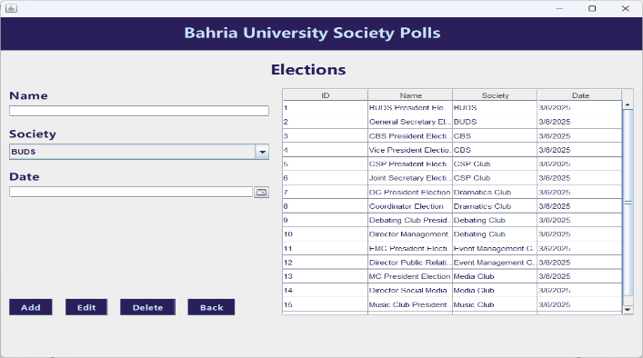


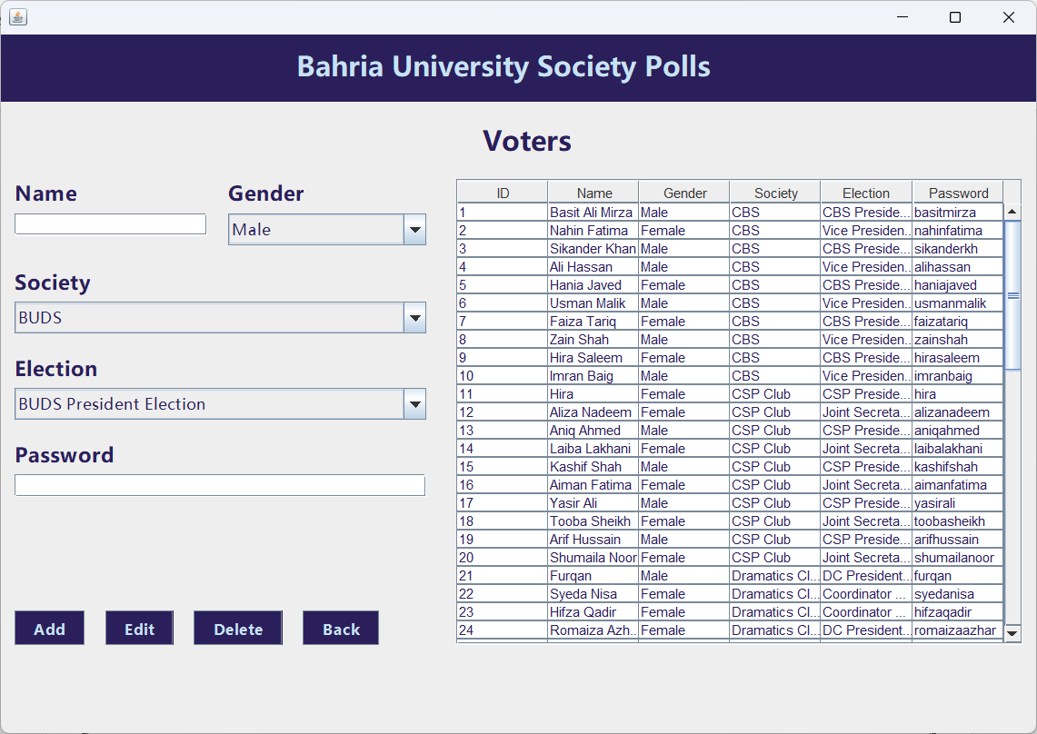

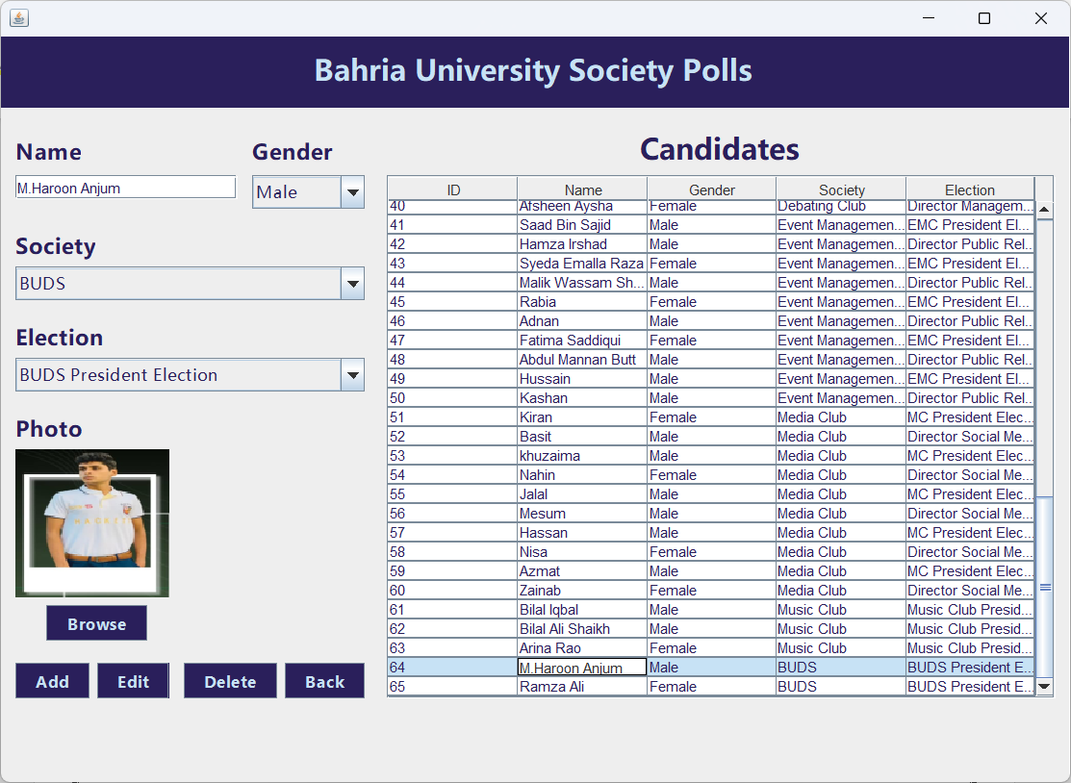
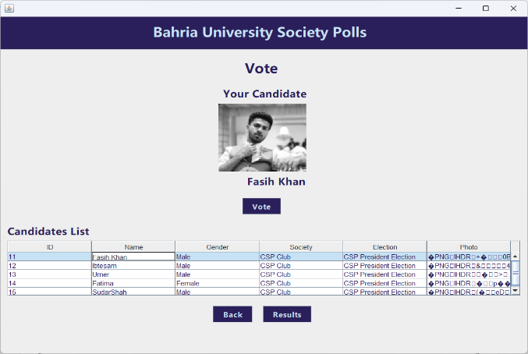
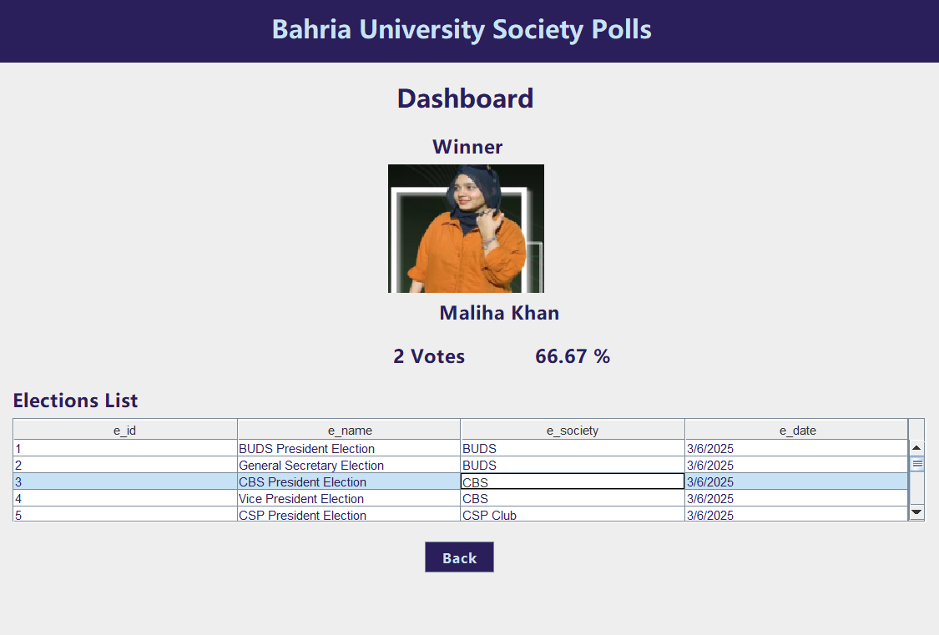

CONCLUSION
The BUSPs project effectively automates the society election process, reducing manual errors and enhancing transparency. By incorporating key OOP principles and using Java Swing coupled with MariaDB, the system provides a secure and intuitive platform for election management. This not only improves operational efficiency but also fosters trust in the electoral process among students and administrators at Bahria University.

