|  |  |  |  |  |
| --- | --- | --- | --- | --- |
|  |  |  |  | |
|  |  |  | **VACCINATION MANAGEMENT SYSTEM** | |
|  |  |  |  |  |
| User | |  |  | | --- | --- | | Student1542863 | Ms. AISHA  NOOR | |  |  |
|  | |  |  | | --- | --- | | Student1542711 | Ms. DURR  E SHAHWAR | |  |  |
|  | |  |  | | --- | --- | | Student1545237 | Ms. SHABIA  TANSEER AHMED | |  |  |
|  |  |  |  |

Introduction:

In the existing system, Vaccines are provided for infants and children under teenage by various

aspects such as by attending school manually and there is a chance that some of the children’s and

infants may miss the opportunity of getting vaccinated due to some mandatory reasons. Which leads

to loss of life or gets affected by various diseases such as polio… etc? This is a time delay process to

wait for each and every one all over the places.

Proposed Solution:

We can change this manual system into e-vaccination system by collecting the info of infants,

registered under website so that those who didn’t took vaccination can avail one more opportunity

to save the life of their children . By this system a lot of man-hours can be saved and it is efficient

too.

Contents

Introduction: 1

Proposed Solution: 1

Hardware/ Software Requirements: 3

system modules/features: 3

ERD: 4

SYSTEM OVERVIEW: 4

Hardware/ Software Requirements:

Hardware

* A minimum computer system that will help you access all the tools in the
* courses is a Pentium 166 or better
* 128 Megabytes of RAM or better

Operating System

* LINUX / Windows 2000 Server (or higher if possible)

Software

* PHP
* MySQL
* PERL
* Apache

system modules/features:

Admin

* Login
* Edit and update profile
* Add, view and edit all children profile details
* Add, view and edit all hospitals details
* Activate and Deactivate hospitals
* View all appointment details
* Approve or reject appointment requests from parents
* View all vaccines and their availability

Parent

* Register and Login
* Edit and update profile
* View activated hospitals
* Book appointment
* View appointments and their status
* View vaccinated children, upcoming appointments and available hospitals count

Hospital

* Login
* Edit and update profile
* View appointments and update their status
* View all vaccines and their availability

ERD:

ERD:

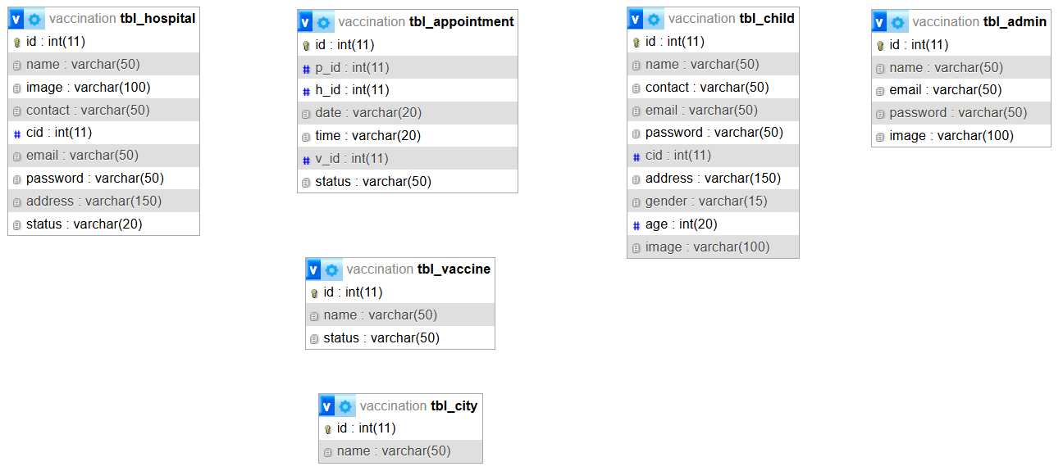

SYSTEM OVERVIEW:

Dynamic Statistics:

View Partnered Hospitals:

Login Options:

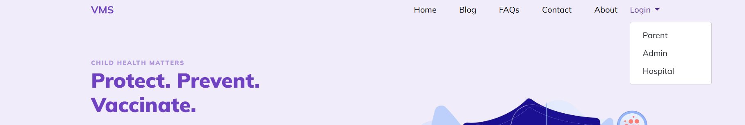

Parent Login System:



Child Registration:



Child Profile:

Book Appointment:

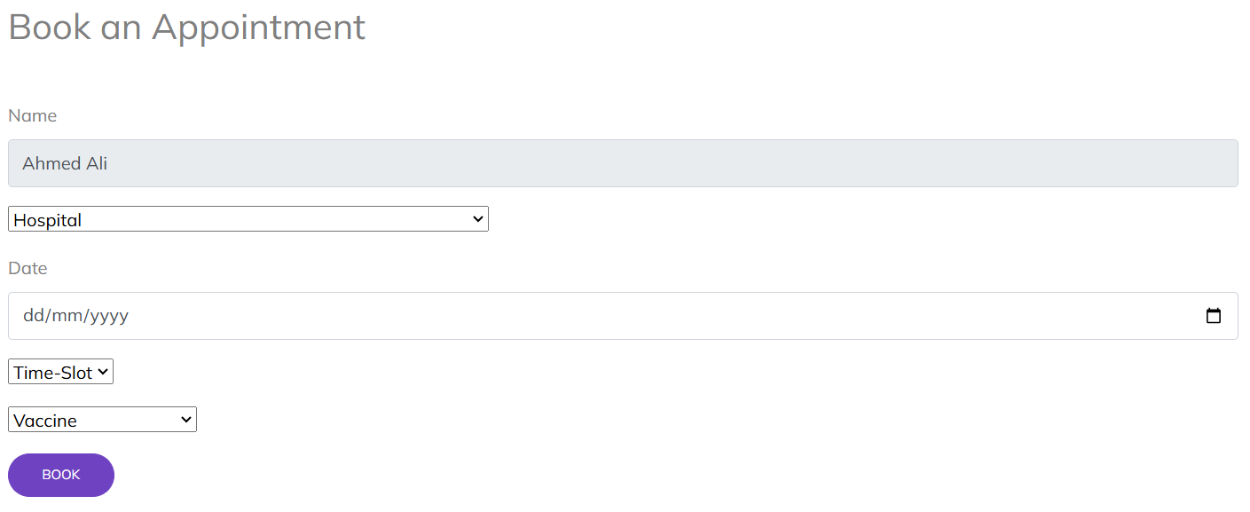

View Appointments:



Admin Login System:



Admin Dashboard:

Admin Profile:

List of Registered Children:

Add Child:

View Child Profile:

Update Child Profile:

List of Partnered Hospitals with functionality to activate or deactivate:

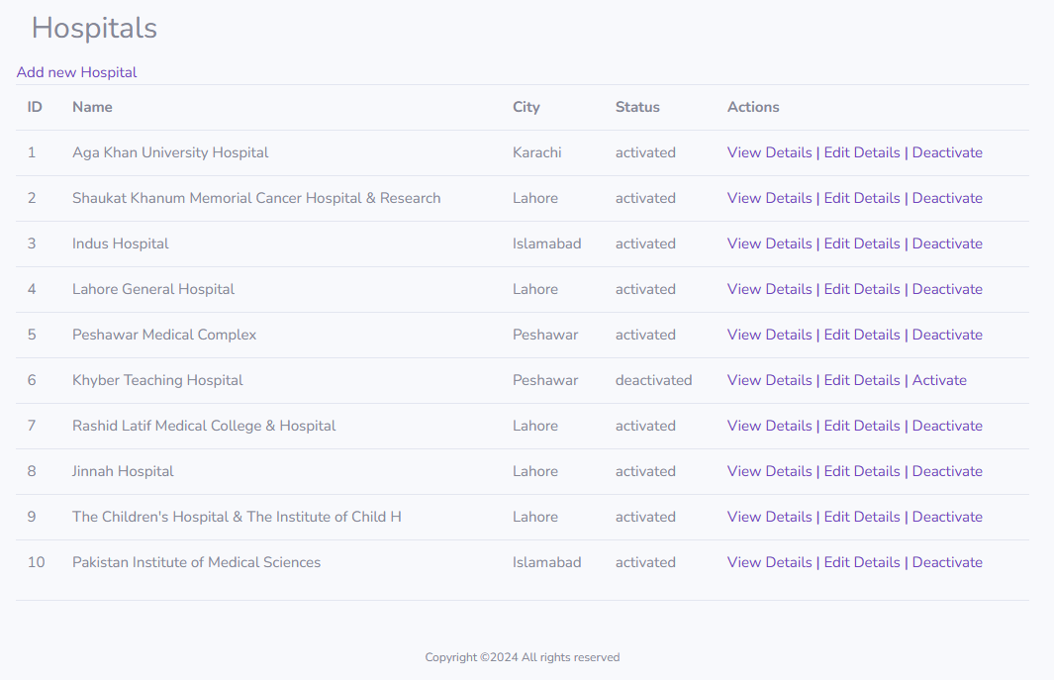

Register a new Hospital:

View Hospital Details:

Update Hospital Profile:

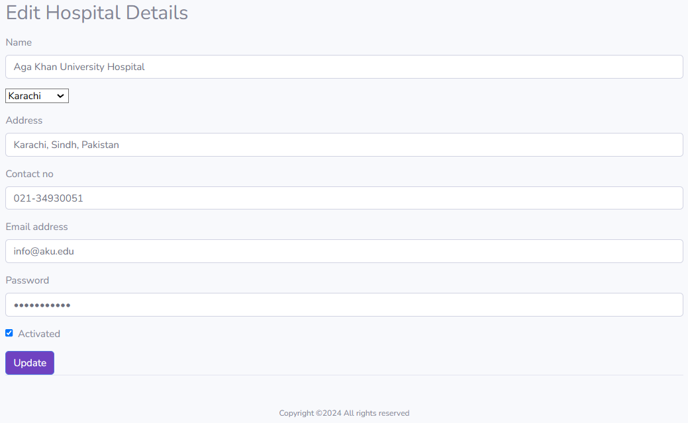

List of Vaccines:

List of Appointment Requests:

Hospital Login System:



Hospital Profile:

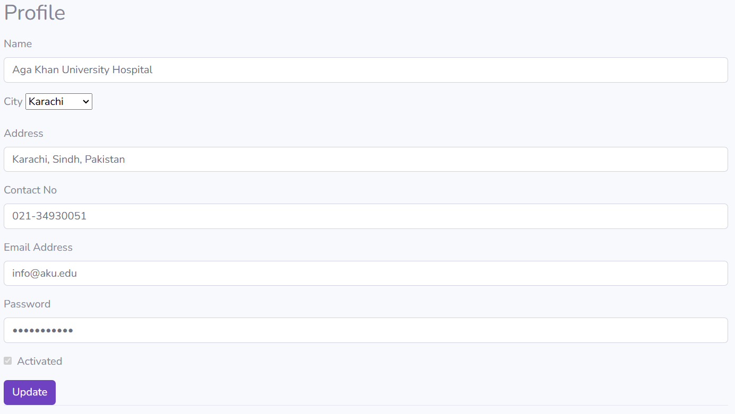

Appointments with functionality to update status to “done”:

List of Vaccines:

