**TEST A PERCEPTUAL PHENOMENON:**

**BACKGROUND INFORMATION**

In the congruent words condition, the words being displayed are color words whose names match the colors in which they are printed: Example RED, BLUE.

In the incongruent words condition, the words displayed are color words whose names do not match the colors in which they are printed: Example PURPLE, ORANGE.

**QUESTIONS FOR INVESTIGATION:**

**1.What is our independent variable? What is our dependent variable?**

Independent variable: An independent variable is an variable which is manipulated in order to test the effect on the dependent variable. the words condition (congruent or incongruent words).

Dependent variable: An dependent variable is the variable tested and measured in the experiment. The dependent variable is dependent on independent variable. the time it takes to name the ink colors in equally sized list.

**2.What is an appropriate set of hypotheses for this task? What kind of statistical test do you expect to perform? Justify your choices.**

The null hypothesis must be the mean for an color recognition for the congruent words equal to or greater than the mean of incongruent words. The other way is congruent word mean is less then an incongruent word.

H0: μC ≥ μI

HA: μC < μI

where μ is a population mean, the subscript "C" represents the congruent words condition, and the subscript "I" represents the incongruent words condition.

**Alternative hypothesis**

The alternative hypothesis, denoted by H1 or Ha, is the hypothesis that sample observations are influenced by some non-random cause.

**One Tailed Dependent Sample t-test**

A one-tailed, dependent samples t-test comparing the difference in means (the time to name the ink colors for congruent words and incongruent words) should be performed. With this test, we seek to determine whether there is enough evidence in the provided sample of data to infer that the congruent words mean colour recognition time is less than the incongruent words mean colour recognition time for the entire population and not just the sample data.

**Example**

A t-test is appropriate because the population variance is unknown and the sample size is less than 30. When the sample size is less than 30, the sample data no longer approximate a normal distribution, which makes the use of a Z-value inappropriate.[1](http://stattrek.com/probability-distributions/t-distribution.aspx) The following assumptions are required for t-tests for dependent means:[2](http://www.psychology.emory.edu/clinical/bliwise/Tutorials/TOM/meanstests/assump.htm" \t "_blank)

**Characteristics:**

* Interval or ratio scale of measurement (approximately interval)
* Random sampling from a defined population
* Samples or sets of data used to produce the difference scores are linked in the population through repeated measurement, natural association, or matching
* Scores are normally distributed in the population; difference scores are normally distributed

A one-tailed test is appropriate under the assumption that incongruent word conditions will not improve recognition times, which is intuitive. The one-tailed test allows for a more scrutinous examination of the negative impact of incongruent word conditions on recognition times.

The t-test should be of the dependent samples variety because the same subject is exposed to two conditions and tested for each, which are the defining criteria for "within-subjects" or "repeated-measures" statistical tests.[3](https://statistics.laerd.com/statistical-guides/dependent-t-test-statistical-guide.php)

**3.  Report some descriptive statistics regarding this dataset. Include at least one measure of central tendency and at least one measure of variability**.

|  |  |  |  |
| --- | --- | --- | --- |
| **Statistic** | **Congruent** | **Incongruent** | **Difference (C-I)** |
| n | 24 | 24 | 24 |
| x̄ | 14.05 | 22.02 | -7.96 |
| Median | 14.36 | 21.02 | -7.67 |
| s2 | 12.67 | 23.01 | 23.67 |
| s | 3.56 | 4.80 | 4.86 |
| SE | 0.73 | 0.98 | 0.99 |

**4. Provide one or two visualizations that show the distribution of the sample data. Write one or two sentences noting what you observe about the plot or plots.**

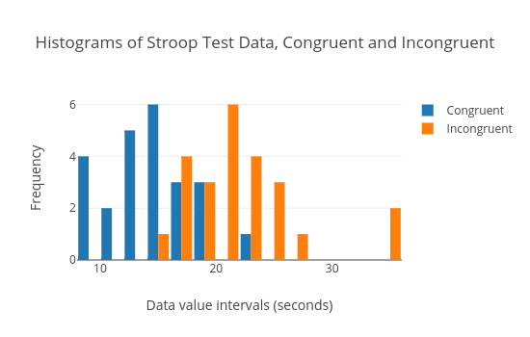

The number of participating data of congruent and incongruent are which has data in the x-axis and time in the y-axis.

**5. Now, perform the statistical test and report your results. What is your confidence level and your critical statistic value? Do you reject the null hypothesis or fail to reject it? Come to a conclusion in terms of the experiment task. Did the results match up with your expectations?**

At the 99% confidence level (α = .01) and 23 degrees of freedom, the critical statistic value for a one-tailed test in the negative direction is -2.5. The calculated t-statistic for the difference in color recognition time means of the congruent and incongruent word data is -8.02. Since the t-statistic is in the critical region, the null hypothesis is rejected. With the data presented, it is very unlikely that the 7.96 second difference in mean time for color recognition for the congruent data vs. the incongruent data is obtained if the two means are actually the same . By conventional criteria, this difference is considered to be extremely statistically significant.

**6. Optional: What do you think is responsible for the effects observed? Can you think of an alternative or similar task that would result in a similar effect? Some research about the problem will be helpful for thinking about these two questions!**

My hypothesis for the effects observed is that the brain dominantly focuses on reading the word rather than recognizing a color when the eyes are presented with a colored word. To recognize a color, one has to override the brain's natural tendency of reading the word. This override takes time and is likely not always successful, which means re-analyzing a word after the error is recognized, which costs more time.

Numerical/Physical size Stroop tasks, where numerical values and physical size are the factors that contribute to congruency/incongruency, results in a similar effect. It takes longer to recognize the number and physical size (two separate tasks) of small numbers that have a large physical size and large numbers that have a small physical size.[4](https://en.wikipedia.org/wiki/Numerical_Stroop_effect)