**Task**

**Aisha Parveen**

**Sp23-bcs-011-A**

**Rcode**

# Salary Vector

salary <- c(50000, 60000, 70000, 80000, 50000, 65000, 45000, 60000)

# Calculate Average Salary

average_salary <- mean(salary)

average_salary

# Age Vector

age <- c(34, 29, 40, 30, 35, 27, 41, 30)

# Find Minimum and Maximum Age

min_age <- min(age)

max_age <- max(age)

min_age

max_age

# Employee List

employee1 <- list(

Name = "X",

Department = "HR",

Age = 34,

Salary = 50000

)

# Display each element

employee1

employee1$Name

employee1$Department

employee1$Age

employee1$Salary

# Variables

salary <- c(50000, 60000, 70000, 80000, 50000, 65000, 45000, 60000)

experience <- c(5, 3, 10, 4, 2, 7, 9, 6)

# Mean

mean_salary <- mean(salary)

mean_experience <- mean(experience)

# Standard Deviation

sd_salary <- sd(salary)

sd_experience <- sd(experience)

# Correlation

correlation <- cor(salary, experience)

# Display results

mean_salary

sd_salary

correlation

#question no 3

# Load dataset

data(mtcars)

# Scatter plot with trend line

plot(mtcars$hp, mtcars$mpg,

main = "Relationship between Horsepower and Miles per Gallon",

xlab = "Horsepower (hp)",

ylab = "Miles per Gallon (mpg)",

pch = 19, col = "blue")

# Add a trend line (regression line)

abline(lm(mpg ~ hp, data = mtcars), col = "red", lwd = 2)

# Box plot of mpg grouped by cylinder count

boxplot(mpg ~ cyl, data = mtcars,

main = "MPG Distribution by Number of Cylinders",

xlab = "Number of Cylinders",

ylab = "Miles per Gallon (mpg)",

col = c("lightblue", "lightgreen", "lightpink"))

# Histogram of car weights

hist(mtcars$wt,

breaks = 10, # Custom number of bins

col = "orange",

main = "Distribution of Car Weights",

xlab = "Weight (1000 lbs)",

ylab = "Frequency",

border = "brown")

Graph Scatter Plot

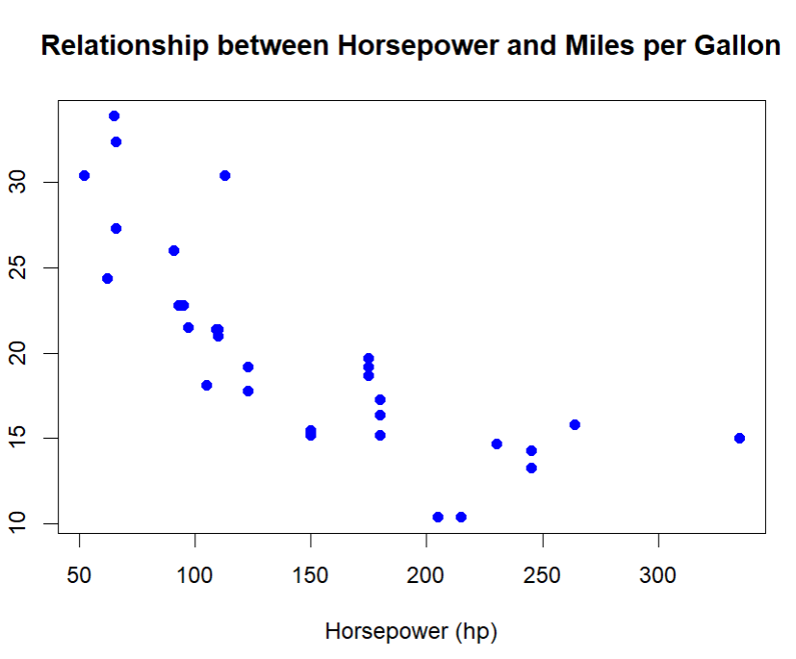

**BoxPLOT**

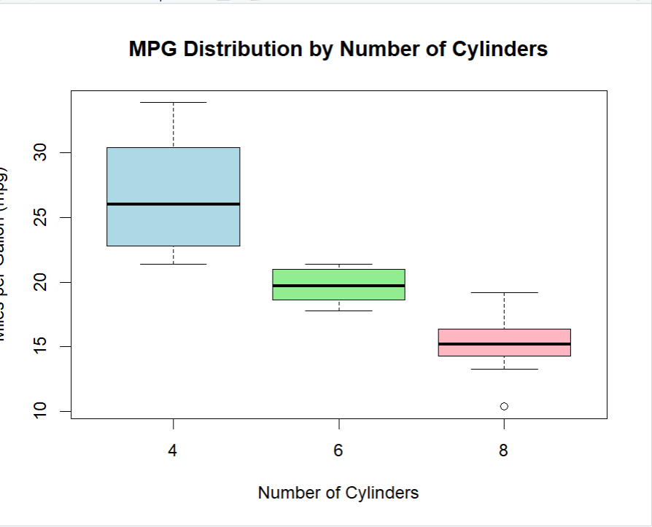

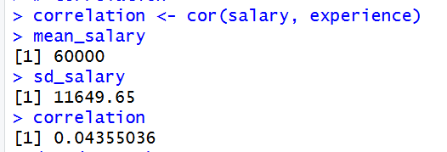

**Histogram**

