

INTERNET AND WEB PROGRAMMING

***DIGITAL ASSIGNMENT-9***

***VTOP ASSIGNMENT-4***

***NAME-AISHIKA SAHA***

***REGISTRATION NUMBER-18BCE2168***

9. Write a PHP program to demonstrate the concept of Session Management and Cookies a. Create a cookie with a value of username and his email Id. The cookie should expire in 3 days. Check whether the cookie is present in the website ,when the user enters his username, the emailed should be given by the cookies.

**CODE:**

**FILE: welcome.php**

<?php

session_start();

echo "<h1>AISHIKA SAHA<br> 18BCE2168</h1>";

setcookie(session_name(), "Hi", time() + 86400*3);

header('Refresh: 2; URL = cookies.php');

?>

**FILE: cookies.php**

<?php

session_start();

if (session_id() == '' || !isset($_SESSION['name'])) {

?>

echo "<h1>AISHIKA SAHA<br> 18BCE2168</h1>"

<a href="cookies2.php">Login</a>

<?php

} else {

  echo "Hi, " . $_SESSION['name'];

?>

<a href="cookies2.php">Logout</a>

<?php

}

?>

**FILE: cookies2.php**

<?php

session_start();

const email = 'Aishika saha';

const name = 'aishisaha1@gmail.com';

if (isset($_POST['name']) && isset($_POST['email'])) //when form submitted

{

  if ($_POST['name'] === name && $_POST['email'] === email)

  {

    $_SESSION['name'] = $_POST['name']; //write login to server storage

    header('Location: welcome.php'); //redirect to main

  }

  else

  {

    echo "<script>alert('Wrong login or password');</script>";

    echo "<noscript>Wrong login or password</noscript>";

  }

}

?>

<form method="post">

<h1>AISHIKA SAHA<br> 18BCE2168</h1>

NAME:<br><input name="email" placeholder="Name"><br>

EMAIL:<br><input name="name" placeholder="Email"><br>

  <input type="submit">

</form>

**OUTPUT:**

**Starting the server:**

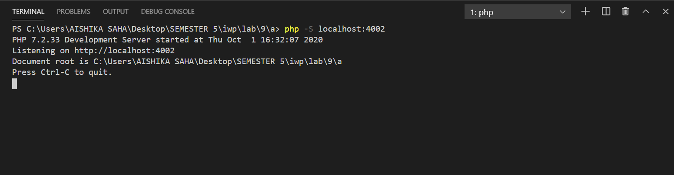

**At** [**http://localhost:4002/welcome.php**](http://localhost:4002/welcome.php)

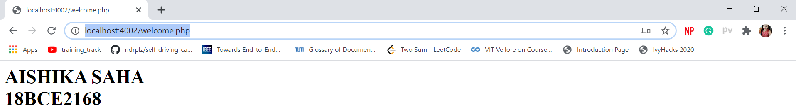

**At** [**http://localhost:4002/cookies2.php**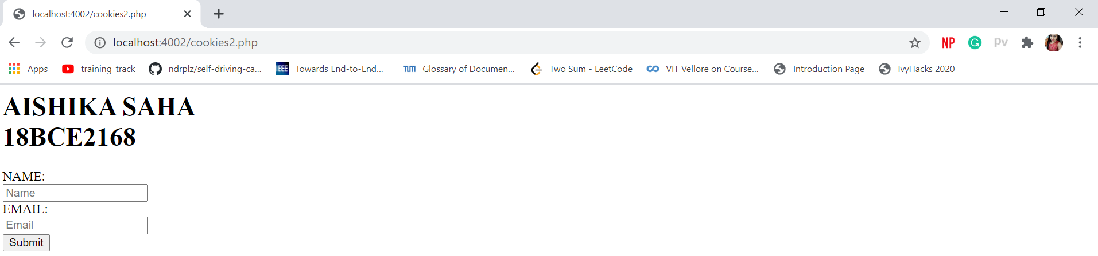](http://localhost:4002/cookies2.php)

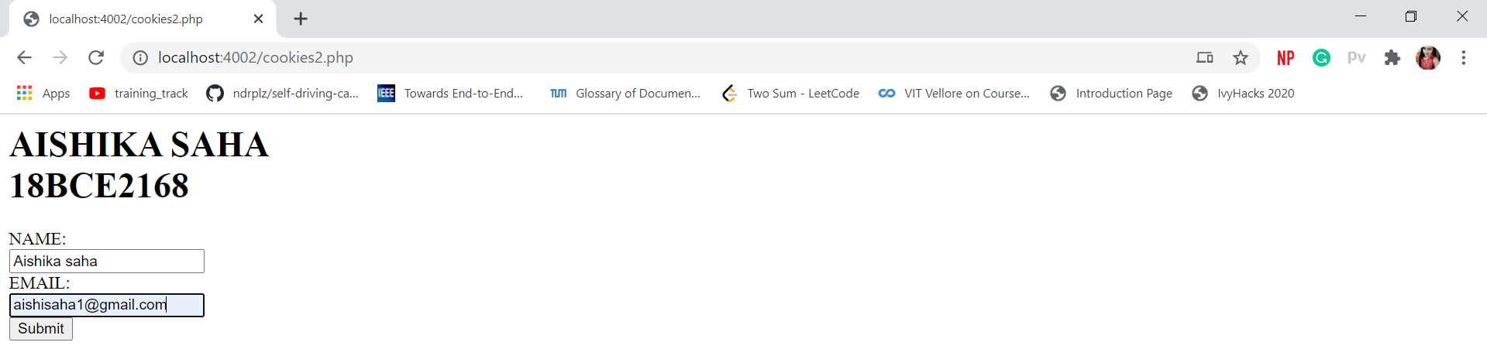

**On clicking submit:**

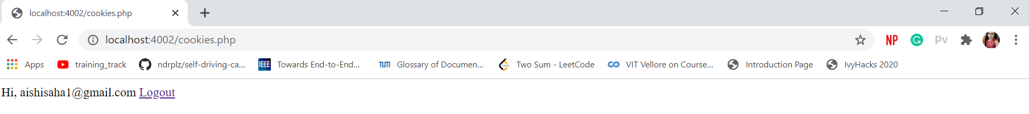

**In case we submit wrong email:**

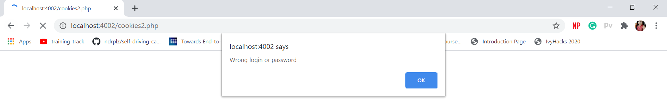

b. Perform the following operations:

i. Create a cookie.Check whether the cookie is enabled or not. Print the status.

ii. Delete the created cookie before an hour

iii. Check whether the cookie is disabled or not. Print the status.

**CODE:**

1. **FOR ENABLING THE COOKIE**

<!DOCTYPE html>

<html>

<body>

    <?php

    $cookie_name = "aishika";

    $cookie_value = "18bce2168";

    setcookie($cookie_name, $cookie_value, time() + 60, "/");

    if(!isset($_COOKIE[$cookie_name])) {

          echo "Cookie named '" . $cookie_name . "' is not ENABLED!";

   }

    else {

          echo "Cookie '" . $cookie_name . "' is ENABLED!<br>";

          echo "Value is: " . $cookie_value;

    }

    ?>

</body>

</html>

**OUTPUT:**

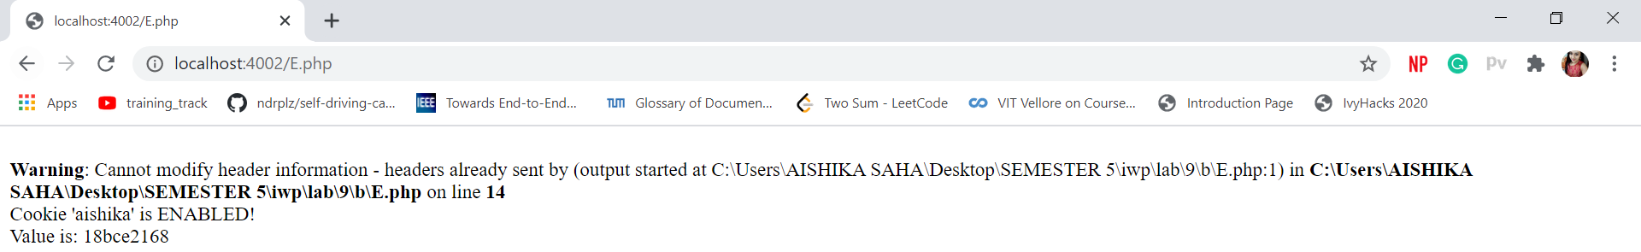

1. **FOR DELETING THE COOKIE**

<!DOCTYPE html>

<?php

setcookie("aishika", "", time() - 3600);

?>

<html>

<body>

    <?php

    echo "Cookie 'aishika' is deleted.";

    ?>

</body>

</html>

**OUTPUT:**

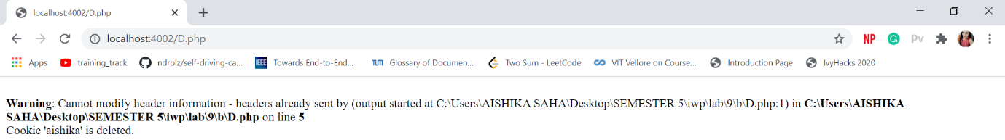

1. **TO DISABLE:**

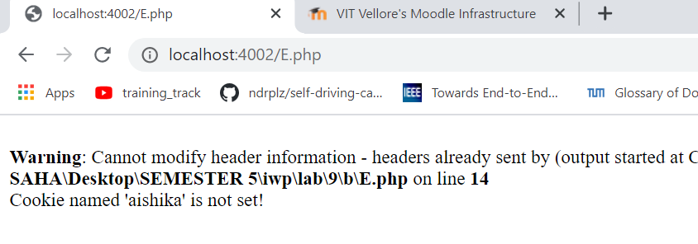



INTERNET AND WEB PROGRAMMING

***DIGITAL ASSIGNMENT-11***

***NAME-AISHIKA SAHA***

***REGISTRATION NUMBER-18BCE2168***

11) Write a program to demonstrate the concept of data storage and parsing in XML

I . Develop a thesaurus tool by creating a schema for thesaurus. When a word is entered the synonyms or antonyms must be displayed based on the user request.

**part.xml**

<?xml version="1.0" encoding="UTF-8"?>

<!DOCTYPE part SYSTEM "part.dtd">

<?xml-stylesheet type='text/xsl' href='part.xsl'?>

<part>

 <word content="Debunk">

 <synonyms>demystify,deflate, uncloak</synonyms>

 <antonyms>ascertain,certfy,determine</antonyms>

 </word>

 <word content="Browbeat">

<synonyms>bully,hector,intimidate,force</synonyms>

 <antonyms>simple,easy,effortless,facile</antonyms>

 </word>

 <word content="Allude">

<synonyms>common,essential,innate,legitimate</synonyms>

<antonyms>abnormal,atypical,artificial,foreign</antonyms>

 </word>

</part>

**Part.dtd**

<?xml version='1.0' encoding='UTF-8'?>

<!--

TODO define vocabulary identification

PUBLIC ID: -//vendor//vocabulary//EN

SYSTEM ID: http://server/path/part.dtd

-->

<!--

An example how to use this DTD from your XML document:

<?xml version="1.0"?>

<!DOCTYPE part SYSTEM "part.dtd">

<part>

...

</part>

-->

<!--- Put your DTDDoc comment here. -->

<!ELEMENT part (word)*>

<!--- Put your DTDDoc comment here. -->

<!ELEMENT word (synonyms)*>

<!ATTLIST word

content CDATA #IMPLIED

>

<!ELEMENT word (antonyms)*>

<!ATTLIST word

content CDATA #IMPLIED

>

<!--- Put your DTDDoc comment here. -->

<!ELEMENT synonyms (#PCDATA)>

<!ELEMENT antonyms (#PCDATA)>

**Part.xsl**

<?xml version="1.0" encoding="UTF-8"?>

<!--

Document : part.xsl

Author : Aishika Saha 18BCE2168

-->

<xsl:stylesheet xmlns:xsl="http://www.w3.org/1999/XSL/Transform"

version="1.0">

<xsl:output method="html"/>

<xsl:template match="/">

<html>

 <head>

 <title>part.xsl</title>

 </head>

 <body>

 <form method="post" action="">

 <table>

 <tr>

 <td>Enter word:</td>

 <td><input type="text" id="search"/></td>

 <td><input type="submit" id="submit"

value="Synonyms"/></td>

 <td><input type="submit" id="submit"

value="Antonyms"/></td>

 </tr>

 <xsl:for-each select="part/word">

 <xsl:if test="@content='Smart'">

 <tr>

 <td>

 <xsl:value-of select="synonyms"/>

 </td>

 <td>

 <xsl:value-of select="antonyms"/>

 </td>

 </tr>

 </xsl:if>

 <xsl:if test="@content='Difficult'">

 <tr>

 <td>

 <xsl:value-of select="synonyms"/>

 </td>

 <td>

 <xsl:value-of select="antonyms"/>

 </td>

 </tr>

 </xsl:if>

 <xsl:if test="@content='Natural'">

 <tr>

 <td>

 <xsl:value-of select="synonyms"/>

 </td>

 <td>

 <xsl:value-of select="antonyms"/>

 </td>

 </tr>

 </xsl:if>

 </xsl:for-each>

 </table>

 </form>

 </body>

</html>

</xsl:template>

</xsl:stylesheet>

**Output:**

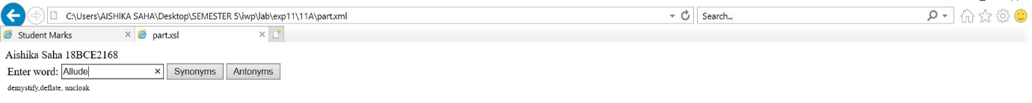**For synonyms**

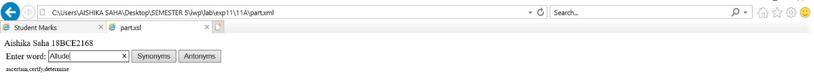

**For antonyms**

ii. XSLT – Create a student mark maintenance system using XML. Create a webpage to display all the students consolidated mark statement with pass (green color)or fail (red color)using XSLT.

**stuMarks.xml**

<?xml version="1.0" encoding="UTF-8"?>

<!DOCTYPE marks SYSTEM "marks.dtd">

<?xml-stylesheet type='text/xsl' href='marks.xsl'?>

<marks>

<student>

<name>AISHIKA SAHA</name>

<score>16.5</score>

</student>

<student>

<name>AMIT SINGH</name>

<score>23</score>

</student>

<student>

<name>SORAV GANGULY</name>

<score>15</score>

</student>

<student>

<name>SHAHRUKH KHAN</name>

<score>20</score>

</student>

<student>

<name>KABIR SINGH</name>

<score>13</score>

</student>

</marks>

**stuMarks.xsl**

<?xml version="1.0" encoding="UTF-8"?>

<xsl:stylesheet xmlns:xsl="http://www.w3.org/1999/XSL/Transform" version="1.0">

<!--

Document : part.xsl

Author : Aishika Saha 18BCE2168

-->

<xsl:output method="html"/>

<xsl:template match="/">

<html>

<head> Aishika Saha 18BCE2168

<title>Student Marks</title>

</head>

<body>

<xsl:for-each select="marks/student">

<xsl:if test="score &gt; 15">

<div style="background-color:green;color:white; padding:1em; font-size:2em; margin: 1em

0;">

<span style="font-weight:bold">

<xsl:value-of select="name"/> | </span>

<xsl:value-of select="score"/> (Pass)

</div>

</xsl:if>

<xsl:if test="score &lt; 15">

<div style="background-color:red;color:white; padding:1em; font-size:2em; margin: 1em 0;

">

<span style="font-weight:bold">

<xsl:value-of select="name"/> | </span>

<xsl:value-of select="score"/> (Fail)

</div>

</xsl:if>

</xsl:for-each>

</body>

</html>

</xsl:template>

</xsl:stylesheet>

**stuMarks.dtd**

<?xml version='1.0' encoding='UTF-8'?>

<!--

TODO define vocabulary identification

PUBLIC ID: -//vendor//vocabulary//EN

SYSTEM ID: http://server/path/marks.dtd

-->

<!--

An example how to use this DTD from your XML document:

<?xml version="1.0"?>

<!DOCTYPE marks SYSTEM "marks.dtd">

<marks>

...

</marks>

-->

<!--- Put your DTDDoc comment here. -->

<!ELEMENT marks (student)*>

<!--- Put your DTDDoc comment here. -->

<!ELEMENT student (name|score)*>

<!--- Put your DTDDoc comment here. -->

<!ELEMENT name (#PCDATA)>

<!--- Put your DTDDoc comment here. -->

<!ELEMENT score (#PCDATA)>

**OUTPUT:**

