

## INTERNET AND WEB PROGRAMMING

***DIGITAL ASSIGNMENT-9***

***VTOP ASSIGNMENT-5***

***NAME-AISHIKA SAHA***

***REGISTRATION NUMBER-18BCE2168***

### *6. Create a program to change the content of the webpage using AJAX.*

### *Create a program to change the content of the Jackpot web page using AJAX.*

### *Allow the user to enter any 4 digit number in the textbox.*

### *Whenever the user enters a number ending with 7,show Rs 1000 as prize money.*

### *When the user enters a number ending with 9,show Rs 3000 as the prize money.*

### *For all other value Rs.100 as the prize money.*

### *Prize Money updation should be done with AJAX.*

<!DOCTYPE html>

<html lang="en" dir="ltr">

<head>

  <meta charset="utf-8">

  <title>18BCE2168</title>

</head>

<body>

  <h1>JACKPOT WEBPAGE USING AJAX<br>AISHIKA SAHA <br>18BCE2168</h1>

  <form class="form" action="index.html" method="post">

    <input type="text" id="num" placeholder="ENTER 4 DIGIT NUMBER">

    <button type="submit" name="submit" onclick="change()">SUBMIT</button>

    <h1 id="prize"></h1>

  </form>

  <script>

    function change() {

      var xhttp = new XMLHttpRequest();

      xhttp.onreadystatechange = function() {

        if (this.readyState === 4 && this.status === 200) {

          valid();

        }else{

          valid();

        }

      };

      xhttp.open("GET", true);

      xhttp.send();

    }

    function valid() {

      var num = document.getElementById("num").value;

      if (num.length == 4) {

        if (num[num.length - 1] === 7) {

          document.getElementById("prize").innerHTML = "You Won Prize Money worth Rs 1000";

        } else if (num[num.length - 1] === 9) {

          document.getElementById("prize").innerHTML = "You Won Prize Money worth Rs 3000";

        } else {

          document.getElementById("prize").innerHTML = "You Won Prize Money worth Rs 100";

        }

      } else {

        document.getElementById("prize").innerHTML = "Please Enter 4 Digit number";

      }

    }

  </script>

</body>

</html>

**OUTPUT:**

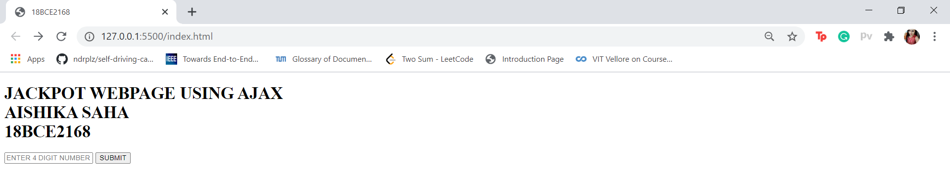

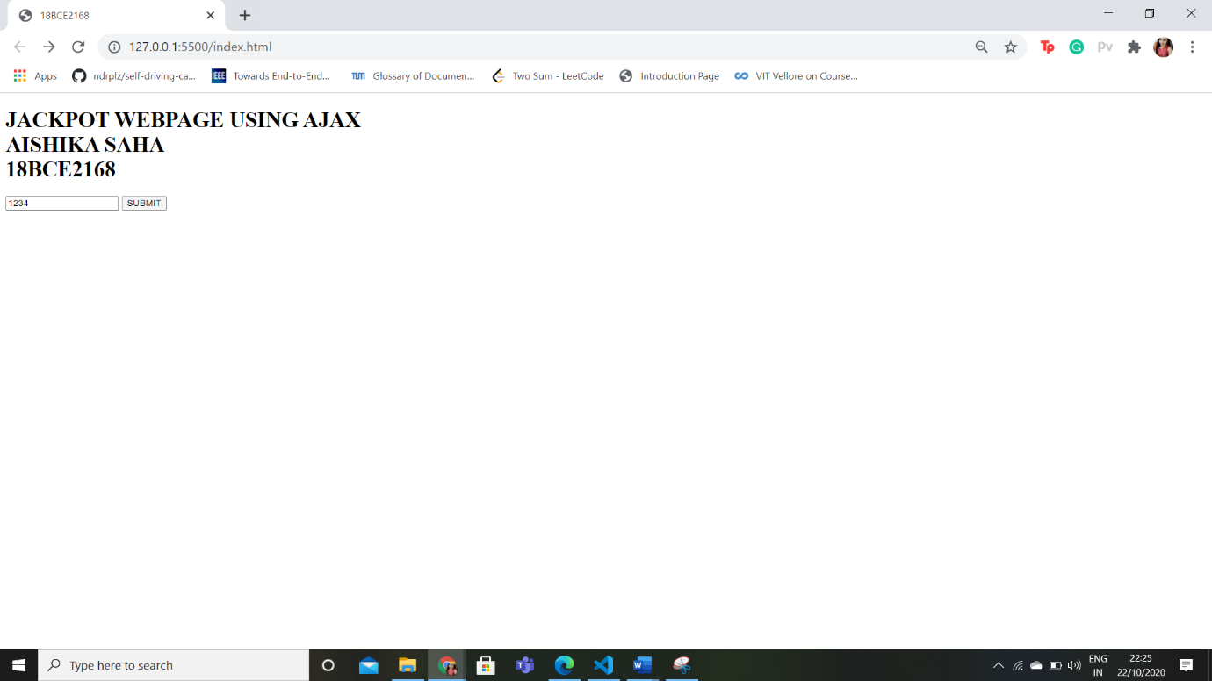



### *Design a web app using PHP to perform all the Database operations.*

* 1. *Create an address book web application that allows the user to store and retrieve several mailing lists from MySQL database. The address book contains firstname, designation, address1, address2, city, state, emailid. User can add, update and delete all address informations in the database. Implement search operation with emailid, when email is given return an HTML page with all the complete address information.*

<!DOCTYPE html>

<html>

<head>

  <title>18BCE2168</title>

  <link rel="stylesheet" href="https://stackpath.bootstrapcdn.com/bootstrap/4.5.2/css/bootstrap.min.css" integrity="sha384-JcKb8q3iqJ61gNV9KGb8thSsNjpSL0n8PARn9HuZOnIxN0hoP+VmmDGMN5t9UJ0Z" crossorigin="anonymous">

</head>

<body>

  <nav class="navbar navbar-light bg-light">

    <span class="navbar-brand mb-0 h1">Address Book</span>

    <span class="form-inline my-2 my-lg-0"> <b> 18BCE268 AISHIKA SAHA</b> </span>

  </nav>

  <h1></h1>

  <table>

    <form action="" method="post">

      <tr>

        <td> <b> Enter First Name : </b></td>

        <td><input type="text" name="firstname"></td>

      </tr>

      <tr>

        <td> <b> Email ID :</b> </td>

        <td><input type="email" name="emailid"></td>

      </tr>

      <tr>

        <td> <b> Enter Designation : </b></td>

        <td><input type="text" name="designation"></td>

      </tr>

      <tr>

        <td> <b>Address 1 : </b>  </td>

        <td><input type="text" name="Address1"></td>

      </tr>

      <tr>

        <td> <b>Address 2 : </b> </td>

        <td><input type="text" name="Address2"></td>

      </tr>

      <tr>

        <td> <b>City :</b>  </td>

        <td><input type="text" name="City"></td>

      </tr>

      <tr>

        <td> <b> State :</b>  </td>

        <td><input type="text" name="State"></td>

      </tr>

      <tr>

        <td><button class="btn btn-primary" name="submit">Add</button></td>

        <td><button class="btn btn-warning" name="update">Update</button></td>

        <td><button class="btn btn-danger" name="delete">Delete</button></td>

      </tr>

      <tr>

        <td> <b>Enter Email ID to Search :</b> </td>

        <td><input type="email" name ="search" id="search"></td>

      </tr>

      <tr>

        <td><button class="btn btn-info" name="searchid">Search</button></td>

      </tr>

    </form>

  </table>

<?php

if(isset($_POST["submit"]))

{

$servername = "localhost";

$username = "root";

$password = "";

$dbname = "aishikasaha";

// Create connection

$conn = new mysqli($servername, $username, $password,$dbname);

// Check connection

if ($conn->connect_error) {

  die("Connection failed: " . $conn->connect_error);

}

$firstname = $_POST["firstname"];

$designation = $_POST["designation"];

$address1 = $_POST["Address1"];

$address2 = $_POST["Address2"];

$city = $_POST["City"];

$state = $_POST["State"];

$emailid = $_POST["emailid"];

$sql = "INSERT INTO address (firstname,designation,address1,address2,city,state,emailid )

VALUES ('$firstname','$designation','$address1','$address2','$city','$state','$emailid')";

if (mysqli_query($conn, $sql)) {

  echo "<b><h3> New record created successfully</h3></b>";

} else {

  echo "<b><h3>Error:</b></h3> " . $sql . "<br>" . mysqli_error($conn);

}

mysqli_close($conn);

}

if(isset($_POST["update"]))

{

  $servername = "localhost";

  $username = "root";

  $password = "";

  $dbname = "aishika";

  // Create connection

  $conn = new mysqli($servername, $username, $password,$dbname);

// Check connection

if ($conn->connect_error) {

  die("Connection failed: " . $conn->connect_error);

}

$firstname = $_POST["firstname"];

$designation = $_POST["designation"];

$address1 = $_POST["Address1"];

$address2 = $_POST["Address2"];

$city = $_POST["City"];

$state = $_POST["State"];

$emailid = $_POST["emailid"];

$sql = "UPDATE address set firstname='$firstname',designation= '$designation', address1='$address1',address2='$address2',city='$city',state='$state' ,emailid='$emailid' where firstname='$firstname' ";

if (mysqli_query($conn, $sql)) {

  echo "<b><h3>Record updated successfully</b></h3>";

} else {

  echo "<b><h3>Error:</b></h3> " . $sql . "<br>" . mysqli_error($conn);

}

mysqli_close($conn);

}

if(isset($_POST["delete"]))

{

  $servername = "localhost";

  $username = "root";

  $password = "";

  $dbname = "aishika";

  // Create connection

  $conn = new mysqli($servername, $username, $password,$dbname);

// Check connection

if ($conn->connect_error) {

  die("Connection failed: " . $conn->connect_error);

}

$firstname = $_POST["firstname"];

$designation = $_POST["designation"];

$address1 = $_POST["Address1"];

$address2 = $_POST["Address2"];

$city = $_POST["City"];

$state = $_POST["State"];

$emailid = $_POST["emailid"];

$sql = "DELETE FROM  address WHERE  firstname='$firstname'  ";

if (mysqli_query($conn, $sql)) {

  echo "<b><h3> Record Deleted successfully</h3></b>";

} else {

  echo "<b><h3> Error: </h3></b>" . $sql . "<br>" . mysqli_error($conn);

}

mysqli_close($conn);

}

if(isset($_POST["searchid"]))

{

  $servername = "localhost";

  $username = "root";

  $password = "";

  $dbname = "aishika";

  // Create connection

  $conn = new mysqli($servername, $username, $password,$dbname);

// Check connection

if ($conn->connect_error) {

  die("Connection failed: " . $conn->connect_error);

}

$search = $_POST["search"];

$firstname = $_POST["firstname"];

$designation = $_POST["designation"];

$address1 = $_POST["Address1"];

$address2 = $_POST["Address2"];

$city = $_POST["City"];

$state = $_POST["State"];

$emailid = $_POST["emailid"];

$sql = "SELECT  * from address WHERE  emailid='$search'  ";

$result = mysqli_query($conn, $sql);

if (mysqli_num_rows($result) > 0) {

  while($row = mysqli_fetch_assoc($result)) {

    echo "<b>First Name:</b> " . $row["firstname"]. "<br>"." <b>Designation:</b> " . $row["designation"]."<br>". "<b>Address 1:</b> " . $row["address1"]."<br>"."<b>Address 2:</b>".$row["address2"]."<br>"."<b>City:</b> ".$row["city"]."<br>"." <b>State:</b> ".$row["state"]."<br>"."<b>Email ID</b>".$row["emailid"]. "<br>";

  }

} else {

  echo "0 results";

}

mysqli_close($conn);

}

?>

</body>

</html>

OUTPUT:

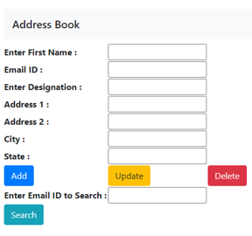

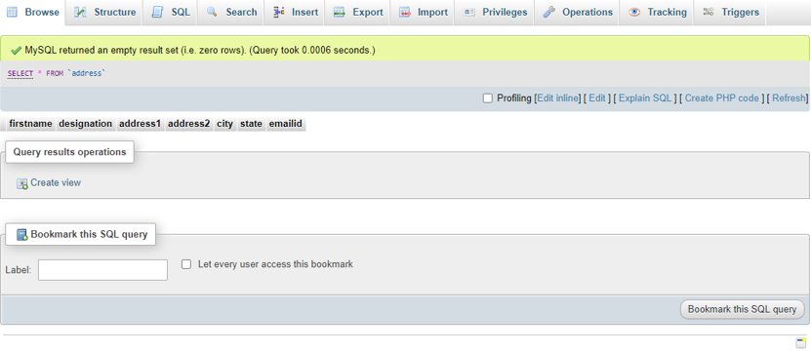

ADDING A RECORD:

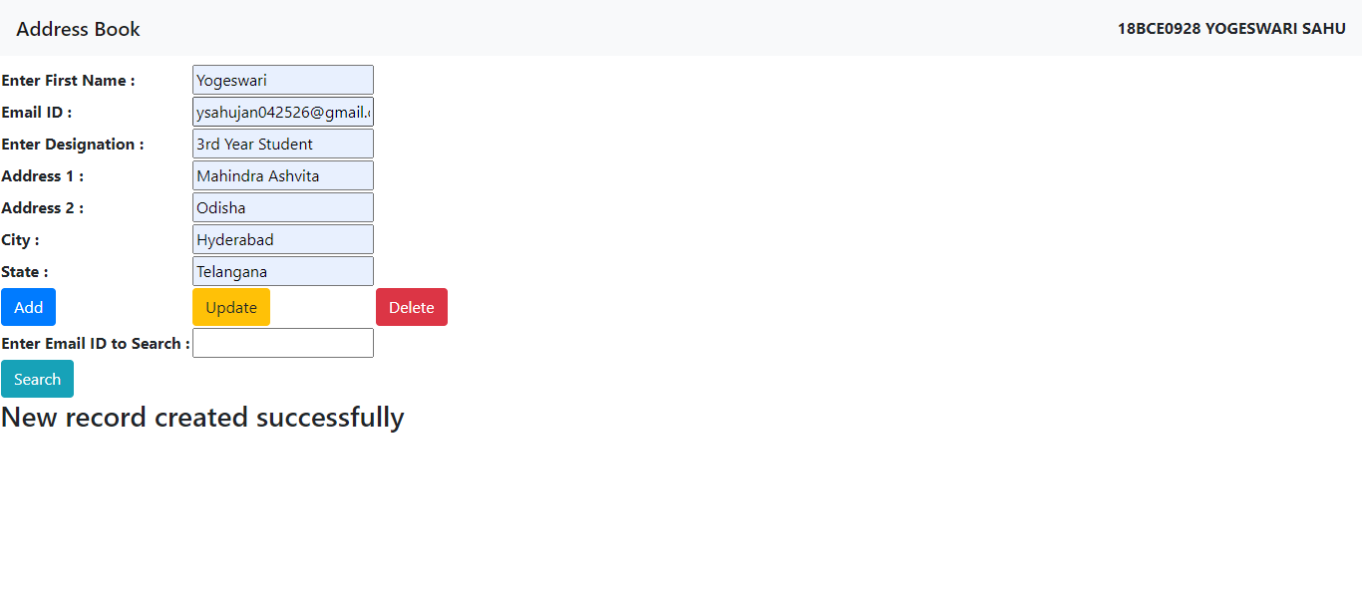

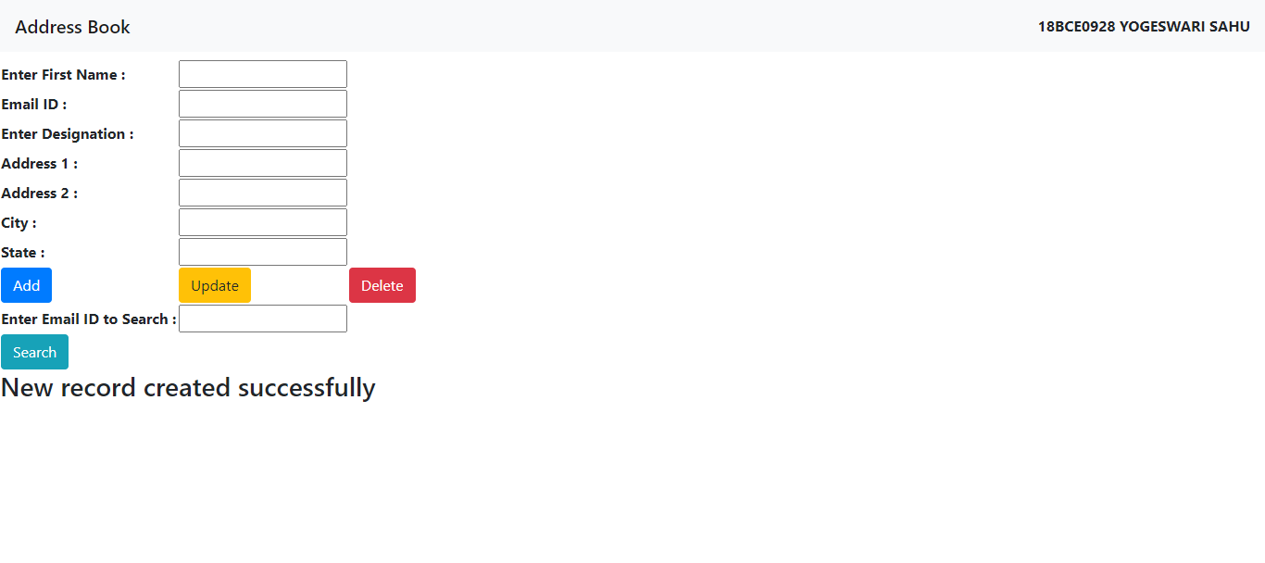

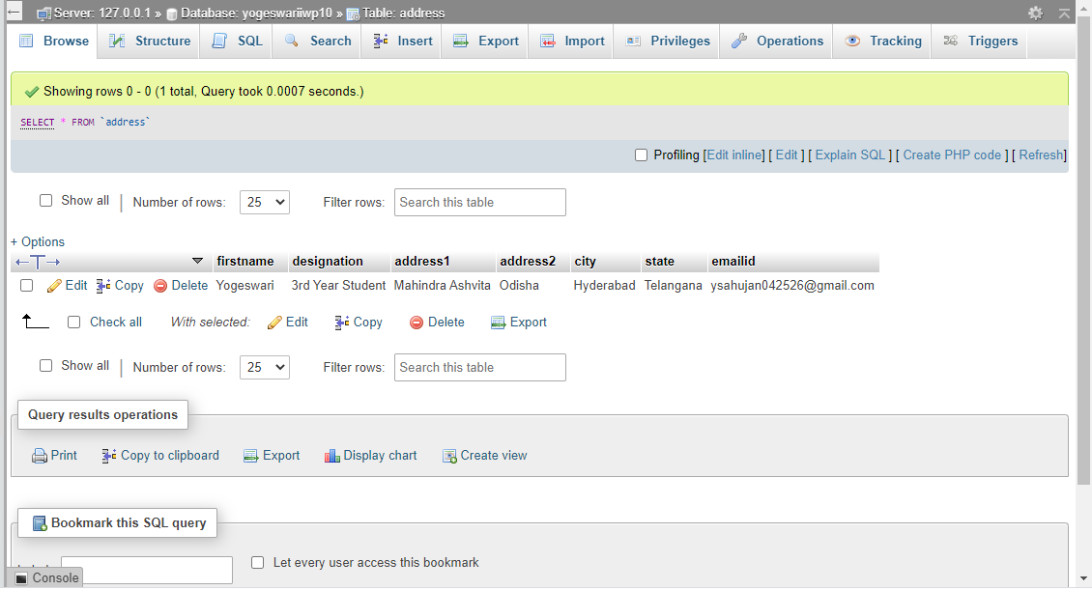

UPDATING RECORD:

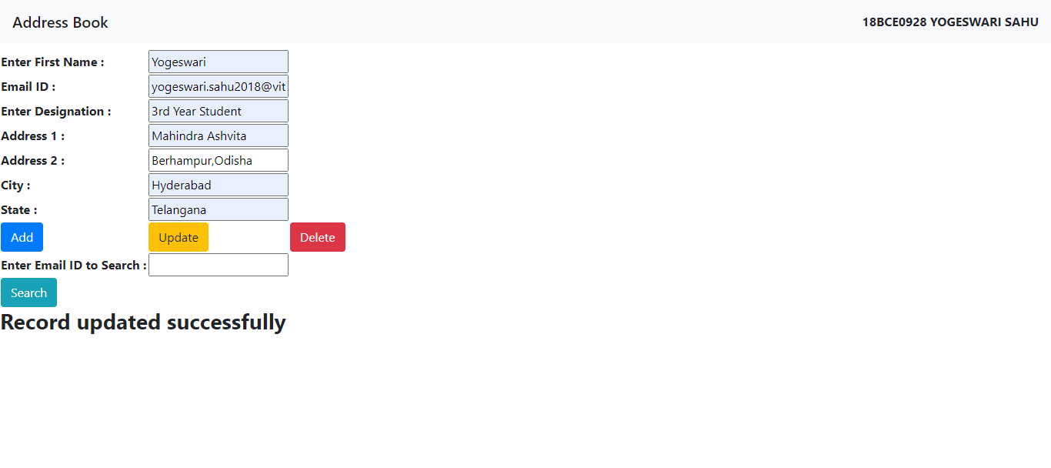

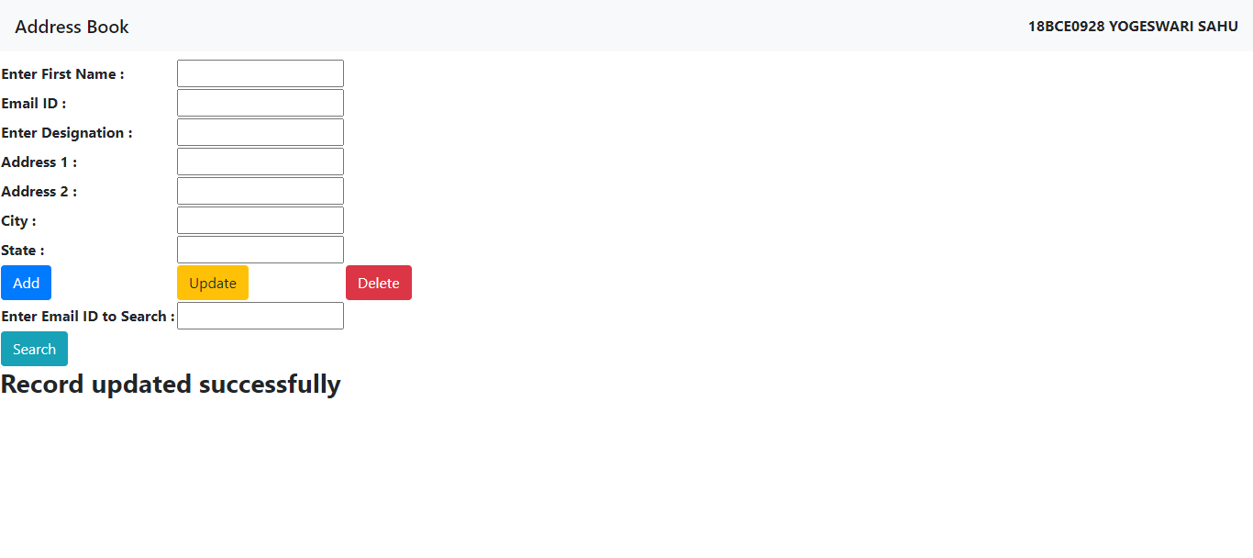

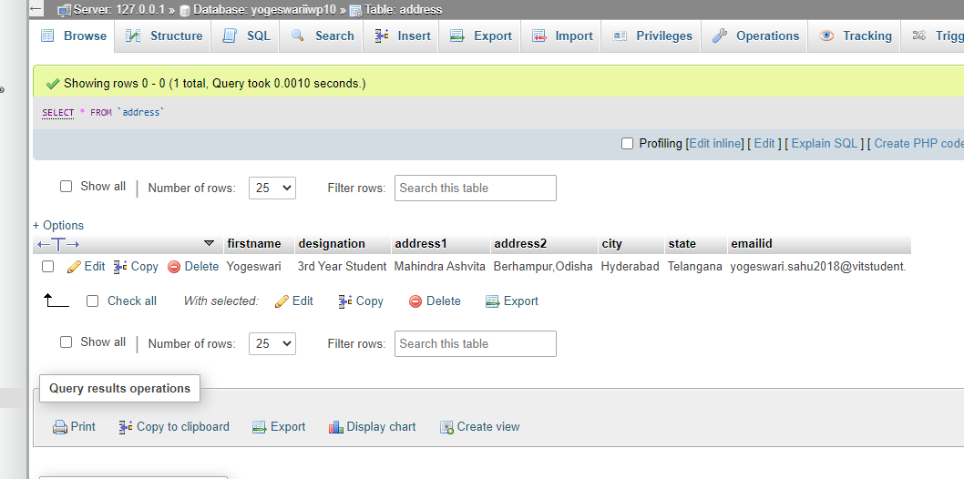

SEARCHING A RECORD:

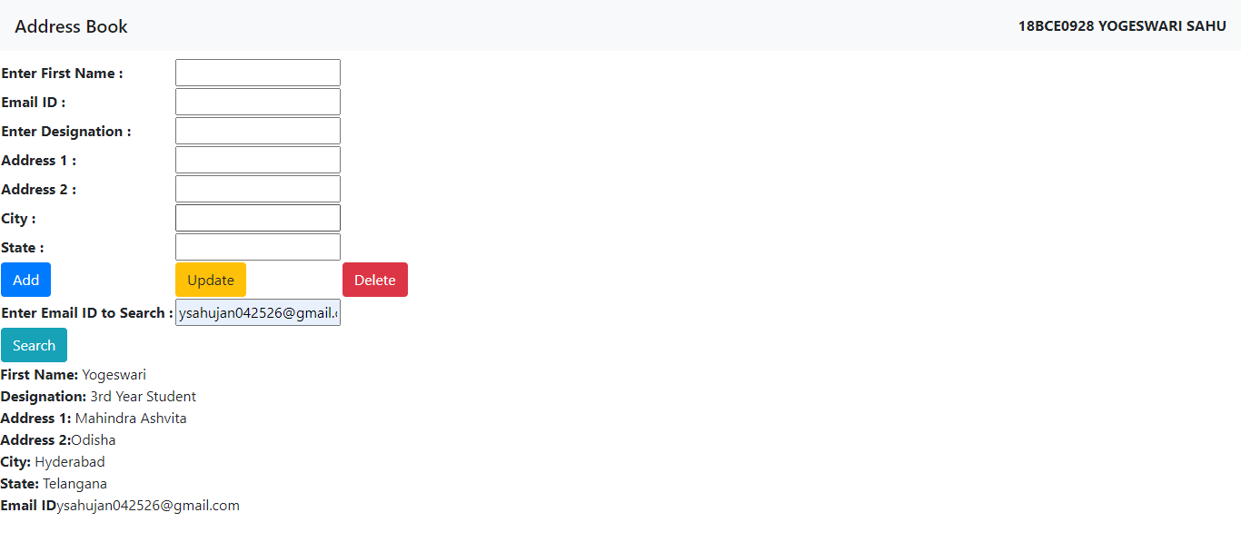

DELETING RECORD:

