

Master Thesis

**Dynamic Smart Office Environment for Occupancy Detection Utilizing Machine Learning**

Submitted by: Aishin Abdulla Yoosufali

First examiner: Prof. Dr. Andreas Pech

Second examiner: Prof. Dr. Peter Nauth

Date of start: 03.01.2024

Date of submission: 10.06.2024

Statement

##### I confirm that I have written this thesis on my own. No other sources were used except those referenced. Content which is taken literally or analogously from published or unpublished sources is identified as such. The drawings or figures of this work have been created by myself or are provided with an appropriate reference. This work has not been submitted in the same or similar form or to any other examination board.



10.06.2024 

##### Date, signature of the student

###### 

Content

1. **Introduction****5**

1.1 Occupancy Detection in Smart Office Environments 5

1.2 Limitations of Conventional Approaches 6

1.3 Emergence of Computational Intelligence for Occupancy Detection 7

1.4 Deep Learning in Occupancy Detection 8

1.5 Motivation and Need for Innovation 8

1.6 Context of Research Problem 9

1.7 Statement of Research Problem 9

1.8 Research Question 10

1.9 Purpose of Research 10

1.10 Overview of Proposed Solution 11

1.11 Scope of the Proposed Research 13

1. **Literature Review****14**

2.1 Evolution of Occupancy Detection 14

2.2 Overview of Occupancy Detection 14

2.3 Modern Sensor Technologies 15

2.4 Integrated Red Pitaya Sensor System in Occupancy Detection 15

2.4.1 Principles of Ultrasonic Sensor 15

2.4.2 Application of Ultrasonic Sensor 15

2.4.3 Advantages of Ultrasonic Sensor Integrated with Red Pitaya Device 16

2.5 Deep Learning in Occupancy Detection 16

2.5.1 Overview of Deep Learning  16

2.5.2 Deep Learning Approaches 17

2.6 Recurrent Neural Network 17

2.6.1 Gated Recurrent Unit (GRU) Neural Network 18

2.6.2 Long Short-Term Memory (LSTM) Neural Network 19

2.6.3 Comparative Analysis of GRU and LSTM Networks 21

2.6.4 Bidirectional LSTM (BiLSTM) Network 21

2.7 Comparative Analysis of GRU, LSTM & BiLSTM Networks 22

2.7.1 Performance Metrics 22

2.7.2 Performance Analysis of GRU, LSTM, and BiLSTM Networks 23

2.8 Privacy and Ethical Considerations 23

2.8.1 Privacy Concerns 23

2.8.2 Non-Intrusive Techniques 23

2.8.3 Ethical Guidelines 24

2.9 Summary and Gaps in Research 24

2.9.1 Key Findings 24

2.9.2 Research Gaps  25

1. **Requirements Analysis** **26**
   1. Research Objectives and Accomplishments26

3.2 General Structure of Occupancy Detection System 27

3.2.1 System Components 27

3.3 Initial State 29

3.3.1 Features of Proposed Occupancy Detection Model 29

3.3.2 Comparison of Traditional vs. Proposed System 31

3.4 Previous Work 31

3.4.1 Sensor Technologies 31

3.4.2 Deep Learning Technologies 32

3.4.3 Comparative Analysis 32

3.5 Research Work Setup Description 32

3.5.1 Physical Environment Setup 32

3.5.2 Hardware Setup 34

3.5.3 Software Setup 34

3.5.4 Data Collection Configuration 34

3.5.5 Network Connectivity 34

3.5.6 Experimental Conditions 34

1. **Realization** **36**

4.1 Data Collection and Labeling Process 36

4.2 Deep Learning Algorithm 37

4.2.1 LSTM Model Architecture 37

4.2.2 Parameter Selection for Algorithm 39

4.2.3 Model and Hyperparameter Optimization 39

4.3 Model Evaluation 41

4.4 Occupancy Detection Model for Red Pitaya’s Software Ecosystem 44

4.4.1 Saving the Model 44

4.4.2 Why is it Necessary to Save Model? 44

4.4.3 Future Scope for Real-Time Applications 44

1. **Summary and Perspectives** **46**
2. **Abbreviations** **47**
3. **References** **49**

# Introduction

## 

This chapter will give comprehensive information about the research on developing and applying occupancy detection systems based on deep learning approaches. It is significant that an ultrasonic sensor integrated with the Red Pitaya (RP) tool is utilized in the implementation of this research. The RP tool, a multipurpose open-source hardware platform, offers a robust yet flexible data collection and processing framework. This tool significantly enhances the functionality and versatility of the system, allowing for the seamless collection and analysis of sensor data. This chapter aims to establish why the study is essential for understanding smart building automation and the contribution of its possibilities to the subject by demonstrating the research background, problem statement, objectives, and significance.

## 1.1 Occupancy Detection in Smart Office Environments

Occupancy detection has evolved significantly over the past few years, driven by the increasing need for energy efficiency and enhanced occupant comfort in various environments, particularly in smart office spaces. Initially, mechanical switches and timers operated light, cooling, and heating (HVAC) systems (Esrafilian-Najafabadi and Haghighat, 2021). These methods, while functional, could have been more efficient and often led to substantial energy waste because of their incapacity to adjust to real-time occupancy changes. The introduction of electronic sensors, such as passive infrared (PIR) sensors, marked a significant improvement. PIR sensors recognize motion through changes in infrared radiation, providing quicker responses and automated control systems. However, as the demand for more innovative and efficient buildings grew, so did the need for more accurate and reliable occupancy detection systems. Accurate occupancy detection is crucial for several reasons, as stated below.

1. It optimizes energy consumption by ensuring lighting and HVAC systems are only active when needed. This approach lowers energy expenses and minimizes buildings' environmental impacts.
2. Precise occupancy detection optimizes occupant comfort by adjusting external factors like lights and temperatures following human presence and activity. This way, it can improve productivity and well-being.
3. Accurate occupancy data can inform intelligent control systems and adaptive building management strategies, assisting in the creation of optimized smart buildings.

Traditional office setups often operate statically, with light, heat, ventilation, and air cooling (HVAC) systems running consistently regardless of occupancy. This approach leads to significant energy waste and fails to utilize resources efficiently. Moreover, inadequate ventilation and air quality monitoring can have a detrimental impact on occupant health and productivity. Recognizing these limitations, smart office environments have emerged, aiming to create smart, responsive solutions that adapt to occupants' evolving needs and reduce environmental impact. This contrast between traditional and smart office setups underscores the urgent need for change and the potential for significant improvement.

Efficient occupancy detection systems are crucial for emerging smart offices to optimize resource allocation, economic benefits, and user comfort. Habitual occupancy monitoring technologies have mainly focused on PIR sensors, which detect motions through variations in infrared lights. However, these customary systems have inherent limitations, primarily their inability to detect stationary occupants and their sensitivity to false positives caused by inhuman motion. As a result, there is an increasing demand for more advanced solutions that provide continuous and precise occupancy data.

Ultrasonic sensors provide another potential alternative to conventional approaches. Sensors like these produce high-frequency sound waves and measure the time it takes to bounce back after striking a person or an object. The ultrasonic sensors can identify tiny variations in distance and motion and are ideally suited to detecting occupancy in dynamic environments. Furthermore, ultrasonic sensors are non-intrusive and can function successfully under various lighting conditions, contrary to other optical alternatives. Incorporating the RP tool and ultrasonic sensors considerably improves the system's functionality and versatility. RP, a multipurpose open-source hardware platform, offers a robust yet flexible data collection and processing framework. The ultrasonic sensors are competent in providing more precise and real-time occupancy data by utilizing RP’s processing power and modular capabilities. The resulting setup allows for the seamless acquisition and analysis of sensor data. It supports advanced signal processing techniques, ensuring the detection system differentiates between various types of occupancy and motion patterns using improved precision. Consequently, this comprehensive approach improves the overall strategy, scalability, and adaptability of occupancy detection systems in smart office environments.

From the perspective of smart workplaces, accurate occupancy detection in smart office spaces serves numerous purposes. Primarily, it encourages efficient energy management by ensuring the light, heat, ventilation, and air cooling (HVAC) systems operate only when necessary, reducing energy consumption and maintenance costs. As suggested by a study, smart buildings with optimized occupancy detection systems can save up to 30% on energy in contrast to conventional techniques (Mahdavi & Tahmasebi, 2015). These potential cost savings are a compelling reason to consider implementing efficient occupancy detection systems in smart office environments.

Subsequently, occupancy detection assists in space utilization through real-time information about room usage and accessibility. The data is crucial for facility management, allowing for improved office space planning and allocation. Lastly, and potentially most significantly, occupancy detection improves user convenience and efficiency. Smart systems, which can modify ambient conditions based on the presence and preferences of occupants, provide a more appealing workplace. Studies conducted empirically have shown that appropriate environmental circumstances improve employee well-being and productivity (Lan et al., 2011). This enhanced user experience is a testament to the transformative power of a successful occupancy detection system, inspiring the audience with the potential impact of their work.

## 1.2 Limitations of Conventional Approaches

Despite their widespread use, traditional occupancy detection methods, such as PIR and optical sensors, have several limitations that hinder their effectiveness. PIR sensors, for instance, detect motion based on changes in infrared radiation. While effective in many scenarios, PIR sensors can lead to false positives or negatives in certain conditions. For example, they may fail to detect occupants who remain still for extended periods or may be triggered by non-occupant movements, such as pets or moving objects. Additionally, temperature fluctuations can affect PIR sensors, impacting their accuracy.

On the other hand, optical sensors rely on visual cues to detect occupancy. These sensors can be affected by lighting conditions, shadows, and obstructions, leading to inaccurate occupancy detection. Moreover, both PIR and optical sensors raise privacy concerns, as they can inadvertently capture sensitive information about occupants. For example, optical sensors might gather images or video clips to identify a person, raising monitoring and data privacy issues. These constraints underscore the need for more advanced and dependable occupancy detection technologies to deliver accurate data while protecting privacy. Developing such systems is crucial for the continued advancement of smart office buildings and realizing their full potential in energy efficiency and occupant comfort.

The field of occupancy detection is continuously evolving, with researchers striving to improve the accuracy and efficiency of their predictive models. Sensor advancements and data processing strategies have advanced recently, allowing for the development of increasingly complex occupancy detection systems. For example, integrating multiple sensor types—CO2 sensors, sound sensors, and WiFi/Bluetooth sensing, has been explored to enhance the accuracy and reliability of occupancy detection systems (Chaudhari et al., 2024). These multi-sensor systems can provide a more comprehensive view of occupancy patterns, reducing the likelihood of false positives and negatives. Furthermore, the Internet of Things (IoT) has drastically changed occupancy detection by seamlessly integrating sensors and data processing devices into smart buildings's infrastructure. IoT-based systems can collect and analyze data from various sensors in real time, providing accurate and timely occupancy information. This interconnectedness of sensors and data processing units creates intelligent and responsive building environments, optimizing energy consumption and enhancing occupant comfort (Chaudhari et al., 2024).

In conclusion, the evolution of occupancy detection has led to significant advancements in sensor technology and data processing techniques. From simple mechanical switches and timers to sophisticated multi-sensor systems and IoT-based solutions, the field has come a long way in addressing the limitations of traditional methods. The continued development of advanced occupancy detection systems is crucial for the future of smart office buildings, enabling significant energy savings and improved occupancy detection.

## 1.3 Emergence of Computational Intelligence for Occupancy Detection

The implementation of computational intelligence in occupancy detection constitutes essential progress in the field of research, driven by the need for more accurate, reliable, and adaptive systems, as illustrated in Figure 1.1 below. Traditional methods, such as PIR and optical sensors, have several limitations, including susceptibility to environmental conditions and privacy concerns. Computational intelligence (CI), encompassing machine learning (ML) and artificial intelligence (AI) techniques, offers a promising solution to these challenges by enabling more sophisticated data analysis and pattern recognition capabilities. ML has been increasingly applied to occupancy detection to enhance accuracy and reliability. These technologies can process extensive sensor data, identify patterns, and predict occupancy levels. For instance, ML-based classification techniques are applied to detect occupancy through environmental sensors, achieving high accuracy rates (Telaga & Salmaa., 2024). These techniques can assess data from many sources, including moisture, humidity, temperature, and CO2 amounts, to provide an overview of occupancy patterns.

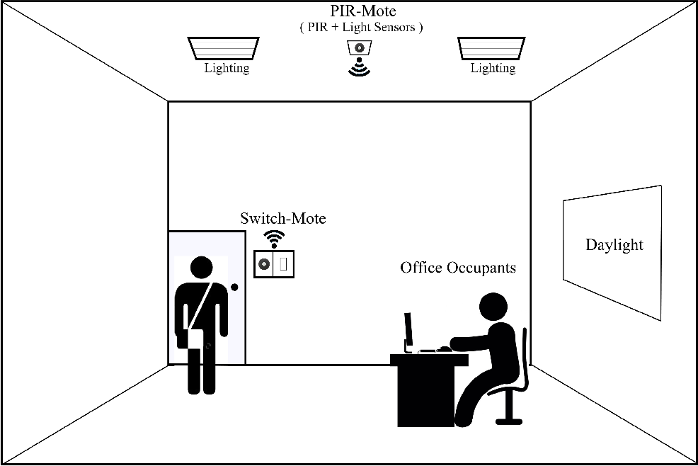

*Figure 1.1: Energy Efficient Occupancy Monitoring System (*Djenouri et al., 2018*)*

One of the critical advantages of AI in occupancy detection is its ability to adapt to changing conditions. Traditional methods often need help maintaining accuracy in dynamic environments, where lighting, temperature, and occupant behavior vary significantly. The algorithms used for ML, on the other hand, may continuously learn from new data and adapt their models accordingly. This adaptability is crucial for maintaining high accuracy in real-world scenarios where conditions are rarely static (Banihashemi et al., 2024). Integrating AI with multi-agent control systems (MACS) represents another significant advancement in the field. With stochastic-based approaches, MACS can provide more robust and adaptive occupancy estimations (Korkidis et al., 2020). These systems can coordinate multiple agents, each responsible for monitoring different aspects of the environment, to provide a holistic view of occupancy. By leveraging AI, MACS can optimize energy consumption and enhance occupant comfort more effectively than traditional methods.

A subfield of ML, deep learning (DL), has also shown great promise in occupancy detection. DL techniques featuring Long Short-Term Memory (LSTM) networks can discover complex patterns in time series and spatial data. These models have been used to analyze data from various sensors, including ultrasonic sensors and cameras, to detect occupancy levels accurately. For example, LSTM models have been trained on labeled data to distinguish between occupants and non-occupants, achieving accuracy rates (Chaudhari et al., 2024). Using DL in occupancy detection also addresses privacy concerns associated with traditional methods. For instance, ultrasonic sensors do not capture visual information, preserving occupant privacy. These sensors can provide accurate occupancy data without compromising privacy when combined with advanced signal techniques for processing, including the Fast Fourier Transform (FFT).

Additionally, integrating DL models with platforms like RP enables real-time data processing and analysis, enhancing the system's accuracy and reliability. The emergence of AI in occupancy detection has significant implications for the future of smart office environments. These technologies can inform smart control systems and adaptive building management strategies by providing more accurate and reliable occupancy data. This can result in substantial reductions in energy consumption and improve employee comfort, making the development of advanced occupancy detection systems a key priority for the future of smart buildings. To summarize, using AI in occupancy detection marks a significant achievement in the discipline. By employing ML and DL methods, researchers can develop more accurate, reliable, and adaptive systems that address the limitations of traditional methods. Integrating these technologies with MACS and advanced signal processing platforms further enhances their effectiveness, paving the way for the continuous advancement of smart office buildings.

## 1.4 Deep Learning in Occupancy Detection

The proposed occupancy detection system relies heavily on deep learning techniques, notably the LSTM neural network model. The LSTM model is well-suited for analyzing time-series data and capturing long-term dependencies, making them ideal for studying occupancy patterns. In this research, the LSTM model has been trained using labeled data generated by an auxiliary system (Pongsomboon, 2022), including sensor data which are labeled with the help of visual information. The model learns to accurately identify occupancy levels from the data, enabling real-time detection of occupants. The occupancy detection model has been trained using a large labeled dataset, with each sample consisting of 84 unique features (generated by the FFT signal processing technique) each time. The labels of each sample serve as target values, validating and training the LSTM model to recognize occupancy patterns.

Other deep learning neural network methods, such as gated recurrent units (GRU) and bidirectional LSTM (BiLSTM), were also used for training and evaluation. The LSTM model demonstrated superior performance, achieving an impressive accuracy rate above 98%. The trained LSTM model is saved in TensorFlow Keras format, allowing seamless real-time processing integration into the RP's software program in the future. Integrating DL techniques in occupancy detection represents a significant advancement over traditional methods. By leveraging the power of LSTM models, the proposed occupancy detection system can accurately detect occupancy levels and adapt to changing conditions, offering a more reliable and effective solution for smart office environments.

## 1.5 Motivation and Need for Innovation

The limits of standard occupancy detection technologies highlight the need for novel solutions to solve these issues. The motivation for this research stems from the desire to develop a more accurate, reliable, and privacy-preserving occupancy detection system. This study intends to develop a system that can accurately identify occupancy levels and distinguish between occupants and non-occupants by utilizing modern technologies such as an ultrasonic detector integrated into the RP controller and an algorithm based on deep learning. Ultrasonic sensors offer several advantages over traditional methods. They are less affected by lighting conditions and temperature fluctuations and do not capture visual information, thereby addressing privacy concerns. However, relying solely on ultrasonic sensors may still result in false positives or negatives. Regardless, to mitigate the privacy issues, the proposed research solution uses integrated ultrasonic sensors with the RP computing platform, which enhances the system's accuracy and reliability. The RP platform is a versatile and powerful tool with advanced signal-processing capabilities. By integrating ultrasonic sensors with the RP controller, the system can process ultrasonic sensor data using FFT techniques to generate data in NumPy format. This processed data can then be selected in Analg-to-Digital Conversion (ADC) or FFT format through the RP GUI interface, allowing for more precise and flexible data analysis. The integration of the RP with ultrasonic sensors offers several benefits:

1. Enhanced Signal Processing: The RP platform's advanced signal processing capabilities enable the conversion of raw ultrasonic sensor data into FFT data, which can be more easily analyzed and interpreted. This enhances the accuracy of occupancy detection by providing more detailed and reliable data.
2. Real-Time Data Analysis: This involves analyzing the RP occupancy levels in real-time scenarios, which is crucial for optimizing energy efficiency and improving occupant comfort in smart office environments.
3. Flexibility and Scalability: The RP platform is highly flexible and scalable, allowing additional sensors and data sources to be integrated as needed. This makes the system adaptable to various conditions and environments, ensuring its effectiveness in different settings.
4. Privacy Preservation: The system, which relies on ultrasonic sensors and advanced signal processing techniques, can provide accurate occupancy data without capturing visual information, thereby addressing privacy concerns.

## 

## 1.6 Context of Research Problem

Occupancy detection is a key determining factor in smart workplaces to regulate energy expenditure, estimation, and business productivity. Some of the traditional approaches have been used in occupancy detection systems, such as passive infrared (PIR) sensors, motion detection, and other non-optical sensors, thereby raising numerous concerns regarding precision and the invasive nature of technology. These sensors are often prone to false positives and negatives, and they have a limited detection range, which increases their complexity for detecting outside the range, leading to incorrect occupancy data. The requirement for more intricate and self-aware buildings has increased interest in smart office environments like smart desk spaces or smart office rooms that can identify the presence of occupants while respecting the occupant's privacy.

Contemporary technologically advanced techniques such as machine learning and modern sensor technology can effectively address the significant challenges in occupancy detection. More precisely, the possibility of using ultrasonic sensors with many capabilities and powerful processing tools, such as RP, holds great potential for occupancy detection. This innovative approach not only ensures accurate detection but also respects the privacy rights of individuals, making it a promising solution for creating an automated office space.

## 1.7 Statement of Research Problem

The core research problem is related to the high demand for a robust occupancy detection solution that can be implemented without compromising the occupant's right to privacy, a crucial ethical consideration, while serving as a standalone system for a smart office environment. Conventional occupancy detection schemes are proven to be inadequate because of their proneness to environmental factors and privacy concerns. The major obstacle is to develop a system that not only recognizes the occupancy of the workspace but also simultaneously ensures the privacy of individuals.

## 1.8 Research Question

This research aims to harness the potential of machine learning techniques, in conjunction with RP and ultrasonic sensor systems, to design and implement a highly accurate occupancy detection DL model system. The goal is to seamlessly load or save this model to the RP-based software ecosystem for practical applications in smart workplace environments, thereby overcoming the current limitations in occupancy detection.

## 1.9 Purpose of Research

The primary objective of this research is to create and validate a reliable deep-learning model that can detect occupancy with unparalleled precision and accuracy. This model will use an auxiliary system consisting of an ultrasonic sensor, an RP computing device, and a webcam to collect data for two categories: "occupant" or "non-occupant," and achieve high accuracy. The effectiveness of this solution will be demonstrated by training and validating the model using labeled data from the auxiliary system (Pongsomboon, 2022).

**Research Objectives**

**Design and Integration**

The primary objective is to capture and extract data from analog to digital signals in Fast Fourier Transform (FFT) format, utilizing a reliable sensor system installed and integrated with an RP tool for enhanced occupancy detection performance.

**Data Collection and Processing**

An auxiliary camera system with an ultrasonic sensor and RP device (Pongsomboon, 2022) labels the ultrasonic sensor data, a classified dataset that differentiates between occupancy categories.

**Development of Deep Learning Model**

Deep learning is a complex neural network method for pattern recognition and data analysis. This research's objectives include designing, training, and evaluating a Long-Short-Term Memory (LSTM) model using FFT-labeled data. The model is optimized by changing various hyperparameters and optimizers to ensure high accuracy and reliability.

**Evaluation and Validation**

Validation aims to evaluate the model's performance in the practical application of workplace scenarios that involve different lighting conditions, seating configurations, objects, and people to justify the viability and efficiency of the proposed model approach compared to traditional techniques.

**Privacy and Ethical Consideration**

Ensuring user privacy is a concerning factor for this research, as the work entirely relies on ultrasonic sensor data instead of image data for occupancy detection.

**Seamless Integration with Red Pitaya Software**

The trained and tested model is saved to Keras TensorFlow and can be connected to the RP software application for future real-time execution. This seamless integration ensures little impact on latency and achieves higher accuracy and reliability in occupancy detection in any dynamic smart office environment.

## 1.10 Overview of Proposed Solution

This research proposes an innovative occupancy detection model using an integrated ultrasonic sensor system with the RP computing platform. The system utilizes ultrasonic sensor data, which is processed using FFT techniques to generate data in NumPy format. The RP platform's signal processing capabilities enable the conversion of raw ultrasonic sensor data into FFT data, which can be selected in ADC or FFT format through the RP's GUI interface. An auxiliary system (Pongsomboon, 2022) combining a camera and the YOLO (You Only Look Once) model is employed to enhance the occupancy detection system's accuracy. The auxiliary system generates FFT data and simultaneously captures the visual information to detect occupancy levels. The YOLO object detection model used in the auxiliary system processes the visual data and labels it as "Occupant (1)" or "Non-Occupant (0)".

This labeled data is then used to train an LSTM neural network model, ensuring the system learns from accurate and reliable data, which learns to identify occupancy features from the combined data. The system can accurately distinguish between occupancy and non-occupancy by incorporating visual data. Using an auxiliary system for data labeling and acquisitions enhances the system's ability to detect occupancy levels precisely. Thus, the LSTM model with the labeled data ensures that the occupancy detection system can learn from the combined data and improve its performance over time. The integration of ultrasonic sensors with the RP controller device and the auxiliary system addresses the limitations of traditional occupancy detection methods. By combining the ultrasonic sensor data with visual information, the proposed solution provides a more accurate and reliable occupancy detection model that can be seamlessly integrated into the RP software ecosystem for real-time applications. This trained model for occupancy detection systems can optimize energy consumption and enhance occupant comfort in smart office environments. Figure 1.2 below is an illustrated example of how the research process and model implementation were conducted.

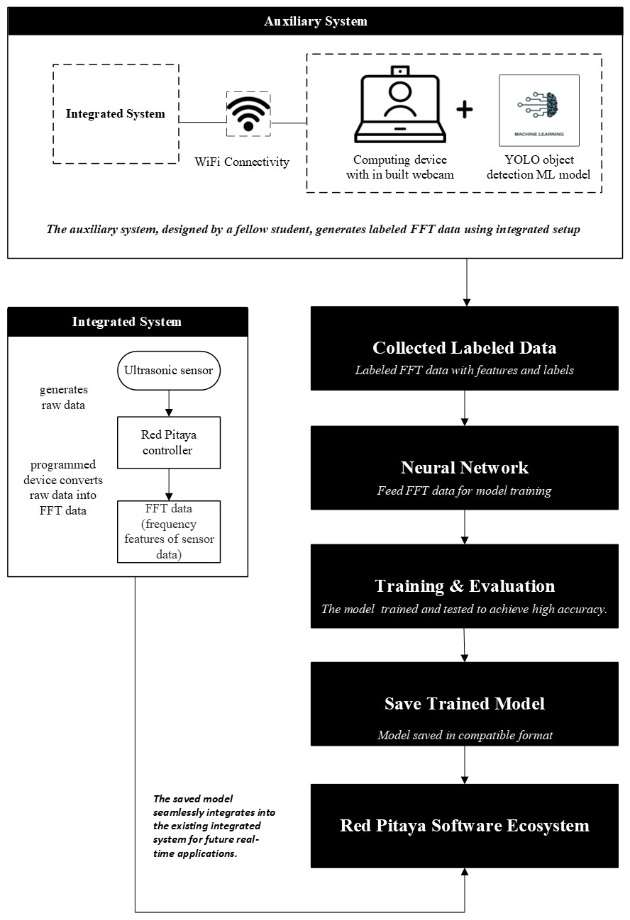

*Figure 1.2: Layout of Proposed Occupancy Detection System*

## 1.11 Scope of the Proposed Solution

This research's scope is more than just developing and validating a robust occupancy detection system tailored for dynamic smart office environments. It is about revolutionizing the way we understand and utilize smart office technologies. The primary focus is on leveraging ML techniques, particularly DL approaches, in conjunction with advanced sensor technologies to achieve high accuracy in occupancy detection while preserving occupant privacy. The research aims to address the following key areas, each of which has the potential to reshape the smart office industry:

1. **Integration of Advanced Sensor Technologies**

This research is not just about using off-the-shelf technologies. It is about pushing the boundaries of what is possible. The proposed research involves the integration of an ultrasonic sensor with an RP computing device. Ultrasonic sensors are chosen for their ability to detect occupancy without capturing visual information, thereby addressing privacy concerns. The RP platform provides advanced signal processing capabilities, enabling the conversion of raw sensor data into FFT data for more precise analysis. This innovative approach sets our research apart and paves the way for new possibilities in the field of smart office technologies.

1. **Auxiliary System for Enhanced Accuracy**

An auxiliary system combining a camera and the YOLO model enhances the occupancy detection system's accuracy further. This system captures visual information to detect occupancy levels and labels the data as "person/occupant" or "object/non-occupant." The labeled data is then used to train an LSTM model, ensuring the occupancy detection system learns from accurate, reliable data.

1. **Machine Learning Development**

The research experiment focuses on designing and training a DL model, particularly RNN methods, to determine occupancy levels. The RNN approaches learn the long dependencies from the complex patterns present in the sequential data. The LSTM model is trained with an enormous set of labeled data that contains samples combining various occupancy situations, such as sitting positions, various kinds of chairs, lighting adjustments, and different people. The model's effectiveness is evaluated using new, unseen data to verify its accuracy.

1. **Seamless Integration into the Red Pitaya Ecosystem**

Following successful training and validation, the LSTM model is saved in a format that is suitable for the RP software platform, allowing it to be integrated into real-world applications. By leveraging the computational power and signal processing capabilities of the RP device, the occupancy detection model can process incoming sensor data and provide accurate occupancy detections in real-time scenarios. Integrating the occupancy detection model into the RP software ecosystem offers several advantages. Firstly, it enables the development of smart occupancy monitoring systems that can optimize energy consumption and enhance occupant comfort in smart office spaces. By accurately detecting occupancy levels, the building management systems can adjust light and HVAC settings accordingly (Esrafilian-Najafabadi & Haghighat, 2021), leading to significant energy savings and improved occupant well-being. Additionally, the real-time occupancy data generated by the LSTM model can inform adaptive control strategies, enabling buildings to respond dynamically to changing occupancy patterns and occupant preferences (Telaga & Salmaa, 2024). Furthermore, the flexibility and scalability of the RP platform allow for the potential integration of additional sensor types and data sources, further enhancing the accuracy and robustness of the occupancy detection system. This modular approach facilitates continuous improvement and adaptation to evolving requirements, ensuring the long-term relevance and applicability of the solution.

# Literature Review / Theoretical Background

## 2.1 Evolution of Occupancy Detection

The literature review’s objective is to establish an understanding of current research about occupancy detection technologies with particular information that will focus on the integration of ultrasonic sensors and the advanced computing platform RP Controller. The structure of this chapter is organized into several key points to provide a structured format for a brief understanding for the reader. It starts with an overview of occupancy detection and its approaches, ranging from traditional to advanced sensor technologies. The characteristics of both traditional and modern techniques will be discussed elaborately. The topic of discussion then turns to ultrasonic sensors, as well as discussing how they can be used in specific applications and how the sensor can be interfaced with the RP tool for occupancy detection in a dynamic smart office environment. Subsequently, the review diverges into machine learning and deep learning techniques, specifically and more extensively on the recurrent neural network (RNN), including long short-term memory (LSTM), gradient recurrent units (GRU), and bidirectional LSTMs. Each of these architectures is discussed in detail, as is their feasibility for handling sequential data analysis and their applications in occupancy detection. This chapter also provides a comparison of the effectiveness of these neural network models, highlighting their performance metrics and opinions from previous research studies. Furthermore, due to the sensitive nature of occupancy detection, it addresses privacy aspects, ethical considerations of the matter, and best practices for non-intrusion into an individual's confidentiality. Finally, this review ends with summarising any key findings, an exploration of any gaps in existing research, and a smooth transition to the research methodology and objectives.

## 2.2 Overview of Occupancy Detection

Occupancy detection has come a long way over the years, with an increased history in energy optimization, safety and security enhancements, and personal comfort. This historical journey has its milestones and key changes that led us today to the development of occupancy detection systems. In the early days, occupancy detection was limited to basic techniques such as manual counting or basic manual switches. The initial techniques were certainly laborious and error-prone, making them feasible for large-scale applications. Nevertheless, as technologies advance, more sophisticated solutions appear for occupancy-based control systems (Kamthe et al., 2009).

Occupancy detection has long been a critical aspect of automated buildings and energy management systems. Conventional methods for occupancy detection have had one of the most significant advancements, with passive infrared (PIR) sensors and optical sensors being used. The PIR sensors detect the motion of occupants through infrared radiation emitted by human bodies (Dodier et al., 2006). These sensors were widely used because of their low cost and easy installation process; however, these sensors have several drawbacks. PIR sensors are capable of false positives caused by environmental temperature or heat-emitting sources, such as sunlight or heat produced by electrical devices (Ekwevugbe et al., 2013). Moreover, these traditional sensors can only detect motions but fail to detect stationary occupants, which leads to inaccuracies in occupancy predictions.

On the other hand, optical sensors only rely on cameras or visual-based sensors to detect occupants (Choi et al., 2021). This sensor can provide more precise occupancy data with the help of visual information, such as body shapes or movements. Nevertheless, optical sensors cause privacy concerns due to their non-invasive nature, as they capture image data, which can be considered a violation of an individual's privacy (Das et al., 2017). Furthermore, the execution of optical sensors can be affected by the light control and obstacles (Sun et al., 2022).

## 2.3 Modern Sensor Technologies

Due to the weaknesses in traditional occupancy detection strategies, various researchers and developers have to look for innovative technologies to use in their devices, including ultrasonic sensors. Ultrasonic sensors work based on ultrasound signals, including the emission of sound waves and the analysis of the reflected signals to detect objects or occupant presence (Shih et al., 2016). The ultrasonic sensors have numerous advantages as compared to the other conventional methods, including non-intrusiveness, as they do not rely on visual data or even heat signatures, thus making them more privacy-friendly. Furthermore, these sensors are not easily influenced by the surrounding environment, such as lighting conditions, and can accurately recognize stationary occupants (Ahmad et al., 2021).

One notable advantage of an ultrasonic sensor integrated with an RP controller is its advanced signal processing abilities. This integration allows the extraction of data in Fast-Fourier Transform (FFT) and Analog-to-Digital Converter (ADC) formats from the sensor, which significantly improves the performance and reliability of the occupation system. This kind of data is particularly suitable for analysis under machine learning and deep learning approaches, more specifically RNNs, which are best suited for sequential data (Ranieri et al., 2021). The improvements achieved by merging ultrasonic sensors with higher computational platforms, such as the RP controller, allow for data processing and evaluation on board.

## 2.4 Integrated Red Pitaya Sensor System in Occupancy Detection

2.4.1 Principles of Ultrasonic Sensors

Ultrasonic sensors are those devices that leverage the principles of sound wave propagation and reflection to sense motion and/or identify the location of objects or occupants within a given environment. These sensors operate by producing high-frequency waves of about 20000 Hz–3 MHz, which are beyond the audible human hearing range (Pan et al., 2020). The sound waves that are transmitted through the air and reflect off surfaces allow the sensor to measure the time of flight (ToF)—the time that passes between the emission and reflection of the reflected sound wave (Mrazovac et al., 2012). The speed of sound can determine the distance to the reflecting object in the medium (air) and is used in the following equation:

*Distance = (Speed of Sound x ToF) / 2 (2.1)*

In equation (2.1), the factor 2 is used considering the sound wave transmits to the object back and forth., effectively doubling the distance (Shih et al., 2016). Ultrasonic sensors can give accurate distance measurements by continuously producing and receiving sound waves, making them excellent for occupancy detection and tracking applications in various environments, including smart office spaces.

2.4.2 Applications of Ultrasonic Sensors

Ultrasonic sensors have drawn substantial interest in occupancy detection systems due to their non-intrusive nature and performance in various conditions. Unlike traditional approaches like PIR sensors or optical sensors, ultrasonic sensors do not rely on images, addressing privacy issues and ease of use in sensitive areas (Abade et al., 2018). In the context of smart office spaces, various studies have shown the use of ultrasonic sensors for occupancy detection and analysis. One research study developed an occupancy detection system with ultrasonic sensors for energy-efficient control of HVAC systems in residential buildings (Khalil et al., 2018). Their findings confirmed the system’s capacity to effectively detect occupancy patterns, which resulted in a significant amount of energy savings over traditional techniques. Another research study proposed a multi-sensor occupancy detection system that included ultrasonic, PIR, and CO2 sensors (Dong et al., 2011). The study discovered that by combining ultrasonic sensors with additional sensors increases the overall accuracy of occupant detection, especially in cases where occupants are stationary or involved in low-motion activities such as sitting and relaxing.

Nevertheless, in this research study, an innovative approach is taken by combining ultrasonic sensors with the RP computing platform, which is a powerful and adaptive hardware-software ecosystem for data collection, processing, and analysis (Red Pitaya, 2023). This integration allows for the collection of high-quality time-series data from ultrasonic sensor reflections, making it easier to use advanced machine-learning approaches for an accurate occupancy detection model. One of the primary benefits of this integration is the ability to utilize the RP controller’s capabilities for real-time data processing and on-device machine learning deployment. By applying computational intelligence algorithms specifically using LSTM network architecture directly for the RP software tool, the system can perform low-latency occupancy detection without the need for external computational resources or cloud-based solutions; this is part of the research work. Furthermore, this research operated with a data collection process, which was designed by another academic research work of a fellow student, who developed an auxiliary system that combines a camera, the integrated RP sensor device, and a YOLO object detection model. This auxiliary system generates labeled data by integrating the ultrasonic sensor readings with visual information from the camera, enabling the training of the LSTM model with accurate occupancy and non-occupancy labels (Pongsomboon, 2022). Through this innovative approach, this proposed research not only addresses the limitations of traditional occupancy detection methods but also contributes to the development of privacy-preserving and energy-efficient solutions tailored for dynamic smart office environments.

2.4.3 Advantages of Ultrasonic Sensor Integrated with Red Pitaya Device

**On-device learning algorithms**: Interestingly, the RP controller can host and operate any computational algorithms. This allows for immediate and direct analysis of sensor data, avoiding the need for offload processing or the occasional use of cloud services. In this research work, an LSTM model is designed to handle the labeled data that is generated using an auxiliary system consisting of a GUI interface from a fellow researcher’s academic work (Pongsomboon, 2022). This auxiliary system creates labeled data by integrating ultrasonic readings with visual information from the camera and with the help of the YOLO algorithm. The labeled data from the auxiliary system has been used in this research work as the label data can be more beneficial for a machine learning model to learn minute patterns of occupancy levels. This dataset contains processed ultrasonic sensor readings with labels about occupancy levels on which the LSTM model was trained. The trained model can then be implemented as a function within the RP software application, addressing occupancy detection and prediction using generated data. Placing the LSTM model directly on the RP controller eliminates the need to fetch more processing capacity or pull from any cloud service because the integrated RP tool can detect occupancy in real-time with low latency.

**Seamless Integration**: The RP platform provides a necessary level of flexibility in the software environment, which can be used for occupancy detection, allowing easy integration of trained deep learning models. This integration allows the practical implementation and application of the occupancy detection method in real-world scenarios of smart office environments.

**Privacy Preservation**: Considering the fact that the integrated system only uses ultrasonic data as input without any visual data or personal identification, it avoids privacy concerns and violations of any data protection rules.

## 2.5 Deep Learning in Occupancy Detection

2.5.1 Overview of Deep Learning

Neural networks have emerged as effective technologies for occupancy detection and analysis in smart office environments because of the capacity they have to recognize patterns and make predictions from data. Traditional machine-learning techniques, such as support vector machines (SVM) and random forests, are commonly used for occupancy detection (Dong et al., 2018). These algorithms are trained using labeled datasets that typically contain features derived from various sensors or data sources. The trained models can then predict occupancy levels or detect occupancy patterns based on unseen data. Nevertheless, traditional machine learning methods usually involve the manual use of feature engineering, can be laborious, and may not capture all significant details from the original data set (Schmidhuber, 2024). This limitation has led to the exploration of deep learning techniques, which have gained immense recognition in occupancy detection and dynamic smart office environments.

2.5.2 Deep Learning Approaches

Deep learning, an aspect of machine learning, was recognized as an effective occupancy detection and analysis method in smart office spaces. Deep learning methods, namely deep neural networks, may extract essential features from raw data without the need for explicit feature engineering (Zou et al., 2017). This capability makes deep learning techniques suitable for analyzing time-series data generated by ultrasonic sensors since these techniques can efficiently capture the hidden patterns and dependencies in sensor data. In the context of this research, deep learning techniques, notably RNNs, were investigated for processing sequential data obtained from the ultrasonic sensor integrated with the RP controller. RNNs, including LSTM networks and GRUs, can capture long-term dependencies in sequential data, making them appropriate for analyzing temporal variations that correspond to occupancy and non-occupancy scenarios (Hochreiter & Schmidhuber, 1997).

The research being conducted focuses on designing an LSTM-based model, whose services will be included in RP’s software application for detecting occupancy in dynamic smart office environments. The LSTM architecture, with its memory cells and gating mechanisms, enables the model to choose to recall or forget information in long sequences, effectively capturing the complex temporal dependencies found in ultrasonic sensor data (Greff et al., 2015). The trained LSTM model efficiently learns patterns related to occupancy and non-occupancy situations using labeled data that is being generated by an auxiliary system. This evaluated LSTM model can then be seamlessly incorporated into RP’s software program, allowing on-device occupancy detection and prediction based on a real-time ultrasonic sensor integrated with the RP system. Furthermore, this research explores various RNN types, such as LSTM, GRU, and bidirectional LSTM, to evaluate their performance and ability to determine the best option for the occupancy detection system. These different neural network architectures provide varying trade-offs regarding computational complexity, time required for training, and the ability to capture complex dependencies in sequential data (Yu et al., 2019). The comprehensive approach of this proposed research not only contributes to the development of accurate and reliable occupancy detection systems but also advances the use of deep learning methods in smart office environments, utilizing the relationship between modern sensor technologies, computing platforms, and machine learning algorithms.

## 2.6 Recurrent Neural Network

Recurrent neural networks, or RNNs, are a type of deep learning technology specifically for processing sequential data, including text, speech, time series, and sensor readings. RNNs feature persistent connections that allow them to keep an internal state while also learning and understanding temporal dependencies in the input data compared to feed-forward neural networks (Mikolov et al., 2010). The fundamental concept within RNNs is to utilize a loop that allows information to remain and flow through the network, resulting in a memory-like structure. Considering this loop, RNNs can capture the dependencies and context identified in sequential data, which makes them ideal for applications like occupancy detection, where precise predictions depend on the patterns and sequences of sensor data (Lipton et al., 2015). Traditional RNNs, on the other hand, suffer from the issue of vanishing gradients, making it impossible for the neural network to discover long-term dependencies in data. The drawback originates from the repetitive multiplication of weight matrices during the backpropagation process, which causes the gradients to either exponentially decline or explode, which limits the network’s ability to successfully learn from long sequences (Pascanu et al., 2013). Figure 2.1 below is the illustration of an RNN architecture (Lui, 2020)

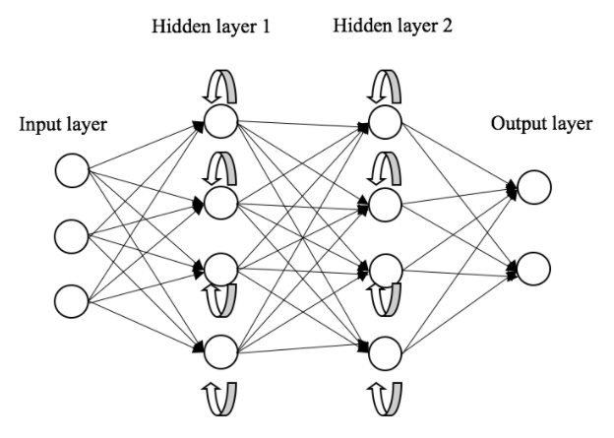

*Figure 2.1: RNN architecture*

2.6.1 Gated Recurrent Unit (GRU) Neural Network

An RNN structure for handling sequential data efficiently and GRU are improved variations of this structure. It is introduced as a primary replacement for LSTM networks intending to bring less complexity into it (Cho et al., 2014). Due to their sensitivity in erasing the long-term dependencies into sequences, GRUs can help resolve various challenges, such as natural language, audio, and time sequence evaluations. The main idea of the GRUs is to contain the gating mechanism in the network’s connection for data flow. This mechanism comprises two separate gates: the one with the ability to reset the gate and the other with the function of updating it as shown in the below equations (2.2), (2.3), (2.4), and (2.5) (Geeksforgeeks, 2023). The reset gate determines how much of the old hidden state needs to be cleared out, and by the same token, the update gate determines how much of the current input needs to be blended in to update the overall hidden state (Chung et al., 2014). Mathematically, the GRU operates as follows:

1. **Reset Gate**

The reset gate (r_t) specifies how much data from the prior hidden state (h_{t-1}) will be discarded:

*R_t = W_r [h_{t-1}, x_t]) (2.2)*

1. **Update Gate**

The update gate (z_t) controls how much of the new input (x_t) should be used to update the hidden state:

*z_t = W_z [h_{t-1}, x_t]) (2.3)*

1. **Candidate Hidden State**

The candidate hidden state (h’_t is calculated using the reset gate and the current input gate:

*h’_t = W_h [r_t h{t-1}, x_t]) (2.4)*

1. **Final Hidden State**

The final hidden state (h_t) combines the prior and current hidden states, adjusted by the update gate:

*h_t = (1-z_t) h_{t-1} z_t h’_t) (2.5)*

This process is repeated each time in the sequence, allowing the GRU to selectively retain or discard information from previous steps based on its relevance to the current input (Wikipedia, 2023). The gating mechanism in GRUs helps mitigate this. The issue of vanishing gradients is a general issue with standard RNNs, allowing the network to learn long-term dependencies more effectively (Cho et al., 2014). GRUs are particularly useful for tasks involving sequential data, such as language modeling, machine translation, or time series forecasting.

In summary, GRUs are a robust variant of RNNs that use a gating mechanism to control the flow of information through the network, enabling them to process sequential data efficiently and capture long-term dependencies. Their mathematical formulation and gating mechanism make them a valuable tool for various applications involving sequential data analysis and predictions. In Figure 2.2 below, the GRU architecture shows how sequential data flows through the reset and update gate to control information (Bibi et al., 2020).

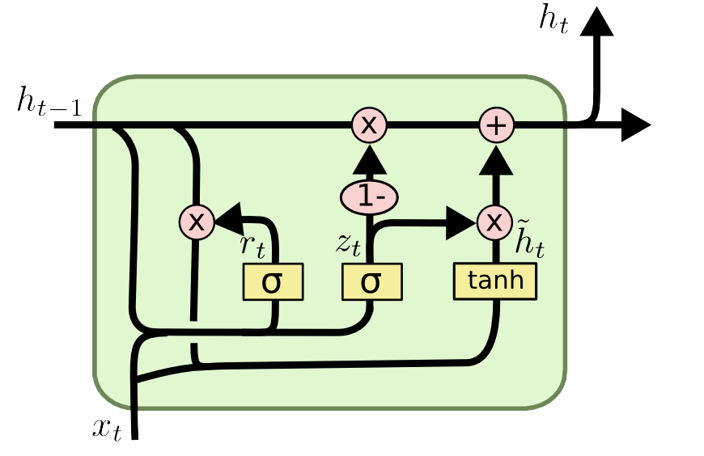

Figure 2.2: GRU Architecture

2.6.2 Long Short-Term Memory (LSTM) Neural Network

LSTM is another kind of RNN architecture conceived to process sequential data efficiently. It was introduced to address the vanishing gradient problem faced by traditional RNNs when dealing with long-term dependencies (Hochreiter & Schmidhuber, 1997). LSTMs excel at dealing with sequential data, making them ideal for applications like language processing, audio recognition, time-sequence analysis, and building occupancy prediction (Khan et al., 2022)

The LSTM architecture consists of three gates: forget, input, and output. These gates control the transfer of information across the network, enabling it to selectively recall or forget data from prior time steps. The equations below (2.6), (2.7), (2.8), (2.9), and (2.10) mathematically explain this (Greff et al., 2017)

1. **Forget Gate**

The forget gate (f_t) determines which information from the prior state (c_{t-1}) should be forgotten:

*f_t = W_f [h_{t-1}, x_t] + b_f) (2.6)*

1. **Input Gate**

The input gate (i_t) controls which new information from the current input (x_t) and previous hidden state (h{t-1}) should be added to the cell state:

*i_t = W_i [h_{t-1}, x_t] + b_i) (2.7)*

1. **Cell State Update**

The cell state (c_t) is updated by combining the previous cell state (c_{t-1}) with the new information from the input gate (i_t) and the candidate cell state (c’_t):

*c_t = f_t c_{t-1} + i_t c’_t (2.8)*

1. **Output Gate**

The output gate (o_t) determines which parts of the updated cell state (c_t) should be used to compute the hidden state (h_t):

*o_t = W_o [h_{t-1}, x_t] + b_o) (2.9)*

1. **Hidden State Update**

The hidden state (h_t) is computed by applying the output gate (o_t) to the updated cell state (c_t):

*h_t = o_t tanh(c_t) (2.10)*

This process is repeated for each time step in the sequence, allowing the LSTM to selectively retain or discard information from previous steps based on its relevance to the current input (Khan et al., 2022), as seen in Figure 2.3 (Yasrab et al., 2020). LSTMs are very beneficial for occupancy prediction applications because they can capture long-term dependencies in sequential data, such as occupancy patterns over time. By processing environmental data (for example, CO2 levels, noise, temperature) occupancy states from previous time steps, LSTMs can learn to predict future occupancy levels accurately (Diarra et al., 2023). LSTMs gate mechanism contributes to solving the issue of vanishing gradients, allowing the network to learn long-term relationships more efficiently than typical RNNs (Hochreiter & Schmidhuber, 1997). This makes LSTMs a valuable tool for occupancy detection, as occupancy patterns often exhibit complex temporal dependencies that span multiple time steps.

In summary, LSTMs are a powerful variant of RNNs that uses a gating mechanism to control the flow of information through the network. This enables them to process sequential data efficiently and capture long-term dependencies. Their mathematical formulation and gating architecture make them well-suited for tasks involving sequential data analysis and prediction, building reliable occupancy prediction.

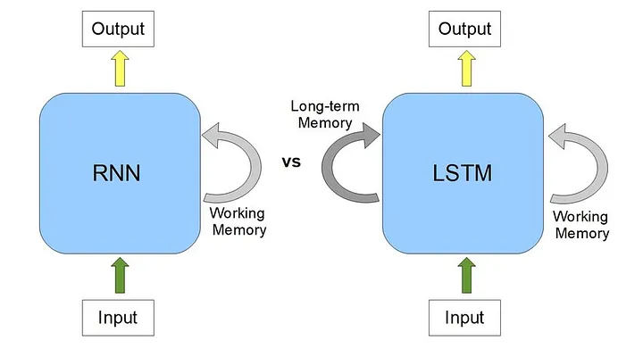

*Figure 2.3: Difference between RNN and LSTM architecture*

In this research, the LSTM architecture was implemented to process time-series data produced by an integrated system that includes an ultrasonic sensor with a red pitaya controller. By training the LSTM model on the collected labeled data using the auxiliary system (combining the ultrasonic readings with labels from visual information) (Pongsomboon, 2022), this model can effectively learn the patterns corresponding to occupancy and non-occupancy scenarios. Numerous studies have shown that LSTM-based models are successful for occupancy detection and evaluation tasks. An LSTM-based occupancy detection system for smart buildings was developed, which would use data from multiple sensors such as PIR, CO2, and temperature. The study indicated that the LSTM model performed far more effectively than standard machine learning algorithms in forecasting occupancy levels (Lam et al., 2009). Another LSTM-based model was designed specifically for detecting occupancy in office environments using ultrasonic sensor data. When the authors evaluated the performance of the LSTM model compared to traditional machine learning methods, they discovered that the LSTM model had higher accuracy and was capable of grasping temporal patterns in ultrasonic sensor data, resulting in increased occupancy detection performance (Chen et al., 2023).

2.6.3 Comparative Analysis of GRU and LSTM Networks

A few studies have examined the performance of GRUs and LSTMs in a variety of applications, including occupancy detection and time-series forecasting. Some authors conducted a comparative study on the performance of LSTM and GRU models for occupancy detection using environmental sensors. The study indicated that both networks performed similarly in terms of accuracy; however, the GRU model trained slightly faster due to its simpler architecture. The framework of this study, based on an integrated ultrasonic sensor with an RP controller to detect occupancy, evaluates both LSTM and GRU models. A comparative analysis using the labeled data generated with the help of an auxiliary system (Pongsomboon, 2022) revealed that the LSTM model achieved higher accuracy than the GRU model. Despite having a similar architecture and employing the same layers and hyperparameters, the GRU model required more training time. One possible reason for this could be that the internal gating mechanisms differ, resulting in more complex computations or less efficient data flow during training. Furthermore, specific dataset characteristics or implementation details may have contributed to the higher training time, indicating that architectural simplicity only sometimes results in faster training.

The LSTM model could potentially recognize patterns from the sequential data of ultrasonic sensors more effectively than the GRU model. This is due to the three-gate structure of LSTM networks (input, output, and forget gates), which are more appropriate for capturing long-term dependencies and patterns in sequential dat**a** (Hochreiter & Schmidhuber, 1997)**.** This architecture enables LSTMs to maintain and forget information selectively, making them more efficient in dealing with complex sequential data than GRUs’ simpler two-gate method (Cho et al., 2014). In conclusion, LSTMs thus produce more complex and accurate predictions in certain scenarios, besides the GRU’s simpler architecture.

2.6.4 Bidirectional LSTM (BiLSTM) Neural Network

Bidirectional LSTMs (BiLSTMs) are an improved version of the standard LSTM architecture that can handle sequential data in both forward and backward directions (Graves & Schmidhuber, 2005). A standard LSTM network analyzes the input data in a forward direction, acquiring information from past events. However, in some situations, future context might be helpful for producing accurate predictions. BiLSTM's architecture addresses this limitation by introducing two independent LSTM layers: one examines each input sequence forward, and the other reverses it, as shown in Figure 2.4 below (Wang et al., 2021). These two-layer outputs are subsequently combined at each time step, enabling the network to record past and future context (Schuster & Paliwal, 1997). The architecture enables BiLSTMs to gain insight into patterns and dependencies that span throughout the entire sequence, possibly improving the accuracy of predictions, particularly in tasks where future context has a significant role.

BiLSTMs can provide various advantages when detecting occupancy using ultrasonic sensor data. Temporal patterns in occupancy data frequently depend on both past and future states, as occupancy levels can be impacted by prior and subsequent events or activities. BiLSTMs can more effectively capture these dependencies by processing sensor data in both forward and backward directions, ultimately leading to higher accuracy in occupancy detection and prediction (Oshima et al., 2022). Moreover, BiLSTMs can be useful in situations where occupancy patterns exhibit cyclic or periodic behavior, as the backward pass could provide crucial information about future states based on previous patterns.

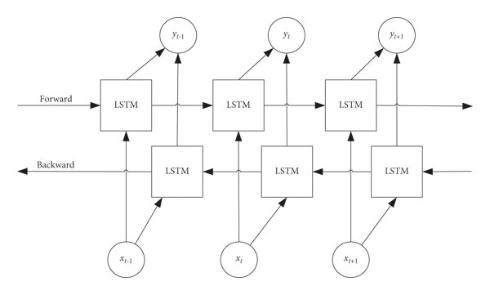

*Figure 2.4: Schematic diagram of the BiLSTM network*

## 2.7 Comparative Analysis of GRU, LSTM & BiLSTM Networks

2.7.1 Performance Metrics

LSTM, GRU, and BiLSTM algorithms are widely examined and compared in occupancy detection applications using various performance measures. These metrics are crucial to quantifying the model's accuracy, precision, recall, and overall predictive analysis.

**Accuracy:** Accuracy is the proportion of correctly anticipated instances over the total number of occupancy and non-occupancy instances.While accuracy is commonly used, it may not provide an overall picture, particularly when the dataset contains discrepancies or the cost of different types of errors is unequal (Sokolova & Lapalme, 2009).

**Precision:** It is the proportion of true positives (correctly predicted occupancy and non-occupancy events) among all positive predictions that are produced by the model. It evaluates the model’s ability to minimize false positive predictions (Goutte & Gaussier, 2005).

**Recall:** Also known as true positive rate, is the proportion of true predictions that are positive among all true cases that are positive. It represents the model's capacity to accurately recognize all occupancy instances (Powers 2020).

**F1-score:** It is the harmonious median of both recall and precision, providing a balanced value that includes the two values (Powers, 2020).

**AUC-ROC curve:** It compares the true positive rate (recall) to the false positive rate at certain thresholds. This curve indicates how well a model distinguishes between occupancy and non-occupancy events; larger values indicate greater performance (Fawcett, 2006).

This study utilized these performance metrics to evaluate and compare the above-mentioned LSTM, GRU, and BiLSTM models. This comprehensive evaluation framework ensures an in-depth understanding of each model’s predictive capabilities. The specific results and comparative analysis of these model metrics will be presented in the next chapter, “Realization.”

2.7.2 Performance Analysis of GRU, LSTM & BiLSTM Networks

It is interesting to note that in the comparative analysis of LSTM, GRU, and BiLSTM models conducted in this research for occupancy detection, the LSTM model outperformed the GRU and BiLSTM architectures across multiple performance metrics. While the BiLSTM has a slightly better mechanism approach, the overall performance of the LSTM model in capturing temporal patterns in data for occupants and non-occupants was evident. The findings of this research are supported by another study, which investigated the performance of various RNN architectures in time-series forecasting tasks (Tavakoli & Namin, 2019). Multiple other research studies have highlighted LSTMs’ potential strengths in addressing long-term dependencies and capturing complex temporal patterns in sequential data (Diarra et al., 2023). The potential of LSTMs to selectively retain and forget information with the help of their gating mechanisms has proven beneficial for modeling the temporal variations present in occupancy data, where previous events and patterns can have a major impact on future occupancy states. Furthermore, a similar research study implies that the increased level of complexity of BiLSTMs may not necessarily translate into greater performance, notably when the future context does not provide significant new information for the task at hand (Bai et al., 2018). The findings obtained through this research are consistent with the above-mentioned assumptions, as the occupancy patterns in the smart office environments were predominantly driven by past events and activities, making the backward pass of BiLSTMs less beneficial. Additionally, a further study highlights the potential overfitting concerns related to BiLSTMs, which can occur due to their increased complexity of architecture and a higher number of trainable parameters (Charef, 2024). To address these issues, the work carried out in this thesis research used careful regularization techniques and hyperparameter optimization tuning to reduce these challenges, but the standard LSTM model still merged as the superior choice for the occupancy detection task. By carefully analyzing the strengths and limitations of these RNN architectures, as well as their suitability for this specific research for occupancy detection tasks, it also contributes to a better understanding of their relevance in dynamic smart office environments, guiding the selection of the most appropriate model for practical implementation.

## 2.8 Privacy and Ethical Considerations

2.8.1 Privacy Concerns

Privacy considerations are an important factor to consider when adopting occupancy detection systems, especially in office environments where people’s privacy and personal data must be protected. Traditional occupancy detection systems, such as optical sensors and cameras, create serious issues with confidentiality since they collect and interpret visual data, which has the ability to identify persons and violate their personal rights (Ahmad, 2020). The collecting and processing of personal data, including visual information, is governed by various data protection and privacy laws, including the European Union's General Data Protection Regulation (GDPR) and the United States' California Consumer Privacy Act (CCPA) (European Commission, 2023). Failure to comply with these regulations might result in serious penalties and legal consequences.

2.8.2 Non-Intrusive Techniques

To address privacy issues and ensure the fulfillment of data protection requirements, researchers and developers have investigated non-intrusive occupancy detection approaches that do not use visual data to personally identify information. Ultrasonic sensors combined with powerful computing platforms such as the RP controller represent a viable approach for privacy-preserving occupancy detection (Zou et al., 2017). By exploiting the RP platform’s data collection, processing, and analysis, researchers can create occupancy detection systems that solely rely on ultrasonic sensor data, removing the requirement for visual data collection and processing. This approach addresses privacy concerns and provides the way for mainstream acceptance and use of occupancy detection technology in sensitive environments like office buildings and workplaces.

2.8.3 Ethical Guidelines

In addition to resolving privacy concerns, it is crucial to follow ethical rules and best practices while implementing occupancy detection technologies in smart office environments. These recommendations should promote transparency, accountability, and fairness in the design and implementation of such systems. One important ethical aspect is the necessity for occupants to provide informed consent and be aware of the presence and purpose of occupancy detection systems. Clear communication and transparency about data collection and processing methods, as well as the intended use of acquired data, are critical for establishing trust and acceptability among occupants (Vinuesa et al., 2020).

Furthermore, ethical guidelines need to consider the proper utilization of occupancy detection data, ensuring that the information collected is not misused or exploited for reasons other than energy management and automated buildings. Strict data protection and security procedures should be established into place to avoid unaithorized access, data breaches, or misuse of sensitive information (European Union, 2016). Finally, ethical guidelines should take into account the potential effects of occupancy detection systems on people’s well-being and workplace situations. While such appliances seek to optimize energy efficiency and comfort, it is critical to maintain a balance and ensure that occupants do not feel unnecessarily monitored or subjected to excessive surveillance, which could have a negative impact on their productivity and overall workplace environments (Stahl et al., 2016).

## 2.9 Summary and Gaps in Research

2.9.1 Key Findings in Research

The existing literature review offers an in-depth review of occupancy detecting systems, focusing on integrating ultrasonic sensors with advanced computing platforms such as the RP controller. The key results from the review include:

1. Traditional occupancy detection approaches, such as PIR and optical sensors, have some limitations in terms of accuracy, reliability, and privacy concerns.
2. Ultrasonic sensors provide a nonintrusive and effective alternative to occupancy detection. They generate time-series data that can be evaluated with deep learning techniques.
3. The integration of ultrasonic sensors with the RP platform allows for more advanced data acquisition, processing, and analysis, making it easier to deploy machine learning or deep learning models for occupancy detection.
4. The analysis with various types of RNN architectures, including LSTM, GRU, and BiLSTM for occupancy detection tasks utilizing ultrasonic sensors incorporated with the RP tool, show unique performance characteristics. In consideration of all three RNN models, the LSTM architecture stands out for its remarkable accuracy, with high test accuracy and ROC AUC scores. This is due to its ability to precisely capture temporal patterns in ultrasonic sensor data. In comparison, while working equally well, the GRU model has a bit lower accuracy than the LSTM.
5. However, the BiLSTM model performs competitively with a shorter training period, making it an effective alternative for real-time applications in the future. These findings highlight the relevance of selecting a suitable RNN architecture adapted to the specific needs of occupancy detection systems in dynamic smart office environments.
6. Privacy and ethical concerns are critical when implementing occupancy detection systems, and nonintrusive solutions such as ultrasonic sensors integrated with the Red Pitaya controller provide a privacy-preserving solution.

2.9.2 Research Gaps

While the existing literature provides valuable insights and knowledge about the advancements in occupancy detection technologies, several research gaps remain to be addressed.

1. Limited research has been conducted on the integration of an ultrasonic sensor with RP platforms for occupancy detection in dynamic smart office environments. Despite the potential advantages of integrating ultrasonic sensors with advanced computing platforms, there has been a significant lack of research into this integration in dynamic office environments. Further investigations of this integrated system could reveal its reliability, efficacy, and practical implications for real-world applications.
2. Lack of comprehensive research on evaluating the performance of various types of RNN architecture for ultrasonic sensor-based occupancy detection in smart workplaces. While previous research provides insights into the performance of different RNN architectures, more comprehensive comparisons are needed to determine their specific benefits and limits. Such studies could provide useful help to determine the most appropriate architecture for occupancy detection systems in smart office environments.
3. There has been limited examination of the seamless integration of trained AI or ML models into the RP controller’s software application for practical deployment and real-world applications. The seamless integration is necessary for real-world scenarios. However, there have been insufficient studies in the literature on the integration process and its resulting benefits for scalability, stability, and performance in diverse smart office settings.

# Requirements Analysis

This chapter discusses the criteria and steps to develop a neural network model for occupancy detection in smart office environments. The goal is to overcome the limits of traditional or existing approaches, such as PIR sensors and optical sensors, by leveraging ultrasonic sensors integrated with the Red Pitaya computing controller and utilizing advanced deep learning techniques. In this section, all the details of what is to be achieved through this research, including the research objectives, system architecture, initial state, previous work, and specific requirements, have been discussed to guide the development process. By providing a comprehensive understanding of this research scope and the methods used, this chapter gives a detailed analysis and implementation of the neural network model for occupancy detection.

## 3.1 Research Objectives and Accomplishments

The fundamental goal of this research is to develop a deep-learning model that is capable of accurately detecting occupancy in smart office environments using ultrasonic sensor data. This occupancy detection method is intended to address the limitations of conventional occupancy detection or modern techniques, which utilize unreliable and visual data. Unlike these approaches, the proposed system ensures higher accuracy, reliability, and privacy preservation. The specific goals include:

1. **Utilizing an Integrated System**

The project leverages an existing integrated system consisting of ultrasonic sensors and the Red Pitaya platform. This system collects time-series data, which is then converted into Fast Fourier Transform (FFT) or Analog to Digital Conversion (ADC) format utilizing Red Pitaya's advanced signal processing techniques. The processed data serves as the foundation for the subsequent steps of this research.

1. **Data Collection and Labeling**

An auxiliary system (Pongsomboon, 2022) is employed to verify that the data is accurately labeled. This auxiliary system combines the integrated ultrasonic sensor with the Red Pitaya system, a camera, and the YOLO ML model for object detection. This system captures the sensor data and uses visual confirmation from the camera and the YOLO model to simultaneously label the ultrasonic sensor data to categorize it as "Person/Occupant" or "Object/Non-Occupant." This accurate labeling is crucial for training the deep learning model.

1. **Model Training**

The labeled data is subsequently utilized to train the RNN-LSTM neural network. This approach is intended to learn the patterns in sensor data features with their respective labels. The LSTM model processes time-series data to accurately detect occupancy, relying on labeled instances to distinguish between occupant and non-occupant events effectively.

1. **Future Integration for Real-Time Processing**

The trained model is saved in a compatible format and is later employed in Red Pitaya's controller software application. This makes future integration into the Red Pitaya software ecosystem possible, including real-time occupancy detection and prediction. This approach protects privacy and allows for realistic deployment in smart office environments by eliminating dependency on visual data and utilizing efficient signal processing.

## 3.2 General Structure of Occupancy Detection System

3.2.1 System Components

The proposed occupancy detection model comprises several interconnected components, each with a critical role in obtaining high accuracy and dependability. The main components include:

1. **Ultrasonic Sensors**

Ultrasonic sensors generate time-series data by emitting high-frequency sound waves and measuring the reflections that bounce back to the sensor. They are used for their nonintrusive nature and ability to offer accurate data without compromising privacy.

1. **Red Pitaya Device**

RP is a versatile computing device used for data collection and processing. The Red Pitaya can transform raw ultrasonic sensor data into FFT or ADC data to extract features from the sensor data, making it suitable for additional analysis. Its advanced signal processing capabilities ensure that data is handled efficiently and prepared for the following stages.

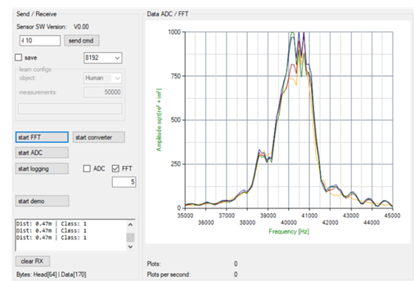

*Figure 3.1: Integrated System Detecting Occupant*

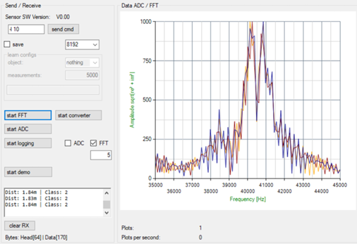

*Figure 3.2: Integrated System Detecting Objects*

1. **Auxiliary system**

An auxiliary system (Pongsomboon, 2022) is employed to ensure the accuracy of data labeling. This system consists of a camera and the YOLO object detection model. The auxiliary system collects ultrasonic sensor data using the same setup as an integrated system but simultaneously uses the camera to process the visual confirmation. The YOLO model then processes the visual information and appropriately labels the extracted FFT data as "Person" and "Object." This dual-validation approach ensures the reliability of the labeled dataset used for occupancy detection model training.

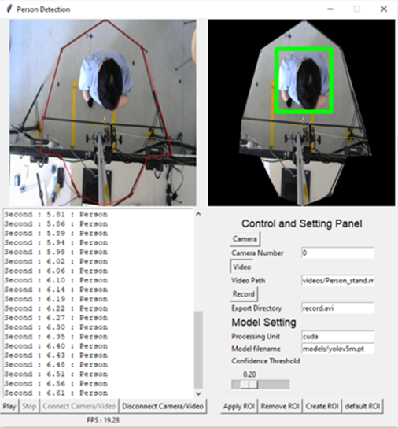

*Figure 3.3: Auxiliary System Detecting Occupant*

1. **Deep Learning Model**

The occupancy detection system's core is an LSTM neural network. This model is explicitly trained on labeled data to understand the temporal patterns and dependencies related to occupancy detection. The LSTM's ability to handle sequential data makes it ideal for analyzing the time-series data generated by the ultrasonic sensors.

1. **Future Integration for Real-Time Processing**

The trained LSTM model is saved in a format that works with the Red Pitaya platform. This enables seamless future integration with the Red Pitaya software application. Once integrated, the model can identify occupancy in real time, allowing its practical deployment in smart office environments. This incorporation enhances the system's functionality and assures low-latency processing and privacy protection by avoiding the need for visual data.

## 3.3 Initial State

Before undertaking this research, the initial state of occupancy detection technology has considerable limitations. Standard approaches, such as PIR, CO2, and optical sensors, face several challenges, highlighting the need for more modern solutions.

1. **Accuracy Issues**

PIR sensors are prone to causing false positives and negatives due to their sensitivity to minor temperature fluctuations and the movement of non-stationary objects. For example, a small drift or curtain movement can cause a PIR sensor to report false occupancy. Similarly, these sensors may fail to detect slow or minimal movement from an occupant, resulting in false negatives.

1. **Reliability Concerns**

Optical sensors, for example, require a clear line of sight and are significantly impacted by lighting conditions. Variations in ambient light, shadows, or direct sunlight can affect the sensor's ability to detect occupancy accurately. Due to this reliance on visual clarity, any obstacle in the sensor's field of view may result in missed detections or incorrect occupancy data.

1. **Privacy Concerns**

The implementation of cameras for occupancy detection creates serious privacy concerns. Continuous video surveillance is considered obstructive and may be inappropriate in many workplace settings. Employees and visitors may feel uncomfortable knowing they are being constantly recorded, and there are legal and ethical considerations regarding the preservation and processing of visual data.

These challenges highlighted the necessity for a more dependable and privacy-preserving approach. The initial capabilities of the Red Pitaya platform, integrated with an ultrasonic sensor, provide a promising foundation for developing such a solution. The Red Pitaya controller can handle complex signal processing tasks, and the nonintrusive nature of ultrasonic sensors contributes to an ideal fit for this research.

3.3.1 Features of Proposed Occupancy Detection Model

The proposed occupancy detection system aims to overcome these limitations by leveraging the strengths of ultrasonic sensors integrated with the Red Pitaya computing device. The key initial advantages include:

1. Non-Intrusive Detection

One of the proposed system's standout features is its noninvasive nature. Ultrasonic sensors detect occupancy based on sound waves, eliminating the need for visual surveillance. This technique preserves privacy by not capturing or storing images or videos of one's personal identity. Privacy preservation is essential in office environments where employees expect a certain level of privacy.

1. Robust Signal Processing

The Red Pitaya platform's powerful signal processing capabilities are crucial to the system's effectiveness. Ultrasonic sensors generate raw data, which can be noisy and difficult to interpret. The Red Pitaya controller processes this raw data and converts it into FFT format, highlighting the signal's frequency components. This processed data is more suitable for machine learning applications, enabling the development of an occupancy detection system.

1. Enhanced Accuracy

The auxiliary system (Pongsomboon, 2022), which comprises a camera and YOLO object detection model with an integrated ultrasonic sensor system and the Red Pitaya tool, plays a pivotal role in appropriately labeling the FFT data. The camera offers visual confirmation of occupancy, and the YOLO model labels the data as either occupant or non-occupant. This labeling process ensures that the training data for the LSTM model is highly accurate, which is also critical for the model's capacity to learn the appropriate patterns and generate accurate predictions. Training on such well-labeled data allows the LSTM model to distinguish between occupant and non-occupant states, overcoming the reliability issues common to standard methods.

1. Scalability and Integration

A further significant advantage of the proposed system is its scalability. The modular nature of the system components- ultrasonic sensors, the Red Pitaya device, and the auxiliary system (Pongsomboon, 2022), allows for easy integration and scalability. This flexibility allows the proposed system to be adapted to diverse workplace spaces of varying sizes or layouts. The Red Pitaya platform's versatility allows for future improvements and integrations, providing it with a solid foundation for continuous research and development.

3.3.2 Comparison of Traditional vs. Proposed System

Below is a comparison table highlighting traditional methods' limitations with the proposed system's initial advantages.

*Table 3.1: Comparison of Traditional Methods with Proposed Research*

| **Aspect** | **Traditional Methods** | **Proposed System** |
| --- | --- | --- |
| Accuracy | Prone to false positives/negatives due to their sensitivity to minor changes and inanimate objects | Higher accuracy by leveraging advanced signal processing and deep learning techniques |
| Reliability | Affected by lighting conditions and requires a clear line of sight | More reliable as ultrasonic sensors are not influenced by lighting conditions |
| Privacy | Raises significant privacy issues with continuous video monitoring | Ensures privacy preservation by avoiding the use of visual data |
| Data Processing | Limited data processing capabilities | Equipped with Red Pitaya’s advanced signal-processing techniques |
| Scalability | Often require complex setups | Simplified integration and scalability with modular components |

In conclusion, by incorporating these advanced technologies, the system tackles the significant challenges of standard approaches, providing the foundations for future real-time occupancy detection applications. This initial state analysis offers a clear reason for the research direction and highlights the proposed system's potential impact on enhancing occupancy detection in smart office environments.

## 3.4 Previous Work

Developing an enhanced occupancy detection system using an integrated sensor (an ultrasonic sensor attached to the RP controller) and advanced deep learning algorithms builds upon a foundation of previous research in the field. Previous studies investigated using multiple sensor technologies and machine learning algorithms for occupancy behavior but have faced certain limitations.

3.4.1 Sensor Technologies

PIR sensors are prone to generating false positive/negative rates since they rely on the temperature emitted by the human body and its surroundings. They can be triggered by other heat sources or sudden temperature changes in the environment (Lam et al., 2009). Optical sensors, such as cameras and PIRs, give visual data that can be used to determine occupancy. However, these sensors require straight sight and consistent lighting conditions. Furthermore, the use of cameras raises a privacy concern that has the potential to invade one's confidentiality (Ardakanian et al., 2016). Finally, ultrasonic sensors were used to identify human presence in indoor spaces. The presence of occupants can be determined by monitoring the variations in the received signal (Dodier et al., 2006).

3.4.2 Deep Learning Technologies

It is widely acknowledged that standard RNNs struggle to learn long-range temporal correlations due to their nature of vanishing and exploding gradient problems during model learning. Thus, other types of modern RNN methods, such as LSTM, GRU, or BiLSTM, were introduced to address these limitations by enforcing the constant error flow through multiple gates, which allows the network to learn continuously over many time steps. LSTMs have shown significant improvement in many sequence modeling tasks, including speech recognition, handwriting recognition, and machine translation (Sak et al., 2014).

3.4.3 Comparative Analysis

By comparing the key aspects of previous research with the unique contribution of this proposed research work, it becomes evident that this proposed approach offers significant advancements in the field of occupancy detection. The integration of the ultrasonic sensor with the RP controller device provides descriptive features of "occupant" and "non-occupant" behavioral patterns. Coupling this featured pattern data with an advanced LSTM model addressed the limitations of standard methods and provided a reliable, nonintrusive solution for smart office environments.

## 3.5 Research Work Setup Description

### 

This research focuses on developing a DL model, specifically an LSTM network, that accurately detects occupancy in smart office environments. The model has demonstrated remarkably well on unseen test data, confirming its effectiveness. The data for model training is collected using an integrated system comprising a Red Pitaya controller with an ultrasonic sensor. The Red Pitaya controller, equipped with advanced signal processing capabilities, converts the raw data from the sensor into FFT data format, capturing unique features indicative of occupancy or non-occupancy behaviors. This acquired data is used to enhance the model's ability, and various RNN deep learning architectures, such as LSTM, GRU, and BiLSTM, were evaluated. Among these, the LSTM model shows the best performance metrics and the least loss during the learning process, making it an optimal choice for this application.

3.5.1 Physical Environment Setup

The research was carried out in an automated lab designed to resemble an office environment. The embedded Red Pitaya sensor was positioned at the appropriate height for accurate data collection. A chair was placed directly underneath the sensor to serve as the setup's focal point. The integrated sensor system, which also includes a graphical user interface (GUI), assisted in data collection. As earlier investigations (Pongsomboon, 2022) mentioned, data labeling was performed using an auxiliary system with visual data provided by a laptop's webcam or an external webcam attached to one of the laptop's interfaces. Various conditions were simulated during the experiments, including different lighting scenarios, various types of chairs, and the presence of both male and female participants.

The provided layout, Figures 3.4 and 3.5 below, depicts the experimental lab setup, clearly visualizing the actual context in which the research was conducted.

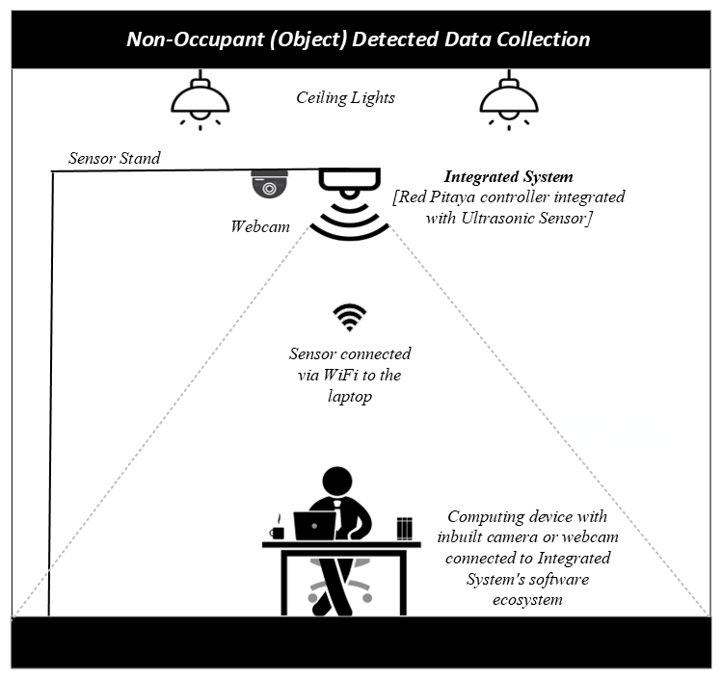

*Figure 3.4: Occupancy Detection Environment Setup*

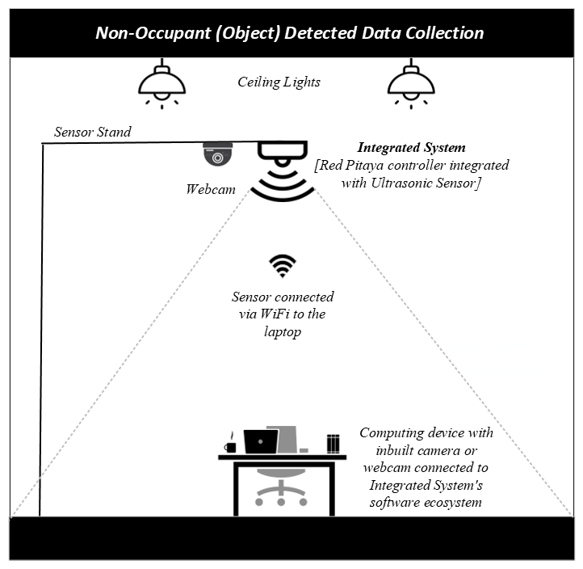

*Figure 3.5: Non-Occupancy Detection Environment Setup*

3.5.2 Hardware Setup

The hardware setup included an integrated Red Pitaya controller platform and an ultrasonic sensor. This integrated system had a GUI interface that provided ADC and FFT data. Additionally, an auxiliary system consisting of an integrated sensor system and a camera was utilized for labeled data collection. The Red Pitaay device was connected via WiFi for remote access and required a USB input for a power source. This configuration enables seamless data collection for occupancy detection.

3.5.3 Software Setup

Model training was conducted using Python and Jupyter Notebook software tools, which are well-known for their effectiveness in designing neural networks and deep learning models. The data acquisition process, as previously described, involved extracting FFT data files and labeling them using the auxiliary system (Pongsomboon, 2022). These labels, derived from FFT filenames, were saved separately. Eventually, all labels were retrieved and combined into comma-separated value (CSV) files with the corresponding FFT data. This comprehensive dataset, consisting of features and extracted labels, was used for training and testing the deep learning models. The software environment also included machine learning libraries and frameworks like TensorFlow or PyTorch, which are essential for model deployment and evaluation.

3.5.4 Data Collection Cofiguration

The setup involved placing the ultrasonic sensor and the auxiliary system (Pongsomboon, 2022) for optimal data collection. The Red Pitaya platform processed the sensor data into FFT format, which was then labeled using visual confirmation from the auxiliary system's camera and YOLO model. This strategy ensured accurate and reliable data labeling, which is essential for practical model training. The figure below clearly shows which categories of data have been collected. The data collection process has been executed for two situations: one in which a person is detected as "Occupant," and the other is an empty chair or any object, meaning "Non-occupant."

3.5.5 Network Connectivity

The network setup features WiFi connectivity for the Red Pitaya device, allowing for remote access and control. The USB input provided power to the Red Pitaya platform, allowing for continuous data collection. The network topology enables efficient data transmission between components and facilitates real-time processing and analysis.

3.5.6 Experimental Conditions

The experiments for this proposed research work were carried out in controlled environmental conditions to ensure consistency in sensor readings. Various scenarios were tested, including varying lighting conditions, chair types, and participant demographics. These conditions were rigorously maintained in order to reduce other factors that could affect the quality and dependability of sensor data. The environmental conditions table summarizes the conditions under which the experiments were conducted and is described below. This table helps in understanding the diversity and comprehensiveness of the experimental conditions under which the data was collected. Each condition was meticulously documented to ensure that the occupancy detection model could generalize well across different scenarios, making it robust and reliable in smart office environments.

*Table 3.2: Data Collection in Different Environmental Conditions*

| **Condition** | **Category** | **Description** |
| --- | --- | --- |
| **People** | Female & Male data | Data has been obtained from both male and female individuals. |
| **Chair** | Desk chair | Standard office desk chair |
|  | Executive chair | Larger, cushioned chair with more ergonomic features |
|  | Stool | Simple, backless stool |
| **Lighting Conditions** | Lights On | Artificial lights switched on |
|  | Lights Off | Artificial lights switched off |
|  | Natural Light | Daylight entering through windows |
| **Windows** | Windows Open | Experiments conducted with open windows |
|  | Windows Closed | Experiments conducted with closed windows |
| **Data Collection Categories** | Person Sitting on Chair (Occupancy) | A scenario where a person is seated on a chair |
|  | Empty Chair (Non-Occupancy) | A scenario where the chair is unoccupied. |

To summarize, this section describes the physical layout, hardware, software, data collection setup, network configuration, and environmental conditions of the research environment. By providing a detailed description of the work environment, this chapter provides the foundation for understanding the occupancy detection system's technique and subsequent results. The following chapter will examine the results, addressing the "how" and thoroughly analyzing the research findings.

# Realization

This realization chapter presents the research's outcome, detailing how the objectives outlined in the previous chapter, “requirement analysis," were achieved. This chapter encompasses the processes of data collection, extraction, preprocessing, model training, and evaluation, thus resulting in the implementation of the occupancy detection model.

## 4.1 Data Collection and Labeling Process

The data was collected using the auxiliary system (Pongsomboon, 2022), in which an integrated Red Pitaya device with an ultrasonic sensor is the main hardware component. This setup includes a GUI interface that facilitates the capture of FFT data for two categories: “Person Sitting on Chair or Occupied Seat” and “Empty Chair or Unoccupied Seat,” which provides each unique feature of detected events. The auxiliary system generated various folders consisting of binary, images, and JavaScript Object Notation (JSON) files. For this research, these binary files were used. The primary steps involved extracting labels from saved binary filenames (which are FFT information from ultrasonic sensors saved in NumPy format from the YOLO model), converting those Numpy files into FFT format, and merging the data into one single CSV file. The processing steps are described below.

1. **Data Collection**

The data collection resulted in a comprehensive dataset of approximately 137,000 records, each with 86 features for each reading. This data was collected using an auxiliary system (consisting of an integrated Red Pitaya and sensor system, which also includes the laptop’s webcam and Yolo object detection model for the labeling process).

1. **Extracting Labels from Filenames**

Labels were extracted from the filenames generated by the auxiliary system (Pongsomboon, 2022). These filenames included key information that helped identify whether the data represented an occupant (“p” for person) or a non-occupant (“o” or “c” for an object). The data files were categorized by cross-referencing the timestamps of FFT data with the visual data obtained from the auxiliary system. This allowed accurate labeling of the data into occupant and non-occupant categories,

1. **Converting NumPy files into FFT format**

The data collected was initially stored in NumPy file format. These files were converted into FFT format, and labels were extracted from the filenames during this process.

1. **Pseudocode for Data Processing**

The table below includes the pseudocode for the above steps to provide a high-level understanding of the process.

*Table 4.1: Pseudocode for Data Processing*

| 1. Define a function to extract labels from the filename  * Map ‘p’ to ‘1’ (occupant) and ‘o’ & ‘c’ to ‘0’ (non-occupant). * Extract the label from the filename using the predefined map.  1. Define a function to convert NumPy files to FFT format and merge them into a CSV file.  * Make an empty list to store the data frame * Transverse through the files in the given folder. * For each .npy file * Load the NumPy data * Convert the data to bytes * Extract ultrasonic data from the bytes. * Create a temporary data frame from the extracted data. * Insert the label extracted from the filename into the data frame. * Append the data frame to the list. * Concatenate all data frames into a final data frame * Save the final data frame into a CSV file |
| --- |

## 4.2 Deep Learning Algorithm

This section details the process of training the occupancy detection model using various RNN architectures, including LSTM, GRU, and BiLSTM. The steps include data preparation, model building, training, and evaluation, with a focus on the LSTM model, which demonstrated the best performance. The purpose of this section is to explain the implementation and results of the training process for the various RNN architectures, explicitly focusing on different layers.

*Table 4.2: Pseudocode for Data Preparation*

| 1. Load the dataset 2. Extract features (feature values) from the dataset, excluding the label column. 3. Extract labels (target values) from the dataset in the first column. 4. Split the data training and testing sets as 70-30%. |
| --- |

4.2.1 LSTM Model Architecture

*Table 4.3: Pseudocode for Model Architecture*

| 1. Initialize a sequential model. 2. Add LSTM layers with dropout for regularization 3. Add a dense output layer with sigmoid activation 4. Compile the model with an optimizer, loss function, and metrics. 5. Define callbacks for early stopping and checkpointing. |
| --- |

The sequential input data and the model’s single-value output (indicated by the ‘sigmoid’ activation function in the final dense or output layer for binary classification) show that the research code implementation uses a many-to-one architecture for the occupancy detection model. This architecture takes a series of inputs and returns a single output value, either “1: Occupant” or “0: Non-Occupant”. Additionally, a concise flow chart has been created to illustrate the model architecture and highlight the layers used for optimal model learning, with the goal of improving performance and designing a reliable occupancy detection model. A detailed description of the model’s architecture layers is shown in Figure 4.1 below.

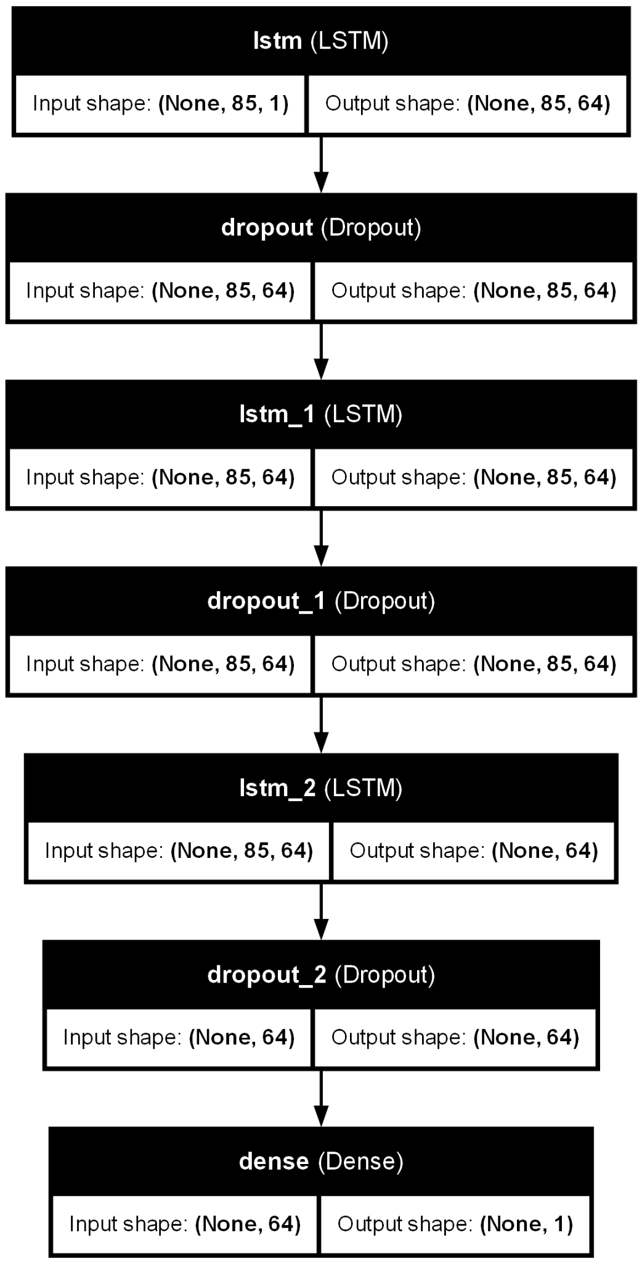

*Figure 4.1: Layout of LSTM Layers Input and Output Shape*

**Detailed Description of Model Architecture**

1. Input Sequence: Each time step is a feature vector from the sequence.
2. LSTM Layer: Each layer consists of 64 units. The LSTM cells process the input sequence one time step at a time and pass their hidden state to the next time step. The first LSTM layer processes the input sequence and passes its output to the next LSTM layer.
3. Dropout Layer: To prevent overfitting, dropout layers have been added to each LSTM layer, randomly switching off a percentage of input units at each training update.
4. Dense Layer: The final output layer takes the output from the LSTM layer and applies a sigmoid activation function to produce a single output value.

4.2.2 Parameter Selection for Algorithm

*Table 4.4: Pseudocode for Setting Hyperparameters*

| 1. Compile the model by initializing hyperparameters 2. Hyperparameters such as optimizer, loss function, and metrics 3. Train the model with training and validation data 4. Store the training history by setting epochs and batch sizes |
| --- |

The hyperparameters used for the model architecture are described in Table 4.5 below.

*Table 4.5: Hyperparameters chosen for the LSTM Model*

| **Hyperparameters** | **Metrics** |
| --- | --- |
| Optimizer | Adam |
| Batch Size | 32 |
| Loss Function | Binary cross entropy |
| Epochs | 50 cycles |
| Learning Rate | 0.001 |

4.2.3 Model Selection and Hyperparameter Optimization

For the occupancy detection model, selecting the optimal model involved a proper exploration of different RNN architectures, layer configurations, and learning rates. This section details the process and findings that led to the selection of the best-performing model.

1. **Initial Model Selection: LSTM vs. GRU vs. BiLSTM**

The first step in developing the occupancy detection model was determining which RNN architecture would perform best. Three different evaluations were conducted for RNN variants: LSTM, GRU, and BiLSTM. For a fair comparison, the same hyperparameters for all models were set, as can be seen below.

* Number of Layers: 3 layers
* Units per Layer: 64 units
* Learning rate: 0.001
* Dropout Rate: 0.5

The evaluation metrics include accuracy, ROC AUC score precision, recall, and F1 score. The results summarized in Table 4.6 below showed that the LSTM model outperformed GRU and BiLSTM across all metrics, particularly in accuracy and ROC AUC score. These metrics indicated that LSTM was more effective at capturing the temporal dependencies in the data, making it the preferred choice for further optimization.

*Table 4.6: Performance Comparison of RNN Architectures*

| **NN Model** | **Accuracy** | **ROC AUC** | **Loss** | **Precision** | **Recall** | **F1 Score** |
| --- | --- | --- | --- | --- | --- | --- |
| LSTM | 0.9817 | 0.9814 | 0.0630 | 0.9802 | 0.9858 | 0.9830 |
| GRU | 0.9726 | 0.9721 | 0.0872 | 0.9701 | 0.9790 | 0.9745 |
| BiLSTM | 0.9768 | 0.9764 | 0.0765 | 0.9758 | 0.9810 | 0.9784 |

1. **Layer Configuration Optimization**

After choosing the LSTM architecture, the next step was to examine the optimal number of LSTM layers. Four different configurations were tested to see how the depth of the network affected performance, and they are listed below.

* Configuration A: 4 LSTM layers with 128 units in the input layer, 64 units in the three hidden layers, and a Dense output layer
* Configuration B: 4 LSTM layers with 64 units in the input layer, 64 units in the three hidden layers, and a Dense output layer
* Configuration C: 3 LSTM layers with 64 units in the input layer, 64 units in the two hidden layers, and a Dense layer
* Configuration D: 2 LSTM layers with 64 units in the input layer, 64 units in the hidden layer, and a Dense output layer

Each configuration was evaluated using the same metrics as in the previous step. The results in Table 4.7 below indicate that Configuration C (3 LSTM layers with 64 units each) achieved the highest accuracy and overall performance. This setup was found to be a good balance between model complexity and performance, as adding more layers did not significantly improve the results and could potentially lead to overfitting.

*Table 4.7: Performance of Different LSTM Layer Configurations*

| **Configurations** | **Layers** | **Accuracy** | **ROC AUC** | **Precision** | **Recall** | **F1 Score** |
| --- | --- | --- | --- | --- | --- | --- |
| A | 128, 64, 64, 64, 1 | 0.9765 | 0.9762 | 0.9762 | 0.9799 | 0.9781 |
| B | 64, 64, 64, 64, 1 | 0.9735 | 0.9730 | 0.9705 | 0.9803 | 0.9754 |
| C | 64, 64, 64, 1 | 0.9817 | 0.9814 | 0.9802 | 0.9858 | 0.9830 |
| D | 64, 64, 1 | 0.9800 | 0.9797 | 0.9795 | 0.9769 | 0.9767 |

1. **Learning Rate Tuning**

The final aspect of optimization involved tuning the learning rate (LR). Two possibilities have been tested with learning rates to see how they affect model performance.

* LR A: 0.001
* LR B: 0.0001

The results, shown in Table 4.8, demonstrated that a learning rate of 0.001 provided a better performance across all metrics. A higher learning rate of 0.001 allowed the model to tend to converge faster and achieve higher accuracy and better overall performance.

*Table 4.8: Performance with various Learning Rate*

| **LR** | **Accuracy** | **ROC AUC** | **Precision** | **Recall** | **F1 Score** |
| --- | --- | --- | --- | --- | --- |
| 0.001 | 0.9817 | 0.9814 | 0.9802 | 0.9858 | 0.9830 |
| 0.0001 | 0.9790 | 0.9785 | 0.9795 | 0.9767 | 0.9693 |

1. **Final Model Configuration**

Based on the experiments, the final model configuration was determined as follows:

* Architecture: LSTM neural network
* Number of Layers: 3 LSTM layers (input and hidden)
* Output Layer: 1 Dense layer
* Learning Rate: 0.001
* Batch Size: 32
* Loss Function: Binary cross-entropy
* Dropout Rate: 0.5

This configuration provided the best balance between model complexity and performance, resulting in a well-optimized occupancy detection model. In summary, through a systematic evaluation of different RNN architectures, layer configurations, and learning rates, the LSTM model with three layers and a learning rate of 0.001 was identified as the best-performing hyperparameter for the model of occupancy detection. This process ensured that the model was accurate and efficient, capable of capturing the necessary temporal dependencies in the data.

## 4.3 Model Evaluation

To provide a complete and detailed analysis of the model’s performance, it’s crucial to include the confusion matrix results for both the training and testing datasets. These evaluations as shown in below figures 4.2, 4.3, 4.4 and 4.5 will offer insights into how well the model distinguishes between the different classes (occupant vs. non-occupant) and highlight any potential issues with misclassification.

**Evaluation Results**

1. **Confusion Matrix for Training & Testing Data**

The confusion matrix for the training dataset provides a visual representation of the model’s performance on the data on which it was trained. It helps to identify how well the model learned.

* **True Occupant:** The number of correctly predicted occupant instances.
* **True Non-Occupant:** The number of correctly predicted non-occupant instances.
* **Predicted Occupant:** The number of non-occupant instances predicted as occupants.
* **Predicted Non-Occupant:** The number of occupant instances predicted as non-occupants.

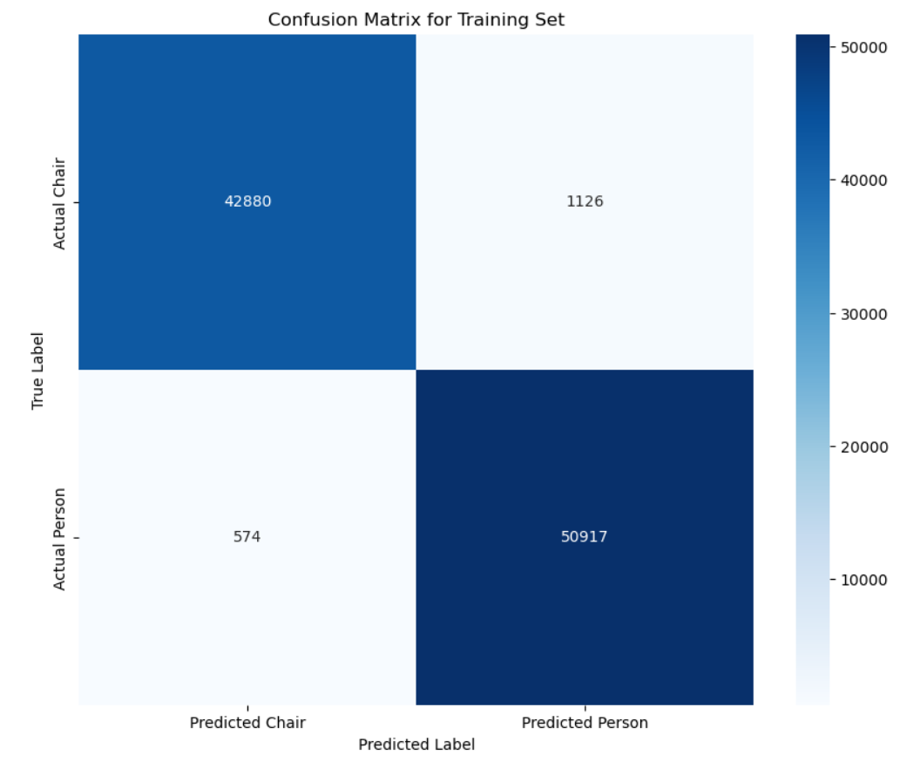

*Figure 4.2: Confusion Matrix of Training Data*

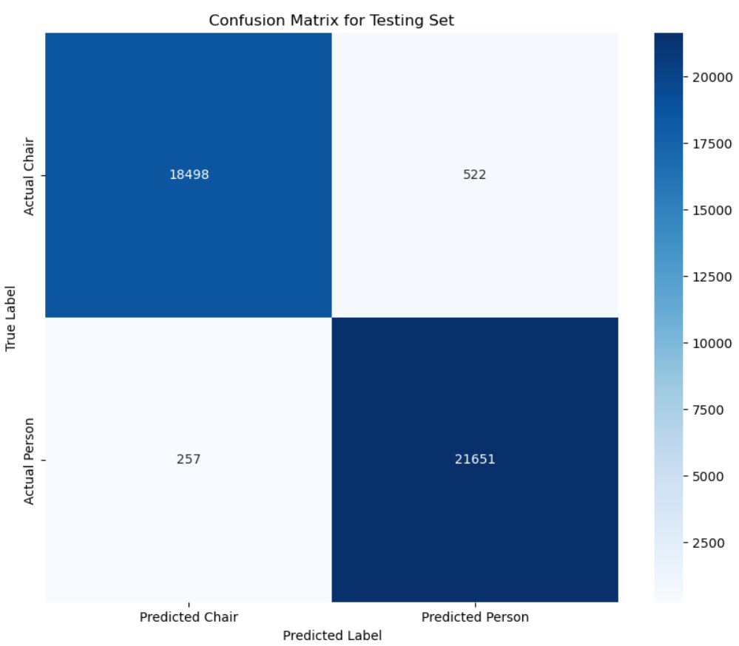

*Figure 4.3: Confusion Matrix of Testing Data*

1. **Performance Metrics for Training & Testing Data**

* Accuracy: The proportion of accurately predicted occurrences to the total occurrences.
* Precision: The ratio of accurately predicted occupant instances to the total predicted occupant instances.
* Recall: The ratio of correctly predicted occupant instances to all instances in the actual occupant class.
* F1 Score: The harmonized average of precision and recall results.
* ROC AUC Score: The amount of area underneath the ROC curve measures the model’s ability to differentiate between classifications.
* Average Precision Score: The average of precision values at different threshold settings.

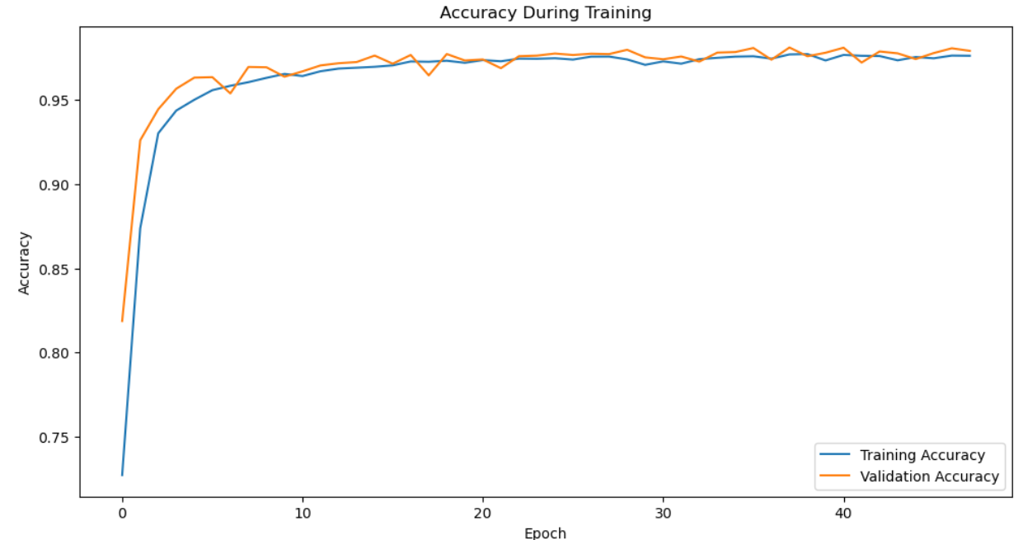

*Figure 4.4: Accuracy values during training*

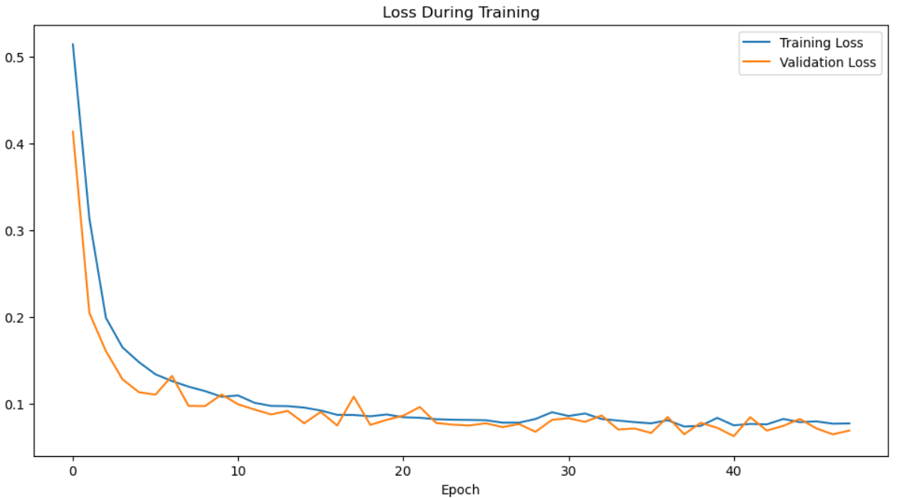

*Figure 4.5: Loss function values during training*

## 4.4 Occupancy Detection Model for Red Pitaya’s Software Ecosystem

Red Pitaya is an advanced open-source software ecosystem that enables high-performance data collection and management. Integrating the trained model into Red Pitaya’s system requires a few steps:

1. Model Conversion: Save the trained TensorFlow Keras model in the TensorFlow SavedModel format.
2. Integration: TensorFlow’s C++ API enables to load and run the model directly in a C++ application used in Red Pitaya’s software ecosystem. This enables real-time occupancy detection.

4.4.1 Saving the Model

The trained and tested occupancy detection model is saved in TensorFlow Keras format to ensure its effectiveness in real-time applications and integration into other software systems. This format preserves the model’s architecture, weights, and training setup, allowing for seamless future incorporation into the integrated system consisting of a Red Pitaya controller with an ultrasonic sensor.

*Table 4.5: Pseudocode for Saving Model*

| 1. Define the file path for saving the model  * Set the file path where the model will be saved, e.g., ‘rnn_lstm_model.h5’ * model_file_path = ‘rnn_lstm_model.h5’  1. Save the trained model.  * Use the save method of the model object to save the model to the specified file path * trained_model.save(model_file_path)  1. Ensure the saved model includes architectures, weights, and training configurations. |
| --- |

4.4.2 Why is it Necessary to Save Model?

* Portability: Saving the model allows it to be effortlessly transported and distributed across various platform settings.
* Reusability: The saved model can be loaded and reused without the need for retraining, which saves computing resources and time.
* Compatibility: The model has been saved in TensorFlow Keras Format and can be later used in a C++ environment by using TensorFlow’s C++ API directly, which is suitable for deployment in applications with limited processing capability, such as into the integrated system for future real-time application usage.

4.4.3 Future Scope for Real-Time Applications

The ability to import and run the trained model into the integrated Red Pitaya ultrasonic sensor system offers several possibilities for real-time occupancy detection applications. An example scenario can be explained better by considering a smart office environment where this integrated system (a Red Pitaya device coupled with an ultrasonic sensor) continuously monitors occupancy through the sensor. When the system detects a vacancy, it can automatically turn off the lights and reduce the air conditioning, thus conserving energy. If someone enters the room, the system can immediately respond by turning the lights back on and setting the climate control to a comfortable level. By storing the model and making it compatible with TensorFlow, the occupancy detection model becomes more versatile and ready for real-time deployment, considerably improving efficiency and automation possibilities in various environments. Some of the advantages of using this system have been discussed below.

1. Smart Office Automation: The model recognizes occupancy in office spaces, which enables intelligent control of lighting, HVAC, and security systems.
2. Energy Efficiency: By accurately detecting occupancy, the system can optimize energy by turning off lighting and climate control systems in unoccupied office spaces.
3. Enhanced Security: Real-time occupancy detection can improve security systems by providing immediate alerts when unexpected movement is detected in restricted areas.
4. Data Collection and Analysis: This integration enables continuous data collection, which may be utilized to improve the model and react to changing conditions.

# Summary and Perspectives

While ensuring resource efficiency and user satisfaction are key aspects in intelligent and interactive smart office environments, demand-controlled occupancy detection and protection of users’ privacy are valuable in enhancing smart services in modern working environments. Hence, this research work contributes to knowledge for better, user-responsible smart solutions. This work has revealed a novel occupancy detection method that uses a highly efficient ultrasonic sensor in conjunction with a powerful Red Pitaya computing device while also respecting user privacy.

The research started by collecting detailed data and utilized an auxiliary system developed in support of the ultrasonic sensor. This system reads the ultrasonic zone in parallel with the camera to capture the existence of the objects and involves the YOLO model for classified occupancy detection. This interconnection between the sensor and the camera enabled labeling the data either as an “occupant” or “non-occupant” as the initial step for a robust classified dataset that could be fed to the DL neural network architectures for learning.

After data collection and label extraction, the next step is to prepare for the exploration of deep learning techniques, an exploration to resolve the complexities of temporal patterns and dependencies in the collected FFT features discovered in occupancy data. Three challenging neural network techniques emerged: the LSTM, GRU, and BiLSTM neural networks, each with its unique strengths and capabilities, notably for sequential data processing. Following evaluation and comparison research, the LSTM model emerged as the top approach with 98.16% accuracy values, surpassing other versions across various performance criteria, such as precision, recall, accuracy, and F1. This triumph could be ascribed to the fact that LSTM has proved to be efficient in storing as well as discarding long-term dependencies between inputs and outputs, employing advanced gating mechanisms.

Even the architecture of the GRU is relatively simpler to enable it to learn temporal patterns with great ease as compared to the BiLSTM, which has the added advantage of bidirectional propagation; nevertheless, the LSTM has proven to be very efficient in the intricate aspects related to the features of occupancy datasets. It is a three-gated model (input, output, forget gates) that turned out to be helpful in dealing with the complex spatial-temporal features of occupancy patterns, and in this way, it produced fewer inaccuracies with comparisons to its other types. An optimized LSTM model with deep learning capabilities or features has been saved in the TensorFlow Keras format, making seamless integration into the Red Pitaya software environment. This demonstration not only enhances scalability and reusability but also opens a way for real-time occupancy detection, which could revolutionize the functioning of smart office spaces.

Imagine a world in which occupancy level information from smart buildings is frequently shared and investigated to ensure purposeful usage of efficient energy and a positive user experience. With this, the trained LSTM model can be further integrated and loaded into the Red Pitaya software ecosystem, which enhances the ultrasonic sensor to achieve accurate occupancy levels. It has a long list of possibilities applied, from regulating the tasks involved in air conditioning, lighting, and heating to real-time occupancy changes right up to optimizing the working space size and effectiveness of teaming up.

Criticism of One's Own Work:

1. Comparing the LSTM, GRU, and BiLSTM models in detail is beneficial. However, a more in-depth analysis of the reason behind LSTM's performance in capturing long-term patterns and solutions to gradient issues can further strengthen the case for its usefulness.
2. While the hyperparameters used for model training have already been provided, further exploring the effect of different hyperparameters, such as layers, units, and regularization settings, on each model's performance may show future improvements.
3. Real-world testing would help to understand better actual deployment difficulties such as scalability, maintenance, integration with existing systems, and user acceptance, which can lead to optimization.

Suggestions for Future Improvements:

1. Discuss and compare the mathematical expressions and gating techniques of LSTM, GRU, and BiLSTM in depth to determine how they can capture long-term dependencies and address gradient challenges for occupancy prediction.
2. Collaborate with industrial counterparts for practical experiments and then understand how some of the deployment issues would actually look like and how the users are going to accept it.
3. It is vital to consider the adaptability of system integration into various scenarios like the issue of placing sensors in residential buildings or storing noise impact, as well as the working occupancy pattern detection for residential buildings and other retail spaces.

# Abbreviations

### A

#### AI Artificial Intelligence

ADC Analog-to-Digital Conversion

AUC-ROC Area under the Receiver Operating Characteristic Curve

### B

#### BiLSTM Bidirectional Long Short-Term Memory

### C

#### CI Computational Intelligence

#### **D**

#### DL Deep Learning

#### **F**

#### FFT Fast Fourier Transform

#### **G**

#### GRU Gradient Recurrent Unit

#### **H**

#### HVAC Heating, ventilation, and air conditioning

#### **L**

#### LSTM Long Short-Term Memory

LR Learning Rate

#### **M**

#### MACS Multi-Agent Control Systems

ML Machine Learning

#### **p**

#### PIR Passive Infrared

#### **Y**

#### YOLO You Only Look Once

# References

1. Esrafilian-Najafabadi, M., & Haghighat, F. (2021). Occupancy-based HVAC control systems in buildings: A state-of-the-art review. Building and Environment, 197, 107810. <https://doi.org/10.1016/j.buildenv.2021.107810>
2. Mahdavi, A., & Tahmasebi, F. (2015). Predicting people's presence in buildings: An empirically based model performance analysis. Energy and Buildings, 86, 349-355.
3. Lan, L., Lian, Z., Pan, L., & Ye, Q. (2011). Neurobehavioral approach for evaluation of office workers' productivity: The effects of room temperature. Building and Environment, 46(5), 1200-1210.
4. Chaudhari, P., Xiao, Y., Ming-Cheng Cheng, M., & Li, T. (2024). Fundamentals, Algorithms, and Technologies of Occupancy Detection for Smart Buildings Using IoT Sensors. Sensors (Basel, Switzerland), 24(7). <https://doi.org/10.3390/s24072123>
5. Telaga, A. S., & Salmaa. (2024). Occupancy detection through machine learning and environmental data. AIP Conference Proceedings, 2926(1), 020120. <https://pubs.aip.org/aip/acp/article-abstract/2926/1/020120/2999324/Occupancy-detection-through-machine-learning-and?redirectedFrom=fulltext>
6. Djenouri, D., Laidi, R., & Zizoua, C. (2018). Electrical Energy Consumption Control in Buildings Using Wireless Sensor Networks.
7. Banihashemi, F., Weber, M., Deghim, F., Zong, C., & Lang, W. (2024). Occupancy modeling on non-intrusive indoor environmental data through machine learning. Building and Environment, 254, 111382. <https://doi.org/10.1016/j.buildenv.2024.111382>
8. Korkidis, P., Dounis, A., & Kofinas, P. (2020). Computational Intelligence Technologies for Occupancy Estimation and Comfort Control in Buildings. Energies, 14(16), 4971. <https://doi.org/10.3390/en14164971>
9. Paween Pongsomboon, “Using Image Processing for Autonomous Illumination Sensor Optimization”, Frankfurt University of Applied Sciences, 2022
10. Kamthe, A., Jiang, L., Dudys, M., & Cerpa, A. (2009). Scopes: Smart cameras object position estimation system. In Wireless Sensor Networks: 6th European Conference, EWSN 2009, Cork, Ireland, February 11-13, 2009. Proceedings 6 (pp. 279-295). Springer Berlin Heidelberg.
11. Dodier, R.H. et al. (2006) 'Building occupancy detection through sensor belief networks', Energy and Buildings, 38(9), pp. 1033–1043. <https://www.researchgate.net/publication/223326780_Building_occupancy_detection_through_sensor_belief_networks>
12. Ekwevugbe, T. et al. (2013) 'Improved occupancy monitoring in non-domestic buildings', Sustainable Cities and Society, 8, pp. 97–107. <https://doi.org/10.1016/j.scs.2017.01.003>
13. Haneul Choi, Chai Yoon Um, Kyungmo Kang, Hyungkeun Kim, Taeyeon Kim. 2021. Application of vision-based occupancy counting method using deep learning and performance analysis. Energy and Buildings, Volume 252, 111389, ISSN 0378-7788, [https://doi.org/10.1016/j.enbuild.2021.111389.](https://doi.org/10.1016/j.enbuild.2021.111389)
14. Aveek K. Das, Parth H. Pathak, Josiah Jee, Chen-Nee Chuah, and Prasant Mohapatra. 2017. Non-Intrusive Multi-Modal Estimation of Building Occupancy. In Proceedings of the 15th ACM Conference on Embedded Network Sensor Systems (SenSys '17). Association for Computing Machinery, New York, NY, USA, Article 14, 1–14. <https://doi.org/10.1145/3131672.3131680>
15. Kailai Sun, Qianchuan Zhao, Ziyou Zhang, Xinyuan Hu. 2022. Indoor occupancy measurement by the fusion of motion detection and static estimation. Energy and Buildings, Volume 254, 111593, ISSN 0378-7788. [https://doi.org/10.1016/j.enbuild.2021.111593.](https://doi.org/10.1016/j.enbuild.2021.111593)
16. Shih, O., Lazik, P., & Rowe, A. (2016, November). Aures: A wide-band ultrasonic occupancy sensing platform. In Proceedings of the 3rd ACM international conference on systems for energy-efficient built environments (pp. 157-166).
17. [Ahmad, J.](https://www.emerald.com/insight/search?q=J.%20Ahmad), [Larijani, H.](https://www.emerald.com/insight/search?q=H.%20Larijani), [Emmanuel, R.](https://www.emerald.com/insight/search?q=R.%20Emmanuel), [Mannion, M.](https://www.emerald.com/insight/search?q=M.%20Mannion) and [Javed, A.](https://www.emerald.com/insight/search?q=A.%20Javed) (2021), "Occupancy detection in non-residential buildings – A survey and novel privacy preserved occupancy monitoring solution", [Applied Computing and Informatics](https://www.emerald.com/insight/publication/issn/2634-1964), Vol. 17 No. 2, pp. 279-295. <https://doi.org/10.1016/j.aci.2018.12.001>
18. Ranieri, Caetano Mazzoni, Scott MacLeod, Mauro Dragone, Patricia Amancio Vargas, and Roseli Aparecida Francelin Romero . 2021. "Activity Recognition for Ambient Assisted Living with Videos, Inertial Units and Ambient Sensors" Sensors 21, no. 3: 768. <https://doi.org/10.3390/s21030768>
19. Pan, Q., Pan, R., Shao, C. et al. Research Review of Principles and Methods for Ultrasonic Measurement of Axial Stress in Bolts. Chin. J. Mech. Eng. 33, 11 (2020). <https://doi.org/10.1186/s10033-020-0431-x>
20. Mrazovac, Bojan & Z. Bjelica, Milan & Kukolj, Dragan & Todorovic, Branislav & Samardzija, Dragan. (2012). A Human Detection Method for Residential Smart Energy Systems Based on Zigbee RSSI Changes. IEEE Transactions on Consumer Electronics. 58. 819-824. <https://www.researchgate.net/publication/235919503_A_Human_Detection_Method_for_Residential_Smart_Energy_Systems_Based_on_Zigbee_RSSI_Changes>
21. Abade B, Perez Abreu D, Curado M. A Non-Intrusive Approach for Indoor Occupancy Detection in Smart Environments. Sensors. 2018; 18(11):3953. <https://doi.org/10.3390/s18113953>
22. Nacer Khalil, Driss Benhaddou, Omprakash Gnawali, Jaspal Subhlok. 2018. Nonintrusive ultrasonic-based occupant identification for energy efficient smart building applications. Applied Energy. Volume 220, pp. 814-828. [https://doi.org/10.1016/j.apenergy.2018.03.018.](https://doi.org/10.1016/j.apenergy.2018.03.018)
23. Dong, B., Lam, K.P. and Neuman, C.P., 2011. Integrated building control based on occupant behavior pattern detection and local weather forecasting.
24. Red Pitaya (2023) Red Pitaya: Ecosystem for Everywhere. Available at:<https://www.redpitaya.com/> (Accessed: 28 May 2024).
25. Dong, Bing & Yan, Da & Li, Zhaoxuan & Jin, Yuan & Feng, Xiaohang & Fontenot, Hannah. (2018). Modeling occupancy and behavior for better building design and operation—A critical review. Building Simulation. <https://www.researchgate.net/publication/325874774_Modeling_occupancy_and_behavior_for_better_building_design_and_operation-A_critical_review>
26. Schmidhuber, Juergen. "Deep Learning in Neural Networks: An Overview." ArXiv, (2014). Accessed June 10, 2024. [https://doi.org/10.1016/j.neunet.2014.09.003.](https://doi.org/10.1016/j.neunet.2014.09.003)
27. Zou, J., Zhao, Q., Yang, W., & Wang, F. (2017). Occupancy detection in the office by analyzing surveillance videos and its application to building energy conservation. Energy and Buildings, 152, 385-398. <https://doi.org/10.1016/j.enbuild.2017.07.064>
28. Hochreiter, Sepp & Schmidhuber, Jürgen. (1997). Long Short-term Memory. Neural computation. 9. 1735-80. doi: <https://doi.org/10.1162/neco.1997.9.8.1735>
29. K. Greff, Klaus & Srivastava, Rupesh & Koutník, Jan & Steunebrink, Bas & Schmidhuber, Jürgen. (2015). LSTM: A search space odyssey. IEEE transactions on neural networks and learning systems. <https://www.researchgate.net/publication/273640320_LSTM_A_search_space_odyssey>
30. Yong Yu, Xiaosheng Si, Changhua Hu, Jianxun Zhang; A Review of Recurrent Neural Networks: LSTM Cells and Network Architectures. Neural Comput 2019; 31 (7): 1235–1270. doi:<https://doi.org/10.1162/neco_a_01199>
31. Mikolov, Tomas & Karafiát, Martin & Burget, Lukas & Cernocký, Jan & Khudanpur, Sanjeev. (2010). Recurrent neural network based language model. Proceedings of the 11th Annual Conference of the International Speech Communication Association, INTERSPEECH 2010. 2. 1045-1048. <https://www.researchgate.net/publication/221489926_Recurrent_neural_network_based_language_model>
32. Lipton, Zachary C., et al. "A Critical Review of Recurrent Neural Networks for Sequence Learning." ArXiv, 2015, /abs/1506.00019. Accessed 10 Jun. 2024. doi:<https://doi.org/10.48550/arXiv.1506.00019>
33. Pascanu, R., Mikolov, T. and Bengio, Y. (2013) 'On the difficulty of training recurrent neural networks', in Proceedings of the 30th International Conference on Machine Learning, pp. 1310–1318. Available from [https://proceedings.mlr.press/v28/pascanu13.html.](https://proceedings.mlr.press/v28/pascanu13.html)
34. Cho, K., van Merrienboer, B., Gulcehre, C., Bahdanau, D., Bougares, F., Schwenk, H., & Bengio, Y. (2014). Learning phrase representations using RNN encoder-decoder for statistical machine translation. arXiv preprint arXiv:1406.1078. <https://doi.org/10.48550/arXiv.1406.1078>
35. Chung, J., Gulcehre, C., Cho, K., & Bengio, Y. (2014). Empirical evaluation of gated recurrent neural networks on sequence modeling. arXiv preprint arXiv:1412.3555. <https://doi.org/10.48550/arXiv.1412.3555>
36. Geeksforgeeks. (2023, March 2). Gated Recurrent Unit Networks. <https://www.geeksforgeeks.org/gated-recurrent-unit-networks/>
37. Wikipedia contributors. (2023, May 25). Gated recurrent unit. In Wikipedia, The Free Encyclopedia. <https://en.wikipedia.org/wiki/Gated_recurrent_unit>
38. Bibi, Iram & Akhunzada, Adnan & Malik, Jahanzaib & Iqbal, Javed & Musaddiq, Arslan & Kim, Sung. (2020). A Dynamic DL-Driven Architecture to Combat Sophisticated Android Malware. IEEE Access. PP. 1-1. [https://www.researchgate.net/publication/343002752_A_Dynamic_DL-Driven_Architecture_to_Combat_Sophisticated_Android_Malware.](https://www.researchgate.net/publication/343002752_A_Dynamic_DL-Driven_Architecture_to_Combat_Sophisticated_Android_Malware)
39. Khan, Irfanullah & Delicato, Flavia & Greco, Emilio & Guarascio, Massimo & WangEsrafilian-NajafabadiGuerrieri, Antonio & Spezzano, Giandomenico. (2023). Occupancy Prediction in Multi-Occupant IoT Environments Leveraging Federated Learning. 0036-0043. <https://www.researchgate.net/publication/376816828_Occupancy_Prediction_in_Multi-Occupant_IoT_Environments_Leveraging_Federated_Learning>
40. Yasrab, Robail & Pound, Michael. (2020). PhenomNet: Bridging Phenotype-Genotype Gap: A CNN-LSTM Based Automatic Plant Root Anatomization System. <https://www.researchgate.net/publication/341131167_PhenomNet_Bridging_Phenotype-Genotype_Gap_A_CNN-LSTM_Based_Automatic_Plant_Root_Anatomization_System>
41. Diarra MK, Maniar A, Masson J-B, Marhic B, Delahoche L. Occupancy State Prediction by Recurrent Neural Network (LSTM): Multi-Room Context. Sensors. 2023; 23(23):9603. <https://doi.org/10.3390/s23239603>
42. Lam, Khee & Hoynck, M & Dong, Bing & Andrews, B & Chiou, Yun-Shang & Zhang, Rongpeng & Benitez, Diego & Choi, Joon-Ho. (2009). Occupancy detection through an extensive environmental sensor network in an open-plan office building. <https://www.researchgate.net/publication/322519286_Occupancy_detection_through_an_extensive_environmental_sensor_network_in_an_open-plan_office_building>
43. Z. Chen, M. Wang and Y. Wang, "Improving Indoor Occupancy Detection Accuracy of the SLEEPIR Sensor Using LSTM Models," in IEEE Sensors Journal, vol. 23, no. 15, pp. 17794-17802, 1 Aug.1, 2023, [doi: 10.1109/JSEN.2023.3287565](https://ieeexplore.ieee.org/document/10161606)
44. Graves, A. and Schmidhuber, J. (2005) 'Framewise phoneme classification with bidirectional LSTM and other neural network architectures', Neural Networks, 18(5–6), pp. 602–610. <https://doi.org/10.1016/j.neunet.2005.06.042>
45. M. Schuster and K. K. Paliwal, "Bidirectional recurrent neural networks," in IEEE Transactions on Signal Processing, vol. 45, no. 11, pp. 2673-2681, Nov. 1997, doi: [10.1109/78.650093.](https://doi.org/10.1109/78.650093)
46. H. Oshima, T. Ishizone, K. Nakamura and T. Higuchi, "Occupancy Detection for General Households by Bidirectional LSTM with Attention," IECON 2022 – 48th Annual Conference of the IEEE Industrial Electronics Society, Brussels, Belgium, 2022, pp. 1-7. doi: [10.1109/IECON49645.2022.9968594.](https://doi.org/10.1109/IECON49645.2022.9968594)
47. Marina Sokolova, Guy Lapalme. 2009. A systematic analysis of performance measures for classification tasks. Information Processing & Management. Volume 45, Issue 4, pp. 427-437. [https://doi.org/10.1016/j.ipm.2009.03.002.](https://doi.org/10.1016/j.ipm.2009.03.002)
48. Goutte, C., Gaussier, E. (2005). A Probabilistic Interpretation of Precision, Recall and F-Score, with Implication for Evaluation. In: Losada, D.E., Fernández-Luna, J.M. (eds) Advances in Information Retrieval. ECIR 2005. Lecture Notes in Computer Science, vol 3408. Springer, Berlin, Heidelberg. <https://doi.org/10.1007/978-3-540-31865-1_25>
49. Powers, D. M. (2020). Evaluation: From precision, recall and F-measure to ROC, informedness, markedness and correlation. <https://doi.org/10.48550/arXiv.2010.16061>
50. Tom Fawcett. 2006. An introduction to ROC analysis, Pattern Recognition Letters, Volume 27, Issue 8, pp. 861-874, ISSN 0167-8655 [https://doi.org/10.1016/j.patrec.2005.10.010.](https://doi.org/10.1016/j.patrec.2005.10.010)
51. Tavakoli, N., & Namin, A. S. (2019). A Comparative Analysis of Forecasting Financial Time Series Using ARIMA, LSTM, and BiLSTM. <https://doi.org/10.48550/arXiv.1911.09512>
52. Bai, S., Kolter, J. Z., & Koltun, V. (2018). An Empirical Evaluation of Generic Convolutional and Recurrent Networks for Sequence Modeling. <https://doi.org/10.48550/arXiv.1803.01271>
53. Charef, Fahima. (2024). A comparison of feed forward and recurrent neural networks in time series forecasting. [10.21203/rs.3.rs-4022444/v1.](https://www.researchgate.net/publication/378935269_A_comparison_of_feed_forward_and_recurrent_neural_networks_in_time_series_forecasting)
54. Ahmad, Jawad. (2020). Privacy-preserving non-wearable occupancy monitoring system exploiting Wi-Fi imaging for next-generation body-centric communication. <https://www.researchgate.net/publication/340232906_Privacy-preserving_non-wearable_occupancy_monitoring_system_exploiting_Wi-Fi_imaging_for_next-generation_body-centric_communication>
55. European Commission (2023) Protection of Personal Data. Available at:<https://ec.europa.eu/info/aid-development-cooperation-fundamental-rights/your-rights-eu/protection-personal-data_en> (Accessed: 28 May 2024).
56. Vinuesa, R., Azizpour, H., Leite, I. et al. The role of artificial intelligence in achieving the Sustainable Development Goals. Nat Commun 11, 233 (2020). <https://doi.org/10.1038/s41467-019-14108-y>
57. European Union (2016) General Data Protection Regulation (GDPR). Available at:<https://gdpr.eu/> (Accessed: 28 May 2024).
58. Ardakanian, O., Bhattacharya, A., & Culler, D. (2016, November). Non-intrusive techniques for establishing occupancy related energy consumption profiles in buildings. In Proceedings of the 4th ACM International Conference on Systems for Energy-Efficient Built Environments (pp. 1-10).
59. Sak, H., Senior, A., & Beaufays, F. (2014). Long Short-Term Memory Based Recurrent Neural Network Architectures for Large Vocabulary Speech Recognition. <https://doi.org/10.48550/arXiv.1402.1128>
60. Wang, Haiyao & Wang, Jianxuan & Cao, Lihui & Li, Yifan & Sun, Qiuhong & Wang, Jingyang. (2021). A Stock Closing Price Prediction Model Based on CNN-BiSLSTM. Complexity. 2021. 1-12. [10.1155/2021/5360828](https://www.researchgate.net/publication/354773136_A_Stock_Closing_Price_Prediction_Model_Based_on_CNN-BiSLSTM)