Experiment No. 4 Transfer function of DC motor

Objectives:
To determine the transfer function of an armature controlled DC motor by static and dynamic tests.
Equipment Required:

Prior to Lab:
Derive the transfer function of an armature controlled servo motor
Theory:
Electrical parameters of the DC motor can be determined by measuring the resistance and impedance of the armature. For measuring the mechanical parameters retardation test is conducted. If the source of energy to a rotating system is cut off, it will continue to rotate due to the initial kinetic energy stored in the system. But as this energy is used up to supply the rotational losses of the system, it slows down and gradually stops. Power is the rate of change of kinetic energy.
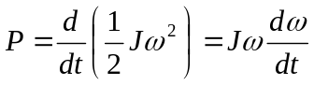
When an electric retarding brake, in the form of a resistance across the armature terminals, is applied, the kinetic energy of the armature has to supply the electric power to the resistor besides its own rotational losses.
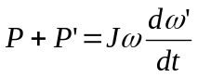
where 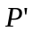is the power dissipated in resistance, 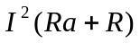, I being the operating current through the breaking resistance R. Ra is the armature resistance. 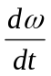 (without breaking resistance) and 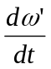(with breaking resistance) can be obtained by plotting the voltage across the armature terminals versus time.
Procedure:

Make the connections as shown in figure for measurement of resistance and inductance. Field is also excited in impedance measurement.

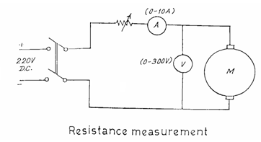
Measurement of Electrical parameters:

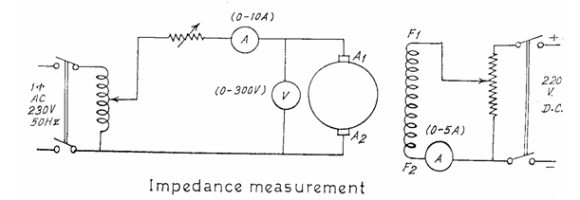

Table 1. Measurement of Armature Resistance

V (volts) | I (amps) | Ra Ohms

Table 2. Measurement of Armature Impedance

V (volts) | I (amps) | Z ohms
Measurement of Mechanical parameters:
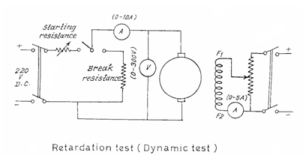
In the retardation test, before the start increase the starting resistance to maximum value. After the start, gradually decrease the resistance. Adjust the speed to rated value. The field current is kept same as in impedance measurement test. Cut off the power supply. Note the voltage across the armature as a function of time as in Table 3.
For braking test, increase the value of starting resistance to maximum. As it picks up speed, decrease the resistance. After bringing up the speed to rated speed, move the switch to braking resistance. Note the voltage across the armature as a function of time as in Table 3.
Table 3: Variation of armature voltage vs time
Sl.  No. | Without breaking resistance |  | With breaking resistance
Sl.  No. | Time | Voltage | Time | Voltage

- Determination of Electrical Parameters

Resistance Measurement:

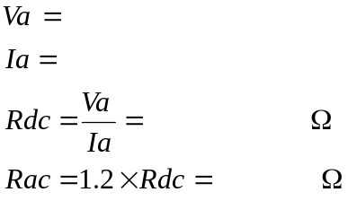

Inductance Measurement:

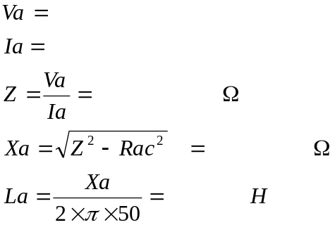

- Determination of Mechanical Parameters (Jm and fm)

Retardation test:

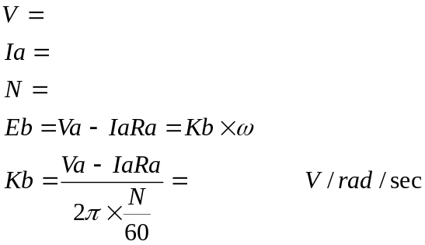

From the graph (without braking)

Slope of voltage decay 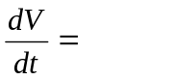
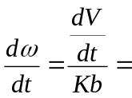

From the graph (with braking)
Slope of voltage decay 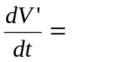
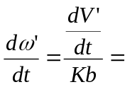

Without braking, 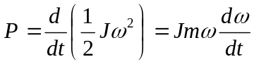
With braking, 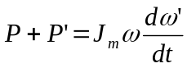
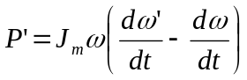 where 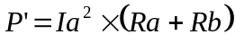
Braking Resistance 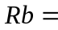
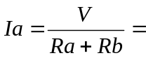
=
Moment of inertia 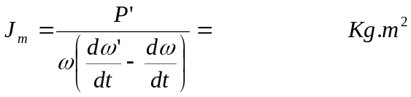

Without braking torque = 0, then viscous friction coefficient fm is
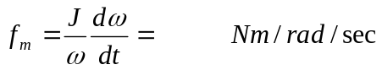

Electrical time constant = 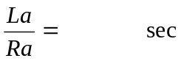
Mechanical time constant = 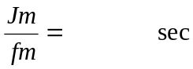
Result:

Electrical and mechanical time constants are determined as ..

