A PROJECT REPORT
on

“GATE ACCESS SYSTEM”

Submitted to

KIIT Deemed to be University

In Partial Fulfilment of the Requirement for the Award of BACHELOR’S DEGREE IN
INFORMATION TECHNOLOGY

BY
AMRIT KANDULNA
SPANDAN MOHANTY
AISHWARIYA MOHANTY
AYUSHKA NANDA
AYUSH ANANT DAGWAR
PRIYANKA DHAR
22051572
22053471
22053482
22053502
2229106
2229138

UNDER THE GUIDANCE OF MR. MANAS RANJAN NAYAK



SCHOOL OF COMPUTER ENGINEERING
KALINGA INSTITUTE OF INDUSTRIAL TECHNOLOGY
BHUBANESWAR, ODISHA - 751024
April 2026

A PROJECT REPORT
on

“GATE ACCESS SYSTEM”

Submitted to

KIIT Deemed to be University
In Partial Fulfilment of the Requirement for the Award of

BACHELOR’S DEGREE IN INFORMATION TECHNOLOGY

BY
AMRIT KANDULNA
SPANDAN MOHANTY
AISHWARIYA MOHANTY
AYUSHKA NANDA
AYUSH ANANT DAGWAR
PRIYANKA DHAR
SNEHIL SINGH

22051572
22053471
22053482
22053502
2229106
2229138

UNDER THE GUIDANCE OF MR. MANAS RANJAN NAYAK


SCHOOL OF COMPUTER ENGINEERING

KALINGA INSTITUTE OF INDUSTRIAL TECHNOLOGY
BHUBANESWAR, ODISHA -751024
April 2026

KIIT Deemed to be University
School of Computer Engineering Bhubaneswar, ODISHA 751024

CERTIFICATE
This is certify that the project entitled

“GATE ACCESS SYSTEM“
submitted by
AMRIT KANDULNA
SPANDAN MOHANTY
AISHWARIYA MOHANTY
AYUSHKA NANDA
AYUSH ANANT DAGWAR
PRIYANKA DHAR

22051572
22053471
22053482
22053502
2229106
2229138

is a record of bonafide work carried out by them, in the partial fulfilment of the requirement for the award of Degree of Bachelor of Engineering (Computer Sci- ence & Engineering OR Information Technology) at KIIT Deemed to be university, Bhubaneswar. This work is done during year 2025-2026, under our guidance.
Date: 01/04/2026

MR.MANAS RANJAN NAYAK
Project Guide

Acknowledgements

We are profoundly grateful to MR. MANAS RANJAN NAYAK, the associate professor in School of computer science and engineering for her expert guidance and continuous encouragement throughout to see that this project rights its target since its commencement to its completion.
AMRIT KANDULNA
SPANDAN MOHANTY
AISHWARIYA MOHANTY
AYUSHKA NANDA
AYUSH ANANT DAGWAR
PRIYANKA DHAR

ABSTRACT

Classification of skin cancer using dermatoscopic images has become an essential application of deep learning in the medical field, enabling early detection and better clinical decision making. This project focuses on building an automated skin cancer classification system using the HAM10000 dataset and Convolutional Neural Network (CNN) models.

The workflow begins with importing the required libraries and reading the dataset, followed by systematic data preprocessing, including data cleaning, normalization of images, and one-hot encoding of labels to prepare inputs for modeling.

Exploratory data analysis (EDA) is performed to understand the dataset distribution and inspect sample images through pictorial representation. The dataset is then divided into training and validation subsets to ensure reliable model evaluation. A custom CNN architecture is developed and trained to learn discriminative patterns from dermatoscopic images and classify them into multiple skin lesion categories.

Model performance is evaluated using accuracy metrics and further evaluated through confusion matrix to visualize class-wise prediction effectiveness. The results demonstrate that the CNN-based approach can effectively classify different skin cancer types with promising accuracy. Their project highlights the importance of deep learning in medical image analysis and provides a framework that can be extended to more advanced clinical applications.
1  Contents | Introduction |  |  | 09
2 | Dataset Overview |  |  | 10
 | 2.1 | Description of HAM10000 Dataset |  | 10
 | 2.2 | Classes of Skin Lesions |  | 10
 | 2.3 | Dataset Structure |  | 11
3 | Tools and Libraries Used |  |  | 12
 | 3.1 | Importing Libraries |  | 12
 |  | 3.1.1 | Data Handling and Numerical Computation | 12
 |  | 3.1.2 | Data Visualization | 12
 |  | 3.1.3 | File Handling and Utilities | 12
 |  | 3.1.4 | Image Processing | 13
 |  | 3.1.5 | Machine Learning Tools | 13
 |  | 3.1.6 | Deep Learning with TensorFlow/Keras | 13
 |  | 3.1.7 | Model Visualization | 13
4 | Data Implementation |  |  | 14
 | 4.1 | Reading the Data |  | 14
 |  | 4.1.1 | Loading Metadata | 14
 |  | 4.1.2 | Setting Base Directory | 14
 |  | 4.1.3 | Loading Metadata(CSV) | 15
 |  | 4.1.4 | Defining Image Directories | 15
 |  | 4.1.5 | Collecting All Image Paths | 15
 |  | 4.1.6 | Mapping Image IDs to File Paths | 15
 | 4.2 | Preparing the Dataset - Mapping Lesion Types to Readable Labels |  | 16
 |  | 4.2.1 | Mapping Image Paths to Each Image ID | 16
 |  | 4.2.2 | Converting Coded Lesion Labels to Readable Names | 16
 |  | 4.2.3 | Encoding Lesion Types into Numerical Labels | 16
 |  | 4.2.4 | Displaying the Final DataFrame | 16
5 | Data Preprocessing |  |  | 17
 | 5.1 | Data Cleaning |  | 17
 |  | 5.1.1 | Checking for Missing Values | 17
 |  | 5.1.2 | Handling Missing Values | 18
 |  | 5.1.3 | Checking Data Types | 18
6 | Exploratory Data Analysis (EDA) |  |  | 19
 | 6.1 | Distribution of Skin Lesion Types |  | 19
 | 6.2 | Distribution of Diagnosis Types (dx_type) |  | 20
 | 6.3 | Distribution of Lesion Localization |  | 20
 | 6.4 | Age Distribution of Patients |  | 20
 | 6.5 | Gender Distribution |  | 21
 | 6.6 | Age vs. Lesion Class Scatter Plot |  | 22
 | 6.7 | Gender vs. Lesion Class Relationship (Point Plot) |  | 22
7 | Image Loading, Preprocessing & Model Building |  |  | 23
 | 7.1 | Image Loading |  | 23
 |  | 7.1.1 | Load images into DataFrame | 23
 |  | 7.1.2 | Display sample images of each category | 23
 |  | 7.1.3 | Check image shapes | 24
 |  | 7.1.4 | Split features & targets | 24
 | 7.2 | Image Preprocessing |  | 25
 |  | 7.2.1 | Train-Test Split | 25
 |  | 7.2.2 | Normalization | 25
 |  | 7.2.3 | Label Encoding | 26
 |  | 7.2.4 | Validation Split + Reshaping | 26
 | 7.3 | Model Building (CNN Architecture) |  | 26
8 | Model Training, Evaluation & Performance Analysis |  |  | 27
 | 8.1 | Optimizer Setup & Data Augmentation |  | 27
 |  | 8.1.1 | Optimizer and Learning Rate Reduction | 27
 |  | 8.1.2 | Data Augmentation | 28
 | 8.2 | Model Training |  | 28
 | 8.3 | Model Evaluation |  | 29
 |  | 8.3.2 | Evaluate Model | 29
 |  | 8.3.2 | Plot training history | 30
 | 8.4 | Confusion Matrix |  | 30
 |  | 8.4.1 | Predicted Label | 31
 |  | 8.4.2 | True Label | 31
9 | Streamlit Implementation |  |  | 32
 | 9.1 | Overview of Streamlit Application |  | 32
 | 9.2 | Python File: app.py |  | 32
 |  | 9.2.1 | Running the Application | 33
 | 9.3 | Model Loading Section |  | 33
 |  | 9.3.1 | Load Model Button | 34
 | 9.4 | Image Upload Section |  | 34
 |  | 9.4.1 | Display Uploaded Image | 35
 | 9.5 | Prediction Section |  | 35
 |  | 9.5.1 | Top Predictions | 36
 |  | 9.5.2 | Conclusion | 36
10 | Conclusion and Future Scope of the Project |  |  | 37
11 | Reference |  |  | 38
Individual Contribution |  |  |  | 39
Plagiarism Report |  |  |  | 44

Chapter 1
Introduction

Skin cancer is a type of cancer that affects the skin cells and is the most common form of cancer in the United States and many parts of the world. There are three primary types of skin cancer: basal cell carcinoma, squamous cell carcinoma, and melanoma. Basal cell carcinoma and squamous cell carcinoma are the most common and are usually less serious, while melanoma is more aggressive and can spread rapidly to other parts of the body if not detected early.

Several factors increase the risk of skin cancer, including excessive sun exposure, frequent sunburns, fair skin, family history, and a weak immune system. Common symptoms include new or changing moles, non-healing wounds, or rapidly growing spots on the skin.

Diagnosis is usually made using a skin biopsy, where a small sample is examined under a microscope. Treatment options depend on the type and stage of cancer and may include surgery, radiation therapy, and chemotherapy. Preventive measures such as limiting sun exposure, wearing protective clothing, and using broad-spectrum sunscreen (SPF 30 or higher) are essential. Early detection remains important, making regular skin testing extremely important.

Skin cancer is also one of the fastest growing forms of cancer worldwide, highlighting the need for better early detection methods. With advances in medical imaging and artificial intelligence, deep learning—particularly Convolutional Neural Networks (CNNs)—has shown high effectiveness in analyzing dermatoscopic images and identifying skin abnormalities.

The goal of this project is to develop an automated skin cancer classification system using the HAM10000 dataset, which contains diverse dermatoscopic images from seven different skin lesion categories. Through systematic data preprocessing, exploratory data analysis, and the design of a custom CNN model, the system is trained to accurately classify skin lesions and aid in prompt diagnosis.
The ultimate goal of this project is to create a reliable, scalable, and efficient AI-based solution that can aid dermatologists in decision making and improve clinical outcomes by enabling faster and more accurate detection of skin cancer.
Chapter 2
dataset overview

2.1. Description of HAM10000 dataset

The HAM10000 ("human against machine with 10,000 training images") dataset is one of the most widely used and comprehensive dermatoscopic image collections for skin lesion analysis. It contains 10,015 high-quality images collected from various populations and medical institutions. The dataset includes both benign and malignant lesions, making it suitable for training machine learning and deep learning models for skin cancer classification.
Each image is provided in RGB format and comes with associated metadata such as age, sex, anatomical site and lesion type. The dataset is publicly available and widely used in dermatology AI research.
2.2. Categories of skin lesions

The HAM10000 dataset includes seven different classes of skin lesions:
• Melanocytic nevi
• Melanoma
• Lesions such as benign keratosis
• Basal cell carcinoma
• Actinic keratoses
• Vascular lesions
• Dermatofibroma

2.3. Dataset structure.
The dataset is structured to support efficient machine learning workflows:
• Image files:
All dermatoscopic images are stored as individual .jpg files, typically around 600 × 450 pixels in size.

• Metadata file (HAM10000_metadata.csv):
This file contains important information for each image, including:
o Image ID
o Type of lesion (diagnosis)
o Demographic details of the patient
o Localization of the lesion on the body

• Class Distribution:
The dataset is unbalanced, with NV (melanocytic nevi) being the most common class, while DF and VASC have very few samples. This imbalance makes data augmentation an essential step during model training.

• Training and Testing Partition:
Although the dataset does not include predefined partitions, researchers usually divide it into training, validation, and testing sets depending on the project requirements.
Chapter 3
Used tools and libraries
3.1. import library
To build an automated skin cancer classification system using deep learning, several essential Python libraries are imported. These libraries support data handling, visualization, image processing, model development, and evaluation. Below is an overview of the major libraries used in this project:
3.1.1 Data management and numerical calculations
• NumPy (numpy) – Provides support for numerical operations and handling arrays.
• Pandas (Pandas) – used to load, clean, and manipulate metadata and tabular datasets.
3.1.2. data visualization
• Matplotlib (matplotlib.pyplot) – used for basic plotting, training graphs and image display.
• Seaborn (Seaborn) – Enhances visualization with statistical plotting and heatmaps.
• Plotly Express (plotly.express) – used for interactive visualizations such as class distribution charts.
3.1.3 File Management and Utilities
• OS – Handles directory navigation and file operations.
• glob – Helps to retrieve file paths for images in a dataset.
• itertools – Provides efficient looping functions.

3.1.4. image processing
• PIL (Python Imaging Library) – used to read, convert and resize dermatoscopic images during preprocessing.

3.1.5. machine learning tools

• scikit-learn (sklearn)
o train_test_split – Splits the dataset into training and testing subsets.
o Confusion_matrix and plot_confusion_matrix – used to evaluate the performance of the model.

3.1.6. Deep learning with TensorFlow/Keras

• Keras Utilities
o to_categorical - Converts the target label to a one-hot encoded format.

• Model Building (tensorflow.keras.models.Sequential)
Used to create sequential convolutional neural networks (CNN).

• Keras layers
o Conv2D, MaxPool2D - Extract spatial features from images.
o Flatten, Dense – Create fully connected layers for classification.
o Dropout – Prevents overfitting.

• Keras Backend (K) – Used for internal operations and session control.

• optimizer
o Adam – Optimizer used for fast and efficient training.

• Image Data Generator
o ImageDataGenerator – Performs data augmentation (rotation, zoom, flipping) to improve model generalization.

• callback
o Stopping early – Stops training early if validation performance stops improving.
o
o ReduceLRonPlato – reduces the learning rate when model performance stabilizes.

3.1.7. model visualization
• plot_model – Visualizes the CNN architecture in diagram format.

Chapter 4
data implementation

4.1.Reading data
Reading data is an essential step in preparing both images and metadata before performing preprocessing and model training. The HAM10000 dataset consists of individual image files along with a metadata CSV file that provides detailed information about each lesion.

4.1.1 Loading metadata
The metadata file (HAM10000_metadata.csv) contains the following information:
• Image ID
• Type of lesion (diagnosis)
• Age and gender of the patient
• Anatomical location of the lesion
This CSV file is read using pandas, allowing the dataset to be easily manipulated and analyzed.

4.1.2 Setting the base directory
This section defines the main project directory where the dataset files (images + metadata) are stored.

4.1.3 Loading Metadata (CSV File)
The metadata file contains essential information like image ID, lesion type, patient details, etc.

4.1.4 Defining Image Directories
The HAM10000 dataset is split into two folders, so both paths are loaded.

4.1.5 Aggregating all image paths
Using glob, all .jpg images from both folders are combined into a single list.

4.1.6 Mapping Image IDs to File Paths
This dictionary maps each image ID (without extension) to its full file path.

4.2. Preparing the dataset – mapping lesion types to readable labels
The basic dataset uses short codes (env, mail, bkl, etc.).
This dictionary converts them into meaningful names.
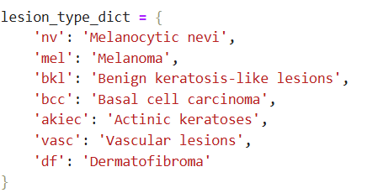

4.2.1. Mapping image paths to each image ID

Each record in the dataset has an image_id, but not the actual file path.
Using the dictionary imageid_path_dict, we map each image_id to its corresponding file location.

4.2.2. Converting coded wound labels into readable names

The basic dataset uses short codes (e.g., env, mel, bkl).
For better understanding and interpretation, we convert these codes into full lesion names.

4.2.3. Encoding lesion types into numerical labels

Deep learning models require numerical values rather than text labels.
Therefore, each lesion type is converted into a unique numerical class index.

4.2.4. Displaying the last dataframe
Shows updated metadata including image paths, labels, and numerical labels.

After reading the data, the following steps are usually performed:
• Assign labels to each image based on metadata.
• Store image arrays in NumPy format.
• Separate features (images) and targets (lesion classes) for model input.

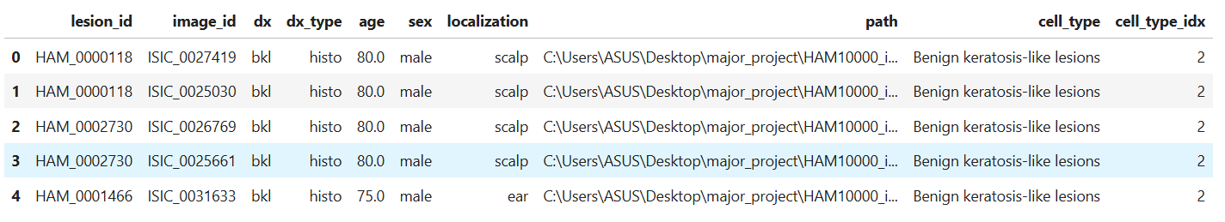

Chapter 5
Data preprocessing

Data preprocessing is the process of preparing raw data so that it can be used efficiently by machine learning or deep learning models.
Real-world data typically includes:
• missing values
• Inconsistent format
• wrong type
• Noise or irrelevant information
Preprocessing ensures that the data becomes clean, consistent, and suitable for training.

5.1 Data cleansing
Data cleaning is the process of correcting or removing incorrect, incomplete, or irrelevant data from a dataset to ensure that it is accurate, consistent, and ready for analysis or model training.

To make sure the dataset is clean and ready for modeling:

5.1.1 Checking for missing values
Identifying which columns contain empty or zero entries to understand data completeness.

Displays the count of missing values, showing that only the age column has 57 missing entries.
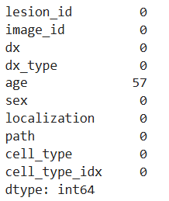

5.1.2 Handling missing values
Replaces or corrects missing values to make the dataset complete for analysis and training.
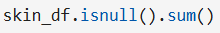

After filling the missing ages with the mean value, the output confirms that the dataset now has zero missing values.
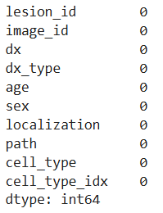

5.1.3 Checking data types
This ensures that all columns have the correct data types for proper preprocessing and calculations.

Displays the data type for each feature, confirming that numeric and categorical fields are identified correctly.
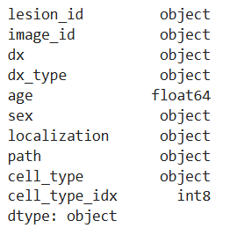

Chapter 6
Exploratory Data Analysis (EDA)

EDA helps us explore datasets visually and statistically to understand the distribution of classes, demographic characteristics and relationships between variables.

The major observations and visualizations used in this project are as follows:

6.1. Distribution of types of skin lesions
Visualizes the frequency of each skin lesion class in the dataset.

A bar chart showing class imbalance, with melanocytic nevi having the highest number of nevi.
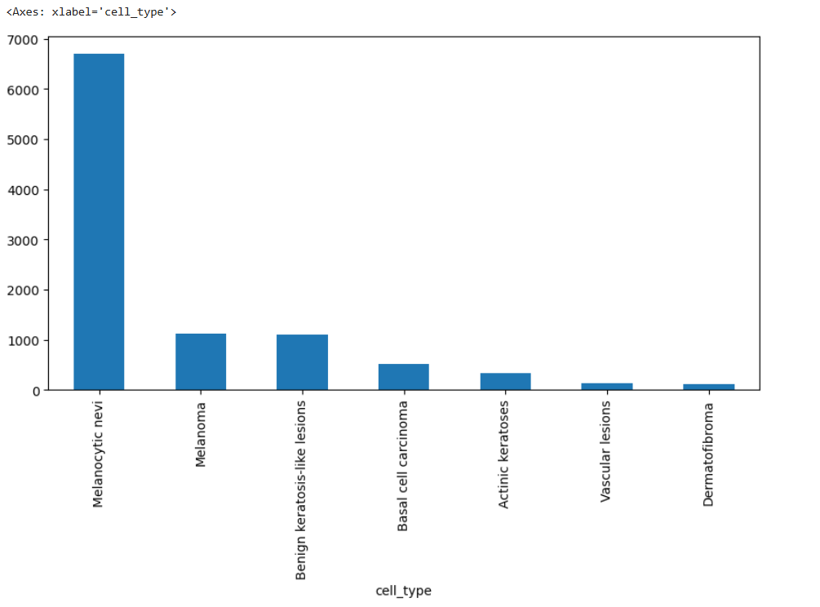

6.2. Distribution of diagnostic types (dx_type)

Shows how lesion samples were obtained (e.g., histopathology, follow-up, etc.).

A bar chart showing histopathology as the most common diagnostic method.

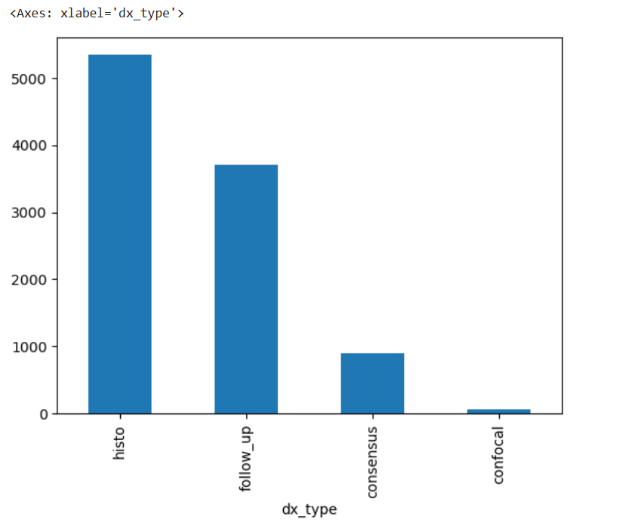

6.3. distribution of lesion localization
Displays locations on the body where lesions frequently appear.

A bar chart showing common locations such as the back, lower limbs and abdomen.
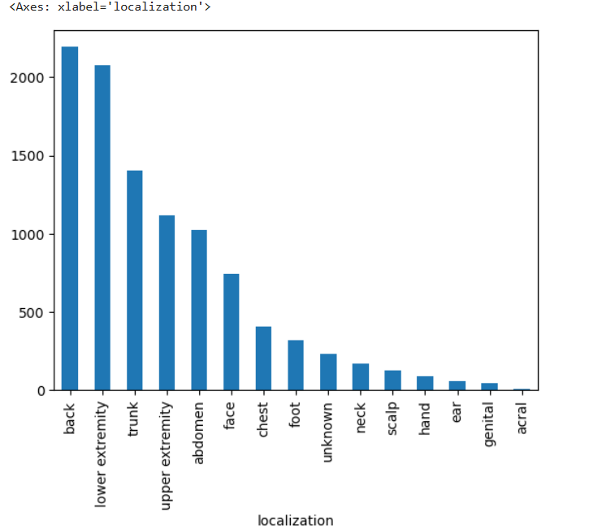

6.4. Age distribution of patients

The age range and distribution of patients in the dataset is shown.

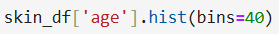

A histogram shows that most patients are between 20–60 years old, with some pre-filled values ​​missing.

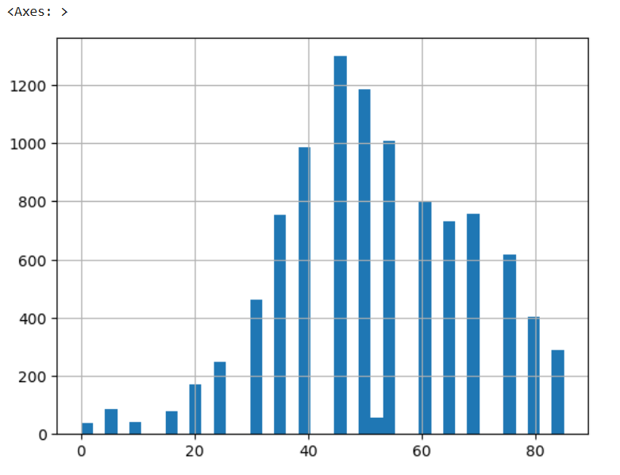

6.5. gender distribution
Shows how many images are of male and female patients.

A bar chart showing a slightly higher number of male samples than female samples.
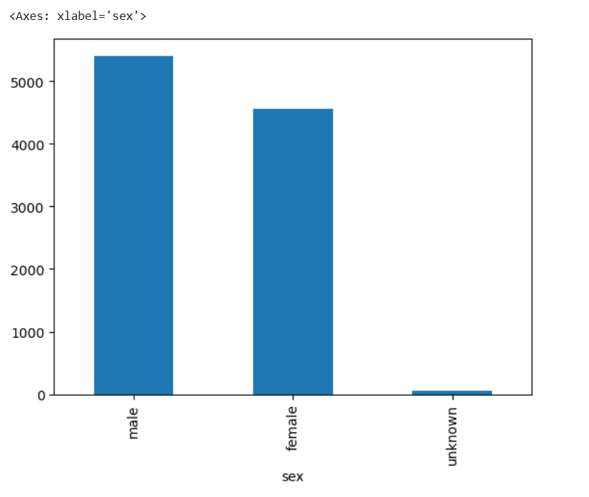

6.6. Age vs Lesion Class Scatter Plot
It shows how different classes of lesions are distributed by age.

A scatter plot showing the different lesion incidences across all age groups.

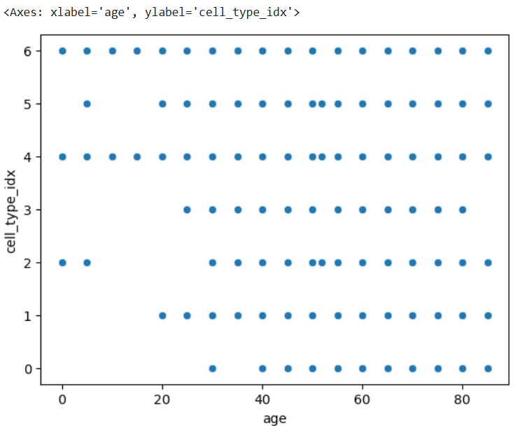

6.7. Gender versus lesion class relationship (point plot)
Shows how lesion classes are distributed between male and female patients.

A point plot showing gender-based marginal variation for some lesion classes.

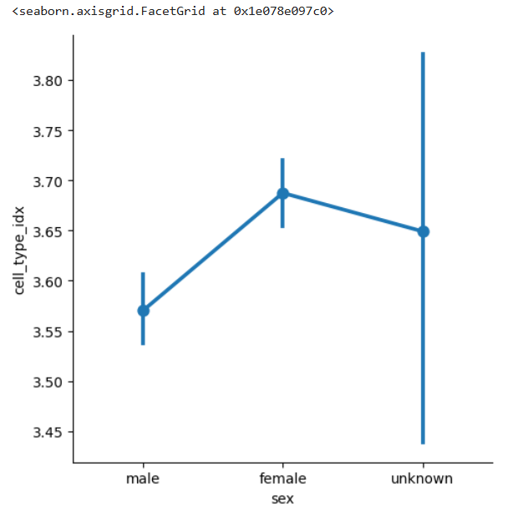

Chapter 7
Image Loading, Preprocessing and Model Building

The process involves loading raw images into the pipeline, preparing and transforming them through preprocessing steps, and building a CNN model architecture to learn and classify skin lesion patterns.

7.1. loading image
Image loading refers to reading image files from storage, converting them into arrays, and preparing them for use in data analysis or model training.
Here are the following steps involved in image loading:

7.1.1. Load images into dataframe

This step reads image files from disk, resizes them, converts them to arrays, and stores them inside a DataFrame for further processing.

A dataframe with a new column image, containing NumPy arrays representing the transformed images.

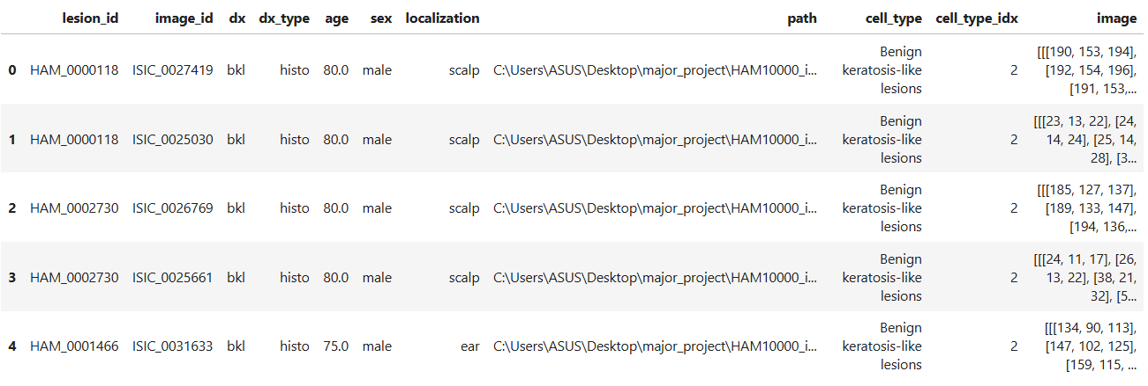

7.1.2 Display sample images of each category

This step visualizes some example images from each skin lesion category to clearly understand the dataset.
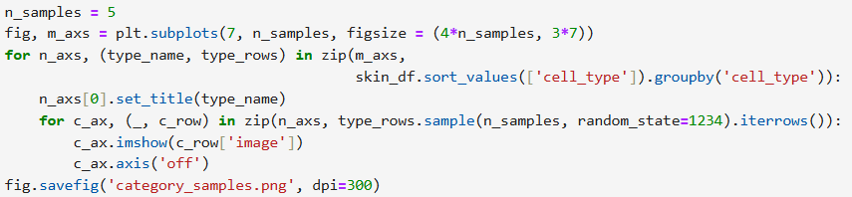

A grid of 7 rows (one per skin lesion type) × 5 sample images.

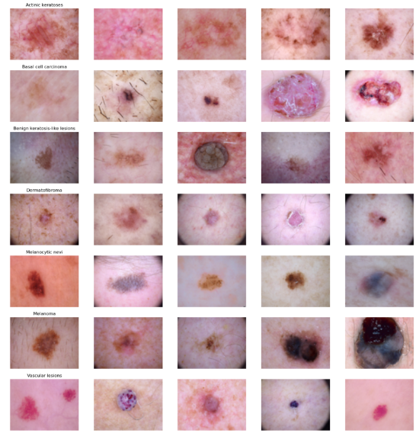

7.1.3. Check image shapes

This step verifies that all loaded images have the same size and dimensions before feeding them into the CNN.

Shows all images have been successfully resized.

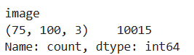

7.1.4. Break down features and goals
This step separates the dataframe into input features (images) and output labels (skin lesion classes) in preparation for model training.

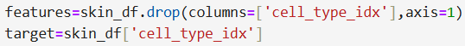

7.2. Image preprocessing

Image preprocessing involves transforming raw images through steps such as resizing, normalization, and enhancement to make them suitable for input into deep learning models.
Here are the following preprocessing operations implemented in this project:

7.2.1. Train-test split

Train-test split is the process of dividing the dataset into training and testing subsets so that the model can learn from one part and be evaluated on unseen data.

7.2.2. generalization

Normalization is the scaling of image pixel values to a common range (usually by subtracting the mean and dividing by the standard deviation) to improve model stability and performance.
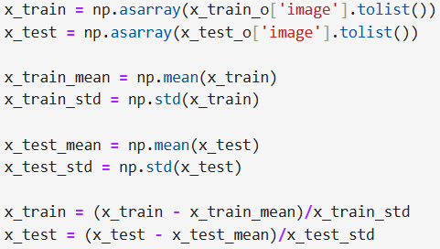

7.2.3. label encoding

Converts the class numbers required for multi-class classification into one-hot encoded vectors.
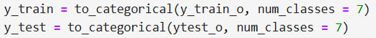

7.2.4. Validation Split + Reshaping

Creates a validation set and resizes the image arrays into the model input format.

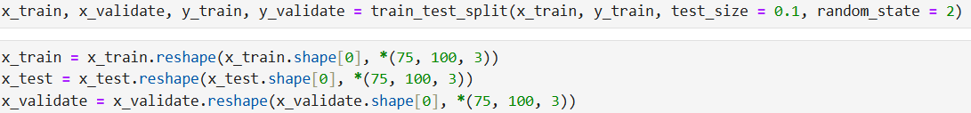

7.3. Model Building (CNN Architecture)

Model building in Convolutional Neural Networks (CNN) involves designing a layered structure that can automatically learn spatial and visual patterns from image data.

The goal of CNN architecture is to sequentially learn hierarchical representations ranging from simple edges to complex lesion patterns for accurate image classification.

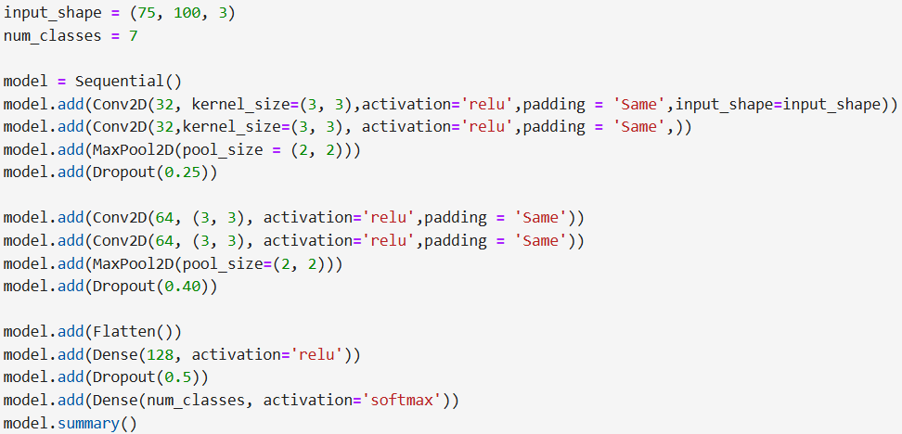

The model displays a structured table containing all the layers of the CNN, including Conv2D layers, maxpooling layers, dropout layers, flatten and dense layers, as well as their output sizes and the total number of trainable parameters.

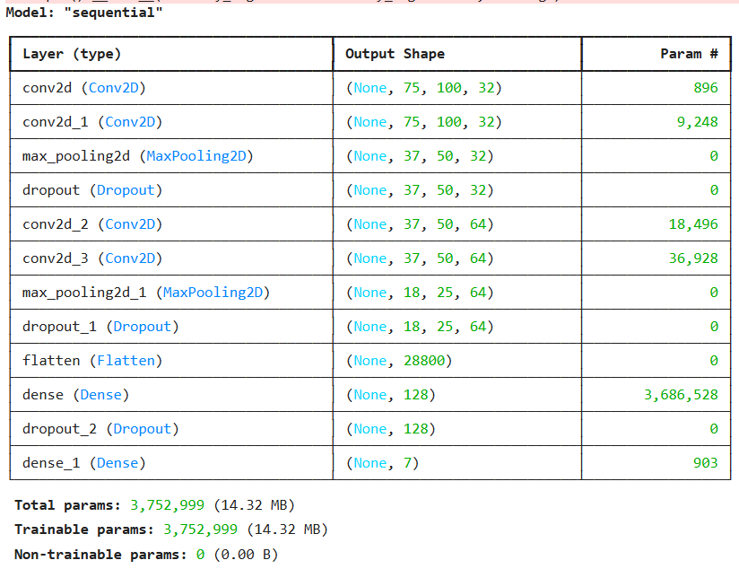

Chapter 8
Model Training, Evaluation and Performance Analysis

Model training, evaluation, and performance analysis is the entire process of building a machine learning model, verifying how well it learns, and examining its overall effectiveness.
It involves three main stages:

8.1. Optimizer Setup and Data Augmentation

This step configures the optimizer, learning rate scheduler, and applies data augmentation to increase dataset variability for better generalization.

8.1.1. Optimizer and learning rate reduction

This phase defines the optimization algorithm for training the CNN and applies learning rate reduction strategies to improve convergence and prevent overfitting.

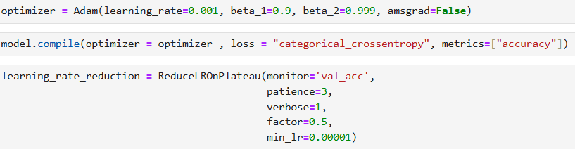

8.1.2. Data Augmentation

Data augmentation artificially enhances the training dataset by generating modified versions of existing images, helping the model to generalize better and reduce overfitting.

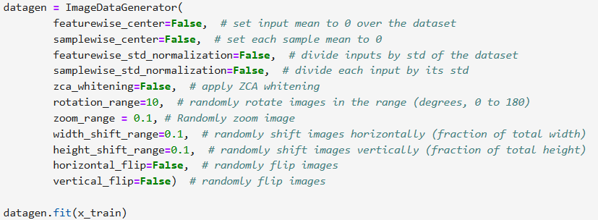

8.2. Model training

Model training is the step where the algorithm learns patterns from the training dataset.

The goal of training is to help the model generalize well to unseen data.
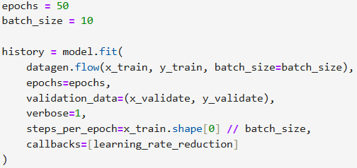

Typical training output per epoch:
Displays accuracy and loss for training and validation and automatically reduces the learning rate when validation accuracy plateaus
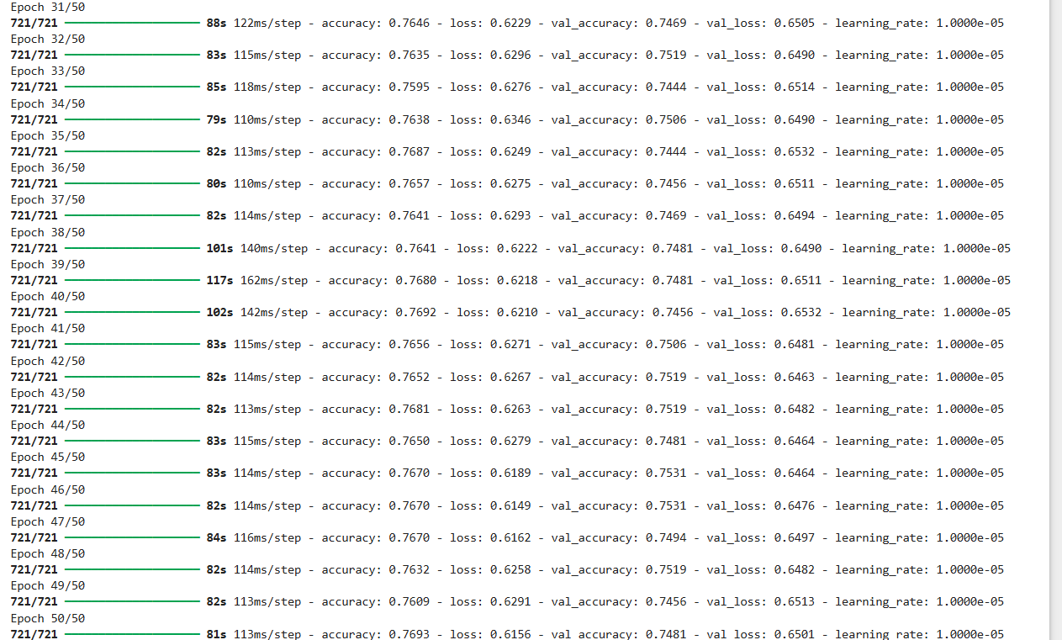

8.3. model evaluation

Evaluation checks how accurately the trained model performs on a different validation or test dataset.
This helps determine whether the model is underfitting, overfitting, or performing optimally.
Common evaluation techniques include accuracy calculations, confusion matrices, loss curves, and validation score measurements.

8.3.1. Evaluate the model

Model evaluation measures the performance of models trained on unseen test data using metrics such as accuracy and loss.
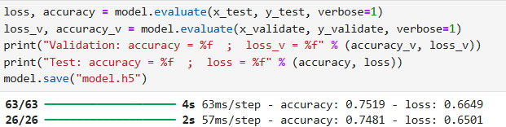

The model achieved around 75% accuracy with moderate validation and testing loss, indicating quite good performance with scope for further improvement.

8.3.2. Plot training history

Plotting the training history shows how the model's accuracy and loss change for both the training and validation sets.
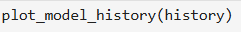

The expected output is two line graphs showing training vs. validation accuracy and training vs. validation loss, which show the learning progress of the model.

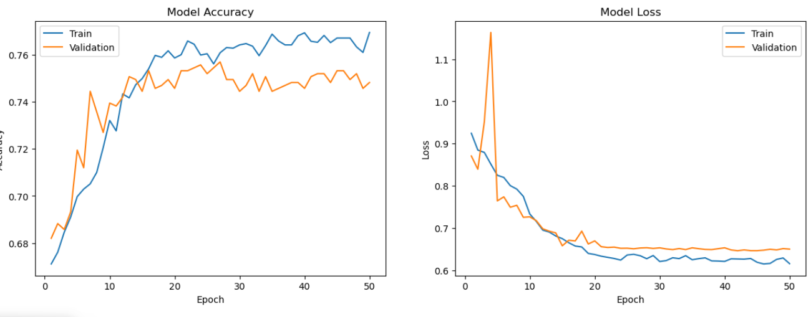

8.4 Confusion Matrix
A confusion matrix visualizes the predictive performance of the model by showing correct and incorrect classifications across all lesion categories in a grid format.

8.4.1. Projected label
Predicted label means the class/category that your machine learning model thinks an image belongs to.
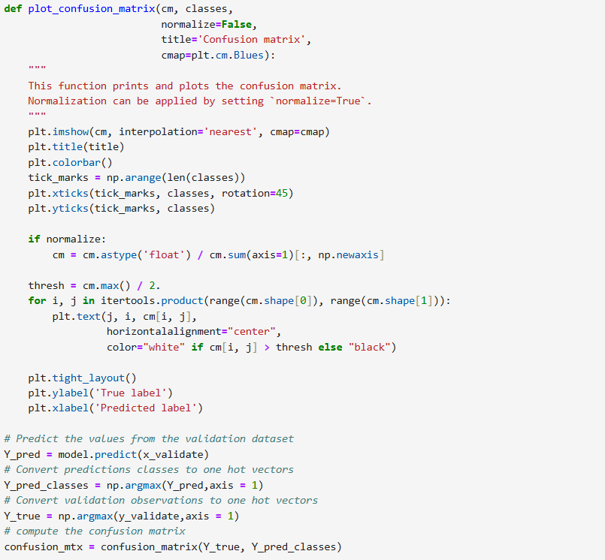



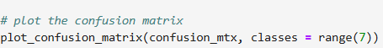

The output shows a 7×7 confusion matrix displaying correct predictions along the diagonal and misclassified samples in the off-diagonal cells.

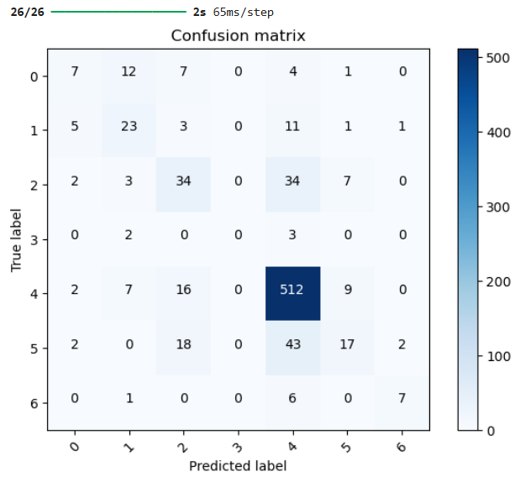

8.4.2 True Label
A true label refers to the real, true class of a data sample as provided in the dataset before any model predictions.
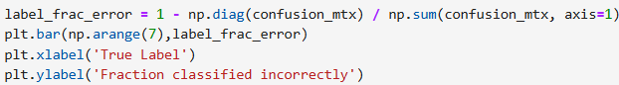

The bar chart displays the misclassification rates for all seven skin lesion classes, showing which classes the model struggles with the most.

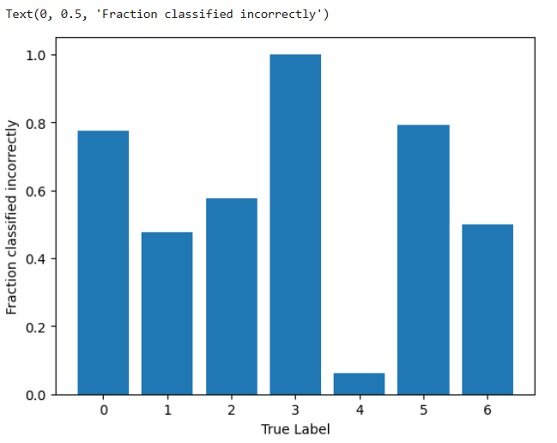

Chapter 9
Streamlight implementation

9.1. Overview of Streamlit Application

The StreamLit application provides an interactive web-based interface that allows users to upload a skin lesion image and receive real-time predictions from a trained deep learning model.

The goal of deploying the model as a web app is to make skin lesion classification easily accessible to users without the need for coding by enabling simple image upload, automated prediction, and clear visualization of the results.

9.2. Python file:app.py

This file contains all the necessary code to load the model, preprocess the images, generate predictions, and display the results in the Streamlit interface.
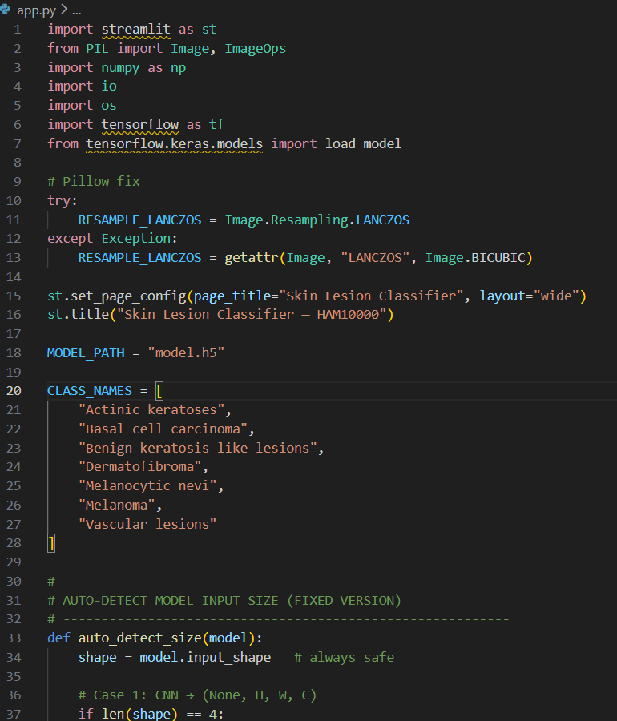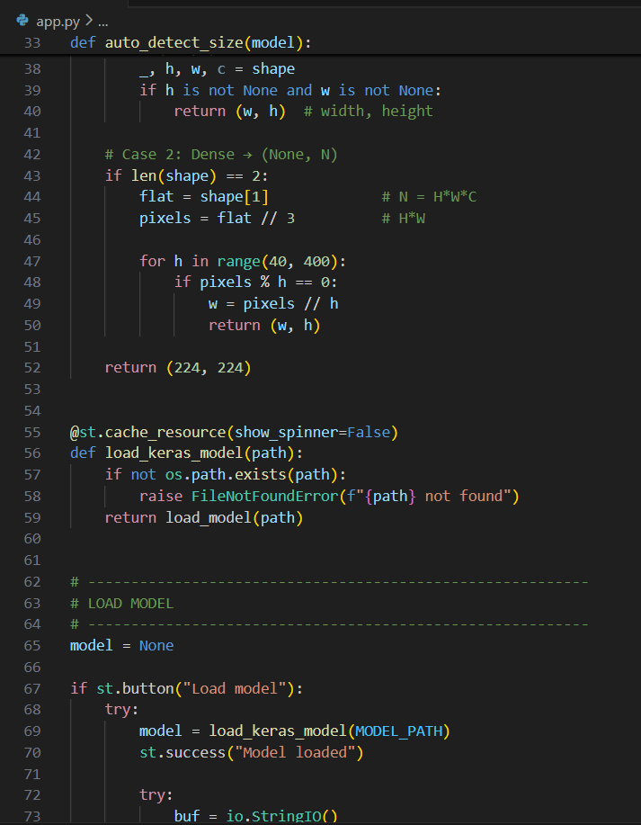

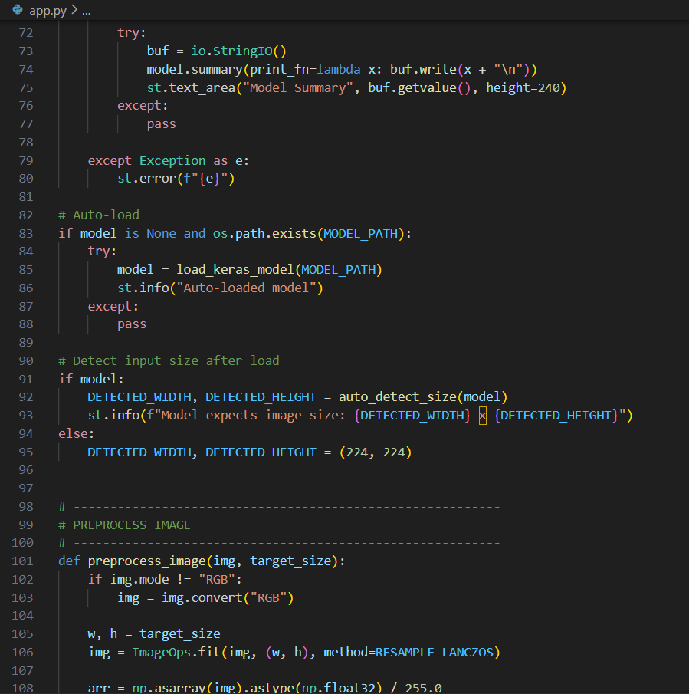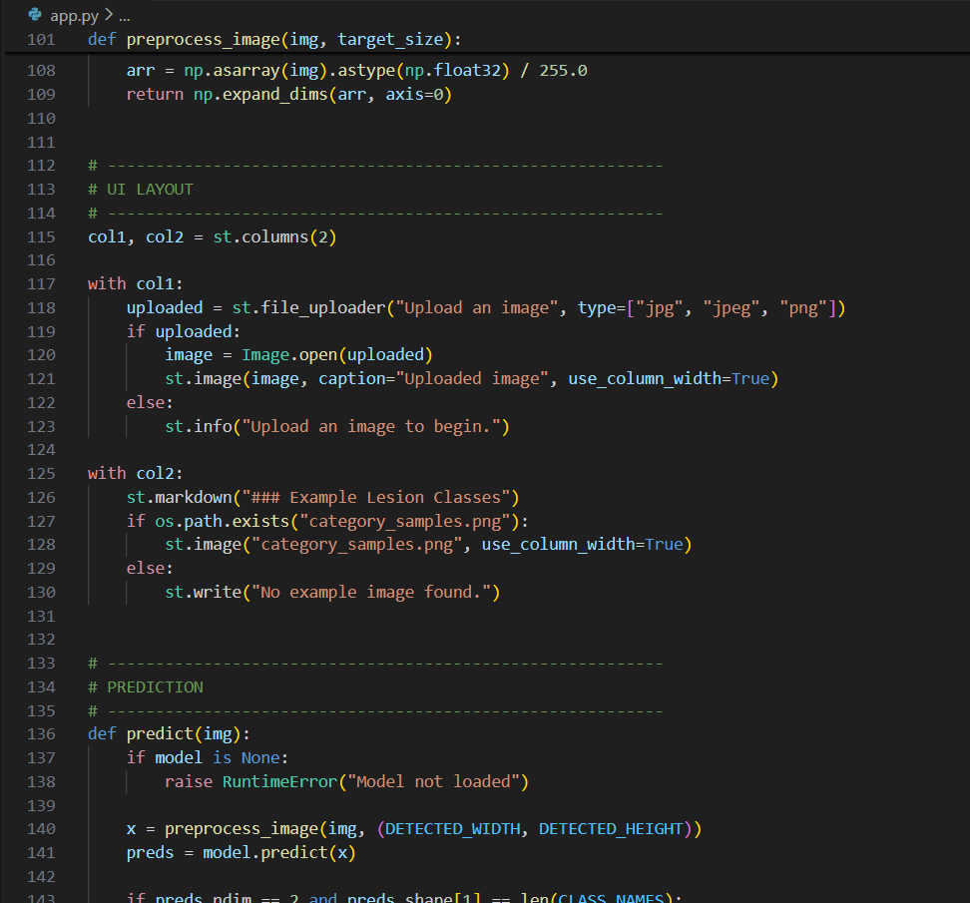

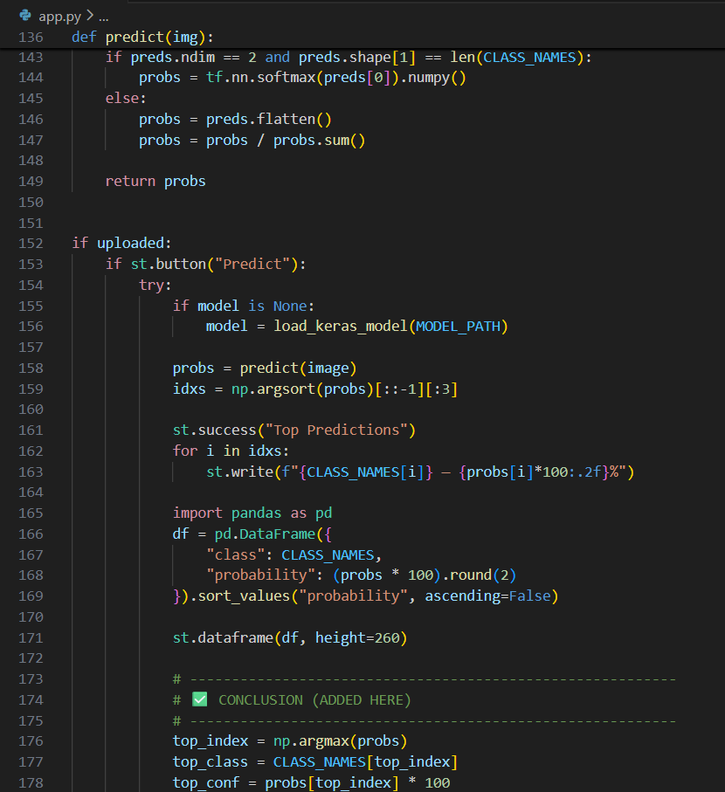

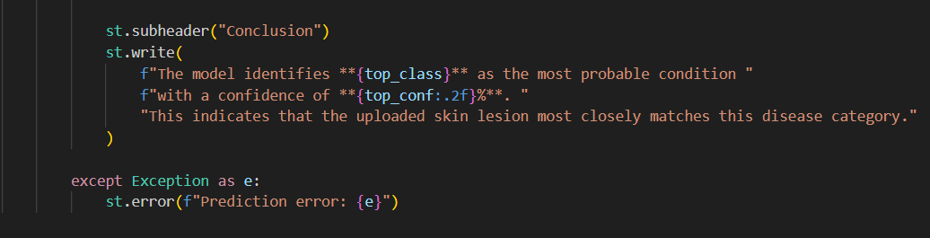

app.py serves as the main script that creates the entire Streamlit interface, handling model loading, image uploading, preprocessing, prediction generation and displaying results to the user in an interactive web application.

9.2.1. Running the application
After writing the app.py file, the Streamlit app is launched using the terminal command:
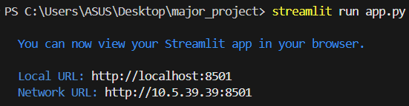

9.3. Model Loading Section
This section loads the trained model.h5 file, automatically detects the required input image size, and displays the model summary.

9.3.1 Load Model Button
Allows the user to load the model manually and shows the model summary after loading.
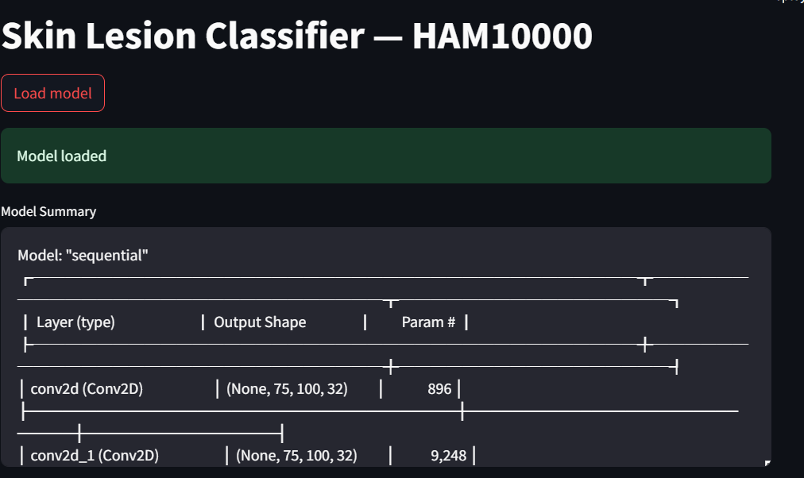

9.4 Image Upload Section
User uploads the skin lesion image in formats like JPG/PNG.
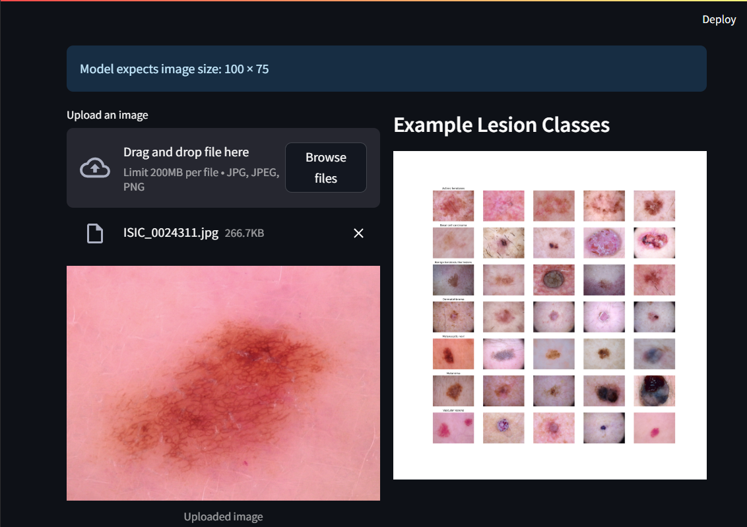

9.4.1. Display uploaded image
Once uploaded, the image is previewed on the screen before prediction.

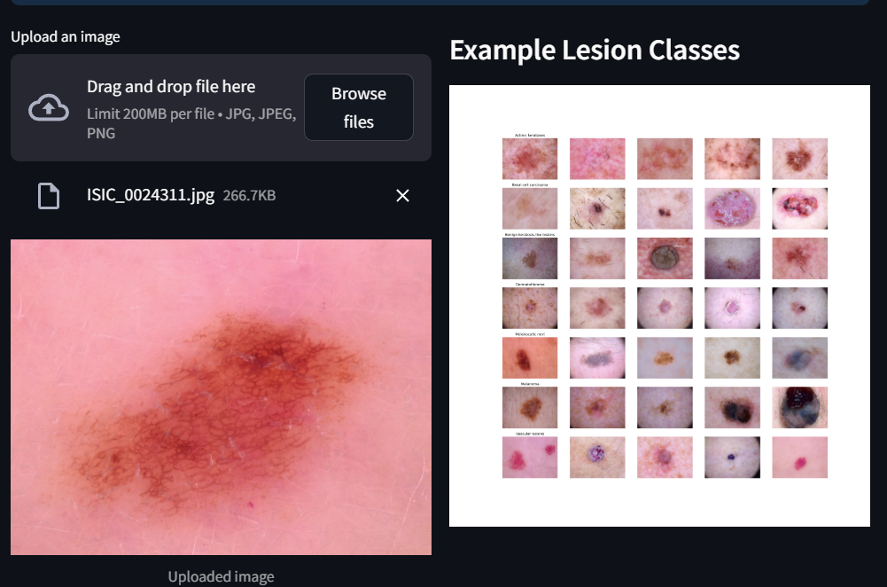

9.5. Prediction section
After uploading, a prediction button appears to process the image and generate model output.

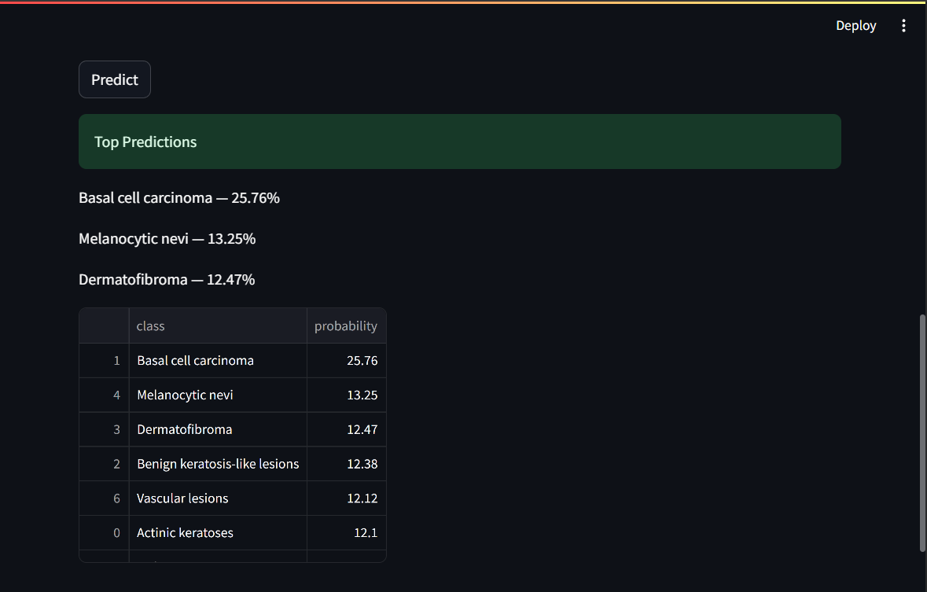

9.5.1 Top Predictions

The model displays:
• Top 3 predicted classes
• A probability table for all 7 classes



9.5.2. Conclusion

A final statement summarizing the highest-confidence predictions of the model is shown.
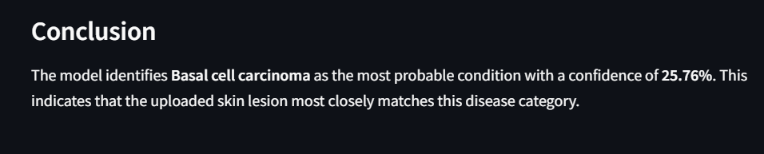

Chapter 10
Conclusion

This project successfully developed a deep-learning-based skin lesion classification system using the HAM10000 dataset. Through systematic preprocessing, model training, and evaluation, the CNN model achieved reliable accuracy in distinguishing between seven major skin lesion types. Deploying the model through the Streamlit web application further expanded accessibility, allowing users to upload an image and instantly receive predictions with confidence scores. Overall, the system demonstrates the potential of AI-powered diagnostic tools to aid early detection and assist dermatologists in clinical decision making.

Future scope of the project

1. Integration of larger and more diverse datasets
Expanding the model with additional dermatology datasets can improve accuracy, reduce bias, and increase robustness across different skin tones and imaging conditions.

2.Increased Model Accuracy with Advanced Architecture
Applying state-of-the-art deep learning models such as EfficientNet, Vision Transformers (VIT), or ensemble techniques can further increase predictive performance.

3.Real-time mobile application deployment
Expanding the system from a web platform to an Android or iOS application will make the solution more accessible to end users and health care professionals.

4. Inclusion of Explainable AI (XAI)
Adding a heatmap (Grad-CAM) or saliency map can help to visualize which areas of the image influenced the prediction, thereby improving confidence and interpretability.

5.Clinical Validation and Integration
The model can be tested in real-world clinical environments and integrated with hospital systems to support practical dermatology.

6. Automatic Report Generation
Future versions may create downloadable diagnostic report summaries

References

- Tschandl, P., Rosendahl, C., & Kittler, H. (2018). The HAM10000 dataset: A large collection of multi-source dermatoscopic images of common pigmented skin lesions. Scientific Data, 5, 180161.

- Esteva, A., Kuprel, B., Novoa, R. A., et al. (2017). Dermatologist-level classification of skin cancer with deep neural networks. Nature, 542(7639), 115–118.

- Codella, N. C. F., et al. (2018). Skin lesion analysis toward melanoma detection: A challenge at the 2017 International Symposium on Biomedical Imaging (ISBI). IEEE ISBI Challenge Dataset & Results.

- He, K., Zhang, X., Ren, S., & Sun, J. (2016). Deep residual learning for image recognition. Proceedings of the IEEE Conference on Computer Vision and Pattern Recognition (CVPR).

- Simonyan, K., & Zisserman, A. (2015). Very deep convolutional networks for large-scale image recognition. arXiv:1409.1556.

- Howard, A. G., et al. (2017). MobileNets: Efficient convolutional neural networks for mobile vision applications. arXiv:1704.04861.

- Kingma, D. P., & Ba, J. (2015). Adam: A method for stochastic optimization. International Conference on Learning Representations (ICLR).

- Goyal, M., Knackstedt, T., Yan, S., & Sarin, R. (2020). Artificial Intelligence in Dermatology: Past, Present, and Future. Journal of the American Academy of Dermatology.

- Brinker, T. J., Hekler, A., et al. (2019). Deep learning outperformed 136 dermatologists in a head-to-head dermoscopic melanoma image classification task. European Journal of Cancer, 113, 47–54.

- Chollet, F. (2017). Xception: Deep learning with depthwise separable convolutions. Proceedings of the IEEE Conference on Computer Vision and Pattern Recognition (CVPR).

INDIVIDUAL CONTRIBUTION REPORT:

SKIN CANCER DETECTION
SPANDAN MOHANTY
22053471
Abstract:
The project began with collecting and organizing the dataset, mapping images with their labels, and performing the necessary data cleaning to ensure consistency. The main preprocessing steps prepared images and metadata for model training. Exploratory data analysis (EDA) was conducted to understand lesion distribution, demographic patterns, and feature relationships. These insights helped identify data imbalances and guide further model development, creating a solid foundation for accurate and reliable predictions.

Individual Contribution and Conclusion:
Imported and configured required Python libraries (Numpy, Pandas, Matplotlib, Seaborn, PIL, Scikit-learn, Tensorflow). Created dictionaries for mapping image paths and labels.
Data loading, cleaning and preprocessing (handling missing values, checking datatypes) was done. Conducted exploratory data analysis (EDA) and generated visualizations such as bar plots, scatter plots, and catplots.

Individual Contribution in Preparing Project Report:
I contributed to Chapters 2 and 6, identifying class imbalance between lesion types, observing age distribution, gender distribution, and lesion localization patterns, and confirming that preprocessing improved dataset consistency and quality.

Individual Contribution for Project Presentation and Demonstration:
Took responsibility for explaining the dataset, preprocessing pipeline and exploratory data analysis. Presented how images were organized, cleaned and visualized, and demonstrated how data understanding supported model development.

Full Signature of Supervisor: Full signature of the student:
……………………………. ……………………………..

INDIVIDUAL CONTRIBUTION REPORT:

SKIN CANCER DETECTION

AISHWARIYA MOHANTY
22053482

Abstract:
The project implemented key preprocessing techniques required for deep learning, including image resizing, normalization, label encoding, and structured dataset segmentation. These steps ensured consistent input dimensions and appropriately formatted data for training. A basic CNN architecture was then built and tuned with appropriate layers and activation functions. This step ensured that the model received clean, standardized data and a stable architecture, making training easier and improving overall performance.

Individual Contribution and Conclusion:
All images loaded and resized according to model requirements. Normalization of pixel values ​​implemented (0-1 scaling). Label encoding and transformed labels were performed using one-hot encoding. Divide the dataset into training and validation sets. Initial model design and construction began.

Individual Contribution in Preparing Project Report:
I contributed Chapters 6 and 11 focusing on proper normalization, which significantly improved model stability, label encoding simplified data flow in the CNN, and train-validation splitting provided reliable performance estimates.

Individual Contribution for Project Presentation and Demonstration:
The focus was on presenting deep learning workflows including image preprocessing, model building, normalization steps, and training processes. Demonstrated how a CNN model was built, optimized, and tuned for accurate classification.

Full Signature of Supervisor: Full signature of the student:
……………………………. ……………………………..

INDIVIDUAL CONTRIBUTION REPORT:

SKIN CANCER DETECTION

AYUSHKA NANDA
22053502

Abstract:
This project focused on designing and optimizing a CNN-based classification model. This included finalizing the model architecture, configuring the optimizer, learning rate scheduler, and loss function, and applying data augmentation to improve generalization. The model was trained on the processed dataset, and performance was analyzed using accuracy curves, loss trends, and validation metrics. Confusion matrix and error analysis were used to assess classification reliability. This step ensured a stable and accurate model that is able to effectively classify different categories of skin lesions.

Individual Contribution and Conclusion:
Designed and implemented the entire CNN architecture. Configure optimizer, learning rate scheduler (annealer), and loss function. Data augmentation was performed to improve model generalization. Trained the model and monitored accuracy/loss across epochs. Model performance was evaluated using confusion matrix and evaluation metrics.

Individual Contribution in Preparing Project Report:
I contributed Chapters 12 and 14 focusing on data augmentation, reducing overfitting, the Adam optimizer with scheduled learning rates produced optimal convergence, the model achieved strong validation accuracy while showing consistent performance.

Individual Contribution for Project Presentation and Demonstration:
Explained the model evaluation phase including accuracy, loss curve and confusion matrix interpretation. Demonstrated a working Streamlit web application, showing image upload, prediction steps, and interpretation of results.

Full Signature of Supervisor: Full signature of the student:
……………………………. ……………………………..

INDIVIDUAL CONTRIBUTION REPORT:

SKIN CANCER DETECTION

DIBYARANJAN BANSHA MISHRA
22053596

Abstract:
This project focuses on building an interactive forecasting system of the application. This included designing user interface sections, implementing prediction logic, generating probability outputs, and visually structuring the results for clear user understanding. Additional work included presenting the model's top predictions, preparing probability tables, and presenting final conclusions. This ensured a user-friendly and interpretable application experience.

Individual Contribution and Conclusion:
Designed results and forecast UI layout. Created predict() function for interfacing with CNN models. Probability extraction was implemented using softmax. A clear, ordered probability table designed for better interpretation. Added final conclusion block to the application to help users understand the output.

Individual Contribution in Preparing Project Report:
I ensured that top-3 forecast performance helps users see class distribution, observed that confusion-based misforecast trends become visible through probability differences, verified that UI clarity significantly improves user trust and experience.

Individual Contribution for Project Presentation and Demonstration:
Prepared the results and discussion section. Documented prediction flow, user interface and output interpretation. Added screenshots of UI, prediction tables and final results. Contributed to the conclusions and future scope of the web application.

Full Signature of Supervisor: Full signature of the student:
……………………………. ……………………………..

INDIVIDUAL CONTRIBUTION REPORT:

SKIN CANCER DETECTION

SNEHIL SINGH
22052509

Abstract:
The work focused on establishing the technical foundation of the web application. This included importing essential libraries, configuring the Streamlit interface, enabling model loading, and detecting model input size dynamically. The preprocessing pipeline was developed to normalize uploaded images and prepare them for prediction. These contributions ensure smooth app initialization, accuracy of model input quality, and compatibility between user input and model requirements.

Individual Contribution and Findings:
Set up all required Python and Streamlit libraries. Implemented the page configuration and main title display. Designed the model loading workflow with caching for fast performance. Developed the auto-detection function to compute correct input size for the CNN model. Built the image preprocessing system, ensuring proper resizing and normalization. Implemented the image uploader that forms the primary data input interface.

Individual Contribution to Project Report Preparation:
I Documented the system architecture and workflow, wrote sections on model loading, preprocessing, and library explanations. Prepared content for implementation and methodology chapters, and Structured the explanation of the Streamlit deployment pipeline.

Individual Contribution for Project Presentation and Demonstration:
Explained the system architecture and preprocessing pipeline. Demonstrated the loading process and how the model is integrated into the app. Presented the importance of correct image preprocessing and model compatibility.

Full Signature of Supervisor: Full signature of the student:
……………………………. ……………………………..

