VISVESVARAYA TECHNOLOGICAL UNIVERSITY
JnanaSangama, Belagavi – 590014.

MINI PROJECT REPORT
ON
“Prison Management System”
Submitted in partial fulfillment for the requirement of 6th semester for the
Degree of Bachelor of Engineering in
INFORMATION SCIENCE & ENGINEERING
For the academic year 2020-2021
SUBMITTED BY:
Aishwarya R
[1DB18IS002]
Under the guidance of:
Mrs. Mamatha Anil ,
Associate Professor,
Dept. of ISE

DON BOSCO INSTITUTE OF TECHNOLOGY, BENGALURU-560074
DON BOSCO INSTITUTE OF TECHNOLOGY
Kumbalagodu, Bengaluru-560074

DEPARTMENT OF INFORMATION SCIENCE AND ENGINEERING
CERTIFICATE

This is to certify that the Project Report entitled “PRISON MANAGEMENT SYSTEM” is a bonafide Project work carried out by AISHWARYA R (1DB18IS002), in partial fulfillment of ‘6th’ semester for the Degree of Bachelor of Engineering in Information Science and Engineering of Visvesvaraya Technological University, Belagavi, during the academic year 2020-21. It is certified that all corrections/suggestions indicated for Internal Assessments have been incorporated with the degree mentioned.

Project Guide Head of Department
Mrs. Mamatha Anil Prof. Gowramma G.S
Assoc. Prof. Head of Department
Dept. of ISE, Dept. of ISE,
DBIT, Bangalore. DBIT, Bangalore.

External Viva
Name of the Examiners Signature with Date
1._________________ _________________
2._________________ _________________
DON BOSCO INSTITUTE OF TECHNOLOGY
Kumbalagodu, Bengaluru -560074
DECLARATION

AISHWARYA R, a student of sixth semester B.E, Department of Information Science and Engineering, Don Bosco Institute of Technology, Kumbalagodu, Bengaluru, declare, that Mini Project Work entitled “PRISON MANAGEMENT SYSTEM” has been carried out by and submitted in partial fulfillment of the requirement of 6th semester April 2021 - Aug 2021. The matter embodied in this report has been submitted to any university or institute for the award of any other degree or diploma.

Place: Bengaluru AISHWARYA R
Date: (1DB18IS002)

ACKNOWLEDGEMENT

At the various stages in making the mini project, a number of people have given me invaluable comment on the manuscript. I take this opportunity to express my deepest gratitude and appreciation to all those who helped me directly or indirectly towards the successful completion of this mini project.
I would like to thank Principal Dr HEMADRI NAIDU. T, Don Bosco Institute of Technology for his support though out this mini project.
I express my whole hearted gratitude to Prof. GOWRAMMA G.S, who is our respectable Head of Dept. Department of Information Science and Engineering. I wish to acknowledge for her valuable help and encouragement.
In this regard, a heartfelt gratitude to guide Mrs. Mamatha Anil. Associate Professor of Department of Information Science and Engineering, for her timely advice on the mini project and regular assistance throughout the mini project work. I would also like to thank the staff members of Department of Information Science and Engineering for their corporation.

ABSTRACT
The main aim and objective was to plan and program system application and to get rid of manual entry and to store it in a file so that easily available. We have to apply the best software engineering practice for system application. I developed “Prison Management System” where the software CodeBlocks (IDE) for C++ is used and perform basic operations like insertion, deletion, display and search can be performed. This system is based on a concept to enter and manage the prisoners’ record. From this system, the user can easily add each and every prisoner’s details. This system contains login system even, to remove a prisoner’s record user has to pass through password verification. So, there’s no chance of data loss or misuse and it is not time-consuming. The whole project is in ‘C++’ Programming language & different variables and strings have been used for the development of this project. It’s easy to operate and understand by users and different types of file handling has also been used such as text file, HTML file and word file so that the user can access the details that are required.

CONTENTS
1. INTRODUCTION.
1.1 PROBLEM STATEMENT
1.2 REQUIREMENTS
1.3 SCOPE
2. FILE STRUCTURE INTRODUCTION
2.1 FILE STRUCTURES USED IN PROJECT
2.2 FILE FUNCTIONS
3. PSEUDOCODE
3.1 INSERTION STATEMENTS
3.2 DELETE STATEMENTS
3.3 DISPLAY STATEMENTS
3.4 SEARCH SATEMENTS
4. SNAPSHOTS.
4.1 LOGIN PAGE
4.2 INSERTION OPERATION
4.3 DISPLAY OPERATION
4.4 SEARCH OPERATION
4.5 TOTALCOST FUNCTION
4.6 DELETE OPERATION
4.7 INDEXES FILES
5. ADVANTAGES OF USING FILES STRUCTURES
6. CONCLUSION.
7. REFERENCES.
Chapter-1
INTRODUCTION
I have developed Prison Management System to get rid from manual entry and store it in a file which can be easily available. Here we perform various operations like inserting a record, deleting a record, searching, updating and displaying a record. For this purpose, we need the software which could easily and conveniently maintain the prisoner details. The record of the prisoners can be stored in a single file. This project “Prison Management System” includes some facilities such as displaying present date and time, password encryption, three different types of file handling (text file, html file and word file) and it is a secured management system.

1.1 PROBLEM STATEMENT
The main aim of designing this project is to get rid from manual entry and store it in a file which is easily available and perform operations like insert, delete, display, search and update the records for prison management system.

1.2 REQUIREMENTS
HARDWARE REQUIREMENT-

Minimum RAM :- 2GB
Processor :- Intel Pentium 5
Operating System :- Windows 8 or higher

SOFTWARE REQUIREMENT-.

Language :- C++

Software used- CodeBlocks
1.3 Scope
The software product “Prison Management System” will be an application that will be used for maintaining the records in an organized manner and to replace old paper work system. This project aims at automating the prisoner details for smooth working of the database by automating almost all the activities. Updating and modification operations will be easily achievable and all the calculations and accounting work will be accurate.

Chapter-2.
FILE STRUCTURE INTRODUCTION
File Structures is the Organization of Data in Secondary Storage Device in such a way that minimize the access time and the storage space. A File Structure is a combination of representations for data in files and of operations for accessing the data. A File Structure allows applications to read, write and modify data.
SHORT HISTORY OF FILE STRUCTURE DESIGN:
General goals of research and development in file structures:
- To find the target information with as few access as possible (i.e., 2 or 3 accesses).
- To get the information we need with one access to the disk.
- To group information to get everything with only one access.
- Trees -in the early 1960s, the idea of applying tree structures emerged as a potential solution. Unfortunately, trees can grow very unevenly as records are added and deleted, resulting in long searches requiring many disk accesses to find a record.
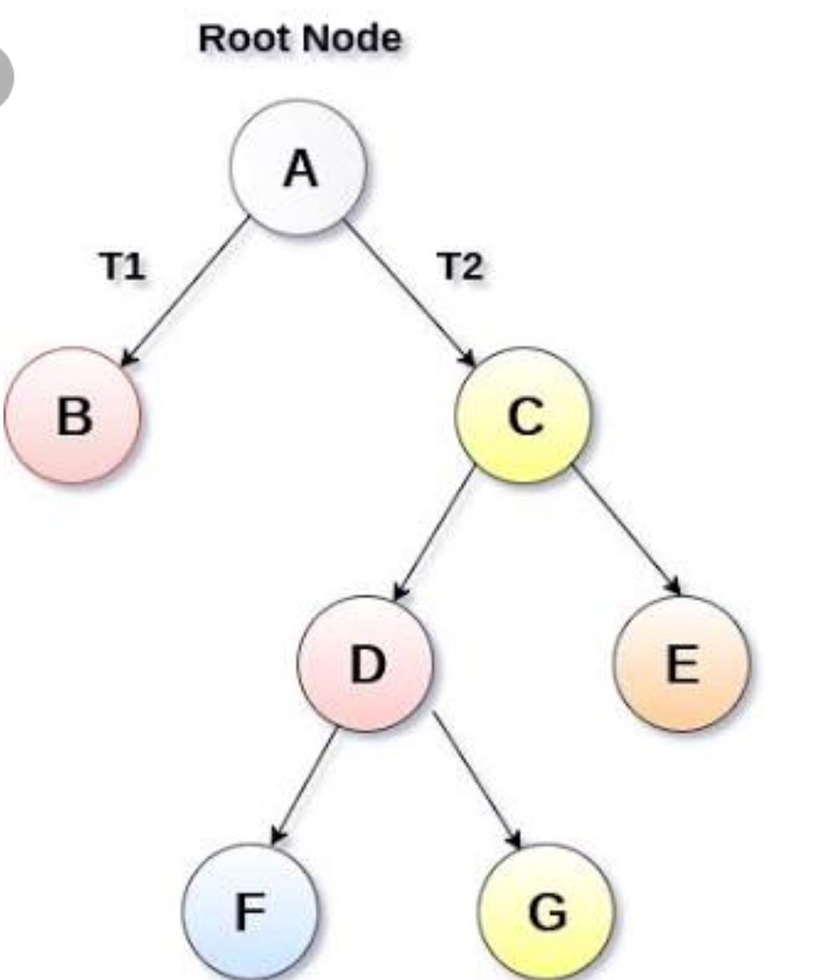

- Sequential access -> Direct access �
Tape -> Disk.
Index : <key, pointer> in smaller file.
- As files grew intolerably large for unaided sequential access an as storage devices such as disk drives became available, indexes are added to files. Indexes made it possible to keep a list of keys and pointers in a smaller file that could be searched more quickly .With the key and pointer, user had direct access to large primary file.
- AVL tree is a self -adjusting binary tree for data in memory .Other researchers began to look for ways to apply AVL trees, or something like them to files.
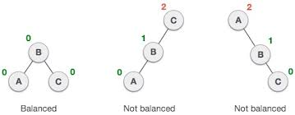
Fig: Examples for AVL tree
- It took nearly 10 years of design work before a solution emerged in the form of the B-tree. B-tree is a balanced tree structure and provide excellent access performance, but sequential access with a cost.
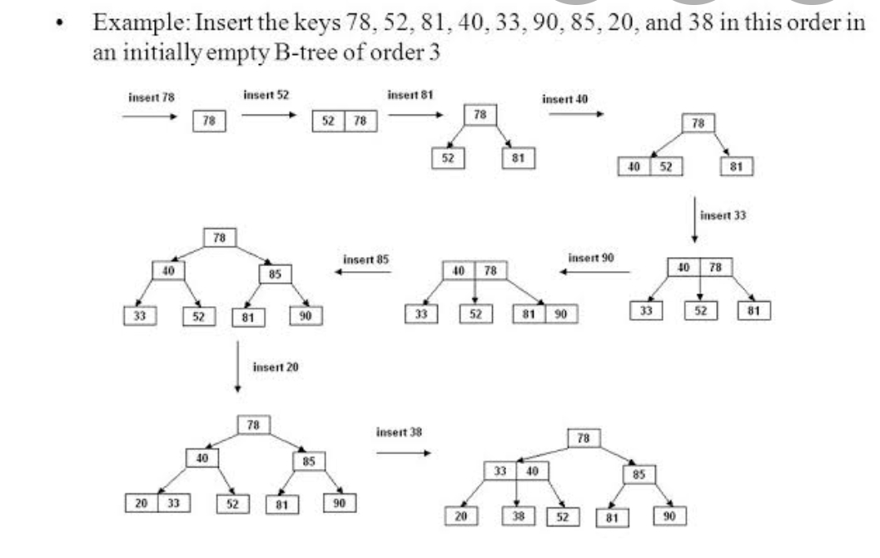
Fig:Example of B-trees

- The combination of a B-tree and sequential linked list is called a B +tree. Over the next 10 years, B-trees and B+ trees became the basis for many commercial file systems.
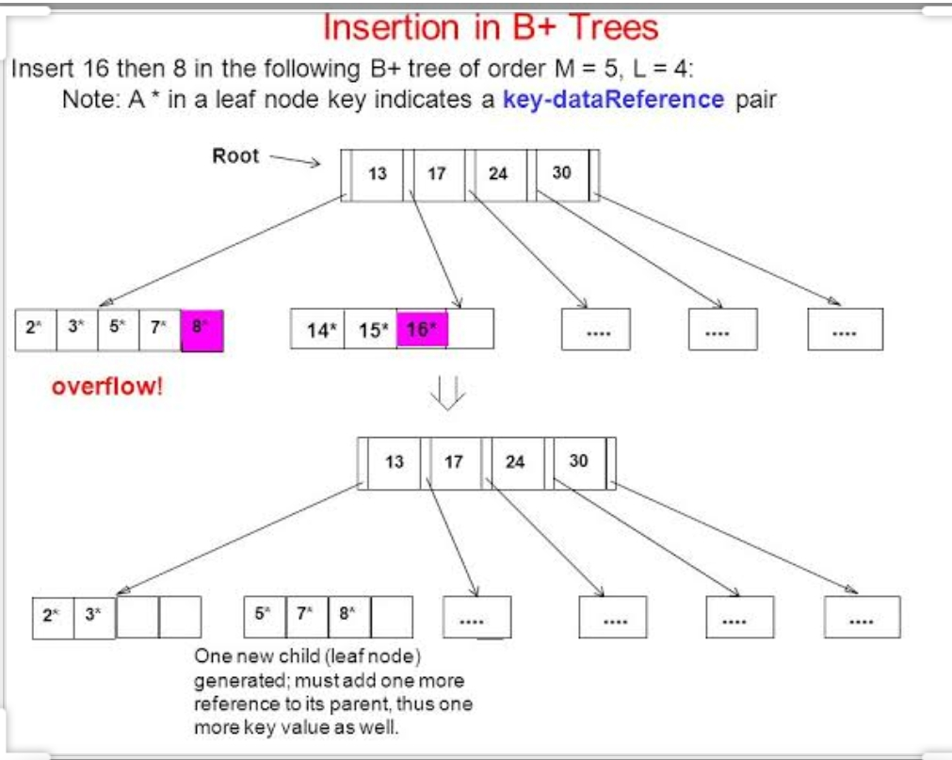
Fig: Example of B+ trees
- An approach called hashing is a good way to do that with the files that do not change size greatly over time. From early on, hashed indexes were used to provide fast access to files.
- After the development of B-trees, researchers turned to work on systems for extendible, dynamic hashing that could retrieve information with one ,or at most ,two disk access no matter how big the file became.
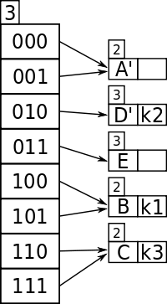
Fig:Extendible hashing
2.1 FILE STRUCTURE USED IN PROJECT:INDEXES
INDEXES:
All indexes are based on same basic concepts-keys and reference fields. The types of indexes we see are called simple indexes because they are represented using simple arrays of structures that contain the keys and reference fields.

A Simple Index for Entry-Sequenced Files

Simple index: An index in which the entries are a key ordered linear list.

- Simple indexing can be useful when the entire index can be held in memory.
- Changes (additions and deletions) require both the index and the data file to be changed.
- Updates affect the index if the key field is changed, or if the record is moved.
- An update which moves a record can be handled as a deletion followed by an addition.

Object Oriented Support for Indexed, Entry Sequenced Files

Entry-sequenced file: A file in which the record order is determined by the order in which they are entered. The index should be read into memory when the data file is opened.
- Indexes That are too Large to Hold in Memory
- Searching of a simple index on disk takes too much time.
- Maintaining a simple index on disk in sorted order takes too much time.
- Tree structured indexes such as B-trees are a scalable alternative to simple indexes.
- Hashed organization is an alternative to indexing when only a primary index is needed.

Indexing to Provide Access by Multiple Keys
Secondary key: A search key other than the primary key.
Secondary index: An index built on a secondary key.

Secondary indexes can be built on any field of the data file, or on combinations of fields.

Secondary indexes will typically have multiple locations for a single key.

Changes to the data may now affect multiple indexes.

The reference field of a secondary index can be a direct reference to the location of the entry in the data file.

The reference field of a secondary index can also be an indirect reference to the location of the entry in the data file, through the primary key.

Indirect secondary key references simplify updating of the file set.

Indirect secondary key references increase access time.
- We could build a catalog for our record collection consisting of entries for album title, composer, and artist. These fields are secondary key fields . Just as the library catalog relates an author entry (secondary key) to a card catalog number (primary key) , so can we build an index file that relates Composer to Label ID, as illustrated in Fig 2.2.1.
- Along with the similarities, there is an important difference between this kind of secondary key index and the card catalog in a library. In a library, once you have the catalog number you can usually go directly to the stacks to find the book since the books are arranged in order by catalog number. In other words, the books are sorted by primary key. The actual data records in our file, on the other hand, are entry sequenced. Consequently, after consulting the composer index to find the Label ID, you must consult one additional index, our primary key index, to find the actual byte offset of the record that has this particular Label Id.
- The procedure is summarized in Fig. 2.2.2. Clearly it is possible to relate secondary key references (e.g., Beethoven) directly to a byte offset (211) rather than to a primary key (DG1 8807). However, there are excellent reasons for postponing this binding of a secondary key to a specific address for as long as possible. These reasons become clear as we discuss the way that fundamental file operations such as record deletion and updating are affected by the use of secondary indexes. Record Addition When a secondary index is present, adding a record to the file means adding a record to the secondary index.

Composer index
Secondary key Primary key
BEETHOVEN ANG3795
BEETHOVEN DG139201
BEETHOVEN DG18807
BEETHOVEN RCA2626
COREA WAR23699
DVORAK COL31809
PROKOFIEV LON2312
RIMSKY-KORSAKOV MER750 16
SPRINGSTEEN COL38358
SWEET HONEY IN THE R FF245

Fig 2.2.1 Secondary key index organized by composer.
PROCEDURE search_on_secondary ( KEY )
search for KEY in the secondary index
once the correct secondary index record is found , set LABEL_ID to the
primary key value in the record's reference field
call retrieve_record (LABEL_ID ) to get the data record

end PROCEDURE
Fig 2.2.2: Search_on_secondary: an algorithm to retrieve a single record
from Datafile through a secondary key index .

Retrieval Using Combinations of Secondary Keys
- The search for records by multiple keys can be done on multiple index, with the combination of index entries defining the records matching the key combination.
- If two keys are to be combined, a list of entries from each key index is retrieved.
- For an "or" combination of keys, the lists are merged.
- I.e., any entry found in either list matches the search.
- For an "and" combination of keys, the lists are matched.
- I.e., only entries found in both lists match the search.

Improving the Secondary Index Structure: Inverted Lists
Inverted list: An index in which the reference field is the head pointer of a linked list of reference items.
Selective Indexes:An index which contains keys for only part of the records in a data file.
Title index
Secondary key Primary key
COQ D'OR SUITE MER75016
GOOD NEWS FF245
NEBRASKA COL38358
QUARTET IN C SHARP M RCA2626
ROMEO AND JULIET LON2312
SYMPHONY NO. 9 ANG3795
SYMPHONY NO. 9 COL3 1809
SYMPHONY NO. 9 DG18807
TOUCHSTONE WAR23699
VIOLIN CONCERTO DG139201

Fig 2.2.3 Secondary key index organized by recording title.

The secondary index structures that we have developed so far result in two distinct difficulties :

1.We have to rearrange the index file every time a new record is added to the file, even if the new record is for an existing secondary key.

For example, if we add another recording of Beethoven's Symphony No. 9 to our collection, both the composer and title indexes would have to be rearranged, even though both indexes already contain entries for secondary keys (but not the Label IDs) that are being added.

2. If there are duplicate secondary keys, the secondary key field is repeated for each entry. This wastes space, making the files larger than necessary. Larger index files are less likely to be able to fit in electronic memory.

2.2 FILES FUNCTIONS USED IN PROJECT:
File handling :-
Many real-life problem handle large volume of data and ,in such situations, we need to use some devices such as Floppy disk or hard disk to store the data. The data is stored in these devices using the concept of files. A file is a collection of related data stored in a particular area on the disk. Programs can be designed to perform the read and write operations on these files.
Class for file stream operation :-
The I/O system of CPP contain a set of classes that define the file handling methods. This include ifstream , ofstream and fstream. These classes are derived from fstream base and the corresponding iostream class, the classes ,designed manage the disk ,are declared in fstream and therefore we must include this file in any program that uses file.
Opening file Syntax:-
File stream-class stream object;
Stream object .open(“filename,ios::mode);
Mode for opening the file:-
1) ios ::app ->To append at the end of file
2)ios::out->it open file in write only mode.
3) ios::in->it open file in read only mode.
Read file syntax:-
Stream –object .read((char*)&class-object,sizeof(class-object));
Write files syntax:
Stream -object.write((char*)&class-object,sizeof(class -object));
- f.close():- It closes the stream. All buffers associated with the stream are flushed before closing. System allocates buffers are freed upon closing. Buffers are assigned with setbuf are not automatically freed.

Chapter-3
PSEUDOCODE
3.1 INSERTION STATEMENTS:-
void Prison ::SetData()
{
system("cls");
Time();
int a, s;
for (a = 0; a <= 100000000; a++)
{
}
cout << "\t\t\t\t -----------------------------------------------------\n";
for (a = 0; a <= 100000000; a++)
{
}
cout << "\t\t\t\t | |\n";
cout << "\t\t\t\t | Enter basic information of prisoner |\n";
cout << "\t\t\t\t | |\n";
for (a = 0; a <= 100000000; a++)
{
}
cout << "\t\t\t\t -----------------------------------------------------\n";
for (a = 0; a <= 100000000; a++)
{
}
cout << "\n\n";
cout << "\t\t\t\t\t";
cout << "Enter first name : ";
cin >> First_Name[o];
cout << "\t\t\t\t\t";
cout << "\n";
cout << "\t\t\t\t\t";
cout << "Enter second name : ";
cin >> Second_Name[o];
cout << "\t\t\t\t\t";
cout << "\n";
cout << "\t\t\t\t\t";
cout << "Enter gender : ";
cin >> Gender[o];
cout << "\t\t\t\t\t";
cout << "\n";
cout << "\t\t\t\t\t";
cout << "Enter age : ";
cin >> Age[o];
cout << "\t\t\t\t\t";
cout << "\n";
cout << "\t\t\t\t\t";
cout << "Enter height : ";
cin >> Height[o];
cout << "\t\t\t\t\t";
cout << "\n";
cout << "\t\t\t\t\t";
cout << "Enter eyecolor : ";
cin >> Eyecolor[o];
cout << "\t\t\t\t\t";
cout << "\n";
cout << "\t\t\t\t\t";
cout << "Enter crime : ";
cin >> Crime[o];
cout << "\t\t\t\t\t";
cout << "\n";
cout << "\t\t\t\t\t";
cout << "Enter punishment span in months : ";
cin >> Punishmentmonths[o];
cout << "\t\t\t\t\t";
cout << "\n";
cout << "\t\t\t\t\t";
cout << "Enter the date of entry in DD/MM/YY : ";
cin >> DateofEntry[o];
cout << "\t\t\t\t\t";
cout << "\n\n\n";
cout << "\t\t\t\t\t";
cout<<"You may proceed!"<<endl;
cout << "\t\t\t\t\t";
cout << "\n\n\n";
cout << "\t\t\t\t\t";
cout << "Your Cell No is " << CellNo[o];
cout << "\n\t\t\t\t\t";
cout << "\n";
cout << "\t\t\t\t\t";
o = o + 1;
cout << "Press 1 to return : ";
scanf("%d", &s);
if (s == 1)
{
Prison ::Afterlogin();
}
}
3.2 DELETE STATEMENTS:-
void Prison ::Release()
{
int s, l, c = 0, r;
char ch;
do
{
system("cls");
Time();
int t;
for (t = 0; t <= 100000000; t++)
{
}
cout << "\t\t\t\t -----------------------------------------------------\n";
for (t = 0; t <= 100000000; t++)
{
}
cout << "\t\t\t\t | |\n";
cout << "\t\t\t\t | Release prisoner |\n";
cout << "\t\t\t\t | |\n";
for (t = 0; t <= 100000000; t++)
{
}
cout << "\t\t\t\t -----------------------------------------------------\n";
for (t = 0; t <= 100000000; t++)
{
}
cout << "\n\t\t\t\t\t";
cout << "\n============================================================================================================================\n";
cout << "SR.\tNAME\t\t\tCell Block\tAge\tGender\tHeight\tEye Colour\tCrime\tPunishment\tDateofEntry\n";
cout << "=============================================================================================================================\n";
for (int x = 0; x <= 19; x++)
{
if (First_Name[x] != " ")
{
cout << First_Name[x] << "" << Second_Name[x] << "\t\t" << CellNo[x] << "\t\t" << Age[x] << "\t" << Gender[x] << "\t" << Height[x] << "\t" << Eyecolor[x] << "\t\t" << Crime[x] << "\t\t" << Punishmentmonths[x] <<"\t\t"<< DateofEntry[x] << endl;
cout << "\n"
<< endl;
c++;
}
}
if (c != 0)
{
cout << "\n\t\t\t\t\t";
cout << "Enter the cell block of the prisoner :";
scanf("%d", &l);
l = l - 1001;
cout << "\n\t\t\t\t\t";
cout << "Name : ";
cout << First_Name[l] << " " << Second_Name[l];
cout << "\n\t\t\t\t\t";
if (Punishmentmonths[l] <= 0)
{
cout << "\n\t\t\t\t\t";
cout << "Prisoner is ready for release";
cout << "\n\t\t\t\t\t";
cout << "Press 1 to release the prisoner :";
cin >> r;
if (r == 1)
{
release:
First_Name[l] = " ";
Second_Name[l] = " ";
Gender[l] = " ";
Age[l] = 0;
Height[l] = 0;
Eyecolor[l] = " ";
Punishmentmonths[l] = 0;
DateofEntry[1] = " ";
cout << "\n\t\t\t\t\tProcessing";
for (int process = 0; process < 7; process
{
for (int a = 0; a <= 100000000; a++)
{
}
cout << ".";
}
cout << "\n\t\t\t\t\t";
cout << "Prisoner released successfully";
}
}
else
{
cout << "\n\t\t\t\t\t";
cout << "Prisoner is not ready for release"<<endl;
cout << "\t\t\t\t\t";
cout << "\n\n\n";
cout << "\t\t\t\t\t";
cout<<"do you still wish to release the prisoner.press y(yes) or n(no)"<<endl;
if(tolower(getch())=='y')
{
goto release;
}
}
cout << "\n\n";
cout << "\n\t\t\t\t\t";
cout << "Press y to choose another prisoner and press n to exit :";
cin >> ch;
}
else
{
int a;
cout << "\t\t\t\t\t";
cout << "\n";
cout << "\t\t\t\t\t";
for (a = 0; a <= 100000000; a++)
{
}
cout << "\t\t\t\t \n";
cout << "\t\t\t\t ------------------------------------------------\n";
for (a = 0; a <= 100000000; a++)
{
}
cout << "\t\t\t\t | No prisoners present |\n";
for (a = 0; a <= 100000000; a++)
{
}
cout << "\t\t\t\t ------------------------------------------------\n";
break;
}
} while (ch == 'y');
cout << "\n";
cout << "\t\t\t\t\t";
cout << "Press 1 to return : ";
scanf("%d", &s);
if (s == 1)
{
Prison::Afterlogin();
}
}
3.3 DISPLAY STATEMENTS:-
void Prison ::SearchPrison()
{
int info;
int CN, i, a, s, l;
int c = 0, p = 0;

system("cls");
cout << "\t\t\t\t ----------------------------------------\n";
for (a = 0; a <= 100000000; a++)
{
}
cout << "\t\t\t\t | Search Menu |\n";
for (a = 0; a <= 100000000; a++)
{
}
cout << "\t\t\t\t ----------------------------------------\n";
for (a = 0; a <= 100000000; a++)
{
}
cout << "\n\n";
cout << "\t\t\t\t";
cout << "Enter the prisoner cell id to be searched : ";
cin >> CN;
cout << "\n\t\t\t\t";
cout << "\n============================================================================================================================\n";
cout << "SR.\tNAME\t\t\tCell Block\tAge\tGender\tHeight\tEye Colour\tCrime\tPunishment\tDateofEntry\n";
cout << "=============================================================================================================================\n";
l = CN - 1001;
info = CellNo[l];
if (CN == info)
{
if (First_Name[l] != " ")
{
cout << First_Name[l] << "" << Second_Name[l] << "\t\t" << CellNo[l] << "\t\t" << Age[l] << "\t" << Gender[l] << "\t" << Height[l] << "\t" << Eyecolor[l] << "\t\t" << Crime[l] << "\t\t" << Punishmentmonths[l] << "\t\t" << DateofEntry[1]<< endl;
cout << "\n"
<< endl;
}
else
{
cout << "\n";
cout << "\t\t\t\t";
cout << "\n";
cout << "\t\t\t\t";
cout << "cell block empty" << endl;
}
}
else
{
cout << "\n";
cout << "\t\t\t\t";
cout << "\n";
cout << "\t\t\t\t";
cout << "invalid cell id" << endl;
}
cout << "\n";
cout << "\t\t\t\t";
cout << "\n";
cout << "\t\t\t\t";
cout << "Press 1 to return : ";
scanf("%d", &s);
if (s == 1)
{
Prison::Afterlogin();
}
}
3.4 SEARCH STATEMENTS:-
void Prison ::SearchPrison()
{
int info;
int CN, i, a, s, l;
int c = 0, p = 0;

system("cls");
cout << "\t\t\t\t ----------------------------------------\n";
for (a = 0; a <= 100000000; a++)
{
}
cout << "\t\t\t\t | Search Menu |\n";
for (a = 0; a <= 100000000; a++)
{
}
cout << "\t\t\t\t ----------------------------------------\n";
for (a = 0; a <= 100000000; a++)
{
}
cout << "\n\n";
cout << "\t\t\t\t";
cout << "Enter the prisoner cell id to be searched : ";
cin >> CN;
cout << "\n\t\t\t\t";
cout << "\n============================================================================================================================\n";
cout << "SR.\tNAME\t\t\tCell Block\tAge\tGender\tHeight\tEye Colour\tCrime\tPunishment\tDateofEntry\n";
cout << "=============================================================================================================================\n";
l = CN - 1001;
info = CellNo[l];
if (CN == info)
{
if (First_Name[l] != " ")
{
cout << First_Name[l] << "" << Second_Name[l] << "\t\t" << CellNo[l] << "\t\t" << Age[l] << "\t" << Gender[l] << "\t" << Height[l] << "\t" << Eyecolor[l] << "\t\t" << Crime[l] << "\t\t" << Punishmentmonths[l] << "\t\t" << DateofEntry[1]<< endl;
cout << "\n"
<< endl;
}
else
{
cout << "\n";
cout << "\t\t\t\t";
cout << "\n";
cout << "\t\t\t\t";
cout << "cell block empty" << endl;
}
}
else
{
cout << "\n";
cout << "\t\t\t\t";
cout << "\n";
cout << "\t\t\t\t";
cout << "invalid cell id" << endl;
}
cout << "\n";
cout << "\t\t\t\t";
cout << "\n";
cout << "\t\t\t\t";
cout << "Press 1 to return : ";
scanf("%d", &s);
if (s == 1)
{
Prison::Afterlogin();
}
}
Chapter-4
SNAPSHOTS
4.1 LOGIN PAGE:-
This is the login page where the administrator needs to enter the name and password for further operations .If the name and password does not matches ,the administrator cannot perform any operations
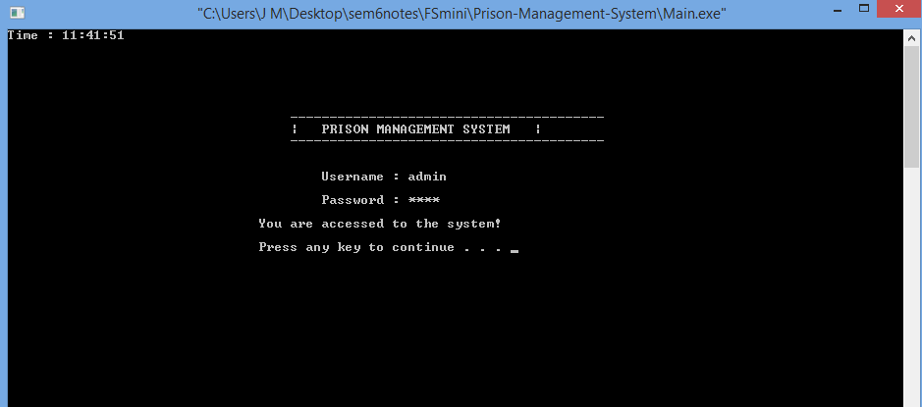
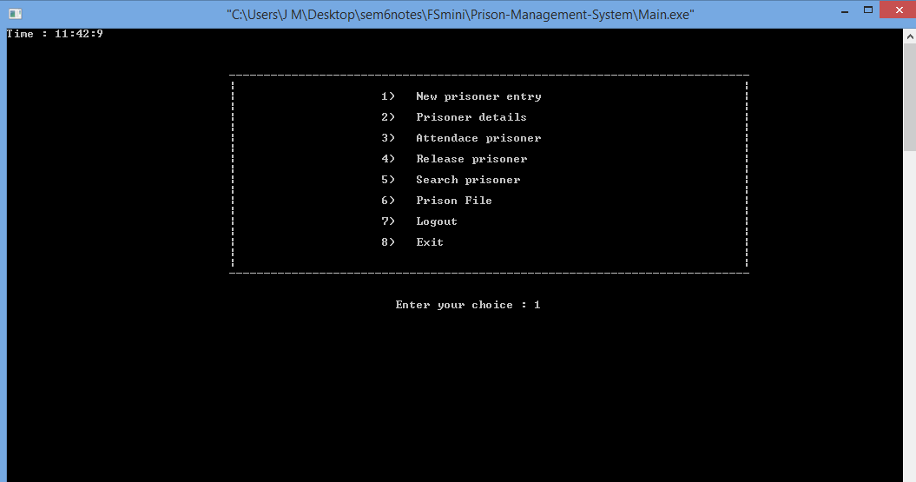
4.2 INSERTION OPERATION:-
Administrator can insert a record once the login is successful which includes the attributes like first name, second name, gender, age, height, eye colour, crime, punishment, date of entry, etc.
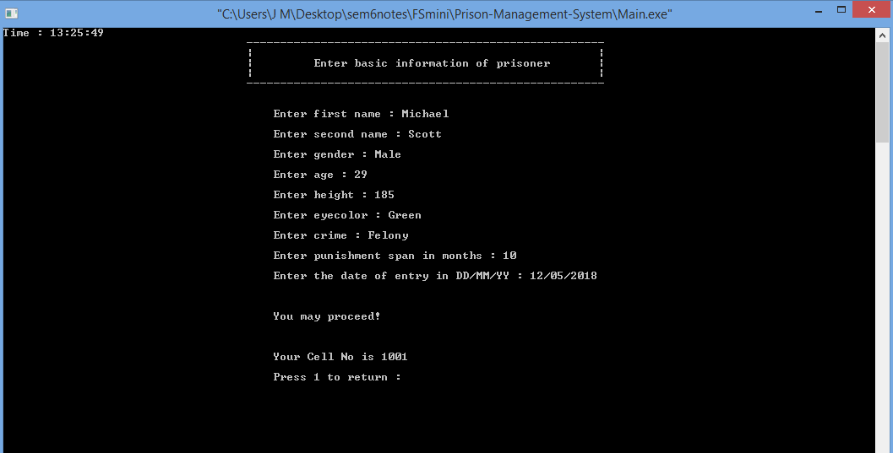
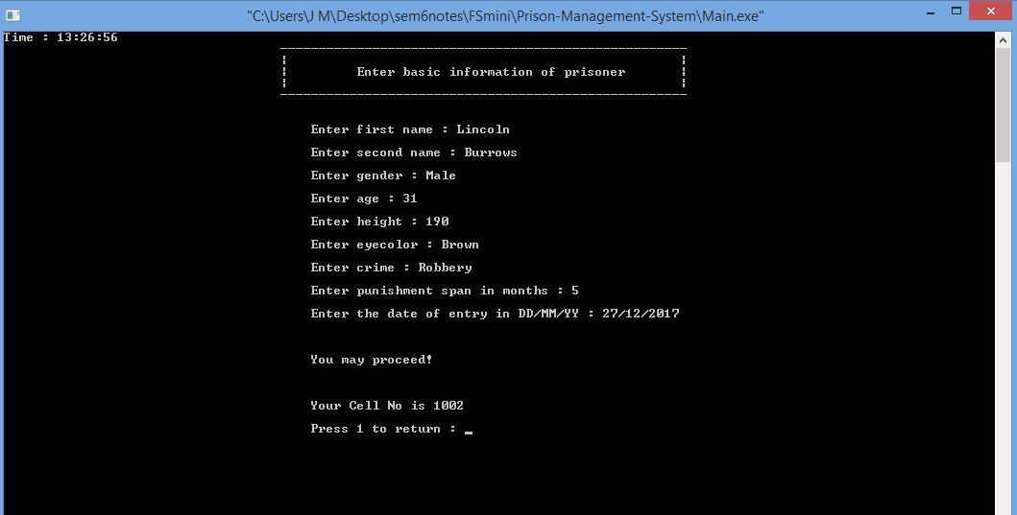
4.3 DISPLAY OPERATION:-
Once the record is inserted, the next would be displaying the record. It displays the record of previously inserted which includes all the attributes like first name, second name, gender, age, height, eye colour, crime, punishment, date of entry, etc.
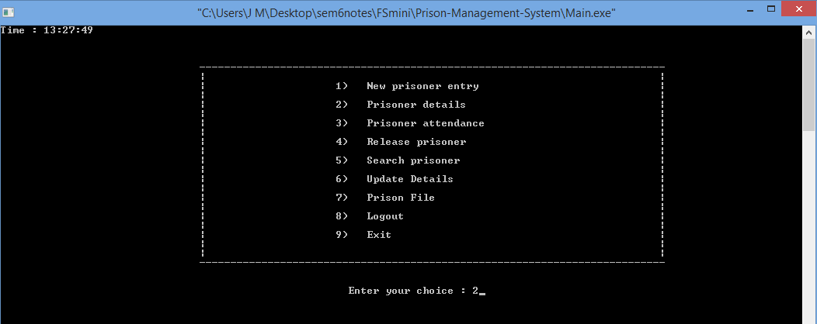
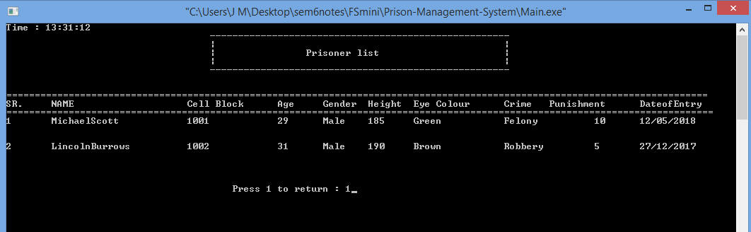
4.4 SEARCH OPERATION:-
After displaying the record, the next operation would be search operation. Here the prisoner cell id would be searched. If the given passenger name is found the search operation is successful and it displays the details of given prisoner. If the given prisoner cell id is not found the search is unsuccessful.
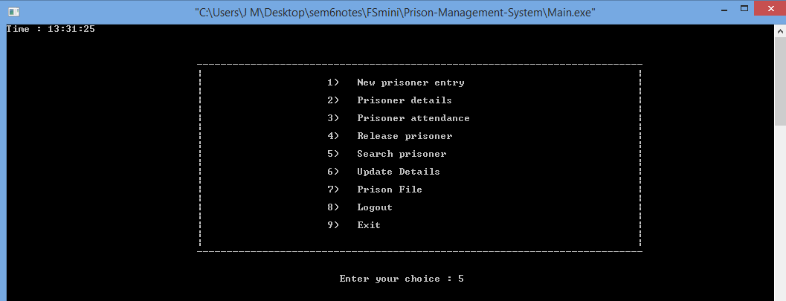
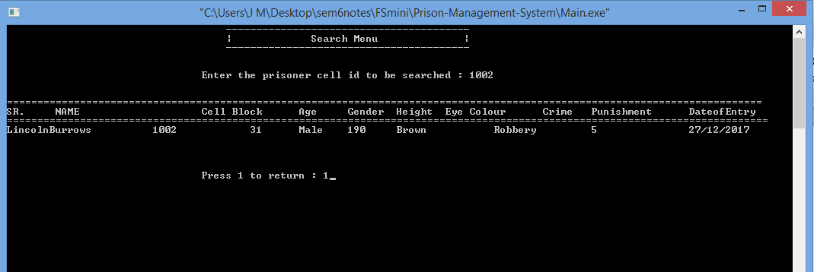
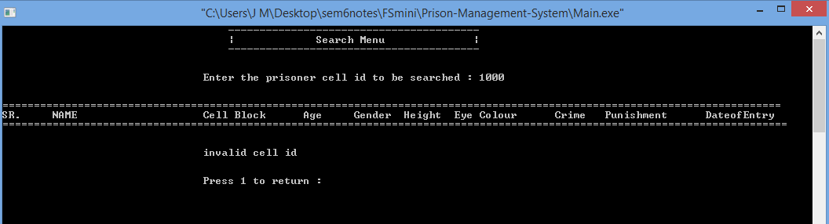
4.5 ATTENDANCE OF PRISONER:-
This operation is mainly used to display monthly attendance of the prisoner and reduces the punishment months by one month.
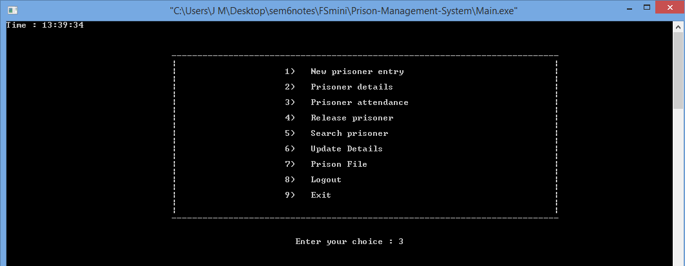
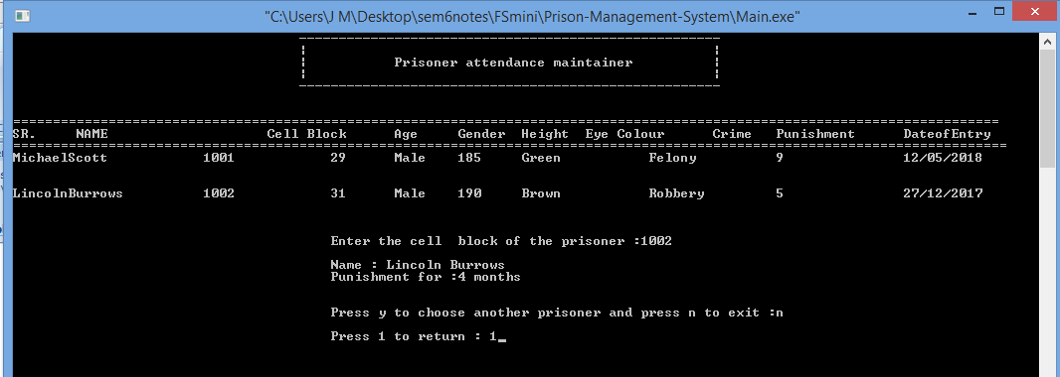
4.6 DELETE OPERATION:-
Delete operation includes deleting a record with the prisoner cell id. If the given prisoner cell id matches then the record would be deleted otherwise it displays invalid prisoner id and delete operation is unsuccessful.
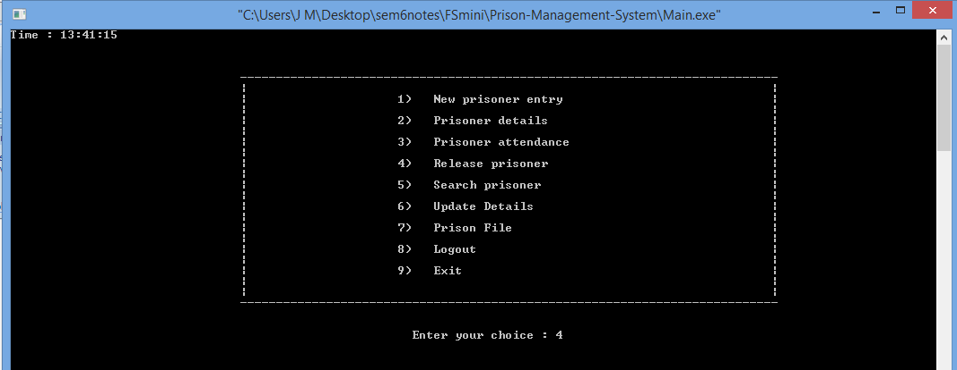
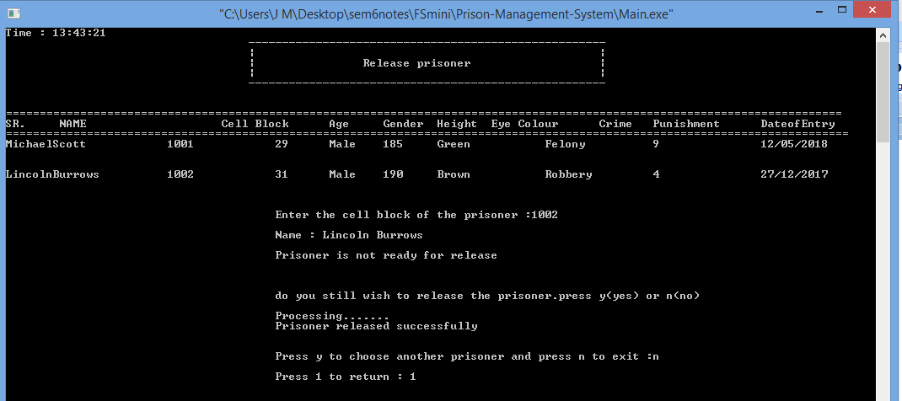

4.7 INDEXES/TEXT FILES
This contains index page where the text files are displayed in either text file, HTML file or word file depending on the data provided by the user.
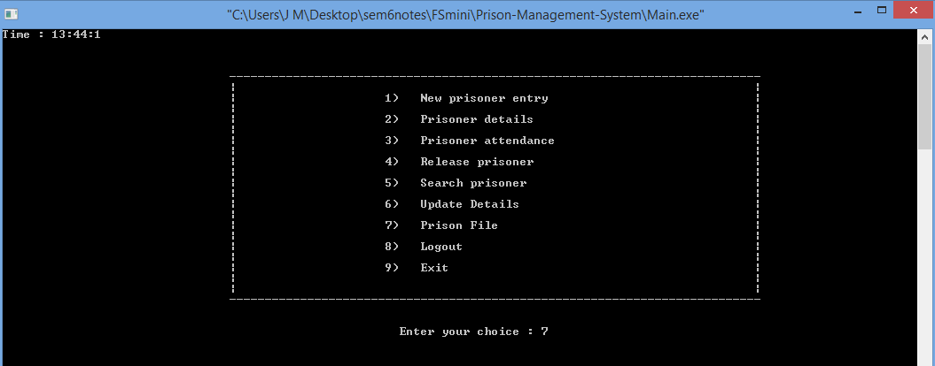
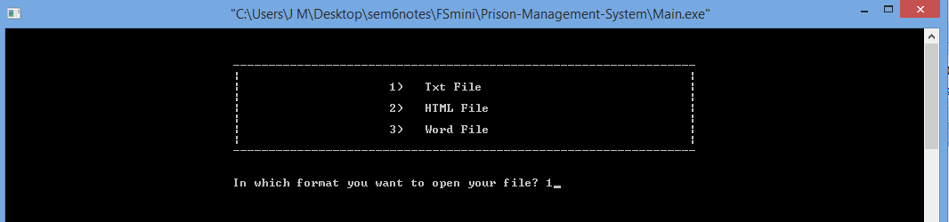
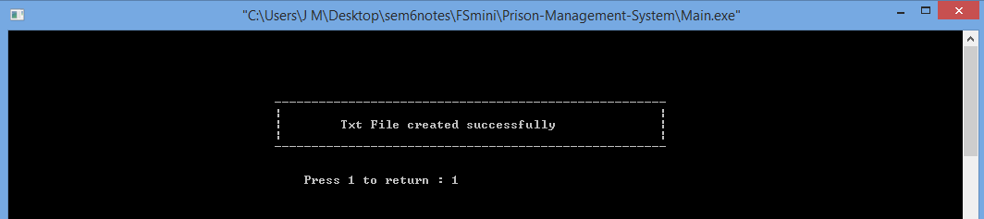
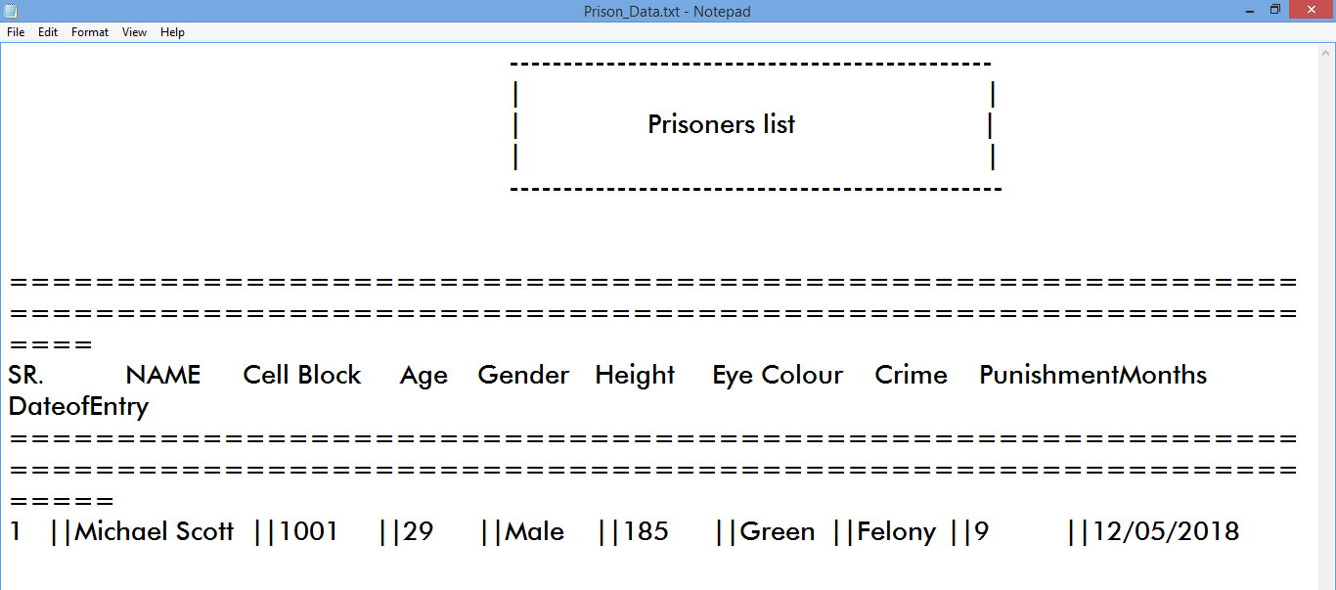
Chapter-5
ADVANTAGES OF FILE STRUCTURES
Advantages of ordered File Organization:
- To find a record in the sequential file is very efficient, because all files are stored in an order.
- It is fast and efficient when dealing with large volumes of data that need to be processed periodically.
Advantages of unordered File Organization:
- insert simple, records added at end of file.
- easier for retrievals a large proportion of records.
- effective for bulk loading data.
Advantages of hashing File Organization:

- Direct Access to the data.
- Hash function or randomizing function.
- Best if equality search is needed on hash-key.

Chapter-6
CONCLUSION
The Mini Project “Prison Management System” is designed in order reduce the burden of maintaining bulk records of all the details in which inserting , retrieving and deleting the details are easy when compared to the manual update and storing. This mini project helps in maintaining the prisoner details as well as attendance and personal details in an organized manner and replaces the old paper work system. This is to conclude that the project that I have undertaken was worked and built upon sincere effort. Most of the requirements are fulfilled up to the mark.

Chapter-7
REFERENCES

1. Reference Book :- Michael J. Folk, Bill Zoellick - File Structures
(1991, Addison Wesley)
2. Website:-
http://www.cppforschool.com/projects.html
http://www.codeincodeblock.com/mini-projects.html
https://www.codewithc.com/c-projects-with-source-code/

