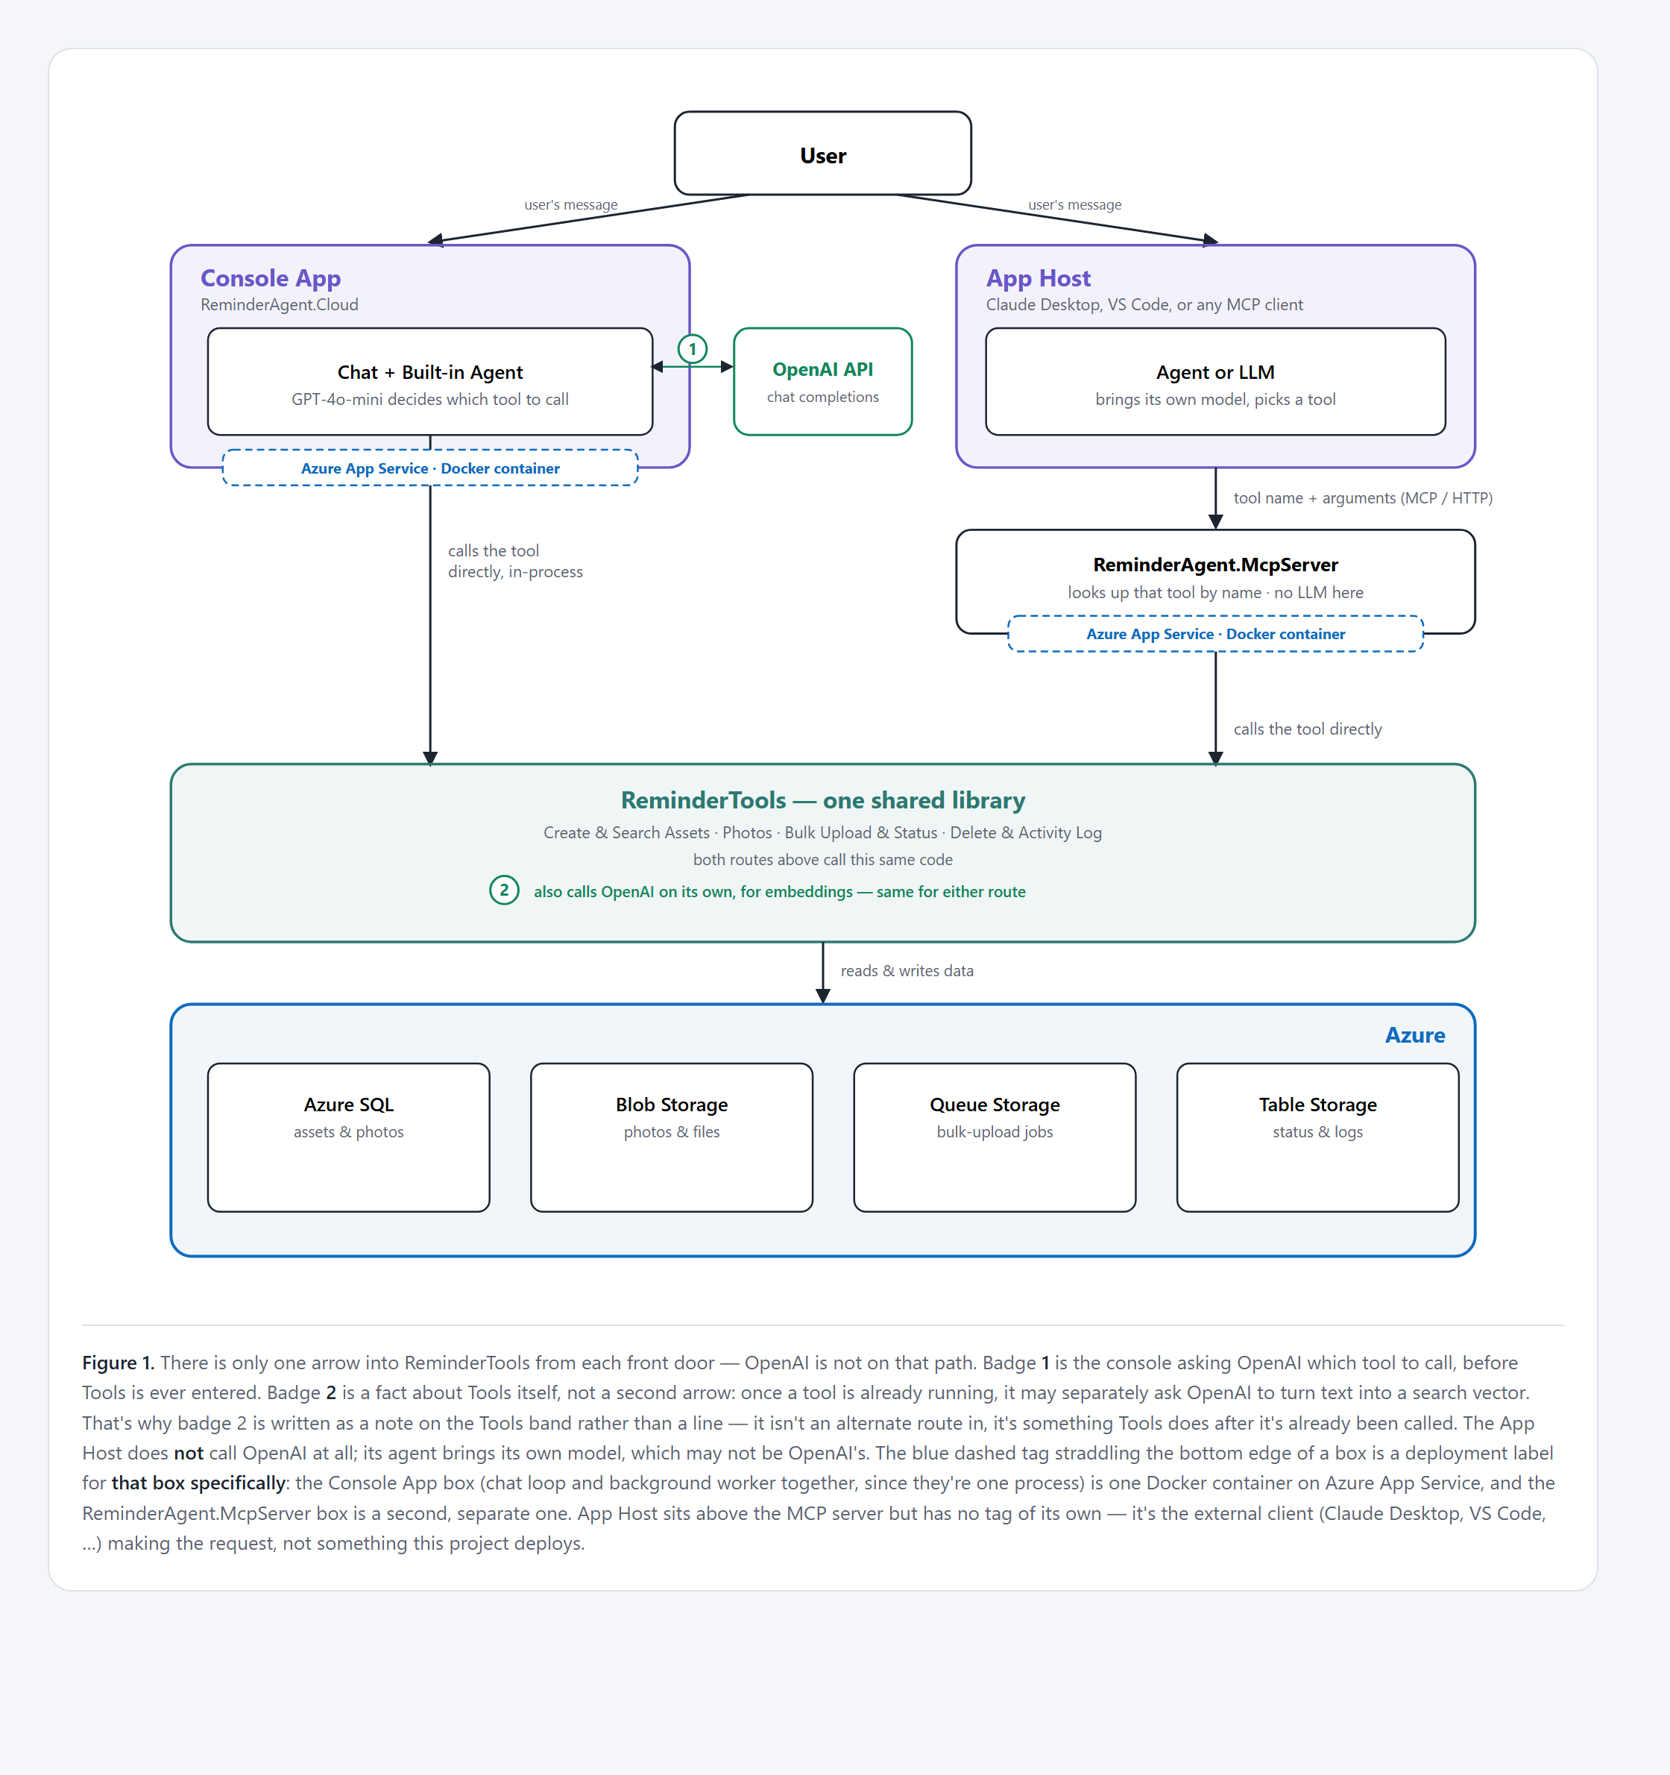
The console has its own built-in agent and calls tools directly. An MCP client instead sends its request over MCP/HTTP to the MCP server; the server itself has no agent — it just runs the tool the client already chose. Either way, there is exactly one path into the tool library — OpenAI is a separate, independent conversation on the side.

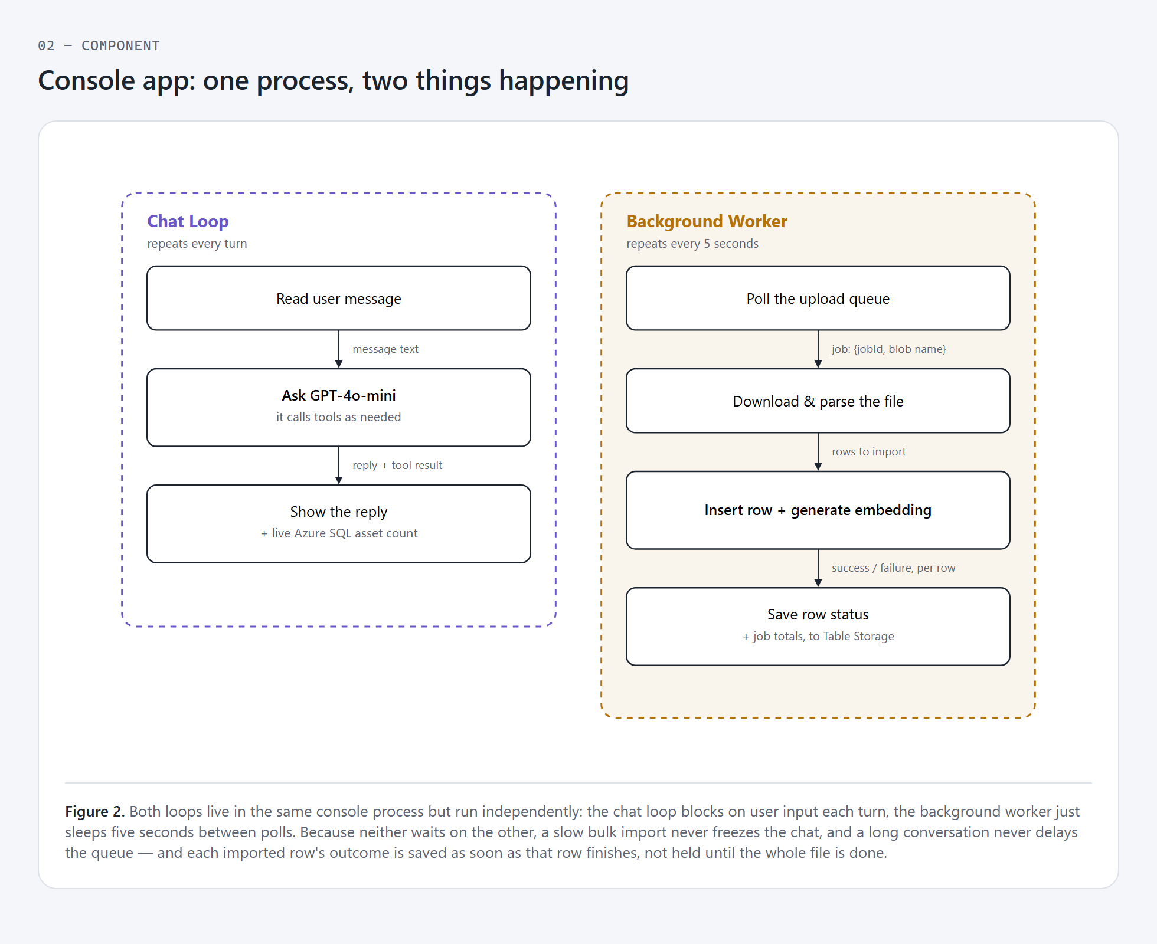
The console runs a chat loop for the person typing, and a background worker for bulk uploads, at the same time, in the same process.

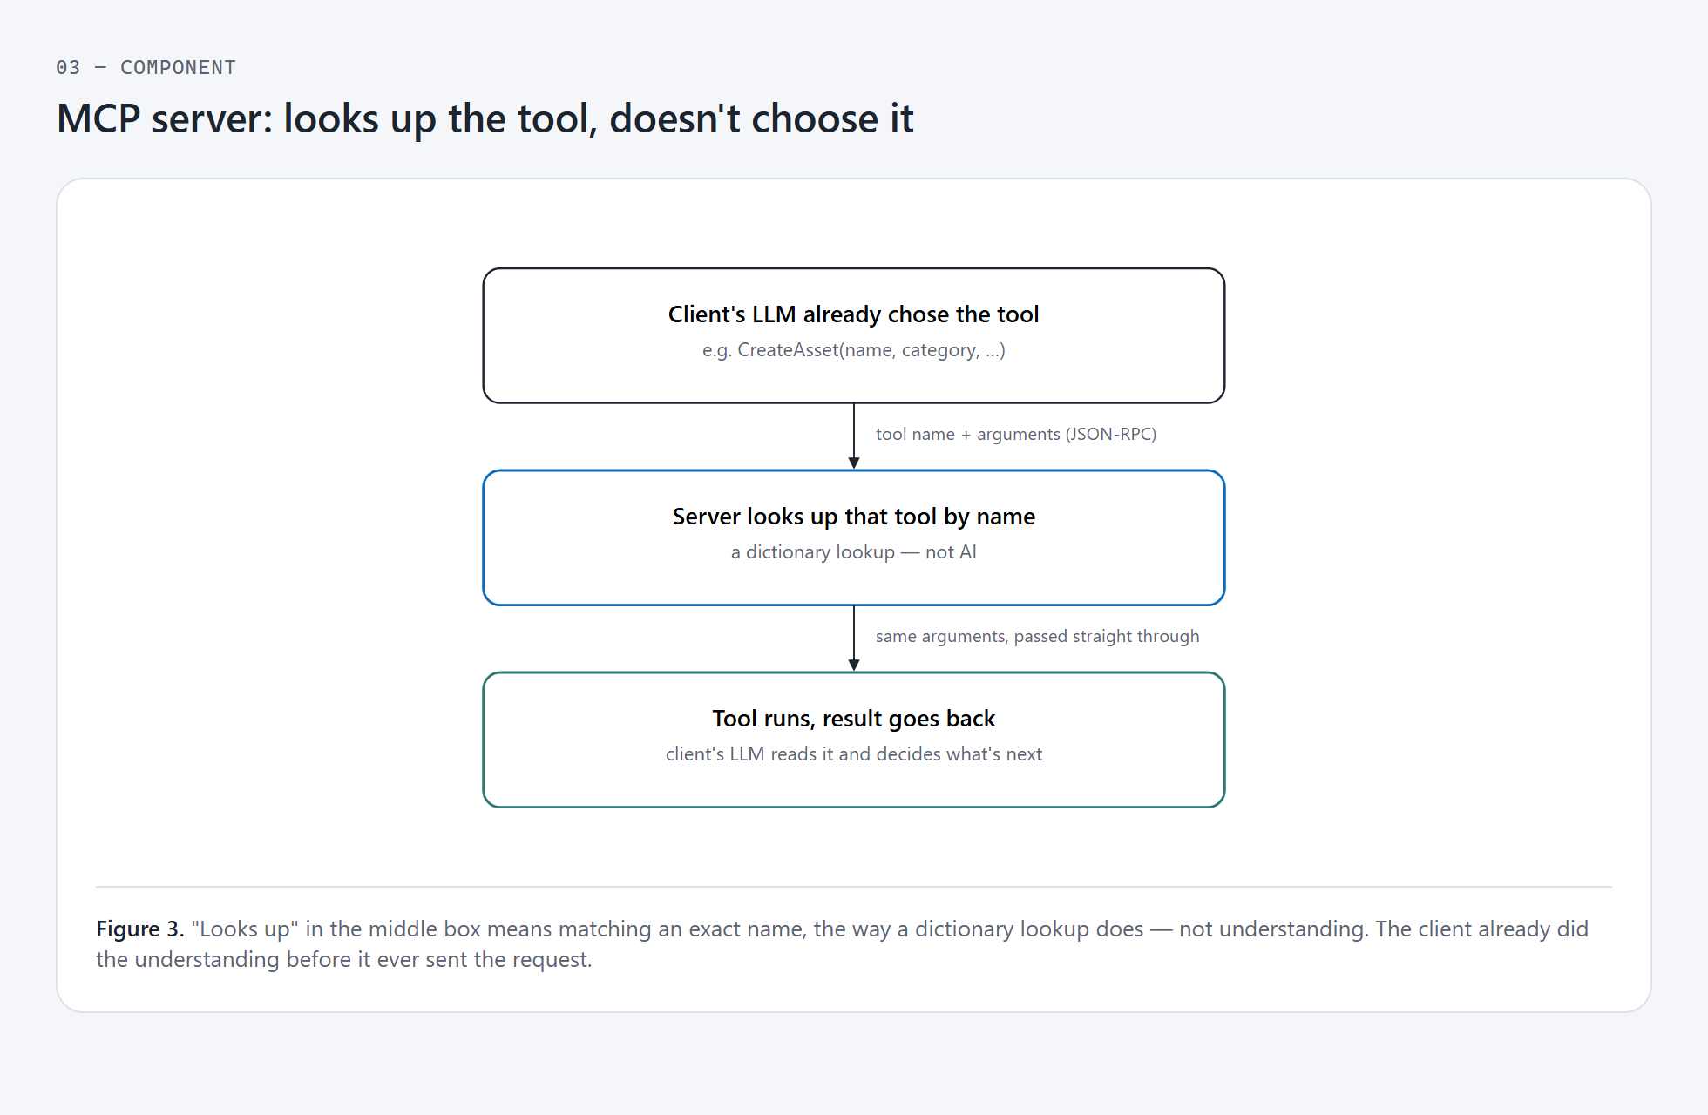

The client's own LLM is what reads the user's request and picks a tool — the server never sees plain language. It only ever sees an exact tool name and gets the arguments ready.

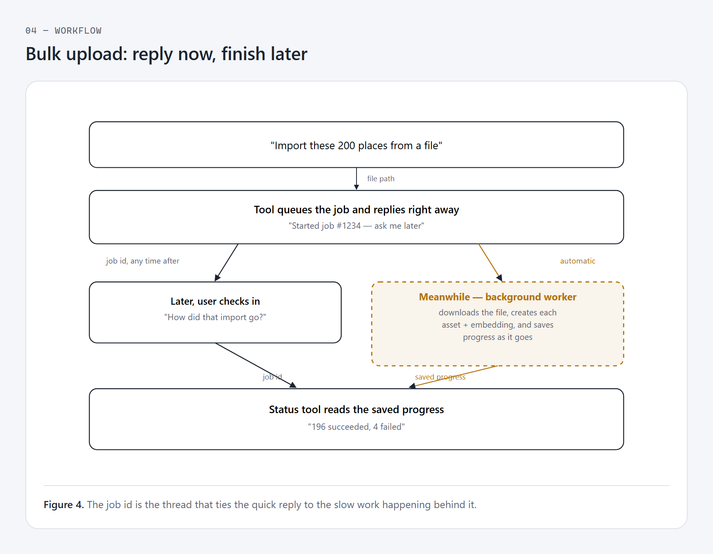
Importing hundreds of rows takes too long to make the user wait. So the tool replies immediately, and the real work happens in the background.

