Okay, we now have a pretty good idea of what the system will do. There are mainly 3 ways we can go with software design, at least as far as I am aware. They are:

- Bottom Up – You know exactly what solution you want to implement and what the components of your system are, you just need to arrange the components in the right way. Kind of like those plastic toys where you had to take the parts out of a grid and put them together for an action figure or a robot or something.
- Top Down – This is what we are going to use. In this case, you have a very good grasp of what your problem is (our requirements) and you need to devide it into sub problems so that its easy to understand.
- Extreme/Agile/Iterative Approach – This is a more recent development, by recent I mean relatively, I think it came up in the mid 90's or something. The Agile approach is all the rage now-a-days with people being pretty devided on whether its a good thing or not for the software world. I will let you research that on your own if your interested. The agile approach mostly consists of identifying core requirements out of a set of requirements taken from the client and then implementing the remaining requirements in future iterations.

FYI, I'm using the following tools to design the diagrams you see below:
- Pencil for the system diagrams for UI wireframes.
- MySQL Workbench for the ER diagram

As I said we will be using the top-down approach, since we already have a relatively clear grasp of what we want to make. From our requirements, we know this is a web app and it needs to store student data. So the our look at the system will give us something like this:

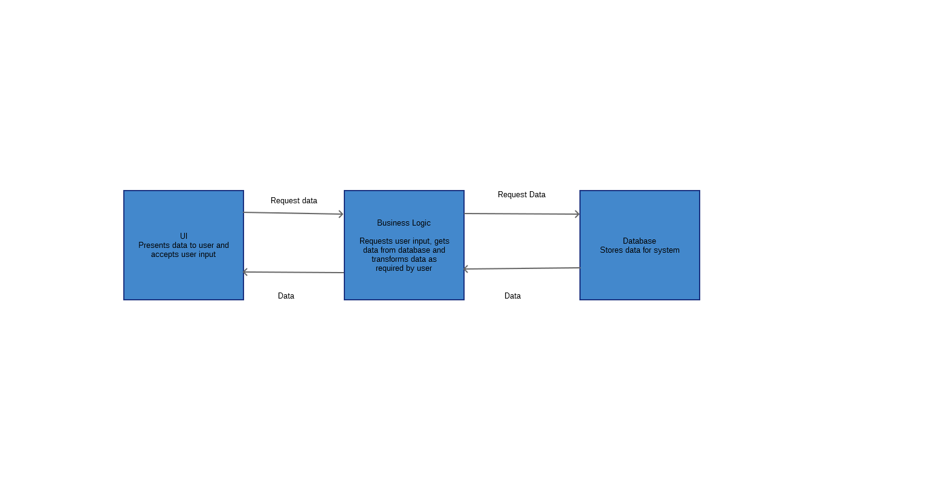
This is called a level zero design diagram. It gives us a high level overview of what it is we're trying to make.

Now lets try to go into a little detail for each of these components, I'm starting at the business logic engine but you can really start with any of the 3 components. This is called the level one design, as it digs a little deeper that our initial design of the system. You can similarly go even deeper into the design and make as detailed a design as you please.

The Logic Engine:

Lets dig into our main logic engine first. In my mind there are three different types of interactions that I feel need to be captured here:

- User Login

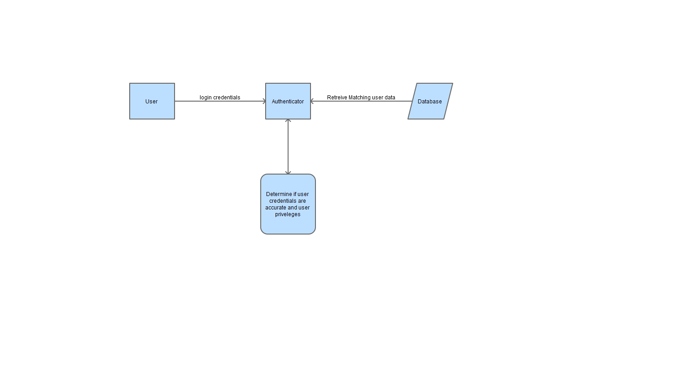

- Principal's Abilities

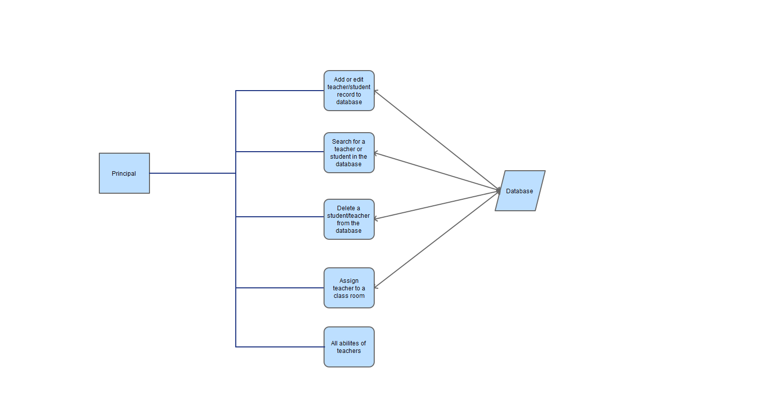
- Teacher's Role

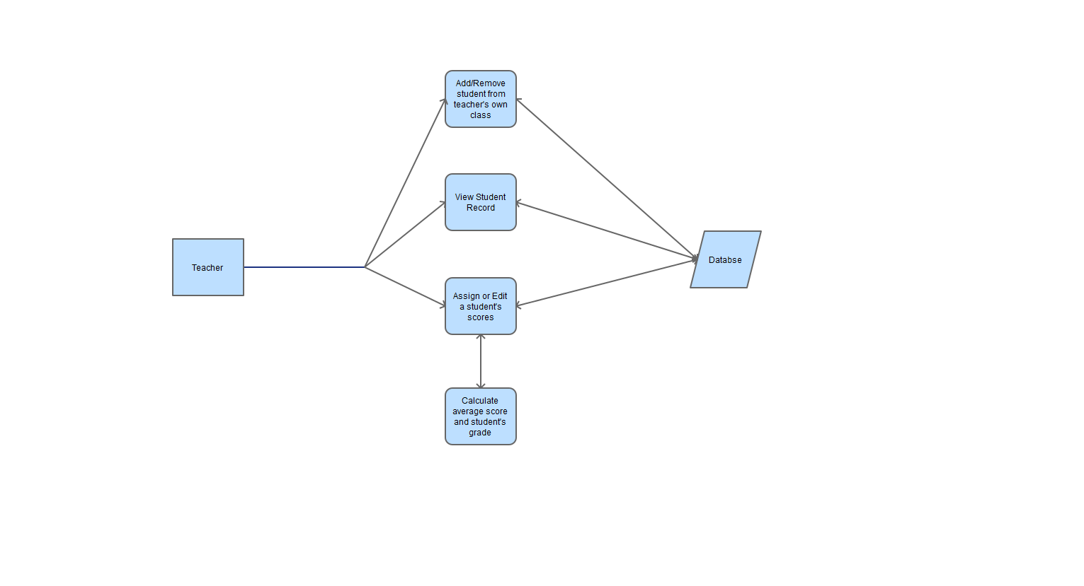

The Database:

Now lets look at our database. I'm only going to show the Entity Relationship diagram here.

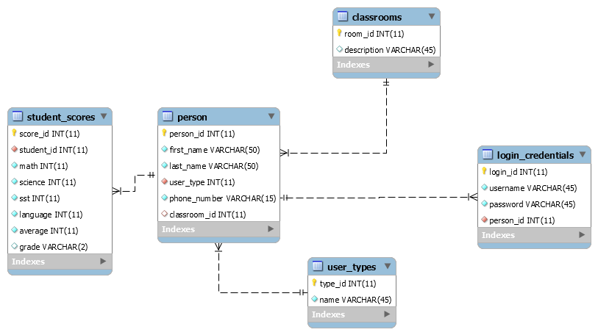
The User Interface (UI):

So a little confession, I am not a designer. In fact the whole UI/UX area is definitely not my cup of tea and this happens to be my first time even making any wireframes. So its really not that great. I'll try to improve this in the future but for now I'm afraid you'll have to live with it.

So without further ado here are our few UI screens:

- Index Page: The user will only login from here.

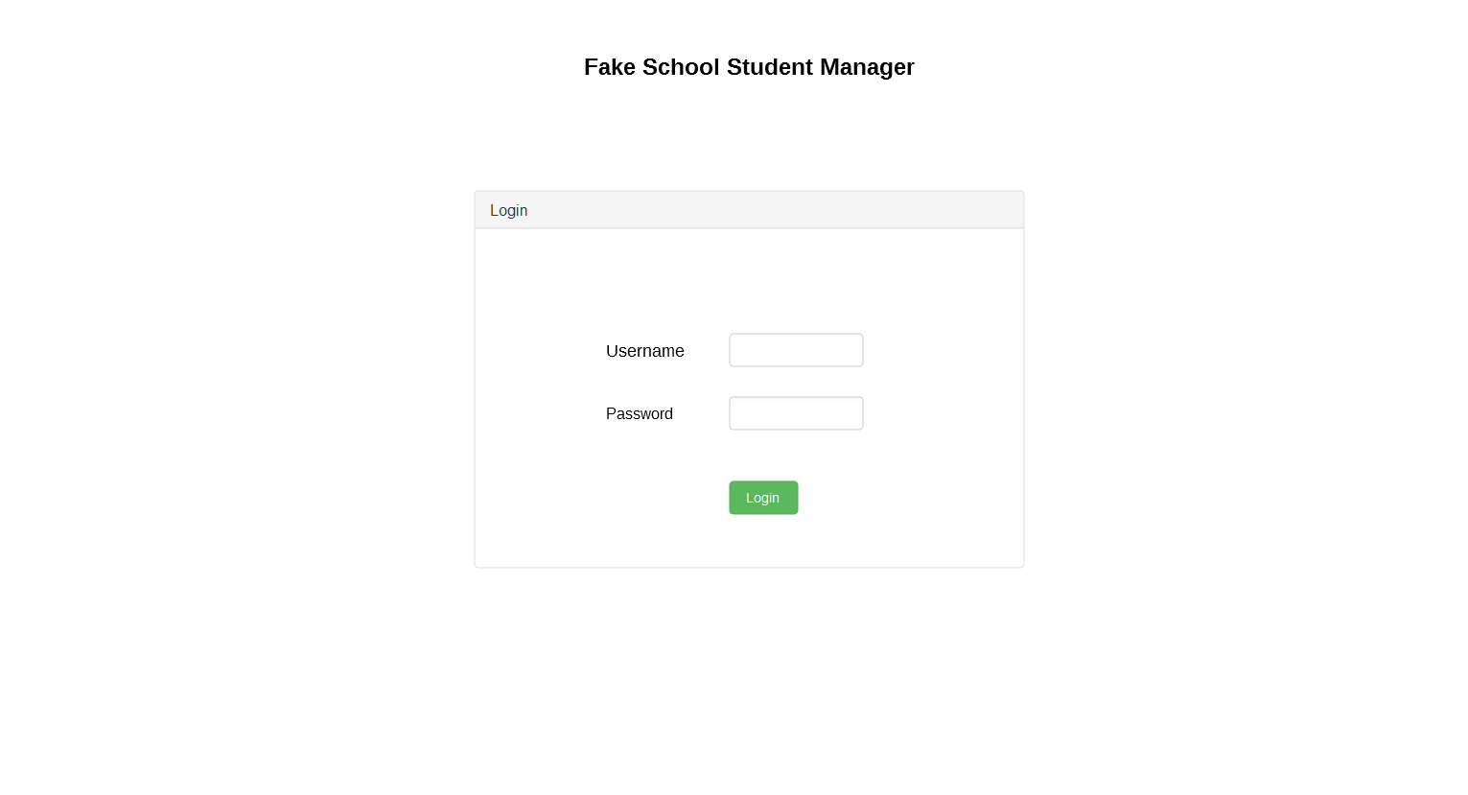
- Control Home Page: This is the page that someone will see when they log in. Just a basic "Hello World" type page with a side bar menu they can use to navigate to other screens.

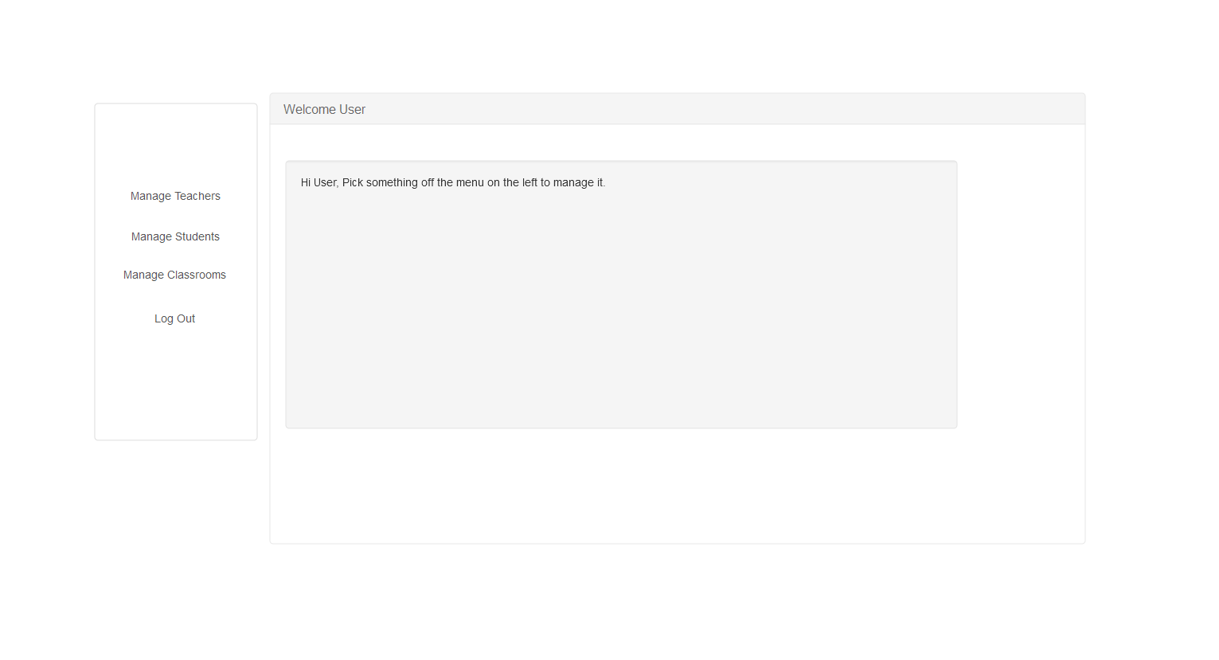

- Manage Page: This is the page peple will see when they are looking at teachers, students or classrooms. As outlined in our requirements.

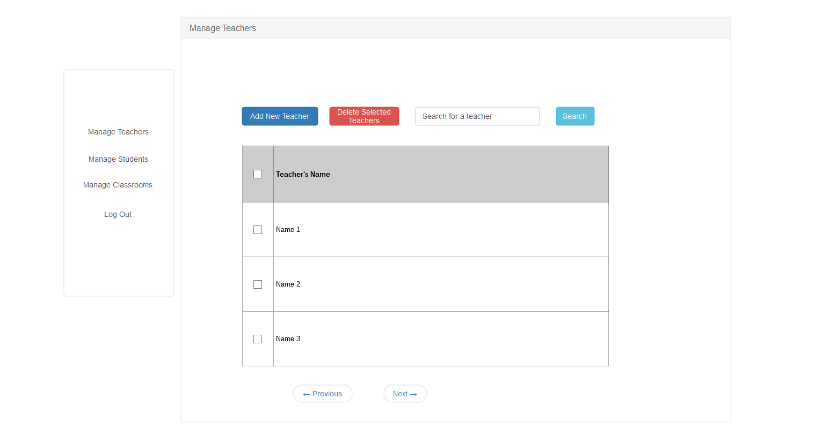
- Individual's Information Page: This page come's up when looking at a teacher's or student's details.

