* homework
  + Currently, the catdog notebook needs to create 6 folders to be able to load the data correctly for Pytorch
  + We end up with 3 dataset variables train_data, validation_data, test_data like so

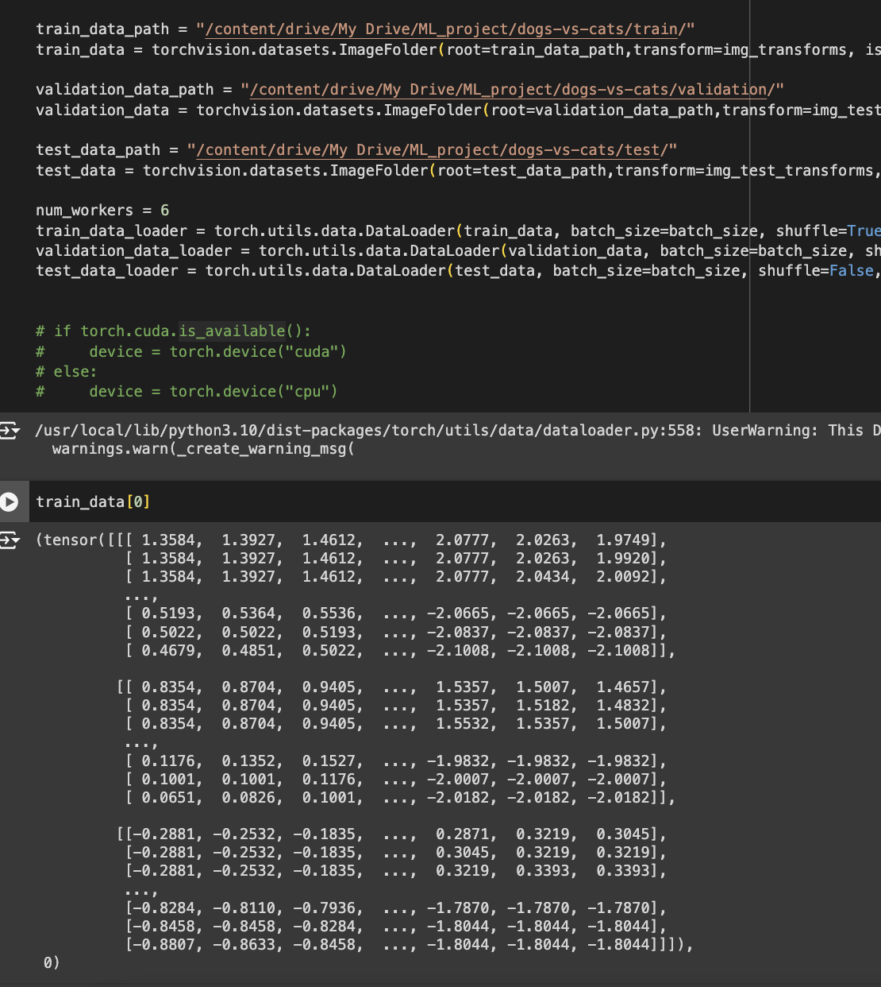

* The objective is to use a custom Dataset class to get this same outcome, i.e. these same 3 variables. The thing to confirm is that when you print train_data[0], you get a tuple (tensor, label) as shown above. Use the GPT example for this.