

**Course: CSE 302 (Section: 2)**

**FALL 2022**

**Lab Assignment Submission Report 03**

**Assignment Title:** Writing SQL Statements for Multi-table, Set and Aggregate Queries

**Submitted By**

AZAZ AHMED SUN  
ID: 2020-2-60-073

**Lab Task 01**

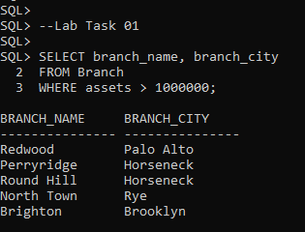

**Lab Task 02**

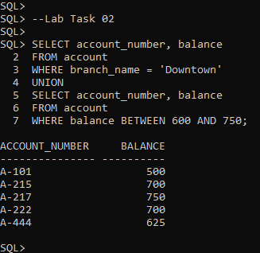

**Lab Task 03**

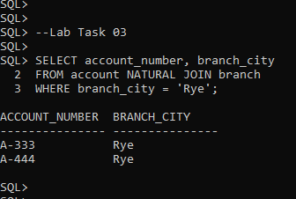

**Lab Task 04**

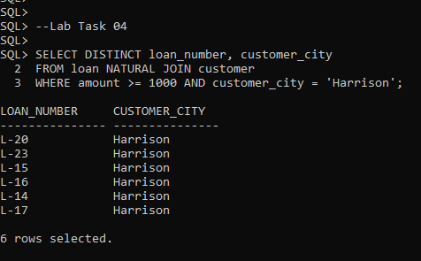

**Lab Task 05**

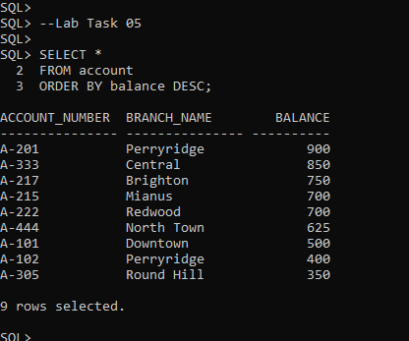

**Lab Task 06**

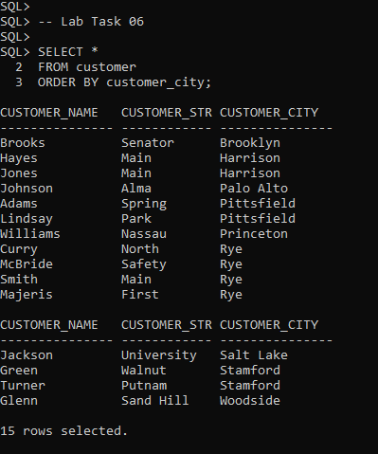

**Lab Task 07**

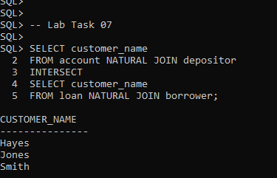

**Lab Task 08**

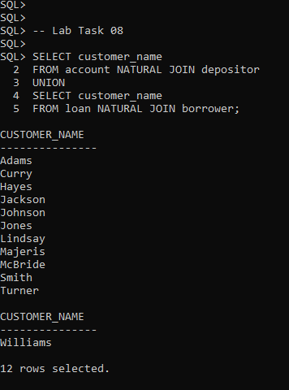

**Lab Task 09**

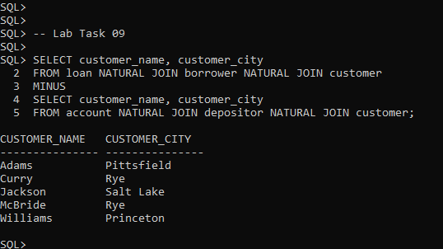

**Lab Task 10**

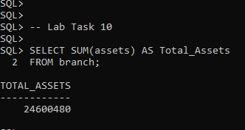

**Lab Task 11**

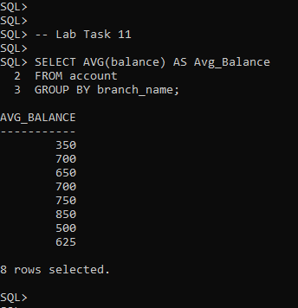

**Lab Task 12**

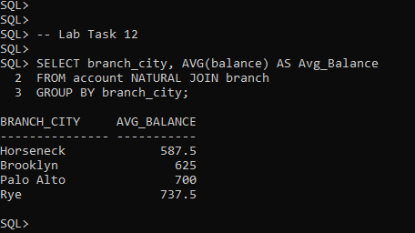

**Lab Task 13**

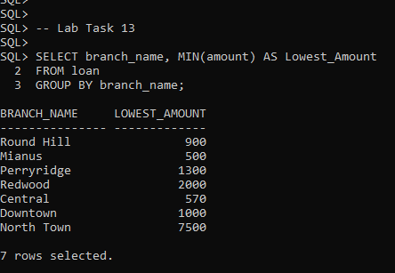

**Lab Task 14**

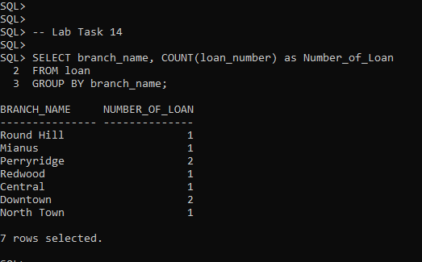

**Lab Task 15**

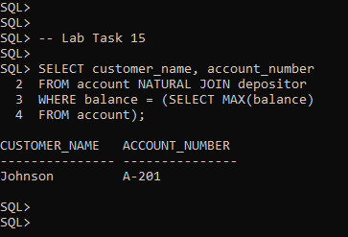

**2. Learning Outcomes :**

From this lab I have learnt CARTESIAN (cross) product and JOIN operator to join multiple table. We have used NATURAL JOIN, JOIN ON, JOIN USING etc operators. The we learnt SET operation (UNION, INTERSECT & MINUS). Then we also learn about DISTINCT keyword, ARITHMETIC operation, LIKE operator to match string, GROUP BY clause and many AGGREGATE FUNCTIONS like AVG, SUM, MIN, MAX & COUNT.