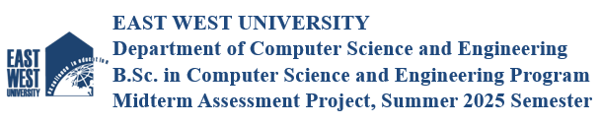

Project Report
Title: Securing a Networked System with PKI
Summer 2025
Course : CSE487
Section : 1

Submitted By;
MD Arham Jawed Akib - 2022-3-60-004
Jannatul Ferdaus Oishi - 2022-3-60-216
Mahin Ahmed Meghla - 2022-3-60-152

Submitted To;
Dr. Md. Hasanul Ferdaus
Assistant Professor, Department of Computer Science & Engineering
East West University

https://drive.google.com/file/d/1GbEPRnO9SM8AYQJh3XeDB_sGkn-d5sKM/view?usp=drive_link
Introduction ;
We built a secure HTTPS web server using Apache2, implementing a Public Key Infrastructure (PKI) hierarchy that includes a Root Certificate Authority (CA), a Subordinate CA, and a Server certificate. The setup involved configuring a simulated DNS environment and implementing firewall rules to ensure secure and controlled access. To verify the implementation, we used a web browser to validate the certificate chain and confirm successful HTTPS connections, and analyzed the encrypted traffic using Wireshark to ensure data confidentiality and integrity throughout the communication.

CA Configuration (RootCA & AcmeCA)
Commands:
sudo -i
mkdir -p ca/{root-ca,sub-ca,server}/{private,certs,newcerts,crl,csr}
chmod -v 700 ca/{root-ca,sub-ca,server}/private
touch ca/{root-ca,sub-ca}/index
openssl rand -hex 16 > ca/root-ca/serial
openssl rand -hex 16 > ca/sub-ca/serial

We created separate folders for Root CA, Sub CA, and Server. Then we generated their private keys and initialized configuration files for certificate generation.

Apache2 Web Server Configuration
Commands:
sudo apt install apache2
a2enmod ssl
a2ensite default-ssl
sudo systemctl restart apache2

We installed Apache2, enabled SSL modules, and prepared the virtual host to serve HTTPS traffic with the signed certificates.

DNS Setup for www.verysecureserver.com
Commands:
echo "127.0.0.2 www.verysecureserver.com" >> /etc/hosts
ping www.verysecureserver.com

To simulate DNS locally, we mapped our custom domain, then verified with ping and nslookup. Also advanced DNS config (BIND) was also used with forward and reverse zone files.

UFW Firewall Setup
Commands:
sudo apt install ufw
ufw default allow outgoing
ufw default deny incoming
ufw allow ssh
ufw allow 80
ufw allow 443
ufw allow 53
ufw enable

Using UFW, we blocked all incoming traffic except the necessary ports: 53 for DNS, 80 for HTTP, and 443 for HTTPS.

CSR Generation & Signing
Commands:
# Generate server key & CSR
openssl genrsa -out server/private/server.key 2048
openssl req -key private/server.key -new -sha256 -out csr/server.csr

# Sign from Sub-CA
cd ../sub-ca
openssl ca -config sub-ca.conf -extensions server_cert -days 365 -notext \
-in ../server/csr/server.csr -out ../server/certs/server.crt

We created a private key and CSR for our server. The CSR was signed by our Sub CA using the server certificate extension.

SSL Certificate Installation
Commands:
# Copy certificates
cp root-ca/certs/ca.crt /home/user/certificate/
cp sub-ca/certs/sub-ca.crt /home/user/certificate/
cp server/certs/server.crt /home/user/certificate/
cp server/private/server.key /home/user/certificate/

# Edit Apache config (or Lampp)
gedit /opt/lampp/etc/extra/httpd-ssl.conf
# Update:
# SSLCertificateFile
# SSLCertificateKeyFile
# SSLCACertificatePath

We installed the signed server certificate and private key into Apache’s SSL config and restarted the server to apply changes.

Trusting AcmeRootCA
Manual Step (GUI or CLI):
- Open browser > Settings > Certificates > Import ca.crt

We imported our Root CA certificate into the browser to mark it as trusted. This completed the certificate chain: Root CA → Sub CA → Server.

Secure File Upload Page

We created a simple file upload page using basic HTML. Files are uploaded securely over HTTPS and saved in the upload folder.
Go To kali linux and it’s root directory

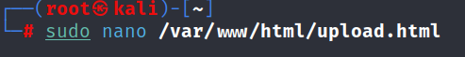

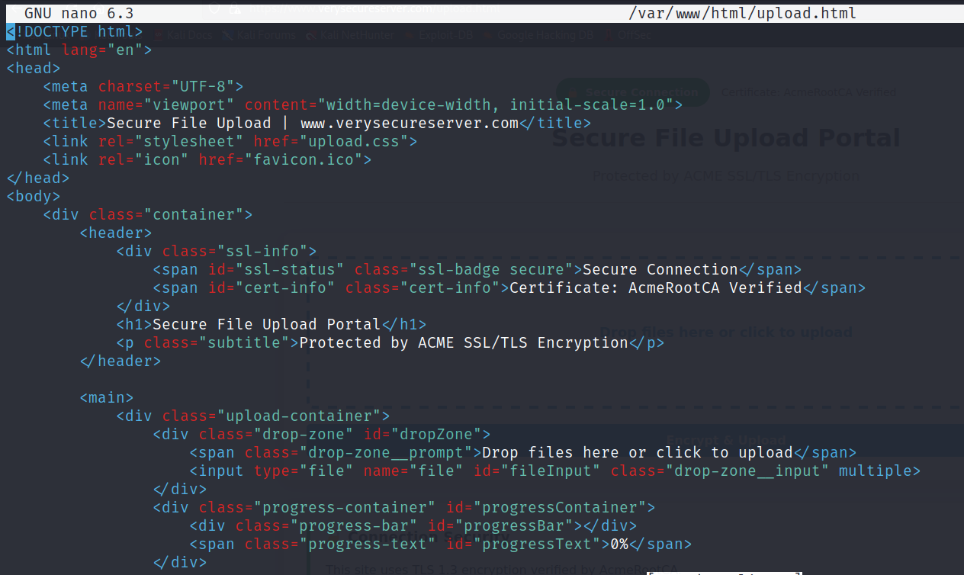

After exit,go to browser and open the webpage is https://www.verysecureserver.com/upload.html

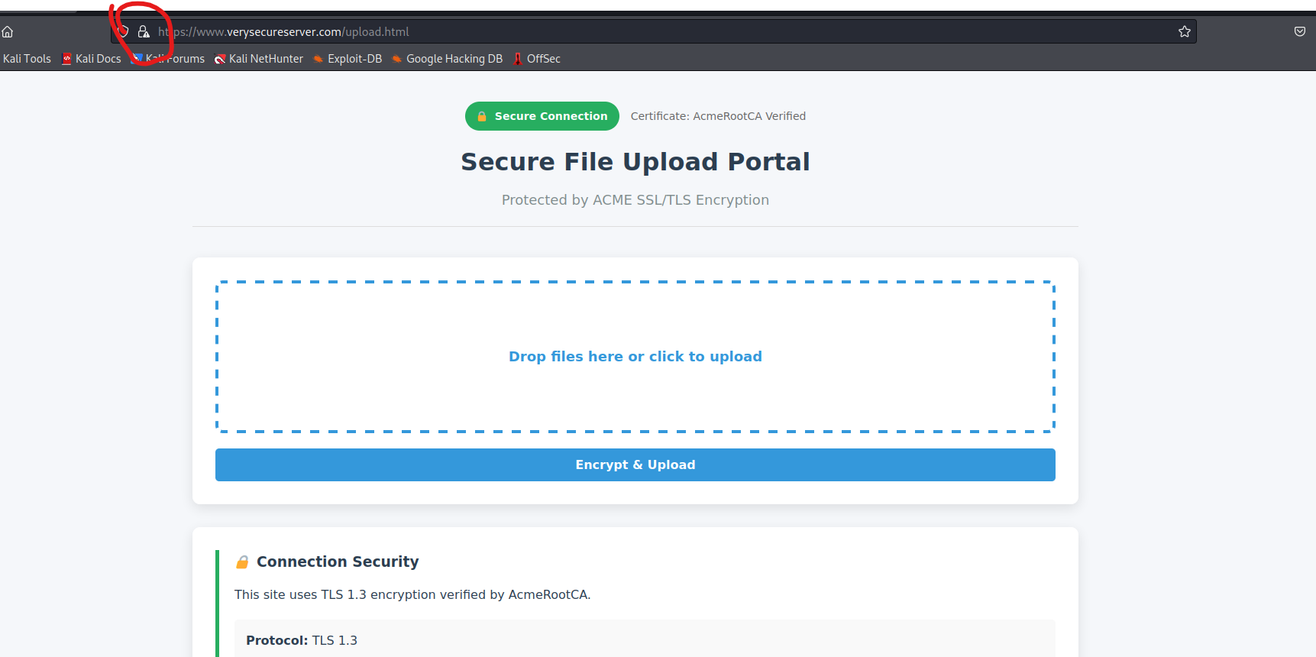
This is a basic web page, and the browser shows it as 'Not Secure' because it's not certified by a trusted authority—it just uses a self-signed digital certificate.
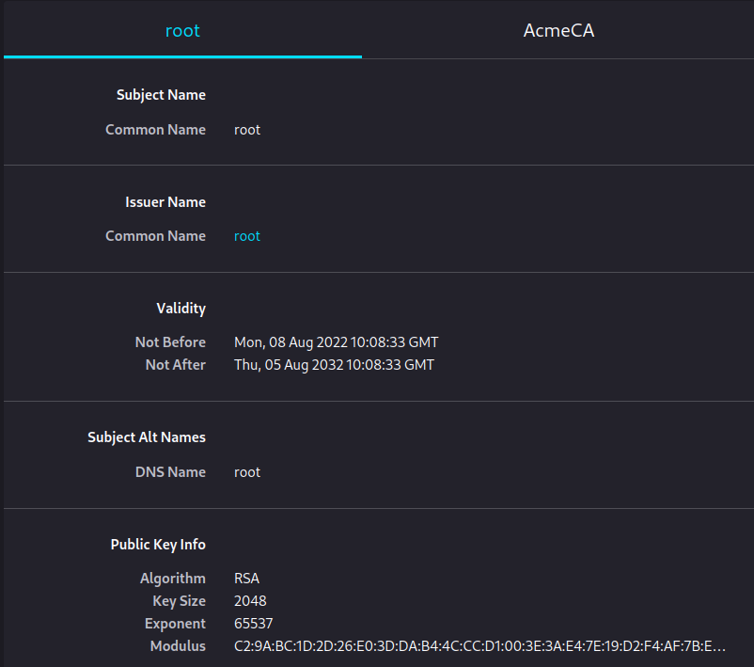
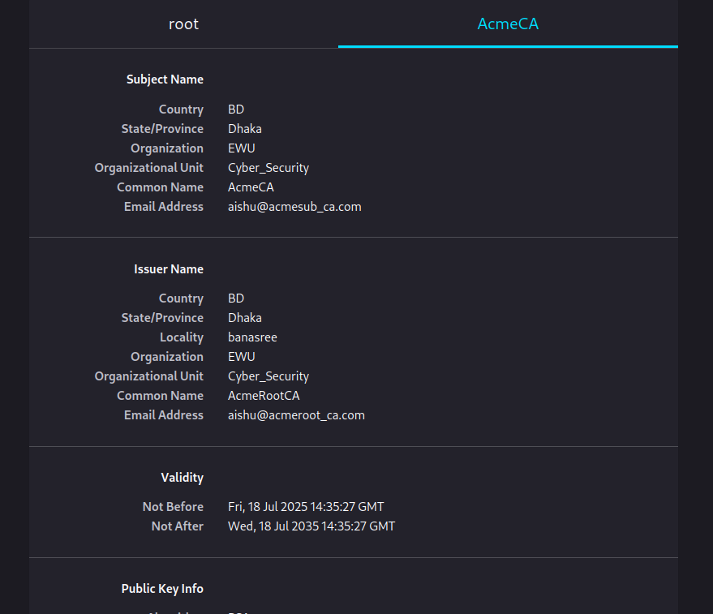
Root Certificate – This is the top-level certificate in the trust chain. It’s self-signed (issuer and subject are both "root"). All other certificates trust it.
AcmeCA – This is a subordinate certificate authority issued by the Root CA. It can issue certificates to websites or organizations.

Now Verifying the security of the connection by inspection (the padlock icon), and with Wireshark from another computer.

- Open Command Prompt.
- To list all interfaces Wireshark can capture on:

┌──(root㉿kali)-[~]
└─# tshark -D
Running as user "root" and group "root". This could be dangerous.
1. eth0
2. any
3. lo (Loopback)
4. bluetooth0
5. bluetooth-monitor
6. nflog
7. nfqueue
8. dbus-system
9. dbus-session
10. ciscodump (Cisco remote capture)
11. dpauxmon (DisplayPort AUX channel monitor capture)
12. randpkt (Random packet generator)
13. sdjournal (systemd Journal Export)
14. sshdump (SSH remote capture)
15. udpdump (UDP Listener remote capture)

3.Start capturing on that interface for TCP port 443:

┌──(root㉿kali)-[~]
└─# tshark -i 3 -f "tcp port 443" -w capture.pcapng
Running as user "root" and group "root". This could be dangerous.
Capturing on 'Loopback: lo'
** (tshark:3201) 09:10:32.606017 [Main MESSAGE] -- Capture started.
** (tshark:3201) 09:10:32.606444 [Main MESSAGE] -- File: "capture.pcapng"

4.Visit the HTTPS site
https://www.verysecureserver.com/upload.html

This will trigger the TLS handshake packets to appear in your capture.

5.Stop the capture
6.Open in Wireshark
┌──(root㉿kali)-[~]
└─# wireshark capture.pcapng

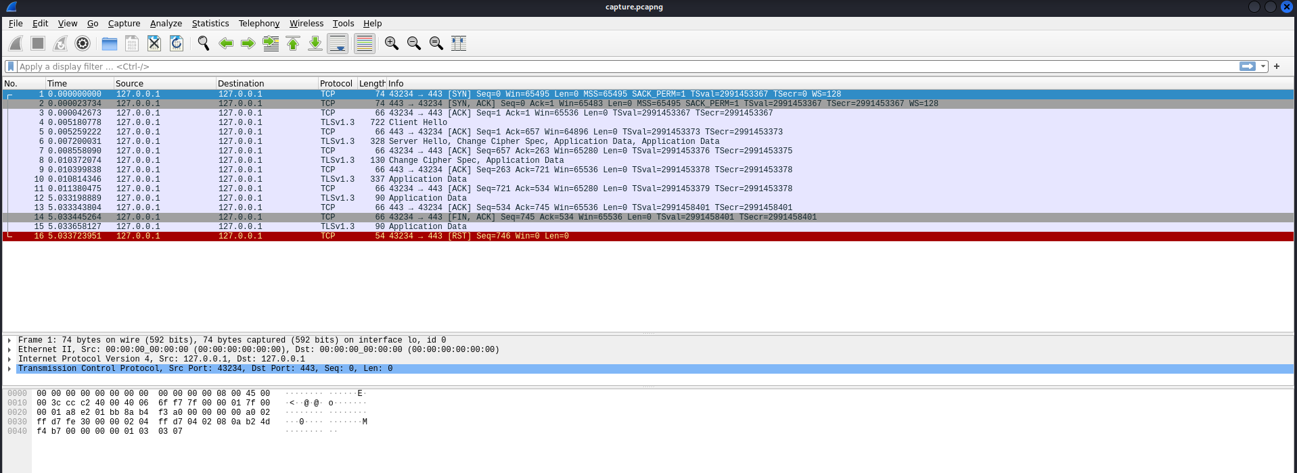

- TCP Handshake (Packets 1–3) – Browser and server connect (SYN, SYN-ACK, ACK).
- Client Hello – Browser proposes encryption settings.
- Server Hello + Certificate – Server chooses settings and proves identity.
- Change Cipher Spec – Switch to encrypted mode.
- Application Data – All further communication is encrypted HTTPS traffic.

