**INTRODUCTION**

A DBMS makes it possible for end users to create, read, update and delete [data](http://searchdatamanagement.techtarget.com/definition/data) in a database. The DBMS essentially serves as an interface between the [database](http://searchsqlserver.techtarget.com/definition/database) and end users or [application programs](http://searchsoftwarequality.techtarget.com/definition/application-program), ensuring that data is consistently organized and remains easily accessible.

The DBMS manages three important things: the data, the database [engine](http://whatis.techtarget.com/definition/engine) that allows data to be accessed, locked and modified -- and the database [schema](http://searchsqlserver.techtarget.com/definition/schema), which defines the database’s logical structure. These three foundational elements help provide [concurrency](http://searchoracle.techtarget.com/definition/concurrent-processing), security, [data integrity](http://searchdatacenter.techtarget.com/definition/integrity) and uniform administration procedures. Typical database administration tasks supported by the DBMS include [change management](http://searchcio.techtarget.com/definition/change-management), performance monitoring/tuning and [backup](http://searchstorage.techtarget.com/definition/backup) and [recovery](http://searchstorage.techtarget.com/definition/recovery). Many database management systems are also responsible for automated [rollbacks](http://searchsqlserver.techtarget.com/definition/rollback), restarts and recovery as well as the [logging](http://whatis.techtarget.com/definition/log-log-file) and [auditing](http://searchcio.techtarget.com/definition/audit-trail) of activity.

The DBMS is perhaps most useful for providing a centralized view of data that can be accessed by multiple users, from multiple locations, in a controlled manner. A DBMS can limit what data the end user sees, as well as how that end user can view the data, providing many views of a single database schema. End users and software programs are free from having to understand where the data is physically located or on what type of storage media it resides because the DBMS handles all requests.

**REVIEW OF LITERATURE**

**OVERVIEW**

Wireless technology has been the enabling domain in reshaping conventional healthcare systems in conjunction with information technology (IT). Emerging technologies such as m-health, ubiquitous health monitoring as well as telemedicine have recently become widespread and attracted the attention of many researchers. The Continuous and realtime monitoring systems, as the key elements of modern caregiving systems, can effectively revolutionize the conventional healthcare systems. Wireless body sensor networks (WBSNs) have received a considerable attention as the viable alternative in achieving continuous health monitoring systems. Currently, WBSNs support a wide range of applications including fall prevention, wireless electrocardiography (ECG) (i.e., wireless ECG), and also remote respiration and temperature monitoring. As it can be deduced, different types of vital sign sensors (e.g, blood pressure, glucose, ECG and temperature) which are wirelessly networked together can incorporate in WBSNs for specific health monitoring purposes. However, currently in hospitals, patients’ vital signs are recorded and supervised several times during the course of a day by clinical staff. Human errors, lack of adequate skills, tiredness and inefficient staff in additional to shortcoming of sufficient accuracy due to wrong measurement and personal interpretation of the results can deteriorate patients’ life, especially when the number of hospitalized patients exceeds.

**SYSTEM ANALYSIS**

**EXISTING SYSTEM**

The current state and projected future directions for integration of remote health monitoring technologies into the clinical practice of medicine. Wearable sensors, particularly those equipped with IoT intelligence, offer attractive options for enabling observation and recording of data in home and work environments, over much longer durations than are currently done at office and laboratory visits. This treasure trove of data, when analyzed and presented to physicians in easy-to-assimilate visualizations has the potential for radically improving healthcare and reducing costs. We highlighted several of the challenges in sensing, analytics, and visualization that need to be addressed before systems can be designed for seamless integration into clinical practice.

**PROPOSED SYSTEM**

A database is a collection of related data, which are organized to extract useful information . The effectiveness of databases derives from the fact from one single, comprehensive database much of the information relevant to a variety of organizational purposes may be obtained. In health care the same database may be used by medical personnel for patient care recording, for surveillance of patient status, and for treatment advice; it may be used by researchers in assessing the effectiveness of drugs and clinical procedures; and it can be used by administrative personnel in cost accounting and by management for the planning of service facilities.

The fact that data are shared promotes consistency of information for decision-making and reduces duplicate data collection. A major benefit of databases in health care is due to the application of the information to the management of services and the allocation of resources needed for those services, but communication through the shared information among health care providers, and the validation of medical care hypotheses from observations on patients are also significant.

The contents and the description of a database has to be carefully managed in order to provide for this wide range of services.The formalization, and the large data quantity implied in effective database operations make computerization of the database function essential; in fact, much of the incentive for early is due to the demands made by information processing needs..

**MODULES**

**a)MICROCONTROLLER WITH UART OUTPUT MODULE:**

UART stands for Universal Asynchronous Receiver / Transmitter. It is a very popular serial communication interface which provides Full Duplex communication between two devices. UART uses two data lines for sending (TX) and receiving (RX) data. Ground/Reference of both devices should be made common. As the name indicates it is an asynchronous communication interface, which means that it doesn’t need to send CLOCK along with data as in synchronous communications. UART is the communication interface used by our old computer’s RS-232 port.

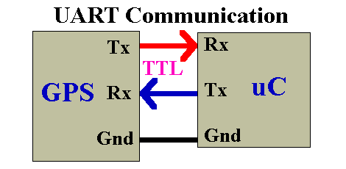

**b)DATA ACQUISITION:**

Data acquisition (DAQ) is the process of measuring an electrical or physical phenomenon such as voltage, current, temperature, pressure, or sound with a computer. A DAQ system consists of sensors, DAQ measurement hardware, and a computer with programmable software. Compared to traditional measurement systems, PC-based DAQ systems exploit the processing power, productivity, display, and connectivity capabilities of industry-standard computers providing a more powerful, flexible, and cost-effective measurement solution. The measurement of a physical phenomenon, such as the temperature of a room, the intensity of a light source, or the force applied to an object, begins with a sensor. A sensor, also called a transducer, converts a physical phenomenon into a measurable electrical signal. Depending on the type of sensor, its electrical output can be a voltage, current, resistance, or another electrical attribute that varies over time. Some sensors may require additional components and circuitry to properly produce a signal that can accurately and safely be read by a DAQ device.

**c)CALIBRATION:**

The present temperature and humidity status can be viewed by clicking the “Acquire” Button on the main screen. A dialog box pops up immediately after the button is clicked which asks the user to enter a file name and choose a location for the creation of a data log file with a DAT extension. The user may see the temperature and humidity values with names of their specific areas configured in the form of plot names. These values are available both numerically and graphically along with time stamp. “Start logging” button has to be clicked whenever the user wants to start the logging operation. Whenever these values cross the specified limits, a red alert message pops up either for temperature or humidity and it can be seen which particular area it is. Moreover, the buzzer also rings when the limits are crossed to alert the user properly.

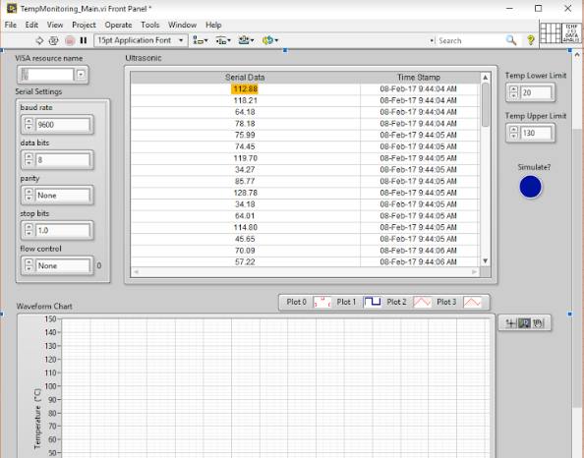

**d)GRAPH GENERATION:**

The data log created previously is available for subsequent analysis. The “Analysis” button when clicked from the main screen prompts the user to enter a file name that he would like to analyze. This function shows a plot of the values recorded previously with the start time/date and stop time/date. These values depicted in the graph can also be seen on Microsoft Excel by exporting them.

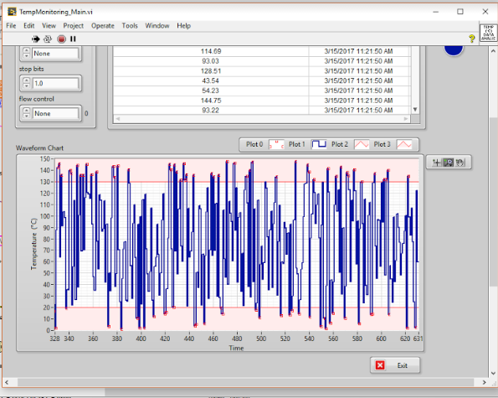

**SYSTEM SPECIFICATION**

**4.1 HARDWARE REQUIREMENTS**

Processor : Intel Pentium

Speed : 2.93 GHz RAM

Capacity : 2GB

Hard disk : 500 GB

Motherboard: Intel

**4.2 SOFTWARE REQUIREMENTS**

Operating System : WINDOWS 7.0 & Above

Software : MP LAB IDE,PROTEUS SIMULATION TOOL,HI

TECH C COMPILER

**CONCLUSION AND FUTURE ENHANCEMENT**

**FUTURE ENHANCEMENT**

The system includes the temperature of the patient that are being monitored at a time interval and graph is generated.The parameters that increases temperature can be added and other features available in the algorithm can be used for adding extra modules in it, also the software provided are enhanced based on the evolutions.

**CONCLUSION**

Thus the “**Health Monitoring Using Database Management System**” aims to predict the chances of health issues by monitoring the temperature and the pulse of the patient in the regular interval of time.

**REFERENCE**

[1] R. .G.K and K. Baskaran, “A Survey on Futuristic Health Care System: WBANs,” Procedia Engineering, vol. 30, pp. 889–896, 2012.

[2] F. Viani, M. Donelli, G. Oliveri, A. Massa, and D. Trinchero, “A WSNbased system for real-time electromagnetic monitoring,” in Antennas and Propagation (APSURSI), 2011 IEEE International Symposium on, 2011, pp. 3129–3132.

[3] K. Roback, “An overview of temperature monitoring devices for early detection of diabetic foot dosorders,” Expert review of medical devices, vol 5, pp. 711-718, 2010.

[4] Archer, A. G., Roberts, V. C., & Watkins, P. J. “Blood flow patterns in painful diabetic neuropathy”, Diabetologia, vol. 27, pp. 563–567, 1984.

[5] T. Giao, C. Pesto, L. Selavo, Y. Chen, J. Ko, J. Lim, A. Terzis, A. Watt, J. Jeng, B. Chen, K. Lorincz, and M. Welsh, "Wireless Medical Sensor Networks in Emergency Response: Implementation and Pilot Results," IEEE Conference on Technologies for Homeland Security, pp. 187-192, May 2008.

[6] Sotera Wireless, "ViSi Mobile | A Product by Sotera Wireless," Available: http://www.visimobile.com/. (Accessed August 25, 2014).