Url for repo -

https://github.com/aishu912/Jenkins-Container.git

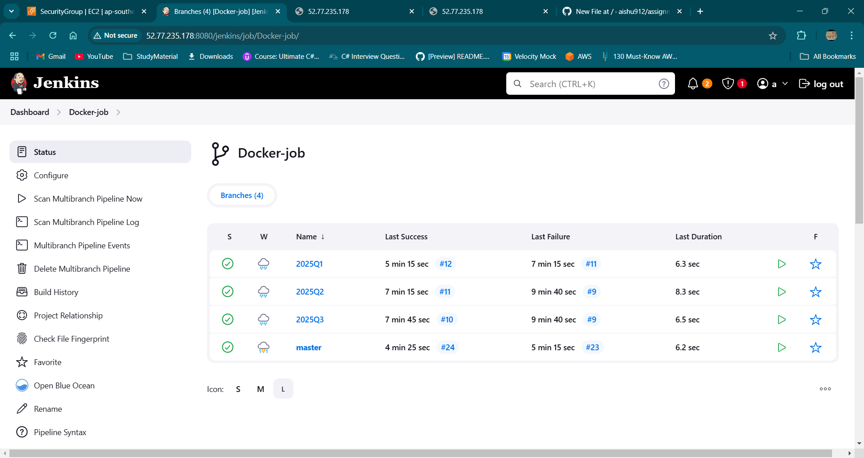

On master branch -

pipeline{

agent{

label{

label 'built-in'

customWorkspace '/root/dockerCont/'

}

}

stages{

stage('cleaning up existing containers'){

steps{

// Stop all running containers

sh "docker stop \$(docker ps -q)"

// Remove all containers (including stopped ones)

sh "docker rm \$(docker ps -a -q)"

}

}

stage('create a container'){

steps{

sh "docker run -d -p 80:80 --name contMaster httpd"

}

}

stage('deploy'){

steps{

sh "docker cp index.html contMaster:/usr/local/apache2/htdocs"

sh "docker exec contMaster chmod 755 /usr/local/apache2/htdocs/index.html"

}

}

}

}