**HOW TO DOWNLOAD MONGODB 5.0.2**

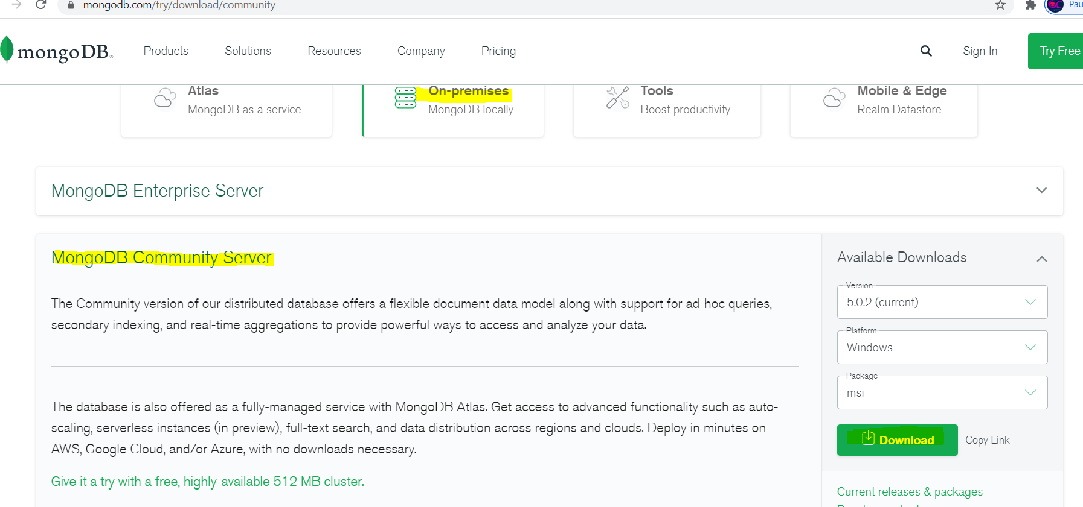

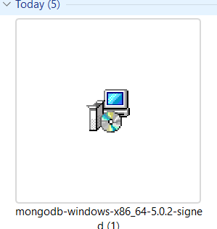

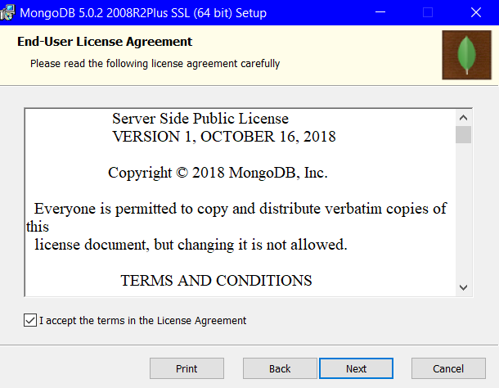

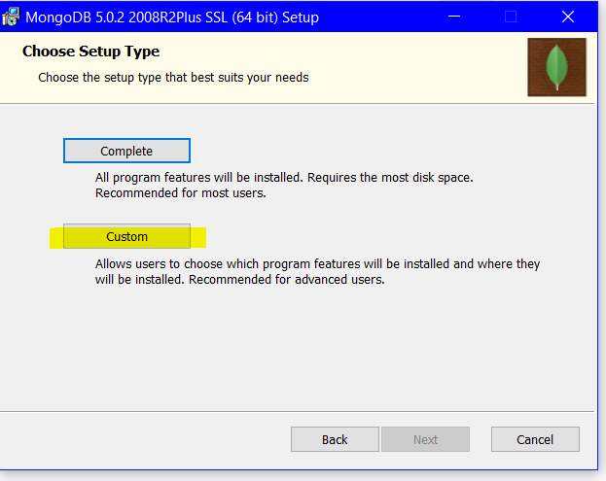

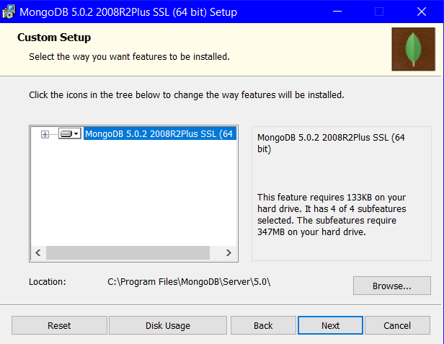

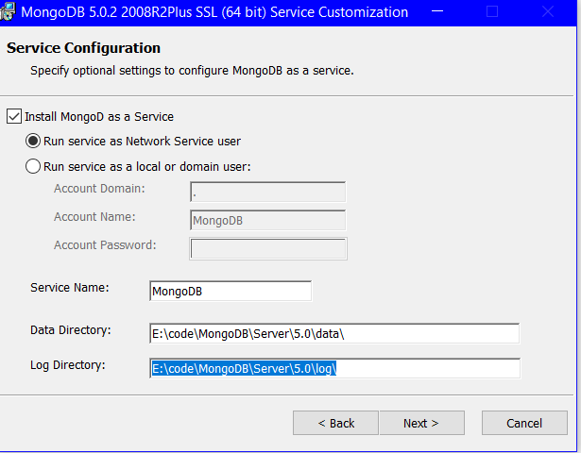

Open CMD navigate to path : cd drive:\\x\MongoDB\Server\5.0\bin

Run command mongod

Run command mongo to start the server

Run command show dbs to list databases

Run command use mydb –which will create a new DB also if not there ,it will not list untill it has data

Collections similar to tables

Run command db.collectionname insert to create collection and add data

Use mydb

Db.mydb.insert({“empname”:”Anu”,”empage”:”30”})

Output: WriteResult({ "nInserted" : 1 })