**MULESOFT TABLE CREATION,INSERTION AND RETRIVAL**

create table movies (name varchar(30),actor varchar(30),actress varchar(30),year number(5),director varchar(30))

insert into movies values('master','vijay','malavika','2021','lokesh');

insert into movies values('kaithi','karthick','','2019','lokesh');

insert into movies values('7aam arivu','surya','shruthihasan','2011','murugadass');

insert into movies values('jai bhim','surya','jose','2021','gnanavel');

select * from moviesa;

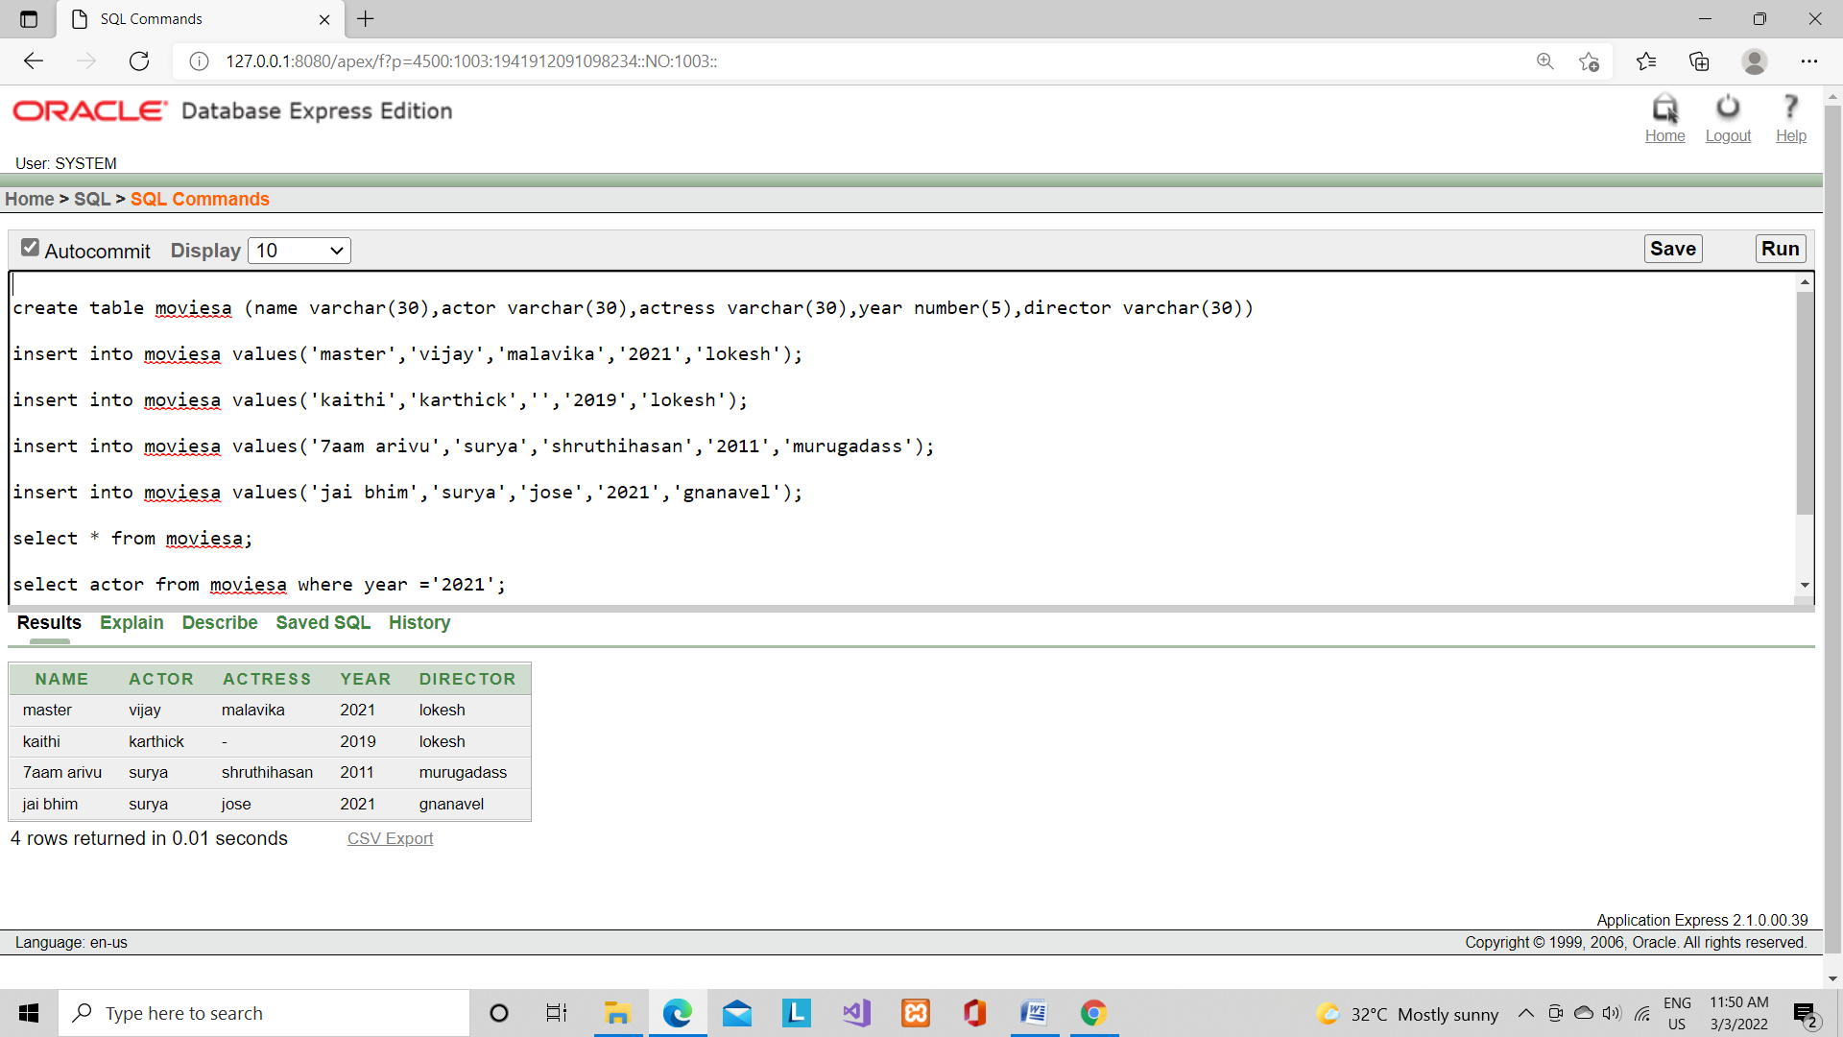

select actor from movies where year ='2021';

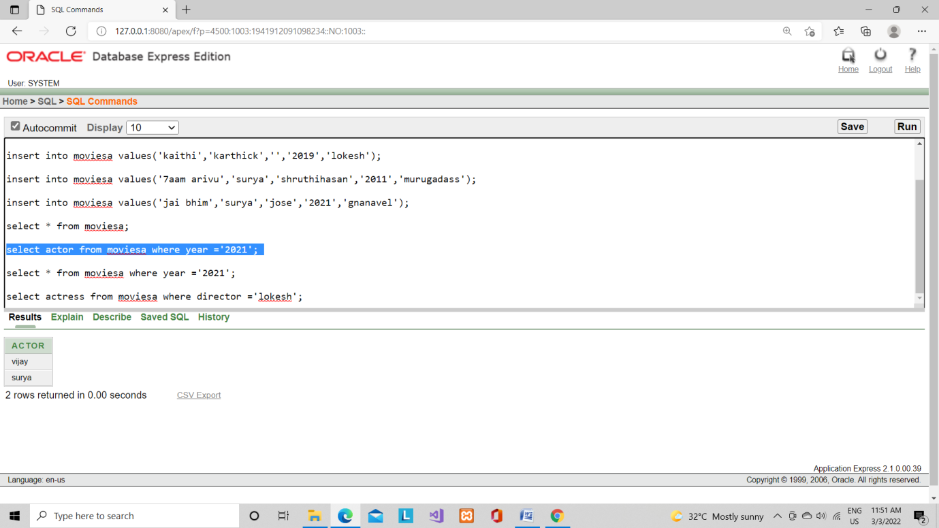

select * from movies where year ='2021';

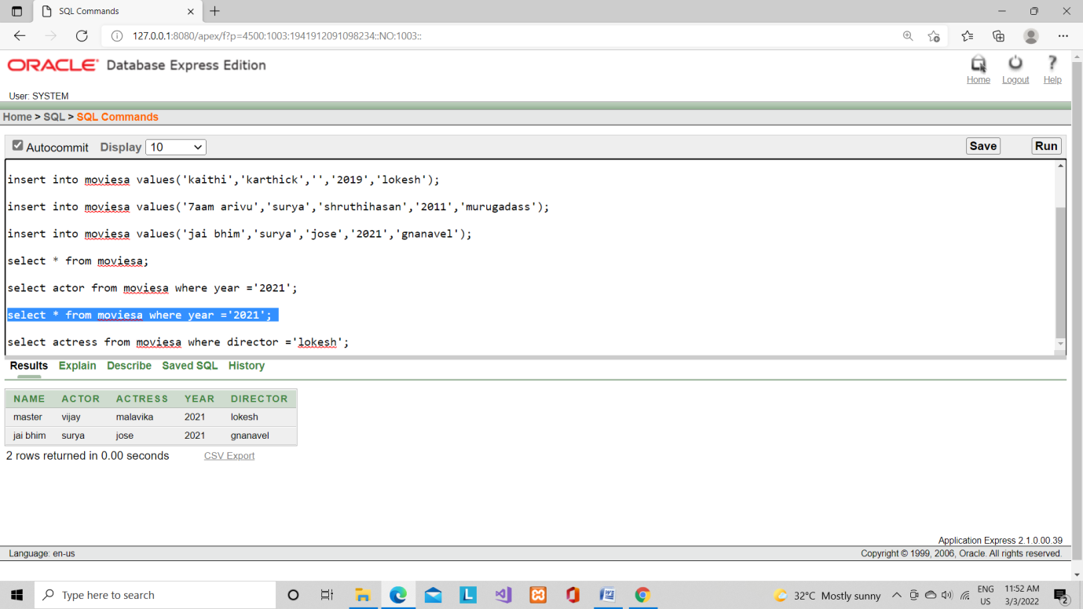

select actress from movies where director ='lokesh';

