Unit 1 — Basic Structure of Computers
CSE23CT201 · Computer Organization & Architecture · CO1 — Topic-wise exam question bank (what to write in the exam)

Chapter 1 — The Five Functional Units

The five functional units (definition to reproduce)
- Input — accepts coded information from outside (keyboard, mouse, sensors, network).
- Memory — stores the programs and data.
- ALU (Arithmetic & Logic Unit) — performs the arithmetic and logic operations.
- Output — sends the results to the outside world.
- Control unit — coordinates all the units with timing signals.
- ALU + Control + registers together form the PROCESSOR.
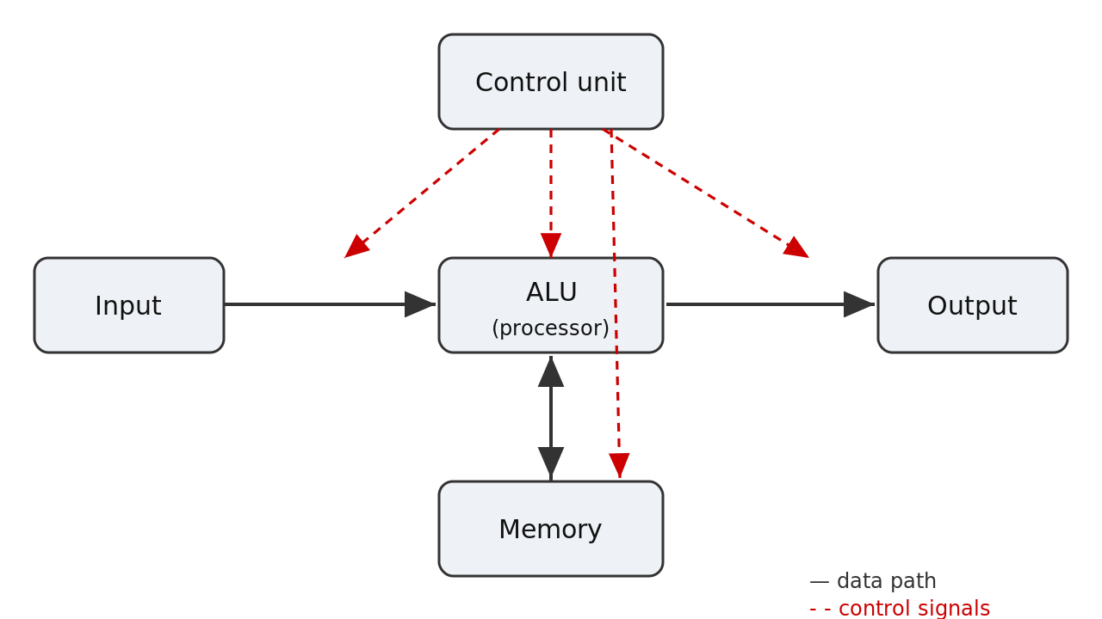
Five functional units — data path (solid), control signals (dashed).

Control unit
- Generates two kinds of signal: clock (timing) signals = WHEN each step happens; control signals = WHAT to do on that tick.
- Reads and decodes the instruction in the IR and drives every other unit at the right instant.

Clock
- A steady square-wave pulse — the computer’s heartbeat, sent to every unit.
- One pulse = one step (one microoperation).
- Ticks per second = clock rate in hertz (e.g. 3 GHz = 3,000,000,000 ticks/second).

Memory hierarchy (clean 5-mark answer)
- Primary / Main memory — fast semiconductor RAM; holds the running program and data; volatile.
- Cache — small, very fast RAM near the processor; holds frequently-used instructions/data.
- Secondary storage — disk, SSD, flash; large, cheap, non-volatile permanent storage.
- Speed order (fastest first): Register → Cache → Main memory → Disk.

Chapter 2 — Basic Operational Concepts

Stored-program concept
- Both the program instructions and the data are stored together in the same memory, each instruction at its own address (100, 104, 108 …).
- The processor fetches instructions one at a time and executes them.

Processor registers (write these four one-liners — 4 marks)
- PC (Program Counter) — holds the address of the NEXT instruction to be fetched.
- IR (Instruction Register) — holds the instruction CURRENTLY being executed.
- MAR (Memory Address Register) — holds the address of the memory location to be accessed.
- MDR (Memory Data Register) — holds the data being written to, or just read from, memory.

RTN (Register Transfer Notation)
- [A] means the CONTENTS of location A; ← means “copied into”.
- The source is unchanged; the destination is overwritten.

Demo program: C = A + B (textbook load/store convention)
Addr | Instruction | RTN
100 | Load R2, A | R2 ← [A]
104 | Load R3, B | R3 ← [B]
108 | Add R4, R2, R3 | R4 ← [R2] + [R3]
112 | Store R4, C | M[C] ← [R4]

Instruction cycle (classic 5-mark answer)
- Phase 1 — Fetch & Decode: PC → MAR → memory; the instruction is read into MDR, then into IR; the control unit decodes the IR.
- Phase 2 — Execute: the operand address goes to MAR, the operand is read into MDR, the ALU acts, the result is stored, and the PC is incremented.
- Written as three steps: fetch · decode · execute.

Chapter 3 — Bus Structures

Bus — definition (reliable 5-marker)
- A bus is a shared set of wires that transfers data and control information between the functional units.
- Only one source may drive it at a time (built with multiplexers or tri-state buffers).
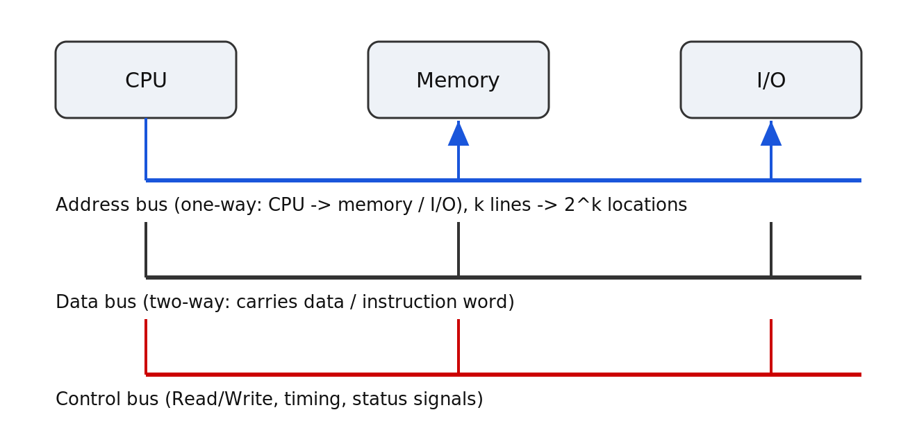
A bus = three groups of lines: address, data, control.

The three line-groups
- Address bus — carries the address to access; k lines → 2^k locations; usually one-way (processor → memory).
- Data bus — carries the data / instruction word; both ways.
- Control bus — carries Read/Write, timing and status signals.

Single vs multiple bus
- Single bus — one shared path; cheap and simple; only one transfer at a time (bottleneck).
- Multiple / two-bus — parallel paths; faster; costlier (more wiring).
- System bus — the main highway tying processor (via cache), main memory and I/O; bundles address + data + control lines.

Chapter 4 — Memory Locations & Addresses

Bit, byte, word
- Bit — a single 0 or 1 (smallest unit).
- Byte — a group of 8 bits (holds one character).
- Word — the n-bit unit the processor handles at once; word length typically 16 / 32 / 64 bits.

Addressing facts (examiners love these)
- Byte-addressable — every 8-bit byte has a distinct address (0, 1, 2, …).
- A k-bit address → 2^k addressable locations (2^24 = 16M; 2^32 = 4G).
- Aligned word — begins at an address that is a multiple of the word size in bytes (32-bit word: 0, 4, 8 … aligned; 6 is not).

Endianness
- Big-endian — most-significant byte at the lowest address.
- Little-endian — least-significant byte at the lowest address.
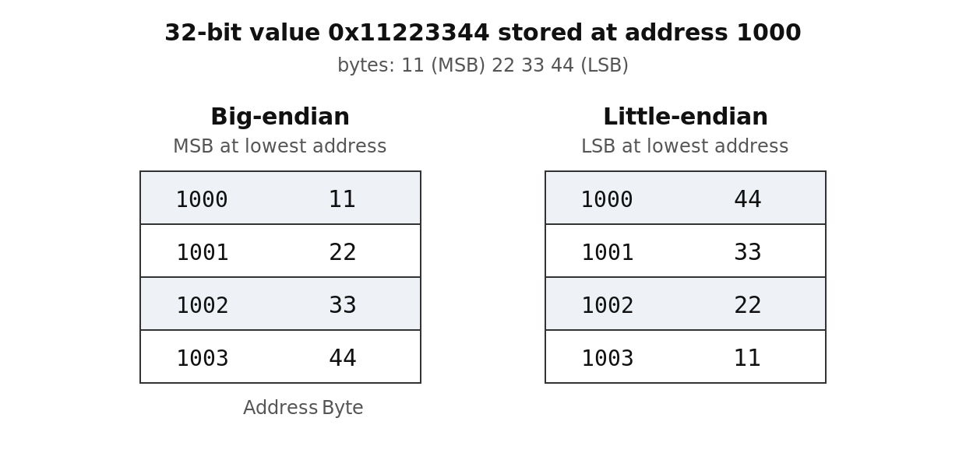
Storing 0x11223344 at address 1000 — big-endian vs little-endian.

Chapter 5 — Memory Operations & Instructions

The two memory operations (in exam words)
- Read — the processor sends an address; memory returns a COPY of the contents; source unchanged. RTN: DR ← [LOC].
- Write — the processor sends an address and data; memory stores it, overwriting the old value. RTN: M[LOC] ← R1.
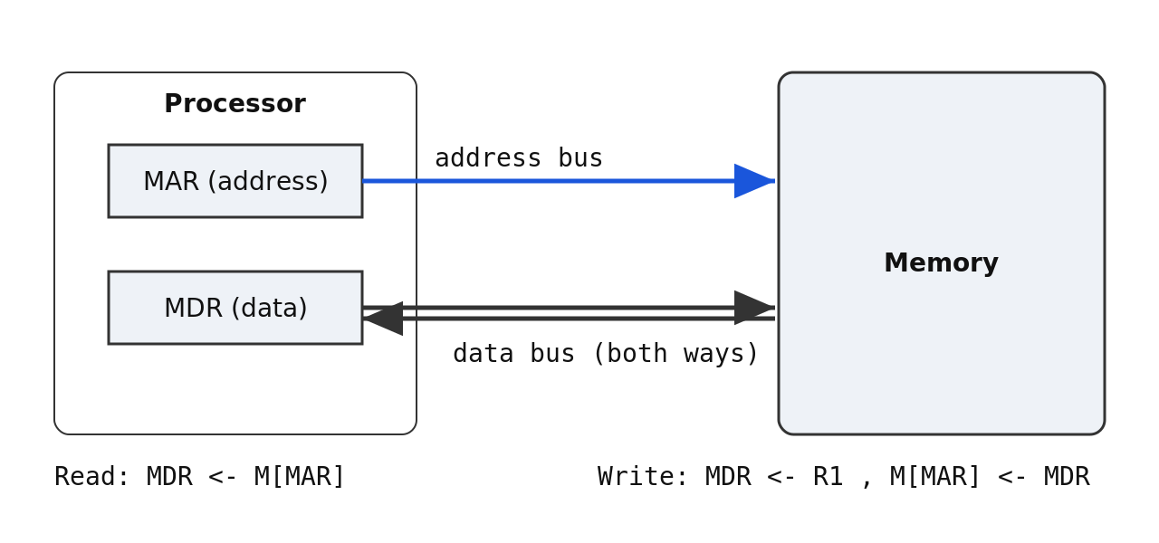
Read and Write — address through MAR, data through MDR.

Instruction basics
- Instruction = opcode (the operation) + operand(s) / address (what it acts on).
- Assembler — translates symbolic assembly (mnemonics) into the binary object program.
- Instruction formats — memory-reference, register-reference, and input–output.

Classify by number of operands (same job C = A + B)
Type | Example | What is implied
3-address | Add C, A, B | nothing — all three named
2-address | Add C, A | destination doubles as a source
1-address | Add B | the accumulator: AC ← [AC] + [B]
0-address | Add | the top two stack entries

RISC vs CISC
 | RISC | CISC
Instruction set | few & simple (often < 100) | many (100s–1000s), memory-to-memory
Execution | one cycle → easy to pipeline | variable length → multi-cycle
Memory access | load/store only (Load/Store touch memory) | arithmetic may act directly on memory
Burden on | the compiler (software) | the hardware
Examples | ARM, RISC-V | x86 (Intel/AMD)

Chapter 6 — Addressing Modes

Addressing modes with effective address (guaranteed question)
Mode | Notation | Effective address
Immediate | #Value | operand is in the instruction
Register | Ri | operand is in Ri
Absolute / Direct | LOC | EA = LOC
Indirect | (Ri) | EA = [Ri]
Index | X(Ri) | EA = X + [Ri]
Relative | X(PC) | EA = X + [PC]
Autoincrement | (Ri)+ | EA = [Ri], then Ri ← Ri + 1
Autodecrement | −(Ri) | Ri ← Ri − 1, then EA = [Ri]

Worked examples to quote
- Immediate: Move R2, #5 → R2 ← 5.
- Direct: Load R2, A → R2 ← [A].
- Indirect: Load R2, (R5) → R2 ← [[R5]] (two memory accesses).
- Index: Load R2, 20(R5) → EA = 20 + [R5]; if R5 = 1000 then 20(R5) reaches address 1020.

Chapter 7 — Instruction Sequencing

The exam essentials
- Straight-line sequencing — the PC is auto-incremented after each fetch, so instructions execute in increasing address order.
- Branching — a branch loads a NEW address into the PC instead of PC+4. Two kinds: unconditional and conditional.
- Unconditional branch (jump) — always taken; PC ← target every time (e.g. loop back).
- Conditional branch — taken only if a tested condition is true. The preceding Compare/arithmetic sets the condition-code flags (Z, N, C, V), which the branch reads (e.g. Branch>0).
- Branch target = the destination address; offset = target − (PC of next instruction); relative EA = PC + offset.

